KP01
A Simple MVB Coupler to Any Processor
Handbook
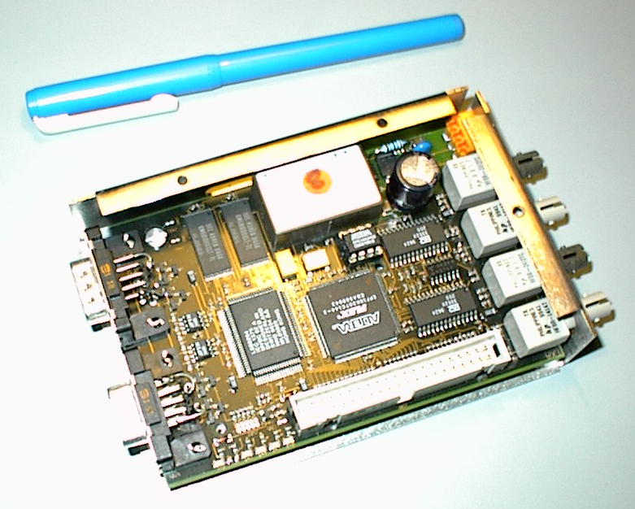

Contents
1 Introduction 3
1.1 Summary 3
1.2 Audience 4
1.3 Definitions and Abbreviations 4
1.4 References 4
1.5 Acknowledgements 4
2 Data sheet of the KP01 5
2.1 Mechanical dimensions 5
2.2 Electrical 6
2.3 Data Interface 6
3 Internal structure 7
4 Supported media 8
4.1 Glass fibers 8
4.1.1 Fibre type 8
4.1.2 Layout rules 8
4.2 RS485 Cable 8
4.2.1 Cable type 8
4.2.2 Connector layout 8
4.2.3 Terminator network 9
4.2.4 Layout rules 9
5 Mechanical dimensions and wiring space 11
6 Connection of the media 12
6.1 Connection between neighbour AC31 12
6.2 Glass fibre connection 13
7 Internals 14
8 Programming of the KP01 15
8.1 „C“- programmed controllers 15
8.1.1 kp_ConfDsp 15
8.1.2 kp_GoOperation 15
8.1.3 kp_ReadDSP 16
8.1.4 kp_WriteDSP 16
8.1.5 kp_Diag 16
8.1.6 Other services 16
8.2 Functional Bloc Language programmed controller 07KT94 16
8.3 IEC 61131-programmed controllers 07KT97/98 17

Introduction

Summary
The Multifunction Vehicle Bus (MVB) is a field bus for time-critical applications according to international standards IEC 61375 [ 1 ] and IEEE 1473-T [ 2 ]. It broadcasts process data cyclically and deterministically according to the Publisher/Subscriber principle - devices exchange data peer-to-peer, without going through a master. There exists a bus master that paces the bus traffic, but it needs not to participate in data exchange. Several bus administrators can take over the master’s role alternatively or upon a failure of the current bus master.
This document describes in detail the KP01, a coupler to attach to the MVB a simple device (Class 1 according to IEC 61375). The KP01 is not an actual device, but a template from which devices can be designed. The KP01 is a generalization of an actual device called 07KP99, which is commercialised by ABB Stotz Contact, Heidelberg, Germany for their family of compact PLCs AC31. The 07KP99 is therefore referred in many documents as an implementation of the KP01. In particular, the software has been developed and tested for the 07KP99.
The KP01 offers a fully redundant physical attachment to two media: optical glass fibre and shielded twisted pair (RS485). A KP01 can serve as repeater between two RS485 segments, and as a star coupler between two fibres.
Figure 1 shows an example of a network of several CPUs connected to the MVB through a KP01. Neighbour groups of KP01 (for instance within the same equipment) are connected by RS485, remote groups over fibre.
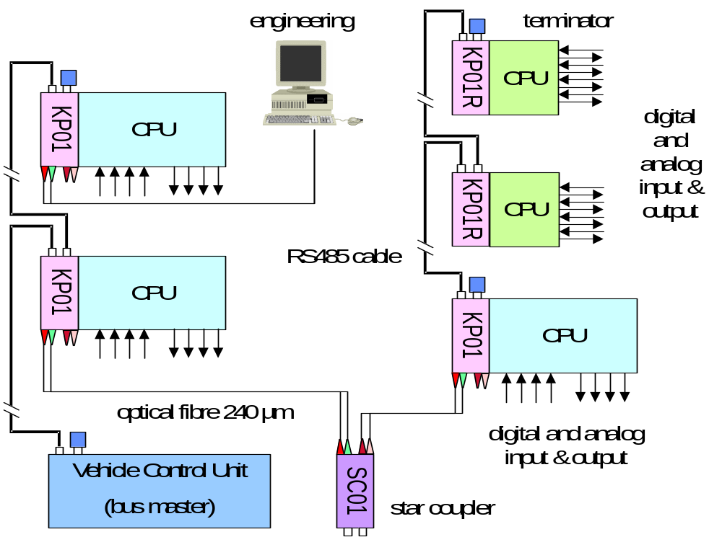
Figure 1: Example of a KP01 network (single line)
As the KP01 is only a Class1 device, another device must play the role of a master, for instance Bombardier’s VCU. An engineering station, for instance running Bombardier’s MicView, can be attached over a fibre.
For simplicity, Figure 1 shows a non-redundant network. In fact, the RS485 connection is basically redundant, while there is less need for redundancy in a fibre network.
Simplified KP01 are possible, the upper left two CPUs are shown with no fibre interface (they are termed KP01R).
The KP01 supports no messaging according to the IEC 61375 standard. However, applications that require some messaging, for instance to download diagnostics can use a very crude service built on a pair of cyclic variables [ 5 ].
Note - A version of the KP01 with an embedded processor, the KP02, will be able perform as a stand-alone device. This device is not covered here, but it is already considered in the software.

Audience
This document addresses developers that use the MVB field bus and would like to develop a simple coupler to their equipment. It is the intention that a person with reasonable skills in the design of hardware and software can connect her or his own Class 1 devices to the MVB based on the documentation enclosed in the KP01 distribution kit.

Definitions and Abbreviations
Note – the definitions available in IEC 61375 are not repeated here
AC31 industrial controllers of ABB Stotz Contact, Heidelberg, Germany 07MR93, 07KT94, 07KT97 or 07KT98.
AF100 ABB designation of the railways field bus MVB (IEC 61375, IEEE 1474).
DAT A 32-bit data item operated on as an indivisible unit (IEC 61331 modules operate with DATs)
DSP Data Set Peripheral, generally called “dataset”. Content of process data frames, which are cyclically dispatched. DSPs are 32, 64, 128 or 256 bits long. A DSP is always read or written as a whole.
KP01 a fictitious device which has the same capabilities as the commercial 07KP99.
KP02 a fictitious device which has capabilities in addition to the 07KP99, in particular the ability of becoming bus master.

References
[1] IEC 61375-1999 Clause 3: Multifunction Vehicle Bus (not enclosed in the KP01 kit)
[2] IEEE Std 1474 „IEEE P1473/D3.4.1 Standard for Communications Protocol Aboard Trains
(not enclosed in the KP01 kit)
[3] MVBC 01: Multifunction Vehicle Bus Controller Data Sheet (ADtranz, Revision C) – enclosed as
MVBC01.pdf
[4] Mark Meng, “Hardware Requirement Specifications for the coupler KP99” Rev. A, enclosed as KP99RevA.pdf.
[5] KP99_Schematics.pdf
[6] KP01: Fieldbus Interface Coupler, Inside.
[7] KP01 software (zipped as KP.ZIP)

Acknowledgements
This distribution kit could be compiled thanks to:
ABB Schweiz AG, BU Printing, Segelhof, 5405 Baden, Switzerland and to
Meng Engineering, Bruggerstrasse 31, 5400 Baden, Switzerland.
These companies kindly accepted yielding their intellectual property rights on the published information.

Data sheet of the KP01

Mechanical dimensions
The KP01 can be arranged in several ways, either as a sector of the motherboard of the CPU (for cost-effective large series), as a subprint (IndustryPack module) on the CPU motherboard, or as a separate casing (as was done with the 07KP99).
Figure 2 shows how the 07KP99 is attached to the 07KT94. It is mounted on a DIN rail adjacently to the processor, to which it is attached by means of a 40-wire flat cable (not visible on Figure 2).

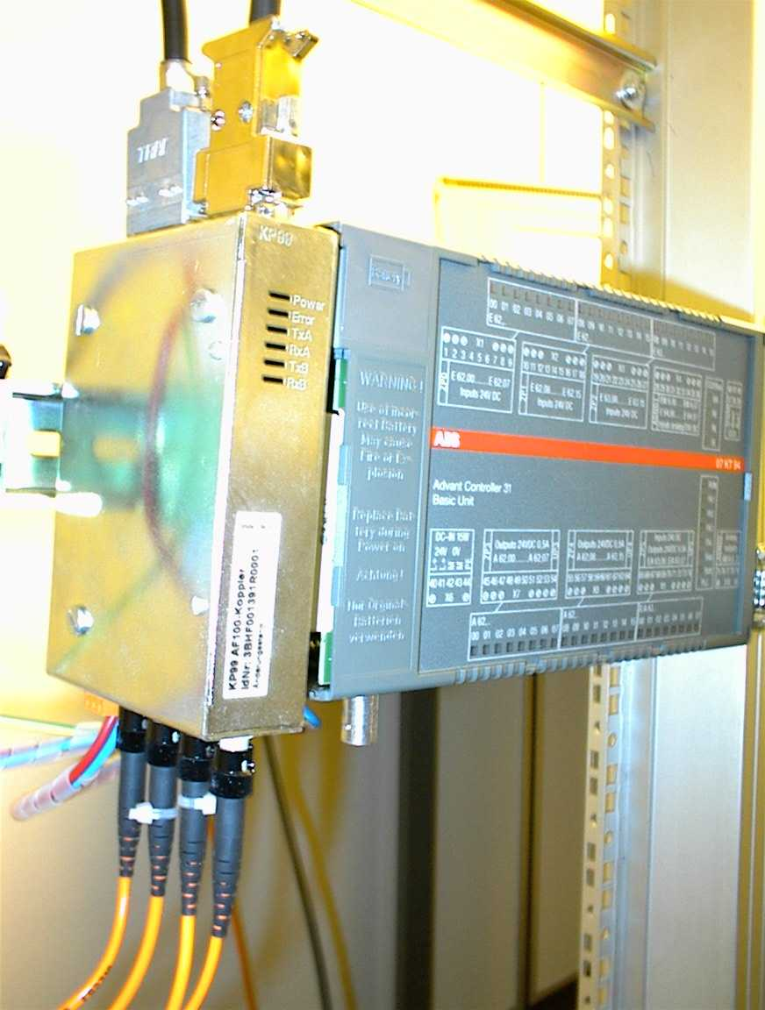
Fig. 2 - A 07KP99 attached to a 07KT94 of ABB Stotz-Contact
(note the four fibres on the bottom and the RS485 connectors on the top)
Figure 3 shows the mechanical dimensions of the 07KP99.
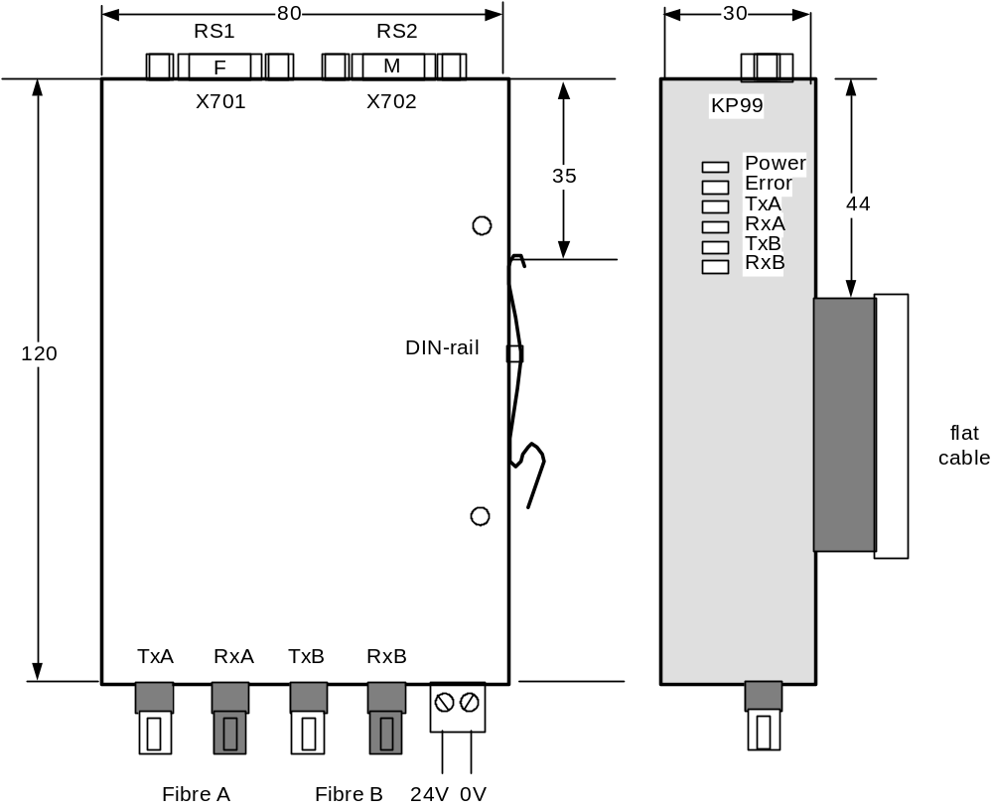
Figure 3 – Mechanical dimensions of the 07KP99 (in mm)
The operation of the KP01 is supervised by 5 LED’s:
Power | 24V present
Error | hardware fault
TxA | KP01 sends on Line A both over glass fibres and RS485.
TxB | KP01 sends on Line B both over glass fibres and RS485..
RxA | KP01 receives on Line A over either glass fibres or RS485.
RxB | KP01 receives on Line B over either glass fibres or RS485

Electrical
The KP01 operates with a 24V supply, drawing less than 70 mA, It generates internally the voltages for the logic and for the RS485 drivers. However, it does not provide galvanic separation for the RS485.

Data Interface
The KP01 operates as a Class1 device. It participates only in the exchange of process data. It can transmit and receive up to 4096 datasets. However the software considers only 256 sets, since this is more than sufficient for practical purposes.

Internal structure
The KP01 contains an MVB controller of the type MVBC02A, which is compatible with its predecessor, the MVBC01 [5], which handles the bus traffic without participation of the CPU. MVBC and CPU exchange data through a common memory, called the traffic store, which is contained in the KP01. The traffic store uses the large model of 128 KB.
The CPU sees the traffic memory through a 16KB window of its address area. Accessing the 128 KB memory over a 16KB window does not impair performance – a mapping mechanism positions automatically the data of a data set when this data set is accessed.
The KP01 serves as repeater (regenerator) between optical and RS485 media. Therefore glass fibre and RS485 can be operated at the same time.
Both media can be duplicated to increase availability. Furthermore, it is possible to mix duplicated segments and not duplicated, e.g. lay out the RS 485 double (the default) and the glass fibbers simple, if the availability requirements do not call for full redundancy.
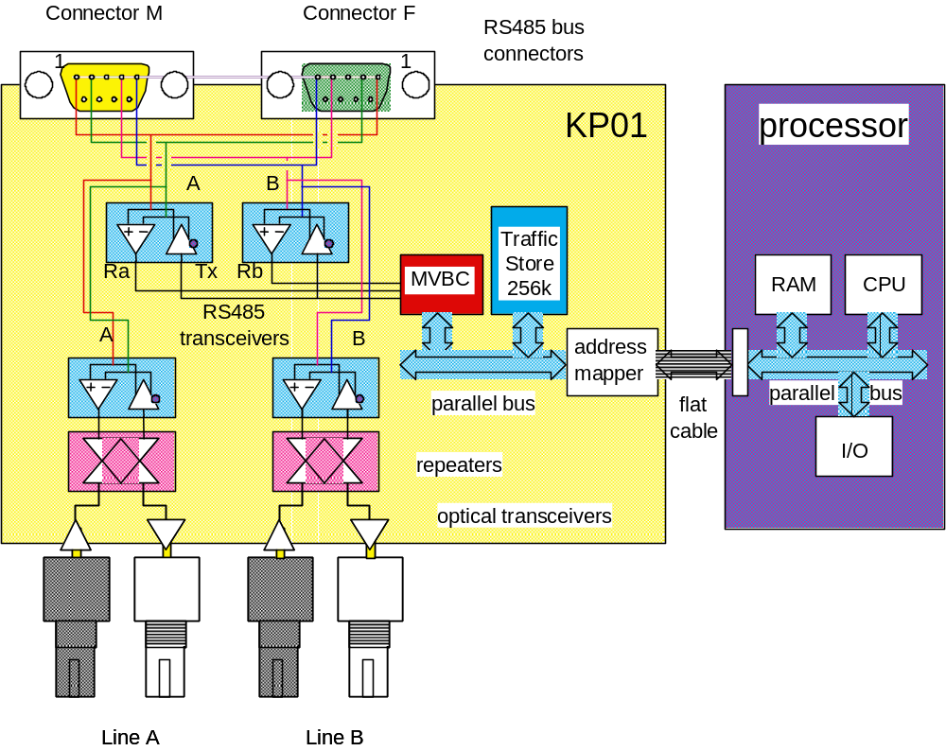
Figure 3 – Hardware of the KP01

Supported media

Glass fibers

Fibre type
The 240 µm silica glass fibres with ST-connectors specified in IEC 61375 [ 1 ] are used.
A dual-line MVB connection consists of 4 glass fibres. The glass fibre end going to the receiver (darker bayonet connector) shall be marked by a bright tape or a bright bending protection, the other glass fibre going to the sender (brighter bayonet connector) shall either be not to be marked or be marked with a dark bending protection. In a double-line arrangement, it is recommended to mark the fibres of line A with red (bright red at one end, dark red at the other end) and green (bright green at one end, dark green at the other)

Layout rules
Optical segments are point-to-point links, which are connected by repeaters. The maximum signal turn-around time (back- and forth) between two any devices on the MVB may not exceed 42 µs (regardless of the media in between).
According to the standard, this limits the number of repeaters switched in series to approximately four with a propagation length (total) of 2 km and 3 µs per repeater. The repeater used in the KP01 has a propagation time below 1 µs and allows thus more repeaters.
Note: MVB devices [ 3 ] permit signal turn-around times in excess of 42 µs, allowing to cover up to 15 km, however with stricter configuration rules. This ability is not supported in the software.
To simplify error detection in a double line arrangement, the A-glass fibre should always be connected to the A-connectors, the B-glass fibre always with the B-connectors.
The fibres are to be laid out in such a way that the length difference between A-segments and B-segments remains below a meter. This restriction will be lifted with future MVB controllers.

RS485 Cable

Cable type
The RS485 medium uses shielded, twisted wire pairs of 120 Ohm with an equipotential line according to RS485, with a biasing according EN50170 (Profibus). Further details can be found in the IEC 61375 standard. By default, each cable carries the two redundant pairs, for a total of 6 wires.
Note: reliability calculations show that the common mode of failure due to the cable is negligible in view of other threats, such as transceiver failures, since redundant cables would have to meet at each device anyhow.
Such cables can be ordered at Huber&Suhner under the number 12553902-60351 or Kabelmetall as „Filotex“ cable.

Connector layout
The RS485 cable carries a sub-D 9 connector at each end, one end being a male connector (M) and the other a female connector (F), so that the two cable runs going to a device can be plugged together should the device be unavailable (or for the purpose of checking the cabling).
The connectors shall be fitted with metric screws (M3).
Caution: serial cables for PC ( COM1/COM2 ) are fitted with US-screws – do not try to screw them on the MVB connector.
The KP01 also has two connectors, a male and a female, as Figure 4 shows.
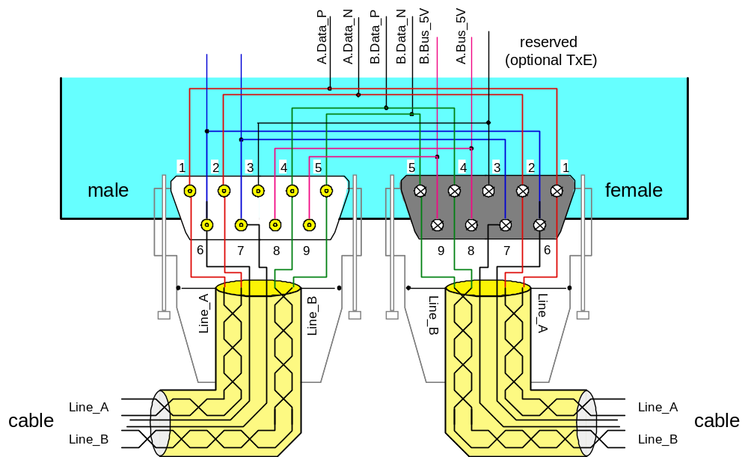
Figure 4 – Pin-out of the Sub-D 9 connector for the RS485 medium

Terminator network
The RS485 bus segment must be terminated at both ends with a terminator network, which is packaged within a connector casing. There exist a terminator within a male (M) and within a female (F) connector.
Figure 5 shows the schematics of the connector.
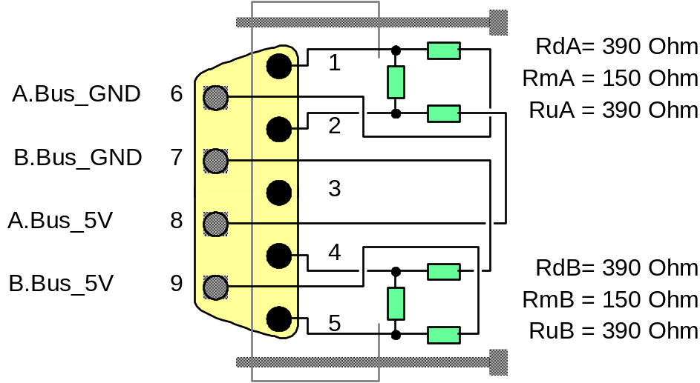
Figure 5 – Terminator network

Layout rules
The distance between two neighbouring devices may not fall below 30 cm, except when all devices are within a meter distance (e.g. if the RS485 cable is laid only within a cabinet). The total of the cable lengths between two devices may not exceed 20 m with the specified cables (signal attenuation). The KP01 does not offer a galvanic separation to the RS485 medium. For the bridging longer distances, glass fibres are to be used.

Mechanical dimensions and wiring space
Many arrangements are possible. The following explains some configuration rules observed in the 07KP99. Glass fibres are connected to the lower side, RS485 cables to the upper side of the 07KP99. Figure 6 shows the bending radii to be observed.
. 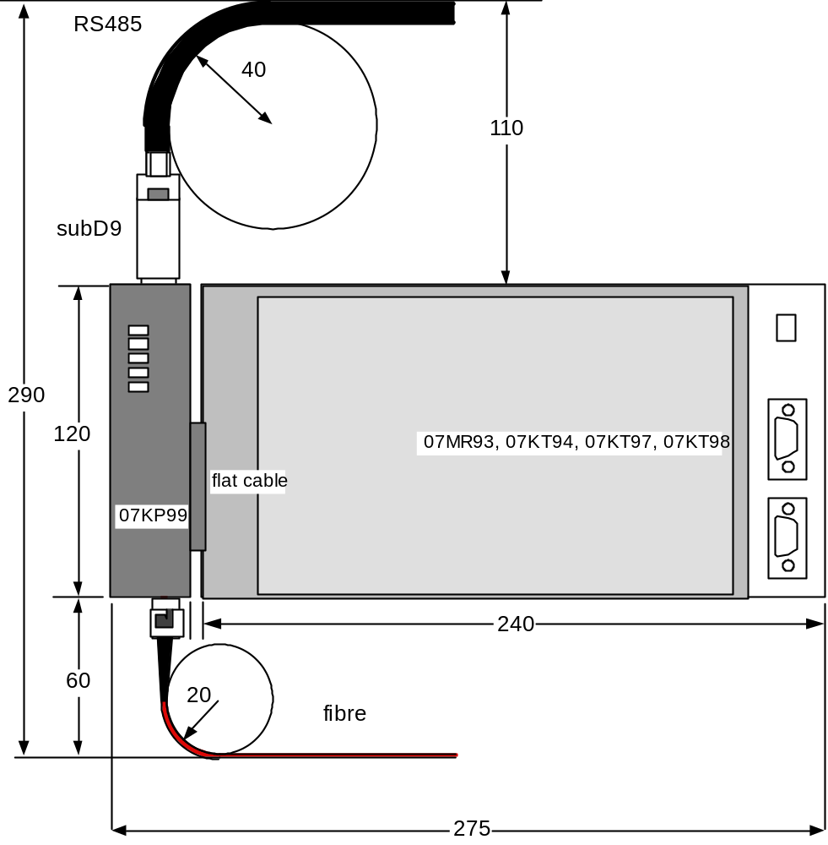
Figure 6 – Bending radii of the fibre and RS 485 media.

Connection of the media
The ability of the KP01 to act as a repeater allows multiple configurations with other ABB controllers. While this is not necessarily relevant for railways applications, it gives an idea how systems can be configured.

Connection between neighbour AC31
Definition: neighbouring AC31 share the same 24V= power supply and can be connected with an RS485 cable without galvanic separation.
Figure 6 shows a typical layout with several neighbouring AC31 connected to an Advant AC160 controller. The AC31 are connected through the RS485 cable. The terminators are mounted in a connector casing.
The lowest AC31 serves as a repeater to access the glass fibres leading to the AC160. Since the AC160 has no direct fibre connection, the coax-based MVB is connected through a TC630 modem. Figure 6 shows a duplicated fibre connection, although such a duplication is normally not needed, since fibres are retroaction-free. The RS485 cable should, however, be always redundant since driver failure is a source of unavailability.
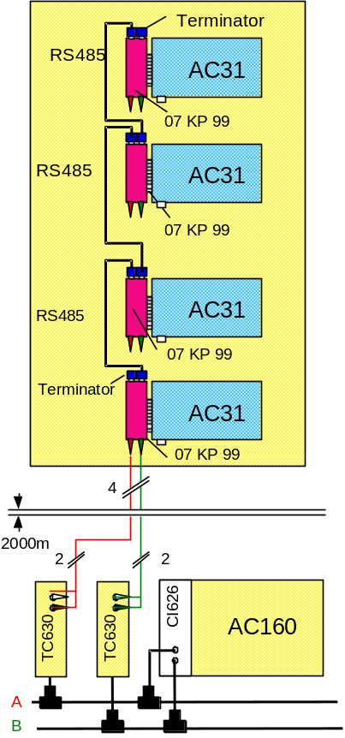
Figure 6 – Duplicated connection of a AC160 with four AC31

Glass fibre connection
Devices which may not be connected to the same power supply should preferably be connected over glass fibres. To spare a star coupler, the bus is threaded through the KP01, going from fibre to RS485 and back to fibre. This presumes that pairs of neighbour AC31 are installed, which is often the case. If the AC31 are far apart, a KP01 without an AC31 con be used – indeed, the KP01 operates by default as a repeater when it is powered up, it requires the AC31 to command it to go to coupler mode.
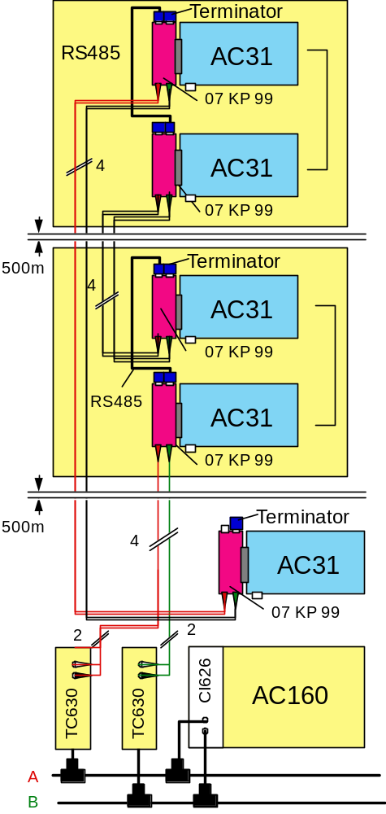
Figure 7- Threading of the bus by alternating glass fibre and RS485 segments, using KP01 as repeaters.

Internals
The schematics of the 07KP99 have been included as an example for the KP01. In another project, the processor interface would be designed differently.
The internal operation of the KP01 is described in the hardware requirement specs of the 07KP99, see [4].
In particular, the position of the registers must be matched with that in the MVBC01 Data Sheet [ 3 ].
The module KP.C shows how the MVBC is initialised.

Programming of the KP01

„C“- programmed controllers
This code delivered in this distribution kit has been developed for the ABB 07MR93 compact PLC.
The 07MR93 uses an Intel x86 processor.
It uses a real-time kernel with static, non-preemptive scheduling of tasks and provides interrupt handlers.
However, the KP01 makes no use of the kernel interface. The CPU accesses the KP01 as if it were a memory region. To this effect, a 16 KB memory block must be mapped out in the processor, so that it accesses the dual-ported RAM instead of its normal RAM. Also, this region should not be cached.
In the 07KP99 (and in the distributed code), this memory block starts at address xC800, other values are possible.
The 07MR93 is programmed in the Borland “C” version 3.0 and 2. It uses the Turbo Debugger and the Paradigm Locator. Although project files belonging to the Borland compilers and to the Paradigm Locator have been included in the distribution kit, the compilers and the locator are not part of this distribution kit.
The C-Library consists of the module KP (KP.H and KP.C), which can be used indifferently for the KP01 and the KP02, when it exists. The software identifies the coupler type and configures accordingly the interface at initialisation time. Although the KP02 does not yet exist, it has been put in the code to show how a different controller could be installed with the same interface. This is useful since a KP02 could require somehow different calling and initialisation conditions. For legacy reasons, the KP01 is identified in the software by the key “9” “9” (ASCII) and the KP02 by the key “9””5”. Indeed, the code for the KP02 has been inherited from a former version, called 07KP95.
Since it was necessary to interface to a function bloc language similar to IEC61131, the API of the KP is somewhat different from what the IEC 61375 standard prescribes – this does not impair its interoperability with other devices.
The “C”-library offers the following services:

kp_ConfDsp

int kp_ConfDsp (char ident, unsigned char nrDats, char set, char dir, unsigned int perMs)
configures a dataset, identified by “set” and “ident” (bus identifier), with a number of DATs (32-bit words, 1, 2, 4 or 8) and an individual period in ms, which is used to control sink time supervision in the KP01. After successful configuration, this function returns a 16-bit handle which will be used for further access (kp_ReadDSP, kp_WriteDSP). On the KP01, this handle is identical to the port index in the traffic store. A return value of “0” is not valid.
The dataset address is calculated internally as (50 * set + ident). For instance, when set=4 and ident = 12, the dataset address is 212. This method was practical to supervise a configuration: the source of the dataset was known from its address. Configuration tools make this method obsolete.
A DAT is a 32-bit unit treated as a whole. Transmission of single 16-bit words is not supported (FunctionCode 0).

kp_GoOperation

void kp_GoOperation(int station, int master, int duplex)
defines the address of the MVB station, whether the coupler is capable of being master or not (this returns an error for the KP01, but is intended for a future coupler) and whether the medium is duplicated or not.
The station address (MVB physical address) should be in the range 0..16 for master devices and more than 128 for Class 1 devices. This is purely a convention to simplify commissioning.
The KP01 ignores the “master” and “duplicated” input, since it cannot be master and considers the medium as being always duplicated. Future couplers will be able to use this information.

kp_ReadDSP

char kp_ReadDsp (int hdl, long far * pData)
copies the contents of the dataset identified by the handle “hdl” from the traffic store to the memory location pointed to by pData.
Caution: there is no check, neither of the validity of the handle nor of the validity of the pData address.
This function returns a status indicating whether the dataset is valid, i.e. whether the dataset was refreshed during the last three individual periods. It does not signal a bus error. If an error occurs, the last correct value is transferred.
The KP01 does not overwrite the dataset with “0” in case of transmission error, the original data is left unchanged.

kp_WriteDSP

char kp_WriteDsp (int hdl, long far * pData)
copies the contents of the dataset identified by the handle “hdl” from the traffic store to the memory location pointed to by pData.
Caution: there is no check, neither of the validity of the handle nor of the validity of the pData address.

kp_Diag

long kp95_kp_Diag(void)
tests the presence of the coupler (life sign check). The coupler is supposed to toggle a bit in the dual port RAM, see [ 4].

Other services
The module afVars (afVars.H, afVars.C) support packing and unpacking of variables within a dataset.
The module AfMsg support the transmission of long messages with no real-time constraints, using a pair of dedicated datasets. See afMsgs.h.

Functional Bloc Language programmed controller 07KT94
The 07KT94 controller is programmed in the Function Bloc Language PC331. The function blocs are identical for 07KP95 and KP01. A firmware version later than January 2001 should be used (available in a SmartCard or downloaded with a terminal emulator).
The function blocs are:
- MVB – Initialisation of the communication
- DSPOUT – Receiving DSP
- DSPIN – Sending DSP

Figure 8 shows the appearance of the function blocs in the development tools:
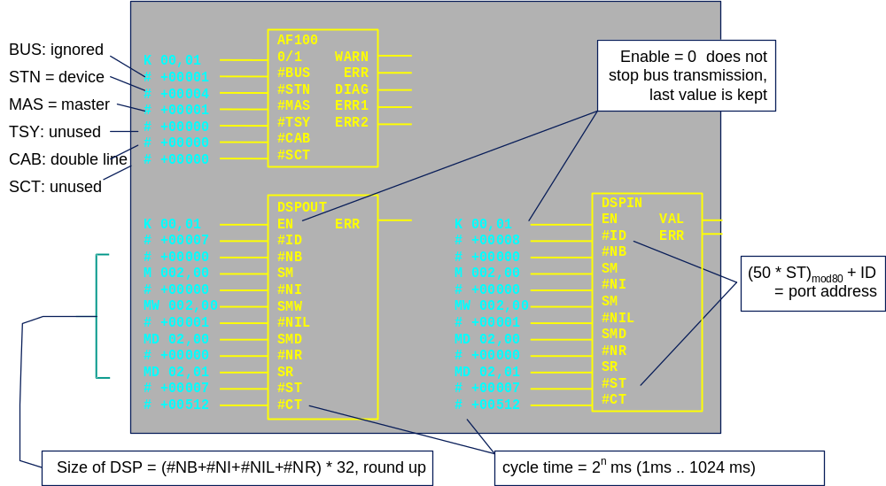
Figure 8 – Function blocs for accessing the MVB in PC331
Note: Due to a 07KP95 restriction, the same dataset cannot be used simultaneously as source and as sink in PC331.

IEC 61131-programmed controllers 07KT97/98
These PLCs are programmed in the IEC 61131 languages (AC1131 of CoDeSys). The function blocs are similar to those of the PCC331 (07KT94), a module kp_StartUpReset has been added.
The modules DSPIN and DSPOUT support packing of 16-bit integers into DATs, i.e. instead of occupying 32 bits, a 16-bit integer only occupies 16 bits. A restriction is however that the 16-bit integers must be declared pair-wise, i.e. the input nrInt16 in DSPIN and DSPOUT must be even.
The module kp_StartUpReset must be called as the first module.
The module AFINIT must be called as the last one in the initialisation.
Baden, 2002 June 9

