NETWORKING

Lesson 1

Ports
Ports
In the Internet Protocol labs we discussed IP addresses, specifically how they serve as an address for computers and devices on a network. Ports are logical connection places used to address specific services running on a computer or device.
Ports are specified by a 16-bit number, allowing for a total of 65,535 network ports. This high number of ports is necessary as services require unique port numbers and you cannot run multiple services on a single port.

Registered ports
Registered port numbers are ports that have been assigned by the Internet Assigned Numbers Authority (IANA) to a specific protocol. For example, the standard port assigned to the HTTP service is port 80; for HTTPS it is port 443. It is worth noting that sometimes you may find the HTTP/HTTPS services on a non-standard port, meaning any port except 80 and 443. Check out this list of IANA assigned port numbers.

Ephemeral ports
When you create a connection to a remote service, you will connect to a fixed port on the server from your side. You also need to allocate a port for the end-to-end connection. As ports can only be used for one connection at a time, your operating system will select a random port and assign it to the connection. This is known as an ephemeral port (‘ephemeral’ meaning to last for a very short time) and is typically selected from the range 1024-65535.

Connecting to services
To connect to a service on a network, you need to know its IP address and the network port number that the service is running on.

Connecting to a service on its registered port
Generally, you do not need to specify the network port for the connection if you are connecting to the protocol’s registered port. For example, you can connect to a website using port 80, which is the registered port for the HTTP protocol, by typing the following URL:
http://immersivelabs.com

Connecting to non-standard ports
Sometimes it’s necessary for services to run on non-standard ports. It could be that the registered port is already in use by another service, or that a different port number is required to separate normal functionality from admin functionality.
If you want to connect to a website on a non-standard (or non-registered) port, there will generally be a way to specify the alternative port. For example, to connect to the same website as before on port 8080, a port commonly used for alternative HTTP connections, you would type the following URL:
http://immersivelabs.com:8080

Lesson 2
Internet Protocol V4

Public and Private networks
A public network is part of the global network where users can access services or the internet. Access to the public network is provided by your Internet Service Provider (ISP). Typically, these networks are not tightly controlled and are therefore openly accessible.
In contrast, a private network has tightly controlled Access Control Lists (ACL) to promote a secure environment. Such networks are found within homes, organisations and universities, and may have very few network devices attached.

IP address classes
An IPv4 address consists of four groups of numbers (not digits) separated by a decimal point (e.g. 192.168.0.10). Each group is called an octet, each of which can contain a maximum of four digits, ranging from 0 to 255. This results in a total combination of just under 4.3 billion unique addresses (0.0.0.0 to 255.255.255.255). However, not all these addresses are available to use – something we’ll cover later on. The defined range of IP addresses is divided into five classes: A-E. However, only A, B, and C are commonly used. The table below shows the IP ranges associated with each class. The third column shows the number of hosts and networks available for each class; more on this will be covered in the Subnet Masks lab.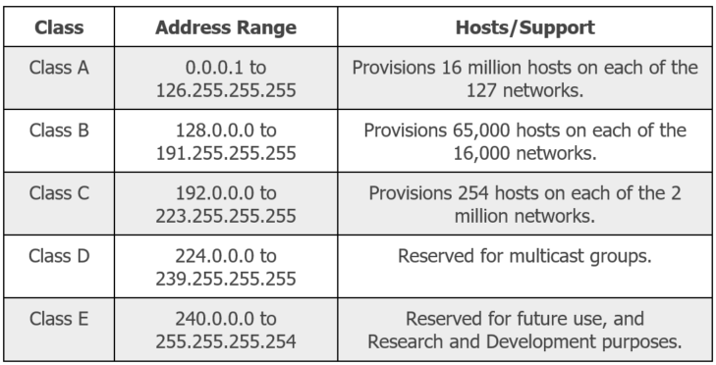IPv4 Classes
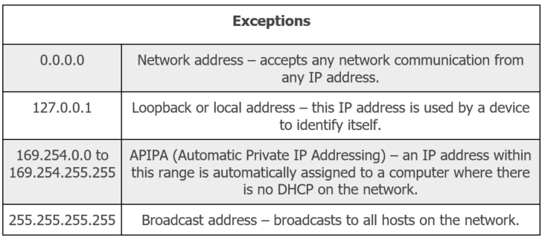IPv4 Reserved Range

Private networks
To prevent IP conflicts on the global internet, a few designated IP address ranges/subnets are made available for private use. Each of the normal classes has a range within that is used to designate private network addresses. These are reserved for private network assignment.
- Class A – private for this range is 10.0.0.0 to 10.255.255.255
- Class B – private for this range is 172.16.0.0 to 172.31.255.255
- Class C – private for this range is 192.168.0.0 to 192.168.255.255
Most operating systems include a command line tool that allows you to view your IP address.
- Windows – ‘ipconfig’
- Linux – ‘ifconfig’ or ‘ip addr’

Lesson 3
Domain Names

Domain Name System
The Domain Name System (DNS) is responsible for translating the human-readable domain names we use to request websites and services into IP addresses that computers can process.

Local DNS cache
When you request a website using its domain name (e.g. immersivelabs.com), your computer will check its local DNS cache for any requests that have recently been made.

Recursive DNS server
If there are no results in the local cache, a recursive DNS server will be queried for the domain name (immersivelabs.com). This server will normally be maintained by your Internet Service Provider (ISP) or your organisation. Other popular options for DNS resolvers include Google Public DNS and OpenDNS.
Recursive DNS servers have their own cache that will contain results for many popular domains.

Root name servers
If there are no cached answers for a query, the recursive DNS servers will query root name servers. There are 13 root name servers across the world; these are accountable for directing queries to the name servers responsible for each Top-Level Domain (TLD). In the case of immersivelabs.com, the root name server directs us to the .com TLD name server.

TLD name servers
Top-Level Domains (TLD) such as .com, .co.uk and .info have their own set of name servers responsible for directing queries to the authoritative name server for a given domain. In our example, the TLD name server directs our query to the authoritative name server for immersivelabs.com.

Authoritative name servers
All the DNS records for a specific domain are stored by an authoritative name server. After the TLD name server directs us to the authoritative name server for immersivelabs.com, we can query it for records pertaining to immersivelabs.com. This will provide the IP address for immersivelabs.com to the web-browser.
All of this occurs in a fraction of a second.

Time to live
All DNS records have a time to live (TTL) value, which stipulates how long, in seconds, a DNS answer can exist for before a recursive DNS server must request a new copy of that record.

Manually querying DNS with dig
DNS is a service that normally happens ‘behind the scenes’. However, it can be queried manually by the user when necessary, using tools like dig and nslookup.
In this example, we are querying Google’s DNS (8.8.8.8) for the IP address of immersivelabs.com. The tool is as follows:
dig immersivelabs.com @8.8.8.8

Lesson 4

TCP (Transmission Control Protocol)
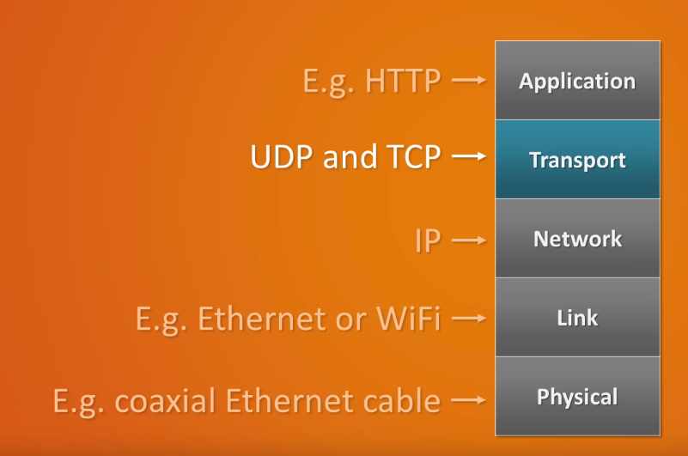
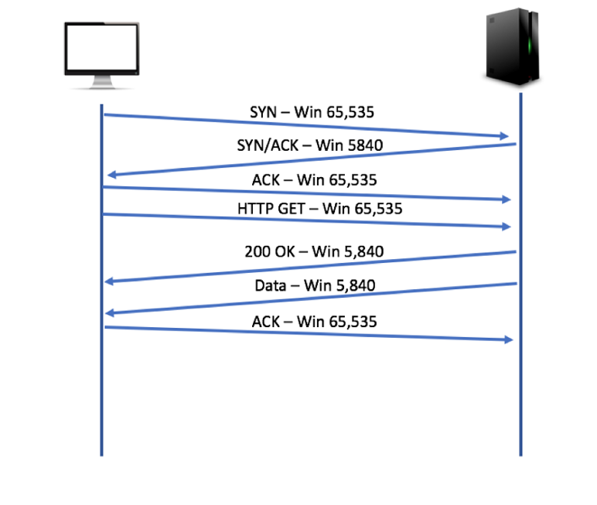

Lesson 5
UDP (User Datagram Protocol)
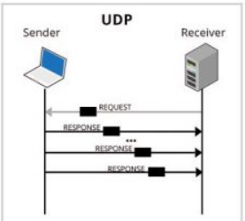

Lesson 5

HTTP Status Codes
Hypertext Transfer Protocol (HTTP) status codes are returned by a server when requests are sent to it, indicating whether or not a request has been successful. They can also be used to identify the cause of an issue when a webpage does not load properly.
Status codes are written in two parts: an initial status code and then a reason phrase, which provides some general information on what that code means. Reason phrases are not fixed and can be substituted for any human-readable alternative – the ones provided are merely recommendations.
Status codes are grouped into five classes:
- 1xx Informational: The request was received, the process continues.
- 2xx Successful: The request was successfully received and understood.
- 3xx Redirection: Requires further action to complete the request.
- 4xx Client Error: The request contains bad syntax or cannot be completed.
- 5xx Server Error: The server failed to process a valid request.
The two major categories you will be familiar with are 4xx Client Error (e.g. 404 Not Found, 403 Forbidden, 400 Bad Request) and 5xx Server Error (e.g. 500 Internal Server Error, 503 Service Unavailable, 502 Bad Gateway). The three other categories do not typically alert a user, because of the nature of them not requiring an error to be addressed.

Common HTTP Status Codes
Here is a comprehensive table of the standard HTTP status codes that exist:
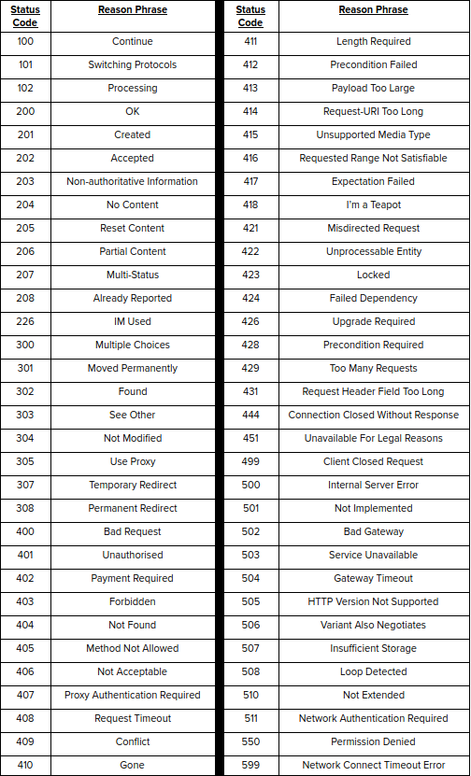
Lesson 6

FTP (File Transfer Protocol)
Other than surfing the web, visiting multiple web pages, the internet is also used for downloading files (music, movies, media files, updates to operating systems). When downloading files from the internet, The file transfer protocol is used (FTP).

How FTP works
There are two main actors involved with the FTP protocol: a server and a client. FTP exclusively uses TCP for transportation.
FTP uses port 20 for data transfer and port 21 for monitoring listening out for incoming ‘input’ commands.
The FTP ‘client’ (p20) will initiate a connection to the FTP ‘server’ (p21) and act on these modes. The server on port 21 is only used for sending commands to the client; connections to the server must always be on an ephemeral port.
- Port 21 (sending commands) is also referred to as the command port
- Port 20 (transferring data) is also referred to as the data port

Passive & Active Connections

Active
In active mode the FTP client connects from a random unprivileged port (N > 1023) to the FTP server's command port, port 21. The client is listening for active connections from Server. On the right is an example of the active mode connection from slacksite.com
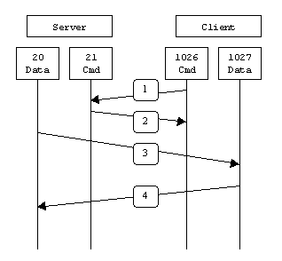active-ftp-image

Passive
Server opens and listens for a passive connection from client on port 21.
Using passive mode, the FTP client is "reaching out" to the server to make the connection.
Firewalls generally block connections that are "initiated" from the outside. Passive mode is used to get around client firewall by opening 2 high ports (ephemeral ports above 1024)
ASCII content of a packet represented as a command “PASV”
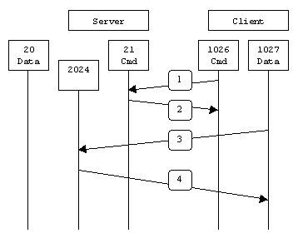passive-ftp-image

Status Codes
When in an FTP session, communication between clients and servers is represented and echoed out to the user in the form of FTP status codes. Some of these codes represent errors or the status of the connection. It is worth knowing that the communication between clients and servers are also represented this way in Wireshark. Examples of some of the codes are shown below.
- 200 Command okay.
- 212 Directory status.
- 213 File status
- 220 Service ready for new user
- 226 Closing data connection.
- 331 User name okay, need password.
- 332 Need account for login.
- 425 Cannot open data connection.
- 501 Syntax error in parameters or arguments
- 530 User not logged in.

FTP Transaction
Below is a simple FTP transaction where a user has logged in, selected a specific port and printed out a list of all the files in the current directory. Each step is followed with an explanation of what the user has done.
Client connects to FTP server.
Server returns code 220 to specify that it is ready for the new user.
Client sends command “USER <username>”
Server returns code 331 if a password is required to access the account.
Client sends command “PASS <password>”.
Server returns code 230 if authentication is successful.
Client sends a PORT command to specify the port number that it wants to transfer data over.
Server returns code 200 if the PORT command was successful.
Client sends a LIST command.
The server sends a list of files in the current directory and returns code.
226, which closes the connection.

Basic FTP Commands
Active FTP sessions allow users to execute commands to communicate with the client & server. Commands are very similar to linux terminal commands. Below are a list of commonly used FTP commands.
- ls - list files in directory
- delete - delete files in a remote directory
- passive - use passive mode
- put - send one file
- mput - send multiple files
- get - receive file
- mget - receive multiple files

Anonymous Login
Anonymous File Transfer Protocol (FTP) allows the public to log into an FTP server with a common login (usually ‘FTP’ or ‘anonymous’) and any password (usually the person's email address) to access the files on the server.

Anonymous FTP is beneficial for the distribution of large files to the public, without having to assign large numbers of login and password combinations for FTP access.

For security purposes, Network Solutions does not support anonymous FTP.

Lesson 7

Arp (Address Resolution Protocol)

Overview
Defined in RFC 826, Address Resolution Protocol (ARP) is used to map the relationships between a link layer address and an internet layer address. Although ARP can be used across a wide range of network technologies, it is most frequently used to map MAC addresses to IP addresses.
When a computer connects to a network, it doesn’t know what other devices are connected or how to direct traffic to the internet — via the router. ARP is a message-based protocol which involves sending a request and response between networked devices. By sending these messages, a computer can learn where other devices are on the network and communicate with them.

Packet structure
The packet structure for an ARP request and response are the same, with different values (or Opcodes) identifying the message type. The message header also contains information about the hardware type, protocol type and size of the addresses.
Each packet contains space for the IP and MAC address of both the sender and recipient. As the recipient (or target) MAC address is not known when sending a request, this field is populated with zeros.

Request/response process
When two computers try to communicate on the same Local Area Network (LAN), the first computer sends out an ARP request message. This contains an IP address and asks which device on the network has the corresponding MAC address. This message is broadcast to the entire network, but it is only acknowledged by the computer assigned the IP address within the request.
The computer responding to the request replies with both their IP and MAC address. As the initial request contains the sender’s information, the response is sent directly to the sender without being broadcast over the entire network.

Caching
To reduce the number of requests sent over a network, the information obtained following an ARP request is stored in a cache. This is periodically flushed and repopulated to ensure that old entries are deleted and to free up storage space. It is also possible to manually flush the cache, forcing the system to store the most up-to-date information.

ARP spoofing
An ARP cache will automatically update each time a new packet is received, without any authentication or validation. As a result, the cache is open to abuse and can be modified by malicious users. This is also referred to as ARP cache poisoning.
By associating their MAC address with the IP address of another device, a malicious user could mount a man-in-the-middle attack, intercepting the traffic intended for another user. This could also be used as a means of performing a Denial of Service (DoS) attack.
In this lab you will need to review a packet capture (pcap) containing several ARP messages. Using this information you will need to answer a series of questions.

