A
SYNOPSIS
ON

Organ Donation Management System(ODMS)

Submitted in partial fulfillment of the requirement for the award of degree of

BACHELOR OF ENGINEERING
IN
COMPUTER SCIENCE AND ENGINEERING

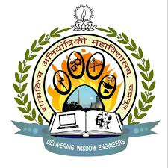

By:
Pranab Deepak Prohit
Prajyot Dipak Khadse
Prashish Gautam Borkar
Rohit Diwakar Sonkusare

UNDER THE GUIDANCE OF

Prof. Jayanti P. Choubey

DEPARTMENT OF COMPUTER SCIENCE AND ENGINEERING
GOVERNMENT COLLEGE OF ENGINEERING, CHANDRAPUR, (M.S.)

Year 2019-2020

ORGAN DONATION MANAGEGEMENT SYSTEM

INTRODUCTION:

The Organ Donation Management System (ODMS) is developed mainly for general hospitals (GH), clinics and other health centers to manage the donor registration and user maintenance.
The public can retrieve information about organ donation through this desktop application. People who are interested in organ donation can register themselves through this system. The application will be processed by the administrator and each donor will receive feedback about their application status.The donor can visit specified medical centers to perform a medical check-up or can ask for a medical assistance at home.
Only administrator have the authority and privileges to print organ list report and total donation report according to district from this system. An analysis study has been done based on the current manual system and all the problems statements and requirements have been identified.
Moreover, ODMS is three tier architecture system which involves client tier, business tier and database management tier. The interfaces for ODMS have been designed according to the requirement and needs of the current market.
This Online Organ Donation Management System will help to improve the current situation and overcome the problems that arise nowadays.

