Bank Account Management

Abstract

This project implements a console-based Account Management System using the C programming language and MySQL database. The system focuses on two primary operations: creating new user accounts and managing existing account information. During account creation, the program collects and validates user inputs such as personal details, contact information, identification numbers, and account type. Strong validation techniques, including regular expressions and logical checks, ensure accurate and error-free data entry. All account records are securely stored in a MySQL database, enabling efficient retrieval and modification. The project demonstrates the integration of C with database systems, systematic input validation, modular programming, and the practical use of SQL for maintaining persistent account records. This provides a simple and reliable solution for basic account creation and data management.

Problem Definition

In many real-world scenarios, tasks and operations are performed manually, leading to inefficiency, errors, and inconsistent results. The absence of a structured, automated system creates challenges such as data inaccuracy, difficulty in retrieval, slow processing time, and poor user experience.
Because of these limitations, users or organizations face delays in decision-making, reduced productivity, and a lack of reliability in overall operations.
Therefore, there is a need for a systematic, automated, and user-friendly solution that can handle data securely, ensure accuracy, improve efficiency, and simplify operations.
The goal is to develop a software system that provides reliable data management; ease of use, faster execution, and improved performance compared to existing manual or unstructured methods.

Implementation

The Banking System is implemented using the C programming language along with MySQL as the backend database. The goal of the implementation is to provide a reliable system for creating and managing bank accounts using secure input handling, structured modules, and database connectivity.
- Programming Language (C):
The system is developed in C due to its efficiency and low-level hardware control. Key features include:
- Structures (struct) for storing user/account data
- File and database handling for persistent storage
- Modular programming using multiple .c and .h files
- Regex-based validation for user inputs
- Menu-driven design using loops and conditionals
- These techniques ensure reliability, clarity, and reusability.
- Database Integration (MySQL)
MySQL is used for storing account information.
The implementation includes:
- Creating tables for customer data
- Inserting records during account creation
- Login validation through SQL queries
- Updating user information using UPDATE statements
- Using MySQL C API functions such as:
- database connection
- executing SQL commands
- fetching results via MYSQL_RES and MYSQL_ROW
- safely closing connections
This provides structured and persistent data management.
- System Modules
- Account Creation Module Handles:
- Input collection (Name, Email, Phone, Password, DOB)
- Regex validation
- Auto-account number generation
- Insertion into the MySQL database
- Account Management Module
- Allows users to:
- Log in via account number & password
- View stored account details
- Modify fields (name, phone, email, password)
- Instantly reflect changes in MySQL
- Input Validation
- The system ensures correct and secure inputs using:
- regex.h for email/phone validation
- fgets() for safe input
- Buffer-clearing techniques to remove unwanted newline characters
- Logical validation such as ensuring age ≥ 18 based on DOB
- This ensures no invalid or insecure data enters the database.
- Error Handling
- The implementation includes:
- Detection of invalid entries
- Clear messages for database connection failures
- Retry loops instead of abrupt termination
- Menu error handling for incorrect choices
- This results in a stable, user-friendly application.
- Code Organization
- The project is modularized into separate files for clarity:
- Account_management.c
- account_creation.c
- account_creation.h
This structure simplifies debugging and improves maintainability.

- User Interface
- The system uses a simple terminal-based user interface that allows:
- Selecting operations
- Entering data
- Receiving immediate feedback
- Its straightforward design makes the application easy to test and operate.

Testing and Result

Conclusion

The Banking System project successfully demonstrates how C programming and MySQL can be combined to create a functional and secure account management application. The system allows users to create new accounts, store validated information, log in securely, and manage their details efficiently. Through the use of modular programming, structured data handling, regex-based validation, and database integration, the project achieves reliability, accuracy, and ease of use.
Overall, the implementation proves that even a console-based application can offer effective data management and user interaction when supported by proper backend organization and input validation techniques.

Future Work
Although the current system performs essential banking functions such as account creation and account management, several enhancements can further improve its usefulness and scalability:
- Transaction Management:
Adding deposit, withdrawal, and fund transfer features to handle real-time transactions.
- Balance Tracking:
Maintaining and updating account balances with transaction history.
- Password Encryption:
Storing encrypted passwords instead of plain text for stronger security.
- Admin Panel:
Introducing an admin login for managing all user accounts and monitoring system activity.
- Graphical User Interface (GUI):
Converting the terminal-based interface into a GUI using GTK or a web interface for better usability.
- Error Logging System:
Saving runtime errors or failed login attempts in log files for debugging and security audit.
- Multi-Threading Support:
Allowing multiple operations simultaneously for future scalability.
- Improved Validation Rules:
Enhancing regex patterns and adding more detailed checks (stronger passwords, better email verification, etc.)
- Cloud Database Integration
Migrating the database to cloud-based MySQL servers for remote access.

References

- MySQL C API Documentation
MySQL Developer Reference Manual
https://dev.mysql.com/doc/c-api/en/

- GNU C Library Documentation
Information on standard C functions, regex, string handling, and memory management
https://www.gnu.org/software/libc/manual/

- Regex Manual – POSIX Regular Expressions
Pattern matching and validation rules
https://pubs.opengroup.org/onlinepubs/9699919799/basedefs/regex.h.html

- W3Schools – SQL Tutorial
Basic SQL queries used in the project (SELECT, INSERT, UPDATE)
https://www.w3schools.com/sql/

- Linux Man Pages
Reference for system-level functions used (termios, fgets, etc.)
https://man7.org/linux/man-pages/

Appendix

- Software Requirements
- GCC Compiler
- MySQL Server & MySQL Client
- Linux Os
- Terminal/Command Prompt
- Project Directory structure
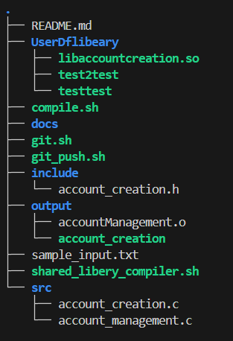

Databases table Structure
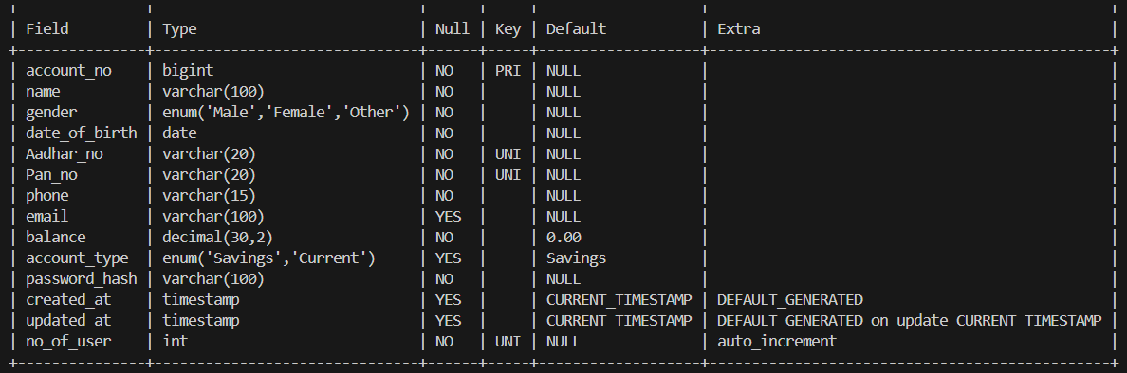

Compilation command
