Android GPS Test Document

Thomas Tallentire

Marc Rafanin

Marc Vouve

Lewis Scott

Test Cases

| Stage | Date Test Run | Test/Scenario | Input | Expected Result | Actual Result | Passed? | Status/Date Fixed |
| --- | --- | --- | --- | --- | --- | --- | --- |
| 1 | March 13 | Client connects to server | host: Datacom.me  port: 8088 | Sending activity is launched | Sending activity is launched | Yes | Fixed (see figure 1) |
| 1 | March 15 | Client validates user input for server information | Correct and incorrect server information | Application notifies that the server information is incorrect | Application notifies that the server information is incorrect | Yes | Fixed (see figures 2,3, and 4) |
| 1 | March 15 | Client sends GPS data in correct xml format | User clicks send button in Sending activity or GPS location changed | Server receives correct xml format | Client sends extra control characters in XML | No | Fix in progress. (see figures 5 and 6 ) |
| 1 | March 15 | Server displays GPS location as pins in webpage | GPS location from client application | Server displays pins on map | Server not displaying pins on map | No | Fix in progress. (see figure 7) |
| 1 | March 15 | Server displays GPS location as pins in webpage | GPS location from client application | Server displays pins on map | Server displays pins on the map but on the same exact point | No | Fix in progress. (see figure 8) |
| 1 | March 15 | Server displays GPS location as pins in webpage | GPS location from client application | Server displays pins on map | Server displays pins on map | Yes | Fixed (see figure 9) |
|  |  |  |  |  |  |  |  |

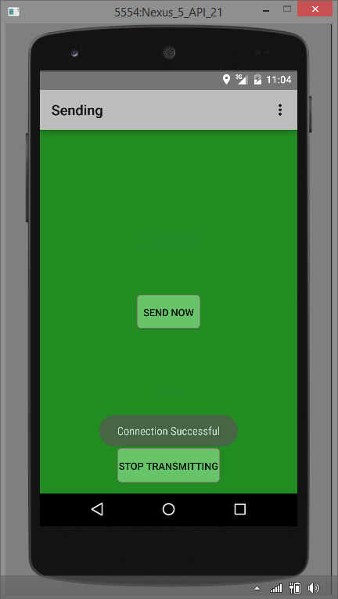

Figure

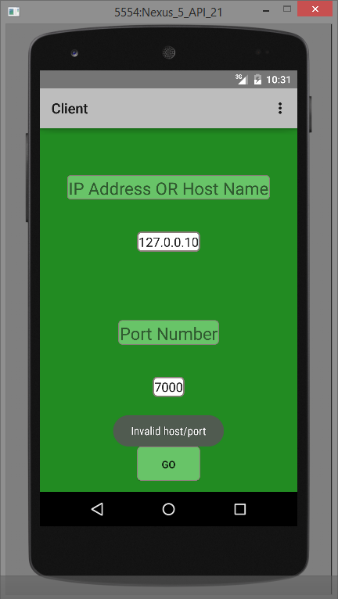

Figure - Invalid IP

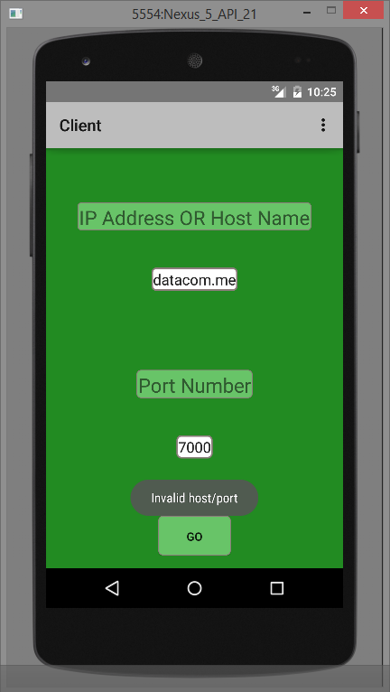

Figure - Valid host, Invalid port

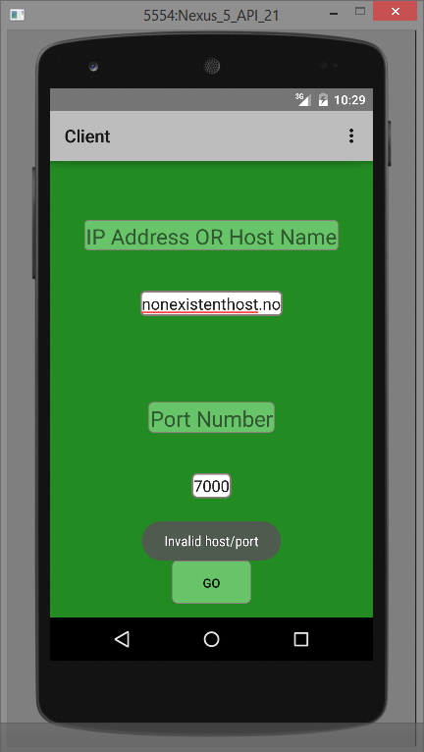

Figure - Invalid host

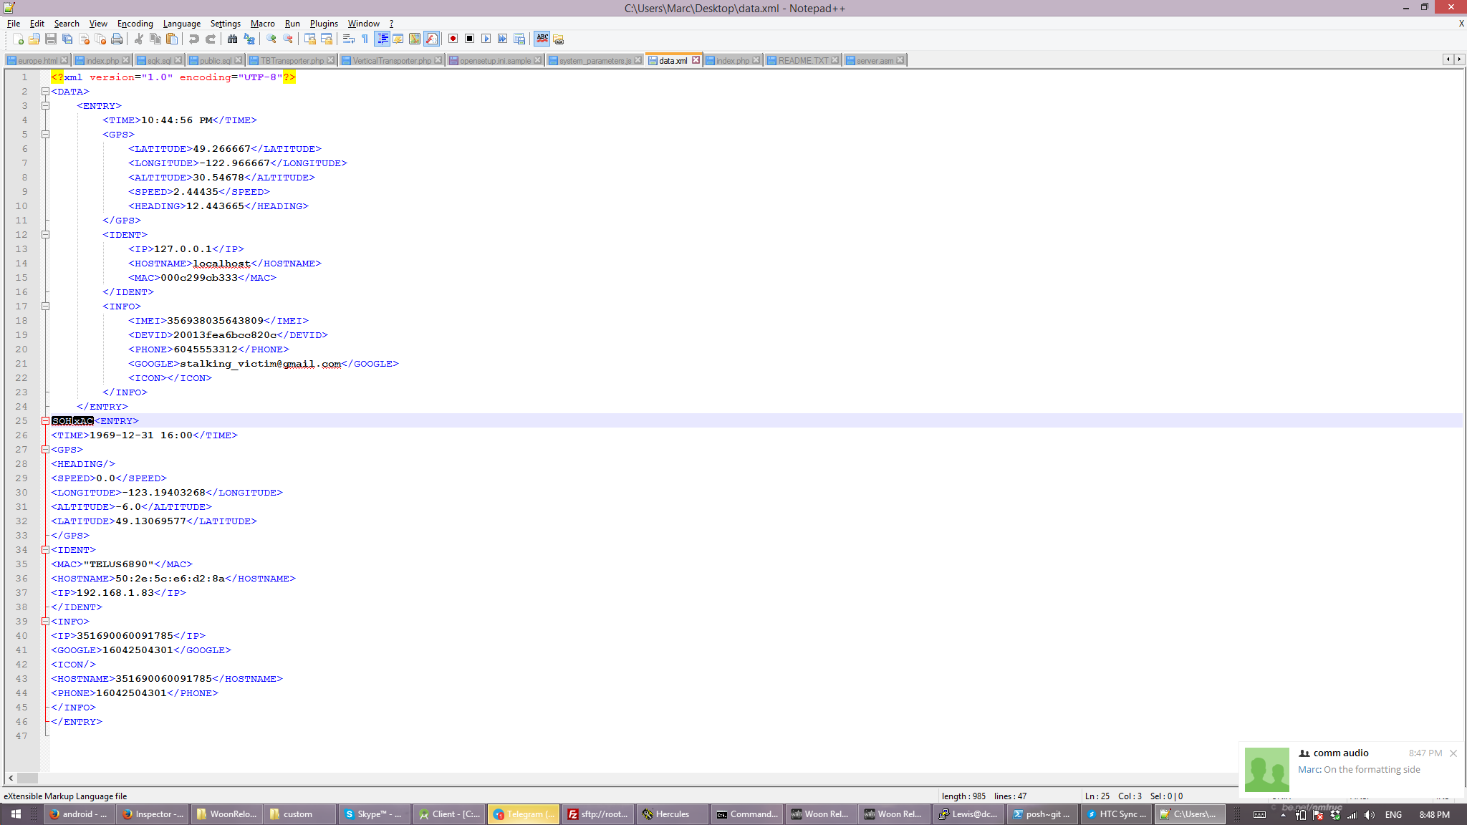

Figure

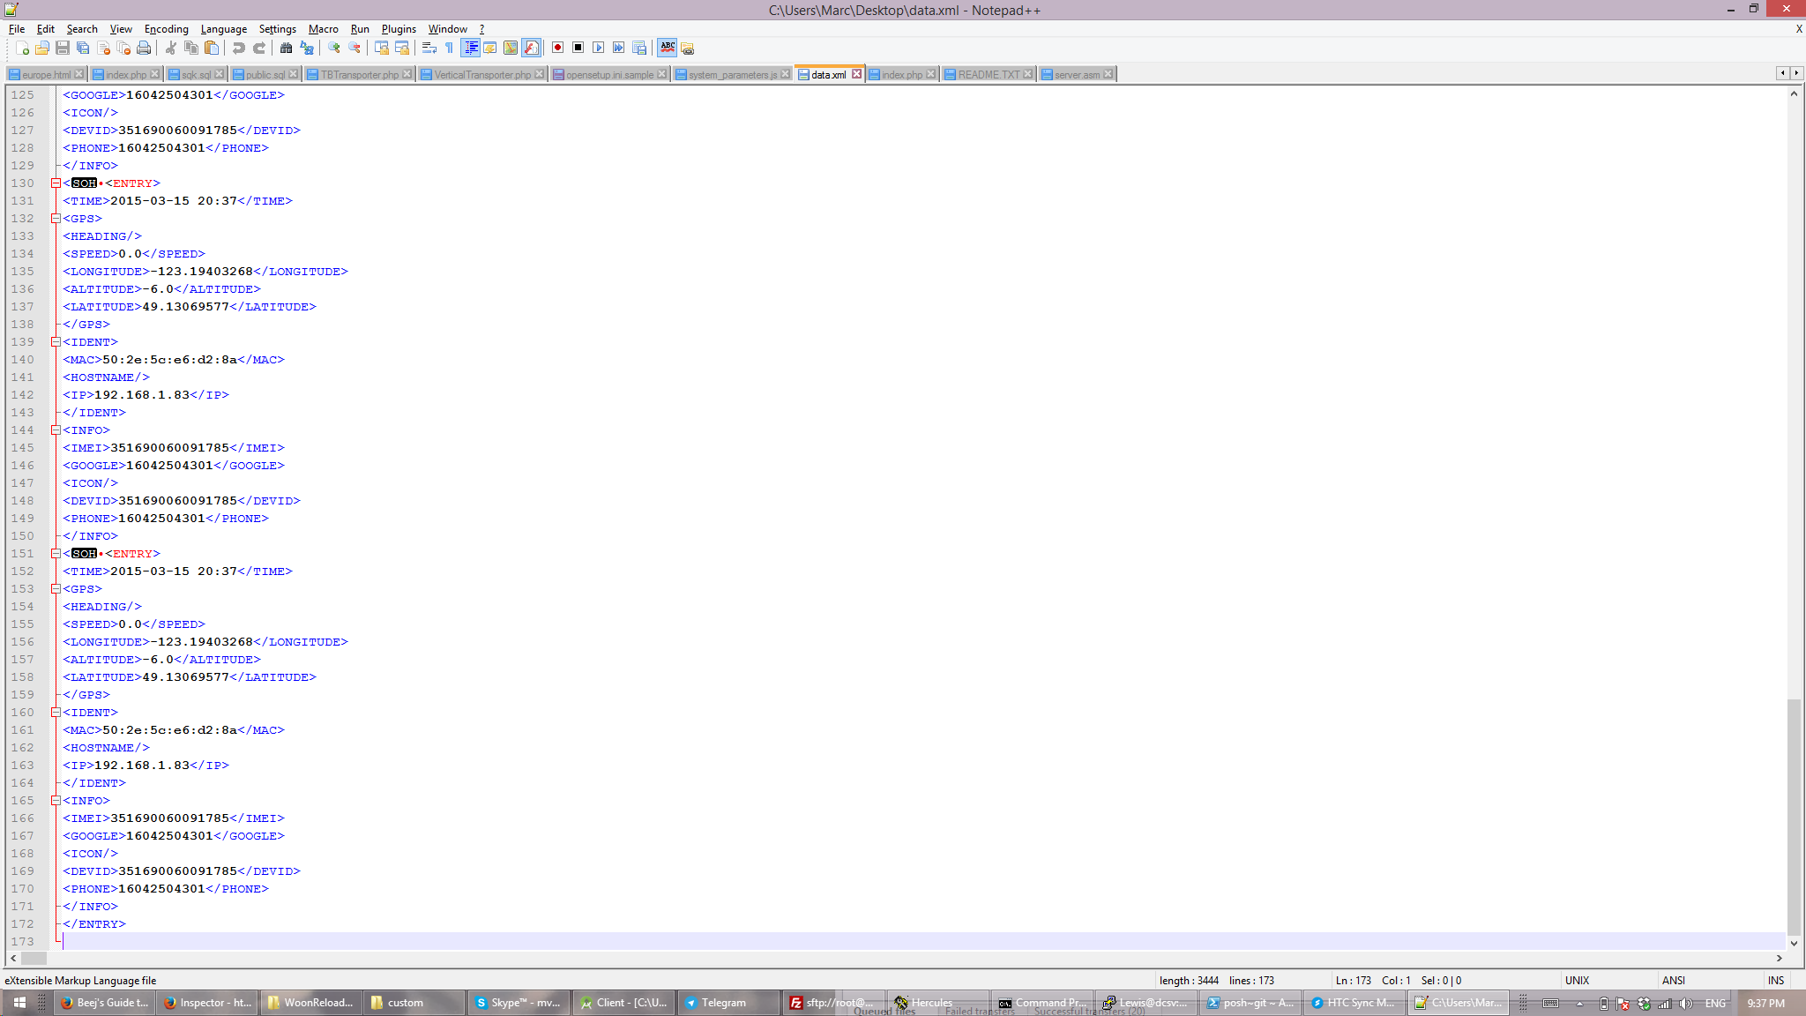

Figure

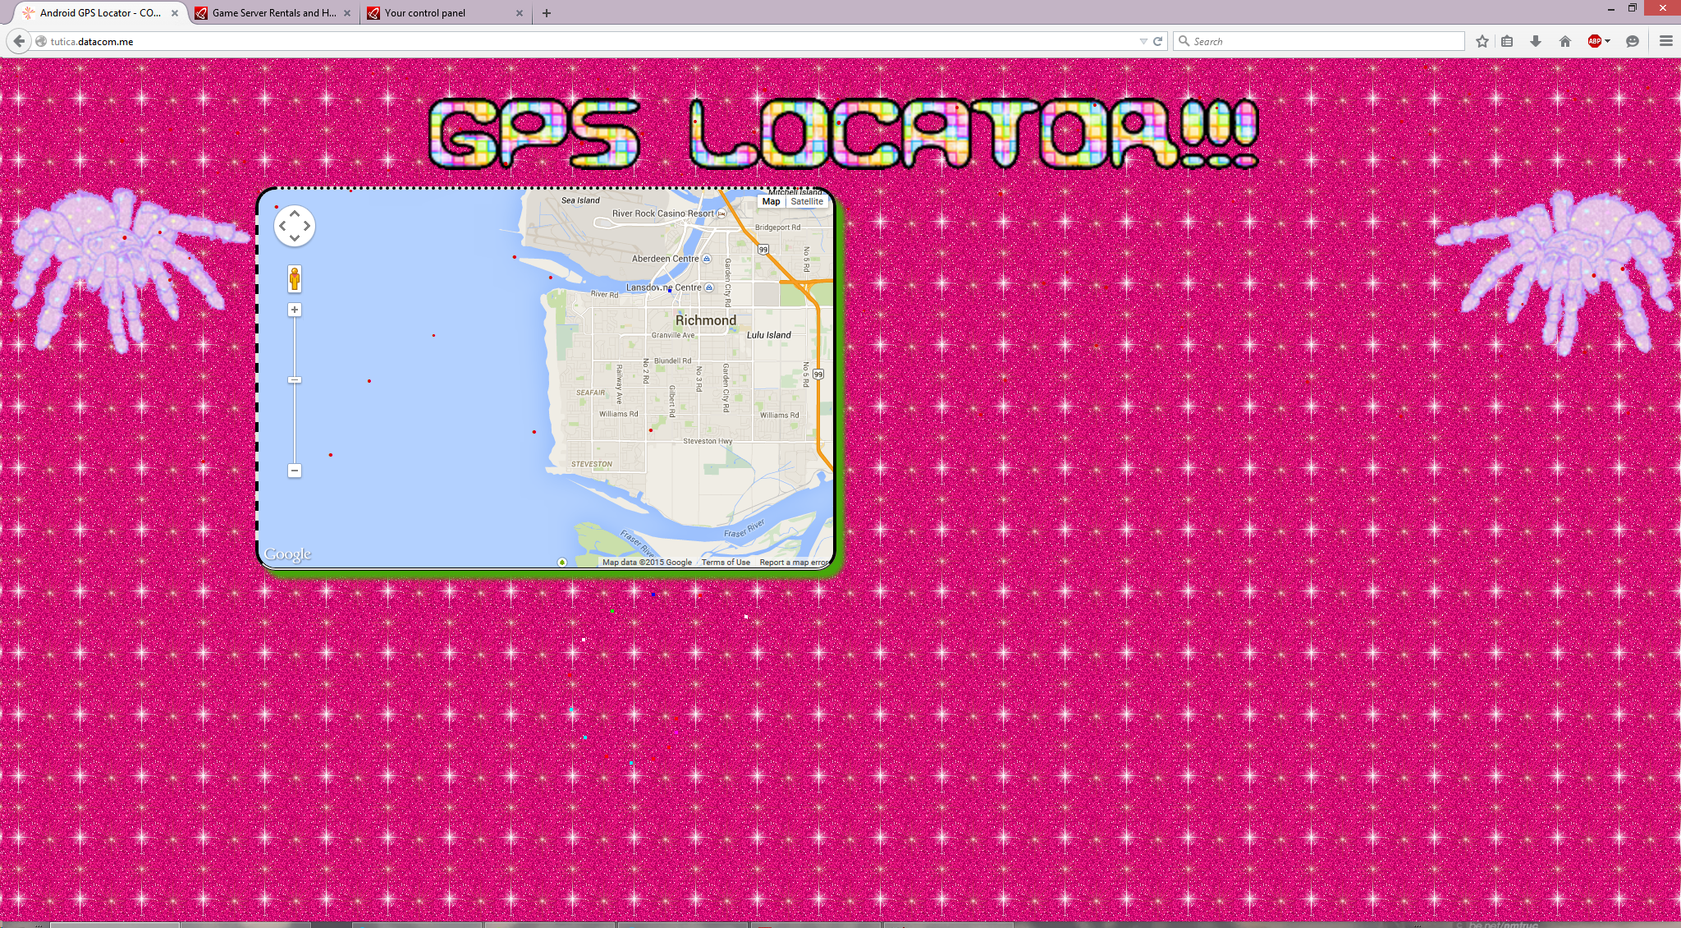

Figure

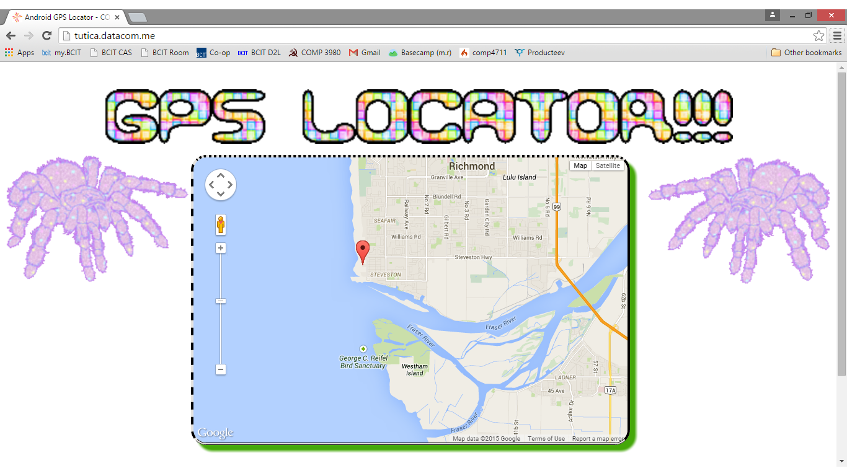

Figure

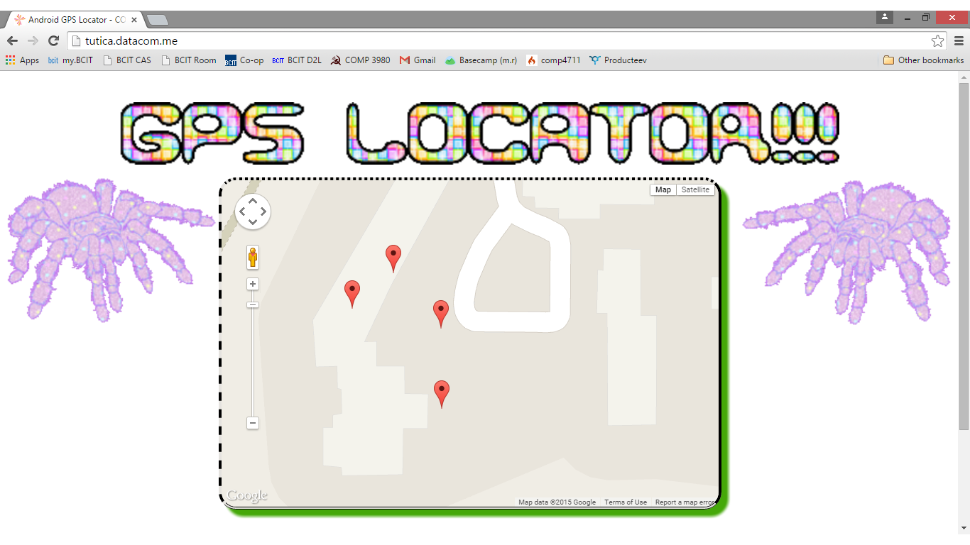

Figure 9