**Comm-Audio**

**client**

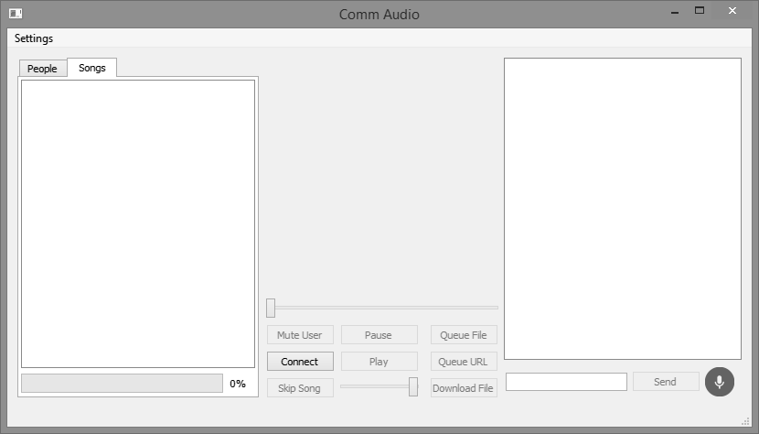

**server**

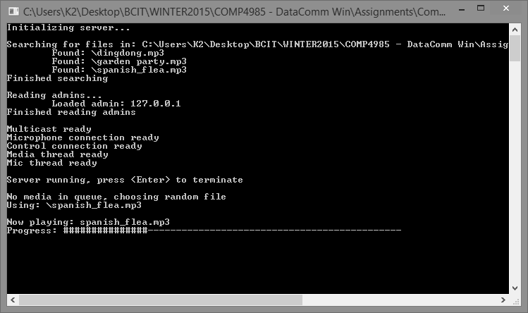

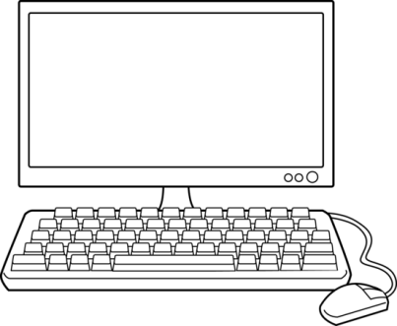

**1x server 1 =< clients**

**____________________________________**

**1. Run Server**



**2. Run Client**



**____________________________________**

**3. Configure**



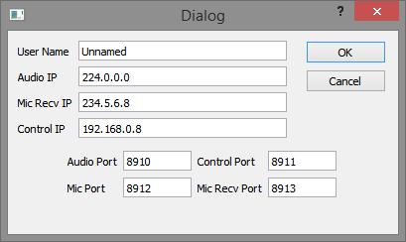

**4. Connect to server**



**____________________________________**

**5. Listen to music**



**Features:**

**1. Song queuing**

****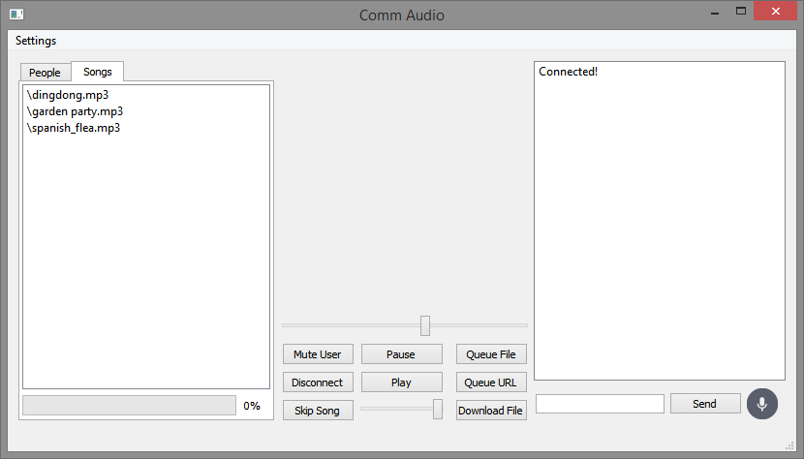





**2. Pause**





**3. Skip song**



**4. Music Bars**

