IT 230 - Final Project Part 2 Milestone 1
Jamai Parker Jr.

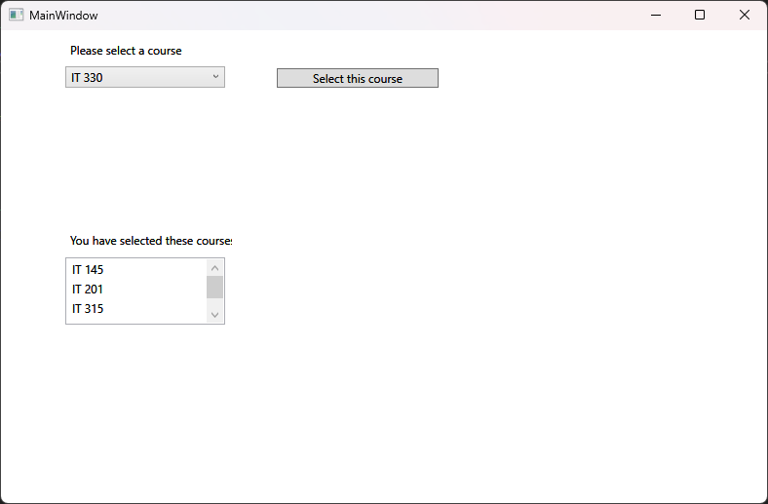

- Source Code:
using System;

namespace CreateClassesObjs
{
public class Course
{
// Private string field to hold the name of the course
private string name;

// Method to set the name field to a given string value
public void setName(string courseName)
{
this.name = courseName;
}

// Method to retrieve the name field
public string getName()
{
return this.name;
}

// Overridden ToString() method to return the name field for WPF display
public override string ToString()
{
return this.name;
}
}

- Explanation:
To complete this assignment, I added a new class file named Course.cs to the existing CreateClassesObjs Visual Studio project. Inside the Course class, I first declared a private string field called name to encapsulate the data. Next, I created two public methods to interact with that private field: setName, which accepts a string argument to update the course name, and getName, which returns the current value. I made sure to name the setter method setName to perfectly match the method calls already written in the provided MainWindow.xaml.cs starter code. Finally, I fulfilled the UI requirement by overriding the ToString() method so that it returns the name field. This ensures that when the Course objects are added to the WPF ComboBox and ListBox, the application displays the actual text of the course name rather than a generic object reference string.
- Reflection:
Writing this class from scratch was a great exercise in understanding how graphical user interfaces interact with underlying object-oriented code. Working backward from the MainWindow.xaml.cs file forced me to think about how objects are instantiated and manipulated behind the scenes. It was particularly interesting to see why overriding the ToString() method is so critical in C#; without it, the WPF window wouldn't know how to visually represent the Course object in the dropdown menu. This assignment really bridged the gap between writing pure console logic and seeing those objects come to life in a functional, user-facing desktop application.

