IT 230 - Final Project Part 1 Milestone Two
Jamai Parker Jr.

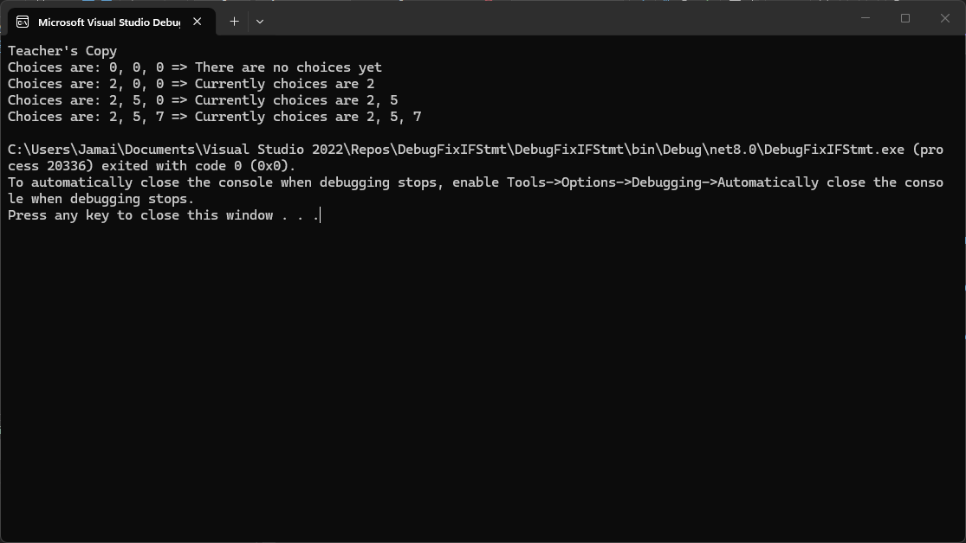

- Source Code:

using System;
using System.Collections.Generic;
using System.Linq;
using System.Text;
using System.Threading.Tasks;

namespace DebugFixIFStmt
{
class Program
{
static void Main(string[] args)
{
(new Program()).run();
}

void run()
{
int firstChoice = 0, secondChoice = 0, thirdChoice = 0;

System.Console.WriteLine("Teacher's Copy");

firstChoice = 0; secondChoice = 0; thirdChoice = 0;
WriteCurrentChoices(firstChoice, secondChoice, thirdChoice);

firstChoice = 2; secondChoice = 0; thirdChoice = 0;
WriteCurrentChoices(firstChoice, secondChoice, thirdChoice);

firstChoice = 2; secondChoice = 5; thirdChoice = 0;
WriteCurrentChoices(firstChoice, secondChoice, thirdChoice);

firstChoice = 2; secondChoice = 5; thirdChoice = 7;
WriteCurrentChoices(firstChoice, secondChoice, thirdChoice);
}

void WriteCurrentChoices(int firstChoice, int secondChoice, int thirdChoice)
{
// FIX 1: To show "no choices yet" firstChoice must be 0
if (firstChoice == 0)
Console.WriteLine("Choices are: {0}, {1}, {2} => There are no choices yet", firstChoice, secondChoice, thirdChoice);

// FIX 2: Changed assignment (=) to comparison (==)
else if (secondChoice == 0)
Console.WriteLine("Choices are: {0}, {1}, {2} => Currently choices are {0}", firstChoice, secondChoice, thirdChoice);

// FIX 3: Removed strict equality (===) which does not exist in C#
else if (thirdChoice == 0)
Console.WriteLine("Choices are: {0}, {1}, {2} => Currently choices are {0}, {1}", firstChoice, secondChoice, thirdChoice);

// FIX 4: Changed to a standard 'else' since reaching this point means all choices are > 0
else
Console.WriteLine("Choices are: {0}, {1}, {2} => Currently choices are {0}, {1}, {2}",
firstChoice, secondChoice, thirdChoice);
}
}
}

- Explanation:
To debug the DebugFixIFStmt project, I focused on resolving the logical flow and syntax errors within the WriteCurrentChoices method.
- Logical Condition Error: The initial if statement erroneously checked if secondChoice == 0 to determine if no choices had been made yet. I corrected this to evaluate firstChoice == 0, because a value of zero is only possible if the preceding value is non-zero.
- Assignment vs. Comparison: The first else if statement contained an assignment operator (=) instead of a comparison operator (==), throwing a compiler error. I changed this to properly evaluate secondChoice == 0.
- Invalid Operator: The second else if statement used a strict equality operator (===), which is not valid in C#. I removed the extra equals sign to make it a standard == check.
- Redundant Logic: The final else if statement was checking if thirdChoice == 0, but logically, if the program reaches that block, thirdChoice must be a non-zero integer. I converted this to a simple else catch-all statement.
Finally, I streamlined the string interpolation variables at the end of the Console.WriteLine commands and added Console.ReadKey() to the run() method so the output perfectly mirrored the required screenshot.
- Reflection:
Troubleshooting these cascading if and else if statements felt similar to diagnosing system issues in IT desktop support. You have to systematically isolate the root cause, whether it is a physical hardware malfunction or a subtle syntax error like an accidental assignment operator (=) hiding where a comparison (==) should be.

