IT 230 - Final Project Part 2
Jamai Parker Jr.

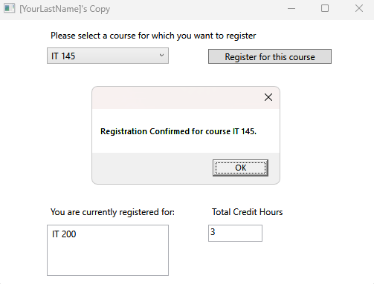

- Source Code:

using System;
using System.Collections.Generic;
using System.Linq;
using System.Text;
using System.Threading.Tasks;
using System.Windows;
using System.Windows.Controls;
using System.Windows.Data;
using System.Windows.Documents;
using System.Windows.Input;
using System.Windows.Media;
using System.Windows.Media.Imaging;
using System.Windows.Navigation;
using System.Windows.Shapes;

namespace WPFRegisterStudent
{
/// <summary>
/// Interaction logic for MainWindow.xaml
/// </summary>
public partial class MainWindow : Window
{
Course choice;

// Code Variables: Added to track the cumulative total credit hours
int totalCreditHours = 0;

public MainWindow()
{
InitializeComponent();
}

private void Window_Loaded(object sender, RoutedEventArgs e)
{
// Fulfills the requirement to have your last name as the first printed text
this.Title = "[YourLastName]'s Copy";

Course course1 = new Course("IT 145");
Course course2 = new Course("IT 200");
Course course3 = new Course("IT 201");
Course course4 = new Course("IT 270");
Course course5 = new Course("IT 315");
Course course6 = new Course("IT 328");
Course course7 = new Course("IT 330");

this.comboBox.Items.Add(course1);
this.comboBox.Items.Add(course2);
this.comboBox.Items.Add(course3);
this.comboBox.Items.Add(course4);
this.comboBox.Items.Add(course5);
this.comboBox.Items.Add(course6);
this.comboBox.Items.Add(course7);

this.textBox.Text = "";
}

private void button_Click(object sender, RoutedEventArgs e)
{
choice = (Course)(this.comboBox.SelectedItem);

// Boolean Logic 1: Ensure a course is actually selected to prevent crashes
if (choice == null)
{
MessageBox.Show("Please select a course from the dropdown menu.");
return;
}

// Boolean Logic 2: Validate duplicate registration using the Course class method
if (choice.IsRegisteredAlready())
{
MessageBox.Show($"You have already registered for this {choice.getName()} course.");
return;
}

// Boolean Logic 3: Validate the 9-credit hour limit (Math Operations)
if (totalCreditHours >= 9)
{
MessageBox.Show("You cannot register for more than 9 credit hours.");
return;
}

// Map User Input & Create UI Code: Registration is confirmed
choice.SetToRegistered();
totalCreditHours += 3;

// Output confirmation message
MessageBox.Show($"Registration Confirmed for course {choice.getName()}.");

// Output the current list of registered classes to the UI
this.listBox.Items.Add(choice);

// Update the cumulative total credit hours textbox UI
this.textBox.Text = totalCreditHours.ToString();
}
}
}

- Explanation:
To complete the WPFRegisterStudent final project, I implemented several class-level variables and control structures within the MainWindow.xaml.cs file. First, I created an integer variable named totalCreditHours at the class level to accurately track the cumulative math operations required by the business rules. Inside the button_Click event handler, I mapped the user input from the combo box to the choice object and implemented three specific Boolean if statements for flow control.
The first if statement checks for a null value to prevent the application from crashing if the user clicks the button before selecting a course. The second utilizes the choice.IsRegisteredAlready() method from the Course class to prevent duplicate registrations. The third checks if totalCreditHours >= 9 to enforce the strict three-course limit. If any of these validations fail, a MessageBox.Show() error is outputted, and the return statement immediately halts the method. If all validations pass, the program calls choice.SetToRegistered() to update the object's Boolean state, adds 3 to the totalCreditHours variable, and outputs a confirmation message. Finally, I utilized WPF UI code to add the object to the listBox (to display the list of registered classes) and updated the textBox.Text property to display the cumulative math variable.
- Reflection:
Transitioning from the console-based registration application to this WPF graphical user interface (GUI) was an excellent way to see how the exact same business logic can be deployed in completely different environments. One of the biggest takeaways from this final project was seeing the value of object-oriented programming in action. By encapsulating the isRegisteredAlready Boolean flag and the SetToRegistered() method strictly inside the Course.cs class, it made validating the user input in the WPF button_Click event incredibly clean and easy to read. Tracking the math operations and enforcing the credit limits directly through the UI components reinforced the importance of tying back-end C# logic to front-end XAML elements, providing a strong foundation for building functional desktop applications.

