IT 230 Coding Activity Two

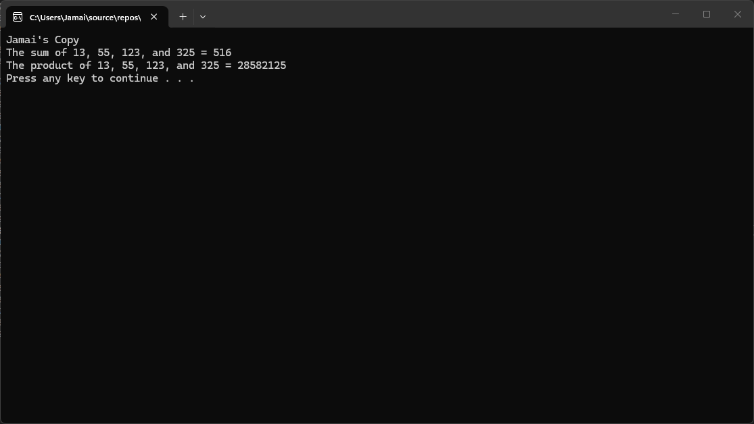

- Source Code:

[using System;

namespace AddMultiplyFourInts
{
class Program
{
static void Main(string[] args)
{
// Initialize four integer variables
int num1 = 13;
int num2 = 55;
int num3 = 123;
int num4 = 325;

// Calculate the sum and product
int sum = num1 + num2 + num3 + num4;
int product = num1 * num2 * num3 * num4;

// Output the results to match the required sample
Console.WriteLine("Teacher's Copy");
Console.WriteLine($"The sum of {num1}, {num2}, {num3}, and {num4} = {sum}");
Console.WriteLine($"The product of {num1}, {num2}, {num3}, and {num4} = {product}");

// Keep console open and match final line
Console.Write("Press any key to continue . . . ");
Console.ReadKey();
}
}
}

- Explanation:
For this assignment, I started by creating a new C# Console Application in Visual Studio. My first step was to declare four separate integer variables and initialize them with the specific values provided in the instructions: 13, 55, 123, and 325. Rather than doing the math directly inside the output commands, I decided to keep the code clean by creating two additional variables to handle the processing. I used the addition operator (+) to calculate the total and stored it in a sum variable, and used the multiplication operator (*) to store the final result in a product variable.
Once the calculations were handled, my focus shifted to matching the required output format exactly. I used Console.WriteLine() combined with string interpolation (using the $ symbol), which allowed me to easily plug my variables directly into the text strings without relying on messy concatenation. Finally, I made sure to include the "Teacher's Copy" header and placed a Console.ReadKey() command at the very end of the script. This ensured the console window would stay open long enough for me to verify the math and grab the required screenshot for my submission.

- Reflection:
Completing this activity reinforced my understanding of variable declaration and basic arithmetic operators in C#. I learned how to efficiently store data in integer data types and manipulate them. Additionally, practicing string interpolation made it much easier to format the console output accurately without having to manually concatenate strings and variables with plus signs.

