IT 230 - Final Project Part 1
Jamai Parker Jr.

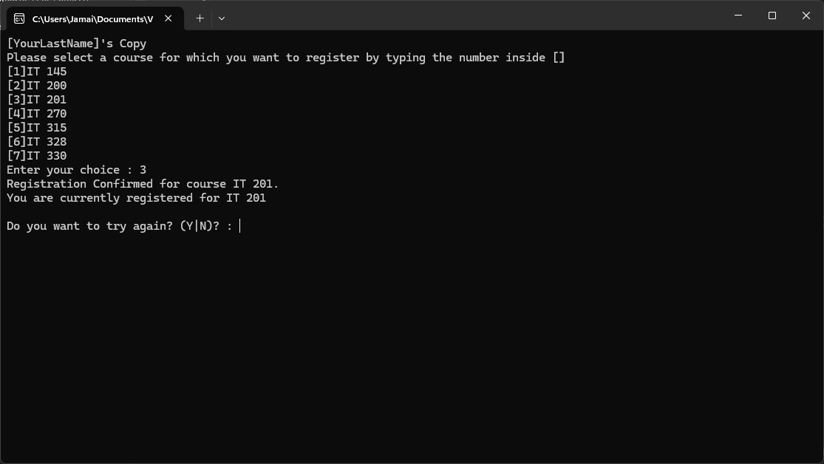
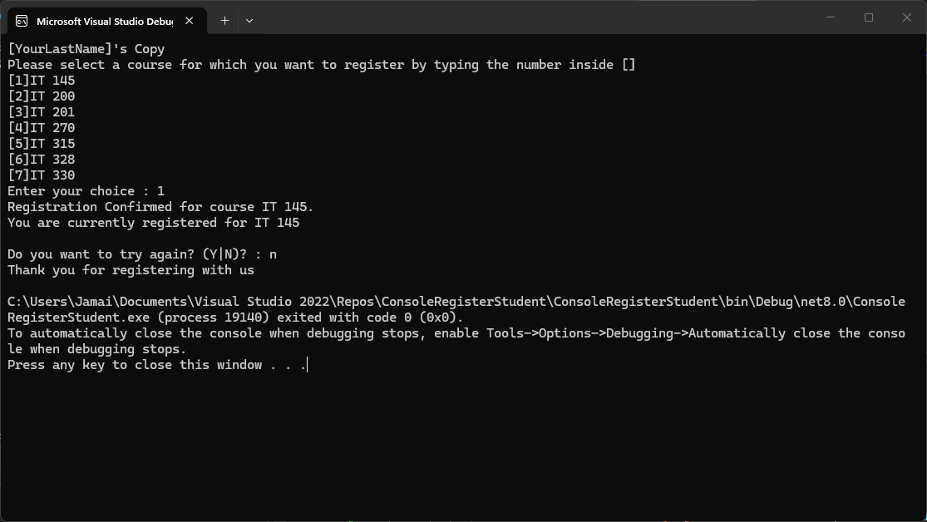
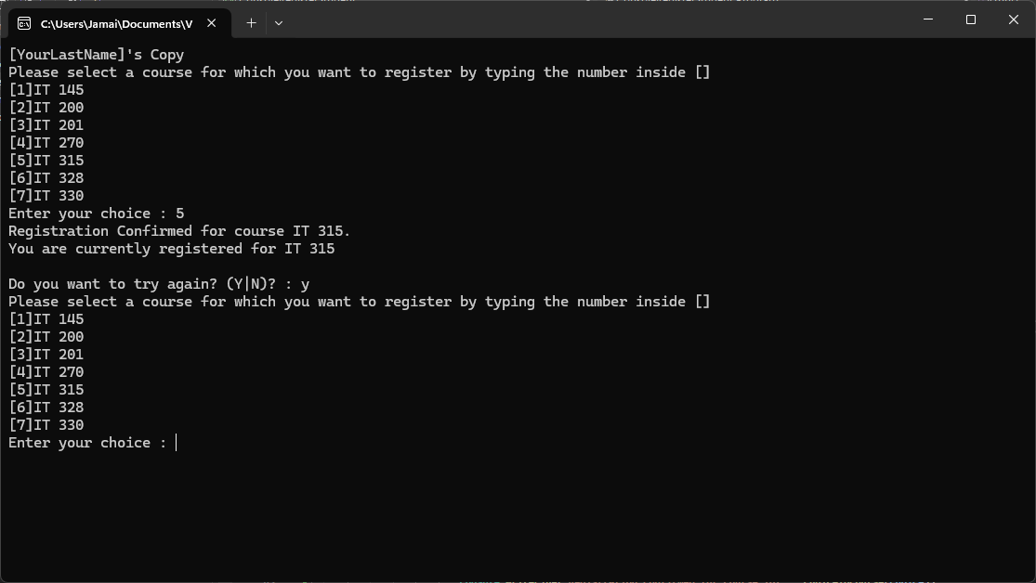

- Source Code:
using System;
using System.Collections.Generic;
using System.Linq;
using System.Text;
using System.Threading.Tasks;

namespace ConsoleRegisterStudent
{
class Program
{
static void Main(string[] args)
{
(new Program()).run();
}

void run()
{
int choice;
int firstChoice = 0, secondChoice = 0, thirdChoice = 0;
int totalCredit = 0;
string yesOrNo = "";

// Added to meet rubric requirement that your last name is the first printed text
System.Console.WriteLine("[YourLastName]'s Copy");

do
{
WritePrompt();
choice = Convert.ToInt32(Console.ReadLine());

switch (ValidateChoice(choice, firstChoice, secondChoice, thirdChoice, totalCredit))
{
case -1:
Console.WriteLine("Your entered selection {0} is not a recognized course.", choice);
break;
case -2:
Console.WriteLine("You have already registerd for this {0} course.", ChoiceToCourse(choice));
break;
case -3:
Console.WriteLine("You can not register for more than 9 credit hours.");
break;
case 0:
Console.WriteLine("Registration Confirmed for course {0}.", ChoiceToCourse(choice));
totalCredit += 3;
if (firstChoice == 0)
firstChoice = choice;
else if (secondChoice == 0)
secondChoice = choice;
else if (thirdChoice == 0)
thirdChoice = choice;
break;
}

WriteCurrentRegistration(firstChoice, secondChoice, thirdChoice);
Console.Write("\nDo you want to try again? (Y|N)? : ");
yesOrNo = (Console.ReadLine()).ToUpper();
} while (yesOrNo == "Y");

Console.WriteLine("Thank you for registering with us");
}

void WritePrompt()
{
Console.WriteLine("Please select a course for which you want to register by typing the number inside []");
Console.WriteLine("[1]IT 145\n[2]IT 200\n[3]IT 201\n[4]IT 270\n[5]IT 315\n[6]IT 328\n[7]IT 330");
Console.Write("Enter your choice : ");
}

int ValidateChoice(int choice, int firstChoice, int secondChoice, int thirdChoice, int totalCredit)
{
// FIX 1: Modified Boolean logic from > 70 to > 7 to reflect the actual number of courses
if (choice < 1 || choice > 7)
return -1;
// FIX 2: Modified Boolean logic from && to || to accurately catch any single duplicate course
else if (choice == firstChoice || choice == secondChoice || choice == thirdChoice)
return -2;
// FIX 3: Modified Math operation from > 9 to >= 9 to prevent exceeding 9 credits
else if (totalCredit >= 9)
return -3;

// FIX 4: Modified Method logic to return 0 instead of -4 for a successful validation
return 0;
}

void WriteCurrentRegistration(int firstChoice, int secondChoice, int thirdChoice)
{
// FIX 5: Modified Control Structure to handle the edge case where no courses are registered yet
if (firstChoice == 0)
Console.WriteLine("You are not currently registered for any courses.");
else if (secondChoice == 0)
Console.WriteLine("You are currently registered for {0}", ChoiceToCourse(firstChoice));
else if (thirdChoice == 0)
Console.WriteLine("You are currently registered for {0}, {1}", ChoiceToCourse(firstChoice), ChoiceToCourse(secondChoice));
else
Console.WriteLine("You are currently registered for {0}, {1}, {2}", ChoiceToCourse(firstChoice), ChoiceToCourse(secondChoice), ChoiceToCourse(thirdChoice));
}

string ChoiceToCourse(int choice)
{
string course = "";
switch (choice)
{
case 1:
course = "IT 145";
break;
case 2:
course = "IT 200";
break;
case 3:
course = "IT 201";
break;
case 4:
course = "IT 270";
break;
case 5:
course = "IT 315";
break;
case 6:
course = "IT 328";
break;
case 7:
course = "IT 330";
break;
default:
break;
}
return course;
}
}
}
- Explanation:
To complete the Final Project Part I assignment, I systematically reviewed and repaired the starter code within the ConsoleRegisterStudent project to meet the provided software requirements. I began by modifying the classes and methods, specifically the ValidateChoice method, which originally returned -4 at the end of its block. I changed this to return 0; so the switch statement in the run() method would properly recognize a valid course selection and trigger the registration confirmation. Next, I addressed two errors in the Boolean logic within that same method. I corrected the course range validation from choice > 70 to choice > 7 to accurately reject invalid menu selections, and I changed the duplicate course check from an AND operator (&&) to an OR operator (||) so the program correctly prevents a user from registering for any single course more than once. To fix the math operations regarding credit limits, I updated the validation from totalCredit > 9 to totalCredit >= 9. Since courses are exactly 3 credits, a student with three classes has exactly 9 credits; checking for greater than or equal to 9 ensures they cannot register for a fourth class. Finally, I modified the control structures in the WriteCurrentRegistration method by adding an if (firstChoice == 0) branch to handle the edge case where a user inputs an invalid choice on their first attempt, allowing the console to output that they are not currently registered for any courses instead of failing silently.

- Reflection:
Completing this final project milestone was an incredibly rewarding way to apply everything I have learned about C# control structures, methods, and Boolean logic. Troubleshooting the provided starter code required a keen eye for detail, as subtle mistakes like using an AND operator instead of an OR operator can completely break the business rules of the application. The Visual Studio IDE was essential for testing these different edge cases and verifying that the loops and switch statements handled invalid inputs gracefully. Successfully debugging this application gave me a lot of confidence in my ability to read and repair existing software requirements, which is a great feeling as I balance the demands of my coursework alongside a 30 to 35-hour work week. Working through these logical puzzles step-by-step has definitely solidified my understanding of foundational programming concepts.

