IT 230 - Final Project Part 1 Milestone One
Jamai Parker Jr.

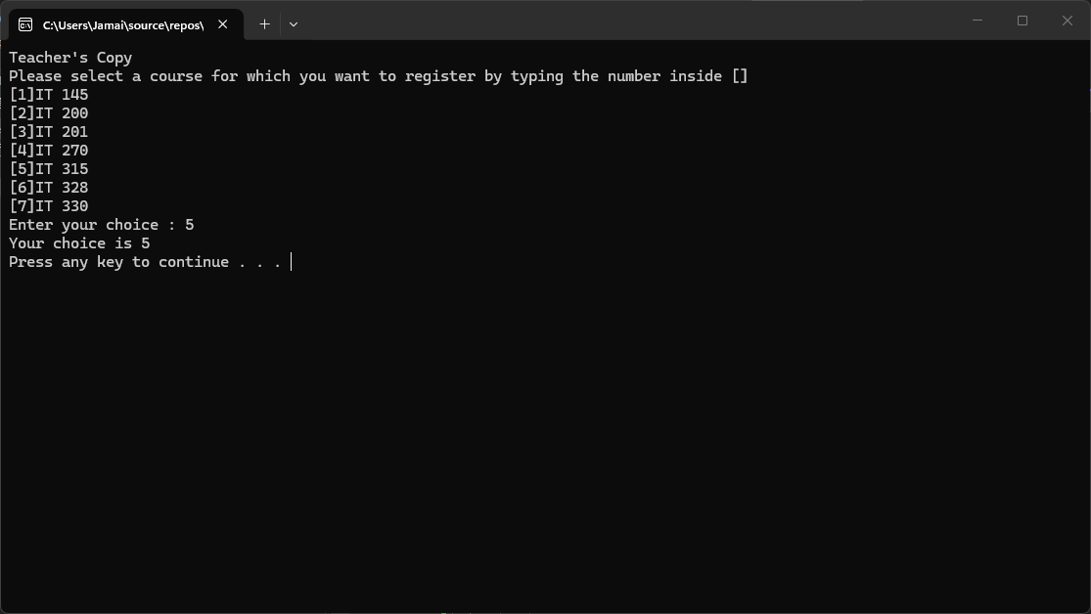

- Source Code:

using System;
using System.Collections.Generic;
using System.Linq;
using System.Text;
using System.Threading.Tasks;

namespace DebugFixMethods
{
class Program
{
static void Main(string[] args)
{
(new Program()).run();
}

void run()
{

//Added to match the required output format
Console.WriteLine("Teacher's Copy");

int choice = 0;

WritePrompt();
choice = ReadChoice();
WriteChoice(choice);

//Added to pause the console window
Console.Write("Press any key to continue . . . ");
Console.ReadKey();

}

//Error fix: Capitalized the 'P' in WritePrompt to match the method name
void WritePrompt()
{
Console.WriteLine("Please select a course for which you want to register by typing the number inside []");
Console.WriteLine("[1]IT 145\n[2]IT 200\n[3]IT 201\n[4]IT 270\n[5]IT 315\n[6]IT 328\n[7]IT 330");
Console.Write("Enter your choice : ");
}

int ReadChoice()
{
string s = "";
s = Console.ReadLine();
//ERROR fix: Parsed string 's' to integer to match int return type
return int.Parse(s);
}

//Error fix: Added the missing 'int' data type
void WriteChoice(int choice)
{
//Error fix: Changed 'Choice' to 'choice' to match the parameter name
Console.WriteLine("Your choice is {0}", choice);
}
}
}

- Explanation:
To complete the DebugFixMethods activity, I utilized the Visual Studio error list to trace and resolve four distinct compiler errors within Program.cs. First, I encountered two case-sensitivity errors: the run() method called WritePrompt(), but the method was defined as Writeprompt() with a lowercase 'p'. Later in the code, the WriteChoice method tried to print a variable named Choice with a capital 'C' instead of the lowercase choice passed into the method. I corrected the capitalization for both to ensure consistency.
Next, I resolved two data type issues. The ReadChoice() method was built to return an integer, but the code attempted to return a raw string s straight from Console.ReadLine(). I fixed this by implementing int.Parse(s) to convert the input. Then, the WriteChoice(choice) method declaration was entirely missing a data type for its parameter. I updated it to WriteChoice(int choice) so the compiler knew what kind of data was being passed. Finally, to ensure the application matched the required screenshot exactly, I added Console.WriteLine("Teacher's Copy") at the beginning of the program and a Console.ReadKey() prompt at the end to keep the window open for testing.

- Reflection:
Debugging this program reinforced how strictly typed and case-sensitive C# is as a programming language. Resolving these errors felt very similar to tackling IT desktop support tickets you have to follow the error logs back to the root cause, isolating one broken piece of logic at a time. The most valuable lesson was seeing how easily a simple typo, like a capitalized letter or a missing int declaration, can completely break the execution of an otherwise functional application. It highlighted the importance of standardizing naming conventions and keeping a close eye on the IDE's compiler warnings.

