Blackbear-Consultant’s Sequence Diagram

Nontrivial Steps

|  |  |  |
| --- | --- | --- |
| Use Cases | Systems | Non-Trivial Steps In Use Case Descriptions |
| View User Statistics | Applications Statistics Menu | 6. The System displays the raw values and graphical image for tasks   1. The System displays raw values and graphical image for ‘Shapes’ task 2. The System displays raw values and graphical image for ‘Letters’ task 3. The System displays raw values and graphical image for ‘Numbers’ task |
| Display Task Progress | Game Selection | 4.1 If no progress has been completed   1. The System displays task has not been started   4.2 If progress has been completed   1. The System displays completion of task   4.3 If progress has been made but failed to finish   1. The System displays failure of task |
| Enter Password | Account Login | 4. The System authenticates the password entered  4.1. If the password is correct   1. The user will be logged in   4.2 If the Password is incorrect   1. The System will prompt user for correct password 2. If the incorrect password is entered three times 3. The System will lock out user |
| Select Game Task | Game Selection | 1. The User selects the dropdown menu to go between task categories    1. The User selects arrows to go between tasks    2. The User selects the start button 2. The System displays the selected task categories 3. The System displays the selected tasks 4. The System starts the selected task |
| Suggest Starting Task | Game Selection | 1. The User will press ‘Start’ to begin suggested task 2. The User will select a different task in select minigame menu |
| Give Prompt (Audio/Visual) | Gameplay | 1. The System will prompt the user with a visual and audio cue   1.1. If the user successfully follows prompt   * 1. System provides a positive visual and audio cue   1.2. If the User fails to follow the prompt  a.The System will prompt the user with additional help |
| Take Pictures | Game Selection | 4.1. If User decides to save photo on device   1. The System saves photo on device 2. Uses saved photo for image in minigame   4.2. If User declines to save photo on device   1. The System will insert the photo into minigame. |
| Get User Permissions | Settings Display | 3. The user:   1. Clicks allow, giving the app permission to use camera and file storage or 2. clicks deny, now allowing the app permission to use camera and file storage.   4. The system:   1. Updates permissions and lets users store photos or 2. does nothing. |
| Click Object | Gameplay | 2. The system processes clicked object:   1. If object selected was correct, sends that information to progress tracker and prompter and new minigame task is given or 2. Object selected was incorrect, sends information to the progress tracker and prompter or 3. Object selected was indicated by prompt and correct. That information is sent to the progress tracker and a new minigame task is given. 4. Object selected was indicated by prompt and incorrect. Information is sent to the progress tracker and a new minigame task is given. |
| Track Progress | Gameplay | 2. The System records the which object the user clicks on.   1. If the user clicked on the correct game object, the system updates the database with success. 2. If the user clicked on an incorrect object, the system updates the database with a failure. |
| Select Game Mode | Statistics Display | 4. The System will display the statistics for the selected task.   1. If the task has not been played, a no data sign will be displayed over statistics graphs and charts or 2. The system will display successes and failures for each task selected. |
| Adjust Audio | Settings Display | 2. The system:   1. Displays a check mark in the checkbox if the sound is muted 2. Displays just an empty checkbox if the sound is unmuted.   3. The system:   1. Mutes the sound the application makes 2. Unmutes the sound the application makes. |
| Log Out User | Settings Display | 2. The system saves all user data, clears current session information, and brings the application to the log in landing menu. |
| Add User | Account Registration | 3.  a. If the username is taken, the registration is denied and a “username taken” message is displayed or  b. If the username and password aren’t taken, the user is added to the registry. |
| Delete User | Account Registration | 4. The system erases user information from the registry and displays the edit screen without any minus signs. |
| Edit User | Account Registration | 6. The system edits that user information and saves it in the user registry. |

**View User Statistics:**

Scenario Description Table

|  |  |  |  |  |
| --- | --- | --- | --- | --- |
| **#** | **Subject** | **Subject Action** | **Parameters** | **Object Acted Upon** |
| 5. | User | Selects | Statistics Button | Application GUI |
| 6.1 | Application GUI | Requests | Task Data | Data Controller |
| 6.2.A | If Task is Shapes |  |  |  |
| 6.2.B | Data Controller | Checks for | Shapes Data | User Database |
| 6.2.C | User Database | Returns | Shapes Data | Data Controller |
| 6.2.D | Data Controller | Returns | Shapes Data | Application GUI |
| 6.2.E | Application GUI | Displays | Shapes Data | User |
| 6.3.A | Else if Task is Letters |  |  |  |
| 6.3.B | Data Controller | Checks for | Letters Data | User Database |
| 6.3.C | User Database | Returns | Letters Data | Data Controller |
| 6.3.D | Data Controller | Returns | Letters Data | Application GUI |
| 6.3.E | Application GUI | Displays | Letters Data | User |
| 6.4.A | Else |  |  |  |
| 6.4.B | Data Controller | Checks for | Numbers Data | User Database |
| 6.4.C | User Database | Returns | Numbers Data | Data Controller |
| 6.4.D | Data Controller | Returns | Numbers Data | Application GUI |
| 6.4.E | Application GUI | Displays | Numbers Data | User |

Analysis Sequence Diagram

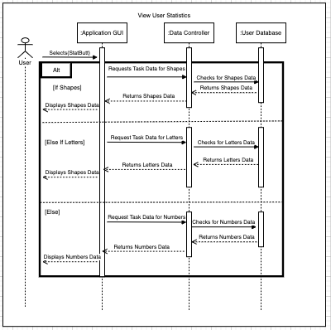

Design Sequence Diagram

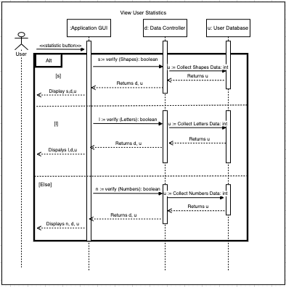

**Display Task Progress:**

Scenario Description Table

|  |  |  |  |  |
| --- | --- | --- | --- | --- |
| **#** | **Subject** | **Subject Action** | **Parameters** | **Object Acted Upon** |
| 1. | User | Selects | Menu | Task Selection |
| 2. | System | Displays | Menu | Task Selection |
| 3. | User | Swipes | Tasks | Completed Tasks |
| 3.1 | User | Swipes | Tasks | Uncompleted Tasks |
| 4. | Task Selection Menu | Displays | Tasks | Task Selection Menu |
| 4.1 | If no progress then |  |  |  |
| 4.1.1 | System | Displays | ‘Not Started’ | Tasks |
| 4.2 | If progress complete then |  |  |  |
| 4.2.1 | System | Displays | ‘Completed’ | Tasks |
| 4.3 | If progress but failed than |  |  |  |
| 4.3.1 | System | Displays | ‘Failed’ | Tasks |

Analysis Sequence Diagram

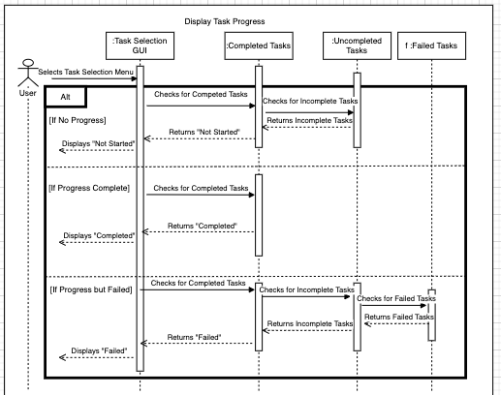

Design Sequence Diagram

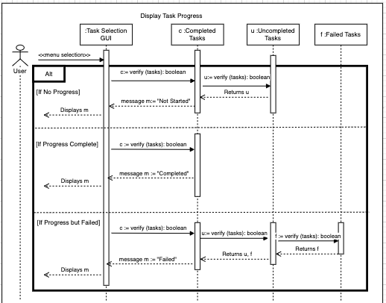

**Enter Password:**

Scenario Description Table

|  |  |  |  |  |
| --- | --- | --- | --- | --- |
| **#** | **Subject** | **Subject Action** | **Parameters** | **Object Acted Upon** |
| 1. | User | Taps | Name | Username |
| 2. | System | Displays | Password | Text field |
| 3. | User | Enters | Password | Username Password |
| 4. | System | Authenticates | Password | Username Password |
| 4.1. | If Password is Correct |  |  |  |
| 4.1.1. | User | Logs In | Password | Password Text field |
| 4.2. | If Password is Incorrect |  |  |  |
| 4.2.1. | System | Prompts | Password | Username Password |
| 4.2.2. | If Password incorrect three times |  |  |  |
| 4.2.3 | System | Locks Out | Password | Username |
| 5. | User | Logs In | Password | Account |
| 5.1 | System | Displays | Game Selection | Game Selection Menu |

Analysis Sequence Diagram

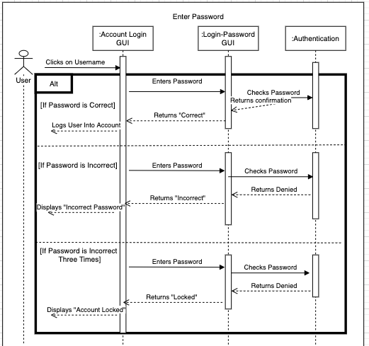

Design Sequence Diagram

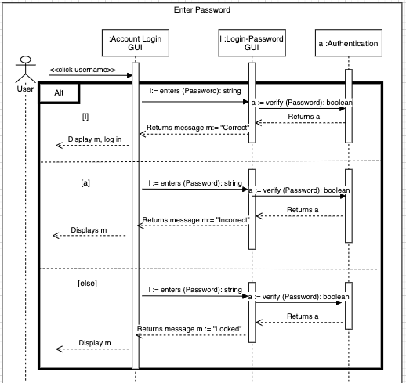

**Select Game Task:**

Scenario Description Table

|  |  |  |  |  |
| --- | --- | --- | --- | --- |
| **#** | **Subject** | **Subject Action** | **Parameters** | **Object Acted Upon** |
| 1. | User | Selects | Task Categories | Dropdown Menu |
| 1.1. | User | Selects | Task | Arrows |
| 1.2. | User | Selects | Task | Start Button |
| 2. | System | Displays | Task Categories | Task Menu |
| 2.1 | System | Displays | Task | Task Menu |
| 2.2 | System | Starts | Task | Start Button |

Analysis Sequence Diagram

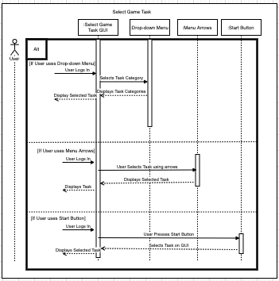

Design Sequence Diagram

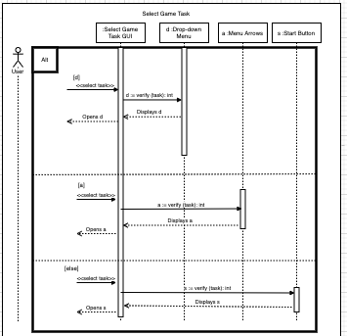

**Suggest Starting Tasks:**

Scenario Description Table

|  |  |  |  |  |
| --- | --- | --- | --- | --- |
| **#** | **Subject** | **Subject Action** | **Parameters** | **Object Acted Upon** |
| 1. | System | Display | Task | Suggested Game Task |
| 2. | User | Press | Task | Start Button |
| 2.1. | User | Selects | Task | Minigame Menu |

Analysis Sequence Diagram

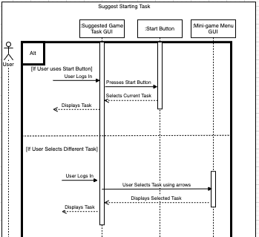

Design Sequence Diagram

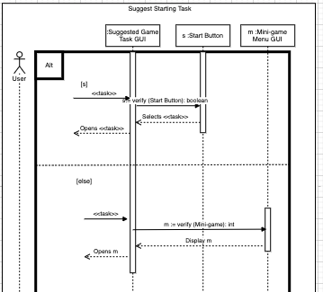

**Give Prompt (Audio/Visual):**

Scenario Description Table

|  |  |  |  |  |
| --- | --- | --- | --- | --- |
| **#** | **Subject** | **Subject Action** | **Parameters** | **Object Acted Upon** |
| 1. | System | Prompt | User | Visual/Audio Cue |
| 2. | If User follows prompt |  |  |  |
| 2.1. | System | Prompts | User | Positive Cue |
| 3. | If User fails prompt |  |  |  |
| 3.1. | System | Prompts | User | Additional Help Cue |

Analysis Sequence Diagram

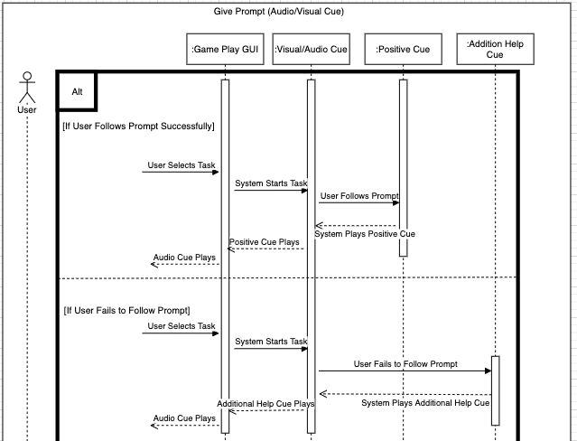

Design Sequence Diagram

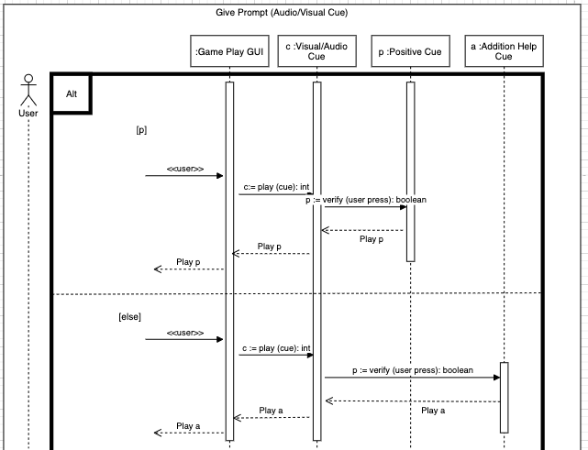

**Take Pictures:**

Scenario Description Table

|  |  |  |  |  |
| --- | --- | --- | --- | --- |
| **#** | **Subject** | **Subject Action** | **Parameters** | **Object Acted Upon** |
| 1. | User | Press | Button | Camera |
| 2. | System | Activates | Camera | Device’s Camera |
| 3. | User | Takes Photo | Camera | Device’s Camera |
| 4. | System | Save Photo | Camera | Device’s Camera |
| 4.1. | If User decides to save photo |  |  |  |
| 4.1.1. | System | Saves Photo | Camera | Device’s Storage |
| 4.2. | If User declines to save photo |  |  |  |
| 4.2.1. | System | Inserts Photo | Camera | Device’s Camera |

Analysis Sequence Diagram

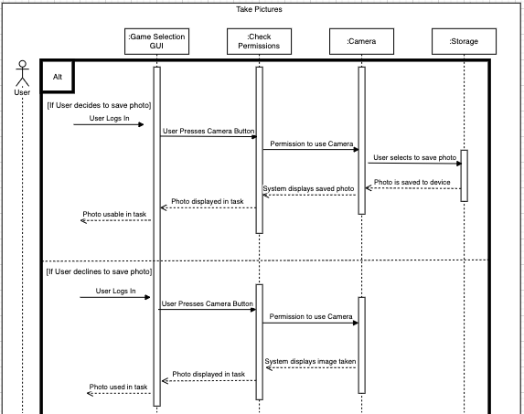

Design Sequence Diagram

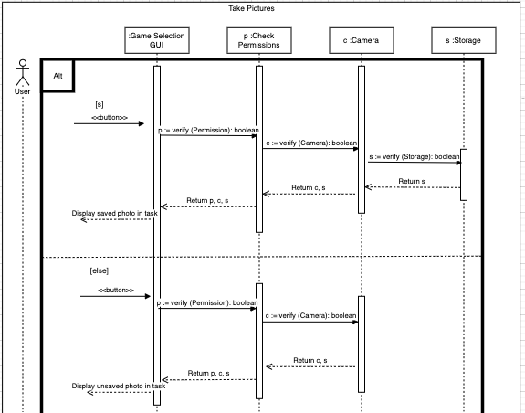

**Get User Permissions:**

Scenario Description Table

|  |  |  |  |  |
| --- | --- | --- | --- | --- |
| **#** | **Subject** | **Subject Action** | **Parameters** | **Object Acted Upon** |
| 3. | User | Taps | Allow or Deny | Application GUI |
| 3.1 | If Allowed |  |  |  |
| 4.1.A | Application GUI | Sends | Allow Request | Permission Controller |
| 4.1.B | Permission Controller | Updates | User Permissions | User Database |
| 4.1.C | Application GUI | Displays | Settings Menu | User |
| 3.2 | If Denied |  |  |  |
| 4.2.A | Application GUI | Displays | Settings Menu | User |

Analysis Sequence Diagram

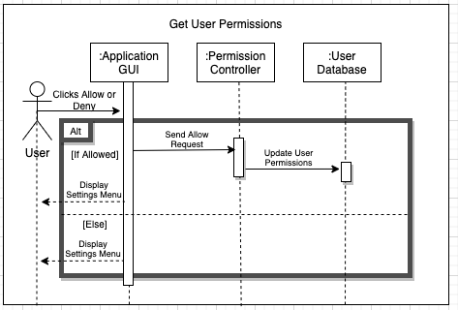

Design Sequence Diagram

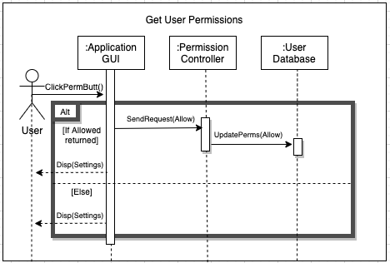

**Click Object:**

Scenario Description Table

|  |  |  |  |  |
| --- | --- | --- | --- | --- |
| **#** | **Subject** | **Subject Action** | **Parameters** | **Object Acted Upon** |
| 1. | User | Taps | Game Object | Application GUI |
| 2.1 | Application GUI | Sends | Object Information | Game Controller |
| 2.2 | If Object was correct |  |  |  |
| 2.2.A | Game Controller | Sends | Correct Game Object | Track Progress Controller |
| 2.2.B | Game Controller | Sends | Correct Signal | Prompt Controller |
| 2.3 | Else if Object was incorrect |  |  |  |
| 2.3.A | Game Controller | Sends | Incorrect Game Object | Track Progress Controller |
| 2.3.B | Game Controller | Sends | Incorrect Signal | Prompt Controller |
| 2.4 | Else if Object was prompted and correct |  |  |  |
| 2.4.A | Game Controller | Sends | Correct Prompted Game Object | Track Progress Controller |
| 2.4.B | Game Controller | Sends | Correct Prompted Signal | Prompt Controller |
| 2.5 | Else |  |  |  |
| 2.5.A | Game Controller | Sends | Incorrect Prompted Game Object | Track Progress Controller |
| 2.5.B | Game Controller | Sends | Incorrect Prompted Signal | Prompt Controller |
| 2.6 | Game Controller | Loads | New Task Display | Application GUI |

Analysis Sequence Diagram

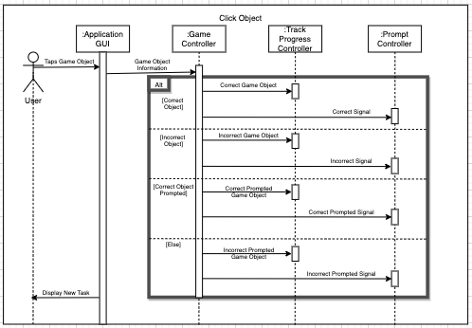

Design Sequence Diagram

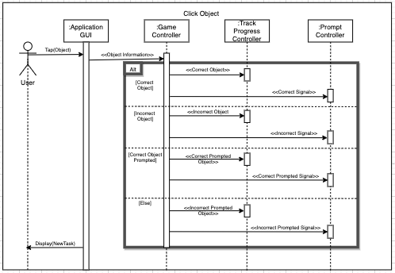

**Track Progress:**

Scenario Description Table

|  |  |  |  |  |
| --- | --- | --- | --- | --- |
| **#** | **Subject** | **Subject Action** | **Parameters** | **Object Acted Upon** |
| 1. | User | Taps | Game Object | Application GUI |
| 2.1 | Application GUI | Sends | Game Object Information | Track Progress Controller |
| 2.4.B | Track Progress Controller | Stores | Game Object Information | User Progress Database |

Analysis Sequence Diagram

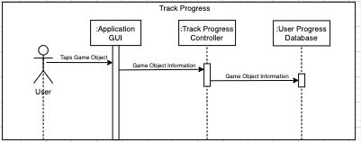

Design Sequence Diagram

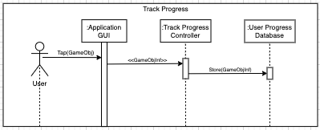

**Select Game Mode:**

Scenario Description Table

|  |  |  |  |  |
| --- | --- | --- | --- | --- |
| **#** | **Subject** | **Subject Action** | **Parameters** | **Object Acted Upon** |
| 3. | User | Selects | Task | Application GUI |
| 4.1 | Application GUI | Gets | User Data | User Progress Database |
| 4.2 | If No Data |  |  |  |
| 4.2.A | Application GUI | Displays | “No Data” | Message |
| 4.3 | Else |  |  |  |
| 4.3.A | Application GUI | Displays | Data Graphics | User |

Analysis Sequence Diagram

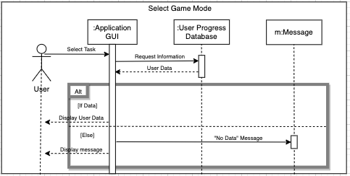

Design Sequence Diagram

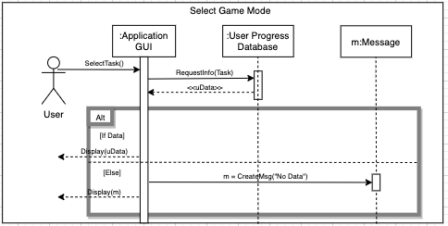

**Adjust Audio:**

Scenario Description Table

|  |  |  |  |  |
| --- | --- | --- | --- | --- |
| **#** | **Subject** | **Subject Action** | **Parameters** | **Object Acted Upon** |
| 1. | User | Taps | Checkbox | Application GUI |
| 2.1.A | If enabled |  |  |  |
| 2.1.B | Application GUI | Requests | Mute Sound | Sound Controller |
| 3.1 | Sound Controller | Mutes | Application Sound | Sound Setting |
| 2.1.C | Application GUI | Displays | Marked Checkbox | User |
| 2.2.A | Else |  |  |  |
| 2.2.B | Application GUI | Requests | Unmute Sound | Sound Controller |
| 3.1 | Sound Controller | Unmutes | Application Sound | Sound Setting |
| 2.2.C | Application GUI | Displays | Unmarked Checkbox | User |

Analysis Sequence Diagram

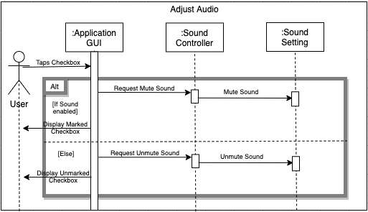

Design Sequence Diagram

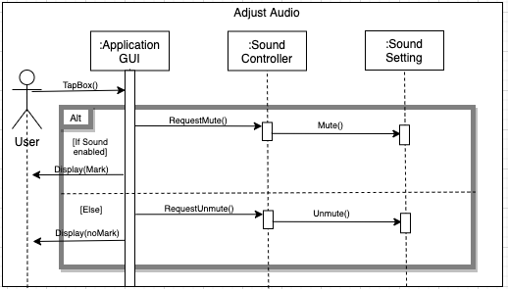

**Log Out User:**

Scenario Description Table

|  |  |  |  |  |
| --- | --- | --- | --- | --- |
| **#** | **Subject** | **Subject Action** | **Parameters** | **Object Acted Upon** |
| 1. | User | Taps | Logout button | Application GUI |
| 2.1 | Application GUI | Sends | Save Request | Track Progress Controller |
| 2.2 | Track Progress Controller | Saves | User Progress | User Progress Database |
| 2.3 | Application GUI | Displays | User Login Menu | User |

Analysis Sequence Diagram

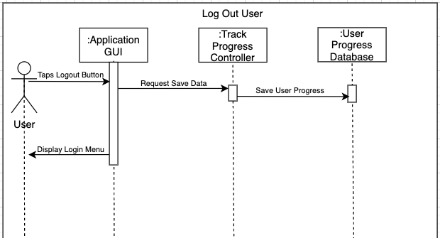

Design Sequence Diagram

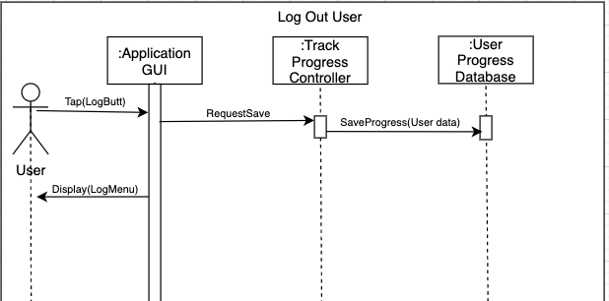

**Add User:**

Scenario Description Table

|  |  |  |  |  |
| --- | --- | --- | --- | --- |
| **#** | **Subject** | **Subject Action** | **Parameters** | **Object Acted Upon** |
| 2. | User | Taps | Add User Button | Application GUI |
| 2.1 | Application GUI | Displays | Information Entry Screen | User |
| 2.2 | User | Enters | Registry Information | Application GUI |
| 3.1 | Application GUI | Sends | Registry Information | Authorizer |
| 3.1.A | Authorizer | Checks | Registry Information | User Database |
| 3.2.A | If Registry Information taken |  |  |  |
| 3.2.B | Authorizer | Creates | “Name taken” | Message |
| 3.3.A | Else |  |  |  |
| 3.3.B | Authorizer | Creates | “Application Success” | Message |
| 3.3.C | Authorizer | Saves | Registry Information | User Database |
| 3.4 | Application GUI | Displays | Message | User |

Analysis Sequence Diagram

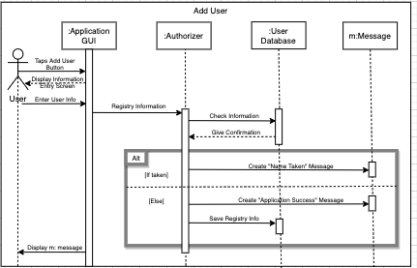

Design Sequence Diagram

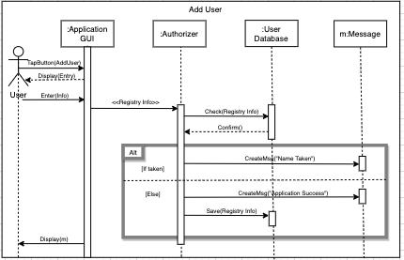

**Delete User:**

Scenario Description Table

|  |  |  |  |  |
| --- | --- | --- | --- | --- |
| **#** | **Subject** | **Subject Action** | **Parameters** | **Object Acted Upon** |
| 3. | User | Taps | Delete Button | Application GUI |
| 4.1 | Application GUI | Sends | Delete Request | Delete Controller |
| 4.2 | Delete Controller | Deletes | User Progress Information | User Progress Database |
| 4.3 | Delete Controller | Deletes | Registry Information | User Database |
| 4.4 | Application GUI | Displays | User Login Landing Page | User |

Analysis Sequence Diagram

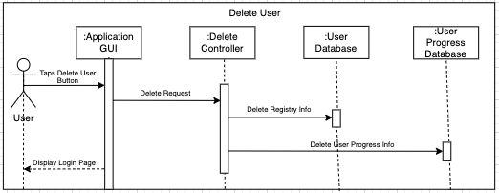

Design Sequence Diagram

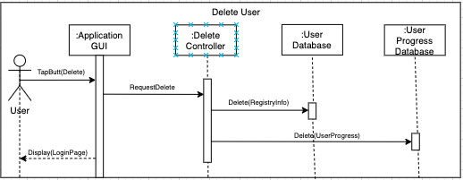

**Edit User:**

Scenario Description Table

|  |  |  |  |  |
| --- | --- | --- | --- | --- |
| **#** | **Subject** | **Subject Action** | **Parameters** | **Object Acted Upon** |
| 5. | User | Taps | Edit Button | Application GUI |
| 6.1 | Application GUI | Creates | “Select User” | Message |
| 6.2 | Application GUI | Displays | Message | User |
| 6.3 | User | Selects | Username | Application GUI |
| 6.4 | Application GUI | Sends | Edit Request | Edit Controller |
| 6.5 | Edit Controller | Creates | “Edit Information” | Message |
| 6.6 | Application GUI | Displays | Message | User |
| 6.7 | User | Edits | Registry Information | Application GUI |
| 6.8 | Application GUI | Sends | New Registry Information | Edit Controller |
| 6.9 | Edit Controller | Saves | New Registry Information | User Database |
| 6.10 | Edit Controller | Creates | “Edit Success” | Message |
| 6.11 | Application GUI | Displays | Message | User |
| 6.12 | Application GUI | Displays | Login Landing Page | User |

Analysis Sequence Diagram

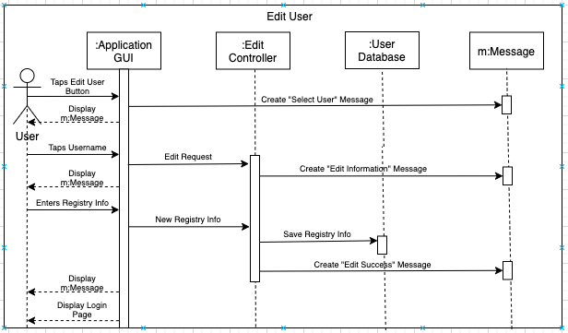

Design Sequence Diagram

