

CS4049 – Blockchain and Cryptocurrency
Assignment 3

Name: Umer Khalid
Roll Number: 22L-6546
Section: BCS-8A
Date: 19-04-2026

Supply Chain Management Dapp workflow:
- Manufacturer is the only one who can register the product, the other roles (Distributor, Retailer and Customer cannot). [Manufactured]
- After creation, the Manufacturer can check the product details or transfer it ahead. The transfer workflow: Manufacturer -> Distributor -> Retailer -> Customer. This workflow cannot be changed i.e., Manufacturer cannot transfer to the Customer directly.
- Manufacturer transfers the product to the Distributor using their wallet address. [In Transit]
- Distributor confirms the delivery once it is received and then transfers it to the Retailer. [AtDistributor -> In Transit]
- Retailer does the same as the Distributor and transfers it to the Customer. [AtRetailer -> In Transit]
- On the customer’s side, the product has been delivered. [Sold to Customer]
- Successful transfer displays the following message:

Unsuccessful transfers display the following error:

Screenshots (in order):
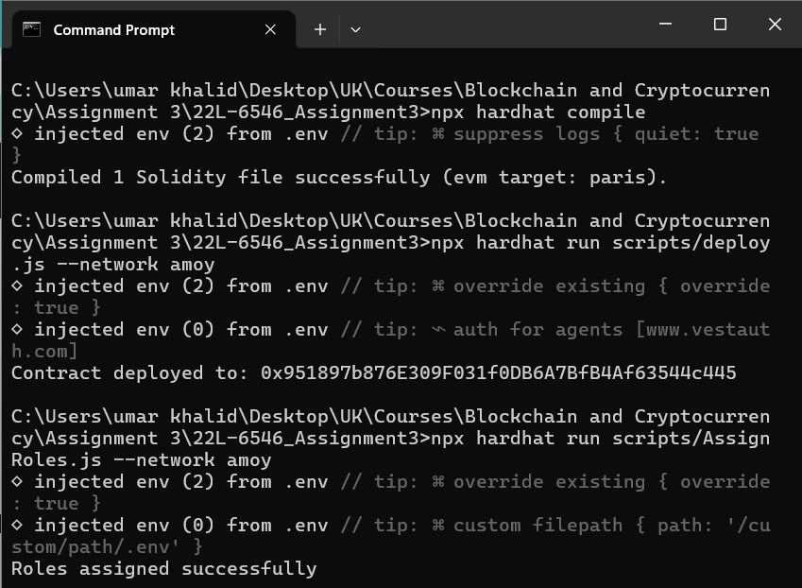
Solidity contract name: UmerKhalid_SupplyChain.sol
The commands ran above compile the contract, deploys it at an address and assigns the 4 roles.
Starting the frontend
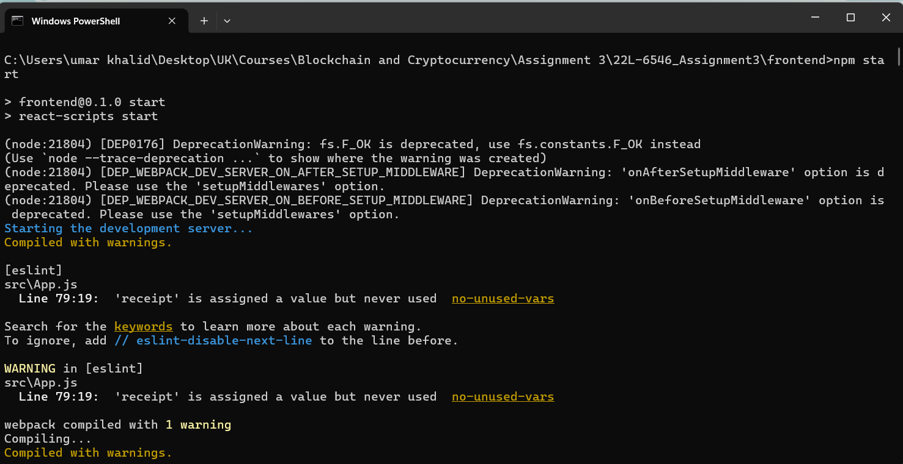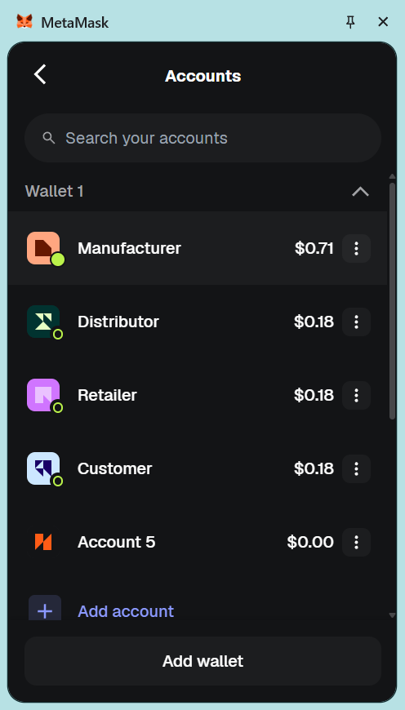
Account 1 – Manufacturer
Account 2 – Distributor
Account 3 – Retailer
Account 4 - Customer
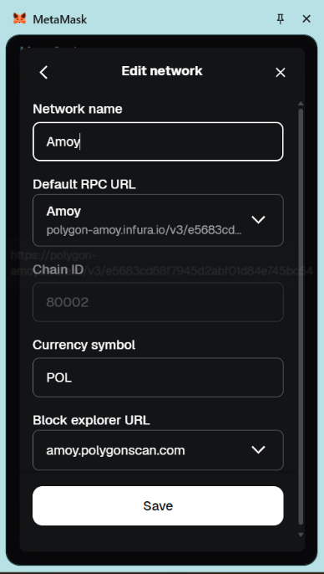
Setting up the Polygon Amoy network

TRANSFER WORKFLOW

