Digital Preservation
Code Migration

Frieder Ulm – 0527031
Hubert Hirsch – 0625008
Eugen Dahm - 0625325
Architechture:
The program to translate BASIC programs into Java code is structured in the following way:
- A grammar parser parses the BASIC code, and constructs a parsing tree. The tree contains a node for every BASIC command and each node contains subnodes with BASIC command parameters, should there be any.
- The parsing tree is traversed, when a node is encountered, the corresponding visitor is invoked. Each visitor handles the respective node's semantic functionality and produces a node that is inserted into a program graph which reflects the sequence of commands that the program structure goes through.
- Once the graph is constructed, the nodes are being iterated through. For each node, the corresponding Java code is generated and written into a text file.

The parser is implemented with JavaCC. JavaCC is a compiler compiler that supports implementing a grammar in Java-like syntax; It also allows construction of the aforementioned parsing tree. The implemented grammar file is then translated into a plain runnable Java program, although the code is not very legible. Our solution then uses the token classes that are generated for each kind of grammar token to handle each kind of command.
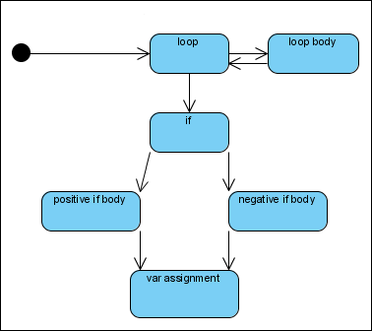Illustration 1: Simple Program Graph Example
For many of the functionality of the BASIC commands it was possible to find corresponding Java statements that exhibit the same behavior as the original commands, for others, a different solution was neccesary.

Problems and Solutions:
- GOTO statements are not supported by Java
  - When GOTO statements occur, we refactor the program code into methods that are called based on the GOTO jumps
- Some functions did not have equivalent counterparts
  - We implemented a class (BasicEmu.java) that implements the desired functionality and moved it to the destination folder of the translated generated Java file. BasicEmu functions are used as a library, whenever commands occur that need special handling, the generated program simply calls the BasicEmu function
- There is no variable typing other than String and number, sometimes numbers are used as integers, sometimes as decimal numbers
  - We encapsulate an integer and double into a class (MultiNumber), the corresponding fields are written and read based on which value a function needs

Instructions on use:
- ant compile: compiles the parser code
- ant quickrun: starts the parser and waits for input
  - terminate with ctrl+D in linux, or ctrl+Z in windows(probably)
- ant run-translate: compiles the the generated javacode
- ant run-java: compiles and runs the generated javacode
- ant clean: deletes everything generated

Java Beautifier Usage:

java com.stevesoft.jbeaut.JavaBeautifier [-tab=number][-braces=NextLine|EndOfLine] file(s)

If the -braces=EndOfLine option is supplied, opening braces will be put at the end of a line.
If the -braces=EndOfLine option is supplied, opening braces will be put on a new line.
If the -tab=number option is supplied, then the default indent will be changed from four to number spaces.

