Midterm Exam

COMPSCI 115 – Python Programming

Exam Duration 100 minutes

Name ______________

***Instructions:***

* ***All your answers should be saved in this word document***
* ***Answer all the questions (10 multiple choice questions and 3 problems solving)***
* ***Your code for each question should be included in this document***
* ***Test your code and take a screenshot of the output***
* ***Upload Python file along with word document to BOLT***

**Part I: Multiple choice questions**

Please Highlight the answer in yellow

1. (1 pt) If you enter 1 2 3 in three separate lines, when you run this program, what will be the output?  
  
 print("Enter three numbers: ")  
 number1 = int(input())  
 number2 = int(input())  
 number3 = int(input())  
  
 # Compute average  
 average = (number1 + number2 + number3) / 3  
   
 # Display result  
 print(average)

A. 2.0

B. 3.0

C. 1.0

D. 4.0

2. (1 pt) What is the printout of the following code?  
  
x, y = 1, 2  
x, y = y, x  
print(x, y)

A. 2 1

B. 1 2

C. 2 2

D. 1 1

3. (1 pt) What is round(3.52657 , 2)?

A. 4

B. 3

C. 5

D. 3.0

E. 3.52

4. (1 pt) The "less than or equal to" comparison operator is __________.

A. <=

B. =<

C. <<

D. <

E. !=

5. (1 pt) Analyze the following code.  
  
even = False  
if even:  
    print("It is even!")

A. The code displays It is even!

B. The code displays nothing.

C. The code is wrong. You should replace if even: with if even = True:

D. The code is wrong. You should replace if even: with if even == True:

6. (1 pt) Analyze the following code fragments that assign a boolean value to the variable even.  
  
Code 1:   
if number % 2 == 0:  
    even = True  
else:   
    even = False  
print(even)

Code 2:   
even = True if number % 2 == 0 else False  
print(even)

Code 3:  
even = number % 2 == 0  
print(even)

A. All three are correct, but Code 1 is preferred.

B. All three are correct, but Code 2 is preferred.

C. Code 3 has a syntax error, because you attempt to assign number to even.

D. Code 2 has a syntax error, because you cannot have True and False literals in the conditional expression.

E. All three are correct, but Code 3 is preferred.

7. (1 pt)  *Suppose x = 1, y = -1, and z = 1. What is the printout of the following statement?*  
if x > 0:  
    if y > 0:  
        print("x > 0 and y > 0")  
elif z > 0:  
    print("x < 0 and z > 0")

A. no printout.

B. x > 0 and y > 0

C. x < 0 and z < 0

D. x < 0 and z > 0

8. (1 pt) Assume x is 0. What is the output of the following statement?  
  
if x > 0:  
   print("x is greater than 0")  
elif x < 0:  
   print("x is less than 0")  
else:  
   print("x equals 0")

A. x is greater than 0

B. x is less than 0

C. None

D. x equals 0

9. (1 pt) What is x after evaluating   
  
x = 2 if 2 > 3 else 3  
print(x)

A. 3

B. 5

C. 4

D. 2

10. (1 pt) Analyze the following code:  
  
even = 231 % 2 == 0  
if even = True:   
   print("It is even!")  
else:  
   print("It is odd!")

A. The program has a runtime error

B. The program displays "It is odd!"

C. The program displays "It is even!"

D. The program has a syntax error on even = True

**Part II: Problem Solving**

1. (3 pts) Write a python program to create a function that prompts the user to enter an integer. If the number is a multiple of 5, print HiFive. If the number is divisible by 12, print Hi Georgia. Else print a message to try again

Here are the sample runs:





Output:



1. (3 pts) Write a program that displays the following table (note that 1 kilogram is 2.2 pounds):

Hint: you have to use a loop statement to convert kilograms to Pounds

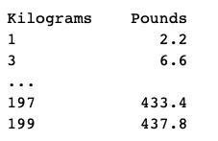

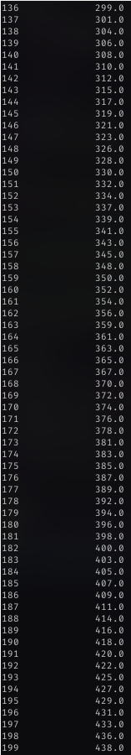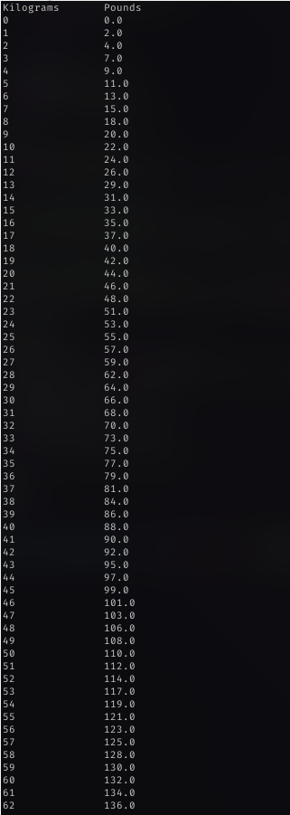Output:

(4 pts) Write a python program that exchanges rate from currency US dollars to Canadian dollars.

1. Create a function named as usToCanadianConversion()that prompts the user to enter the amount in US dollars to convert it to Canadian dollars and print out the entered amount in Canadian dollar.
2. Create a function names as canadianToUsConverstion() that prompts the user to enter the amount in Canadian dollars to convert to US dollars and print out the entered amount in US dollar.
3. Create a function named as userInput()that prompt the user to enter 0 or 1

In the function userInput():

Invoke the function usToCanadianConversion()if the user enter 1

Invoke the function canadianToUsConverstion()if the user enter 0.

Else display an error message “Incorrect input”

**1 Canadian dollar = 0.82 US dollar**

Here are the sample runs:

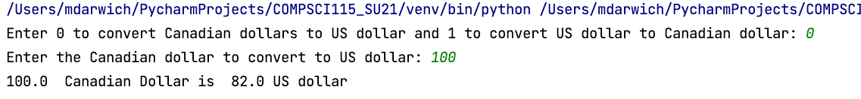

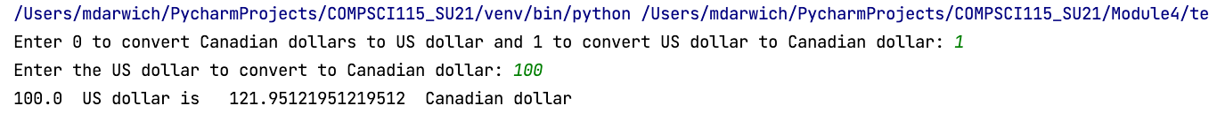



Output:

