**Module 1 Labs**

**COMPSCI 115**

**Name Matthew Yackiel**

***Instructions:***

* ***All your answers should be saved in this word document***
* ***Your code for each question should be included in this document.***
* ***Test your code and take a screenshot of the output***

1. Create a Python Script that executes from the command line. It should take the initials and nickname of a name as arguments and give the output as shown in *Figure*



1. Create a simple Python script that takes a distance and a completion time and outputs the speed in knots, miles per hour, and feet per second.

* The formula for calculating speed is **distance/time = speed**.
* To convert miles to knots, divide the miles by 1.15078.
* To convert miles to feet, multiply the miles by 5280.
* To convert hours to seconds, multiply hours by 3600.
* The output should resemble *Figure* shown below.



1. Create a simple Python script that calculates the diameter and area of a circle

* The formula for calculating diameter is **2 * r**.
* The formula for calculating area is **π * r^2** , **r** being the radius.
* π can be approximated to 3.14159.



Note: All orange underlines are a docstring recommendation from my LSP. Not an error

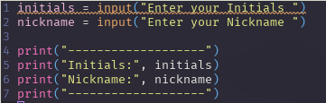1.

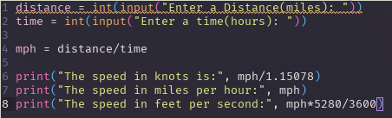2.

3.

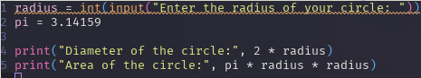

Outputs: (sry for the weird artifact)

