Module 3 Labs

COMPSCI 115

***Instructions:***

* ***All codes should be saved in this word document***
* ***Your code for each question should be included in this document.***
* ***Test your code and take a screenshot of the output***
* ***Upload the phyton file to BOLT***

1. The U.S. federal personal income tax is calculated based on filing status and taxable income. There are four filing statuses: single filers, married filing jointly, married filing separately, and head of household. The tax rates vary every year. The table shows the rates for 2009. If you are, say, single with a taxable income of $10,000, the first $8,350 is taxed at 10% and the other $1,650 is taxed at 15%. So, your tax is $1,082.50.

Write a python program to compute personal income tax. Your program should prompt the user to enter the filing status and taxable income and then compute the tax. Enter 0 for single filers, 1 for married filing jointly, 2 for married filing separately, and 3 for head of household.

**2009 U.S. Federal Personal Tax Rates**

| **Marginal Tax Rate** | **Single** | **Married Filing Jointly** | **Married Filing Separately** | **Head of Household** |
| --- | --- | --- | --- | --- |
| **10%** | $0–$8,350 | $0–$16,700 | $0–$8,350 | $0–$11,950 |
| **15%** | $8,351– $33,950 | $16,701–$67,900 | $8,351–$33,950 | $11,951–$45,500 |
| **25%** | $33,951–$82,250 | $67,901–$137,050 | $33,951–$68,525 | $45,501–$117,450 |
| **28%** | $82,251–$171,550 | $137,051–$208,850 | $68,526–$104,425 | $117,451–$190,200 |
| **33%** | $171,551–$372,950 | $208,851–$372,950 | $104,426–$186,475 | $190,201–$372,950 |
| **35%** | $372,951+ | $372,951+ | $186,476+ | $372,951+ |

1. Write a python program that displays the following table (note that 1 mile is 1.609 kilometers):

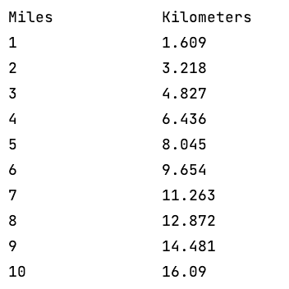

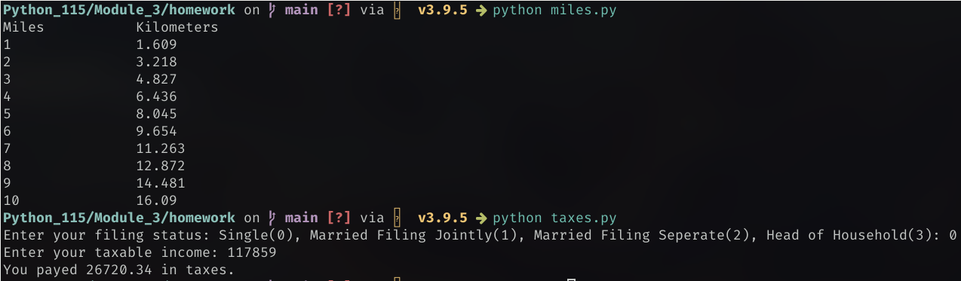Output: