**Module 5 Labs**

**COMPSCI 115**

**Name_______________**

***Instructions:***

* ***All codes should be saved in this word document***
* ***Your code for each question should be included in this document.***
* ***Test your code and take a screenshot of the output***
* ***Upload the phyton file to BOLT***

1. Write a program to create two functions to split the numbers list into two lists: one containing all even values, and one containing all odd. Print out all two lists, as well as each list’s sum and average. Assume all input values are integers

numbers: [1, 5, 8, 2, 8, 100, 3, 7, 27, 5, 89, 100, 75, 13, 10, 41, 31, 57]

1. Create a reverse function that reverses a list by copying it to a new list. The function that reverses the list passed in the argument and returns this list. Write a test program that prompts the user to enter a list of numbers in one line, invokes the function to reverse the numbers, and displays the numbers. (don’t use the built in function reverse())



You program should contain the following functions:

*# get the list elements from the user and return i*

**def** getListElements():

*# the function receives the list elements, reverse and return them*  
**def** reverseList(list_elements):

**def** main():

1. Write a function that checks whether two words are anagrams. Two words are anagrams if they contain the same letters. For example, silent and listen are anagrams. The following functions might be included in the program:

**def** sort(word):

**def** isAnagram(word1,word2)

**def** main():

(Hint: Obtain two lists for the two strings. Sort the lists and check if two lists are identical.)

Write a test program that prompts the user to enter two strings and checks whether they are anagrams.

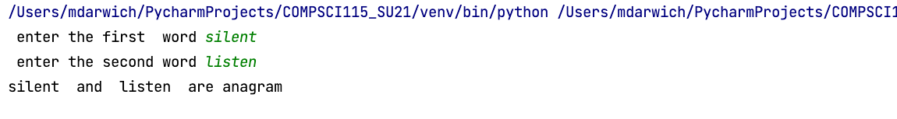

Outputs:

