1. (24 Point) Complete the following table of equivalent values. Use binary numbers with 1 sign bit and 7 bits for the value.

|  |  |  |  |  |
| --- | --- | --- | --- | --- |
| **Decimal** | **Sign-magnitude** | **1’s complement** | **2’s complement** | **Hex** |
| **123** | 01111011 | 01111011 | 01111011 | 7B |
| **-98** | 11100010 | 10011101 | 10011110 | -62 |

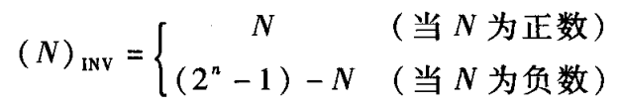

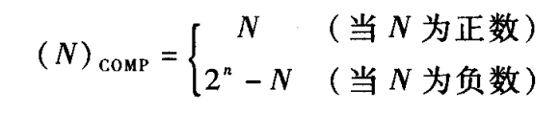

1. (36 Point) Simplify the following Boolean functions with K-map, and draw out the logic circuit with only nand gate.
2. 













1. 















1. (40 Point)Design a combinational circuit that will accept 8421BCD code and output Gray code.
2. Determine the output and input variables
3. Derive the truth table.
4. Obtain and simplify the boolean function.
5. Draw the logic diagram.

|  |  |
| --- | --- |
| **Decimal** | Gray |
| 0 | 0000 |
| 1 | 0001 |
| 2 | 0011 |
| 3 | 0010 |
| 4 | 0110 |
| 5 | 0111 |
| 6 | 0101 |
| 7 | 0100 |
| 8 | 1100 |
| 9 | 1101 |

Answer：

1. Input variables : (LSB) output variables : (LSB)
2. Truth table

|  |  |
| --- | --- |
| Input | output |
|  |  |
| 0000 | 0000 |
| 0001 | 0001 |
| 0010 | 0011 |
| 0011 | 0010 |
| 0100 | 0110 |
| 0101 | 0111 |
| 0110 | 0101 |
| 0111 | 0100 |
| 1000 | 1100 |
| 1001 | 1101 |
| 1010 | XXXX |
| 1011 | XXXX |
| 1100 | XXXX |
| 1101 | XXXX |
| 1110 | XXXX |
| 1111 | XXXX |

1. 























1. the logic diagram

