FLIPKART E-COMMERCE SALES & CUSTOMER ANALYTICS DASHBOARD
(A Business Intelligence & Retail Sales Analytics Study)
A Mini Project Report
Submitted in partial fulfilment of the requirements for the award of the degree of
BACHELOR OF TECHNOLOGY
in
COMPUTER SCIENCE AND ENGINEERING
by
Abhishek Rawat — University Roll No. 2401010038

Faculty Coordinator
Mr. Arpit Goel, HOD – 3rd Year, Department of CSE


DEPARTMENT OF COMPUTER SCIENCE AND ENGINEERING

UTTARANCHAL INSTITUTE OF TECHNOLOGY

UTTARANCHAL UNIVERSITY, DEHRADUN
August, 2026

CERTIFICATE
This is to certify that the mini project report entitled “Flipkart E-Commerce Sales & Customer Analytics Dashboard” is submitted by Abhishek Rawat (2401010038) in partial fulfilment of the requirement for the award of the degree of Bachelor of Technology in Computer Science and Engineering to Uttaranchal University, Dehradun. This work has been carried out under my supervision and has not been submitted elsewhere for any other degree/diploma.
Date: 20/08/2026
Place: Dehradun
Mr. Arpit Goel
HOD, 3rd Year, Department of CSE

DECLARATION
I hereby declare that the mini project work entitled “Flipkart E-Commerce Sales & Customer Analytics Dashboard” is an original work carried out by me under the guidance of Mr. Arpit Goel. The matter embodied in this report has not been submitted elsewhere for the award of any other degree.
1. Abhishek Rawat — 2401010038
B.Tech Computer Science & Engineering
Uttaranchal Institute of Technology (UIT), Uttaranchal University, Dehradun

ACKNOWLEDGEMENT
I would like to express my sincere gratitude to everyone who supported and guided me throughout the successful completion of this Mini Project.
I am deeply thankful to the Director, the Head of the Department, and my Faculty Coordinator, Mr. Arpit Goel, for their valuable guidance, encouragement, and continuous support.
I am also grateful to Simplilearn for the ‘Power BI for Beginners’ training programme that provided the conceptual foundation for this project, and to Kaggle for the open Superstore Sales dataset used for the analysis.
I would also like to thank my friends and classmates for their valuable suggestions and support during the project.

ABSTRACT
Retail organisations generate large volumes of sales data that are difficult to interpret without proper visualisation tools. This project presents the design and implementation of a Flipkart-style E-Commerce Sales & Customer Analytics Dashboard built using Microsoft Power BI. The Kaggle ‘Superstore Sales Dataset’ was imported into Power BI Desktop and cleaned using Power Query to handle inconsistent formats. Data Analysis Expressions (DAX) were used to create key measures, including Total Sales, Total Orders and Average Order Value, forming the analytical backbone of the dashboard. An interactive single-page dashboard was then designed with KPI cards, a category-wise sales chart, a regional map, a monthly sales trend line, and slicers for Category, Region and Date, styled with a vibrant yellow-and-blue theme inspired by Flipkart’s brand colours. The dashboard allows quick identification of top-performing product categories, regional sales distribution and overall order patterns without manual spreadsheet analysis. Testing confirmed that all DAX measures matched manually verified values and that slicers correctly cross-filtered every visual. The project demonstrates practical application of Power BI skills — data import, transformation, DAX modelling and dashboard design — learned through the Simplilearn ‘Power BI for Beginners’ course, and results in a portfolio-ready business intelligence artifact.

TABLE OF CONTENTS
Certificate i
Declaration ii
Acknowledgement iii
Abstract iv
List of Figures v
List of Tables vi
1. Introduction 1
2. Literature Review 1
3. Problem Statement & Objectives 2
4. System Analysis & Design 3
5. Implementation 4
6. Testing 5
7. Results & Discussion 6
8. Conclusion & Future Scope 6
References 7
Appendix (Source Code / Screenshots) 7

LIST OF FIGURES
Figure 4.1 System Architecture Diagram 3
Figure 4.2 Data Flow Diagram (ETL Process) 4
Figure 4.3 Data Model (train Table Structure) 4
Figure 7.1 Final Dashboard Screenshot 6

LIST OF TABLES
Table 4.1 Hardware & Software Requirements 3
Table 6.1 Test Cases and Results 5

1. Introduction

1.1 Background
E-commerce in India has grown rapidly over the past decade, with platforms such as Flipkart and Amazon generating massive volumes of daily sales transactions. Business Intelligence (BI) tools like Microsoft Power BI allow organisations to consolidate this raw transactional data into interactive dashboards that reveal sales trends, category performance and regional demand. This project is set in the broader context of retail analytics, using Power BI to convert a sample sales dataset into meaningful, decision-ready visual insights.

1.2 Motivation
As part of the Simplilearn ‘Power BI for Beginners’ course, hands-on project work was required to reinforce concepts such as data import, Power Query transformations, DAX measures and dashboard design. Flipkart was chosen as the visual inspiration because it is a widely recognised Indian e-commerce platform, making the resulting dashboard both relatable and useful as a portfolio piece. The motivation is to move beyond passive video learning and demonstrate practical, job-ready Power BI skills.

1.3 Scope of the Project
The project covers importing a CSV sales dataset into Power BI Desktop, cleaning it with Power Query, building DAX measures, and designing an interactive single-page dashboard with KPI cards, category/regional visuals, slicers and a Flipkart-branded yellow-and-blue theme. It does not cover real-time API integration, machine-learning-based sales forecasting, or publishing to the Power BI online service, which are out of scope for this beginner-level mini project.

1.4 Organization of the Report
Chapter 2 reviews existing literature on Power BI-based retail analytics. Chapter 3 defines the problem statement and objectives. Chapter 4 covers system analysis, requirements and design diagrams. Chapter 5 describes the implementation, including DAX measures and modules. Chapter 6 presents the testing strategy and test cases. Chapter 7 discusses the results, and Chapter 8 concludes the report with future scope.

2. Literature Review

S.No. | Title / Author / Year | Methodology / Approach | Limitations / Gap
1. | Retail Insights: Unveiling E-commerce Dynamics with Power BI — Yadav, Lakshmi & Alekya (2024) | Used Power BI to analyse a retail/e-commerce sales dataset, building interactive dashboards across category, region and payment mode. | Used a generic retail dataset without custom DAX-driven KPIs or brand-specific theming; this project adds custom measures and Flipkart-style theming.
2. | Data Visualization and Dashboard Design for Enterprise Intelligence — Surwade, Shiragapur & Hussain (2024) | Reviewed dashboard design principles for enterprise BI, focusing on layout, KPI placement and visual hierarchy. | Largely conceptual, without an implemented case study; this project applies those design principles practically on a real dataset.
3. | Retail Store Sales Analysis: Unveiling Insights Through Power BI Business Analytics — Murugan et al. (2024) | Applied Power BI with predictive analytics to examine sales trends, customer demographics and regional variation. | Forecasting adds complexity beyond a beginner scope; this project instead prioritises clear descriptive KPIs suited to a mini project.
4. | E-Commerce Sales Analysis Dashboard using Microsoft Power BI — IJIRMPS (2024) | Analysed e-commerce fields (Category, Region, Segment, Profit, Discount, Ship Mode) to build interactive dashboards and reports. | Did not address custom theming/branding; this project adds a Flipkart-inspired yellow-and-blue theme for improved presentation.
5. | Data Analysis and Visualization of Sales Dataset using Power BI — IJRASET | Demonstrated transforming raw sales data into shareable Power BI reports, highlighting mobile-BI adoption trends. | General-purpose overview without specific DAX measure design; this project builds targeted measures (Total Sales, Orders, AOV).
6. | Enhancing Business Intelligence with Real-Time Sales Dashboards: Integrating SQL Databases and Power BI — IJRASET | Investigated integrating SQL databases with Power BI for real-time sales dashboards using an exploratory research design. | Assumes a live SQL backend; this project instead uses a static Kaggle CSV dataset suitable for an academic mini project.

3. Problem Statement & Objectives

3.1 Problem Statement
Retail and e-commerce businesses generate large volumes of transactional data, but this data is often left in raw spreadsheet form and is difficult to interpret manually. Store managers and decision-makers need a fast, visual way to identify top-performing categories, regional sales patterns and overall business performance. This project addresses that gap by transforming a raw Superstore sales dataset into an interactive, Flipkart-style Power BI dashboard that surfaces key metrics and trends at a glance.

3.2 Objectives
- To import and clean a real-world retail sales dataset using Power Query for accurate analysis.
- To design DAX measures (Total Sales, Total Orders, Average Order Value) that summarise key business metrics.
- To build an interactive, Flipkart-themed dashboard with KPI cards, category/regional charts and slicers for data-driven decision-making.

4. System Analysis & Design

4.1 Requirement Analysis
The following hardware and software requirements were used for development:
Hardware Requirements | Software Requirements
Processor: Intel i5 or above; RAM: 8 GB minimum; Storage: 500 MB free space | OS: Windows 10/11; Tool: Power BI Desktop (latest version); Data Source: CSV (Kaggle Superstore dataset)
Table 4.1 Hardware & Software Requirements

4.2 System Architecture
The overall system architecture, showing how raw data flows from the CSV source to the final dashboard, is illustrated below.
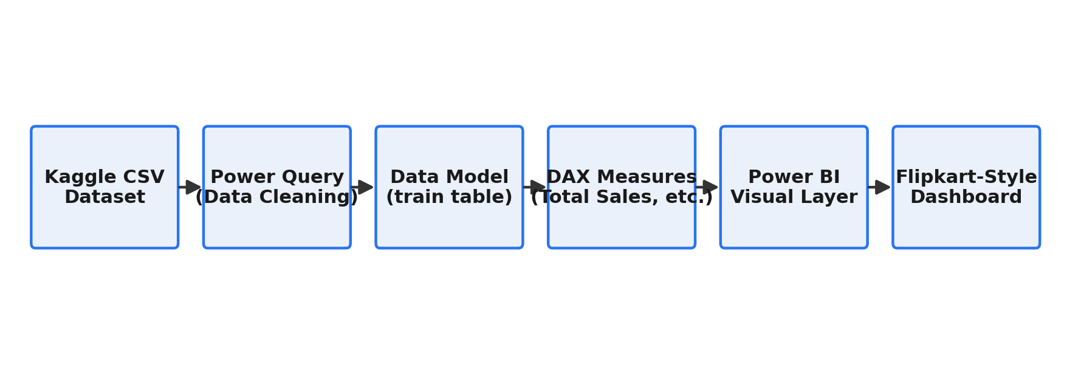
Figure 4.1: System Architecture Diagram

4.3 Design Diagrams
The data flow (ETL) diagram below shows how data moves through Extract, Transform, Load, Analyze and Visualize stages, followed by the data model used for the single flat "train" table.
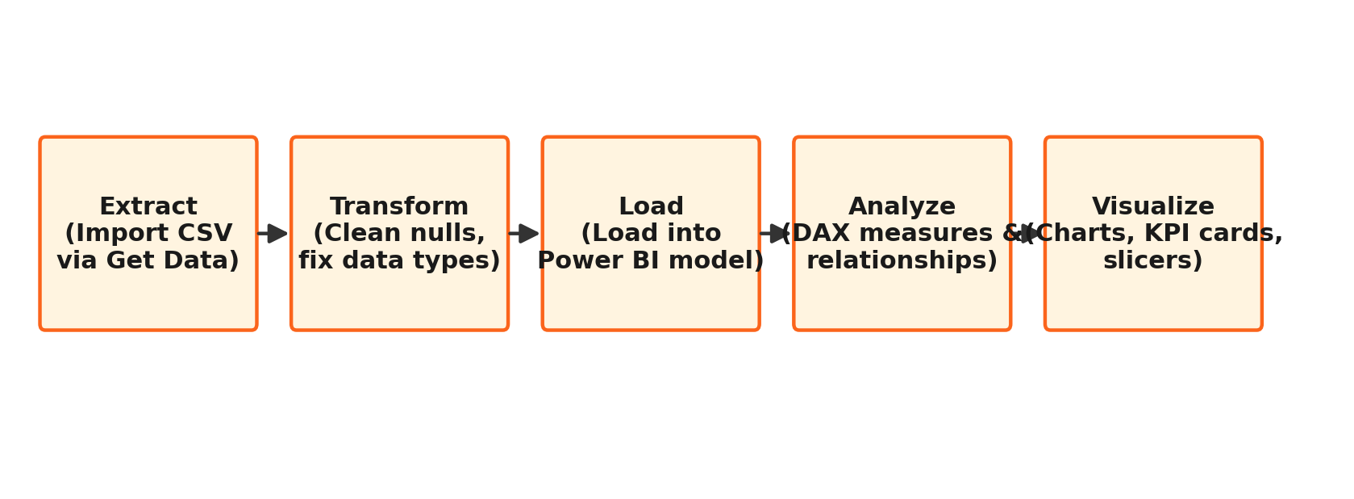
Figure 4.2: Data Flow Diagram (ETL Process)
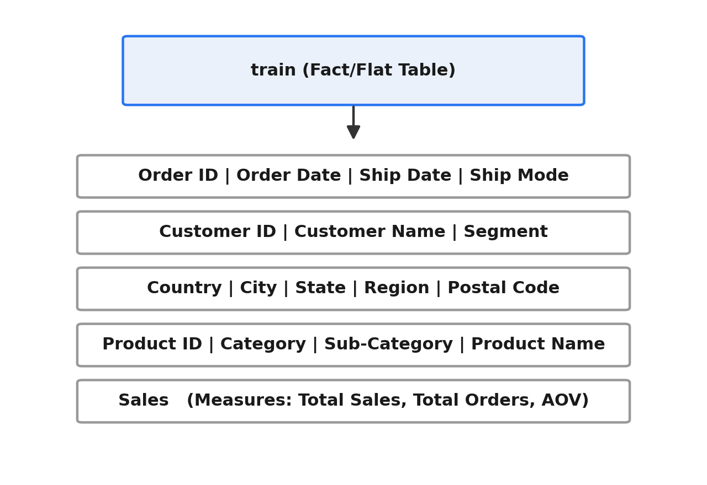
Figure 4.3: Data Model (train Table Structure)

5. Implementation

5.1 Technology Stack
Microsoft Power BI Desktop was used as the primary development environment because it is free, beginner-friendly and industry-standard for business intelligence work. Power Query (M language) was used for data cleaning and transformation, chosen for its no-code, step-based interface. DAX (Data Analysis Expressions) was used to build calculated measures, as it is purpose-built for aggregations over tabular data models. The Kaggle ‘Superstore Sales Dataset’ (CSV format) was used as the data source, providing realistic retail fields (Category, Region, Sales, Order Date) suitable for a Flipkart-style analysis.

5.2 Module Description
- Data Import & Cleaning Module — imports the CSV dataset via Get Data and uses Power Query to remove nulls and correct data types before loading.
- DAX Measures Module — defines calculated measures (Total Sales, Total Orders, Average Order Value) that power every KPI card and chart.
- Visualization & Theming Module — builds the KPI cards, charts, map and slicers, and applies a custom yellow-and-blue JSON theme matching Flipkart’s brand colours.

5.3 Key Algorithm / Code Snippets
The core logic of the dashboard is expressed through three DAX measures defined on the train table: Total Sales = SUM(train[Sales]); Total Orders = DISTINCTCOUNT(train[Order ID]); Avg Order Value = DIVIDE([Total Sales], [Total Orders]). Total Sales aggregates all transaction values, Total Orders counts unique orders using DISTINCTCOUNT to avoid duplicate line-item counting, and Avg Order Value uses DIVIDE (rather than the / operator) to safely handle any potential divide-by-zero case. Two further measures were added to complete the KPI row and the category-level breakdown: Total Customers = DISTINCTCOUNT(train[Customer ID]), which counts unique customers, and Total Line Items = COUNTROWS(train), which counts sold product line items per category (the dataset has no explicit quantity field, so line-item count is used as the closest available proxy). Together, these five measures feed the KPI cards and are also used in the category, regional and ship-mode charts.

6. Testing

6.1 Testing Strategy
Manual validation testing was used rather than automated unit testing, as is appropriate for a BI dashboard project. Each DAX measure was cross-checked against an equivalent Excel formula (SUM, COUNTA) on the same raw dataset to confirm numerical accuracy. Interactive elements — slicers and cross-filtering — were tested by selecting different filter values and visually confirming that every card and chart updated consistently. The custom yellow-and-blue theme was tested by applying the JSON theme file and checking that all visuals rendered with sufficient contrast.

6.2 Test Cases
S.No. | Test Case | Expected Result | Actual Result | Status
1. | Verify Total Sales measure | Compare DAX SUM(Sales) with Excel SUM formula on the same dataset | Values matched exactly | Pass
2. | Category slicer cross-filtering | Select a Category value in the slicer | All visuals (KPI cards, charts, map) updated to reflect only that category | Pass
3. | Total Orders (DISTINCTCOUNT) accuracy | Compare DAX DISTINCTCOUNT(Order ID) with Excel COUNTA of unique Order IDs | Values matched exactly | Pass
4. | Avg Order Value calculation | Verify DIVIDE(Total Sales, Total Orders) returns the correct ratio | Matched manual calculation | Pass
5. | Yellow/blue theme JSON application | Import custom theme JSON via View > Themes > Browse for themes | Dashboard background/colours changed to the Flipkart-style yellow/blue theme | Pass
Table 6.1 Test Cases and Results

7. Results & Discussion
The completed dashboard makes it possible to identify, at a glance, which product categories and regions contribute most to overall sales, and how sales trend over time — insights that would otherwise require manual pivot-table analysis. The finished dashboard, shown in Figure 7.1, reports a Total Sales figure of 2.26M, Total Orders of 5K, an Average Order Value of 459.48, and 793 unique Total Customers across the dataset. Technology emerges as the leading product category by sales, and the West region records the highest combined sales across ship modes. The KPI cards immediately surface overall business performance, while the category, sub-category and regional visuals allow drill-down into specific segments, directly satisfying Objective 3 (interactive, decision-ready visualisation) set out in Chapter 3.
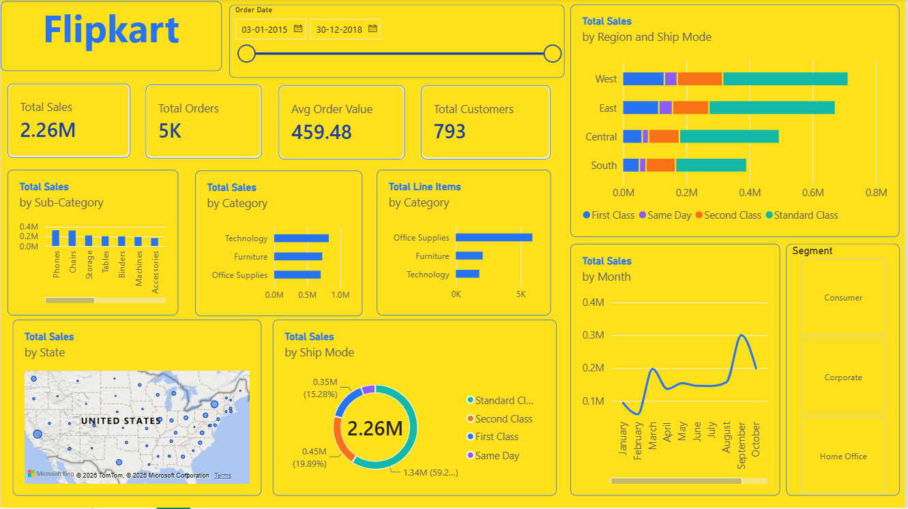
Figure 7.1: Final Dashboard Screenshot

8. Conclusion & Future Scope

8.1 Conclusion
This project successfully demonstrates the end-to-end Power BI workflow — importing raw retail data, cleaning it with Power Query, modelling it with DAX, and presenting it through an interactive, Flipkart-themed dashboard. All three DAX measures were verified for accuracy, and the dashboard’s slicers and visuals were confirmed to cross-filter correctly, meeting every objective defined in Chapter 3.

8.2 Future Scope
Future extensions could include integrating a live SQL or API-based data source for real-time updates, adding machine-learning-based sales forecasting, publishing the report to the Power BI Service for online sharing, and expanding the dashboard into a multi-page report covering profit and customer segmentation analysis in greater depth.

References

[1] L. S. Yadav, T. V. Lakshmi, and V. Alekya, “Retail Insights: Unveiling E-commerce Dynamics with Power BI,” International Research Journal on Advanced Engineering and Management, vol. 2, no. 5, pp. 1680–1682, 2024.
[2] N. B. Surwade, B. Shiragapur, and A. Hussain, “Data Visualization and Dashboard Design for Enterprise Intelligence,” in Metaheuristics for Enterprise Data Intelligence, 2024, pp. 71–91.
[3] S. Murugan, K. L. Daniel, M. Ananthi, P. Rajkumar, and S. S. Jenitha, “Retail Store Sales Analysis: Unveiling Insights Through Power BI Business Analytics,” SSRN Electronic Journal, 2024.
[4] “E-Commerce Sales Analysis Dashboard using Business Intelligence Tool – Microsoft Power BI,” International Journal of Innovative Research in Engineering & Multidisciplinary Physical Sciences (IJIRMPS), 2024.
[5] “Data Analysis and Visualization of Sales Dataset using Power BI,” International Journal for Research in Applied Science & Engineering Technology (IJRASET). [Online]. Available: ijraset.com. [Accessed: Aug. 2026].
[6] “Enhancing Business Intelligence with Real-Time Sales Dashboards: Integrating SQL Databases and Power BI,” IJRASET. [Online]. Available: ijraset.com. [Accessed: Aug. 2026].
[7] R. Sahoo, “Superstore Sales Dataset,” Kaggle. [Online]. Available: kaggle.com/datasets/rohitsahoo/sales-forecasting. [Accessed: Aug. 2026].
[8] Microsoft, “Power BI Documentation,” Microsoft Learn. [Online]. Available: learn.microsoft.com/power-bi. [Accessed: Aug. 2026].
[9] Simplilearn, “Power BI for Beginners,” Simplilearn Free Course. [Online]. Available: simplilearn.com. [Accessed: Aug. 2026].

Appendix
The complete .pbix Power BI file, along with the DAX measure definitions and the custom yellow-and-blue theme JSON file, are available at: [Insert GitHub / OneDrive link]. Additional dashboard screenshots are included on the following pages.

