

# Milestone 2

## CS4102 Knowledge Graphs & Linked Data

## Semester Project Group-A06

Momin Salar i180574

Rizwan Haidar i180536

M. Abdullah i180416

*Submitted to: Dr. Amna Basharat*

Department of Computer Science BS(CS)

FAST-NUCES Islamabad

# Domain Description

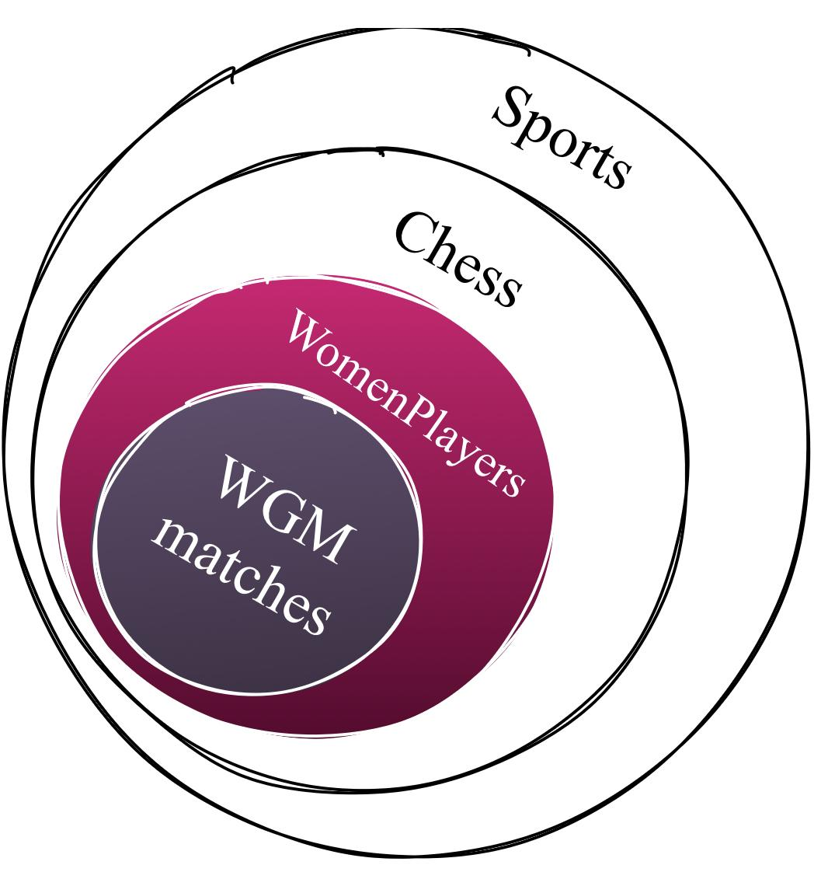

We have an overall domain of Sports. In that domain, we have narrowed our project’s domain to Women Grandmasters who have played chess matches against other Women players with various titles. Our domain shall be able to answer various questions such as: a) who played the most matches in a certain date range, b) who won the most matches, c) top women players with the best overall FIDE ratings and d) details of any particular chess player within the dataset (e.g homeland, year of birth, favorite or most played game types etc.).

# Competency Questions

### How many women chess players have been GM, IM, FM, CM[1] up till 2020?

|  |  |  |
| --- | --- | --- |
| **Patterns** | | **Justification** |
| **Type** | Counting | ‘How many’ |
| **Polarity** | Positive | ‘Have been’ instead of ‘not’ |
| **Arity** | Binary | Chess player has a Title and should be a Woman |
| **Modifier** | Quantity |  |

### Top 10 highest rated chess women players (Blitz U Standard U Rapid)?

|  |  |  |
| --- | --- | --- |
| **Patterns** | | **Justification** |
| **Type** | Selection | ‘Top 10’ |
| **Polarity** | Positive | ‘Highest rated’ |
| **Arity** | N-ary | Each chess player has many **ratings** and should be a Woman |
| **Modifier** | Numeric |  |

### Find two players who played the most matches with each other?

|  |  |  |
| --- | --- | --- |
| **Patterns** | | **Justification** |
| **Type** | Selection | ‘Find two players’ |
| **Polarity** | Positive | ‘Played the most’’ |
| **Arity** | Binary | Max(Count(**p1 hasPlayedwith p2**)) |
| **Modifier** | Quantity | ‘most matches’ |

### Find all players who have won the game under 30 mins in each category?

|  |  |  |
| --- | --- | --- |
| **Patterns** | | **Justification** |
| **Type** | Selection | ‘Find all players’ |
| **Polarity** | Positive | ‘Have won |
| **Arity** | N-ary | Players win a game, in some time, in a category (Blitz, Rapid..) |
| **Modifier** | Quantity | ‘Under 30 mins’ |

### Find all players with minimum winning time in each category?

|  |  |  |
| --- | --- | --- |
| **Patterns** | | **Justification** |
| **Type** | Selection | ‘Find all players’ |
| **Polarity** | Positive | ‘With minimum winning’ |
| **Arity** | N-ary | Players win a game, in some time, in a category (Blitz, Rapid..) |
| **Modifier** | Quantity | ‘Minimum time restriction’ |

### Find the Federation with the least number of grandmasters?

|  |  |  |
| --- | --- | --- |
| **Patterns** | | **Justification** |
| **Type** | Selection | ‘Find federation’ |
| **Polarity** | Positive | ‘With least number’ |
| **Arity** | Binary | Federation has players who are GM |
| **Modifier** | Quantity | ‘Least number of GMs’ |

### Number of federations who have not won any GM or other titles

|  |  |  |
| --- | --- | --- |
| **Patterns** | | **Justification** |
| **Type** | Counting | ‘Number of feds’ |
| **Polarity** | Negative | ‘Not won’ |
| **Arity** | N-ary | Federation has players who have titles |
| **Modifier** | Quantity | ‘Any titles’ |

### Find top 10 games with shortest/longest game time

|  |  |  |
| --- | --- | --- |
| **Patterns** | | **Justification** |
| **Type** | Selection | ‘Top 10 games’ |
| **Polarity** | Positive | ‘With shortest/longest’ |
| **Arity** | Unary | Each game has a game time |
| **Modifier** | Quantity | ‘shortest/longest’ |

### Find top 10 games with shortest/longest number of moves

|  |  |  |
| --- | --- | --- |
| **Patterns** | | **Justification** |
| **Type** | Selection | ‘Top 10 games’ |
| **Polarity** | Positive | ‘With shortest/longest’ |
| **Arity** | Unary | Each game has some moves |
| **Modifier** | Quantity | ‘shortest/longest’ |

### Find the Federations which have not won more as white as much as black or vice versa?

|  |  |  |
| --- | --- | --- |
| **Patterns** | | **Justification** |
| **Type** | Selection | ‘Find the feds’ |
| **Polarity** | Negative | ‘Have not won’ |
| **Arity** | N-ary | Feds partake games, games have white or black players |
| **Modifier** | Quantity | ‘As much as’ |

### How many players have resigned within 30 minutes?

|  |  |  |
| --- | --- | --- |
| **Patterns** | | **Justification** |
| **Type** | Count | ‘How many players’ |
| **Polarity** | Positive | ‘Have resigned’ |
| **Arity** | Binary | Players play a game, and game has a result |
| **Modifier** | Quantity | ‘Within 30 minutes’ |

### Has someone won more than 10 games in some year (user entered)?

|  |  |  |
| --- | --- | --- |
| **Patterns** | | **Justification** |
| **Type** | Binary | ‘Has someone won’ |
| **Polarity** | Positive | ‘won’ |
| **Arity** | N-ary | Players play a game, and game has a result **and** a date |
| **Modifier** | Quantity | ‘More than 10, in some year’ |

### Who has played the most rapid/blitz/bullet games within a given year?

|  |  |  |
| --- | --- | --- |
| **Patterns** | | **Justification** |
| **Type** | Selection | ‘Who’ |
| **Polarity** | Positive | ‘Has played’ |
| **Arity** | N-ary | Players play a game, and game has a type **and** a date |
| **Modifier** | Quantity | ‘Most games, in some year’ |

# Conceptual Model

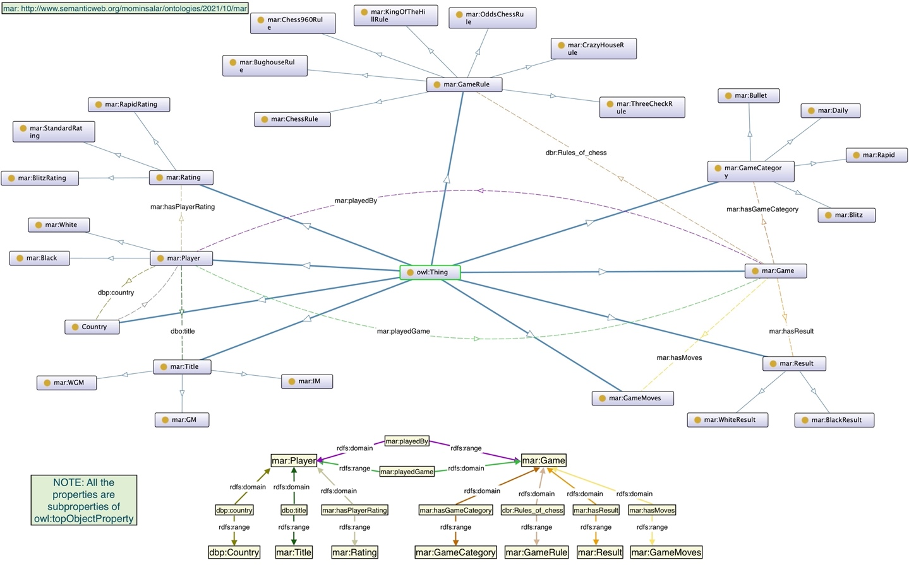

Figure Domain Model

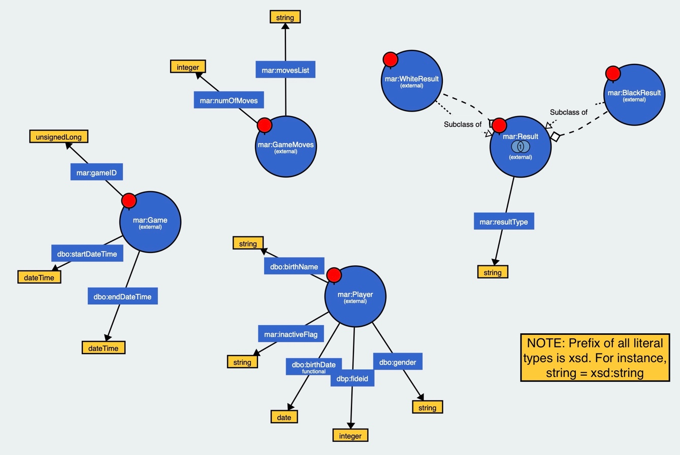

Figure Data Properties

Figure 3 below shows a sample instance of how the A-box will look like with our Chess Ontology. The boxes in green are the Individuals/Instances and the boxes in yellow are the Objects. The dotted lines link the instances with their respectives classes while the solid lines link the object properties or the classes. For further clarity, we are providing all the figures on google drive on the following the link: <https://drive.google.com/drive/folders/1p9oWhSCfJE4eDgHoZxtmKuHGwby05stG?usp=sharing>

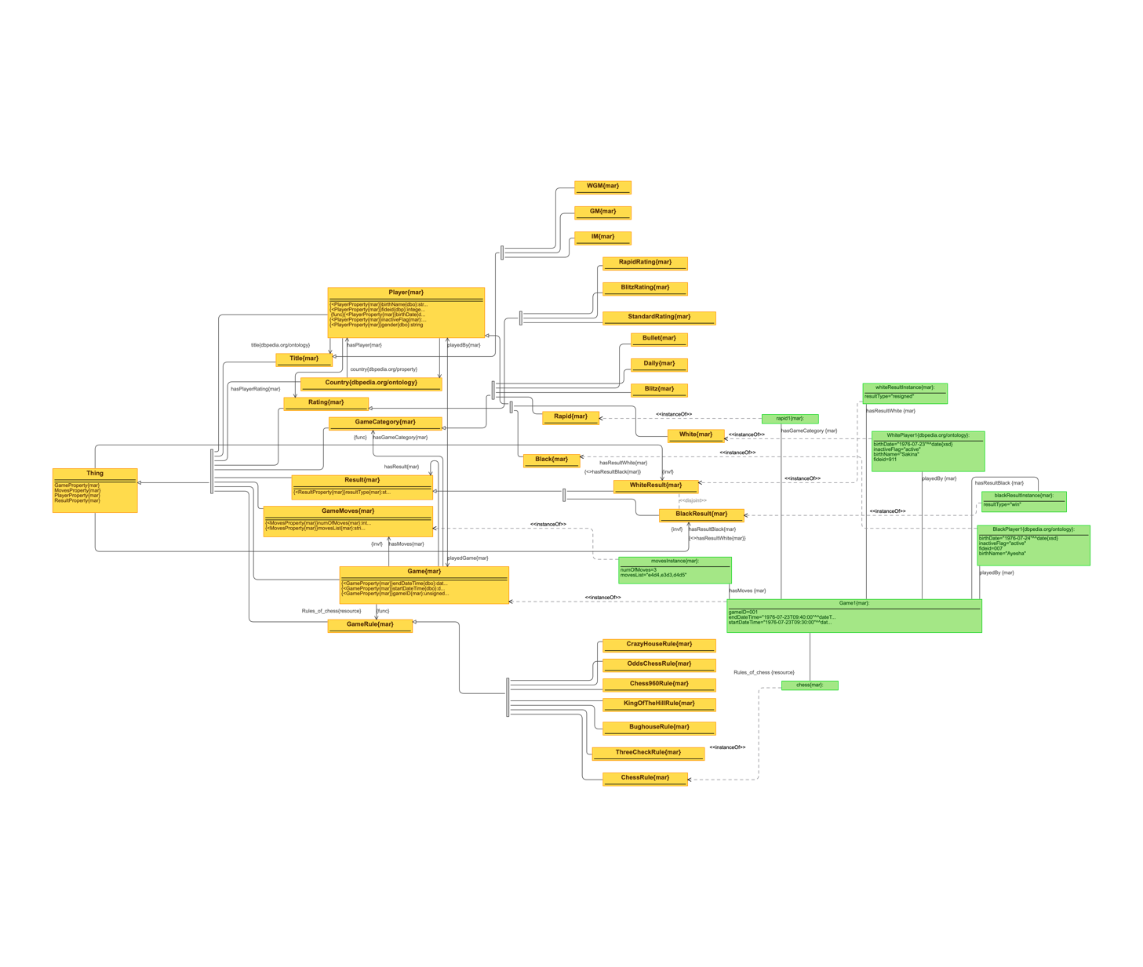

Figure T-box and A-box

# Dataset Description

Becoming a Woman Grandmaster (WGM) is no easy feat. It is the highest honored rank in the domain of Chess which means the 458 WGMs currently are certainly an elite set of individuals[2].

Our dataset comprises the top women chess players with various titles (WGM, GM, IM, FM, CM) with their FIDE ID, full name, Federation, year of birth, ratings (Standard, Rapid, Blitz) and whether they’re still active or not.

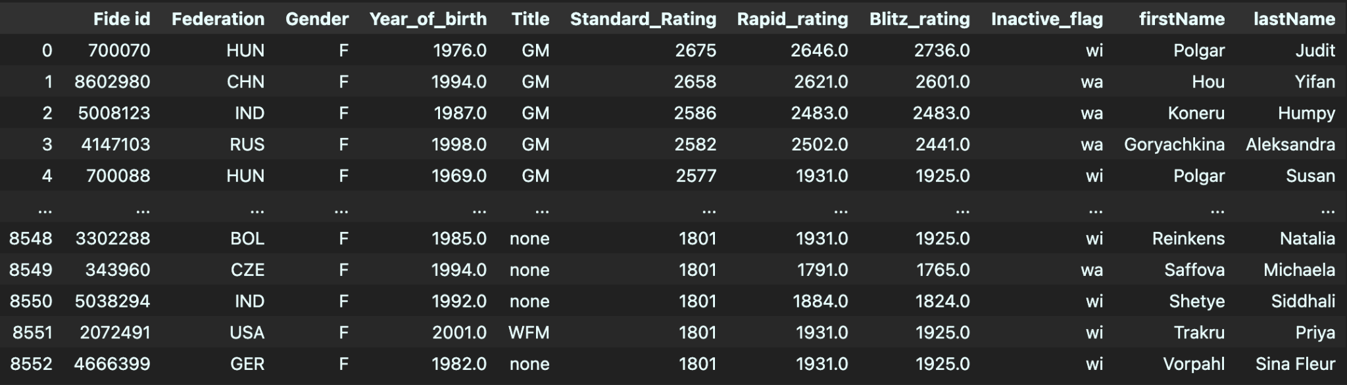

We also have a dataset of matches played by WGMs that comprises the Match ID, start and end times of a match, time class (game category), game rule type, moves made by the players, number of total moves made in a match and finally the result of white and black players.

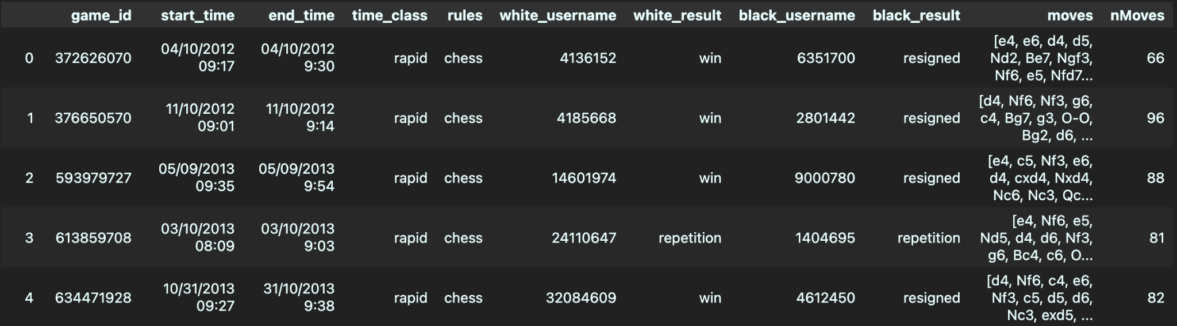

We cleaned both the datasets and considered few hypothetical values:

1. Start_time: Keeping in mind the time range of the time_class, we subtracted a calculated value from the end_time
2. Usernames: Usernames were populated from the first dataset using their FIDE IDs.

# Links with External data

### List of Women Chess Players (DBPEDIA)

<http://dbpedia.org/resource/List_of_female_chess_players>

* dbr:Person
* dbo:birthName
* dbo:birthDate
* dbo:abstract
* dbr:GrandMaster_(chess)

### A player’s page (DBPEDIA)

[https://dbpedia.org/page/Judit_Polgár](https://dbpedia.org/page/Judit_Polg%C3%A1r)

* dbr:City
* dbp:fideid
* dbp:FideTitles (<https://dbpedia.org/page/FIDE_titles>)

### All the FIDE related information (DBPEDIA)

<https://dbpedia.org/page/FIDE_world_rankings>

* dbt:Federation
* dbr:Champions/Winners

1. GM: Grandmaster, IM: International Master, FM: Fide Master, CM: Candidate Master
2. https://www.chess.com/terms/woman-grandmaster-chess