Game Design Document

Fill up the following document

1. Write the title of your project.

Save The World

1. What is the goal of the game?

Get the antidote and save the people who r alive from the zombies

1. Write a brief story of your game.

The Hero woke up and sow the building was about tot fall he jumped out of the building and the zombies sow him he started running and someone pulled him in a hotle and it was Dante the hotel manager told him that a big company thought of a plan to zombify the world the people who paid them money can be in coma under ground safe and when most of the population will be zombifyed they will spread the antidote threw air and then make a new world in the way they want it to be htne the hero takes a gun from Dante and left saying I will find the antidote and spread it before more people get convorted in to zombies

1. Which are the playing characters of this game?

* Playing characters are the ones who respond to the user based on the input from the user.
* Cars, monkeys, dinos, wizards, etc., are the playing characters in the game.

|  |  |  |
| --- | --- | --- |
| Number | Character Name | What can this character do? |
| 1 | Yota | Kill the zoimbes |
| 2 |  |  |
| 3 |  |  |
| 4 |  |  |
| 5 |  |  |
| 6 |  |  |
| 7 |  |  |
| 8 |  |  |

1. Which are the Non-Playing Characters of this game?

* Non-Playing characters are the ones that don't have an action or behavior when the user interacts with the game.
* Hurdles, stones, bananas, coins, etc., are non-playing characters in the game.

|  |  |  |
| --- | --- | --- |
| Number | Character Name | What can this character do? |
| 1 | Zombies | Try to kill Yota and People |
| 2 | People | Try to stick with Yota |
| 3 | Zombie Wolf | Try to Kill Yota |
| 4 | Dante | The Hotle manager |
| 5 |  |  |
| 6 |  |  |
| 7 |  |  |
| 8 |  |  |

Draw your imagination of this game. What does this game look like?

* Draw the game either on your computer or on paper.
* Add images of the game scenes to show each of the playing and non-playing characters at least once.

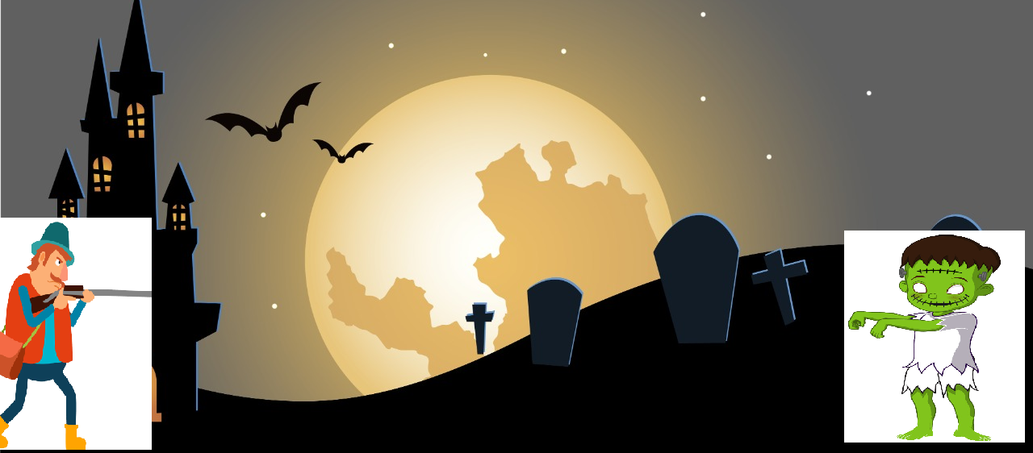

How do you plan to make your game engaging?

Sound, Animations, Lvls, score, helth, ablity