CS200 B Grade – Animation

JeongHak Kim [junghak.kim@digipen.edu](mailto:junghak.kim@digipen.edu)

2019 FALL

* Description  
  Animation is implemented with a sprite sheet which has all frames of animation. It can be done by changing image fast, but its cost of computation is big. So, we use sprite sheet and texture coordinate. An image shows only the part that is in the texture coordinate. Using this, we can display the specific part of the sprite sheet. There is animation frame index and by using this, we can get a unit width and unit height of a frame in the sprite sheet. The shader only gets 0 and 1 by texture coordinate. By using texture coordinate, unit width & height, and frame index, we can calculate texture coordinate that we want to display. (texture coordinate \* unit width) or height => this can distinguish whether the texture coordinate bottom & left or top & right, then add (unit width \* frame index) to know actual texture coordinate. But if the row of sprite sheet is bigger than one, there is a problem. So, I used frame index to calculate frame x index and frame y index. Divide frame index by number of columns will be frame y index and modulus frame index by number of columns will be frame x index.  
  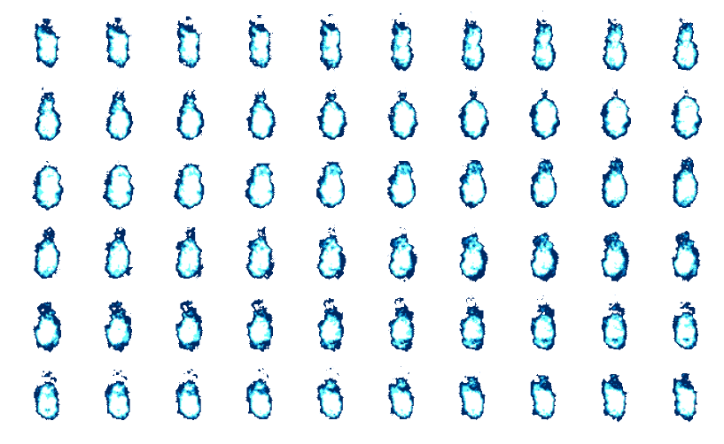  
  For example, this sprite sheet has 10 columns and 6 rows. If the frame index is 14, the red circled frame will be shown.  
  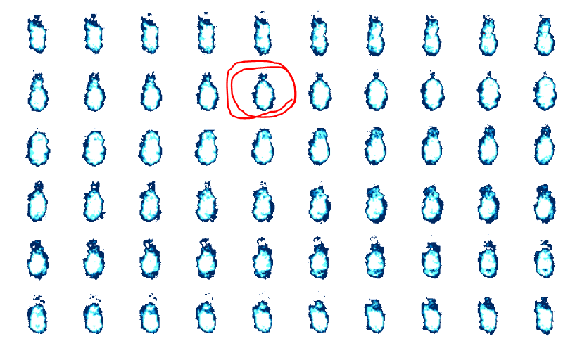  
  Divide 14 by 10 will be 1, modulus 14 by 10 will be 4. Then the texture coordinate exactly indicates red circled one.