Profile

Date of birth

1 mei 1972

address

Spaarndammerstraat 111e

1013 TD Amsterdam

phone number

06-41374109

E-mail

frolvink@hotmail.com

Twitter

@frouzy

**FD work**

<https://fd.nl/auteur/franka-rolvink-couzy>

**code Portfolio**

<https://github.com/Frouzy>

Analytic thinker and excellent storyteller by writing and telling complex stories for the best business media. Has an extensive network. Won a worldwide known award for journalistic talent. Worked as a newsroom manager for three years, but most of all: loves to make things happen.

Experience

Journalistic innovator and innovation journalist at HEt Financieele Dagblad (FD) - jan 2015 - present

Responsible for high-profile stories in a broad range, from big data till artificial intelligence and new business models. Experiment with innovative formats by combining writing, coding and design skills. Beside this daily work also the Presenter of the FD Gazellen-Awards and a coach of young FD-professionals.

FOunder jomo media - may 2015 - present

Raised funding with crowdfunding to publish the selfwritten youth novel 'De Geldfabriek’ and became an entrepreneur. Created a new brand, published the book, and is still teaching children about financial literacy. Set up nice deals with De Nederlansche Bank, Heutink and Fontys Hogeschool Tilburg.

Franka Rolvink Couzy

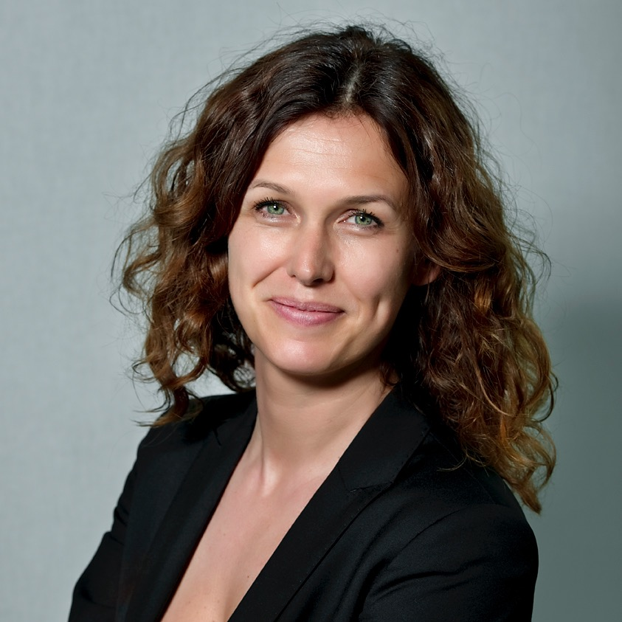

Chief editor at FD - June 2012 - Jan 2015

Responsible for the publications of the global and local business, innovation, and strategic, economical and political developments. Span of control: 20 editors, 15 correspondents.

*Achievements:* implemented a new culture (from old to new journalism) and a digit first newsroom, founded the news update FD7 and FDblogs: which made editors a brand, set up self steer editorial teams, coached reporters from moderate to good performance, introduced a planning system.

Chief editor entrepreneur at FD JAN 2012 - June 2012

Responsible for the publications about entrepreneurship. This includes creating new concepts and the presentation of events. Overarching mission was to integrate this editorial department into the larger editorial department Enterprises. This succeeded within two months.

Senior reporter at FD - Aug 2004 – jan 2012

Topics: mergers and acquisitions, corporate governance, finance, remuneration policies in business, the debt crisis and the food- and retail sector. In 2008, I made an investigative journalistic trip through China.

Vice-President working council FDMG - May 2007 - Sept 2011

*Important advice:* reorganization in 2009, potential acquisition of one of the best Dutch newpapers, reforming distribution and renewed composition of the board of the company.

Lecturer financial journalism at the school of journalism in Utrecht - Sept 2008 - June 2012

Teaching financial and economical journalism to journalists who work for RTLZ, Nieuwsuur, nu.nl and other Dutch media.

Editor at elsevier and FEM Business - Jan 2001 - AUG 2004

Wrote business stories with an opinion. See also at Award.

Other experience - 1988 - 2003

Final editor Finance Television (2000), Editor Money View news agency (1999), editor TV program Business Update (internship 1998), Secretary of the Dean at faculty of Law, Uva (part time 1998-1999), Travel Consultant Estee Lauder Clinique division in the Netherlands and Belgium (1993-1996), guide G2 youth trips (1996-1999) several horeca (1988-1998)

Award, 2004

Citigroup Award for talent in financial and economical journalism. From the jury report: "The jury chose Franka for her highly accessible articles based on broad research. She has an open style of writing and the structure of her items is well-balanced."

Assessment at InContext, May 2012

Outcome: university level

Competencies: "Franka is elegant, outgoing, cheerful and an entrepreneurial. She likes to work in a team and contributes to convey information by facts and unbiased.

References

Jan Bonjer, editor in chief at Het Financieele Dagblad: about my work as a chief editor. See attachment.

Roy op het Veld, editor in Chief at De Limburger and former deputy editor in chief at Het Financieele Dagblad: about my work as a chief editor and as a reporter (Linkedin)

Education

Business Journalist, Insead Business School Fontainebleau, 2007

Business Journalist, Columbia University New York City, 2004

Bachelor of Economics and Laws at the HES (average graduation rate 8; internship rating; excellent), thesis: law and ethics in journalism (rate 8), 1996-1999

Journalism Course at Forum 1998

Nima-A marketing education, 1997

MBO, 1989-1992

Courses

Web Development and design, New York Code and Design Academy (html, css, javascript, jquery), 2017

Masterclass Robotics, Delft University of Technology, 2016

Narrative journalism, Henk Blanken 2016

Coaching, leadership, InContext 2013-2014

Self-managed teams, Mieke Bello 2014

Coaching and feedback, Per Anderson, 2013

Presentation, Speech Republic, 2013

Presentation, Maarten Bouwhuis, 2012

M&A/Valuation, Amsterdam Institute of Finance 2010

Creativity, Centre for development and creative thinking 2006

Interview technique, Forum 2002

Literary short stories, Writers School 2001

Creative writing, Writers' School 1999

Journalism at Hogeschool Utrecht, 1998

Other

Help my father with the micro-credit-project Toto Travel in Indonesia, to help local drivers get a better income

Debate and discussion leader on stage

Board member Vve, responsible for accounting and solarsystems, 2005-2014

Board Member at Vrouw & Media foundation. Meetings and consultations with vacancies at senior positions, 2004-2006

Driving license B

Languages: Dutch (native), English (fluent); German (basic)