# **CoustomMqtt**

1.Please open the plugin

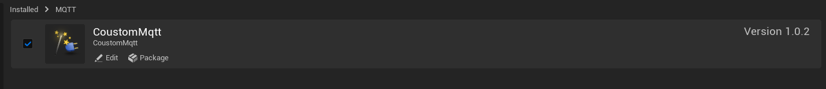

2.Creating an Actor of type mqtt

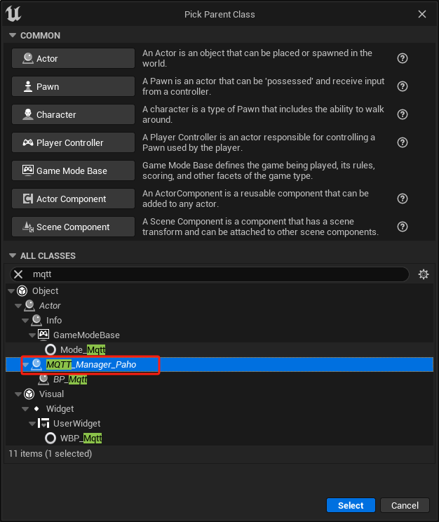

3.Connecting to mqtt data

## Connect

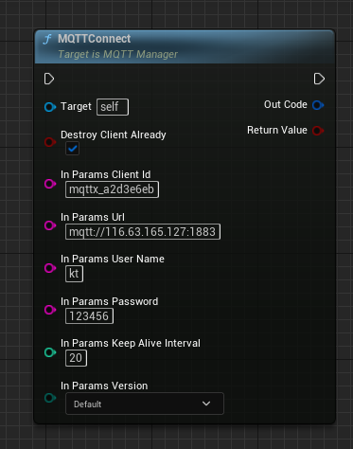

Connects to an MQTT server using the provided connect options.

In Param ClientId : a client identifier that is unique on the server being connected to

In Param Address:the address of the server to connect to

In Param UserName : The user name for connecting to the MQTT broker.

Param Password : The password for connecting to the MQTT broker.

## Subscribe

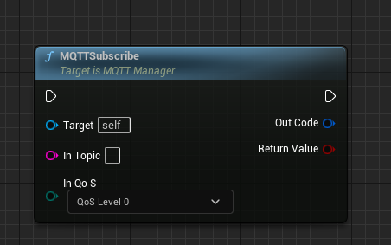

In Topic:the topic to subscribe to, which can include wildcards.

In QoS:The quality of service for the subscription.

## UnSubscribe

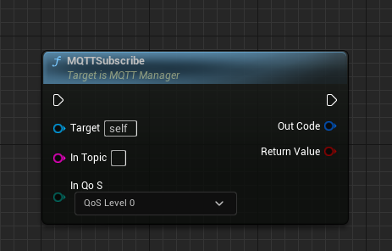

In Topic:the topic to subscribe to, which can include wildcards.

## Publish

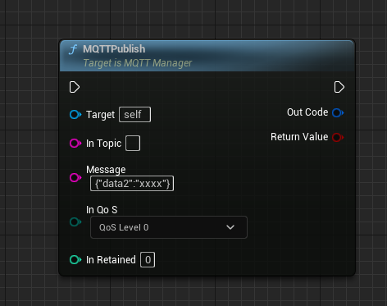

In Topic:the topic to subscribe to, which can include wildcards.

In payload:send message

inQoS : the Quality of Service to deliver the message at. Valid values are 0, 1 or 2.

## Disconnect

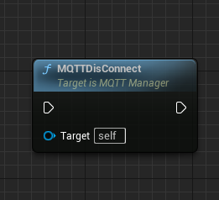

Disconnects from the server And destroy oneself

## Bind Connected Delegate

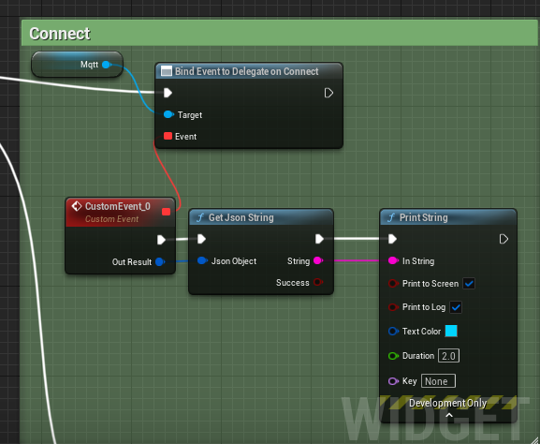

This method is called when the client is connected.

## Bind Connected Failure Delegate

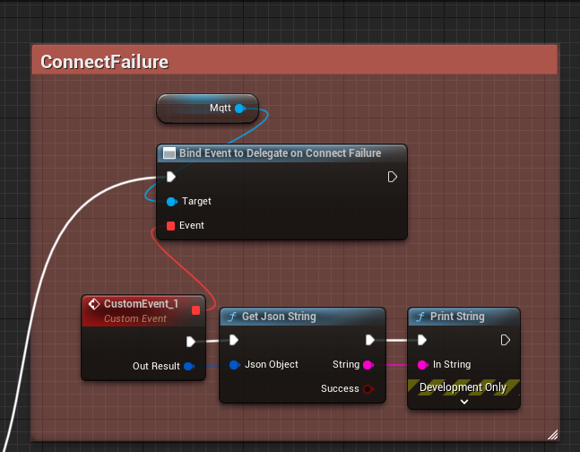

## Bind DisConnected Delegate

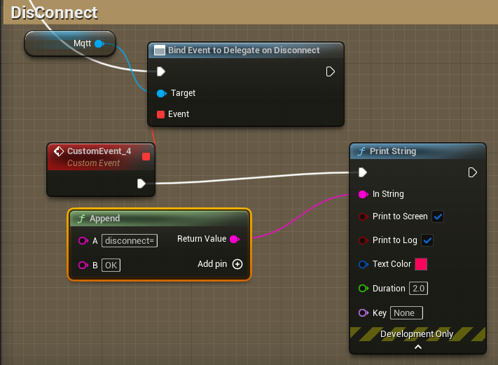

## Bind Send Delegate

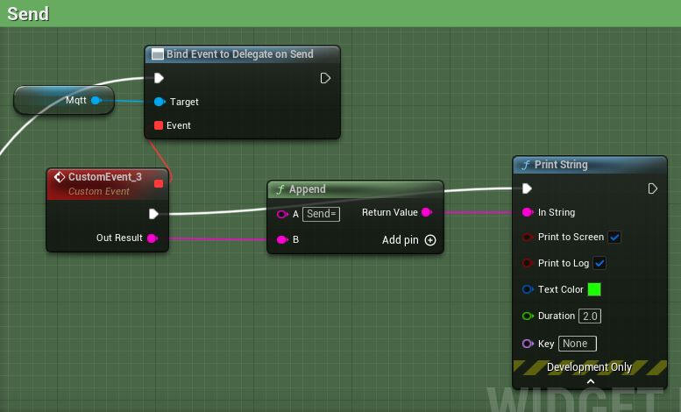

## Bind SendFailure Delegate

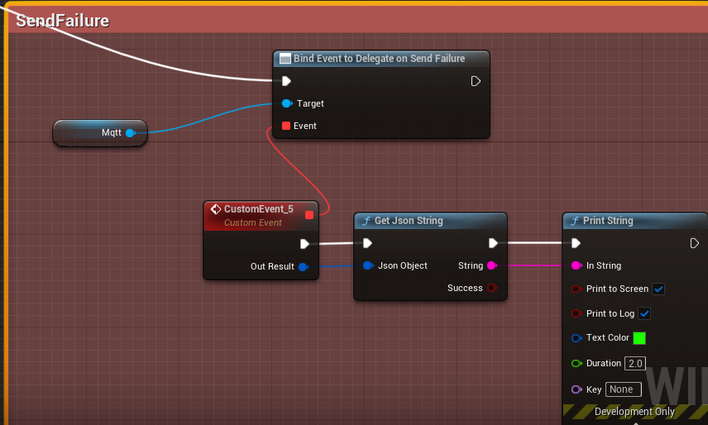

## Bind Message Delegate

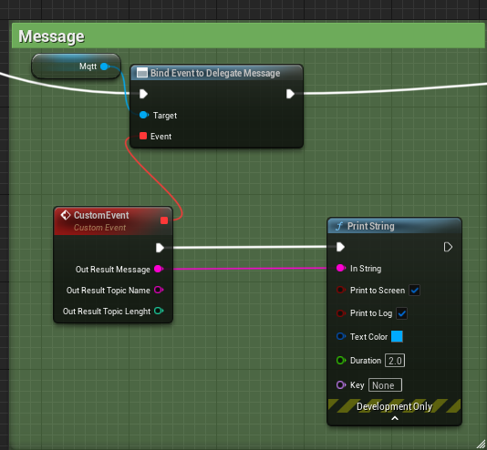

## Bind Lost Delegate

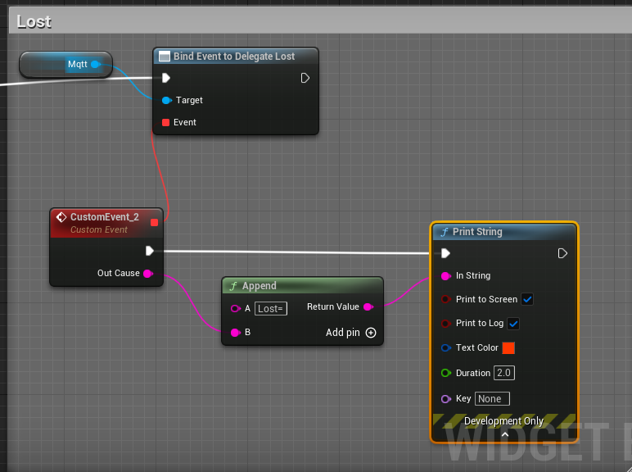

# Example

