1.LoginScreen

This screen allows the registered sellers to login bingo app.

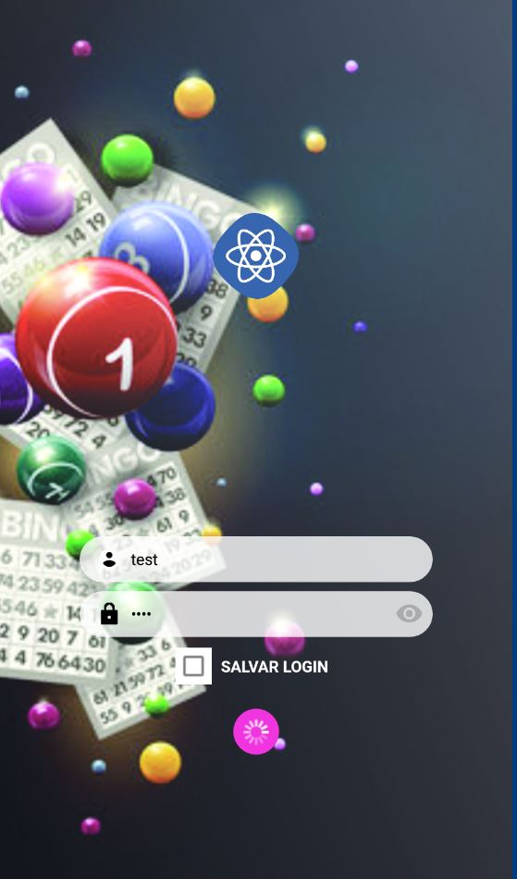

Username and password of seller are registered in admin part.

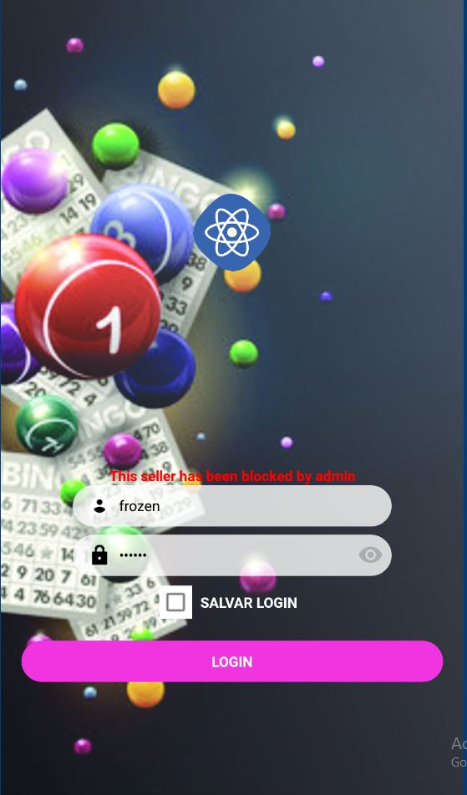 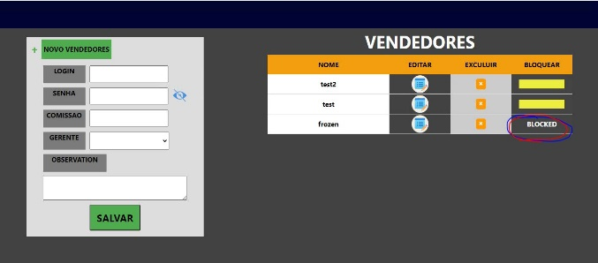

Blocked sellers by admin can’t login

2. Menu Screen

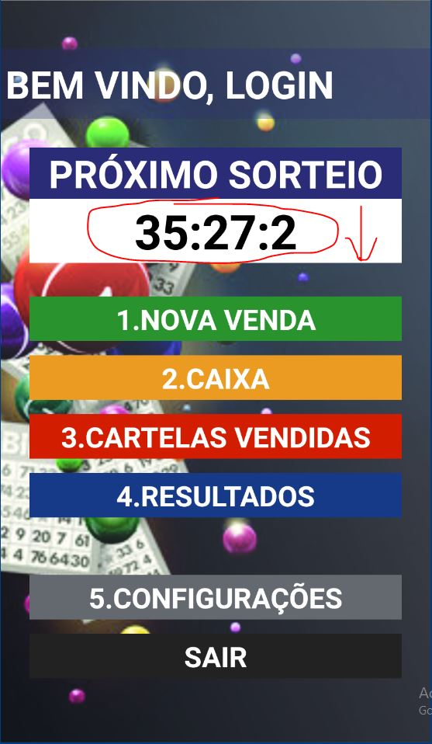

If there are no active draws, the count stops at 00:00:00

When click 1.NOVA VENDA button, the toast shows that ‘There are no active draws’

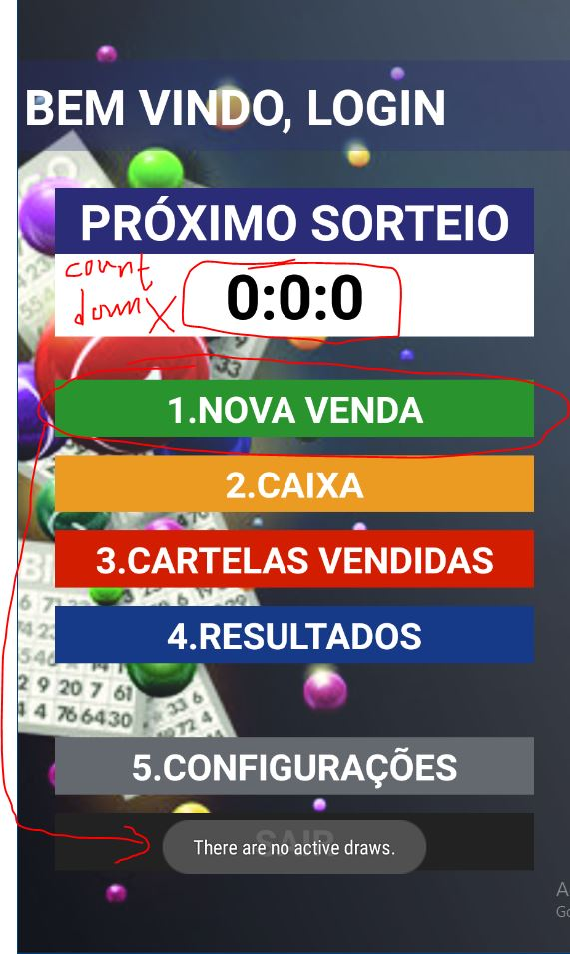

Count down to the starting time of the closest draw.

If the time reaches 00:00:00 , then the ‘1001 draw started’ message appeared.

Then get another closest draw and count down again.

If the draw started, then the draw state becomes ‘PROCESSING’ from ‘ACTIVE’

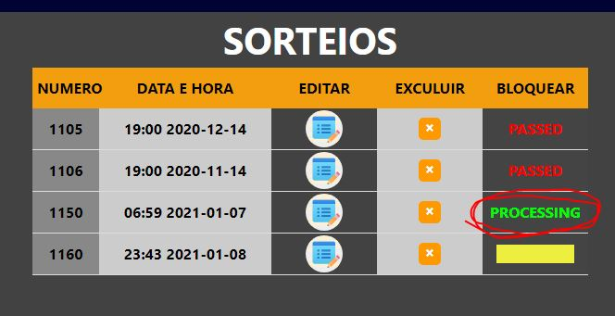

3.New Sale Ticket Screen (1 – 2)

This contains two screens – one is to select ticket count and the other is to generate tickets.

This is the starting time of the current draw.

This is the value stored on db not static.

If the draw changes, this text changes also.

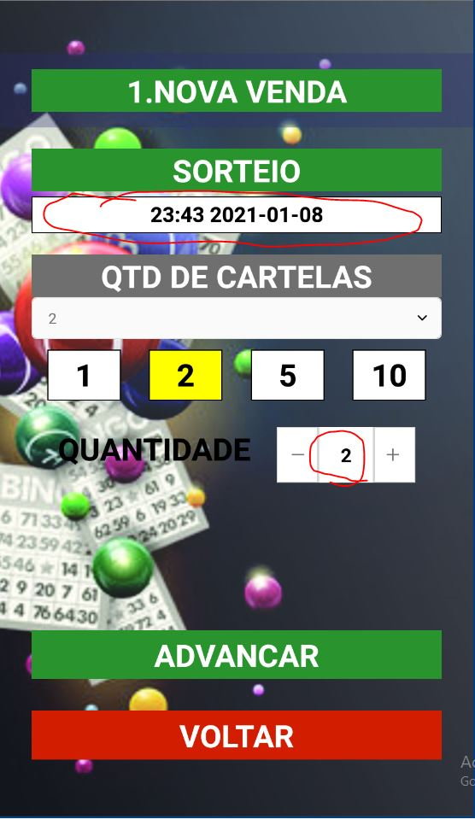

There are 3 ways to decide the tickets count.

After you decide tickets count, then if you click ‘ADVANCE’ button , then you go to the second screen for ticket generation.

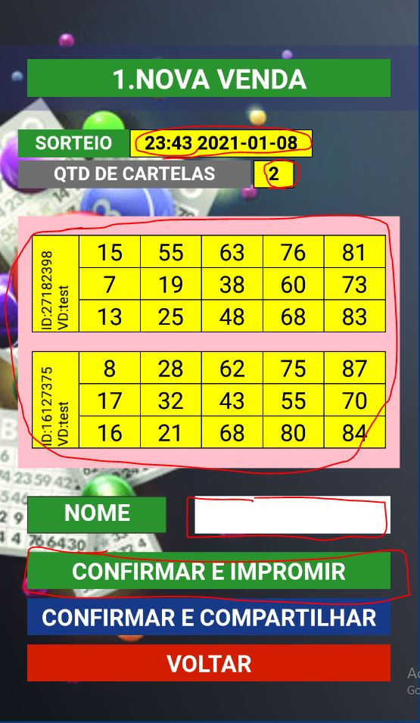

This values are from the previous screen. The draw date and the tickets count.

Two tickets are generated by server.

They are unique for every draw. And it is stored on db when you click Genearte button.

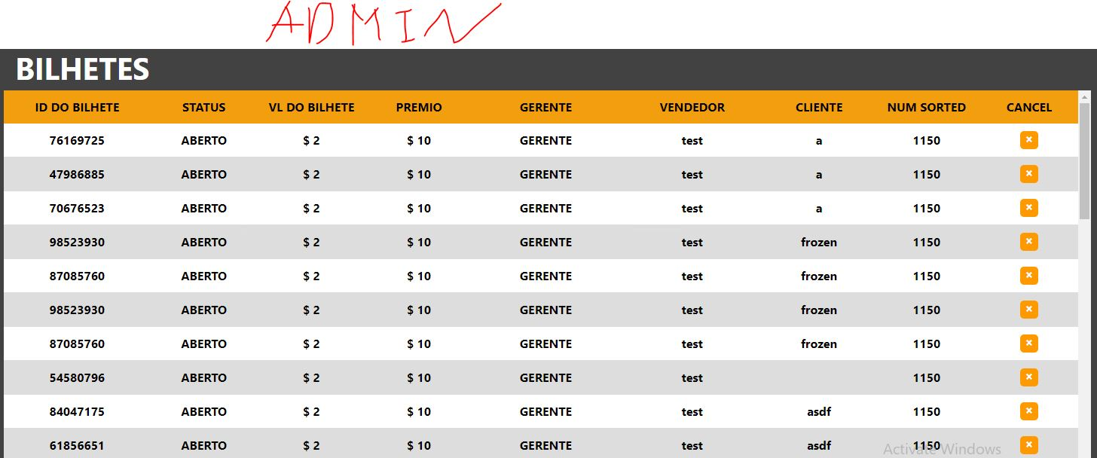

You can see generated tickets on admin table.

4.Cashier Screen

This screen shows the result(extract, exit, commission,final)

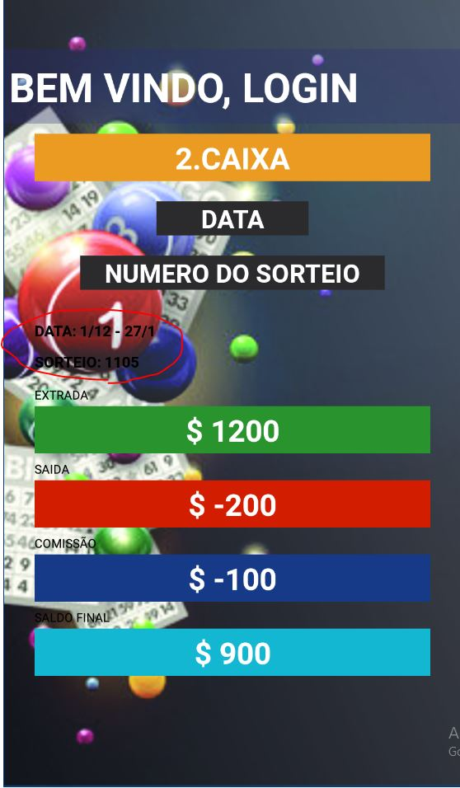

According some filters.

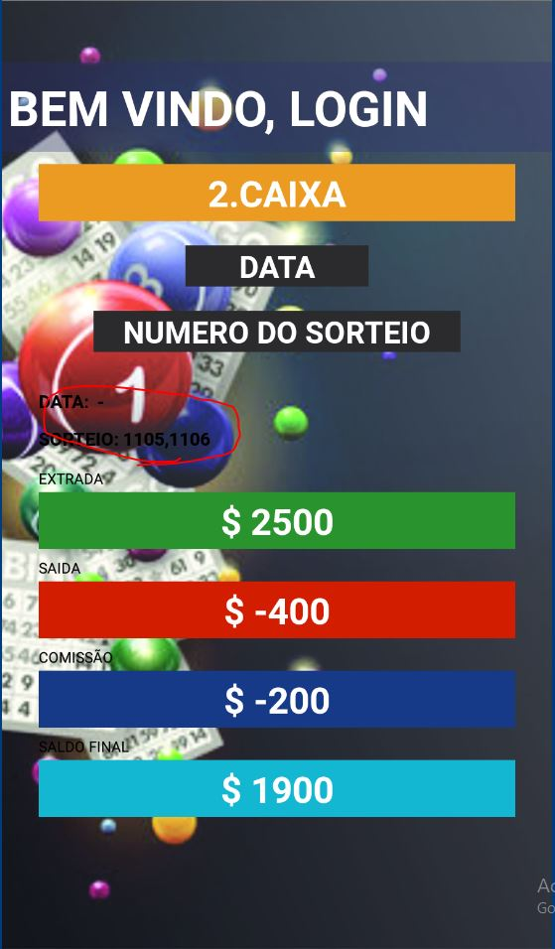

By default, this screen shows the results for all draws by login seller

When you click DATA, then you can select date-range for filter.

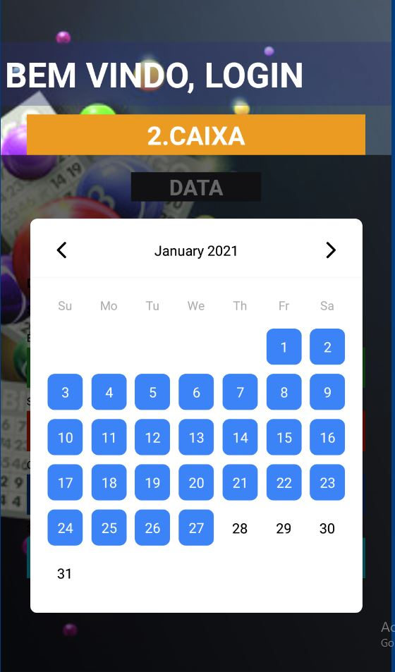

After filtering date-range selected, then the result updated according the filter values.

5.Sold Cards screen.

This screen shows the sold cards by login seller according some filters.

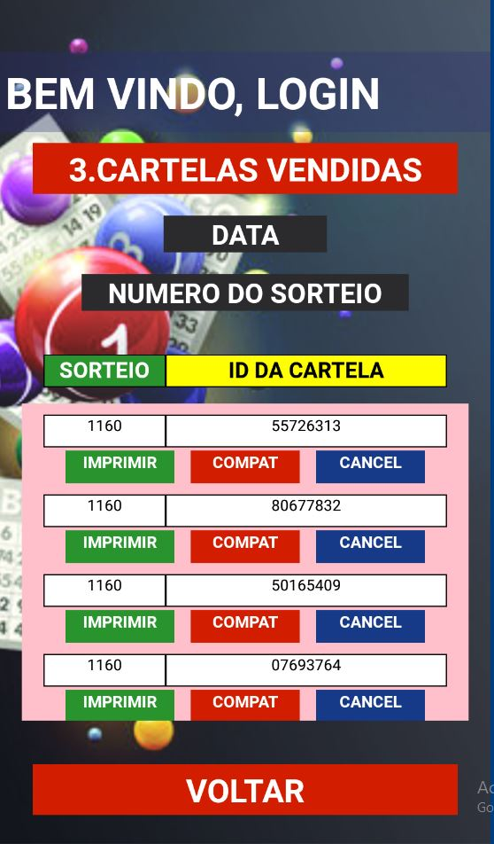

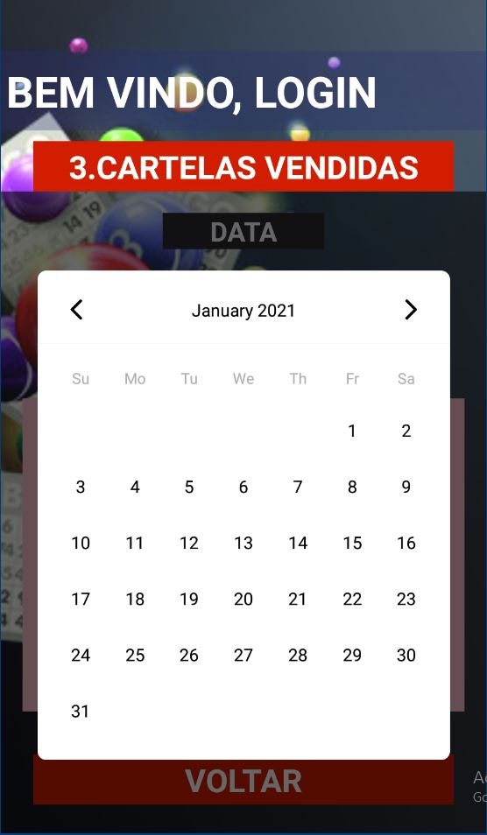

Default the screen shows all sold tickets for current open draw by login seller.

By click DATA you can filter with date range with sold tickets.

Then the result changes according the selected date-range.

Here print and share functions are not completed.

I want to discuss about these functions.

How to print? and what does COMPAT mean?

If you click OK, then the ticket is cancelled.

It will affect also ticket table on admin part.

When you click CANCEL for tickes, then it shows alert to see if you really to cancel specific ticket.

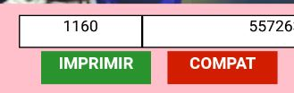

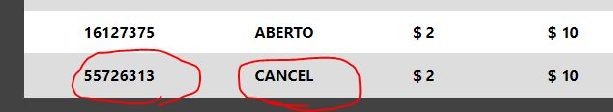

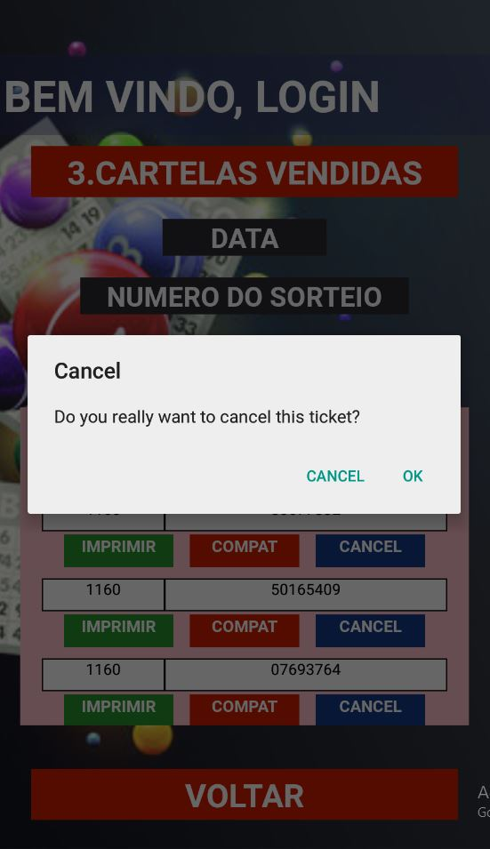

6. Result Screen

This screen shows the draw result.

Which ticket number aquires LINHA, BINGO or ACCUMULATED.

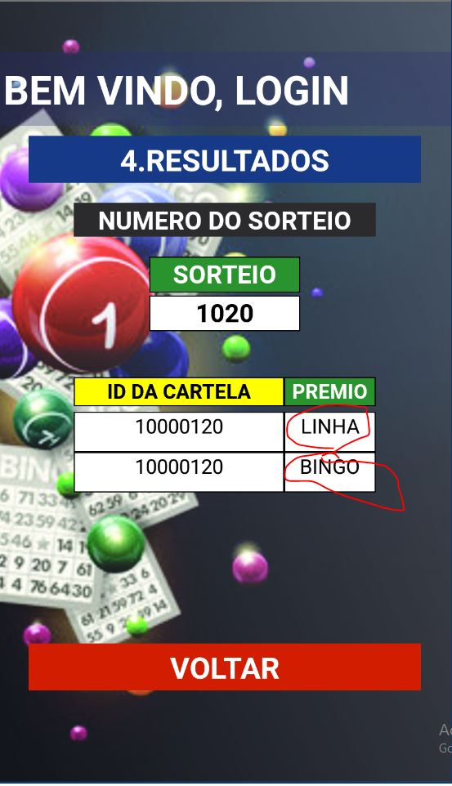

7.Settings Screen

This screen has got 2 settings. Keep login and Bluetooth.

Selected button background is green.

And Red background button is non-selected.

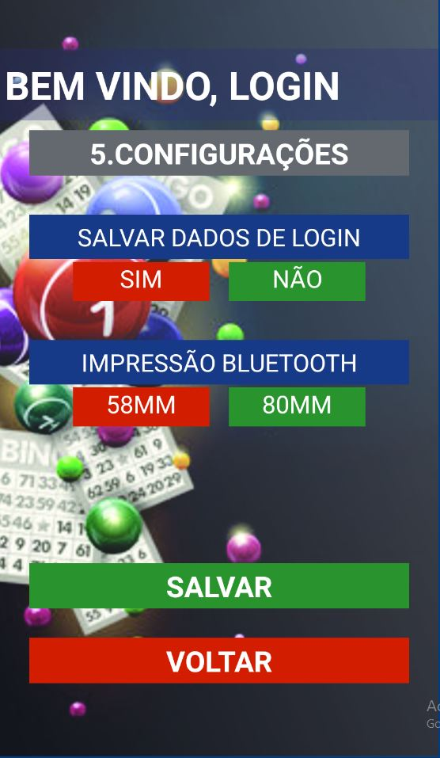

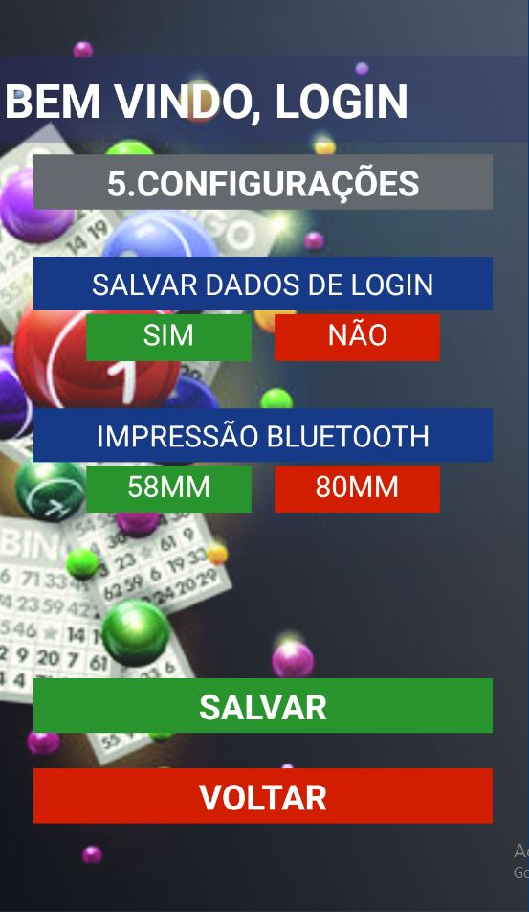

I can’t understand BLUETOOTH here.

It will be a great help if you give some instructions about this.

All functions in mobile app work via API with server.

And it also cooperates with admin part.

I also changed some admin part with styling and filtering data.

Next purpose is to connect db info with User part.