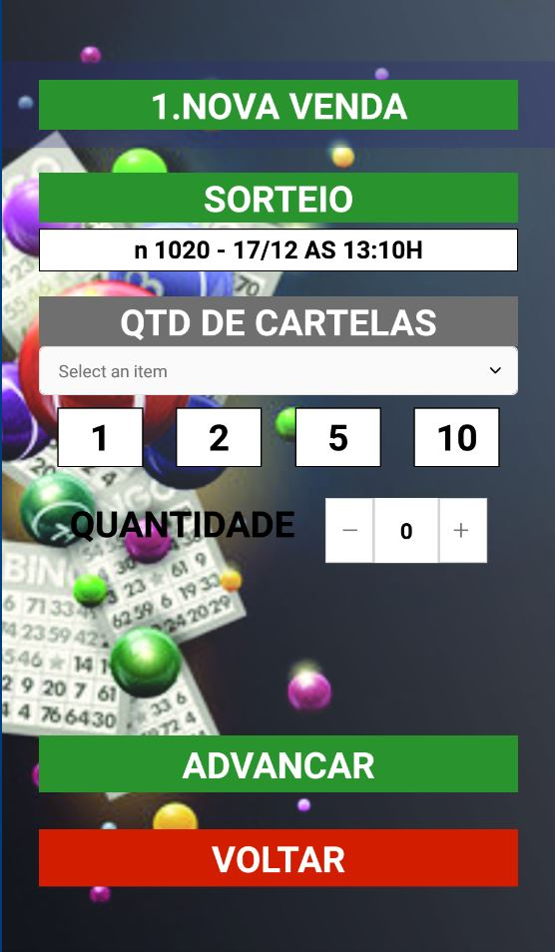

1.These three fields value are same?

If no, then what is the meaning of QUANTIDADE?

If yes, are there three ways to set ticket counts? (comboBox, buttonClick and InputBox)

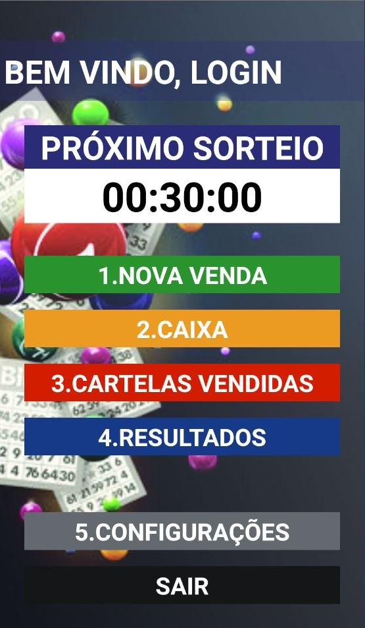

2. When this time reaches at 00:00:00, then I have to disable function to sell tickets to customer right?

And what else to do when the time is 00:00:00

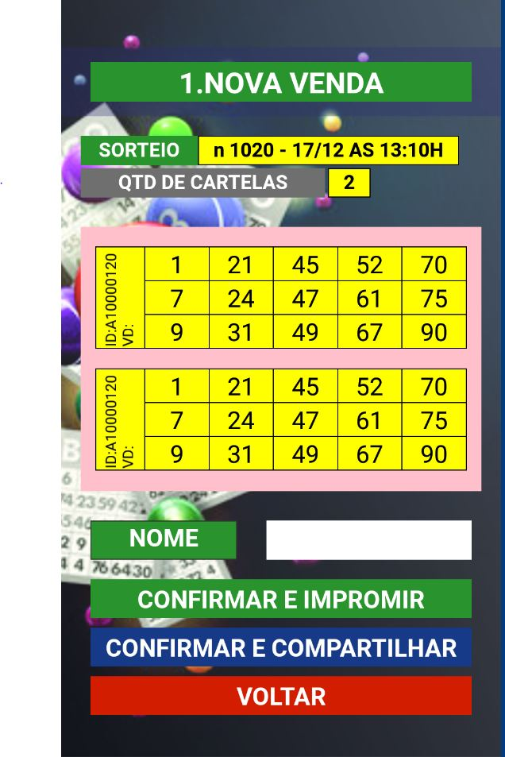

3. Maybe here IDs has to be different , right?

And what is VD mean here?

4.Whose name is this? Seller or Customer?

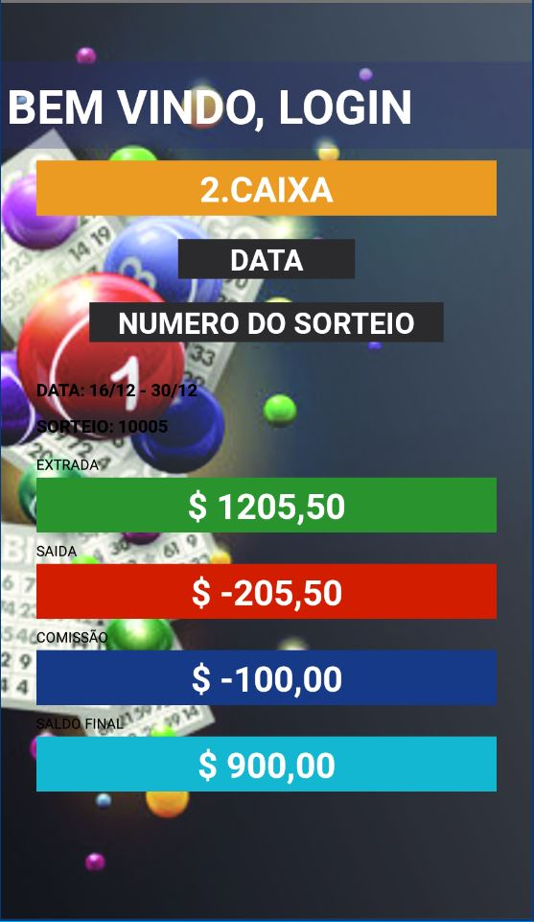

5.These are maybe not text fields.

Then what are they?

Sellers can select data range and draw number with these buttons? Or static fields?