

**About Me**

Hello! I'm Gabriel Consolin.

I'm fullstack developer with 5+ years experience.

I worked on several frontend and backend frameworkds including React, NodeJS, VueJS, Angular, Laravel and so on

• Age 27

• Residence Brazil

• Address Sao Vicente, Brazil

• e-mail [gabriel.consolin2@gmail.com](mailto:gabriel.consolin2@gmail.com)

• Freelance Available

**Education**

#### Universidade do Anhembi Morumbi

2012-2017 Universidade Inc.

In 1970, Anhembi Morumbi was founded as the first college in Brazil to offer higher education in the Tourism sector. Back then, many people did not quite understand the breadth of the Tourism segment, or even its importance to the country’s economy. Concepts such as tourism potential and hospitality were introduced. And most importantly: a process of professional qualification started, which is increasingly valued in the labor market.

**Experience**

#### Fullstack-developer

Dec 2014 - Current BBD Participacoes

From Dec 2014 I worked as a fullstack-developer.  
I have experiences working with BBD Participacoes company

#### Frontend-developer

Dec 2012 - Dec 2014 Santander S.A. company

I worked with Banco Santander S.A. company.  
I was suppossed to design and develop frontend web pages.

### Frontend Skills

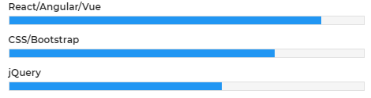

### Backend Skills

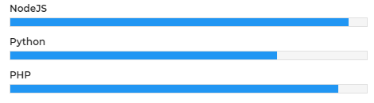

### My Services

#### PHP

fullstack frameworks including Laravel , CodeIgnator and so on

#### Javascript

frontend : React,Vue,Angular

backend : NodeJS

#### Web Design

HTML5 , CSS , jQuery and so on

#### Database

MySQL , MongoDB and so on

### Portfolio

pelotas.rs.gov.br //Laravel

compare.techtudo.com.br //VueJS

serra.es.gov.br //Laravel

meu.inss.gov.br //React

sbcoaching.com.br //Laravel

reclameaqui.com.br //React

ecommerce.xpi.com.br //VueJS

inss.gov.br //DJango

ufrgs.br //DJango

### 

### 

### 

### 