Enterprise Development Project

IT2166-01

OT Meals

| Team Members: | Vernon Tan Jing Xue 214555M |
| --- | --- |
|  | Sammi Wong Li Yi 210845R |
|  | Vianna Chua LeeAnne 213899D |
|  | Ve.H Sujith 210664T |

| Last Updated: 7/12/2022 |
| --- |

# Project Plan

### Problem

The key pillar we have selected is the Sustainable Living Pillar, one of the main focuses in this pillar is circular economy which focuses on zero waste. For our problem we are going to focus specifically on food wastage in Singapore.

Food waste being one of the biggest streams of waste locally has increased by 20% over the last 10 years it is becoming an even bigger issue for us. With every food wasted more food would have to be imported to meet demand and because Singapore imports over 90% of our food supply, food wastage would have a detrimental effect on our food security.

Besides having an effect on our food security, generating food waste means wasting the resources which were used to grow and deliver the food and wasted food require extra resources to dispose of such as landfills or incinerators which would lead to an increase to our carbon footprint and this directly affects global warming and climate change.

### Solution

Our solution is to create an online platform service called OT meals, which allows users to educate themselves on food management, as well as to do their part in combating food wastage through the services we provide.

In our application we have four main features, the first feature involves a booking system which allows users to reserve surplus food after regular opening hours from food stalls for self-pickup at designated locations. The second feature focuses on charity rounding up where users are given an option to round up their final total amount to the next decimal and that amount used in the rounding up will be given to charitable food programs such as Food From the Heart. The third feature is a reward system, for every successful transaction made by our users points which can be used to redeem coupons or vouchers will be given to them. The last feature involves donating surplus food products with valid shelf life onto our application at a lowered price compared to the market price to give the food product a chance to be repurposed before their shelf life runs out.

### Target Users

Based on our survey results and research, we have found that our target users of our application are targeted towards teenagers and adults. This is due to the age group of teenagers and millennials standing out the most when it comes to the use of technology. Since OT meals is an application that includes food booking for food stalls, it is also designed for food stalls owners to sell their surplus meals. Despite this, our focus is not only targeted towards a specific age group but towards those who want to contribute in helping the economy by reducing their food wastage.

### Team Members

| **Name** | **Role** | **Responsibility** | **Remarks** |
| --- | --- | --- | --- |
| Vernon | Team Leader | Accounts and Food Donation Page | * Keep track of project schedule * Record minutes of meeting * Arranging meetings |
| Vianna | Member | Menu and Food Booking | * Keep track of project documentation * Record minutes of meeting |
| Sammi | Member | Checkout Cart and Payment Page | * Meeting project schedule deadlines * Team Morale |
| Sujith | Member | Information and Rewards Page | * Meeting project schedule deadlines * Team Motivator |

### Features

The features in OT meals includes surplus food booking from food stalls, checkout and online payment, food donation, charity rounding up and incentives.

**Information on food wastage (Sujith)**

The information page so far is a static page where users can read up and equip knowledge about the situation regarding food wastage not only around Singapore but also throughout the world as well. They can also read up on the effect food wastage has on the world in the form of greenhouse gasses. They can also read up on the initiative Singapore takes to help solve or lower the rate of food wastage as well.

**Surplus meal booking (Vianna)**

The surplus meal booking are found under the menu pages, it consists of menus with surplus meals or dishes posted daily by food stall owners. Due to the guidelines of selling leftover meals, these surplus meals will have a set duration that it can be sold for by each food stall. Users have the option of choosing the different locations for specific food stalls, provided that those food stalls are selling surplus meals for that day as well. When users are ordering their dish or meal, they are able to choose the portion size, quantity they wish to buy from the surplus meals stock and options if they would like to remove any ingredients from their meal.

**Checkout and payment (Sammi)**

The checkout and payment page would include the charity round up. Once the user is at the payment page, the user would be prompted with a pop up if they would like to round up their total to the nearest dollar or decimal, in which the round up would be given to charitable food programs like Food From the Heart.

**Food donation (Vernon)**

The Food Donation page consists of a form for store owners to add their food items for donation, a menu where the donated food items are displayed for users and store owners to choose from and a form for when the users click into any specific food item, where additional information such as expiry date and availability is shown from here the user can choose the quantity of the product they wish to add to their cart before proceeding to the payment page or going back to choose more items.

**Rewards (Sujith)**

The rewards page consists of a points system. The points are gained by each user when each transaction has been made. The points gained by users can be redeemed as rewards. The rewards awarded to the users are in the form of Free drink vouchers, Offer/discounted meal vouchers, free take-way vouchers on “healthier meals”.

### Project Schedule

| **Deliverable Milestone** | **Team member responsible** |
| --- | --- |
| Project Discussion | All |
| - Identify and assign project features to team members  - Record meeting minutes  - Complete project plan | Vernon, Vianna  Vernon, Vianna  All |
| Complete system design  - Team to construct a use case diagram.  - Individual to identify key entities, attributes, and relationships for the data models. Construct ER diagram | All |
| Consolidate project plan and design report  Prepare slides for proposal presentation. | All |

### Communication Plan

Most of our communication was done online rather than offline due to our packed schedules. When we called over online we used the Discord app. We called over Discord and did up required slides and reports whilst discussing. We also have a discord chat allocated for us to exchange online links for websites where we could gather information for the project as well. We also have a WhatsApp group chat whereby we discuss the meeting timings and other information such as the deadline given by our group leader to complete individual tasks allocated to us.

# 

# System Design

### Use Case Diagram

### 

### Data Model Design with ER Diagram

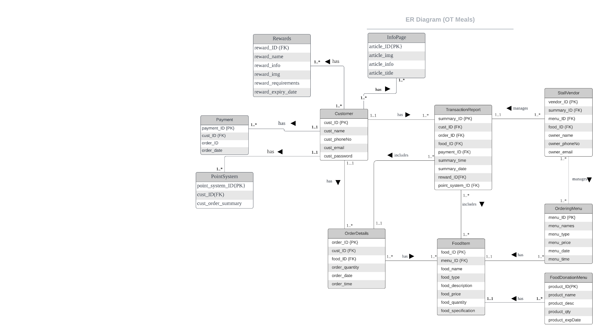

# 

# Minutes of Meeting

| **Date:** 25/11/2022 | **Time:** 1700 | **Location:** Online Meeting |
| --- | --- | --- |
| **Presence:** Vernon, Sammi, Vianna, Sujith | | |
| **Absence(Indicate reason):** - | | |
| **Topics Discussed / Issues Raised / Action Items:** | | **Action By** |
| Solution Discussion | | Vianna |
| Role Allocation For Wireframe | | Vernon |
| Wireframe Design (Color Scheme, General Layout) | | All |
| **Minutes Taken By:** Vernon | | |

| **Date:** 6/12/2022 | **Time:** 1800 | **Location:** Online Meeting |
| --- | --- | --- |
| **Presence:** Vernon, Sammi, Vianna, Sujith | | |
| **Absence(Indicate reason):** - | | |
| **Topics Discussed / Issues Raised / Action Items:** | | **Action By** |
| Report Discussion | | Vernon |
| Use Case Diagram | | All |
| Role allocation for project | | All |
| **Minutes Taken By:** Vernon | | |

| **Date:** 7/12/2022 | **Time:** 2100 | **Location:** Online Meeting |
| --- | --- | --- |
| **Presence:** Vernon, Sammi, Vianna, Sujith | | |
| **Absence(Indicate reason):** - | | |
| **Topics Discussed / Issues Raised / Action Items:** | | **Action By** |
| ER Diagram | | All |
| Presentation Slides | | All |
| **Minutes Taken By:** Vernon | | |