WeAreCars Car Rental System
Software Modelling Report: Use Case Scenario, Flow Chart and Class Diagram
Module: CET131 - Software Engineering
Assignment 1
Table of Contents
1. Introduction 2
2. Use Case Scenario: Processing a Car Booking 2
2.1 Cost Calculation Rules Supporting the Use Case 3
3. Flow Chart: Staff Login Validation 4
4. Class Diagram 5
5. Conclusion 5
6. References 6

1. Introduction
WeAreCars is a new car rental company that needs a stand-alone Windows Forms application to manage its car rental operations. The current report describes three software engineering models created during the design phase of the project which include a detailed use case scenario describing the car booking process, a flowchart outlining staff login verification process as well as a class diagram demonstrating the structure of the system being proposed. Collectively, these diagrams are the means of breaking the client requirements into simpler and manageable parts.

2. Use Case Scenario: Processing a Car Booking
The use case provided below adheres fully to the standard use case template and details an interaction that takes place between a staff member and the system in moments when a booking for renting a vehicle is made. It illustrates which data has to be collected, how the price is calculated, and what limitations have to be respected, according to WeAreCars including conditions such as the necessity of having a valid driving licence and the restriction that the rental period should not exceed twenty-eight days.
Use Case ID | UC-01
Use Case Name | Process a Car Booking
Actor(s) | Staff Member (primary); WeAreCars Booking System (supporting)
Description | An employee has the capability to register the car rental for a customer. He is required to fill in the personal data of the customer, choose a vehicle and type of fuel, select extra options, and calculate the amount that has to be paid for the rental.
Preconditions | 1. The staff member has successfully logged into the system (see Flow Chart, Section 3).  2. At least one car of the requested type is available for rental.
Postconditions | 1. A new booking record is created and stored in the system.  2. The rented car is marked as unavailable and appears in the Currently Rented Cars list.  3. A total cost is calculated and displayed to the staff member.
Trigger | A customer arrives at the branch and requests to rent a vehicle.
Main Flow (Basic Path) | 1. The staff member selects 'New Booking' from the main menu.  2. The system displays the booking entry form.  3. The staff member enters the customer's first name, surname, address and age.  4. The staff member indicates whether the customer holds a valid driving licence.  5. The staff member enters the number of rental days (1-28).  6. The staff member selects the car type (City, Family, Sports or SUV).  7. The staff member selects the fuel type (Petrol, Diesel, Hybrid or Full Electric).  8. The staff member optionally selects Unlimited Mileage and/or Breakdown Cover.  9. The system validates that all mandatory fields are complete and calculates the total cost (base rate x days, plus car-type surcharge, fuel surcharge and extras).  10. The system displays the calculated total cost for confirmation.  11. The staff member confirms the booking.  12. The system saves the booking, updates the car's availability status and returns to the main menu.
Alternative Flows | A1 - Missing mandatory field: at step 9, if a mandatory field is incomplete, the system highlights the field and displays 'This field is required'. The staff member returns to step 3.  A2 - No cars of selected type available: at step 6, if no car of the chosen type is available, the system displays 'No vehicles of this type are currently available' and prompts the staff member to select an alternative type.
Exception Flows | E1 - Customer does not hold a valid driving licence: at step 4, if the answer is 'No', the system displays 'Booking cannot proceed - a valid driving licence is required' and the use case ends without a booking being created.  E2 - Number of days out of range: at step 5, if the value entered is not between 1 and 28, the system displays 'Please enter a value between 1 and 28' and returns to step 5.
Priority | High
Frequency of Use | Several times per day, per branch

2.1 Cost Calculation Rules Supporting the Use Case
The total amount of a booking results from the initial daily charge of £25, multiplied by the number of days and any additional charges that may be associated with a particular car model, type of fuel or extra services, as shown in Tables 1 to 3.
Car Type | Surcharge (per booking)
City car | £0.00 (no extra charge)
Family car | £50.00
Sports car | £75.00
SUV | £65.00
Table 1: Car type surcharges
Fuel Type | Surcharge (per booking)
Petrol | £0.00 (no extra charge)
Diesel | £0.00 (no extra charge)
Hybrid | £30.00
Full electric | £50.00
Table 2: Fuel type surcharges
Optional Extra | Cost
Unlimited mileage | £10.00 per day
Breakdown cover | £2.00 per day
Table 3: Optional extra charges (applied per day)
This structure ensures the booking calculation is transparent and easy to validate during testing, since each component of the total cost can be checked independently before the values are summed.

3. Flow Chart: Staff Login Validation
The flow chart depicted in Figure 1 illustrates how the credentials of any user must be validated before access to the WeAreCars booking system is allowed. The flow chart involves some basic input validation along with the limit of user failing three prior attempts to log into their account before it is automatically locked, and providing clear feedback about results of the verification process at each decision point. This is done to minimize the chances for unauthorized access while keeping the process easy for the staff to use.
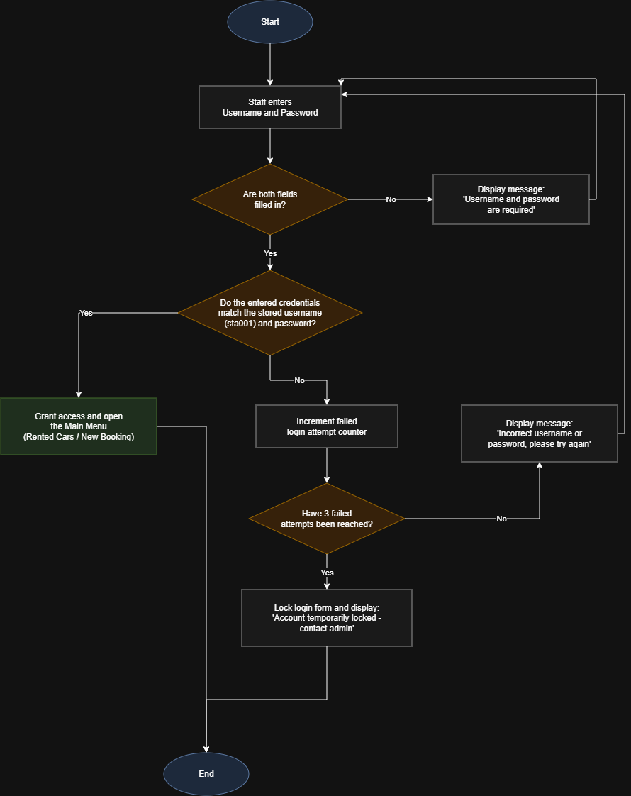
Figure 1: Flow chart for staff login credential validation
Locking out users after three times of being unsuccessful, as opposed to unlimited tries, constitutes a low-effort protective measure suitable to simple standalone applications since it prevents easy guessing attempts without requiring elaborate account recovery system which would otherwise be disproportionate to the current size and budget of WeAreCars.

4. Class Diagram
The class diagram shown in Figure 2 illustrates the main classes necessary for implementing the WeAreCars system, along with their attributes, methods, and relationships. The Car class has four subclasses, CityCar, FamilyCar, SportsCar, and SUV, which all implement their own version of the calculateSurcharge() function, meaning that there is no need to duplicate logic that is common to all vehicles but still allows for individual pricing rules for types of cars. The Booking class has associations with a Customer and a Car, along with the possibility to aggregate OptionalExtras; this indicates that incidentals like mileage or insurance may not be needed for every rental. The BookingManager class retains current rentals and takes care of the creation of new bookings and the LoginManager class separates the authentication logic from the booking process.
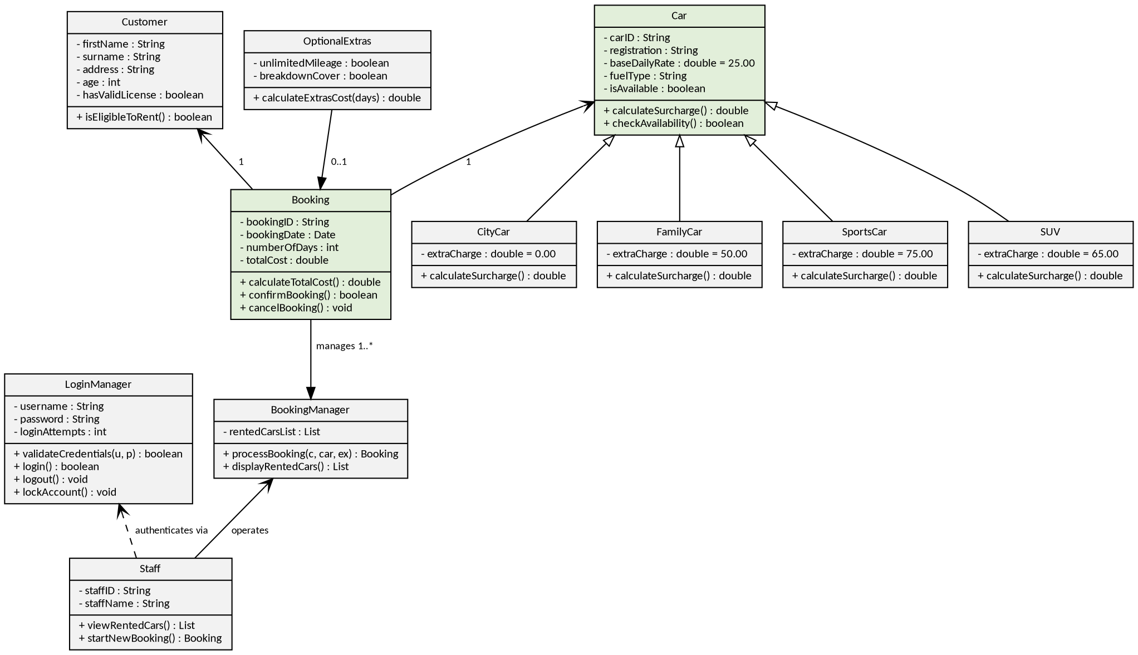
Figure 2: Class diagram for the WeAreCars rental system
Segregating LoginManager and BookingManager from the domain classes (Customer, Car, Booking) exemplifies the single-responsibility principle as the issues regarding authentication have been separated from issues regarding rental processing, making maintenance and testing simpler as WeAreCars continues to change its requirements.

5. Conclusion
The use case scenario, flow chart, and class diagram exemplified in this document altogether decompose the WeAreCars booking system into well-defined parts thus meeting Learning Outcome 1 by demonstrating the appropriate application of engineering software tools in breaking down the programming issue. The models are in complete agreement with each other as in Section 4 the classes established provide the objects and methods needed for performing the actions described in the use case in Section 2, and the class LoginManager provides for the validating logic represented in Section 3 thus facilitating the direct transfer of models into a working Windows Forms prototype.

6. References
- Bennett, S., McRobb, S. and Farmer, R. (2010) Object-Oriented Systems Analysis and Design Using UML. 4th edn. London: McGraw-Hill.
- Booch, G., Rumbaugh, J. and Jacobson, I. (2005) The Unified Modeling Language User Guide. 2nd edn. Boston: Addison-Wesley.
- Sommerville, I. (2016) Software Engineering. 10th edn. Harlow: Pearson Education.

