ASSIGNMENT 3

Name : Hrithvik Kondalkar

Roll : 002211001088

1. Write a generic method in Java that takes an array of any data type and sorts the array in ascending order using any sorting algorithm.

import java.util.Arrays;

class Main{

public static <E extends Comparable<E>> void sort(E[] array){

int length = array.length;

E temp;

//bubble sort

for(int i=0;i<length;i++){

for(int j=1;j<length-i;j++){

if(array[j-1].compareTo(array[j])>0){

temp = array[j-1];

array[j-1] = array[j];

array[j] = temp;

}

}

System.out.println(Arrays.toString(array));

}

}

public static void main(String[] args){

Integer[] arr = new Integer[]{5,3,4,2,1};

System.out.println(Arrays.toString(arr));

sort(arr);

}

}

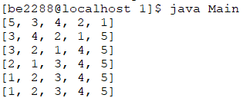

1. Write a generic method in Java that takes any type of an array as input and finds the frequency of each data element.

import java.util.HashMap;

import java.util.Map;

class Main{

public static <E> void freq(E[] array){

HashMap<E,Integer> map = new HashMap<>();

for(E elem:array){

if(map.containsKey(elem)){

map.replace(elem,map.get(elem)+1);

}

else{

map.put(elem,1);

}

}

for(Map.Entry m:map.entrySet()){

System.out.println(m.getKey()+" = "+m.getValue());

}

}

public static void main(String[] args){

Integer[] array = new Integer[]{2,1,4,2,3,4,5,1,2};

freq(array);

}

}

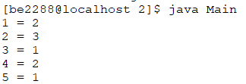

1. Design a generic Java class having a method that takes an array of any data type and prints all the duplicate elements.

import java.util.HashMap;

import java.util.Map;

class Main{

public static <E> void dupl(E[] array){

HashMap<E,Boolean> map = new HashMap<>();

for(E elem:array){

if(map.containsKey(elem)){

map.replace(elem,true);

}

else{

map.put(elem,false);

}

}

System.out.print("Duplicate Elements : ");

for(Map.Entry m:map.entrySet()){

if((boolean)m.getValue()){System.out.print(m.getKey()+ " ");}

}

}

public static void main(String[] args){

Integer[] array = new Integer[]{2,1,4,2,3,4,5,1,2};

dupl(array);

}

}



1. Test the functionalities of different java reflection APIs such as getClass(), getMethods(), getConstructors(), getDeclaredMethod(), getDeclaredField(), setAccessible() etc.

import java.lang.reflect.\*;

class Test{

public int field1;

private int field2;

public Test(int a, int b){

field1 = a;

field2 = b;

}

public void print(){

System.out.println("field1 = "+field1);

System.out.println("field2 = "+field2);

}

public void method1(){

System.out.println("method1 called");

}

private void method2(){

System.out.println("method2 called");

}

}

class Main{

public static void main(String[] a)throws Exception{

Test obj = new Test(1,2);

Class c = obj.getClass();

System.out.println(c);

System.out.println("-----------------------------------");

Method[] m = c.getMethods();

for(Method meth:m){System.out.println(meth);}

System.out.println("-----------------------------------");

Constructor[] cons = c.getConstructors();

for(Constructor t:cons){System.out.println(t);}

System.out.println("-----------------------------------");

Field[] f = c.getFields();

for(Field z : f){System.out.println(z);}

System.out.println("-----------------------------------");

Method m2 = c.getDeclaredMethod("method2");

System.out.println(m2);

m2.setAccessible(true);

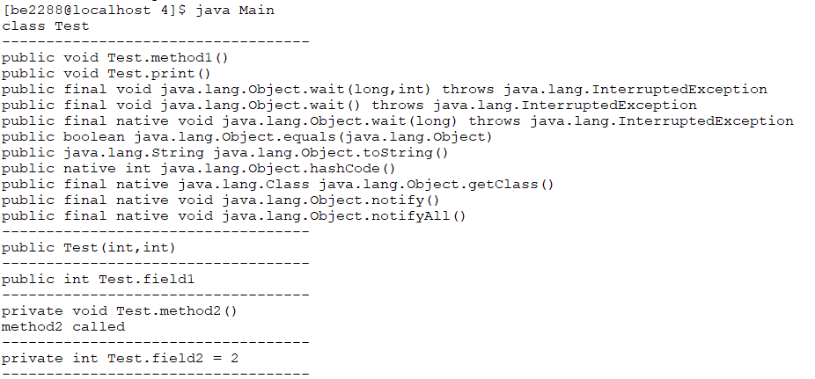

m2.invoke(obj);

System.out.println("-----------------------------------");

Field f2 = c.getDeclaredField("field2");

f2.setAccessible(true);

System.out.println(f2 + " = " + f2.get(obj));

System.out.println("-----------------------------------");

}

}