ASSIGNMENT 4

NAME : HRITHVIK KONDALKAR

ROLL: 002211001088

1. To design a class diagram, sequence diagram, use case diagram and activity diagram for a Customer Support system

AIM: Analyze and design Customer Support system.

Experiment Description:

Product Delivery System:

∙ Choose your shipping and delivery options.

∙ There, it shows the delivery speed (Between dates to date).

∙ After we have to press continue button.

Create Order:

∙ Open the website (Amazon, Flipkart).

∙ Open the category list and search product.

∙ Select the item.

∙ Check the details of item. If it is ok add to the cart.

∙ If we want to buy multiple items repeat 3 & 4 steps.

∙ Proceed to check out the item.

∙ After preceding it shows the login address there we have to enter email id & password. ∙ After login we have to select a delivery address if address is already

∙ Exist click on “deliver to this address” or else we can enter new Delivery address. ∙ Confirm payment details.

Payment Confirmation:

∙ Select a payment method .There it will appears another payment method. ∙ Credit Card

∙ Debit Card

∙ Net Banking

∙ Cash on Delivery (COD)

∙ We have to enter the payment information.

∙ After we have to press continue button.

∙ It shows valid confirmation about the product.

∙ Click on confirm order.

∙ Here it shows the details of our place order of the given product with price. ∙ Last it will show order successfully placed”.

Cancel order:

∙ For cancelling the order, we should login with our id & password.

∙ Click on select “your order”.

∙ It displays “cancel request” button and press it.

∙ They send cancel order confirmation to customer mail & phone number. ∙ Order will be cancelled automatically within 24 hours

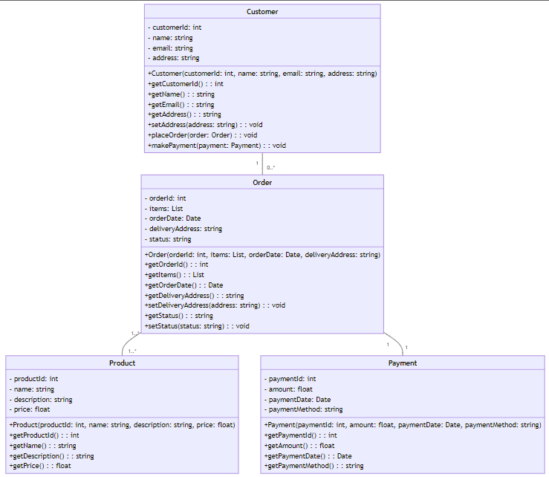Class Diagram :

Sequence diagram:

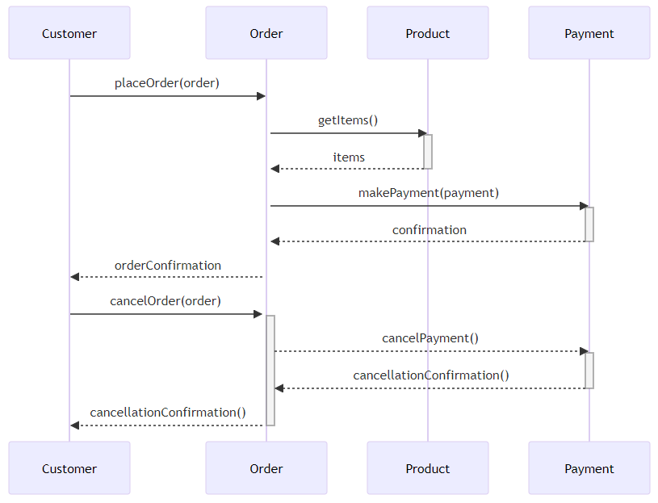

Use case diagram:

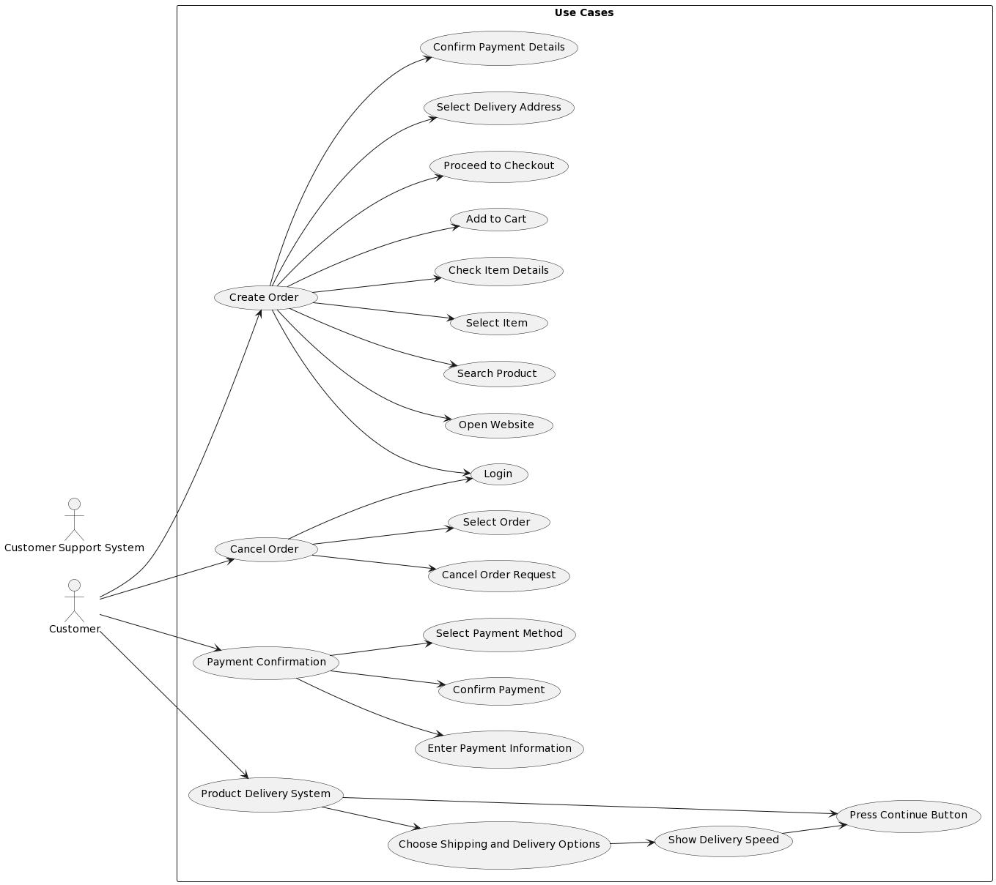

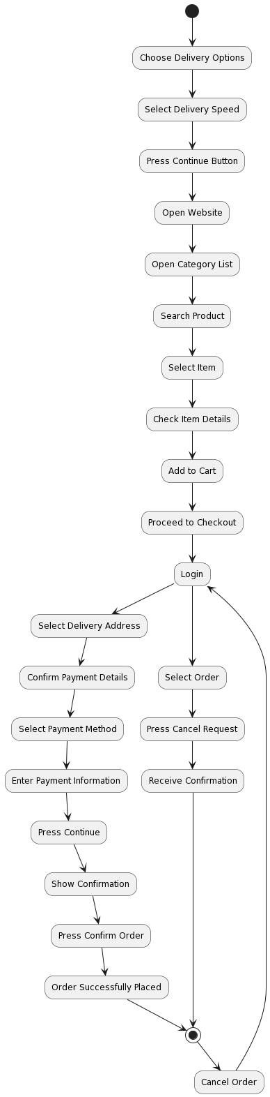Activity diagram:

1. To design a class diagram, sequence diagram, use case diagram and activity diagram for an Airline Reservation System

AIM: Analyze and Design Airline Reservation System.

EXPERMENT DESCRIPTION:

The Airlines Reservation system facilitates the user to view the flight schedules, inquire about the flight details, availability of seats and many more. The major functionality of system is to allow the user to book and cancels the flights as per user requirements. It also provides the administrator or manager to modify existing flights or to introduce new flights in the schedule. Major features provided by the system are:

∙ Flight Enquiry

The system allows the user or member to perform flight inquiry including flight scheduling, seats availability status, fare details, etc.

∙ User Registration

It allows the user to register in order to be a member of the organization. User is then granted a privilege to book or cancels flights.

∙ Flight Reservation

The system allows the member to book the flights as per his/her requirements. The member is prompt to enter the passenger details and credit card details. The member then receives the unique PNR No. and E ticket.

∙ Flight Cancellation

The functionality is used by the member to cancel an existing reservation made by the member earlier.

∙ Administration

The administration module of the system allows the admin/manager to manage the flight scheduling. It provides the admin /manger to modify or change the existing flights or to introduce a new flight’s. Apart from scheduling it also allow the admin/manager to generate report of daily or weekly transactions based on requirements.

Class Diagram:

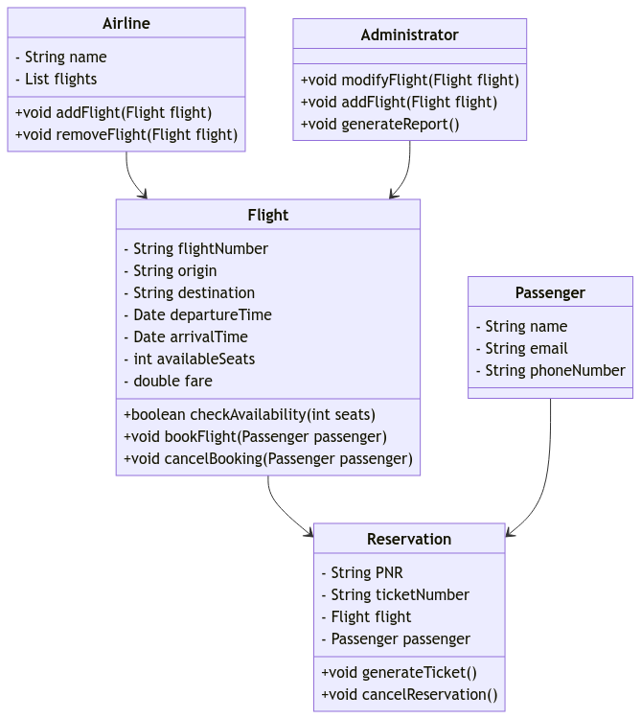

Sequence diagram:

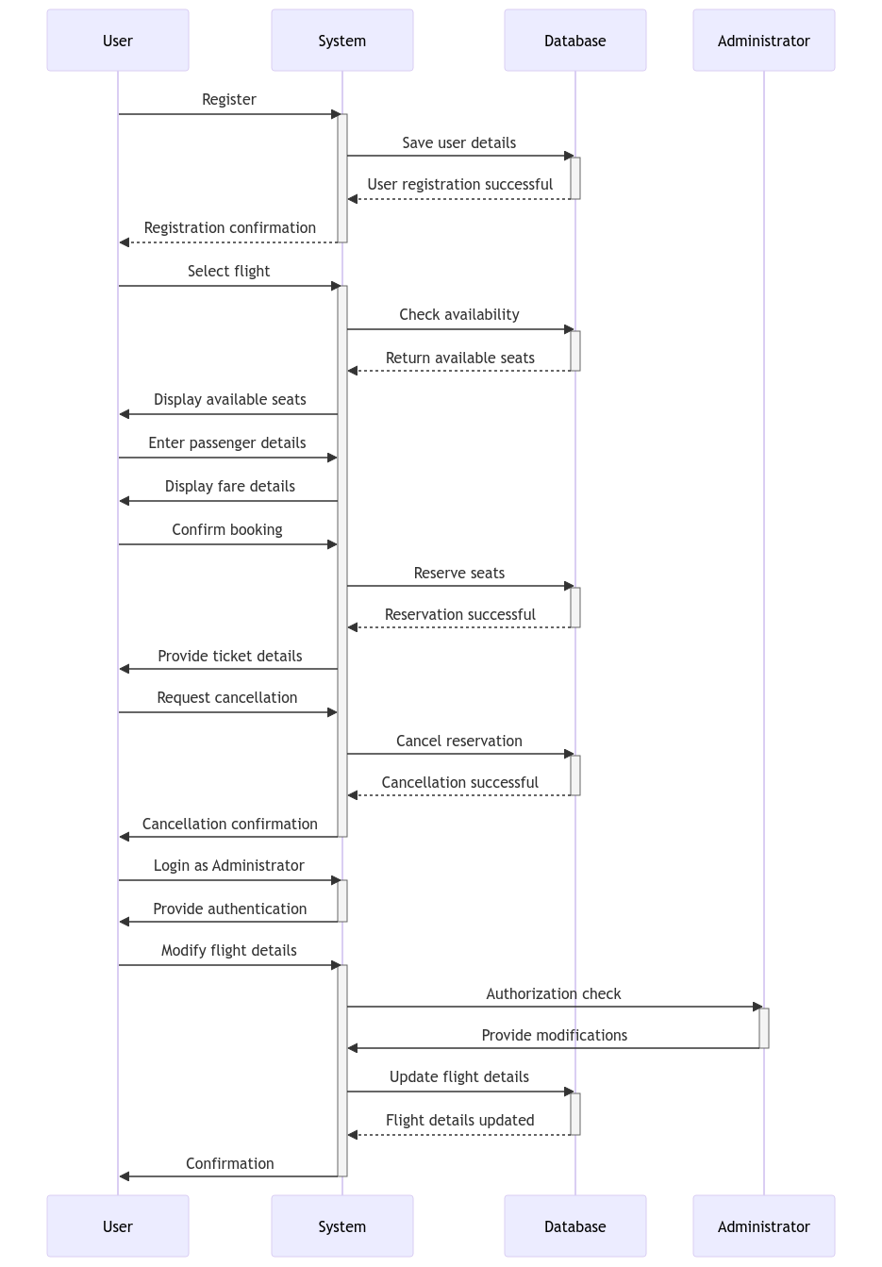

Use case diagram:

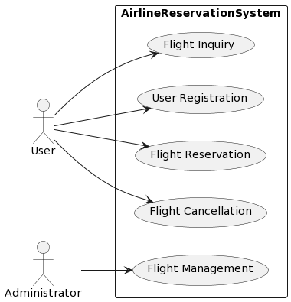

Activity diagram:

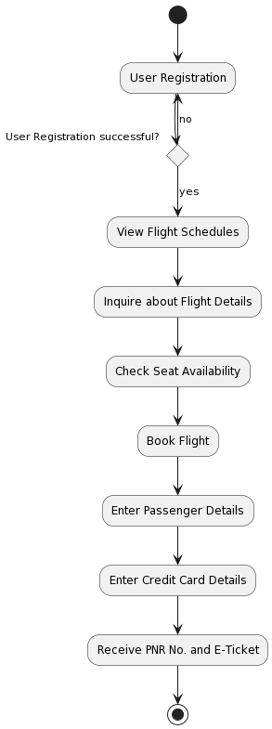

1. To design a class diagram, sequence diagram, use case diagram and activity diagram for a Hotel Management System

AIM: Analyze and Design Hotel Management System.

EXPERMENT DESCRIPTION:

This Project is a fine thought to make the complex procedure of the Hotel management system to an easy manner which is systematic, modular designed, selective menu based user display. The modular design and constructed system is very much user oriented in which user can easily understand the tools and can do edit of his own choice. The system is not any tough more and does not possesses many applications but it is made by focusing on the maintaining records employee’s actions in a computerized system rather than time taking and cumbersome manual system.

Two kinds of users can handle the system.

∙ Online Users

∙ Administrator or Hotel Management.

The Online users are the customers or the staff who can see the news and updates of the Hotel and the Administrator are responsible for updating the Hotel details on computer. The Administrator is the authorized user who has power to change or edit the updates as well as the Password. The daily activities includes the Room activities, Entering details of the new customer check in, To allocate a room as per the customer need and interest, Recording the checkout time and details, Releasing or Empty of room and to record the process in a computer system for future.

The application of the Hotel Management System bears the following functions to use by the Administrator.

⮚ Room status

⮚ New Room inauguration

⮚ Allocated Room Modification

⮚ Details for the Customer Check in and Check out

⮚ New Customer Admission

⮚ Allocation of Room as per the Customer Interest

⮚ Statement and Transactions of the Customer

⮚ Total Customers Present In the Hotel

⮚ Separate Customer Report

Class diagram:

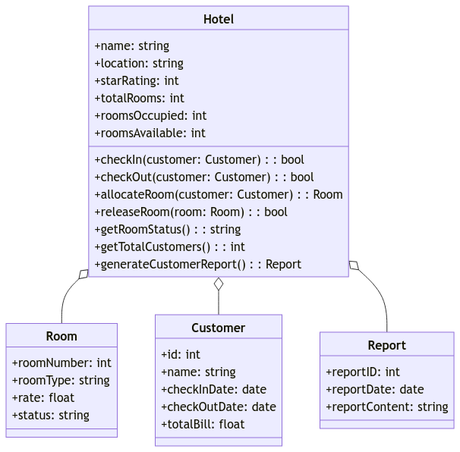

Sequence diagram:

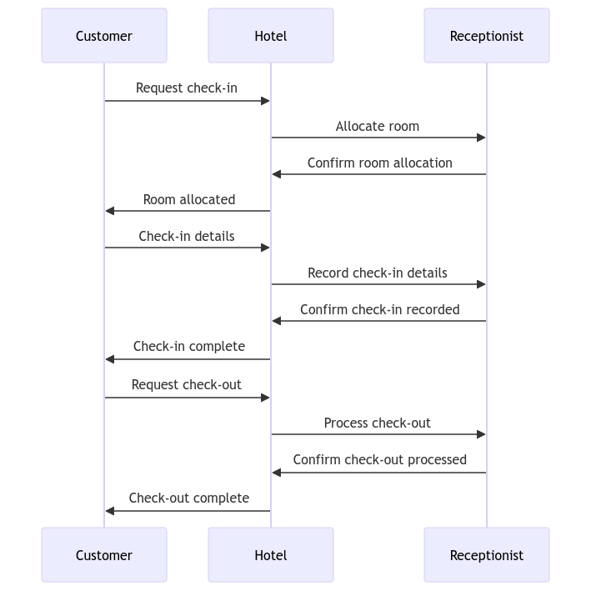

Use case diagram:

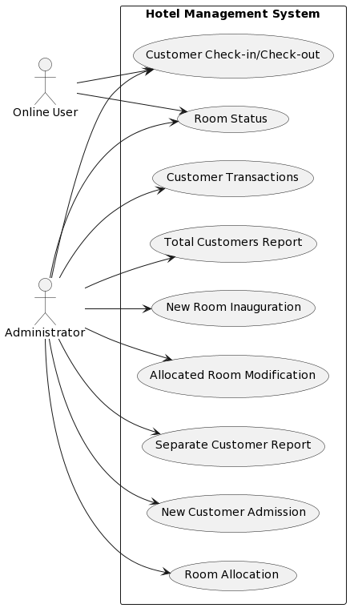

Activity diagram:

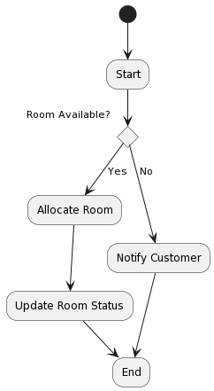

1. To design a class diagram, sequence diagram, use case diagram and activity diagram for a Process of sale

AIM: Analyze and Design Process of sale.

Experiment Description:

Main Success Scenario (or Basic Flow):

∙ Customer arrives at POS checkout with goods and/or services to purchase. ∙ Cashier starts a new sale.

∙ Cashier enters item identifier.

∙ System records sale line item and presents item description, price, and running total. ∙ Cashier repeats steps 3-4 until indicates done

∙ System presents total with taxes calculated.

∙ Cashier tells Customer the total, and asks for payment.

∙ Customer pays and System handles payment.

∙ System logs completed sale and sends sale and payment information to the external Accounting system and Inventory system (to update inventory).

∙ System presents receipt.

∙ Customer leaves with receipt and goods (if any).

Extensions (or Alternative Flows):

∙ at any time, System fails:

∙ Cashier restarts System, logs in, and requests recovery of prior state.

∙ Invalid identifier:

∙ There are multiple of same item category and tracking unique item identity not important (e.g., 5 packages of veggie-burgers)

∙ Customer asks Cashier to remove an item from the purchase:

∙ Customer tells Cashier to cancel sale:

∙ Cashier suspends the sale:

∙ the system generated item price is not wanted

∙ System detects failure to communicate with external tax calculation system service: ∙ Customer says they are eligible for a discount (e.g., employee, preferred customer): ∙ Customer says they have credit in their account, to apply to the sale:

∙ Customer says they intended to pay by cash but don't have enough cash:

∙ Paying by cash:

∙ Paying by credit:

Class diagram:

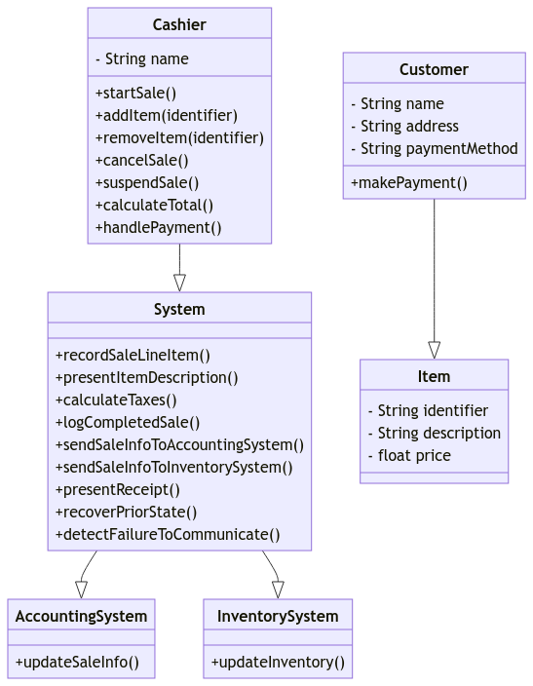

Sequence diagram:

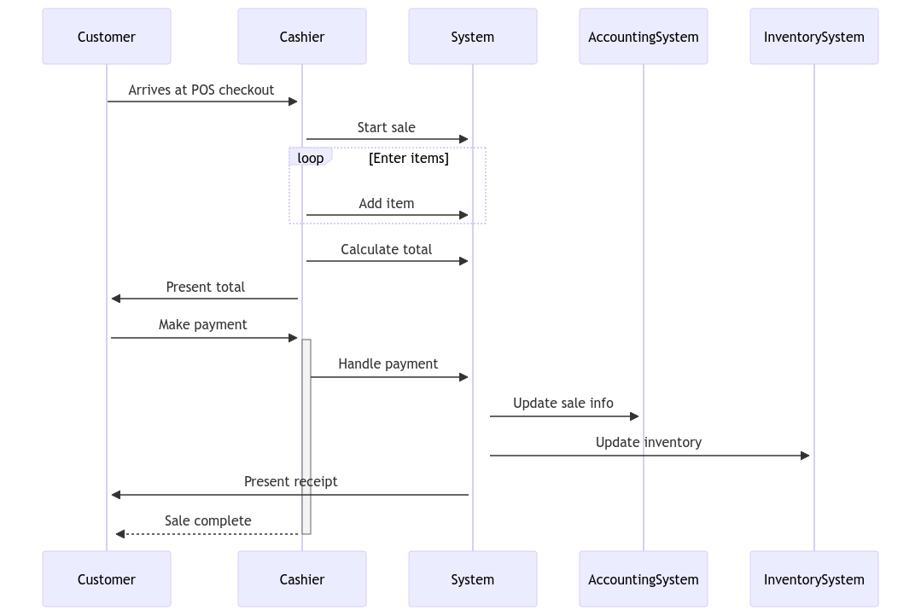

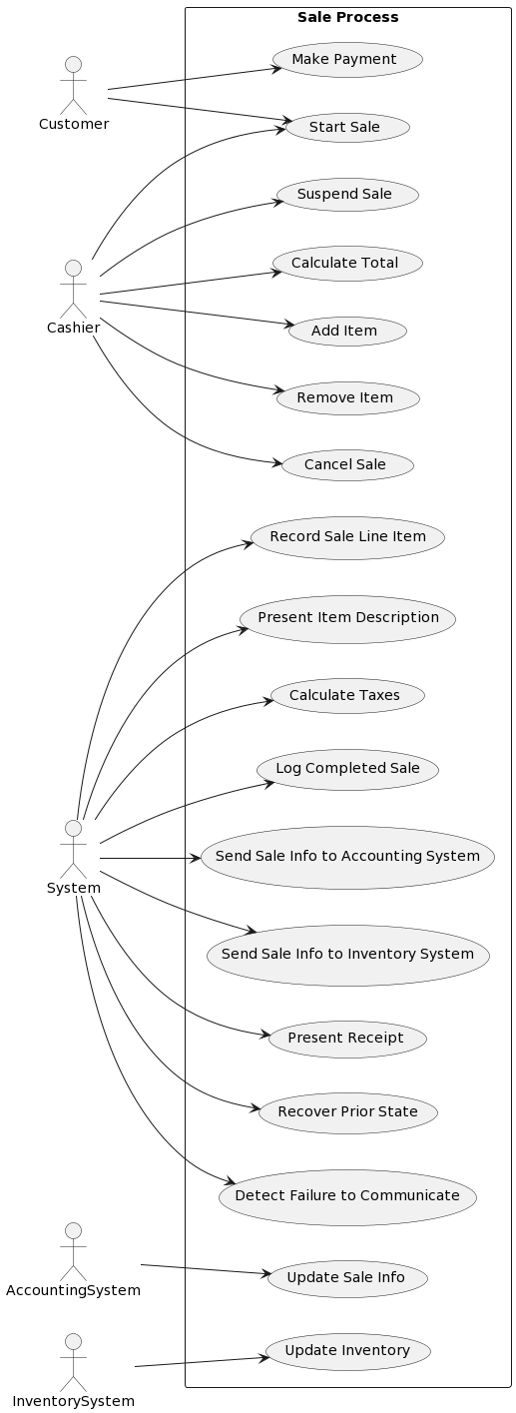Usecase diagram:

Activity diagram:

