**Name : Hrithvik kondalkar Roll:002211001088**

1. *Show the details of all employees.*

**SELECT * FROM EMP;**

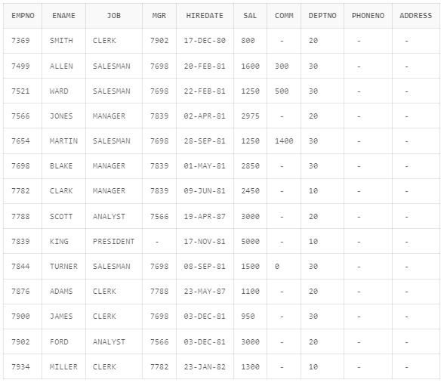

1. *Show the department no. and name of all departments.*

**SELECT deptno , dname FROM dept;**

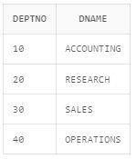

1. *Display the employee id, name and department no of all employees whose department no is 20.* **SELECT empno,ename,deptno FROM emp WHERE deptno =20;**

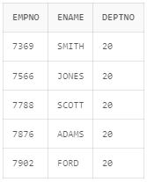

1. *Display the details of all employees where department no should be in descending order.*

**SELECT * FROM emp ORDER BY deptno desc;**

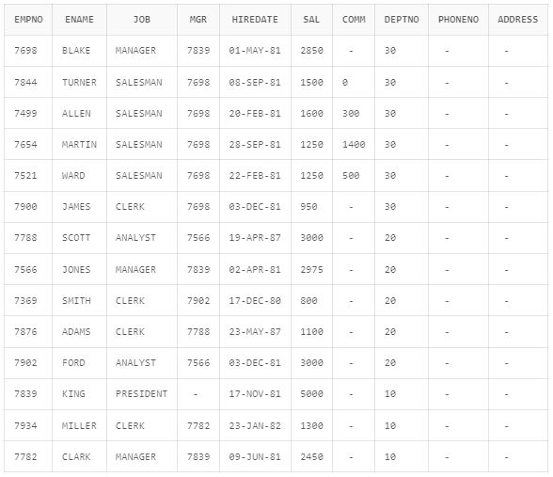

1. *Show all available jobs in the employee table.*

**SELECT DISTINCT job FROM emp;**

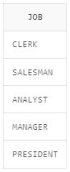

1. *Show the name, Annual Salary and department no of employees who works as a clerk in department 20.*

**SELECT ename, sal, deptno FROM emp WHERE deptno=20 AND job = 'CLERK';**

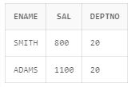

1. *Show the name and HIRED date of those employee whose name start with ‘S’ or second character is ‘C’.*

**SELECT ename, hiredate FROM emp WHERE ename LIKE 'S%' OR ename LIKE '_C%';**

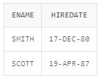

1. *Show the name, hire date and salary of those employee who are not a manager.*

**SELECT ename, hiredate, sal FROM emp WHERE job!='MANAGER';**

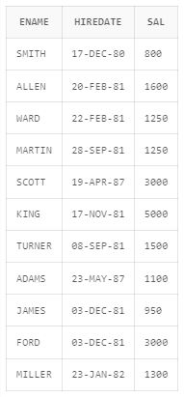

1. *Display all employee names in title case and length of the name.*

**SELECT INITCAP(ename), LENGTH(ename) from emp;**

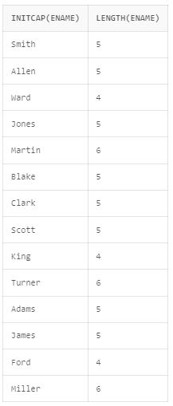

1. *Display the name of employee who gets the salary between 4000 to 6000.*

**SELECT ename FROM emp WHERE sal BETWEEN 4000 AND 6000;**

