NAME : HRITHVIK KONDALKAR ROLL:002211001088

1. Display the Name, manager Id, and hire date of all employees who are either clerk or works in dept 20.

**SELECT ENAME, MGR, INITCAP(TO_CHAR(HIREDATE,'DDSPTH MONTH, YYYY')) DATE_HIRED FROM EMP WHERE LOWER(JOB)='CLERK' OR DEPTNO = 20;**

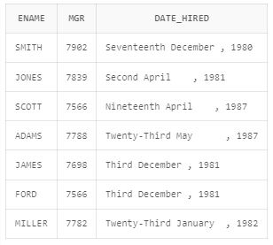

1. List the employee name and old salary and new increased salary by 25% and expressed as a whole number.

**SELECT ENAME, SAL OLD_SALARY, ROUND(SAL*1.25) NEW_SALARY FROM EMP;**

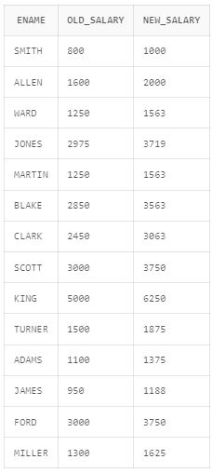

1. List the employee name and salary where name is displayed as left justified and salary with right justified.

**SELECT RPAD(ENAME,10) ENAME, LPAD(SAL,15) SALARY FROM EMP;**

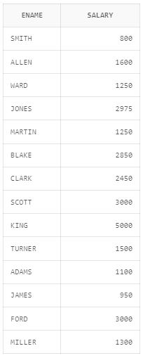

1. Produce the output as follows(for all employees)

ROLE OF THE EMPLOYEE

Name1 (<Job of Name 1>)

Name2 (<Job of Name 2>)

........

Note: Only first character of Name and job will be in uppercase.

**SELECT INITCAP(ENAME||' '||JOB) ROLE_OF_THE_EMPLOYEE FROM EMP;**

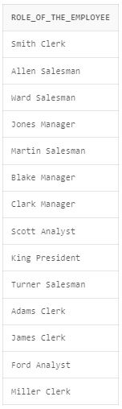

1. Display each employee name with hiredate and salary review date. Assume that date is one year after hiredate. Order the output in ascending review date order.

**SELECT ENAME, HIREDATE, ADD_MONTHS(HIREDATE,12) REVIEWDATE**

**FROM EMP**

**ORDER BY REVIEWDATE;**

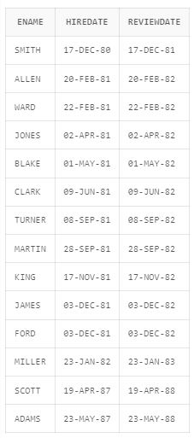

1. Find the employees(s) who earn the highest salary in each job type sort in descending salary order(Use IN operator and subqueries).

**SELECT \***

**FROM EMP**

**WHERE (JOB,SAL) IN (SELECT JOB,max(SAL) FROM EMP GROUP BY JOB )**

**ORDER BY SAL;**

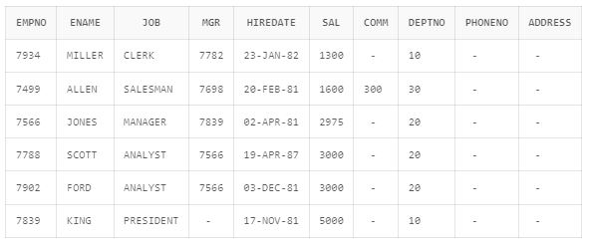

1. Find the most recently hired employee in each department (give number only).

**SELECT DEPTNO, ENAME**

**FROM EMP**

**WHERE (DEPTNO,SYSDATE-HIREDATE)**

**IN**

**(SELECT DEPTNO, MIN(SYSDATE-HIREDATE) FROM EMP GROUP BY DEPTNO)**

**GROUP BY DEPTNO,ENAME;**

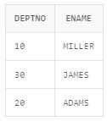

1. Show the name of the department and no of employees who works in that department. Sort in department number.

**SELECT EMP.DEPTNO ,COUNT(EMPNO)**

**FROM EMP,DEPT**

**WHERE DEPT.DEPTNO = EMP.DEPTNO**

**GROUP BY EMP.DEPTNO**

**ORDER BY EMP.DEPTNO;**

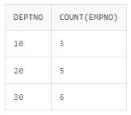

1. Display the Id, name, salary and the salary grade for any employee who earns the maximum salary for their department. Sort in department number.

**SELECT EMP.EMPNO, EMP.ENAME, EMP.SAL, SALGRADE.GRADE**

**FROM EMP, SALGRADE**

**WHERE (EMP.SAL BETWEEN SALGRADE.LOSAL AND SALGRADE.HISAL)**

**AND**

**(EMP.DEPTNO, EMP.SAL) IN (SELECT DEPTNO, MAX(SAL) FROM EMP GROUP BY DEPTNO)**

**ORDER BY EMP.DEPTNO;**

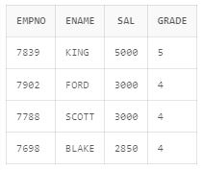

1. In which year did most people join the company? Display the year and number of employees.

**SELECT YEAR, EMP_JOINED**

**FROM (SELECT EXTRACT(YEAR FROM HIREDATE) YEAR, COUNT(EXTRACT(YEAR FROM HIREDATE)) EMP_JOINED FROM EMP GROUP BY EXTRACT(YEAR FROM HIREDATE))**

**WHERE EMP_JOINED = (SELECT MAX(COUNT(EXTRACT(YEAR FROM HIREDATE))) EMP_JOINED FROM EMP GROUP BY EXTRACT(YEAR FROM HIREDATE));**

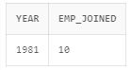

1. Show the every alternate row in employee table.

**SELECT INDX.R ROW_NUMBER,EMP.\***

**FROM EMP, (SELECT EMPNO, (ROW_NUMBER() OVER (ORDER BY EMPNO))-1 R FROM EMP) INDX**

**WHERE (EMP.EMPNO = INDX.EMPNO) AND (REMAINDER(INDX.R,2)=0);**

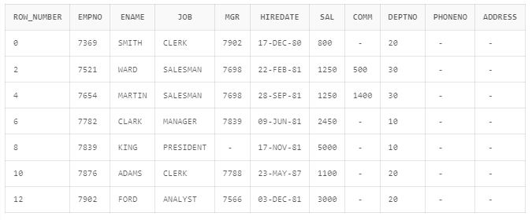

1. Display the total salary of all employees. Total salary = salary + commission.

**SELECT SUM(CTC) TOTAL_SAL**

**FROM (SELECT EMP.*, R.CTC CTC**

**FROM EMP, ((SELECT SAL + COMM CTC, EMPNO**

**FROM EMP WHERE COMM IS NOT NULL)**

**UNION**

**(SELECT SAL CTC, EMPNO**

**FROM EMP WHERE COMM IS NULL)) R**

**WHERE R.EMPNO = EMP.EMPNO);**

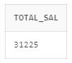

1. Display the department name and available jobs in that department.

**SELECT DNAME, LISTAGG(JOB, ', ') WITHIN GROUP (ORDER BY DNAME) AVAILABLE_JOB**

**FROM (SELECT DISTINCT DEPT.DNAME DNAME ,EMP.JOB JOB FROM EMP, DEPT WHERE DEPT.DEPTNO = EMP.DEPTNO ORDER BY DEPT.DNAME)**

**GROUP BY DNAME;**

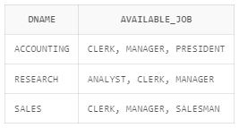

1. Display all the available departments and the employee(s) works under it.

**SELECT DNAME, LISTAGG(ENAME, ', ') WITHIN GROUP (ORDER BY DNAME) EMPLOYEES**

**FROM (SELECT DISTINCT DEPT.DNAME DNAME, EMP.ENAME ENAME FROM EMP, DEPT WHERE EMP.DEPTNO=DEPT.DEPTNO ORDER BY DEPT.DNAME)**

**GROUP BY DNAME;**

