1. Write a PL/SQL code to print Today is fall on weekend or weekdays using if else statement.

declare

t_date DATE;

t_day varchar(9);

begin

t_date := sysdate;

t_day := to_char(t_date,'day');

t_day :=initcap(t_day);

if t_day like'Sunday%' or t_day like'Saturday%' then

dbms_output.put_line(t_day||' is weekend');

else

dbms_output.put_line(t_day||' is weekday');

end if;

end;



1. Write a PL/SQL code to check that an inputted a single character is vowel or not .If vowel then display which vowel it is.

declare

c varchar(1);

begin

--c:= :c; USER INPUT DOESN'T WORK IN LIVE SQL

c:= 'E';

c:= lower(c);

if c like 'a' or c like 'e' or c like 'i'or c like 'o' or c like 'u' then

dbms_output.put_line(c||' is vowel');

else

dbms_output.put_line(c||' is not vowel');

end if;

end;



1. Write a PL/SQL code block to find out the sum of first twenty natural numbers (1+2+3+4+5+6+7+8+9+10+-----+20 this series).

DECLARE

t_sum NUMBER :=0;

BEGIN

FOR i IN 1..20 LOOP

t_sum:=i+t_sum;

END LOOP;

dbms_output.put_line('sum is : '||t_sum);

END;



1. Write a PL/SQL block that will ask for two numbers and one operand (+, -, *, /). Then it will calculate and display the result.

declare  
 x int := 5;  
 y int := 4;  
 op char(1) := '*';  
begin  
 case op  
 when '+' then dbms_output.put_line('The sum is: '|| x+y);  
 when '-' then dbms_output.put_line('The difference is: '|| x-y);  
 when '*' then dbms_output.put_line('The product is: '|| x*y);  
 when '/' then dbms_output.put_line('The quotient is: '|| x/y);  
 end case;  
end;



1. Write a PL/SQL code block to display a number in a reverse way.

DECLARE

numb int :=512;

rev int:=0;

BEGIN

dbms_output.put_line('original number : '||numb);

while numb!=0 loop

rev:= rev*10;

rev:= rev+remainder(numb,10);

numb:=floor(numb/10);

end loop;

dbms_output.put_line('reversed number :'rev);

END;

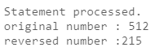

1. Write a PL/SQL block to display the dates of this month which are Tuesday.

declare  
 i int:= 3; --1st Tuesday is at 3rd Oct  
begin  
 dbms_output.put_line('The Tuesdays in October 2023 is : ');  
 while(i<=31) loop  
 dbms_output.put_line(' '||i);  
 i:=i+7;  
 end loop;  
end;

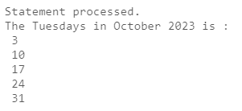

1. Write a program in PL/SQL to print the prime numbers between 1 to 50.

declare

i int;

j int;

cnt int := 0;

begin

for i in 1 .. 50 loop

cnt:=0;

for j in 1 .. i loop

if(MOD(i,j)=0) then

cnt:=cnt+1;

end if;

end loop;

if(cnt=2) then

dbms_output.put_line(' '||i);

end if;

end loop;

End;

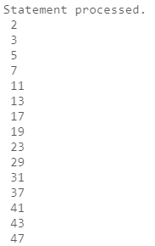

1. Write a program in PL/SQL to print the sum of digits of a number

DECLARE

numb int :=512;

t_sum int:=0;

BEGIN

dbms_output.put_line('original number : '||numb);

while numb!=0 loop

t_sum:= t_sum+remainder(numb,10);

numb:=floor(numb/10);

end loop;

dbms_output.put_line('sum digits :'||t_sum);

END;

