Some notes on population dynamics

Table of Contents

# The model

This is a citation: Hampton et al. (2015) – we can also have citations in brackets (Hampton et al. 2015).

## Lists

1. one fish
2. two fish
3. red fish
4. blue fish

# Methods

There is an equation, which we can cite with 1.

$$J′(p)=\frac{1}{\text{log}(S)}×\left(−∑p\text{log}(p)\right) (1)$$

# Tables

We can do tables:

|  |  |
| --- | --- |
| Column 1 | Column 2 |
| c1 | c2 |

# Figures

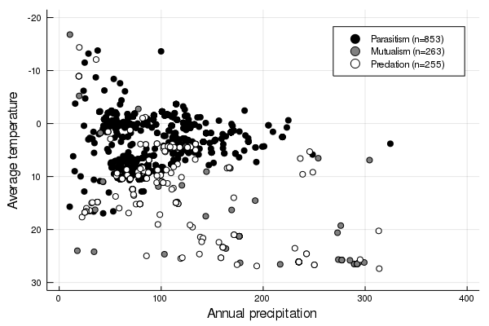

Figure 1: This is the legend of the figure

We can refer to fig. 1.

# Code?

Yes

for i in eachindex(x)  
 x[i] = zero(eltype(x)) # Don't do that  
end

# References

Hampton, Stephanie E., Sean S. Anderson, Sarah C. Bagby, Corinna Gries, Xueying Han, Edmund M. Hart, Matthew B. Jones, et al. 2015. “The Tao of Open Science for Ecology.” *Ecosphere* 6 (7): 1–13. <https://doi.org/10.1890/ES14-00402.1>.