Yihui Xie

[Email address]

Abstract

[Draw your reader in with an engaging abstract. It is typically a short summary of the document.   
When you’re ready to add your content, just click here and start typing.]

A Minimal Book Example

[Document subtitle]

A Minimal Book Example

Yihui Xie

2020-08-20

**Table of Contents**

Prerequisites 1

(PART) Part I 2

Introduction 2

Literature 4

Methods 4

(PART) Part II 4

Applications 4

Example one 4

Example two 4

Final Words 4

# Prerequisites

Tips:

* You have to use rmarkdown::render_site(encoding = 'UTF-8') in order to build all the documents
* The {-} allows to create a section without numbering it

This is a *sample* book written in **Markdown**. You can use anything that Pandoc’s Markdown supports, e.g., a math equation $a^{2}+b^{2}=c^{2}$.

The **bookdown** package can be installed from CRAN or Github:

install.packages("bookdown")  
# or the development version  
# devtools::install_github("rstudio/bookdown")

Remember each Rmd file contains one and only one chapter, and a chapter is defined by the first-level heading #.

To compile this example to PDF, you need XeLaTeX. You are recommended to install TinyTeX (which includes XeLaTeX): <https://yihui.name/tinytex/>.

A normal paragraph.

(ref:foo) A scatterplot of the data cars using **base** R graphics.

plot(cars) # a scatterplot  
plot(pressure, pch = 19, type = 'b')

# (ref:foo)(ref:foo)

# (PART) Part I

# Introduction

You can label chapter and section titles using {#label} after them, e.g., we can reference Chapter @ref(intro). If you do not manually label them, there will be automatic labels anyway, e.g., Chapter @ref(methods).

Figures and tables with captions will be placed in figure and table environments, respectively.

par(mar = c(4, 4, .1, .1))  
plot(pressure, type = 'b', pch = 19)

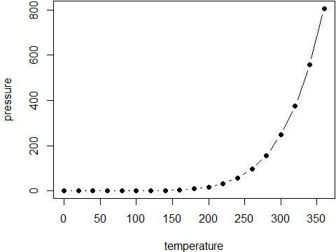

Here is a nice figure!

Reference a figure by its code chunk label with the fig: prefix, e.g., see Figure @ref(fig:nice-fig). Similarly, you can reference tables generated from knitr::kable(), e.g., see Table @ref(tab:nice-tab).

knitr::kable(  
 head(iris, 20), caption = 'Here is a nice table!',  
 booktabs = TRUE  
)

Here is a nice table!

|  |  |  |  |  |
| --- | --- | --- | --- | --- |
| Sepal.Length | Sepal.Width | Petal.Length | Petal.Width | Species |
| 5.1 | 3.5 | 1.4 | 0.2 | setosa |
| 4.9 | 3.0 | 1.4 | 0.2 | setosa |
| 4.7 | 3.2 | 1.3 | 0.2 | setosa |
| 4.6 | 3.1 | 1.5 | 0.2 | setosa |
| 5.0 | 3.6 | 1.4 | 0.2 | setosa |
| 5.4 | 3.9 | 1.7 | 0.4 | setosa |
| 4.6 | 3.4 | 1.4 | 0.3 | setosa |
| 5.0 | 3.4 | 1.5 | 0.2 | setosa |
| 4.4 | 2.9 | 1.4 | 0.2 | setosa |
| 4.9 | 3.1 | 1.5 | 0.1 | setosa |
| 5.4 | 3.7 | 1.5 | 0.2 | setosa |
| 4.8 | 3.4 | 1.6 | 0.2 | setosa |
| 4.8 | 3.0 | 1.4 | 0.1 | setosa |
| 4.3 | 3.0 | 1.1 | 0.1 | setosa |
| 5.8 | 4.0 | 1.2 | 0.2 | setosa |
| 5.7 | 4.4 | 1.5 | 0.4 | setosa |
| 5.4 | 3.9 | 1.3 | 0.4 | setosa |
| 5.1 | 3.5 | 1.4 | 0.3 | setosa |
| 5.7 | 3.8 | 1.7 | 0.3 | setosa |
| 5.1 | 3.8 | 1.5 | 0.3 | setosa |

You can write citations, too. For example, we are using the **bookdown** package (Xie 2020) in this sample book, which was built on top of R Markdown and **knitr** (Xie 2015).

# Literature

Here is a review of existing methods.

# Methods

We describe our methods in this chapter.

# (PART) Part II

# Applications

Some *significant* applications are demonstrated in this chapter.

## Example one

## Example two

# Final Words

We have finished a nice book.

Xie, Yihui. 2015. *Dynamic Documents with R and Knitr*. 2nd ed. Boca Raton, Florida: Chapman; Hall/CRC. <http://yihui.name/knitr/>.

———. 2020. *Bookdown: Authoring Books and Technical Documents with R Markdown*. <https://CRAN.R-project.org/package=bookdown>.