QuatreFoil Game Design

Version 1.2
04/05/25
Revision changes:
- -> 1.1: Added references.
1.1 -> 1.2: Added table of contents.

Table of Contents
1. Overview 2
1.1 Introduction 2
1.2 Scope 2
2. Target system 2
2.1 Game engine 2
3. Specification 2
3.1 Basic concept 2
3.2 Game world / structure 2
3.3 Players 3
3.4 Player actions 3
3.5 Objectives 3
3.6 Graphics 3
3.6.1 Sprites 3
4. Gameplay 3
4.1 World 3
4.2 Combat 3
4.2.1 Enemy 3
4.2.2 Player 4
5. User interface 4
5.1 Menu 4
5.2 During game 4
6. Development 4
6.1 Editor 4
7. Bibliography 4

1. Overview

1.1 Introduction
This document specifies the design for the gameplay of “QuatreFoil”. It is a demo game for the game engine also named “QuatreFoil”.

1.2 Scope
This document is to be read by anyone involved in the design of this game, as well as the testing of “QuatreFoil”.

2. Target system
“QuatreFoil” is only currently being developed for PC. This includes, windows, Linux and macOS, due to the main component being OpenGL.

2.1 Game engine
As said earlier, the game will be created as a demo for a game engine also named “QuatreFoil”. It uses the OpenGL graphics API, version 4.6 [2].

3. Specification

3.1 Basic concept
The concept of “QuatreFoil” exists to serve as a demo for the game engine. It will use most of the engine’s features, mainly using the entity component system.

3.2 Game world / structure
The world will exist entirely in 1 level. There will be a main menu system to enter the game, and then the game can be played after that. To get to the end, certain enemies will have to be defeated. Due to this game being a demo, the size of the game will be small, only allowing 5-10 minutes of gameplay.

3.3 Players
This game will only be single player. Enemies will be controlled by AI. Players can control the character using rudimentary keyboard controls e.g. wasd and arrow keys.

3.4 Player actions
Using the keyboard, a and d will allow the player to move left and right respectively, while using the arrow keys will allow directional attacks. All attacks will be a close range ‘slash’ that can be combined into each other. Such as an up attack followed by a down attack will complete a ‘waterfall’ attack, where they slash from the top down, rather than just doing down slash at the players feet afterwards.

3.5 Objectives
The main objective will be for the player to discover new attacks, as well as progress through the level to the end, where the game ends upon killing the last enemy.

3.6 Graphics
The world is set in a 2D plane. The world will be in a cave setting, with organic lights dotted around. The camera will follow on the x plane where the player is. Currently for the demo there is no verticality set for the game so a y plane tracking is unnecessary, but a feature that can be implemented tin the future. At all times, the camera will follow the player, even during the menu screen, as it will just be an overlay of the world, with physics simulation paused in the background.

3.6.1 Sprites
Only a few sprites will be made, such as the player, small effects, the enemy and the background.

4. Gameplay

4.1 World
The game will exist entirely within a small cave featuring organic lights from plants, and a soft ambient light in order to not make the scene too dark. This will be completed by running a rendering a light pass over the existing frame to make areas lighter/darker based on sources of light. A similar example to the vision of this game is Hollow Knight [3].

4.2 Combat
Combat from the player and enemies will be vastly different.

4.2.1 Enemy
For simplicity of a demo, the enemies will only be able to do 1 attack. This will be a simple slash to the direction of the player

4.2.2 Player
The player. As slightly mentioned earlier, will have directional attacks, these are:
- Up
- Down
- Left
- Right
These attacks if performed on their own, simply slash a sword in the direction of the arrow key. If the right arrow key is pressed, the player will attack to the right. However, from a predetermined list of ‘combos’ the player can use specific attacks in a row to do certain moves. Following on from the previous example, if the player does a right, left, right attack, instead of the second right slash being a simple right slash, it will do a ‘whirlwind’ slash. This is like how combos are handled in fighter games like Mortal Kombat [1].

5. User interface

5.1 Menu
The menu will simply have a play button. For being a demo, the menu doesn’t not need anything else, possibly a close button to safely terminate the program.

5.2 During game
During the gameplay, only health will be apparent. For debug reasons, there might also be text at a corner of the screen to track recent attacks, movement speed etc... but only if in ‘debug mode’.

6. Development

6.1 Editor
The game is made to be a demo for the “QuatreFoil” engine, so hence it will be built in this engine. This engine can be used for other games as well. Blocks and objects can be placed via this editor and due to using and entity component system, unique scripts can be ran depending on what is needed, for example, a unique attack script for the player.

7. Bibliography
[1] Probe software. Mortal Kombat [Video Game]. 1992.
[2] Khronos Group. “OpenGL 4.6 Specification” .2017. Available: https://registry.khronos.org/OpenGL/specs/gl/glspec46.core.pdf
[3] Team Cherry, Hollow Knight [Video Game]. 2017.
QuatreFoil Technical Design
Version 1.0
07/05/25

Table of Contents
1. Overview 1
1.1 Introduction 1
1.2 Scope 1
1.2 Description 1
2. Architecture 2
2.1 Core modules 2
2.1.1 Entry Point 2
2.1.2 Engine Core 2
2.1.3 Renderer 2
2.1.4 Layer 3
2.1.5 ImGuiLayer 3
2.1.6 Game Layer 3
2.1.7 VAO 3
2.1.8 VBO 3
2.1.9 EBO 3
2.1.10 Shader 3
2.1.11 Texture 3
2.1.12 Quad 3
3. External Libraries 4
3.1 CMake 4
3.2 GLFW 4
3.3 GLAD 4
3.4 stb_image 4
3.5 ImGui 4
3.6 EnTT 4
4. Entity component system 4
4.1 Creation of an entity 4
4.2 Components 5
4.2.1 Renderable 5
4.2.2 Transform 5
4.3 Future Components 5
5. Rendering 6
5.1 Pipeline 6
5.2 Limitations 6
6. Input system 6
7. Glossary 6
7.1 General engine 6
7.2 Rendering and graphics 6
7.3 ECS ( Entity component system) 6

1. Overview

1.1 Introduction
This document outlines and specifies the architecture of the underlying engine of QuatreFoil. This file is also in parallel with the Game Design Document, that explains the demo game which will be made from this engine.

1.2 Scope
This document is intended for developers contributing or understand the underlying engine.

1.2 Description
QuatreFoil is a custom game engine that uses the OpenGL graphics API and supplements the engine used for its demo game. It is written in C++ and using some external libraries which will be talked about further in this document. It uses CMake for building so the engine is largely portable between than of Windows, Linux and macOS.

2. Architecture

2.1 Core modules
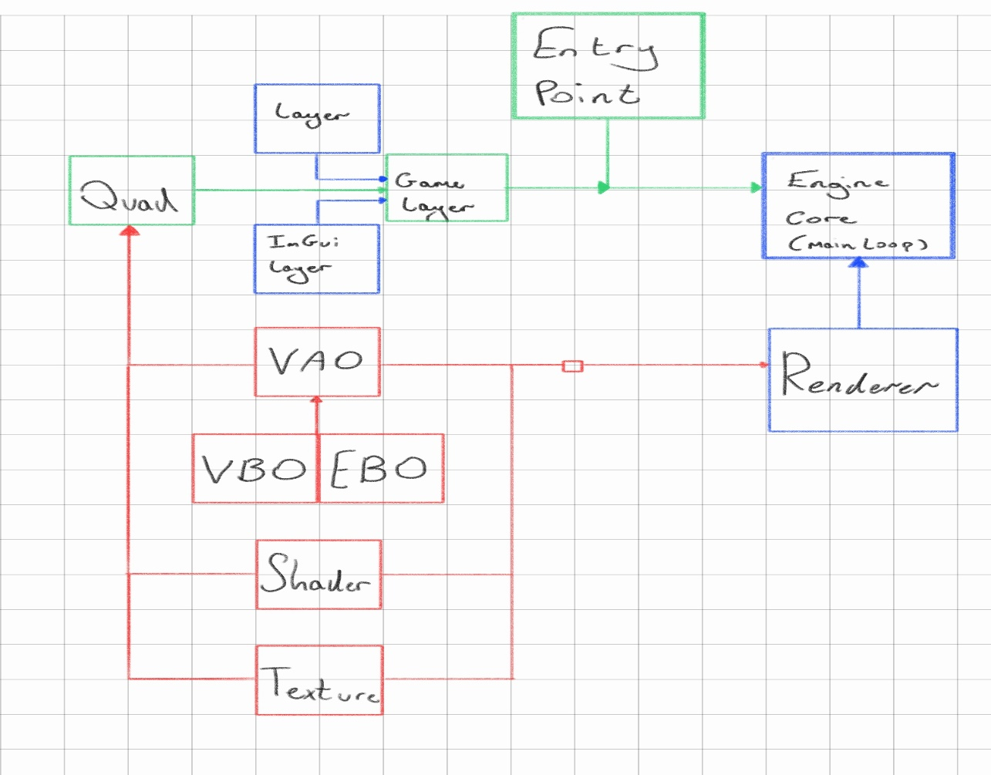
This is a very basic diagram of the classes and how they interact. The following sub sections describe these.

2.1.1 Entry Point
Entry point is a file that the game programmer must make. This creates an instance of the engine, as well as attaching the game layer to the engine, so it can run the games code.

2.1.2 Engine Core
The engine core is where the main loop is. Here, the GLFW window is made , and glad loads all of the low level OpenGL code. The game layer interacts mainly here with the main loop. The game layers OnRender, OnUpdate and others run here. This is what allows the game to be attached to the engine.

2.1.3 Renderer
The renderer takes powerful use of the entity component system here. This will be talked about further in the document. Firstly, it updates the cameras viewport so the camera can be live. Secondly, it takes all entities that have a renderable component (Containging the VAO’s, textures and shaders) attached and binds and renders them to the screen. In the future this can be made to include batch or instanced rendering, but this would require more input from the game developer.

2.1.4 Layer
Layer is just an abstract class that is meant to be inherited by the game developer and create a child class of their own. This has the basic functions of OnRender, OnStart, OnUpdate and others which are ran in the engine core, so the game developers can attach their own game layer to the engine core via entry point and run their own code.

2.1.5 ImGuiLayer
The ImGui layer hosts all the initialisation and boiler plate code that is needed for it to show up. This is fed into the Engine Core so that it can run the ImGui code and the game developer in their own layer, can customise which widgets appear and such.

2.1.6 Game Layer
This is up to the game developers decision on what code to implement. The only necessary ones are the functions that it inherits from the Layer class. Whatever code is inside of the functions from the Layer class are directly ran by the Engine Core.

2.1.7 VAO
The VAO class encapsulates additional functionality beyond a traditional Vertex Array Object. From the extra data passed through the constructor for the VAO, is has the possibility to make a VBO and EBO by itself automatically. The game developer therefore does not need to make these and are all managed within the VAO class. It hosts the binding and unbinding functions and vertex buffers to allow information to be entered into shaders.

2.1.8 VBO
This simply generates and binds the buffers with the information passed down from the VAO.

2.1.9 EBO
To make making loads of quads more efficient and limiting the amount of vertex data needed for every quad, an EBO is used. Instead of the game developer repeating vertex points where triangle corners would match up in the quad, they can specify unique corners, and indices of how the EBO should make the triangles from them.

2.1.10 Shader
Shader files are handled by GLSL type files here. The game developer can make the shader from simply making a shader and pointing to the file location of it. Currently, it can only utilise a vertex shader and fragment shader, but potentially in the future when newer OpenGL versions release, a mesh shader would also be appropriate to add due to the nature of the 2D game, and being able to create quads on the GPU would be powerful.

2.1.11 Texture
The texture constructor argument is just a path to the image, and It then generates then texture buffers and creates the texture image and generates the mip maps. Just like the other buffers, it includes the functions to bind and unbind the texture, which is currently only used in the renderer.

2.1.12 Quad
The quad class is simply here for ease of use. It takes in a position and a scale. It automatically has a VAO class and shaders and textures with it, so all the game developer has to do is create the quad with where it needs to be and how big it is.

3. External Libraries

3.1 CMake
CMake is used to build the solution in any file location. This allows portability with the engine, as all visual studios setups are different and all dependencies and include are handled here, easily.

3.2 GLFW
GLFW is used to handle the creation and deletion of the window as well as in the future, inputs. This is mainly created and used in the Engine Core class. It also handles the OpenGL context creation.

3.3 GLAD
GLAD is used to expose OpenGL functions and allow most of the rendering to happen. It is initialised once during startup and then throughout the whole engine, OpenGL functions can be exposed and used.

3.4 stb_image
This is a simple image loading library to load image files of most kinds, such as PNG or JPG. It is mainly implemented in the texture class, in order to place textures from an image onto a quad using the texture coordinates.

3.5 ImGui
This is a large backbone of the game engine. It allows a game developer interface to be easily made. This can be customised by the game developer if needed, and currently, it is used by the game engine to be able to spawn entities, move entities, switch between gameplay and game engine mode and in the future, will be capable of a lot more.

3.6 EnTT
(Entity Component System). This is the main external library used. The rendering and creation of entities relies on this, because it allows components to be added to an entity. This is currently in the form of a renderable component, and a transformable component, these hold the information (per entity) of their buffers and such, and the ability to transform the entity in world space.

4. Entity component system

4.1 Creation of an entity
Right now, everything is handled by an entity registry. This registry holds the information of all the entities connected to it. So, when the renderer is run in OnRender, the registry is passed through as a reference. To create an entity, right now it is being hard coded to create quad, from the Quad class, which takes the registry as a reference and creates an entity in the registry. This is then given a renderable transform component, which holds a VAO class, texture class and a shader class. It is also then given a transform component to allow it to be moved in world space. Here is an example of the code:
void Quad::CreateQuad(glm::vec2 position, glm::vec2 scale)
{
m_quad = m_registry.create();
m_VAO = std::make_shared<VAO>(m_quadVerts, m_quadIndeces);
m_VAO->AddVertexBuffer(stuff……);
m_texture = std::make_shared<Texture>(m_imagePath);
m_shader = std::make_shared<Shader>(m_vertexPath, m_fragPath);
auto& renderComp = m_registry.emplace<Renderable>(m_quad);
renderComp.m_vao = m_VAO;
renderComp.m_shader = m_shader;
renderComp.m_texture = m_texture;
auto& transformComp = m_registry.emplace<Transform>(m_quad);
transformComp.position = position;
transformComp.scale = scale;
}

4.2 Components

4.2.1 Renderable
The renderable component simply holds a pointer to a vao, shader and a texture. This allows the renderer to easily pull all of the information it needs when rendering the entity.

4.2.2 Transform
The transform component holds a position (vec2), a rotation and a scale (vec2). It also, for ease of use, has a function for returning a four-by-four model matrix. This is done my translating, rotating, and scaling the model matrix with the values in the struct (pos, rot, and scale), and then returning the matrix. This is done so that the shaders can have the model matrix as a uniform to perform camera calculations and translate from world to screen space.

4.3 Future Components
In the future, when physics is added and not being hard coded (if y = -100) { y = 0; } we can have a physics component that allows the object to have a hit box, and even a rigid body. These will most likely be sperate components due to some things needing a collider but not needing to be affected by gravity etc… like a world floor, needing a collider to keep the player up but not falling.

5. Rendering

5.1 Pipeline
Currently the render loop is as follows:
1. Bind FBO (so that game view can appear in ImGui image)
2. Clear the screen
3. Update the camera
4. Draw entities (glDrawElements using the EBO)

5.2 Limitations
Currently, it gets every entity one by one, binds their respective buffers, and then draws it. There is currently no batch rendering yet, or instanced rendering. This would be ideal in a 2D game due to the nature of needing multiple of certain shapes that are the same, such as similar rocks and repeating trees.

6. Input system
Right now, inputs are the next stage to be added. They will be added via an input class than can be attached to the game layer and engine core, they will have a static pointer to the window from the engine core, and the game layer can choose what key events will do what, such as a GLFW_KEY_A making the players x velocity go negative to go left. Inputs will only be polled for when the game engine is in GamePlay mode.

7. Glossary

7.1 General engine
- Engine core – The class that holds the main loop of the engine.
- Entry Point – The file that holds int main() and creates an instance of the engine.
- Layer – An abstract class that the game developer should use to make their game.

7.2 Rendering and graphics
- OpenGL – The graphics API used for rendering in QuatreFoil.
- VAO (Vertex Array Object) – OpenGL object that stores vertex attributes layouts.
- VBO (Vertex Buffer Object) – Stores vertex data in GPU memory.
- EBO (Element Buffer Object) – Stores indices for indexed drawing.
- Shader – Program than runs on the GPU.
- Texture – Image data that can be attached to quads on the screen.
- Quad – A rectangle made from 2 triangles.

7.3 ECS ( Entity component system)
- Entity – an ID of an object in a registry.
- Registry – Collection of ID’s and their components.
- Component – Data that can be attached to an entity.
- Renderable – A component that holds VAO, texture and shader data.
- Transform – A component that holds position, rotation and scalar data.
- EnTT – A c++ ECS library.

QuatreFoil Prototype description
Version 1.0
09/05/25
Project Name: QuatreFoil
Student Name: Corey Medland
Supervisor: Amudhavel Jayavel

1. Overview
A 2D Game Engine that renders objects to a screen and allows the game developers to make games. The main element of this is that it uses an Entity Component System (ECS) which allows scripts to be attached to certain entities, this can be components like a transform, or even a collider.

2. Core Features
Right now, the main window is an ImGui docking space that has a viewport for the game view, as well as two panels. The bottom panel is for accessing global data, so things like how many entities are there on the screen, start gameplay/engine mode and right panel is for accessing certain entities data, like their position. There is also a button than spawns a new entity in origin of world space.

3. Technical Implementation
The project follows an OOP style. It is built using CMake so it is portable to most computers. I utilize smart pointers to avoid memory leaks and also use a variety of libraries such as GLFW for window and input handling, as well as GLM for a mathematics library. I also use ImGui for the user interface and EnTT to handle my entity component system.
The renderer and engine core right now handles rendering and the main game loop, and the layer that injects into the core is currently the Game Engine. There is simple Input gameplay right now, where the user can move an entity let and right uses keyboard keys.

4. Limitations & Future Development
The gameplay in the future this will have to be abstracted into its own project and not hard coded into the game engine itself, also utilizing an ECS where it can have its own OnUpdate functions and such that can be ran within the game engine layer.
Currently the renderer gets every entity one by one, binds their respective buffers, and then draws it. There is currently no batch rendering yet, or instanced rendering. This would be ideal in a 2D game due to the nature of needing multiple certain shapes that are the same, such as similar rocks and repeating trees.
Most progress will happen here as the gameplay will need to be made and polished, as well as extra features for the game engine itself.

