Label-free DEM inversion: training a per-pixel network on the solver's objective
Built 2026-10-31 from 13 section files.

Abstract
Differential emission measure (DEM) inversion finds how much coronal plasma lies at each temperature along a line of sight, one optimisation per pixel. Supervised emulators need solver DEMs for every training image. We train on the solver's objective instead: an MLP maps one pixel's six SDO/AIA intensities to the solver's 54 basis weights, trained on Basis Pursuit's (BP) sparsity and noise-band objective or on ElasticNet's; solver DEMs only score it. The final BP model has 1.5M parameters, the ElasticNet model 409k. On 153 held-out images (86 distinct days) the ElasticNet model beats a supervised emulator on every measure (DEM MSE 0.310 against 0.318). The BP model wins four of six headline measures with a median pixel error 3.6 times lower (0.031 against 0.112); its DEM MSE is 1.2 times higher (1.08 against 0.91), and flare cores, one pixel in 10,000, hold 92% of its squared error. BP's original failure there was the loss, not training: at band weight μ = 1 the quadratic exterior penalty prices hot plasma out. A stiffer band (μ = 100) restores it (flare-core emission 40% to 96.7% of the solver's). Penalty-method theory gives the band violation as λ_c tσ_c/(2μ), so μ follows from the response, the noise and a tolerance. Larger models blow up on scores only when trained without deconvolution-clamp pixels; with them a 1.5M model is the best BP model. Small models lose from those pixels (BP 409k 2.37 to 2.79, ElasticNet 409k 0.310 to 0.439), so the ElasticNet final excludes them.
Sources: results/plots/23_meeting_followup_20261024/ (bp_h232_h680_clampmask.json: DEM MSE, W1, EM error, the final model's parameter recipe; bp_bright_failure_fu_bp_h680_clampmask.txt: flare-core emission 96.7%, 92.0% of the squared error, median pixel error; bp_aia_fit_fu_bp_h680_clampmask.txt: AIA MAE and MSE, four of six measures; enet_bright_failure_fu_enet_clampmask.txt: ElasticNet with clamp pixels; bp_clampmask runs in bp_bright_failure_fu_bp_clampmask.txt: BP 409k with clamp pixels); report/sections/03_method.md (3.1 parameter counts, 3.3 the law) and 07_failure_analysis.md (Table 7.2: the clamp runs); results/plots/13_bright_diagnostic_20260928/bp_bright_failure_supervised.txt (the supervised numbers); results/plots/19_final_models_20261004/bp_bright_failure_final.json (the old model's 40%); STATE.md (2026-10-04 blocks: the ElasticNet numbers); dataset/test_datetimes.txt (153 test images on 86 days).

1. Introduction
The differential emission measure (DEM) says how much plasma lies at each temperature along a line of sight. It is a key diagnostic of coronal thermal structure, separating the warm corona near 1 MK (logT 6.0) from flare plasma near 8 MK (logT 6.9). The Atmospheric Imaging Assembly (AIA; Lemen et al. 2012) on the Solar Dynamics Observatory (SDO) images the full disk at 4096 × 4096 pixels in six EUV channels (94, 131, 171, 193, 211 and 335 Å), each sensitive to a different mix of temperatures, so a DEM can be estimated for every pixel of every image.
Six intensities constrain a DEM on 18 temperature bins, so many DEMs fit the observations within their noise, and the solver's tie-break decides the shape it reports (section 2). Two solvers are the references here. Basis Pursuit (BP) returns the DEM with the smallest total basis weight that reproduces every channel within a noise band, one linear program per pixel. ElasticNet fits the same basis by least squares with L1 and L2 penalties on the weights. BP follows Cheung et al. (2015) and the ElasticNet form Athiray and Winebarger (2024); DeepEM (Wright et al. 2019) first trained a network on BP's DEMs.
Both solve every pixel separately, which is what makes them expensive. One image on our 2048 × 2048 grid (every second AIA pixel in each direction) is 4.2 million problems. BP solved about 1,400 pixels per second per CPU core; with the deconvolution and the retries at relaxed tolerances, a BP job took about 9.5 minutes per image on 16 cores and an ElasticNet job about 5.25. Clean BP and ElasticNet DEMs for our 1,223 images took 2,446 such jobs and 1.74 TB of output.
Supervised emulators move this cost into training. DeepEM trained a network on solver DEMs, and the supervised side's emulator modernises it with Fourier-feature inputs, a wider SiLU network and a binned distribution over each output. Inference is one forward pass per pixel, but the model stays bound to its labels. It needs solver DEMs for every training image. A change of solver settings invalidates them: 886 GB of our first ElasticNet DEMs (α = 1) were superseded when the supervised side's α = 0.001 was confirmed. And it learns the solver's answer even where that answer is questionable: at the 40% of pixels where the deconvolution clamped a channel to zero, nearly all faint, BP still fits a DEM to the artefact (section 7.2).
We instead train on the solver's objective, which depends only on the observations and their noise. This is amortised optimisation: one network learns the map from an observation to its solution instead of solving each pixel afresh, and it never sees a solver DEM. The objective must be the solver's own: in an early per-pixel test, losses that only fit the six channels reproduced AIA about 12 times better than BP yet landed about 5 times further from its DEMs (appendix A). The network reads one pixel's six intensities and outputs the solvers' 54 basis weights, from which the fixed basis and response matrix give the DEM and the predicted intensities. For ElasticNet the loss is the solver's objective with its settings; for BP it is the sparsity term with the band as a penalty, zero inside and quadratic outside, weighted by the band weight μ (section 3). When the ElasticNet setting changed, the model was simply retrained. Solver DEMs enter only the evaluation, on the supervised side's protocol: both models are scored on the same pixels of 153 test images (86 distinct days, September to December 2015) against the same solver DEMs (section 4); ours trains on 917 earlier images. The work is AIA-only; XRT and the uncertainty output are left open, and the network's speed against the solver is unmeasured (section 9).
This report makes four claims.
- Label-free training matches or beats a supervised emulator. Our final models are per-pixel MLPs on one pixel's six intensities, trained only on the solver's objective: 409k parameters on ElasticNet, 1.5M on BP. The first is ahead of the supervised model on every measure. The second is ahead on four of six headline measures and 3.6 times closer to BP on the typical pixel (median pixel error 0.031 against 0.112), and loses DEM MSE (1.08 against 0.91) and AIA MAE (section 5).
- The one BP failure was in the loss. At flare cores the network sat close to its loss's per-pixel optimum (a median 8% above it), and at μ = 1 that optimum leaves out the hot plasma. A stiffer band (μ = 100) puts it back: flare-core emission rises from 40% of the solver's to 93% with a 409k model and 96.7% with the final one (section 6). μ need not be tuned blind: penalty-method theory places each channel λ_c tσ_c / (2μ) half-widths outside its band at the optimum, with λ_c the channel's dual price in BP's linear program, so μ follows from the response matrix, the noise and a chosen tolerance (section 3.3).
- Larger models blow up on scores only when trained without the clamp pixels. At scale the per-pixel MLP beats the patch CNN, and larger MLPs improve the typical pixel a little (section 5.4). Trained without the pixels where the deconvolution clamped a channel to zero, they blow up on a few rare pixels: inputs that training excluded, lone single-channel spikes among zeroed channels, where a larger network extrapolates further (section 7.1). With those pixels kept and only the clamped channels freed from the band, a 1.5M model drops from DEM MSE 897 to 1.08 and is the best BP model we have. The small models lose from the same change (BP 409k 2.37 to 2.79 at 40 epochs, ElasticNet 409k 0.310 to 0.439), so the ElasticNet final stays at 409k without them. A few single-channel outliers remain, nearly all without a solver DEM, and a self-check on the reconstruction flags them (section 7.1).
- The remaining error is concentrated. Flare cores, where some channel reaches 32 times its Bright cutoff, are one pixel in 10,000 yet hold 92% of the final BP model's squared error and 90% of the supervised model's (section 5.2). The outliers at the low end of the AIA joint distributions are the clamp again: where a channel was zeroed the observation itself is wrong, and the solver's DEM disagrees with it too. With the clamped channels freed that low cluster holds about 5.5M pixels, 0.8% of the test set, and barely moves the scores (section 7.2).
Sections 2 to 4 give the problem, method and evaluation, sections 5 to 8 the results and their analysis, and section 9 the limitations.
Sources: CLAUDE.md (Project Overview, What is DEM, Reference Solvers and Architecture: AIA's channels and resolution, BP and ElasticNet, the supervised emulator's design; 2026-07-31 entries: BP 9.5 and ElasticNet 5.25 minutes per job, 2,446 jobs, 1.74 TB, the 2048 grid as every second AIA pixel; 2026-09-11: the ElasticNet setting α = 0.001 and the retrain on the same observations; 2026-10-21: the penalty-method result); results/meeting_20260728_scaling_brief.md (one full-disk image of 4,194,304 pixels, BP at 1,383 pixels per second per core, 3 min 10 s of solving on 16 cores, 9 min 28 s with deconvolution and relaxation); STATE.md (2026-10-14 block: the 409k stiff-band model's 93%; 2026-10-04 blocks: the ElasticNet numbers and the ElasticNet blow-ups; 2026-10-03 night: the 886 GB of α = 1 ElasticNet DEMs superseded); results/followup_recap_20261013.md (section 1: data and split; section 5: the network 8% above its loss's optimum at flare cores; section 6: 1 MK and 8 MK; sections 8 and 9: the stiff band and longer training, the stiff-band blow-ups); slides/deck_outline.md (slides 2, 4, 5 and 6: the summary, the two training loops, the model and the loss; slide 7: the split by date; slides 9 and 10: the patch CNN and the width choice; slide 28: the fit-only losses, 12 times better on AIA and 5 times further from BP); slides/talk_prep.md (inference speed unmeasured; the supervised model's design); dataset/train_datetimes.txt and dataset/test_datetimes.txt (917 and 153 images; the test period and its 86 days); results/plots/23_meeting_followup_20261024/ (bp_h232_h680_clampmask.json, bp_bright_failure_fu_bp_h680_clampmask.txt, bp_aia_fit_fu_bp_h680_clampmask.txt, bp_jpdf_pixels_h680_clamp.txt: the final BP numbers, 40% of pixels clamped, the low cluster; bp_bright_failure_fu_bp_clampmask.txt, enet_bright_failure_fu_enet_clampmask.txt: the small models with clamp pixels); report/sections/07_failure_analysis.md (Tables 7.1 and 7.2, the lone spikes, the self-check); results/plots/13_bright_diagnostic_20260928/bp_bright_failure_supervised.txt (flare cores: 0.01% of pixels, 90.0% of the squared error); results/paper_outline_20260807.md (framing only).

2. Problem setting

2.1 Observations and the DEM
The data are SDO/AIA images in six EUV channels (94, 131, 171, 193, 211 and 335 Å), deconvolved for the instrument's point-spread function (with the revised functions of Hofmeister et al. 2025) and corrected for exposure time and degradation, so a pixel's six values o_c are intensities in DN/s. DEMs are computed on a 2048 × 2048 grid, DEM pixel (i, j) taking the AIA values at pixel (2i, 2j).
A DEM has 18 values, on temperature bins from logT 5.5 to 7.2 in steps of 0.1 dex (about 0.3 to 16 MK). Each is the emission measure in its bin in units of 10^26 cm^-5, which this report calls one unit of plasma. (The solver files pad the grid to logT 8.0 with zeros.) The response matrix R (6 × 18) gives each channel's DN/s per unit of plasma in each bin, so the predicted intensities are R times the DEM. With six measurements and 18 unknowns, many DEMs fit within the noise; the solver's regulariser picks one.

2.2 The basis
Neither solver solves for the 18 bins directly. Both solve for 54 non-negative weights w on a fixed basis B (18 × 54), with DEM = Bw and predicted intensities RBw. At each bin B has a spike (one unit in that bin and nothing elsewhere) and two Gaussians in logT centred on the bin, exp(−(ΔlogT/a)²) with a = 0.1 and 0.2 dex and a peak of 1, values below 0.04 of the peak set to zero (Table 2.1).
Table 2.1. The three basis components at a bin away from the ends of the grid.
Component | Bins covered | Plasma per unit of weight
Spike | 1 | 1
Gaussian, a = 0.1 dex | 3 | 1.74 = 1 + 2 × 0.368
Gaussian, a = 0.2 dex | 7 | 3.50 = 1 + 2 × (0.779 + 0.368 + 0.105)

The weights are therefore not the plasma. A unit of weight on a spike is one unit of plasma in one bin, but a unit on the 0.1 dex Gaussian spreads 1.74 units over three bins, and a unit on the 0.2 dex Gaussian 3.5 units over seven. So the sum of the 54 weights, which BP minimises (our BP loss's sparsity term), is not the plasma summed over the 18 bins: a DEM shaped like one 0.2 dex Gaussian costs 1 written as that Gaussian and 3.5 written as seven spikes. Responses differ the same way: per unit of weight, the 0.2 dex Gaussian at logT 6.8 gives 94 Å 0.67 DN/s, the spike at logT 6.9 only 0.266.
Our network's basis has this truncation; the solver runs that made the reference DEMs used --notrunc, which keeps the tails, so their Gaussians carry about 1.77 and 3.54 units per unit of weight. Both generation commands we have pass --notrunc (ours for BP, the supervised side's for ElasticNet). The difference is at most 2.1% of an element's emission and moves the price bounds of section 3.3 by under 1%; where solver DEMs are rewritten as 54 weights (sections 6.3 and 8.3) the decomposition uses our truncated basis.

2.3 Noise
Each pixel and channel has a noise σ_c from AIA's instrument noise model: the estimate_error routine of aiapy (Barnes et al. 2020) with the SolarSoft error table, which adds shot (photon), dark, read, quantisation and onboard-compression noise in quadrature, with the photometric-calibration and atomic-data terms off. Shot noise grows as the square root of the counts, so the relative noise falls as a pixel brightens. In the median pixel σ/o is 1.12 in 94 Å, 0.60 in 335 Å and 0.44 in 131 Å, against 0.06 to 0.08 in 171, 193 and 211 Å. The band of channel c is o_c ± tσ_c with t = 1.4.

2.4 Basis Pursuit
For each pixel BP solves the linear program
minimise Σ_k w_k over w ≥ 0, subject to o_c − tσ_c ≤ (RBw)_c ≤ o_c + tσ_c for every channel c.
The band is a rule: every DEM inside it is equally acceptable, and the smallest weight sum breaks the tie. As a pixel brightens, its band narrows relative to the signal until it is tighter than the accuracy of R itself and no DEM fits. The solver then retries the pixel with the band three and then five times wider (t = 4.2, then 7.0) and our copy of the solver records the outcome per pixel as tolLevel: 1 inside the band, 3 or 5 after relaxation, 0 if no DEM was found. On one full-disk image, 89.78% of pixels were solved inside the band, 10.04% at three times its width, 0.16% at five times and 0.02% not at all; relaxation was more common on the disk (13.4% against 6.3% off the limb) and in brighter pixels. Section 7.3 returns to these pixels.

2.5 ElasticNet
ElasticNet fits the same weights by penalised least squares:
minimise over w ≥ 0: (1/2C) Σ_c [((RBw)_c − o_c) / (tσ_c)]² + αλ Σ_k w_k + ½α(1 − λ) Σ_k w_k²,
with each residual divided by the band's half-width tσ_c (floored at 0.5 DN/s). The supervised side's settings are α = 0.001, λ = 0.5 (the l1_ratio of scikit-learn; Pedregosa et al. 2011) and C = 6, the number of channels, since scikit-learn's ElasticNet divides the squared error by twice the number of rows; the fit is non-negative (positive=True), without intercept, with at most 10,000 iterations. With no band there is no relaxation: every pixel gets a DEM, though our solver runs at these settings logged convergence warnings. The L2 term spreads weight over more components, so ElasticNet DEMs are broader than BP's. Our first ElasticNet runs used α = 1, the code's default; every ElasticNet number in this report uses α = 0.001.

2.6 What the channels see
Table 2.2. AIA response to one unit of plasma (10^26 cm^-5) in a single bin, in DN/s.
Plasma at | 94 Å | 131 Å | 171 Å | 193 Å | 211 Å | 335 Å
1 to 1.3 MK (warm, logT 6.0 to 6.1) | 0.19 to 0.22 | 0.5 to 1.2 | 36 to 95 | 29 to 55 | 5 to 7 | 0.4
8 MK (hot, logT 6.9) | 0.27 | 0.40 | 0.05 | 0.34 | 0.08 | 0.05

A unit of warm plasma lights 171 and 193 Å by tens of DN/s and 211 Å by several, so those low-noise channels pin it down. A unit of hot plasma lights no channel by more than 0.4 DN/s. At ordinary pixels most of the 94 Å signal comes from warm plasma that the other channels demand anyway. At flare cores most of it comes from hot plasma, which only 94 and 131 Å ask for, two of the three noisiest channels, so a bright 94 Å reading needs hundreds of units of it. How a loss prices those units decides whether the hot plasma appears in the DEM at all (section 6).
Sources: CLAUDE.md (Reference Solvers; 2026-07-31 entries: DEM pixel (i, j) from AIA pixel (2i, 2j), the 18 bins and the eight zero bins stacked on, σ/o medians over 655k pixels; 2026-09-11: α = 0.001 confirmed against the earlier α = 1; 2026-09-13: convergence warnings in our α = 0.001 ElasticNet run; 2026-10-21: 0.67 and 0.266 DN/s of 94 Å per unit of weight); RData.npz (R and the logT grid); fullBP.py (lines 91 to 116, getBasis: the spike and Gaussians, the 0.04 truncation and notrunc; solveLP: the linear program; solveElasticNet: residuals divided by max(tσ, 0.5 DN/s), scikit-learn settings; invertDEMCube: retries at 3 and 5 times the band; parseArgs: t = 1.4, the basis widths 0, 0.1 and 0.2, α = 1 by default); dataset/fullBP.py (our copy of the solver: exposure and degradation scaling, the estimate_error call with no calibration flags, tolLevel); dataset/submit_bp_aia_hofdeconv_full.py and eval_and_enet_specs/submit_enet_aia_hofdeconv_full.py (generation flags: the PSF deconvolution with --errorfn full --notrunc --extendto8 --decimate 2, and --zerochill with α = 0.001 for ElasticNet); experiments/train_scaled.py (line 186: the network's basis, built with the default truncation); eval_and_enet_specs/README.md (the ElasticNet objective and settings); .venv/lib/python3.13/site-packages/aiapy/calibrate/uncertainty.py (the noise terms and their defaults); slides/talk_prep.md ("What is σ?"); results/meeting_20260728_scaling_brief.md (one full-disk image: tolLevel shares, the share infeasible at the band on and off the disk and its rise with 171 Å brightness); results/followup_recap_20261013.md (section 6: Table 2.2, where 94 Å signal comes from, hundreds of units). The sums in Table 2.1 and the untruncated 1.77 and 3.54 follow from the Gaussian formula in getBasis on the 0.1 dex grid.

3. Method: amortised optimisation
Both solvers solve one problem per pixel: from the six intensities o and their noise σ, find the 54 non-negative basis weights w that minimise the solver's objective. We train one network f_θ to do this for any pixel, by minimising the same objective over the training pixels:
$$ \theta^\star = \arg\min_\theta \sum_{p} L\left(f_\theta(o_p);\ o_p, \sigma_p\right) $$
Solving is paid for once, in training, and each new pixel then costs one forward pass. No solver DEM enters training. Solver DEMs score the result (section 4) and compare losses with different band weights on validation pixels (section 3.5).

3.1 Network
The network sees the six intensities of one pixel: not its neighbours (section 5.4) and not σ, which only the loss uses. Each intensity, in DN/s, is square-rooted and lifted to sines and cosines at 12 fixed frequencies 2π·2^(i/2), i = −4, …, 7 (Fourier features; Tancik et al. 2020), which with the square roots themselves gives 6 × 25 = 150 inputs. This is the supervised model's input path; the square root spreads the bright end far more than the old model's log1p (a 10^4 DN/s flare core maps to 100, against 9.2).
Four hidden layers with SiLU activations feed a linear layer to 54 outputs and a softplus, which keeps every weight non-negative. The softplus input is clamped at −20 so that its gradient never vanishes, and the output layer starts small (weights scaled by 0.01, bias −3) so that the first DEM reproduces intensities of the order of the observations; both fixes date from the collapse of the first full-disk runs (appendix A). The width differs by track. The final BP model is 680 wide, with 1,528,694 parameters, quoted as 1.5M; the ElasticNet model is 336 wide, with 408,630 parameters, quoted as 409k. For width W the count is 150W + 3W² + 54W weights and 4W + 54 biases. On six log1p inputs the same widths have 1.43M and 360k. Section 3.5 says how each width was set. The speed of either network against the solver has not been measured.
The output is the solver's own variable. Neither solver works on the 18 DEM bins (logT 5.5 to 7.2, 0.1 dex apart) directly: both solve for 54 weights on a fixed basis B, at each bin a spike and two Gaussians exp(−ΔlogT²/a²) with a = 0.1 and 0.2 dex, and report DEM = Bw, whose intensities are Dw with D = RB (R in DN/s per 10^26 cm^-5). Predicting the same weights, the network searches the solver's space of DEMs (the solver fits flare cores in it, so the basis is not the limit), BP's sparsity term means the same thing for both, and the sparsity score (Σw)²/Σw² is comparable with the solver's (1.79 on BP). The supervised model instead outputs the 18 bins. One difference remains: our basis zeroes each Gaussian below 0.04 of its peak, while the solver runs pass --notrunc and keep those tails, at most 2.1% of an element's emission; both generation commands we have pass it, and the difference moves the price bounds of section 3.3 by under 1%.

3.2 Losses
With o_c and σ_c the observation and noise of channel c in DN/s, (Dw)_c the intensity the DEM reproduces and t = 1.4 the solver's first tolerance level, the band is o_c ± tσ_c. The BP loss is
$$ L_{\mathrm{BP}}(w) = \sum_{k=1}^{54} w_k + \mu \sum_{c=1}^{6} \left[ \frac{\max\left(0,\ |(Dw)_c - o_c| - t\sigma_c\right)}{t\sigma_c} \right]^2, \qquad w \ge 0. $$
The first term is BP's objective, the total weight. The hinge is zero inside the band, so there is no fit term there: any DEM within the noise is equally good and sparsity breaks the tie, as in BP. Dividing by the half-width tσ_c makes a half-width outside cost the same in every channel, so 94 Å at a few DN/s counts as much as 171 Å at hundreds. The square is our choice (BP is a linear program with a hard band): it makes the penalty smooth at the edge, at the cost of an optimum that sits slightly outside the band at any finite μ (section 3.3). The band weight μ is the exchange rate between squared half-widths and units of weight. BP treats the band as a rule and the loss treats it as a price; section 6 turns on that difference. The old model used μ = 1, the final BP model the stiff band, μ = 100. Per pixel the loss is convex in w, so each pixel has one best answer under the loss.
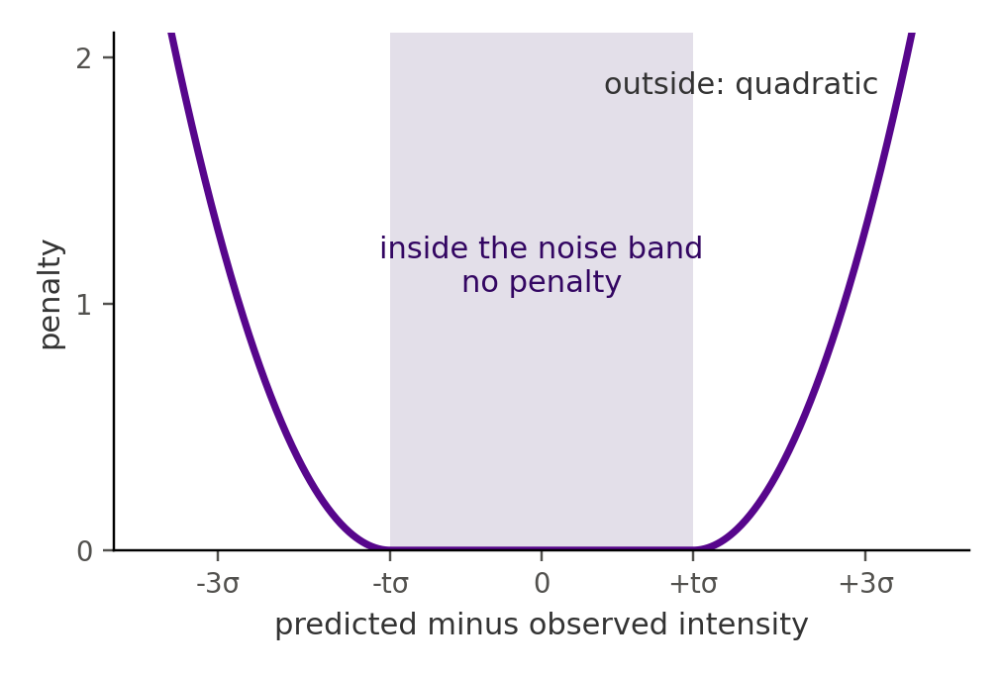
Figure 3.1. The BP loss's band penalty for one channel: zero inside the band of ±tσ around the observation, growing as the square of the distance outside it, measured in half-widths. (slides/img/band_penalty.png)
The ElasticNet loss is
$$ L_{\mathrm{EN}}(w) = \frac{1}{2C} \sum_{c=1}^{6} \left[ \frac{(Dw)_c - o_c}{t\sigma_c} \right]^2 + \alpha\lambda \sum_{k=1}^{54} w_k + \frac{\alpha(1-\lambda)}{2} \sum_{k=1}^{54} w_k^2, \qquad w \ge 0, $$
with the supervised side's α = 0.001, λ = 0.5 and C = 6. This is the solver's objective term for term (scikit-learn's non-negative ElasticNet fitted to D and o divided by tσ_c, whose 1/(2N) over N = 6 rows is the 1/(2C) above), except that the solver floors tσ_c at 0.5 DN/s; on the staged validation errors 1.4σ falls below 0.5 DN/s at under 0.1% of pixels, so the floor hardly ever binds. The L2 term makes it strictly convex, so each pixel's best answer under the loss is, up to that floor, the solver's DEM; and with no band there is nothing to price, which is why ElasticNet never had BP's flare-core failure. Both losses are averaged over the 8,192 pixels of a batch.

3.3 The band weight μ
The BP loss is the quadratic exterior penalty of BP's linear program,
$$ \min_{w \ge 0} \ \sum_{k} w_k \quad \text{subject to} \quad o_c - t\sigma_c \le (Dw)_c \le o_c + t\sigma_c, \quad c = 1, \dots, 6, $$
and penalty-method theory says what it does at finite μ (Nocedal and Wright 2006, chapter 17). At the penalised optimum, a channel whose band edge binds sits outside the band by v_c DN/s, where the marginal penalty, 2μv_c/(tσ_c)² per DN/s, equals the marginal saving in total weight: the linear program's dual price λ_c of that edge, in weight units per DN/s. Hence
$$ \frac{2\mu\, v_c}{(t\sigma_c)^2} = \lambda_c \qquad \Longrightarrow \qquad \frac{v_c}{t\sigma_c} = \frac{\lambda_c\, t\sigma_c}{2\mu}. $$
In half band-widths the violation falls as 1/μ and grows with the noise and the price. The relation is exact once μ is large enough that the penalised optimum keeps the basis elements and binding edges of the linear program's solution.
When a single edge binds, the linear program can always buy a DN/s of that channel from its most efficient basis element, so R and B alone bound the price:
$$ \lambda_c \le \frac{1}{\max_k \, (RB)_{c,k}}. $$
Table 3.1. Single-channel price bound, in weight units (10^26 cm^-5) per DN/s.
94 Å | 131 Å | 171 Å | 193 Å | 211 Å | 335 Å
1.48 | 0.10 | 0.003 | 0.007 | 0.026 | 0.60

The bound differs more than 400-fold between 94 Å and 171 Å: a unit of weight buys at most two thirds of a DN/s of 94 Å but a few hundred of 171 Å. 94 Å is the dear channel.
At the flare core worked through in section 6, 94 Å reads 164 DN/s with σ = 11.5, so tσ = 16.1 and the band runs from 148 to 180. At the bound the 94 Å violation is 1.48 × 16.1/(2μ) = 11.9/μ half-widths. At μ = 1 that exceeds the 9.2 half-widths (148/16.1) by which a DEM without hot plasma falls short, so the best answer drops the hot plasma outright. At μ = 10 the violation is 1.19 half-widths, at 30 it is 0.40, at 100 0.12 and at 300 0.04; μ = 120 holds the pixel within 0.1 half-width.
Turned round, a tolerance of ε half-widths needs μ ≥ λ_c tσ_c/(2ε), a number set by the response, the basis and the noise, with no solver DEM. Photon noise makes σ grow as the square root of the counts, so the μ needed grows with the square root of the brightness. Faint pixels have small σ, and their 94 Å comes free with the warm plasma that 171, 193 and 211 Å demand (section 6), so they hardly respond to μ; flare cores combine the largest σ with the dearest channel and need μ near 100. The same law, a small violation below the lower band edges that shrinks as 1/μ, explains the old model's emission deficit at ordinary pixels: on validation pixels at 0.3 to 1 times the Bright cutoff, the best answer under the loss emits 0.861 of the solver's emission at μ = 1 and 1.009 at μ = 100.
Two refinements follow, neither yet trained. A per-pixel, per-channel weight proportional to λ_c tσ_c, with the bound standing in for λ_c, needs only R, B and σ and would hold every pixel to the same tolerance. An L1 exterior penalty, μ Σ_c max(0, |(Dw)_c − o_c| − tσ_c)/(tσ_c), is exact: once μ exceeds λ_c tσ_c in every binding channel (about 24 at the flare core above), its minimiser solves BP's linear program itself, at the cost of a slope that jumps at the band edge.
The bound assumes one binding edge. When several bind, the price can exceed it, because the element that sets the bound may push another channel out of its band. The 94 Å bound comes from warm plasma, the 0.2 dex Gaussian at logT 6.1 (0.676 DN/s per unit), which also lights 171 Å; at a flare core the hot element at logT 6.8 (0.669 DN/s per unit) sets a price 1% higher, and other combinations can raise it further. The theory is therefore checked on validation pixels.
Validation check. On the 11,954 validation pixels of the μ screen (every flare core of the split and about 1,000 per brightness band), we solved BP's linear program at t = 1.4 for its dual prices and the best answer under the loss at μ = 1 to 1,000, and compared the measured violation with λ_c tσ_c/(2μ) (experiments/mu_theory.py, Figure 3.2).
- The law holds. At μ = 100 the measured violation divided by the predicted one has a median of 1.00 over 45,925 violated pixel-channels, and the median is 1.00 in every band below flare cores for μ ≥ 10 and at flare cores for μ ≥ 30. μ times the violation stays constant from μ = 10 to 1,000 (a coefficient of variation of 0.00 to 0.06 at the median pixel below flare cores, 0.19 at flare cores). Below μ ≈ 10 the best answer drops basis elements the linear program keeps, the hot plasma at bright pixels, and the first-order law no longer applies (at flare cores the median ratio is 0.66 at μ = 1).
- The prices. At flare cores the median 94 Å price is 1.46, at the single-edge bound of 1.48; it exceeds the bound at 49% of them (99th percentile 8.8) where other edges bind. 94 Å is the dearest channel at 70% of flare cores, 335 Å at 15% and 131 Å at 13%; over all pixels 94 Å leads at 40%, 335 Å at 26% and 131 Å at 17%.
- μ for a tolerance. From the measured prices, holding the median flare core within 0.5, 0.2 and 0.1 half-widths needs μ = 34, 84 and 168; the 90th-percentile flare core needs 153, 382 and 763. At μ = 100 the median flare core sits about 0.17 half-widths outside its band and the 90th percentile about 0.8, roughly one noise σ beyond the edge. Over all pixels the median needs only μ = 13 for 0.5 and 64 for 0.1. A single global μ cannot hold every pixel to one tolerance: the most demanding feasible pixel in the sample, a flare core priced on 335 Å, would need 63,801 for 0.1 half-width. This is the case for the per-pixel weight above.
- Infeasible pixels. At 8.8% of the sample (12% of flare cores) no DEM fits the 1.4σ band, and these are exactly the pixels the solver relaxed (section 7.3). There the violation stops falling at a floor set by the observation, whatever μ, and the law does not apply.
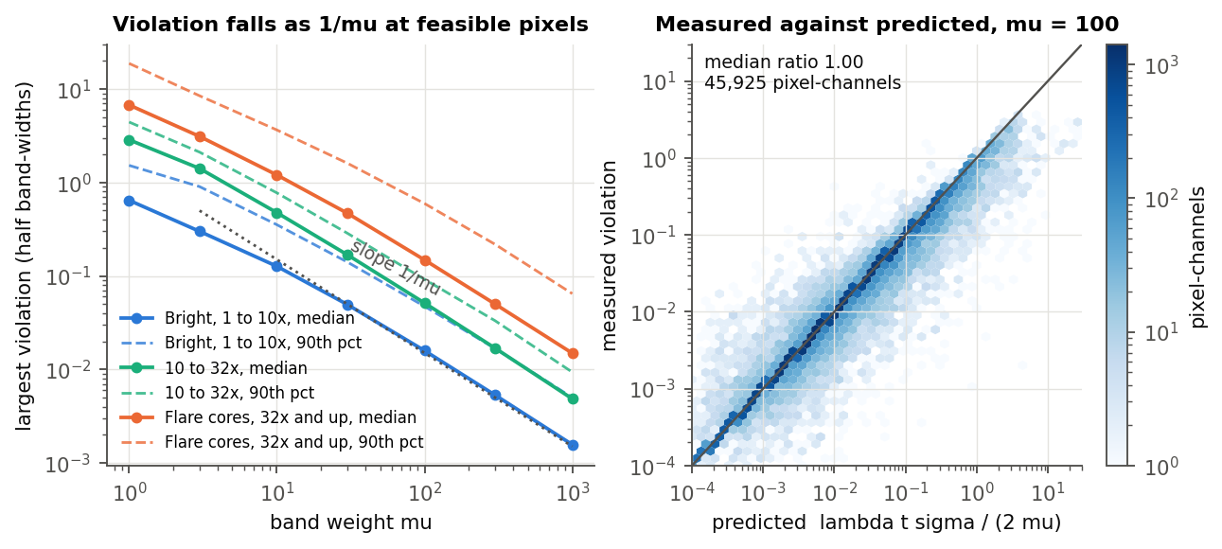
Figure 3.2. Left: the largest band violation at feasible validation pixels against μ, median and 90th percentile, for three brightness ranges, with a 1/μ guide. Right: measured against predicted violation at μ = 100, per violated pixel-channel. (results/plots/23_meeting_followup_20261024/fig1_violation_vs_mu.png)
So μ is not a free hyperparameter. Given the response, the basis and the noise, the theory states how far outside its band the best answer sits at any μ, and validation confirms it pixel by pixel. μ = 100 is the value that holds the typical flare core to about a sixth of a half-width; section 7.3 shows that once the band is relaxed where the solver relaxes it, larger μ only moves the best answer closer to the solver.

3.4 Training
The 1,223 full-disk images (2014 and 2015, about two a day, deconvolved, with σ per pixel and channel; section 2) are split in time: 917 for training (1 January 2014 to 16 June 2015), 153 for validation (to 21 September 2015) and 153 for test (to 31 December 2015). Each image's 2048 by 2048 DEM grid is cut into 256 blocks of 128 by 128 pixels, of which a seeded random 64 are kept once at staging: 58,688 training blocks. AIA is subsampled by 2, so DEM pixel (i, j) sees AIA pixel (2i, 2j), the one the solver used. Each epoch draws 512 fresh pixels uniformly from the valid pixels of every block, 30,048,256 in all, off-disk pixels included.
A pixel is valid if the solver solved it (this flag, not a DEM, is the one solver output training reads) and its observations and σ are finite. The positivity clamp after deconvolution sets negative values to zero, so a channel can read zero where the others carry signal. We call a channel clamped when it reads at or below MIN_OBS = 10^-3 DN/s, three decades below the faintest channel's median (94 Å, 0.76 DN/s). A clamped channel is an artefact, and the solver fits a DEM to it anyway.
There are two treatments. The first, used for the ElasticNet model and for every BP run before the confirmation runs of section 7.1, drops every pixel with a clamped channel from training and validation. That mask was estimated at about 5% of pixels from the two brightest channels; counted over all six it drops about 40% of valid pixels (39.7% on the shared test set), nearly all faint (section 7.1). The second (--clamp_mode mask), used for the final BP model, keeps those pixels and frees only their clamped channels: such a channel's band is made so wide that it adds nothing to the loss, the other channels keep their bands, and the network still reads the zero as an input. The ElasticNet loss drops a freed channel the same way. Either way the pixels stay in the test set (section 7.2). Keeping them is what removed the large models' score blow-ups (section 7.1).
Until 2 October 2026 each block's draw was seeded by its index alone, so every epoch reused one fixed sample of 30M pixels, about 0.8% of the training images' pixels (appendix C); every full-disk model in sections 5 to 8 was trained with fresh pixels.
Training uses Adam (Kingma and Ba 2015; peak learning rate 3 × 10^-4, no weight decay) with a linear warm-up of 500 steps on BP and 3,000 on ElasticNet, then cosine decay to zero; batches of 16 blocks of 512 pixels, 3,668 steps per epoch; and a global gradient-norm clip at 1, which on the stiff band acts on every step (norms 20 to 500; without it the AIA fit improved but every DEM measure got worse). The ElasticNet model trains 40 epochs. The final BP model trains 120 epochs at μ = 100 from scratch. The earlier 409k stiff-band model (width 336, clamp pixels excluded) trained 120 epochs at μ = 100, then 120 more from that checkpoint with --init_from (weights only; new optimiser, warm-up and schedule). The full training state is saved every epoch, so runs proceed in resumable segments of under two hours, past which the cluster cancels GPU jobs at low utilisation; the model used is the last epoch's, with no early stopping. An epoch of the ElasticNet model takes 152 to 174 s on one GPU, so its 40 epochs take under two hours; the final BP model took a median 169 s per epoch and 6.6 hours in all.

3.5 Model selection on validation
For a fixed loss we select on the training loss itself, computed after every epoch on a fixed validation sample, with no solver DEM: 512 pixels from each of the first 256 validation blocks, 131,072 pixels. Blocks are stored in time order, 64 to an image, so these are the first four validation images, 16 to 18 June 2015.
This signal chose the per-pixel MLP over the patch CNN (section 5.4), width 336 on the original BP loss (2.148 against 2.155 at 1.43M, a tie that favours the smaller model) and the square root plus Fourier input on ElasticNet (0.0533 against 0.0575 for log1p); on the original BP loss the input tied (2.1472 against 2.1478), so the old model kept log1p. On the stiff band it chose the new input for BP (5.731 against 6.006), kept the clip (against 8.052 without it) and ranks the 409k stiff-band model first among the 409k stiff-band runs (5.444, against 5.488 for 240 epochs from scratch and 5.648 for 120). The screen's DEM error, below, preferred 240 epochs from scratch (14.0 against 15.8), but that run put 130 times the 120-epoch model's band penalty on the validation flare cores, against 13 times for the continuation.
Different band weights give different losses, so μ cannot be chosen on the training loss. The band weight and the stiff-band candidates were compared on about 12,000 pixels drawn from all 153 validation images, 6,000 of them flare cores, by DEM error against the solver's DEMs with each brightness band weighted by its share of pixels (section 6): the one place solver DEMs enter a choice. The screen's 94 Å column needs no solver DEM and levels off at μ = 100 (26%, 81%, 89%, 93% and 94% at μ = 1, 10, 30, 100 and 300). The band weight was chosen this way before the account of section 3.3 existed; that account now says why the screen levelled off there.
Three choices were made with test evidence, because 131k pixels from four images are too few for the rarest pixels and, with clamp pixels excluded, contain none of the inputs that fail. The first is width. At matched training the validation loss tied with or preferred every model above 409k parameters that we trained (on ElasticNet 0.0533 at 722k, 0.0528 at 1.43M and 0.0522 at 10M, against 0.0575 with the log1p input and 0.0533 with the final input at width 336; on the stiff BP band 5.562 at 1.5M and 5.706 at 10M, against 5.648 and 5.731), yet each blew up on a few rare test pixels (DEM MSE 3.24, 36.2 and 2,062 against 0.48 and 0.310 on ElasticNet; 897 and 35.7 against 2.00 and 2.37 on BP). With clamp pixels excluded, width 336 is the largest that does not blow up on either track, which is why the ElasticNet model stays at 409k; on BP the screen's stratified sample also flagged the 1.5M model (DEM error 4,170 against 17.8). The second is the ElasticNet training length: 120 epochs reaches a lower validation loss (0.0523 against 0.0533) and improves DEM MAE, the median pixel error, EM error, W1 and AIA MAE on test, but worsens DEM MSE from 0.310 to 0.362 and AIA MSE from 161 to 188, so 40 epochs stay.
The third is the final BP model itself. The validation losses of clamp-mask runs use a different mask from the earlier runs (the 1.5M run ends at 4.910 against the 409k stiff-band model's 5.444, on a sample that now holds faint clamp pixels), so they cannot rank the two, and no 409k clamp run at 120 epochs exists to compare at matched training. The 1.5M clamp model was therefore chosen on test scores: DEM MSE 1.08, against 1.75 for the 409k stiff-band model and 2.79 for the 409k clamp run at 40 epochs. μ = 100 was kept from the screen; the relaxed-band run at μ = 300 was not adopted (section 7.3). Validating on every pixel of the 153 validation images, clamp pixels included, is the fix (section 9).
Sources: experiments/train_ablations.py (FourierFeatures at line 47, CenterMLP at line 72); experiments/train_scaled.py (NormalizedInput at line 109 and its square-root mapping, ClampedSoftplus, init_output_head, make_scheduler, Adam at 3 × 10^-4, clip 1, checkpoints and resumable segments, --init_from); src/losses.py (barrier_loss_batch at line 169, enet_loss_batch); src/zarr_data.py (ZarrPatchBlockDataset and its validity mask, clamp_mode and UNCONSTRAINED, EpochResampler, MIN_OBS with the 0.76 DN/s and 5% figures); fullBP.py (getBasis at line 91, the 0.04 truncation and --notrunc, --tolfac 1.4, solveElasticNet, _minimumDNs = 0.5); dataset/stage_hofdeconv_full.py (256 blocks per image, a seeded 64 kept, time order); dataset/{train,val,test}_datetimes.txt (split dates, the first four validation images); experiments/job_train_followup.sbatch, experiments/job_train_input_encoding.sbatch, experiments/submit_followup.sh (16 blocks per batch, warm-up 500 and 3,000 steps, segments, gradient norms 20 to 500, the continuation, the clamp-mask runs); results/plots/20_sqrtff_final_20261004/sqrt_ff_19141672.log (408,630 parameters, 58,688 blocks, 30,048,256 and 131,072 pixels, 3,668 steps per epoch, C = 6, 152 to 174 s per epoch, validation 0.0533); eval_and_enet_specs/README.md, eval_and_enet_specs/submit_enet_aia_hofdeconv_full.py (ElasticNet settings, --notrunc); results/plots/21_followup_20261006/scaled_mlp6_*_history.json (stiff-band, 10M and ElasticNet 120-epoch validation losses); results/plots/23_meeting_followup_20261024/scaled_mlp6_barrier_h680_sqrt_ff12_resample_clampmask_mu100_ep120_history.json (the 1.5M clamp run: validation 4.910, epoch times, 6.6 hours), bp_jpdf_pixels_h680_clamp.txt (39.71% of valid pixels clamped), bp_h232_h680_clampmask.json, bp_bright_failure_fu_bp_clampmask.txt (DEM MSE 1.08 and 2.79); results/plots/21_followup_20261006/bp_objective_gap_val.txt (emission against μ at 0.3 to 1 times the cutoff); results/plots/17_sweep_resample_20261003/sweep_table.txt (width sweep); results/followup_recap_20261013.md (Parts 3, 6, 7, 8 and 10); STATE.md (2026-10-04 blocks); CLAUDE.md (2026-07-31: the 5% estimate; 2026-10-02; 2026-10-21: the price bounds and the worked violations); slides/deck_outline.md (slides 4 to 6, 9, 10); slides/talk_prep.md (σ not an input, training time, speed unmeasured); RData.npz with experiments/train_scaled.py:load_operators (the 94 Å yields 0.676 and 0.669 per unit of weight and the 2.1% truncated share, computed for this section and not yet in a results file).

4. Evaluation protocol
Both models are scored on the supervised side's protocol: the same test pixels, the same solver DEMs as targets, the same Bright cutoffs and the same validity rule, so every comparison in section 5 is made on identical pixels. Each track is scored against its own solver's DEMs.

4.1 The shared test set
The test images are the 153 of the time split, taken on 86 distinct days from 21 September to 31 December 2015. None was used in training, and they entered model selection only in the three exceptions of section 3.5. The split has no gap at this end: the first test image follows the last validation image by 47 s. Each image has five solver targets: the solve of the clean image and four re-solves of copies with Gaussian noise added of half the estimated σ (the generation command passes no --noisescale, and fullBP.py defaults it to 0.5; earlier material said σ). The noisy files store only the DEM, so the network's input is the clean AIA for all five. Each target is scored on its own seeded random 64 of the image's 256 blocks of 128 by 128 pixels, which gives 48,960 blocks and 802,160,640 pixel-targets, all of them valid on ElasticNet. On BP, 705,016,779 carry a solver DEM and the other 12% carry none. They are the pixels where no DEM fits the 1.4σ band: the generation passes --zerochill, which skips the solver's relaxation, and the missing share is 7.7% at clean solves, close to the 8.5% our own clean labels relax, and 12% to 13% at the noisier re-solves (section 7.3). Nothing else is removed: the deconvolution-clamp pixels, which the final BP model trains on and the ElasticNet model does not (section 3.4), are all scored (section 7.2).

4.2 Bright, Quiet and brightness bands
Table 4.1. Bright cutoffs, each channel's top 5% of intensities over the test split, in DN/s.
94 Å | 131 Å | 171 Å | 193 Å | 211 Å | 335 Å
3.1212 | 16.9986 | 448.8948 | 498.3444 | 190.7388 | 10.3326

A valid pixel is Bright when any channel reaches its cutoff and Quiet otherwise; Full is all valid pixels. Bright is 10.1% of the BP pixel-targets and 10.5% of the ElasticNet ones. The cutoffs come from the test split; training uses them only to log the share of Bright pixels it draws.
The analyses by brightness use I, the largest channel over its own cutoff, in nine bands with edges at 10^-1.5, 10^-1, 10^-0.5, 1, 10^0.25, 10^0.5, 10 and 10^1.5, written 0.03, 0.1, 0.3, 1, 1.8, 3.2, 10 and 32 times the cutoff. The first four bands are Quiet and the other five Bright. Flare cores are the pixels at 32 times the cutoff and above: 69,283 BP pixel-targets (0.0098%) and 75,832 on ElasticNet (0.0095%). Table 5.4 (section 5.2) gives each band's share of pixels.

4.3 DEM measures
A pixel-target is valid when the solver's DEM is finite in all 18 bins and the prediction is finite. With p the predicted DEM and y the solver's, DEM MAE and MSE average |p_b − y_b| and (p_b − y_b)² over valid pixel-targets and the 18 bins b, in 10^26 cm^-5 and its square. The total-emission error is a ratio of sums,
$$ \text{EM error} = \frac{\sum_{\text{pixels}} \left| \sum_b p_b - \sum_b y_b \right|}{\sum_{\text{pixels}} \sum_b y_b}, $$
so bright pixels weigh most in it. W1 treats each DEM, normalised to unit total, as a distribution over logT and measures the area between the two cumulative distributions, in dex:
$$ W_1 = \sum_{b=1}^{17} \left| P_b - Y_b \right| \Delta, \qquad P_b = \frac{\sum_{j \le b} p_j}{\sum_j p_j}, \quad Y_b = \frac{\sum_{j \le b} y_j}{\sum_j y_j}, \quad \Delta = 0.1\ \text{dex}, $$
averaged over the pixels where both DEMs have a positive total. It says where the emission sits in temperature, whatever its amount. DEM MSE, EM error and W1 follow the supervised side's table script; DEM MAE comes from our diagnostic on the same pixels and mask.

4.4 AIA reconstruction
Every DEM, the label-free model's, the supervised model's and the solver's, is pushed through the 18-bin response, ŷ = R·DEM, and compared with the six observed intensities of the same pixel. AIA MAE and MSE average |ŷ_c − o_c| and (ŷ_c − o_c)² over valid pixel-targets and channels, in DN/s and (DN/s)², on one mask per track: a finite solver DEM, six finite observations and finite reconstructions from both models. Both are in raw DN/s, so channels count by brightness: the 171 and 193 Å cutoffs are 144 and 160 times the 94 Å cutoff. The solver's own reconstruction is not exact, since BP only has to land inside the band. By channel and band the analyses report Σŷ_c/Σo_c over the band's pixels, where 1.00 is exact; "flare-core 94 Å reproduced" is this ratio for 94 Å at flare cores, and "flare-core emission" is the predicted total emission there over the solver's.

4.5 Percentiles and the solver's own scatter
The per-pixel error is the squared error summed over the 18 bins, one value per valid pixel-target. We report its median (the median pixel error), p90, p99 and p99.9, read from a histogram of log10 SSE in 0.02-dex bins and so good to about 2% (the final BP model also has a 0.0001-dex histogram, noted under Table 5.1), together with the share of the total held by the worst 1% of pixels and by flare cores. Percentiles come first because the error is heavy-tailed. On the test split in August, one pixel in five million held 94.0% of a model's mean per-pixel BP loss (2.09 × 10^8 of 2.22 × 10^8): that model's mean, 44.32, was four times the patch CNN's 11.27, yet it was lower at every percentile. For the final BP model, flare cores hold 92.0% of the DEM squared error, so DEM MSE mostly reports them. We give both.
The five targets also set a floor that no deterministic emulator can beat. They share one input, so a model predicts the same DEM for all of them. Where several targets cover the same block (64% of blocks are covered by two to five), the model's MSE over those targets splits exactly into the squared distance to the mean solver DEM and the variance of the solver's DEMs across targets, the solver's own scatter. For the final BP model the scatter is 2.0% of the model's MSE on those pixels, 1.4% on Bright pixels, 43.9% on Quiet and 0.3% at flare cores; for the ElasticNet model it is 19.1%, 8.2%, 48.6% and 0.09%. The Bright and flare-core error is the model's, not label noise, while about half of the Quiet error is the solver disagreeing with itself. With 2.3 targets per pixel on average the variance is underestimated, so these shares are lower bounds.
Sources: eval_and_enet_specs/README.md and eval_and_enet_specs/aia_thresholds.json (the cutoffs; Bright, Quiet and Full; five targets on the repeated clean input; 48,960 blocks); student_package/table1_dem_metrics/compute_paper_table_metrics.py (DEM MSE, EM error and W1, the validity mask, cutoffs as each channel's top 5% over the test split); experiments/diagnose_bright_failures.py (the nine bands and the Bright/Quiet split of them, the per-pixel SSE histogram in 0.02-dex bins, the worst-1% share, the solver-scatter split); experiments/summarize_followup.py (DEM MAE as the mean of the per-bin MAE); experiments/eval_aia_shared_test.py and experiments/aia_fit_by_brightness.py (AIA MAE and MSE, the common mask, reconstructed over observed per channel and band); experiments/train_scaled.py (the cutoffs used only for logging); dataset/stage_hofdeconv_full.py (each target's own seeded 64 of 256 blocks); dataset/test_datetimes.txt and dataset/val_datetimes.txt (153 images on 86 days, the 47 s boundary); eval_and_enet_specs/submit_enet_aia_hofdeconv_full.py and fullBP.py (--noisy, --noisescale default 0.5, --zerochill); results/plots/23_meeting_followup_20261024/bp_bright_failure_fu_bp_h680_clampmask.{json,txt} (705,016,779 pixel-targets, Bright 10.1%, 69,283 flare cores and their 92.0% share, BP scatter shares and 2.27 targets per pixel) and bp_h232_h680_clampmask.json (the 0.0001-dex histogram); results/plots/19_final_models_20261004/enet_bright_failure_final.json (802,160,640 pixel-targets, Bright 10.5%, 75,832 flare cores, ElasticNet scatter shares); CLAUDE.md (2026-07-31: 0.02% unsolved without --zerochill; 2026-08-02: one pixel holding 94.0% of a mean; 2026-09-11: the five targets; 2026-09-28: the scatter decomposition); STATE.md (2026-09-28 caveat: 64% of blocks shared, scatter biased low); slides/deck_outline.md (slides 7 and 33).

5. Results
Every number in this section is measured on the shared test set of section 4: 153 images (86 distinct days) never used for training, with five solver targets per block, 705 million valid pixel-targets on the BP track and 802 million on the ElasticNet track. "Label-free" means the final BP model (width 680, 1.5M parameters, square root plus 12 Fourier frequencies, the stiff band, 120 epochs, clamp pixels kept in training with their clamped channels freed from the band) and the ElasticNet model (width 336, 409k parameters, same input, 40 epochs, clamp pixels excluded). "The 409k stiff-band model" is the earlier BP model (width 336, same input and band, 120 epochs then 120 more continued from that checkpoint, clamp pixels excluded); it is kept as a comparison, and sections 7 and 8, where it is the model under analysis, call it "the adopted BP model". "Supervised" is the supervised side's emulator for the same solver, scored on the same pixels against the same solver DEMs. DEM MSE is the squared error per temperature bin averaged over pixels, in units of (10^26 cm^-5)^2; the per-pixel error behind the percentiles is the squared error summed over the 18 bins. Lower is better everywhere except the two flare-core rows, where closer to 100% is better. The tables carry the final model's numbers; the figures of this section and section 6 were drawn for the 409k stiff-band model, as their captions say.

5.1 Headline comparison
Table 5.1. BP track, the final BP model against the supervised model, with the 409k stiff-band model and the old model (width 336, log1p input, μ = 1, 40 epochs) for reference.
Measure | Final BP model | Supervised | Better | 409k stiff-band model | Old model
DEM MAE | 0.072 | 0.100 | label-free | 0.074 | 0.106
DEM MSE | 1.08 | 0.91 | supervised | 1.75 | 4.28
EM error | 11.0% | 14.3% | label-free | 11.0% | 19.6%
W1 (dex) | 0.070 | 0.133 | label-free | 0.068 | 0.083
AIA MAE (DN/s) | 3.54 | 2.95 | supervised | 3.48 | 4.34
AIA MSE ((DN/s)^2) | 148 | 157 | label-free | 103 | 83
Median pixel error | 0.031 | 0.112 | label-free | 0.036 | 0.026
p90 | 1.82 | 1.95 | label-free | 1.86 | 3.55
p99 | 25.7 | 26.9 | label-free | 24.5 | 70.8
Quiet MSE | 0.033 | 0.033 | level (0.0331, 0.0335) | 0.032 | 0.058
Flare-core emission | 96.7% | 92% | label-free | 93% | 40%
Flare-core 94 Å reproduced | 88% | 85% | label-free | 77% | 23%

The final model's percentiles here come from a finer histogram (0.0001 dex bins) than the other columns' (0.02 dex, section 4.5). In the 0.02 dex histogram its p90 is 1.86, the same bin as the 409k stiff-band model's, its p99.9 170, and its median and p99 are unchanged at this precision.
Table 5.2. ElasticNet track, the ElasticNet model against the supervised model.
Measure | Label-free | Supervised | Better
DEM MAE | 0.151 | 0.188 | label-free
DEM MSE | 0.310 | 0.318 | label-free
EM error | 12.2% | 18.0% | label-free
W1 (dex) | 0.103 | 0.121 | label-free
AIA MAE (DN/s) | 0.56 | 6.32 | label-free
AIA MSE ((DN/s)^2) | 161 | 598 | label-free
Median pixel error | 0.85 | 1.12 | label-free
p90 | 7.76 | 8.51 | label-free
p99 | 29.5 | 35.5 | label-free
Quiet MSE | 0.122 | 0.130 | label-free
Flare-core emission | 99% | 87% | label-free
Flare-core 94 Å reproduced | 53% | 48% | label-free

On BP, the final model wins four of the six headline measures (DEM MAE, EM error, W1 and AIA MSE); the supervised model keeps DEM MSE and AIA MAE. It also wins the median, p90, p99, flare-core emission and flare-core 94 Å, and is level on Quiet MSE. The supervised model's lead on DEM MSE is a factor of 1.2 and comes entirely from flare cores (section 5.2). One pixel holds 6.0% of the final model's DEM MSE, which is 1.02 without it; we have not computed the same removal for the supervised model. The lead on AIA MAE should be read with the solver in view: the BP solver's own AIA MAE on the same pixels is 4.26 DN/s (MSE 61.9), higher than either network's, because BP only has to land inside the band, so AIA MAE on this track measures something the solver itself does not optimise.
Against the 409k stiff-band model, the final model lowers DEM MSE from 1.75 to 1.08 and the median pixel error from 0.036 to 0.031, and raises flare-core emission from 93% to 96.7% and flare-core 94 Å from 77% to 88%. It pays for that on the AIA fit (AIA MSE 148 against 103, AIA MAE 3.54 against 3.48) and slightly on W1 (0.070 against 0.068), p99 (25.7 against 24.5) and Quiet MSE (0.033 against 0.032). Against the old model it improves every measure except the median pixel error (0.031 against 0.026) and AIA MSE (148 against 83).
On ElasticNet, the label-free model is ahead on all twelve measures. The narrowest is DEM MSE (0.310 against 0.318); the widest is AIA MAE (0.56 against 6.32, eleven times lower). The ElasticNet solver's own AIA MAE is 1.41 DN/s, so here the label-free model reproduces the observations more closely than the solver it emulates.
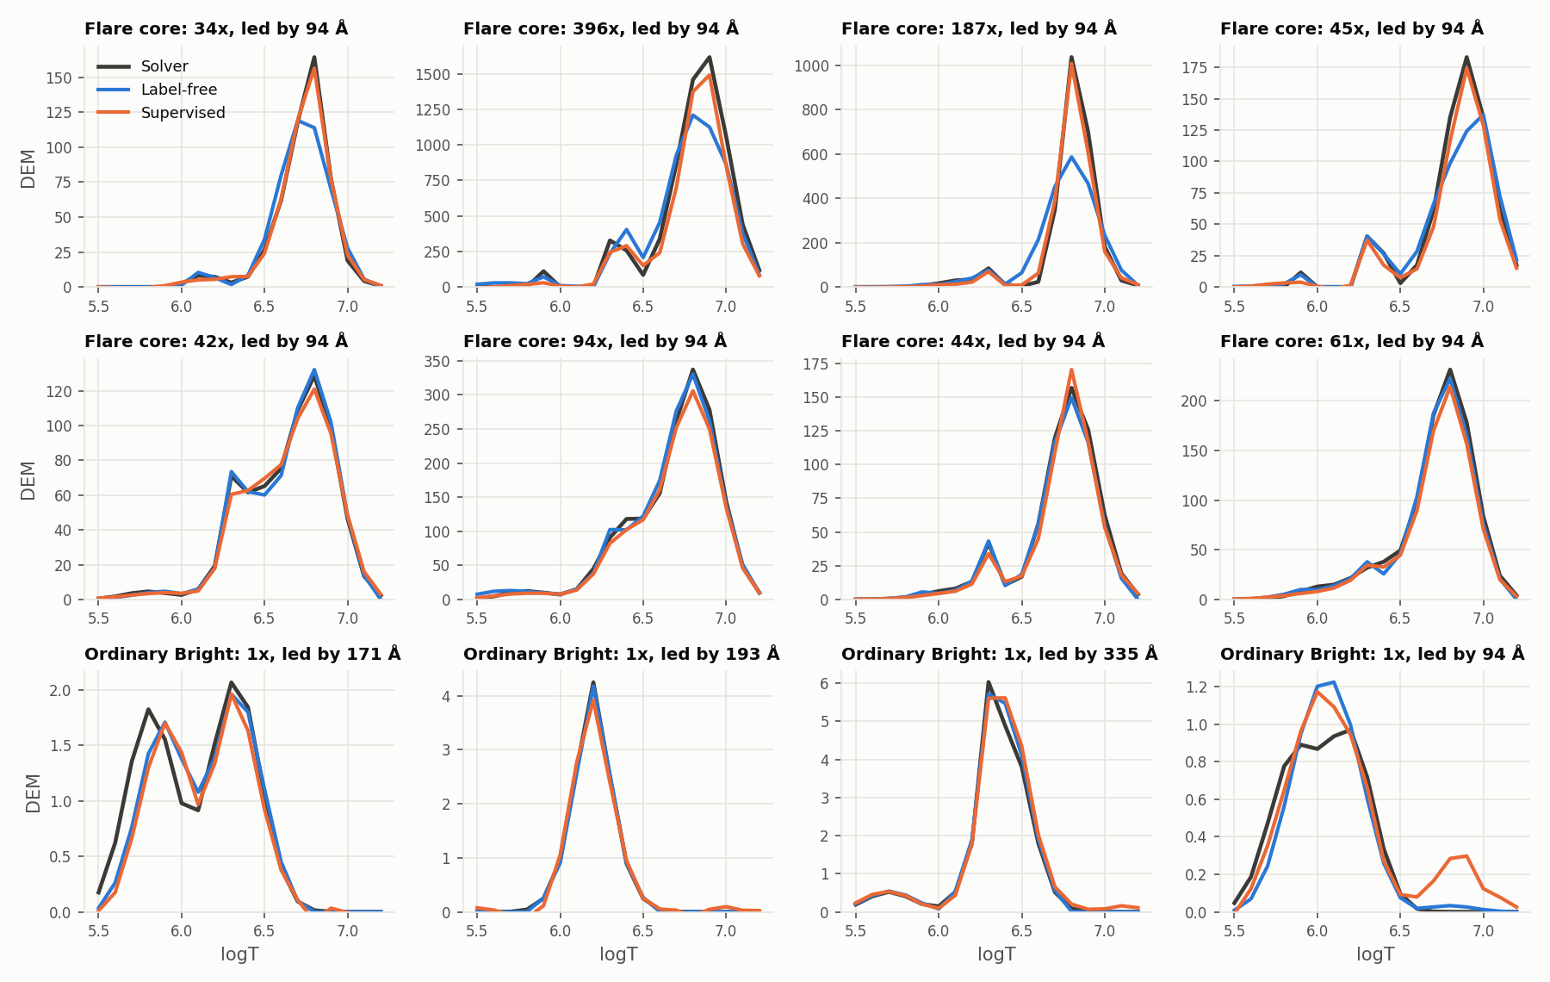
Figure 5.1. Example DEM curves on the BP track: solver, the 409k stiff-band model and supervised, at eight flare cores and four ordinary Bright pixels of the test set (source: results/plots/22_adopted_bp_20261014/fig4_example_curves_bp.png)
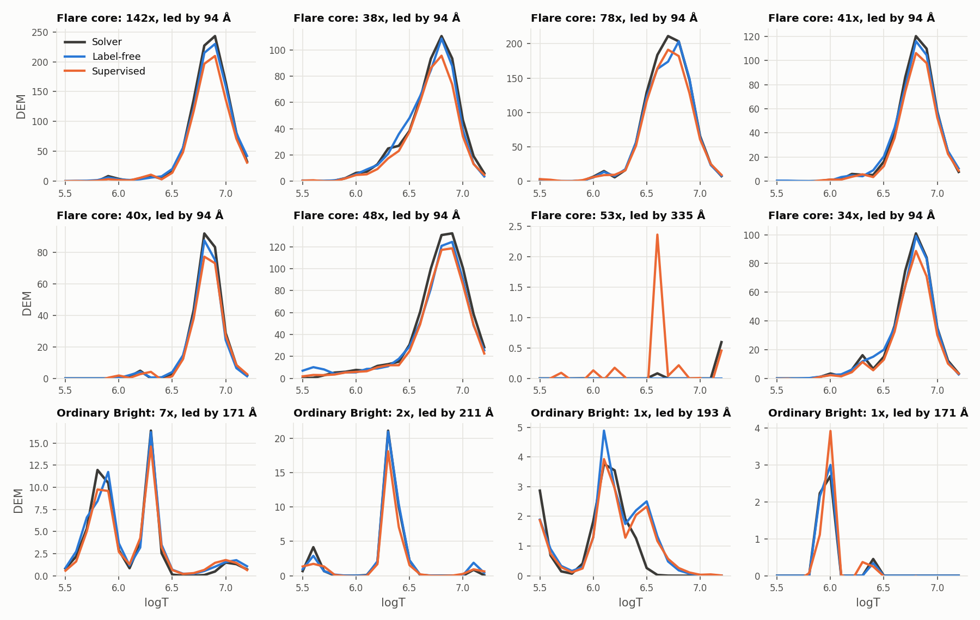
Figure 5.2. The same for the ElasticNet track, with the ElasticNet model (source: results/plots/22_adopted_bp_20261014/fig4_example_curves_enet.png)

5.2 The typical pixel and the mean disagree
Table 5.3. Per-pixel squared error (sum over the 18 bins) at the percentiles, and where the total squared error sits. Flare cores are the pixels at 32 times the Bright cutoff and above: 69,283 of the 705 million BP pixel-targets (0.010%) and 75,832 of the 802 million on ElasticNet. The last row removes them and averages the rest.
 | BP final | BP 409k stiff-band | BP supervised | ENet label-free | ENet supervised
Median pixel error | 0.031 | 0.036 | 0.112 | 0.85 | 1.12
p90 | 1.82 | 1.86 | 1.95 | 7.76 | 8.51
p99 | 25.7 | 24.5 | 26.9 | 29.5 | 35.5
p99.9 | 169 | 170 | 162 | 102 | 178
Share of SSE in the worst 1% of pixels | 96.4% | 97.7% | 95.2% | 54.9% | 49.4%
Share of SSE in flare cores | 92.0% | 94.2% | 90.0% | 44.5% | 33.9%
DEM MSE without flare cores | 0.087 | 0.102 | 0.091 | 0.172 | 0.210

On the typical BP pixel the final model is 3.6 times closer to the solver than the supervised model (median 0.031 against 0.112). It stays ahead up to the 99th percentile (p90 1.82 against 1.95, p99 25.7 against 26.9). The order flips only in the last 0.1% (p99.9 169 against 162), and because the error is so heavy-tailed those pixels set the mean: the worst 1% of pixels hold 96.4% of the final model's BP squared error and 95.2% of the supervised model's, and flare cores alone, one pixel in 10,000, hold 92.0% and 90.0%. Without flare cores the final model is ahead, 0.087 against 0.091 (the 409k stiff-band model was behind, 0.102). On ElasticNet the label-free model is ahead at every percentile, and flare cores hold 44.5% of its error against 33.9% of the supervised model's; without them it leads by a wider margin (0.172 against 0.210).
Table 5.4. DEM MSE of each label-free model divided by the supervised model's, by brightness band (the largest channel over its Bright cutoff; pixel shares from the BP track).
Band | Share of pixels | Final BP / supervised | 409k stiff-band / supervised | Old BP / supervised | ElasticNet / supervised
below 0.03 | 3.9% | 0.64 | 0.55 | 0.64 | 1.06
0.03 to 0.1 | 10.5% | 0.79 | 0.70 | 0.80 | 1.02
0.1 to 0.3 | 33.0% | 0.83 | 0.81 | 0.96 | 0.98
0.3 to 1 | 42.5% | 1.01 | 0.98 | 1.84 | 0.93
1 to 1.8 (Bright) | 6.5% | 1.04 | 1.16 | 2.16 | 0.82
1.8 to 3.2 | 2.3% | 0.97 | 1.25 | 2.57 | 0.76
3.2 to 10 | 1.2% | 0.85 | 0.88 | 4.96 | 0.51
10 to 32 | 0.08% | 0.98 | 1.89 | 17.5 | 0.47
32 and above (flare cores) | 0.010% | 1.22 | 2.02 | 4.74 | 1.28

The final BP model is ahead on the faintest 47% of pixels (ratios 0.64 to 0.83), within 4% of the supervised model from 0.3 to 1.8 times the cutoff, ahead again from 1.8 to 32 times (0.85 to 0.98), and behind only at flare cores (1.22). The 409k stiff-band model was slightly closer on the faintest pixels but behind by 1.89 and 2.02 from 10 times the cutoff upward, and the old model's ratios ran from 0.64 to 17.5; the stiff band (section 6) removed that failure and the extra width with clamp pixels took most of the rest. The ElasticNet model sits at 0.47 to 0.98 of the supervised error everywhere from 0.1 times the cutoff to 32 times, at 1.02 to 1.06 on the two faintest bands, and at 1.28 at flare cores.
What remains at BP flare cores is a shortfall in height rather than a misplaced curve: the final model holds 96.7% of the solver's emission there, its peak height is 0.89 of the solver's (supervised 0.91), its mean logT shift is -0.01 dex, and 83% of its squared error there lies along the solver's curve. The 409k stiff-band model held 92.6% and 66%; the old model held 40% and 23%, and shifted 0.18 dex cooler. The final model flags fewer flare-core pixels as multi-peaked than the solver (14.2% against 18.3%; the supervised model 12.8%; the 409k stiff-band model drew too many, 25.4%). Section 8 takes up the multi-peaked DEMs.
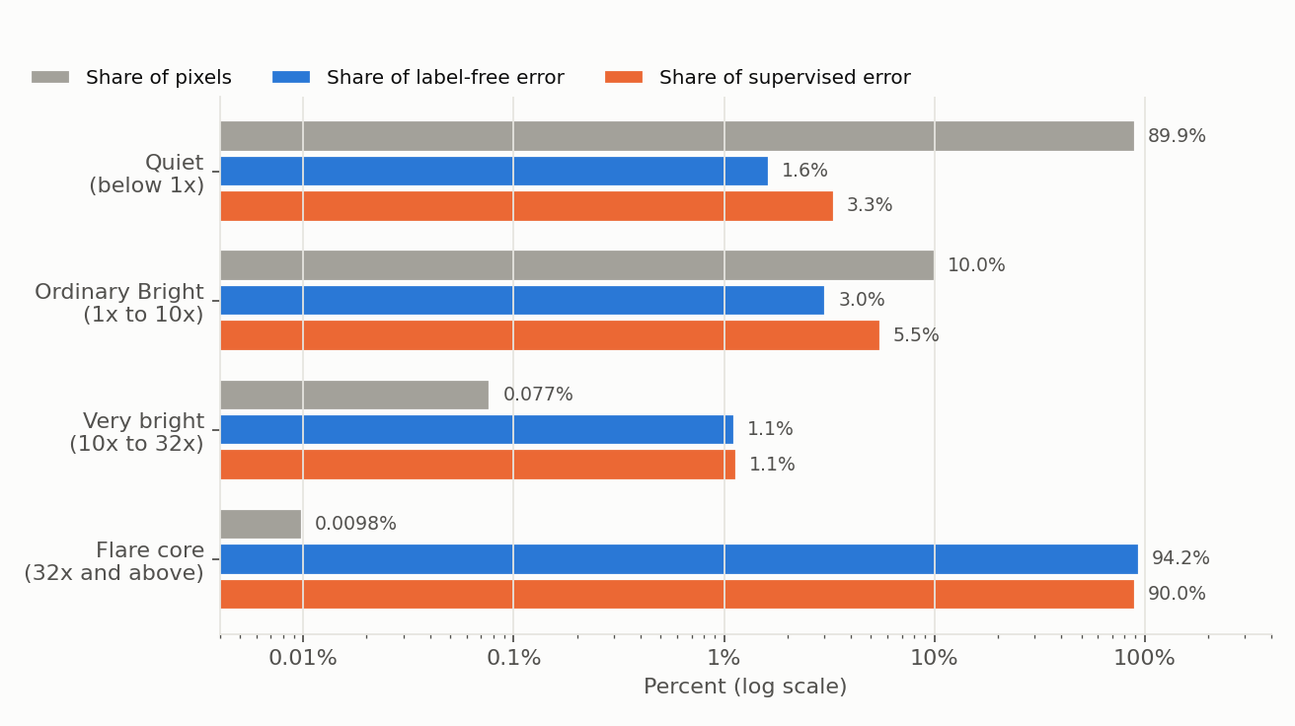
Figure 5.3. Share of pixels against share of DEM squared error in four brightness groups, BP track, for the 409k stiff-band model: flare cores are 0.0098% of pixels and 94.2% of its error, 90.0% of the supervised error (source: results/plots/22_adopted_bp_20261014/fig1_error_share_by_brightness.png)
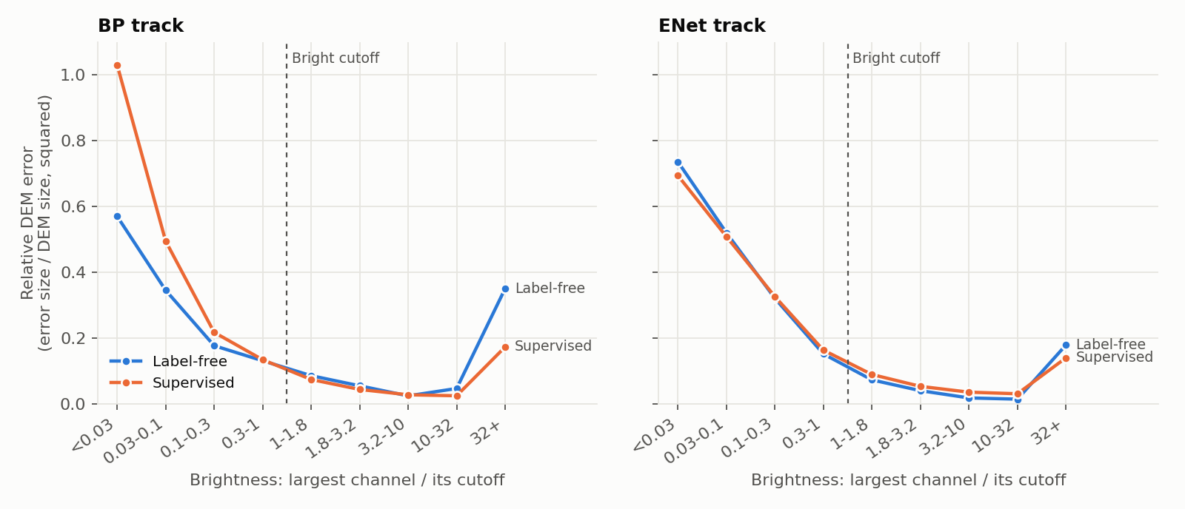
Figure 5.4. Relative DEM error (error energy over reference energy) by brightness band, both tracks, the 409k stiff-band model and the ElasticNet model against supervised (source: results/plots/22_adopted_bp_20261014/fig2_relative_error_by_brightness.png)

5.3 AIA reconstruction
Each DEM is pushed back through the response matrix and compared with the six observed channels. Pooled over all valid pixels, the BP track gives AIA MAE / MSE of 3.54 / 148 for the final model, 2.95 / 157 for the supervised model and 4.26 / 61.9 for the solver; the ElasticNet track gives 0.56 / 161, 6.32 / 598 and 1.41 / 134. At flare cores the per-channel picture is the following.
Table 5.5. Reconstructed over observed intensity per channel, summed over the flare cores of the test set (1.00 is exact).
Channel | BP solver | BP final | BP 409k stiff-band | BP supervised | ENet solver | ENet label-free | ENet supervised
94 Å | 0.92 | 0.88 | 0.77 | 0.85 | 0.55 | 0.53 | 0.48
131 Å | 1.01 | 1.00 | 1.01 | 0.90 | 0.78 | 0.80 | 0.68
171 Å | 0.99 | 1.00 | 1.00 | 0.78 | 1.00 | 0.97 | 0.70
193 Å | 1.01 | 1.00 | 1.00 | 0.90 | 0.98 | 0.97 | 0.76
211 Å | 0.98 | 0.99 | 0.99 | 0.90 | 0.98 | 0.97 | 0.76
335 Å | 1.04 | 1.04 | 1.09 | 0.96 | 0.94 | 0.93 | 0.76

On BP the final model reproduces 131, 171, 193 and 211 Å at flare cores to within 1% and over-reproduces 335 Å by 4%, as the solver does. The one gap is 94 Å, the channel that sees the hot plasma: 88% of the observed signal against the solver's 92% and the supervised model's 85% (409k stiff-band model 77%, old model 23%). The supervised model is now further from the observation on every channel but 335 Å (0.96), and 22% short on 171 Å. Away from flare cores the final model tracks the solver band by band, including the solver's own shortfall on the faint channels where the band permits it (94 Å at 0.3 to 1 times the cutoff: 0.81 label-free, 0.82 solver; 131 Å below 0.03 times the cutoff: 0.29 and 0.32), whereas the supervised model does not follow the solver there (131 Å at 1.65 on the faintest band).
On ElasticNet the solver itself reproduces only 55% of 94 Å at flare cores, and the label-free model reproduces the channels the way its solver does, within 3 points on every channel (94 Å 53% against 55%). The supervised model falls 24% to 32% short on five channels and reaches 48% on 94 Å. On the 409k stiff-band model the BP 94 Å gap was a training gap and not a loss gap: section 6 shows the best answer under the stiff loss reproduces 93% of 94 Å at the validation flare cores. The same check has not been run on the final model.
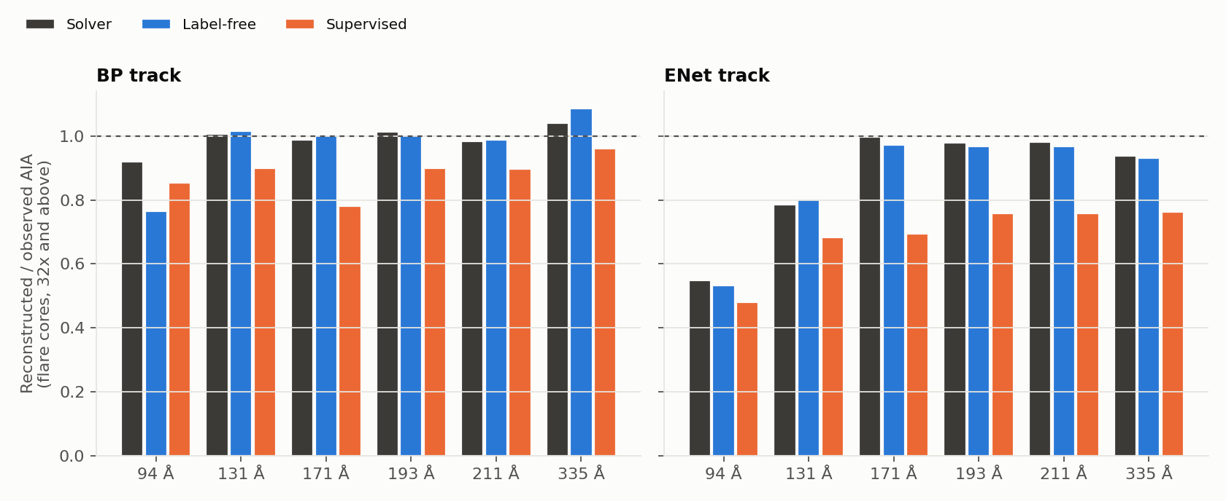
Figure 5.5. Reconstructed over observed AIA at flare cores, per channel, both tracks: solver, label-free (the 409k stiff-band model on BP) and supervised (source: results/plots/22_adopted_bp_20261014/fig5_aia_fit_flare_cores.png)

5.4 Architecture and size
The patch CNN against the per-pixel MLP at scale. Both were trained on the same 917 images with fresh pixels, log1p input, 40 epochs, the original BP loss (μ = 1) or the ElasticNet objective, and matched in size: the CNN sees a 9 by 9 patch at stride 2 through three 3 by 3 convolutions of 64 channels and layers of 256, 256 and 54 (1.48M parameters); the MLP is width 680 on the centre pixel (1.43M). Table 5.6 scores each track's own training loss per pixel on 5,013,504 sampled test pixels.
Table 5.6. Per-pixel training loss on the test split, MLP against patch CNN.
 | BP MLP | BP CNN | ENet MLP | ENet CNN
Median | 0.98 | 1.01 | 0.020 | 0.033
p90 | 4.62 | 4.74 | 0.137 | 0.154
p99 | 17.9 | 18.8 | 0.47 | 0.52
p99.9 | 51 | 57 | 1.19 | 1.44
Mean | 2.07 | 2.24 | 0.057 | 0.245
Share of the mean in the worst 0.1% of pixels | 5.6% | 9.7% | 8.2% | 73.4%
Largest single-pixel loss | 7,622 | 421,309 | 1,490 | 622,832
AIA MAE (DN/s) | 4.93 | 4.73 | 0.54 | 0.82
Sparsity score on the 54 weights (solver 1.79) | 1.90 | 2.03
Validation loss | 2.155 | 2.248 | 0.0528 | 0.0683

The MLP is lower at every percentile on both tracks, and validation agrees with test. The CNN's one win is BP AIA MAE (4.73 against 4.93). The four-fold gap in the ElasticNet mean is mostly a few CNN pixels: its worst 0.1% hold 73.4% of its loss and its largest single-pixel loss is 622,832 against the MLP's 1,490.
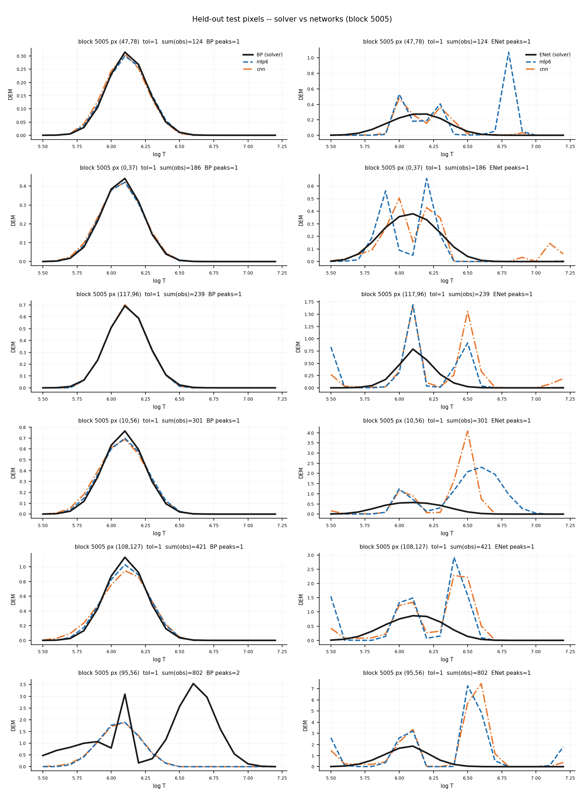
Figure 5.6. Held-out test pixels of one block: solver DEM against the MLP and the patch CNN, BP track on the left and ElasticNet on the right (source: results/plots/18_cnn_vs_mlp_resample_20261003/dem_curves_block05005.png)
The width sweep. Seven MLP widths per track, fresh pixels, log1p input, 40 epochs, clamp pixels excluded, the original BP loss (μ = 1) or the ElasticNet objective; the parameter counts are for the six raw inputs (the same widths with the Fourier input are 409k at 336 and 1.5M at 680). The validation loss is each track's training loss on the first four validation images and needs no solver DEM.
Table 5.7. Width sweep on the shared test set; validation loss from training.
Width | Parameters | BP validation loss | BP median | BP DEM MSE | BP flare-core emission | ENet validation loss | ENet median | ENet DEM MSE | ENet AIA MSE
680 | 1.43M | 2.155 | 0.023 | 5.10 | 20% | 0.0528 | 0.81 | 36.2 | 908,611
480 | 722k | 2.167 | 0.025 | 5.15 | 19% | 0.0533 | 0.85 | 3.24 | 41,849
336 | 360k | 2.148 | 0.026 | 4.28 | 40% | 0.0575 | 1.07 | 0.48 | 650
232 | 176k | 2.237 | 0.030 | 5.28 | 15% | 0.0689 | 1.70 | 0.79 | 414
160 | 87k | 2.251 | 0.043 | 5.15 | 19% | 0.0614 | 1.55 | 0.64 | 199
108 | 42k | 2.261 | 0.047 | 4.58 | 35% | 0.0707 | 2.24 | 0.83 | 217

Bigger helps the typical pixel a little: the BP median pixel error falls from 0.068 at 20k parameters (width 72) through 0.030 at 176k to 0.023 at 1.43M, and the ElasticNet median from 2.24 at 42k to 0.81 at 1.43M. Width 48 (10k) collapsed on BP (validation loss 61.4, median 1.55). DEM MSE, by contrast, is erratic across widths because flare cores set it: BP flare-core emission jumps between 12% and 40% with no trend. On the original BP loss, width 336 is the validation choice (2.148; 1.43M ties at 2.155 and only nudges the median at four times the size). On ElasticNet the honest note applies: validation preferred the bigger models (0.0533 at 722k, 0.0528 at 1.43M, against 0.0575 at 336), but on the full test set 722k and 1.43M blow up on a handful of rare pixels (AIA MSE 41,849 and 908,611 against 650; DEM MSE 3.24 and 36.2 against 0.48) that the validation sample never contained, so 336 was kept as the largest stable width on test evidence. The ElasticNet epochs were settled the same way: 120 epochs improves DEM MAE, the median, EM error, W1 and AIA MAE but worsens DEM MSE from 0.310 to 0.362, so 40 stays. The earlier, fixed-sample sweep had concluded that 176k was enough; that conclusion did not survive fresh pixels.
Larger models and the clamp pixels. Table 5.8 collects every larger model trained, each next to its run with clamp pixels kept where one exists.
Table 5.8. Size and clamp pixels, shared test set. "Excluded" drops every pixel with a clamped channel from training; "kept" keeps them and frees only the clamped channels from the loss.
Model | Parameters | Loss | Clamp pixels | DEM MSE | AIA MSE | Quiet MSE | Median
Final BP model (width 680, 120 epochs) | 1.5M | stiff band | kept | 1.08 | 148 | 0.033 | 0.031
BP width 680, 120 epochs | 1.5M | stiff band | excluded | 897 | 21.7M | 12.5 | 0.034
409k stiff-band model (width 336, 120 + 120 epochs) | 409k | stiff band | excluded | 1.75 | 103 | 0.032 | 0.036
BP width 336, 40 epochs | 409k | stiff band | excluded | 2.37 | 44 | 0.035 | 0.062
BP width 336, 40 epochs | 409k | stiff band | kept | 2.79 | 45 | 0.035 | 0.056
BP width 1800, 40 epochs | 10.1M | stiff band | excluded | 35.7 | 1.7M | 0.070 | 0.041
BP width 1800, 40 epochs | 10.1M | μ = 1 | excluded | 5.10 | 125 | 0.058 | 0.022
ElasticNet model (width 336, 40 epochs) | 409k | ElasticNet | excluded | 0.310 | 161 | 0.122 | 0.85
ElasticNet width 336, 40 epochs | 409k | ElasticNet | kept | 0.439 | 162 | 0.212 | 1.55
ElasticNet width 1800, 40 epochs | 10.1M | ElasticNet | excluded | 2,062 | 83M | 5.22 | 0.78
ElasticNet width 1800, 40 epochs | 10.1M | ElasticNet | kept | 1.82 | 1.5 × 10⁵ | 0.227 | 1.48
ElasticNet width 480 (sweep, log1p) | 722k | ElasticNet | excluded | 3.24 | 41,849 | 0.123 | 0.85
ElasticNet width 680 (sweep, log1p) | 1.43M | ElasticNet | excluded | 36.2 | 908,611 | 0.123 | 0.81

With clamp pixels excluded the pattern is the same each time: the typical pixel is as good as or better than the 336-wide model's (the medians in the last column), and a few pixels fail by orders of magnitude. The 680-wide stiff-band model has a median of 0.034 and a DEM MSE of 897, with the worst 1% of its pixels carrying 99.996% of the squared error; at flare cores it over-predicts 171 Å three-fold. The stiff-band 10M model fits 98% of pixels as well as width 336 (MSE 0.037 against 0.036) and its worst 0.1% carry 14 times the error of the 336-wide model's worst 0.1%. On the original loss the 10M model does not blow up but helps nothing either: a median within 5% of the base model's (0.022 against 0.023) and 20% of the solver's emission at flare cores against 35%. The ElasticNet 10M model over-predicts flare-core emission two-fold (216%).
Larger models blow up on scores only when trained without the clamp pixels. Section 7.1 shows that the failing pixels are inputs training excluded, and that keeping them removes the score blow-ups: the 680-wide BP model goes from DEM MSE 897 to 1.08 and becomes the best BP model we have, and the ElasticNet 10M model from 2,062 to 1.82. The small models lose from the same change (BP 409k at 40 epochs 2.37 to 2.79; ElasticNet 409k 0.310 to 0.439, with Quiet MSE 0.122 to 0.212 and the median 0.85 to 1.55), so the ElasticNet final stays at 409k without them. The ElasticNet 10M model still trails the 409k model and keeps a very large AIA MSE (1.5 × 10⁵); an ElasticNet 1.5M model with clamp pixels has not been run.
Spatial context does not help: the earlier evidence. On the four-day, 128 by 128 crop data the patch CNN looked better than a capacity-matched centre-pixel MLP in sample (sparsity score 1.70 against 1.89, solver 1.79), but that edge came from scoring pixels of days it had trained on. Leave-one-day-out, training on three days and scoring the fourth, gave held-out sparsity scores of 1.59, 1.78, 1.83 and 1.96 for the MLP against 1.64, 1.61, 1.83 and 2.31 for the CNN: the MLP wins two folds (including the X1.6 flare day), ties one and loses one (quiet sun), with the better held-out MAE on three of four. Re-scoring both on 400 held-out pixels per day gave DEM MAE 0.042 for the MLP against 0.047 for the CNN (W1 0.043 against 0.048 dex). The scaled comparison above is the fifth look at the question, and none has found a CNN advantage on unseen images, so the final models take one pixel and no neighbourhood.
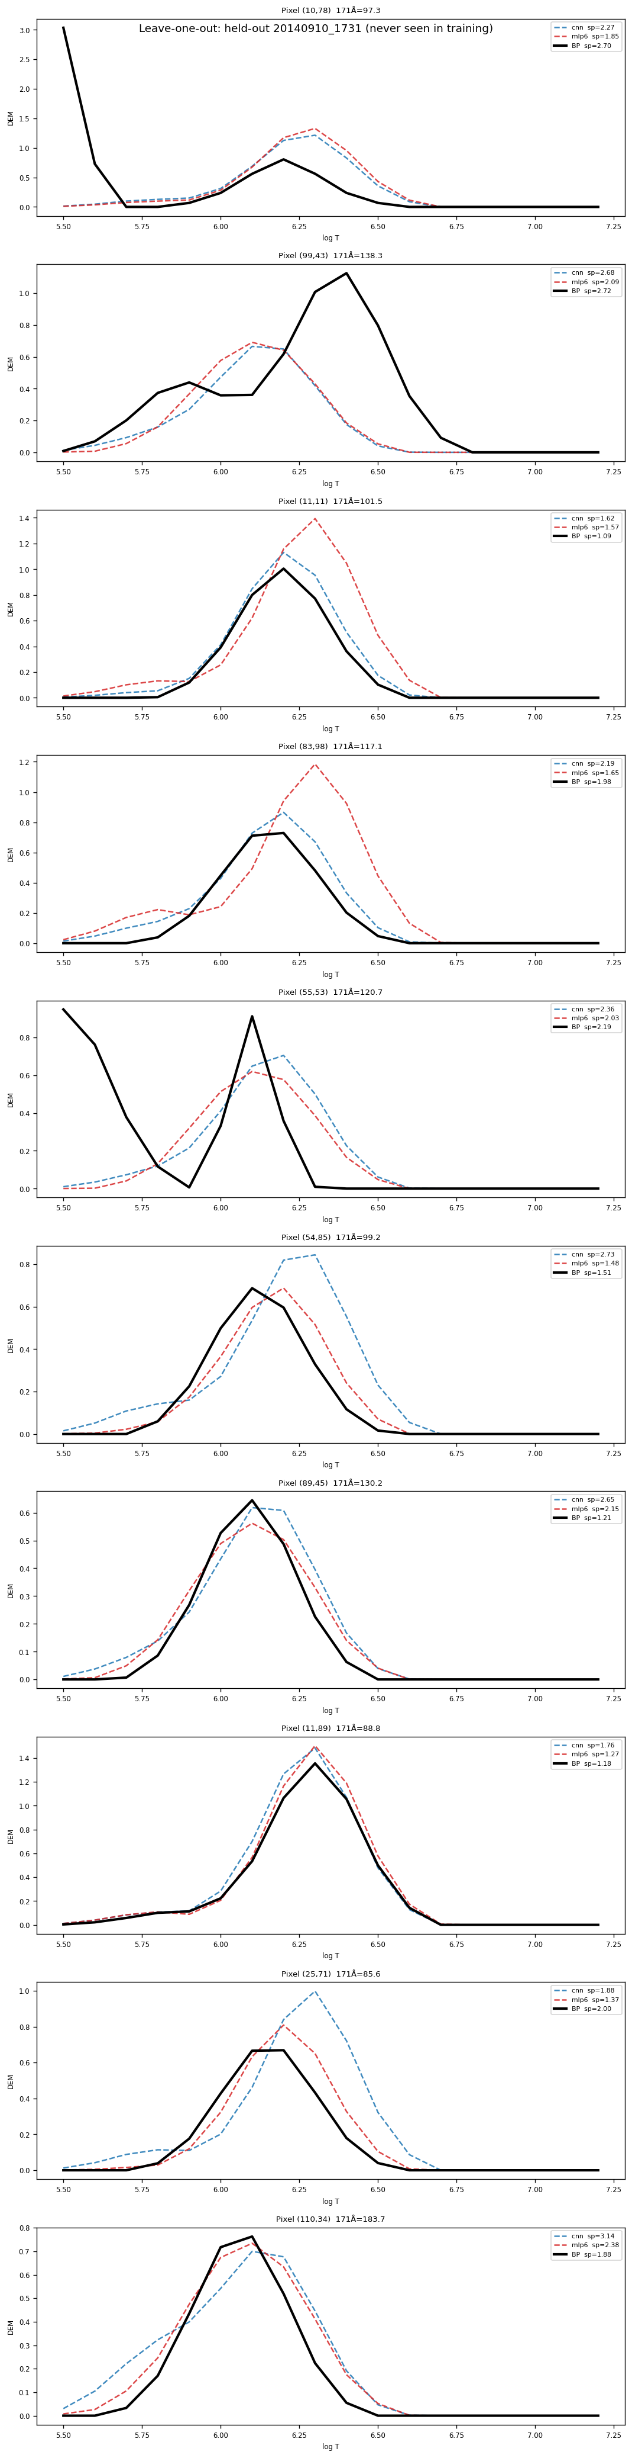
Figure 5.7. Leave-one-day-out on the X1.6 flare day, never seen in training: solver against the MLP and the patch CNN, ten pixels of the crop (source: results/plots/09_loo_20260711/loo_heldout_20140910_1731.png)
Sources: results/plots/23_meeting_followup_20261024/bp_h232_h680_clampmask.json (final model: DEM MSE, EM error, W1, Quiet MSE, the 0.0001 dex percentiles, the worst-pixel removal), bp_bright_failure_fu_bp_h680_clampmask.{json,txt} (DEM MAE as the mean of population.full.mae_by_logt, by-band DEM MSE, flare-core emission, peak, shift, along-curve share, multi-peaked rates, the 0.02 dex percentiles), bp_aia_fit_fu_bp_h680_clampmask.txt (BP per-channel reproduction and pooled AIA numbers), bp_jpdf_pixels_h680_clamp.txt (Quiet MSE 0.0331 and 0.0335), and in the same folder bp_bright_failure_fu_bp_clampmask.txt, bp_aia_fit_fu_bp_clampmask.txt, enet_bright_failure_fu_enet_clampmask.txt, enet_aia_fit_fu_enet_clampmask.txt, enet_bright_failure_fu_enet_10m_clampmask.txt, enet_aia_fit_fu_enet_10m_clampmask.txt (the clamp rows of Table 5.8); STATE.md (2026-10-14 block; 2026-10-04 blocks; 2026-10-03 fresh-pixel sweep and first-MLP rerun; 2026-10-03 resample table for the ENet width-232 AIA MSE), results/followup_recap_20261013.md (Parts 8 to 11), results/plots/21_followup_20261006/summary.json (the other BP and ElasticNet run metrics: DEM MAE/MSE, EM error, W1, AIA MAE/MSE, Quiet MSE, flare-core emission and 94 Å, median), results/plots/21_followup_20261006/bp_bright_failure_fu_bp_mu100_ep120_cont.{json,txt} (409k stiff-band model: percentiles, worst-1% share, by-band DEM MSE, flare-core emission, peak and shift, multi-peaked rates), results/plots/21_followup_20261006/bp_aia_fit_fu_bp_mu100_ep120_cont.{json,txt} (its per-channel reproduction and pooled AIA numbers), results/plots/21_followup_20261006/bp_bright_failure_fu_bp_mu100_h680_ep120.txt and bp_bright_failure_fu_bp_mu100_10m.txt (the blow-up tails), results/plots/19_final_models_20261004/bp_bright_failure_final.json (old model percentiles and by-band DEM MSE), results/plots/19_final_models_20261004/enet_bright_failure_final.json and enet_aia_fit_final.json (ElasticNet percentiles, by-band DEM MSE, per-channel and pooled AIA), results/plots/19_final_models_20261004/README.txt, results/plots/13_bright_diagnostic_20260928/bp_bright_failure_supervised.{json,txt} and enet_bright_failure_supervised.{json,txt} (supervised percentiles and by-band DEM MSE), results/plots/22_adopted_bp_20261014/README.txt (figure provenance), results/plots/18_cnn_vs_mlp_resample_20261003/eval_scaled_tail_summary.json, eval_scaled_summary.json, eval_tail_20005027.log and eval_rs_19108218.log (CNN against MLP), results/plots/17_sweep_resample_20261003/sweep_table.txt and enet_aia_fit_resample_h{680,480,336,160,108}.txt (width sweep), slides/deck_outline.md (slides 2, 9, 10, 12, 13: the CNN architecture, DEM MSE without flare cores for the 409k stiff-band and ElasticNet models, validation numbers), CLAUDE.md (2026-07-02 ablation, 2026-07-11 leave-one-day-out, 2026-10-10 and 2026-10-13 blow-ups). The ratios in Table 5.4 and the "DEM MSE without flare cores" row of Table 5.3 are computed from the full-population and by-band rows of the diagnostic JSONs named above.

6. Flare cores: the failure and the fix
Flare cores, the pixels at 32 times the Bright cutoff and above, are about one pixel in 10,000 of the shared test set (69,283 of 705 million BP pixel-targets) and hold most of the BP DEM squared error for every model (section 5.2). On the BP track the old model failed there, and the cause was the loss, not training: under the original band weight (μ = 1) the best answer under the loss leaves the hot flare plasma out of the DEM, and the old model had already reached it. A stiffer band (μ = 100), chosen on validation, makes the loss ask for the hot plasma, and longer training takes the network most of the way there; the final BP model, wider and with clamp pixels in training, goes further (section 6.7). This section follows the work in order, so it is mostly about the 409k stiff-band model that came first. The ElasticNet track never had this failure (Appendix B).

6.1 The failure
At flare cores the old model (width 336, log1p input, μ = 1, 40 epochs) held 40% of the solver's emission. Its peaks were 23% as high as the solver's, its mean logT 0.18 dex cooler, its curves almost twice as wide (an emission-weighted width of 0.41 dex against 0.23), and 83% of them had extra peaks, against 18% of the solver's. Flare cores held 90.5% of its DEM squared error, but the supervised model puts 90.0% of its error there too: that concentration is what squared error does to DEMs a thousand times larger than typical. The label-free defect was the amount, with 97.6% of the flare-core error lying along the solver's curve rather than across it.
The AIA reconstruction showed which plasma was missing. At flare cores the old model's DEM reproduced 171, 193 and 211 Å to within 2%, as the solver's did, but only 23% of the observed 94 Å, 76% of 131 Å and 67% of 335 Å, where the solver reproduced 92%, 101% and 104%. 94 Å is the channel that sees hot flare plasma (logT about 6.9, 8 MK): where the solver draws a tall peak at logT 6.8 to 6.9, the old model draws a low bump near 6.3 to 6.4 and a tail near 7.0.
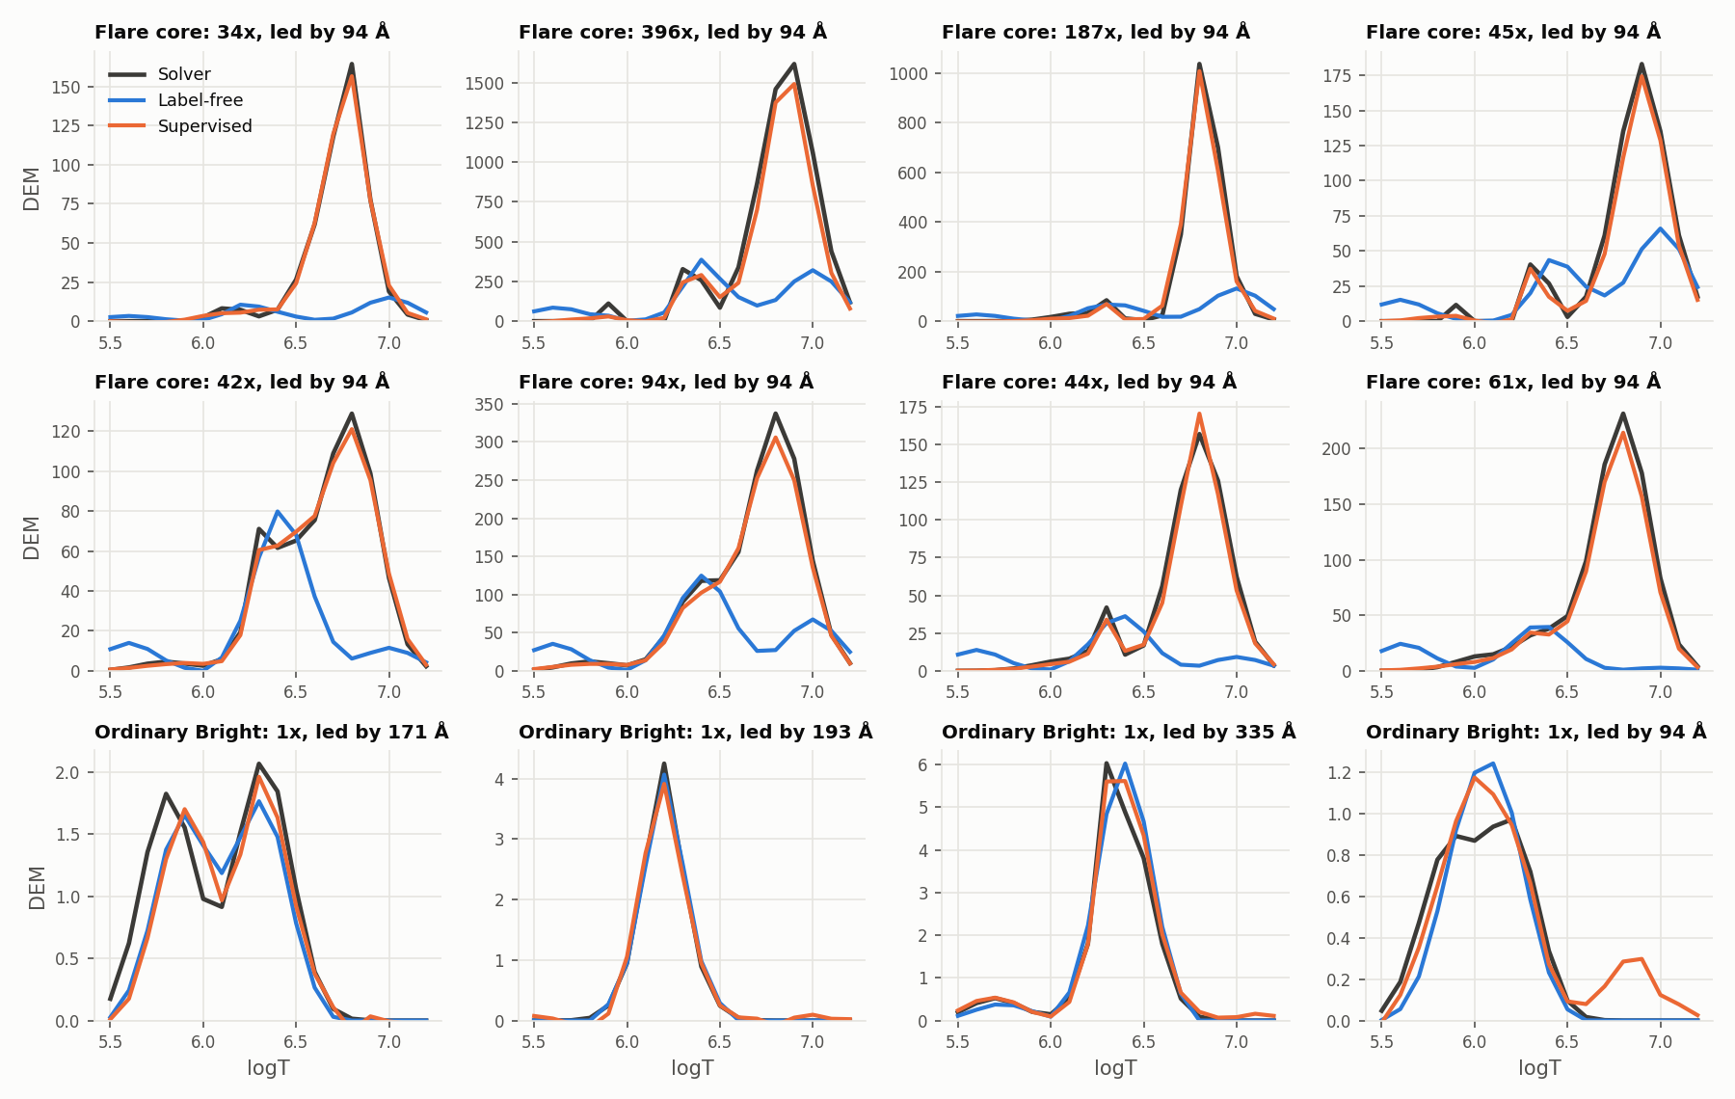
Figure 6.1. The old model at eight randomly drawn flare cores and four ordinary Bright pixels of the test set: solver in black, label-free in blue, supervised in orange. The same twelve pixels as Figure 5.1. (results/plots/19_final_models_20261004/fig4_example_curves_bp.png)
Two other explanations were ruled out: the solver's own scatter across re-solves of a block is 0.38% of the old model's Bright error (0.09% at flare cores), and pixels where the solver's DEM has two or more peaks and the model's one hold 1.25% of its squared error, so neither label noise nor missed second peaks is the cause. The diagnosis was first made in September on an earlier width-232 model trained on the fixed pixel sample of Appendix C (41% of the emission, 24% of 94 Å).
Because the network fit the cool channels and missed 94 Å, it seemed to be failing its own objective, which asks for every channel inside its band: a training problem. Hence the three suggestions: show it more flare cores, train it longer, make it bigger.

6.2 Training-side suggestions that did not help
Each suggestion was one change to a common recipe: width 336, fresh pixels, 40 epochs, μ = 1, and the square root plus 12 Fourier frequencies input the follow-up adopted for both tracks. This base is slightly worse than the old model (DEM MSE 4.56 against 4.28, flare-core emission 35% against 40%). Oversampling draws pixels in proportion to brightness (clipped to 1 to 1,000 times the Bright cutoff), so flare cores rise from about 1 in 8,900 training pixels to 1 in 1,060, about 8.4 times as often. The 10M model is 1,800 wide (10.1M parameters).
Table 6.1. The suggestions on the original loss (μ = 1), shared test set.
BP run, μ = 1 | DEM MSE | DEM MAE | Median pixel error | AIA MSE | Quiet MSE | Flare-core emission | Flare-core 94 Å
Base (square root + Fourier, 40 epochs) | 4.56 | 0.106 | 0.023 | 83 | 0.057 | 35% | 15%
Oversample flare cores | 5.05 | 0.106 | 0.025 | 87 | 0.058 | 24% | 9%
120 epochs | 4.21 | 0.105 | 0.022 | 108 | 0.057 | 37% | 16%
10M parameters | 5.10 | 0.106 | 0.022 | 125 | 0.058 | 20% | 8%

Away from flare cores the four runs score alike (DEM MAE 0.105 to 0.106, Quiet MSE 0.057 to 0.058). At flare cores none helps: oversampling empties the DEMs further (11% of the solver's emission on the validation flare cores, against the base's 34%), 120 epochs trims DEM MSE by 8% but moves flare-core emission only from 35% to 37% while AIA MSE rises from 83 to 108, and the 10M model holds 20%. Training harder did not move the failure, so the loss itself needed checking.

6.3 The objective gap
The BP loss is convex in the 54 weights, so each pixel has one lowest value, which an optimiser can find with no network. That minimiser is the best answer under the loss: no network can do better on that pixel. experiments/objective_gap.py finds it with L-BFGS-B (started from the network's output and from the solver's DEM, keeping the lower) on 11,954 validation pixels across the brightness bands, 6,000 of them flare cores. It then scores four answers under the same loss: the network's output, the best answer, the solver's DEM and the supervised model's DEM, the last two rewritten as the sparsest set of 54 weights that reproduces them.
Table 6.2. Flare cores of the validation split, every answer scored under the original loss (μ = 1): the sparsity term plus the band penalty.
Answer | Loss | Sparsity + band penalty | 94 Å reproduced | Emission vs solver | DEM MSE
Old network | 565 | 294 + 270 | 28% | 38% | 233,000
Best answer under the loss | 463 | 220 + 243 | 26% | 30% | 233,000
Solver's DEM | 1,125 | 1,119 + 6 | 94% | 100% | 0
Supervised model's DEM | 1,878 | 1,107 + 771 | 91% | 95% | 38,000

The network had converged on its loss. Its median loss sits 0.8% to 3.6% above the best answer in every band from 0.03 to 32 times the Bright cutoff, 7.4% in the faintest band and 8.0% at flare cores, where its DEM error equals the best answer's (233,000 for both). Over all validation pixels, weighted by band as in section 6.5, its DEM MSE is 36.9, the same as the best answer's. A perfect network would land on the best answer, which reproduces 26% of 94 Å and holds 30% of the solver's emission: on this loss no training change can fix flare cores.
The loss prefers the DEM without the hot plasma. The solver's DEM keeps every channel in its band (penalty 6) and pays 1,119 in sparsity for the hot plasma; the best answer drops most of it and pays 220 plus 243 in band penalty. The loss rates the solver's DEM 2.4 times worse than a DEM without the hot plasma (1.3 to 1.5 times in the other Bright bands), so every training step at a flare core moves away from the solver. The supervised model shows it from the other side: under our loss its DEM scores worst (1,878), yet it is the closest network to the solver (DEM MSE 38,000 against 233,000). A low loss does not mean close to the solver.
Two caveats. L-BFGS-B stopped at its iteration limit on 271 of the 11,954 pixels at μ = 1; the loss is convex, so the true minimum there is at or below the value found, which can only widen the solver's deficit. And flare cores are a larger share of the validation days than of the test days (0.015% of pixels against 0.0098%), so validation values run higher than test values: compare rows, not sections.

6.4 Why: the price of hot plasma
The solver and the loss share one goal, the DEM with the smallest total weight that reproduces the six observations, and differ in how they treat the band. For the solver the band is a rule: every channel must land inside it. For the loss it is a price: a channel may land outside whenever that saves more in sparsity than it costs in band penalty.
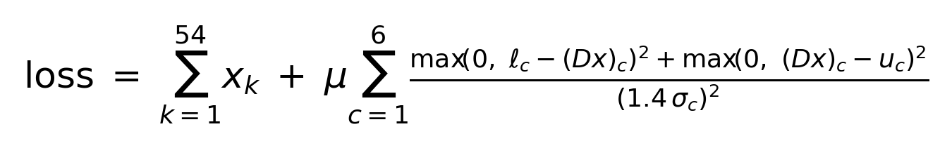
Figure 6.2. The BP training loss: the sum of the 54 weights (the sparsity term) plus μ times the band penalty over the six channels; x_k are the weights, (Dx)_c the channel the DEM reproduces, l_c and u_c the band edges, σ_c the noise; the penalty is zero inside the band and grows as the square of the distance outside it, in half band widths (source: results/plots/21_followup_20261006/loss_formula.png)
Table 2.2 (section 2.6) gives what each channel sees per unit of plasma, a unit being 10^26 cm^-5 of emission measure (the unit of the weights, the DEM and the sparsity term). Warm plasma (1 to 1.3 MK, logT 6.0 to 6.1) lights 171, 193 and 211 Å by several to tens of DN/s per unit; it has to be in the DEM for those channels, and its 94 Å signal comes free. At flare cores most of the 94 Å signal comes from hot plasma, which lights no channel by more than 0.4 DN/s per unit (a spike at logT 6.9, 8 MK, gives 0.266 DN/s of 94 Å, 0.40 of 131 Å and 0.34 of 193 Å), so a bright 94 Å reading needs hundreds of units, all paid in the sparsity term, and only 94 and 131 Å ask for them.
Take a typical flare core, counting 94 Å alone: it reads 164 DN/s with σ = 11.5, so its band runs from 148 to 180 (half width 16.1).
Table 6.3. The worked example at μ = 1.
Option | Sparsity | Band penalty | Total
Hot plasma in, as a spike at logT 6.9: 164 ÷ 0.266 ≈ 616 units | 616 | 0 | 616
Hot plasma in, as the 0.2 dex Gaussian centred at logT 6.8: 164 ÷ 0.67 ≈ 245 units | 245 | 0 | 245
Hot plasma out: 94 Å near 0, 148 below the band | 0 | (148 ÷ 16.1)² = 85 | 85

One unit of weight on a spike at logT 6.9 gives 0.266 DN/s of 94 Å, so including the hot plasma that way costs 616. The cheapest hot shape is the 0.2 dex Gaussian centred at logT 6.8, at 0.67 DN/s per unit, and including the plasma that way costs about 245. That is within 1% of the most 94 Å any basis element gives (0.676 DN/s per unit, the bound of 1.48 weight units per DN/s in section 3.3), which comes from the warm Gaussian at logT 6.1; that element also lights 171 Å by about 170 DN/s per unit, so it cannot stand in for hot plasma. Both exceed the 85 that leaving the plasma out costs at μ = 1, so the conclusion holds either way; at μ = 100 the same miss costs 8,500 and the plasma goes back in. The real price, the linear program's dual price of the 94 Å lower edge solved pixel by pixel, agrees: at the validation flare cores its median is 1.46 weight units per DN/s, at the single-edge bound, and it exceeds the bound at 49% of them (99th percentile 8.8), where another channel's upper edge also binds and makes the plasma dearer (section 3.3).
The failure grows with brightness because brighter pixels draw more of their 94 Å from hot plasma. On validation the best answer reproduces 91% of the observed 94 Å at 1 to 1.8 times the Bright cutoff, 92% at 1.8 to 3.2, 78% at 3.2 to 10, 44% at 10 to 32 and 26% at flare cores, where the solver's DEM reproduces 100%, 101%, 95%, 88% and 94%. The band itself is sound: σ follows photon counting, growing as the square root of the signal.
The same price explains why the label-free BP model emitted about 15% less than the solver even at ordinary pixels, a September finding left unexplained. Inside the band nothing pulls a channel toward its observation, so the sparsity term drags the emission down to the band's lower edge, where the solver's answer also sits; a squared penalty has zero slope at that edge, so with a finite μ it always pays to go a little past it. At 0.3 to 1 times the Bright cutoff the best answer emits 0.855 of the solver's emission at μ = 1, then 0.886, 0.941, 0.981 and 1.002 at μ = 3, 10, 30 and 100 (the first screen, on a sample of test pixels; the validation repeat gives 0.861 at μ = 1 and 1.009 at μ = 100). The old network sat at 0.866 in that sample. Over the full test set the old model emits 0.848 of the solver's emission, the 409k stiff-band model 0.984 and the final BP model 0.988.

6.5 The μ screen on validation
The screen tests the loss, not a network. For each μ it solves every validation pixel's best answer and scores it against the solver's DEMs, asking how close to the solver a network that learned this loss perfectly would get. The DEM error is the DEM MSE with each brightness band weighted by its share of the validation split; the Quiet MSE is the same over the bands below the Bright cutoff.
Table 6.4. The μ screen: the best answer under each loss on the validation split, with the supervised model (a trained network) for reference.
Loss | DEM error | Quiet MSE | Flare-core 94 Å | Flare-core emission
μ = 1 (original) | 36.9 | 0.076 | 26% | 30%
μ = 10 | 10.8 | 0.037 | 81% | 90%
μ = 30 | 5.10 | 0.032 | 89% | 97%
μ = 100 | 2.32 | 0.041 | 93% | 100%
μ = 300 | 1.80 | 0.048 | 94% | 101%
Supervised model | 6.10 | 0.054 | 91% | 95%

Stiffer helps bright pixels and costs faint ones. The DEM error falls to a minimum near μ = 300 (1.89 at 200, 1.80 at 300, 2.16 at 1,000). The Quiet MSE is lowest at μ = 20 to 30 (0.031 to 0.032) and rises beyond: at faint pixels the band is mostly noise, and a stiff band makes the best answer chase it. At a flare core, by contrast, a price 100 times higher works like the solver's rule.
μ = 100 takes most of the gain (DEM error 2.32) with the Quiet MSE still below the supervised model's (0.041 against 0.054); μ = 300 lowers the DEM error only to 1.80 and raises the Quiet MSE to 0.048. The flare-core 94 Å column, which compares the reconstruction with the observation and so needs no solver DEM, plateaus at μ = 100 (93%, then 94% at 300 and 95% at 1,000). The stiff band is still not the solver's rule: at the validation flare cores it rates the solver's DEM about 1.3 times worse than its best answer (1,688 against 1,264), but that best answer now holds the hot plasma.
A second candidate (μ = 30 with the sparsity term divided by the square root of brightness on Bright pixels) screened nearly as well, DEM error 1.95, but trained worse (section 6.6). μ is one scalar chosen on validation with the solver's DEMs, like any loss weight; training never sees them. An earlier screen on test pixels was repeated on validation, which kept μ = 100, and the choice rests on validation alone. Section 3.3 gives the theory: the band violation at the best answer falls as 1/μ, so μ follows from the response matrix, the noise and a chosen tolerance, with no solver DEM.

6.6 The stiff-band runs
The recipe stays the same (width 336, square root plus 12 Fourier frequencies, fresh pixels, clamp pixels excluded); the runs vary the training length, the sampling and the size. The row above the supervised model in Table 6.5 repeats the 680-wide run with clamp pixels kept (section 7.1).
Table 6.5. BP runs on the stiff band (μ = 100), shared test set. The validation error is the DEM error of Table 6.4 for the trained network.
BP run | DEM MSE | Median pixel error | AIA MSE | Quiet MSE | Flare-core emission | Flare-core 94 Å | Validation error
Original loss, base (reference) | 4.56 | 0.023 | 83 | 0.057 | 35% | 15% | 39.7
40 epochs | 2.37 | 0.062 | 44 | 0.035 | 89% | 68% | 20.1
120 epochs | 2.00 | 0.041 | 44 | 0.032 | 92% | 75% | 17.8
240 epochs from scratch | 1.74 | 0.036 | 591 | 0.035 | 91% | 73% | 14.0
120 + 120 epochs, continued (the 409k stiff-band model) | 1.75 | 0.036 | 103 | 0.032 | 93% | 77% | 15.8
Oversample flare cores, 40 epochs | 2.50 | 0.071 | 39 | 0.037 | 88% | 63% | 21.1
10M parameters, 40 epochs | 35.7 | 0.041 | 1.7M | 0.070 | 92% | 74% | not scored
680 wide (1.5M), 120 epochs | 897 | 0.034 | 21.7M | 12.5 | 115% | 78% | 4,170
680 wide (1.5M), 120 epochs, clamp pixels in training: the final BP model | 1.08 | 0.031 | 148 | 0.033 | 97% | 88% | not scored
Supervised model | 0.91 | 0.112 | 157 | 0.033 | 92% | 85% | 6.10

The band alone halves the DEM MSE (4.56 to 2.37) and lifts flare-core emission from 35% to 89%. Training then becomes the limit: at the validation flare cores the 40-epoch network's loss sits a median 118% above its best answer (the old network on the old loss: 8%). Longer training therefore helps; after 120 epochs the gap is 47%, the DEM MSE 2.00 and the flare-core 94 Å 75%.
240 epochs from scratch misfits rare pixels. It keeps improving the DEM (MSE 1.74, validation error 14.0), but its AIA MSE rises from 44 to 591 and its Quiet MSE from 0.032 to 0.035: a few pixels break the band badly, and on the validation flare cores its mean band penalty is 129 times the 120-epoch model's.
120 + 120 epochs, continued, is the 409k stiff-band model, the best BP model until the clamp runs. Warm-started from the 120-epoch checkpoint with a fresh cosine schedule, it gets the same DEM gains (MSE 1.75, median pixel error 0.036) while holding the AIA MSE at 103, below the supervised model's 157, with a flare-core band penalty 13 times the 120-epoch model's. It improves on the 120-epoch model in every measure except AIA MAE and AIA MSE. Not chosen: 120 epochs alone (AIA MSE 44 but DEM MSE 2.00) and 240 from scratch.
Nothing else helps. Oversampling still hurts (DEM MSE 2.50, median pixel error 0.071). The 10M and 680-wide models blow up on rare pixels while their median pixel error stays low (section 5.4). Section 7.1 shows which pixels, and that keeping them in training takes the 680-wide model from DEM MSE 897 to 1.08: that run is the final BP model. log1p input is worse than square root plus Fourier (DEM MSE 3.23 against 2.37). Gradient clipping at norm 1 fires on every step on the stiff band (90% of steps on the original loss); without it AIA fits better (AIA MSE 36) but every DEM measure worsens (DEM MSE 3.20). The second screen candidate trained worse than μ = 100 (validation error 22.4 against 20.1). μ = 300, on the same 120-epoch recipe, trailed μ = 100 at every matched epoch (validation DEM MAE 0.114 against 0.088 at epoch 48, 0.099 against 0.079 at epoch 76) and was stopped after about 90 epochs, never scored on the test set.

6.7 Flare cores now
Table 6.6. BP flare cores on the shared test set (69,283 pixel-targets).
 | Old model | 409k stiff-band model | Supervised | Solver
Emission vs solver | 40% | 93% | 92% | 100%
94 Å reproduced | 23% | 77% | 85% | 92%
131 Å reproduced | 76% | 101% | 90% | 101%
Peak height vs solver | 23% | 66% | 91% | 100%
Mean logT shift (dex) | -0.18 | -0.01 | 0.00 | 0
W1 (dex) | 0.255 | 0.033 | 0.015 | 0
Curves with extra peaks | 83% | 25% | 13% | 18%
Share of the model's DEM squared error | 90.5% | 94.2% | 90.0%

With the stiff band alone the plasma is back at the right temperature: 93% of the solver's emission (supervised 92%), a mean shift of -0.01 dex, W1 down from 0.255 to 0.033 dex, and 131 Å reproduced as the solver does. Spurious extra peaks no longer carry the error: pixels where the solver's DEM has one peak and the model's several held 42.0% of the old model's squared error and hold 3.5% of this model's (supervised 1.4%), though it still draws extra peaks on 25% of flare-core curves against the solver's 18% (section 8). Figure 5.1 shows this model at the same twelve pixels as Figure 6.1.
What was left is height at the very top. The 409k stiff-band model tracks the solver's peak up to a height of about 100 (0.97 of it at 32 to 100), then falls behind: 0.81 at 100 to 320, 0.61 at 320 to 1,000, 0.51 at 1,000 to 3,200 and 0.40 above 3,200. The old model fell from 0.77 to 0.095 over the same range; the supervised model holds 0.89 to 0.93, then 0.71 above 3,200. The 269 pixel-targets above 3,200 hold 73.1% of its DEM squared error.
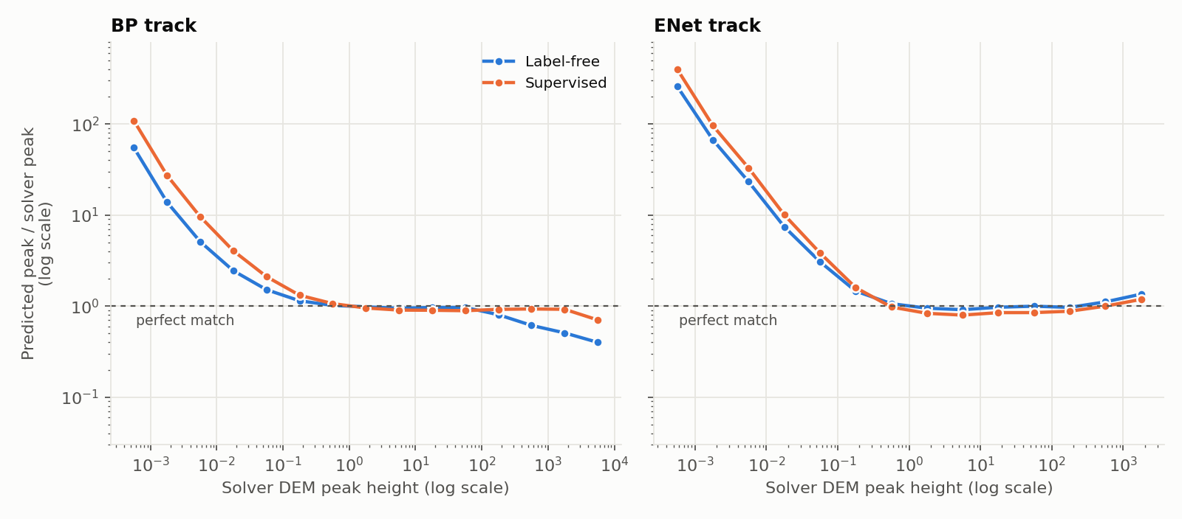
Figure 6.3. Predicted over solver peak height, binned by the solver's peak height, both tracks, label-free (the 409k stiff-band model, the ElasticNet model) against supervised: on BP that model follows the solver to a peak of about 100 and reaches 0.40 of it above 3,200; at the faint end both models draw peaks above the solver's near-zero ones (source: results/plots/22_adopted_bp_20261014/fig3_peak_height_calibration.png)
By brightness band (Table 5.4 in section 5.2), its DEM MSE is 0.55 of the supervised model's on the faintest pixels and 2.02 at flare cores; the old model's ratios ran from 0.64 to 17.5.
What remained on the 409k stiff-band model.
- Flare cores held 94.2% of its DEM squared error and set the BP DEM MSE gap: 1.75 against 0.91 (a factor of 1.9), and 0.102 against 0.091 without them (section 5.2).
- The shortfall was in 94 Å: 77% of the observed signal against the solver's 92%; 131, 171, 193 and 211 Å are within 2%, and 335 Å is at 109% (section 5.3).
- It was a training gap, not a loss gap. Under the stiff band the best answer reproduces 93% of 94 Å at the validation flare cores and this model 77.5%, with its loss there a median 35% above the best answer. The solver's own re-solve scatter is 0.2% of its flare-core error, so this is model error, not label noise.
- Longer training kept closing the gap, but 240 epochs from scratch began to break the band on rare pixels.
- Open: why the median pixel error rose from 0.026 (old model) to 0.036 while the Quiet MSE fell from 0.058 to 0.032. The final model is at 0.031 and 0.033.
The final BP model at flare cores. The final model (1.5M parameters, the stiff band, 120 epochs, clamp pixels in training) closes most of what was left. At flare cores it holds 96.7% of the solver's emission (supervised 92%), reproduces 88% of 94 Å (supervised 85%, solver 92%) and 100% of 131 Å, and peaks at 0.89 of the solver's height (supervised 0.91), with a mean shift of -0.01 dex, W1 of 0.018 dex (supervised 0.015) and extra peaks on 14% of curves (supervised 13%, solver 18%). It follows the solver's peak much further: 0.98 at 32 to 100, 0.97 at 100 to 320, 0.92 at 320 to 1,000, 0.78 at 1,000 to 3,200 and 0.53 above 3,200. Flare cores still hold 92.0% of its DEM squared error, 83.0% of the total in those same 269 pixel-targets above 3,200, and its DEM MSE there is 1.22 times the supervised model's. That is the whole of the remaining BP gap: 1.08 against 0.91 overall, and 0.087 against 0.091 without flare cores (section 5.2). Tables 5.1 and 5.5 give the rest.
Sources: results/followup_recap_20261013.md (Parts 2 to 9: run recipes, the worked example, the screen and run tables), results/plots/21_followup_20261006/summary.json (the shared-test run metrics in Tables 6.1 and 6.5), results/plots/23_meeting_followup_20261024/bp_bright_failure_fu_bp_h680_clampmask.{txt,json}, bp_aia_fit_fu_bp_h680_clampmask.txt and bp_h232_h680_clampmask.json (the final BP model: the last run of Table 6.5, emission over all pixels, its flare-core numbers and peak calibration), results/plots/21_followup_20261006/bp_objective_gap_val.txt (Table 6.2, the old network's gap by band and band-weighted DEM MSE, 94 Å by brightness for the best answer and the solver, validation populations, the non-converged count), results/plots/21_followup_20261006/bp_objective_gap_val_sweep.txt (Table 6.4 and μ = 20, 200 and 1,000, band-weighted from the per-band rows), results/plots/21_followup_20261006/bp_objective_gap.txt (the first screen on test pixels: emission 0.855 to 1.002, the old network's 0.866), results/plots/21_followup_20261006/bp_objective_gap_val_final_mu100.txt, bp_objective_gap_val_overnight_cont.txt, bp_objective_gap_val_overnight_ep240.txt, bp_objective_gap_val_overnight_h680.txt and bp_objective_gap_val_nets_early.txt (gaps and band penalties under the stiff band, validation errors, the solver's DEM under μ = 100, the oversampled emission on validation), results/plots/21_followup_20261006/bp_bright_failure_fu_bp_mu100_ep120_cont.{txt,json} (Table 6.6, the 409k stiff-band column, peak calibration, the shape cross-tab, solver scatter, emission over all pixels), results/plots/21_followup_20261006/bp_aia_fit_fu_bp_mu100_ep120_cont.txt (per-channel reconstruction at flare cores), results/plots/21_followup_20261006/scaled_mlp6_barrier_*_history.json (flare-core sampling rates, clipping rates, μ = 300 against μ = 100 at matched epochs), results/plots/19_final_models_20261004/bp_bright_failure_final.json and bp_aia_fit_final.json (the old model: emission, peak, shift, width, extra peaks, along-curve share, solver scatter, missed second peaks, per-channel reconstruction), results/plots/13_bright_diagnostic_20260928/bp_bright_failure_supervised.json (the supervised model at flare cores), results/plots/23_meeting_followup_20261024/bp_mu_theory_val.txt (the single-channel price bound of 1.480 weight units per DN/s for 94 Å), RData.npz with getBasis in fullBP.py (the 94 Å response of each basis element, computed: 0.266 DN/s per unit for the spike at logT 6.9 and its other channels, 0.669 for the 0.2 dex Gaussian at 6.8, 0.676 for the one at 6.1, which gives 171 DN/s of 171 Å per unit), results/bright_failure_story_20260929.md (the September diagnosis on the width-232 model), slides/deck_outline.md (slides 15 to 22: the 0.266 response and the talk notes), slides/talk_prep.md (the emission-deficit mechanism; μ = 300), CLAUDE.md (2026-09-28; 2026-10-10; 2026-10-13, including the μ = 300 value 0.099 at epoch 76; 2026-10-15; 2026-10-21, the cheapest shape at 0.67 DN/s per unit and the price of 245), experiments/objective_gap.py (the method) and experiments/submit_followup.sh (the warm start). The old network's band-weighted DEM MSE (36.9) and the band-penalty ratios (13 and 129) are computed from the per-band rows of the files named above.

7. Failure analysis
Three questions from the last review are answered here: which pixels blow up when the network gets bigger, and why a bigger network should fail at all (7.1); what the pixels at the low end of the AIA joint distributions are (7.2); and what happens at the pixels where no DEM fits the noise band, which is where relaxing the constraint matters (7.3). The first two have the same root: a small set of inputs that training never contained.

7.1 Which pixels blow up, and why bigger networks fail there
Every model's DEM error is concentrated in a few pixels, but the larger models concentrate it far more (Table 7.1). On the shared test set the 409k stiff-band model's worst 0.01% of pixels hold 95% of its squared error; the 1.5M-parameter model trained on the same loss (680 wide, μ = 100, 120 epochs) puts 99.7% of its error in its worst 100 pixels, out of 705M.
Table 7.1. Concentration of the DEM squared error on the shared test set (sum over the 18 bins, per pixel), by model.
Track | Model | DEM MSE | Worst 0.01% of pixels | Worst 100 pixels
BP | 409k, adopted | 1.75 | 95.1% | 67.3%
BP | 1.5M, μ = 100, 120 epochs | 897 | 99.99% | 99.7%
BP | 10M, μ = 100 | 35.7 | 99.7% | 98.0%
BP | 10M, μ = 1 | 5.10 | 91.5% | 50.1%
ElasticNet | 409k, final | 0.310 | 44.8% | 29.1%
ElasticNet | 722k, log1p input | 3.24 | 94.7% | 70.0%
ElasticNet | 1.4M, log1p input | 36.2 | 99.5% | 68.7%
ElasticNet | 10M | 2,062 | 99.99% | 96.9%

Two kinds of worst pixel. The 409k stiff-band model's worst 1,000 distinct inputs are 993 flare cores, and the 10M BP model's worst 1,000 overlap them almost entirely (Jaccard 0.88): these are the brightest flare cores, hard for every model. The pixels that make the large models blow up are different. The 1.5M model's worst 100 share only 7% with the 409k stiff-band model's (Jaccard 0.07), and they look alike: in its worst 100 distinct inputs a median of five of the six channels read exactly zero, and in 56% only one channel has signal, always 94 Å, at a median 3.0 DN/s, 28 times the median of its eight neighbours (more than 5 times in every case). The ElasticNet 10M model's worst 100 are the same kind (64% a lone 94 Å reading of about 4.2 DN/s, 57 times its neighbours). The ElasticNet 722k and 1.4M log1p models fail on a related set: in about a quarter of their worst 100 the lone channel is 131 Å, at about 200 DN/s, 1,500 to 2,000 times its neighbours. Figure 7.2 shows one such pixel.
Why training never saw them. A channel that reads exactly zero is the positivity clamp of the PSF deconvolution: the deconvolved value came out negative and was set to zero. The training mask required every channel above 10⁻³ DN/s, which drops every pixel with a clamped channel. That is 40% of the valid test pixels, nearly all faint (96% of the faintest band, 2.2% at 1 to 1.8 times the Bright cutoff, none above 3.2 times), so it barely touches the pixels the metrics weigh. But it removes every input in which a channel is zero, and the lone-spike pixels are exactly such inputs. The validation loss uses the same mask, so it could not see them either (section 3.5 also notes that it covers only the first four validation images). This is why validation preferred every model larger than 409k while each of them blew up on test.
How far they are from the training data. We drew 2 million valid training pixels and measured, for each test pixel, the distance to the nearest one in standardised log intensity (Figure 7.1). Ordinary test pixels sit at a median 0.09 to 0.21 from a training pixel, depending on brightness. The 1.5M BP model's worst inputs sit at about 4.9, and the ElasticNet 10M model's at 3 to 5: twenty to fifty times further out than anything the network was fitted on. The 409k stiff-band model's worst pixels, the brightest flare cores, sit at a median 0.40 against 0.21 for flare cores in general; 19% are outside the range of the training sample in some channel. They are at the edge of the training data, not off it.
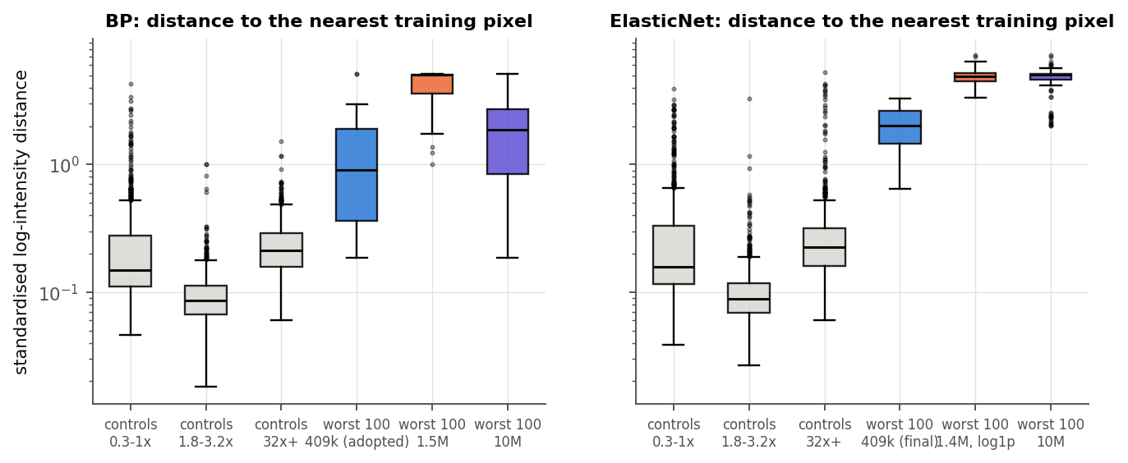
Figure 7.1. Distance from each model's worst 100 distinct test inputs to the nearest of 2 million training pixels, in standardised log intensity, against random test pixels of three brightness bands (controls). Shared test set. (results/plots/23_meeting_followup_20261024/fig3_blowup_distance.png)
The mechanism. A per-pixel network is an interpolator. Where training pixels are dense its output is pinned by the loss; far from them nothing constrains it. A larger network has more freedom to bend between and beyond the data, and the Fourier encoding, whose purpose is to let the network represent sharp functions of its input, gives it the means. At the lone-spike inputs the larger models return DEMs up to 10⁵ times the solver's: the ElasticNet 10M model's worst 1,000 inputs have a median emission 1.6 × 10⁵ times the solver's, and the 1.5M BP model reconstructs 171 Å at more than 2 × 10⁵ times the observation at a tenth of its worst 1,000. Bigger is therefore not worse at fitting the data: the larger models match or beat 409k at the median (section 5.4). It is worse at extrapolating, and the evaluation contains inputs that training excluded.
Confirmation runs. If this is the cause, training on those inputs should remove the blow-ups. Four runs repeat existing ones with one change, the clamp pixels kept and only their clamped channels freed from the band (--clamp_mode mask).
Table 7.2. The same recipe with and without clamp pixels in training, shared test set.
Run | DEM MSE, excluded | DEM MSE, clamp pixels kept | Note
BP 1.5M, μ = 100, 120 epochs | 897 | 1.08 | flare-core 94 Å 88%, emission 96.7%
ElasticNet 10M, 40 epochs | 2,062 | 1.82 | AIA MSE still 1.5 × 10⁵
BP 409k, μ = 100, 40 epochs | 2.37 | 2.79 | flare-core emission 85% against 89%
ElasticNet 409k, 40 epochs | 0.310 | 0.439 | AIA MSE 162 against 161

The score blow-ups are gone: two models that failed by orders of magnitude now score normally, and the 1.5M BP model is the best BP model we have, which is why it became the final model. Clamp pixels do not help the 409k models. They take a large share of each epoch's draws, and a small network pays for that: BP loses flare-core emission, and ElasticNet loses on faint pixels too (Quiet MSE 0.122 to 0.212, median pixel error 0.85 to 1.55). The ElasticNet 10M model still trails the 409k model and keeps a few wild reconstructions, so its failure is reduced rather than removed.
Correction (31 October 2026). The drop from 897 to 1.08 in Table 7.2 is not evidence for the clamp account on its own. In the 1.5M run with clamp pixels excluded, one unclamped flare-core input (131 Å above 90,000 DN/s), seen through two targets, holds 96.7% of the squared error, and pixels with a clamped channel hold 2.9% (bp_blowup_census.npz, arrays worst_h680_mu100_ep120_*; flare cores hold 97.1%, results/plots/21_followup_20261006/bp_bright_failure_fu_bp_mu100_h680_ep120.txt). The clamp account does hold for the BP 10M model and the ElasticNet 722k, 1.43M and 10M models (93% to 99% of the squared error in clamped pixels), and on the 1.5M model it shows in Quiet MSE (12.5 to 0.033). Why the final model does not fail on that flare-core input is unknown; with one run of each configuration it may be chance.
What the runs did not fix. The score blow-ups and the wildest reconstructions are not the same thing. On the eight full disks of the viewer, counting a pixel as wild when some channel is reconstructed above 10³ DN/s and more than 100 times its observation, the old 409k BP model has 126 wild pixels of 33.5M and the new model 124; the new model's largest overshoot is about 20 times higher (2.5 × 10⁸ against 1.2 × 10⁷). Nearly all have no solver DEM (123 of 124), because they are unsolved even at the 5 times band; training excludes unsolved pixels in either mode, so clamp masking cannot reach them, and they are absent from every DEM score. They are single-channel readings among zeros (335 Å at 1,320 DN/s, typical value about 10, with the other channels zero): not plasma. One does have a solver DEM: a lone 335 Å reading of 44 DN/s on 9 December, which alone holds 97.7% of the new model's error on that disk.
A self-check closes this. Simple input rules do not work: a clamp-plus-neighbour-spike rule flags up to 14% of all pixels, and a dominant-channel rule catches at most 79% of the wild ones. The direct test does: a DEM must reproduce what was observed, so a pixel whose reconstruction overshoots its observation by more than 100 times is flagged. This needs neither a solver nor a label, flags 124 of 33.5M pixels, and removes the outliers from the viewer's images. The scores in this report do not apply it. They would barely move: on the shared test set the wild pixels have no BP target, and the single pixel that holds 6% of the final model's DEM error (1.08, or 1.02 without it) is a real flare core, not a spike.

7.2 The low end of the AIA joint distributions
In the viewer's joint distributions of observed against reconstructed AIA, some pixels observed near 1 DN/s are reconstructed far above the diagonal by the label-free model but not by the supervised one. We counted them over the whole shared test set: observed below 1 DN/s and reconstructed above 10 times the observation (both floored at 0.5 DN/s, as in the plots).
Table 7.3. Pixels in the low cluster on the shared test set, BP track, by channel and by whose DEM puts them there. Out of 705M valid pixels.
Channel | Label-free | Supervised | Solver | Label-free cluster with that channel clamped
94 Å | 0 | 1 | 0
131 Å | 18,625 | 3,792 | 152,767 | 84%
171 Å | 51 | 369 | 0 | 96%
193 Å | 8,073 | 460 | 123,154 | 89%
211 Å | 95 | 36 | 0 | 93%
335 Å | 23,370 | 63 | 102,110 | 81%

The cluster is small: about 50,000 pixels, 0.007% of the test set. Almost all of it is the deconvolution clamp: 81% to 96% of the pixels have that very channel at exactly zero, and 96% to 100% are isolated dips against their eight neighbours. It splits into two groups.
- 131, 193 and 335 Å: the observation is wrong, not the DEM. Here the solver's own DEM sits above the zeroed observation more often than ours (152,767 pixels against 18,625 in 131 Å) and by as much (mean 1.25 against 1.09 dex above). No DEM that fits the other five channels can produce zero in the sixth. The supervised model sits closer to the zero, because it learned these pixels from the solver's labels.
- 171 and 211 Å: the network extrapolates. Here only our model is far off (3.4 and 1.9 dex above the observation; the solver 0.04 and 0.0; the supervised model 0.6 and 0.0). These are the lone-spike inputs of 7.1: half of the 171 Å cluster is a lone 94 Å reading of about 3.5 DN/s, 38 times its neighbours, with the five other channels zero (Figure 7.2). The solver cannot fit that 94 Å reading without lighting the zeroed channels, so it reproduces almost nothing; our network has never seen such an input and returns a large DEM.
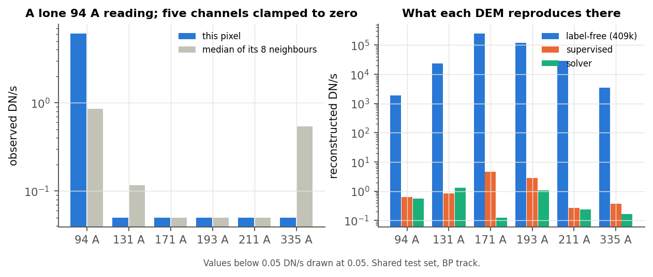
Figure 7.2. One lone-spike pixel from the 171 Å low cluster. Left: the six observed channels and the median of the eight neighbouring pixels. Right: what each DEM reproduces. Values below 0.05 DN/s are drawn at 0.05. (results/plots/23_meeting_followup_20261024/fig4_lone_spike_example.png)
Cosmic rays. The advisor's suggestion fits the lone spikes: a single channel reading 30 to 2,000 times its neighbours, in a patch where everything else is clamped to zero, is the signature of a residual cosmic-ray hit or a hot pixel (one image cannot tell them apart). The broader cluster is the clamp, not cosmic rays. The opposite corner, observed above 20 DN/s and reconstructed below a tenth of it, is rare for our model (25 pixels in 131 Å, 137 in 335 Å); 60% to 83% of those are isolated spikes too.
Where the clamp falls. Replaying the block positions of our test split: on the disk 26% of pixels have a clamped channel, but only in the faint channels (94 Å 12%, 335 Å 12%, 131 Å 5%, the bright three at most 0.06%); within 100 pixels of the limb 16%; off the limb 63%, in every channel.
Effect on the headline numbers. Removing the 49,991 pixels of the label-free low cluster from both models' scores changes our BP DEM MSE from 1.751 to 1.745 but our AIA MSE from 103 to 69; the supervised model's stays at 157. A model-independent mask, every pixel with a clamped channel removed (40% of pixels, nearly all faint), gives AIA MSE 108 against 256 and DEM MSE 2.88 against 1.49, higher for both because the remaining pixels are brighter on average. On ElasticNet the cluster is larger but shared with the solver (335 Å: ours 578,931, the solver's 611,921), and removing it moves AIA MSE only from 161 to 158 (supervised 598 to 593).
With clamp pixels in training. The 1.5M model's low cluster is larger, not smaller: 3.6M pixels in 171 Å, 2.0M in 193 Å and 1.1M in 211 Å, all with that channel clamped, about 5.5M pixels or 0.8% of the test set. This is what freeing a channel means: nothing pulls the reconstruction down to a zero we no longer trust, so the DEM fits the other five channels and predicts roughly 15 times the floored value in the clamped one. The JPDFs therefore show a fuller column at the floor, while the scores barely move (AIA MSE 148 with the cluster, 149 without). The high corner is nearly empty (102 pixels, all in 335 Å).

7.3 Where no DEM fits the band: relaxing the constraint
At some pixels no non-negative DEM fits all six channels within 1.4σ. The solver then widens its band to 3 times and, failing that, 5 times (fullBP.py:515), and records the level. On our clean labels the band is relaxed at 8.5% of test-split pixels (3 times) and 0.08% (5 times); 0.01% stay unsolved. On the validation sample of the μ screen we solved the linear program ourselves: every tolLevel-1 pixel is feasible at 1.4σ, and every relaxed pixel is infeasible (936 of 1,055) or numerically unsolvable (119), so the flag records infeasibility. (The solver's stored DEMs sit inside their bands to within 0.01 half-widths, a median 5 × 10⁻⁴: float rounding.)
These pixels carry the stiff band's cost. Our loss keeps the 1.4σ band everywhere. At feasible pixels the best answer under the loss moves toward the solver at every μ, in every brightness band, all the way to μ = 1,000 (at flare cores its DEM error falls from 1.8 × 10⁵ at μ = 1 to 9.5 × 10³ at 100 and 1.9 × 10³ at 1,000). At relaxed pixels it moves away, because a stiffer band forces an inconsistent observation that the solver itself gave up on (at 0.3 to 1 times Bright, 0.055 at μ = 1, 0.92 at 100, 1.29 at 1,000). The relaxed pixels are 0.5% to 12% of each band above 0.3 times Bright, but hold 70% to 90% of the best answer's DEM error at μ = 100 between 0.3 and 10 times Bright, and 46% (10 to 32 times) and 38% (flare cores) above. The U-shape of the μ screen's Quiet error (section 6.5) is entirely theirs.
Relaxing the band as the solver does. We re-solved the best answer at the relaxed pixels with the solver's own band, keeping the excess measured in units of the unrelaxed 1.4σ (experiments/relaxed_band_screen.py). The trade-off disappears (Figure 7.3, Table 7.4): every column improves monotonically with μ.
Table 7.4. The μ screen on validation with the fixed 1.4σ band and with the solver's band (excess in noise units). Population-weighted as in section 6.5.
μ | DEM error, fixed | DEM error, solver's band | Quiet MSE, fixed | Quiet MSE, solver's band | Flare-core 94 Å, solver's band
10 | 10.9 | 12.1 | 0.037 | 0.027 | 80%
30 | 4.94 | 5.47 | 0.034 | 0.015 | 89%
100 | 2.30 | 2.79 | 0.046 | 0.0079 | 92%
300 | 1.78 | 1.11 | 0.053 | 0.0036 | 93%
1,000 | 2.17 | 0.63 | 0.055 | 0.0018 | 94%

The solver reproduces 94% of flare-core 94 Å; the supervised model's numbers on this screen are a DEM error of 6.10 and a Quiet MSE of 0.054. How the excess is measured matters: dividing it by the widened half-width instead softens the penalty 9 or 25 times in DN/s at relaxed pixels and gives flare cores back their deficit (88% of 94 Å at μ = 100).
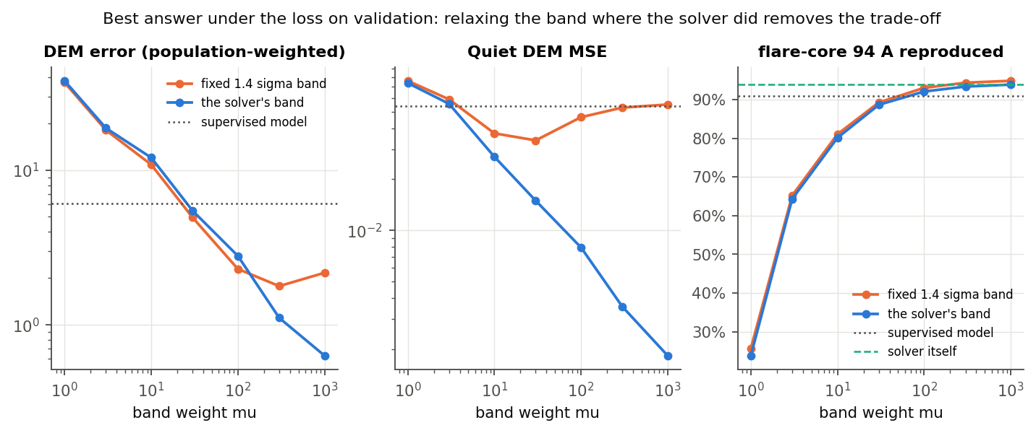
Figure 7.3. The best answer under the loss on validation, with the fixed band and with the solver's band at the pixels it relaxed. (results/plots/23_meeting_followup_20261024/fig2_relaxed_band_screen.png)
What this means for μ. With the solver's own rule in the loss, μ has no interior optimum. The loss is the exterior penalty of the solver's program, relaxation included, and μ only sets how far outside the band the answer may sit, λ_c tσ_c/(2μ) (section 3.3). Larger is better for the best answer; the reasons to stop at a finite μ are training stiffness and the 1/μ law's diminishing returns. On the fixed band, μ = 300 trained behind μ = 100 at matched epochs (section 6.6), and the relaxed pixels, whose penalty never reaches zero, are a likely cause.
What the headline numbers see. The shared test set's BP targets are missing at 7.7% of clean-solve pixels and 12% to 13% of the noisy re-solves. The supervised side's generation command passes --zerochill, which skips the relaxation (we have the ElasticNet command; the BP rate at clean solves, 7.7%, matches our relaxed share of 8.5%), so the pixels where the band is infeasible have no BP answer and are not scored. The headline BP numbers therefore come from feasible pixels only, where the fixed and relaxed bands coincide.
The training run. We trained μ = 300 with the solver's band for 120 epochs (409k, no clamp pixels). At the relaxed pixels it does what the screen predicts: validation DEM MAE there is 0.15 against 0.50 for μ = 300 on the fixed band and 0.45 for μ = 100. It also trains faster than μ = 300 on the fixed band (0.090 against 0.099 at feasible pixels at epoch 76), but stays behind μ = 100 (0.079). On the shared test set it reaches DEM MSE 1.54, flare-core emission 96.8% and 94 Å 87%, better than the 409k μ = 100 model at 120 epochs (2.00, 92%, 75%), but Quiet MSE rises to 0.050 against 0.032, and one validation pass spiked to 4 × 10¹⁶ at epoch 40. So the relaxed band works as theory says at the pixels it targets, but a stiffer loss still costs training time on the faint majority. μ = 100 stays. A 1.5M model on the relaxed band is untested.

7.4 Summary
- The large models' score blow-ups came from inputs training never saw: a lone channel spike, consistent with a cosmic-ray hit or hot pixel, among channels the deconvolution clamped to zero. Keeping clamp pixels in training removes them (BP 1.5M: 897 to 1.08), and that model is now the BP final. The most extreme single pixels remain, nearly all without a solver answer, and a self-check on the reconstruction flags them.
- The rest of the low JPDF cluster (131, 193, 335 Å) is the clamp itself, where the observation is wrong and the solver's DEM disagrees with it as much as ours does.
- The stiff band's cost on faint pixels comes from the 9% of pixels where the band is infeasible. For the best answer, relaxing the band there as the solver does removes it and μ becomes a convergence parameter. In training, the relaxed band fixes those pixels but μ = 300 still costs the faint majority, so μ = 100 stays.
Sources: results/plots/23_meeting_followup_20261024/ (bp_blowup_census.txt, enet_blowup_census.txt, bp_jpdf_pixels.txt, enet_jpdf_pixels.txt, bp_jpdf_pixels_tol.txt, bp_mu_theory_val.txt, bp_relaxed_band_screen.txt, and the figures); the per-pixel arrays behind them (output/meeting_followup/*.npz, pulled from output/experiments/diagnostics/ on Torch); lone_spike_check.txt, spike_flag_test.txt, fulldisk_outliers.txt, bp_bright_failure_fu_*, bp_aia_fit_fu_*, enet_*_fu_*, bp_h232_h680_clampmask.json, bp_jpdf_pixels_h680_clamp.txt, and the training histories (lone_spike_check.txt holds the lone-spike counts for each model's worst 100 distinct inputs and the shared test set's missing BP answers by target); eval_and_enet_specs/submit_enet_aia_hofdeconv_full.py (--zerochill); fullBP.py:515 (relaxation); experiments/blowup_census.py, experiments/jpdf_pixels.py, experiments/mu_theory.py, experiments/relaxed_band_screen.py.

8. What the network learned
The advisor asked what the final layer looks like, sorted by eigenvector. The output layer maps the last 336 hidden units to the 54 basis weights, so it can be read three ways: the weight matrix itself, the 54 outputs it produces over many pixels, and the DEMs those outputs make. We analysed all three for the adopted BP model, the ElasticNet model and, for contrast, the old BP model (μ = 1, log1p input, 40 epochs), on 611,947 validation pixels: up to 100,000 per brightness band and every flare core of the split (experiments/final_layer.py).

8.1 The output layer is low-rank, and the stiff band widened it
Table 8.1. Effective dimension of the output layer and of what it produces. The participation ratio of a spectrum is (Σλ)²/Σλ²; "for 90%" is the number of components that hold 90% of it.
 | BP adopted | ElasticNet | BP old (μ = 1)
Weight matrix (54 × 336): participation ratio of the singular values | 9.5 | 7.4 | 2.9
Weight matrix: components for 90% / 99% of the energy | 22 / 40 | 19 / 40 | 11 / 24
The 54 outputs over pixels: participation ratio of their correlation | 13.5 | 6.7 | 5.7
Last hidden layer (336 units): components for 90% / 99% of the variance | 14 / 90 | 11 / 57 | 6 / 34
DEM shapes (unit sum): components for 90% / 99% | 8 / 12 | 10 / 15 | 4 / 8
The solver's DEM shapes on the same pixels | 6 / 13 |  | 6 / 13

The old model's output layer was close to rank three, and its DEMs lived in a family of four shapes where the solver's need six. The stiff band tripled the layer's effective rank, and the adopted model's DEMs span as many shape directions as the solver's (8 against 6 for 90%, 12 against 13 for 99%). The 336 hidden units are far from saturated: 14 directions carry 90% of their variance. Width is not what limits the typical pixel, which agrees with section 7.1: extra width buys freedom away from the data, not accuracy on it.
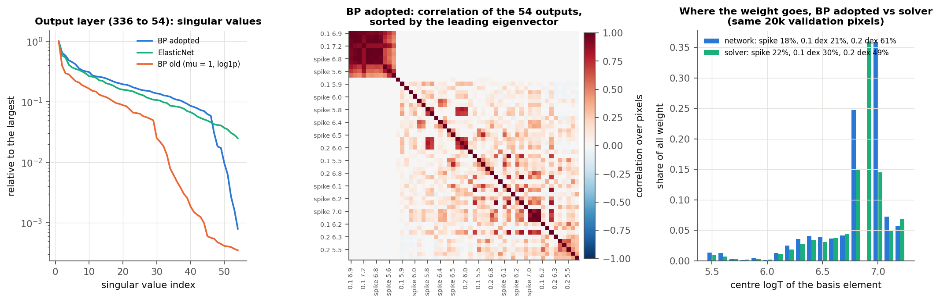
Figure 8.1. Left: singular values of the output weight matrix, relative to the largest. Centre: correlation of the adopted BP model's 54 outputs over validation pixels, sorted by the leading eigenvector ("0.1 6.9" is the 0.1 dex Gaussian centred at logT 6.9). Right: where the weight goes, by the centre temperature of the basis element, for the adopted model and for the solver's own fewest-weights decomposition of its DEMs, on the same 20,000 validation pixels. (results/plots/23_meeting_followup_20261024/fig5_final_layer.png)

8.2 Sorted by eigenvector: a hot-plasma mode
Sorting the 54 outputs by the leading eigenvector of their correlation (Figure 8.1, centre) does not produce a smooth sweep in temperature. It produces one tight block: the spikes and 0.1 dex Gaussians at logT 6.6 to 7.2, joined by the coolest spikes at logT 5.6 and 5.7, whose ten members move together with a mean correlation of 0.86. The leading direction is how much hot plasma the pixel has. The same block leads at every brightness from 0.03 to 32 times the Bright cutoff. At flare cores the leading direction shifts to the hottest elements (logT 7.0 to 7.2) together with cool 0.2 dex Gaussians, the variation that remains once hot plasma is always present. The second eigenvector separates the hottest end (7.0 to 7.2) from the cool end (5.5 to 6.2). The weight matrix's own singular vectors give the same picture: its first left singular vector orders the outputs from the spike and 0.1 dex Gaussian at logT 7.0 downward through the hot elements.

8.3 How the network uses the basis
Table 8.2. Weight by basis shape, and active elements per pixel (above 1% of the pixel's largest weight), on 20,000 validation pixels stratified by brightness. The solver's DEMs are decomposed into their fewest-weights representation.
 | Spike | 0.1 dex Gaussian | 0.2 dex Gaussian | Active elements per pixel, mean (median)
BP adopted | 18% | 21% | 61% | 6.6 (6)
Solver | 22% | 30% | 49% | 5.7 (6)
BP old (μ = 1), all pixels | 2% | 6% | 93% | 4.2 (4)

The adopted model is a little less sparse than the solver: it leans on the wide Gaussians (61% of its weight against 49%) and uses about one more element per pixel. The old model built nearly every DEM from a few wide Gaussians: 93% of its weight sat on the 0.2 dex shape, at logT 6.3 to 6.4 and at 7.0, with nothing between 6.6 and 6.9, which is where the solver puts its hot plasma (section 6).
The weights also show that the 54-weight representation is not unique. The adopted model puts 25% of its weight on elements centred at logT 6.8 and 36% at 7.0, and essentially none at 6.9; the solver puts 15%, 36% and 15% there (Figure 8.1, right). Both describe the same hot bump around logT 6.9: two Gaussians either side of a bin add up to a curve centred on it. The loss scores only the light a DEM makes and its total weight, so the network is free to pick either decomposition, and the DEM error compares curves, not weights.
The ElasticNet model spreads its weight over all three shapes (27%, 36% and 36%) and about 20 elements per pixel, as the L2 term asks; its weight matrix and outputs are lower-rank than the adopted BP model's (Table 8.1).

8.4 The final 1.5M model
The sections above analyse the 409k stiff-band model. The same analysis on the final 1.5M model (width 680, clamp pixels in training) shows the same structure at slightly higher rank, with one change in the eigenvectors.
Table 8.3. The final model against the 409k stiff-band model.
 | Final 1.5M | 409k stiff-band | Solver
Weight matrix: participation ratio | 10.9 | 9.5
Weight matrix: components for 90% / 99% | 24 / 43 | 22 / 40
Outputs: correlation participation ratio | 8.3 | 13.5
Last hidden layer: components for 90% / 99% | 18 / 137 of 680 | 14 / 90 of 336
DEM shapes: components for 90% / 99% | 8 / 13 | 8 / 12 | 6 / 13
Weight by shape (spike, 0.1 dex, 0.2 dex), solver's pixels | 26%, 35%, 39% | 18%, 21%, 61% | 22%, 30%, 49%
Active elements per pixel, all pixels, mean | 7.1 | 7.0 | 5.7

Doubling the width barely changes the effective dimension of the last hidden layer (18 against 14 directions for 90% of its variance), so the extra width is not spent on more directions of the typical pixel. The final model's weight shares are closer to the solver's on either side, where the 409k model leaned on the widest Gaussian, and it no longer leaves the elements at logT 6.9 empty: its weight there is 17%, between 12% at 6.8 and 13% at 7.0. Its leading eigenvector differs: the cool elements (logT 5.6 to 6.1) lead, with the hot spikes behind them, rather than one hot block. We read this as an effect of the clamp pixels, which give the network a large faint population to represent, but we have not tested that.
Sources: results/plots/23_meeting_followup_20261024/final_layer_h680_clamp.txt (the final model); results/plots/23_meeting_followup_20261024/final_layer.txt and final_layer.json (all numbers of Tables 8.1 and 8.2 except the 20,000-pixel shares, which come from final_layer.npz, arrays bp__sol_x_network and sol_x_solver, summed by shape and by centre logT); experiments/final_layer.py; experiments/plot_meeting_followup.py (Figure 8.1). The solver comparison of the ElasticNet model is omitted because the script decomposed BP solver DEMs for all three models.

9. Limitations and open items
Validation. The validation loss that chose widths, inputs and checkpoints covers only the first four validation images (256 blocks, 131,072 pixels). With clamp pixels excluded it never contains a pixel with a clamped channel, and it preferred every model larger than 409k, each of which blew up on test (sections 3.5 and 7.1). The clamp-mask runs keep clamp pixels in that sample, but it is still those four images, and their losses are not comparable with the earlier ones. So three choices rest on test evidence: the ElasticNet width, the ElasticNet epochs and the final BP model itself. No 409k clamp run at 120 epochs exists to compare it with. Validating on every pixel of the validation split, clamp pixels included, is the fix.
Clamp pixels. Pixels with a clamped channel are 40% of valid pixels, nearly all faint. The final BP model trains on them with the clamped channels freed from the band; the ElasticNet model excludes them, because at 409k they cost more than they give (DEM MSE 0.310 to 0.439, Quiet MSE 0.122 to 0.212). Only the 10M ElasticNet model has been trained with them at a larger size: its DEM MSE falls from 2,062 to 1.82, still behind the 409k model, with AIA MSE 1.5 × 10⁵. An ElasticNet 1.5M model with clamp pixels is untested. A freed channel is not fitted, so the final BP model predicts about 15 times the floored value there: the low cluster of its AIA joint distributions holds about 5.5M pixels, 0.8% of the test set, and barely moves the scores (section 7.2).
Remaining outliers and the self-check. Keeping clamp pixels removes the score blow-ups, not the most extreme single pixels. On the eight full disks of the viewer the final BP model has 124 wild pixels of 33.5M, about the same as the 409k stiff-band model's 126, and its largest overshoot is about 20 times higher. Of the 124, 123 have no solver DEM: they are unsolved even at the 5 times band, so no training mask reaches them and no DEM score sees them. The one that has a solver DEM alone holds 97.7% of the final model's error on its disk (section 7.1). Simple input rules do not isolate these pixels. A self-check does, with no solver and no label: flag a pixel whose reconstruction overshoots its observation by more than 100 times. The viewer applies it; the scores in this report do not. It flags pixels without repairing them, so a user still needs to treat those pixels as missing.
The band's rule. Our loss keeps the 1.4σ band where the solver relaxed it (8.5% of our test split). Section 7.3 shows that the solver's own rule, with the excess measured in noise units, removes the trade-off for the best answer, so μ has no interior optimum there. The one training run on it (409k, μ = 300, 120 epochs) confirms this at the relaxed pixels (validation DEM MAE 0.15 against 0.50 on the fixed band) and improves flare cores, but Quiet MSE rises to 0.050 against 0.032, and one validation pass spiked to 4 × 10¹⁶, so μ = 100 stays. A 1.5M model on the relaxed band is untested. The per-pixel weight and the L1 exact penalty of section 3.3 are untested in training.
The evaluation protocol. The shared test set's BP targets exclude the pixels where the band is infeasible (7.7% of clean solves, 12% to 13% of re-solves), so the BP headline numbers say nothing about them. The four re-solves add Gaussian noise of 0.5σ, not σ (the generation command uses the default --noisescale 0.5). Our network's basis truncates each Gaussian below 4% of its peak while the solver's runs keep the tails (--notrunc); the difference is at most 2.1% of an element's emission and moves the price bounds by less than 1%. The ElasticNet solver floors its residual scale at 0.5 DN/s and our loss does not; 1.4σ falls below 0.5 DN/s at under 0.1% of pixels.
Flare cores. The final BP model still holds 92% of its DEM error in flare cores, where it reproduces 88% of 94 Å against the solver's 92% and its DEM MSE is 1.22 times the supervised model's (section 6.7). On the 409k model a continuation of 120 more epochs improved flare cores; a continuation of the 1.5M model is untested. The objective-gap measurement of section 6 has not been repeated on the final model, so how much of its 94 Å gap is training has not been measured.
The analysis of the network. Section 8 analyses the 409k stiff-band model in detail and the final model in summary (section 8.4). The figures of sections 5 and 6 also show the 409k stiff-band model and have not been redrawn.
Not addressed. Inference speed against the solver is unmeasured. The uncertainty head, which needs a distribution over DEMs rather than one answer, and the AIA plus XRT models are outside this report.
Sources: report/sections/03_method.md (3.5), 06_flare_cores.md, 07_failure_analysis.md (Table 7.2, the outlier counts, the self-check, 7.3); results/plots/23_meeting_followup_20261024/ (bp_h232_h680_clampmask.json, bp_bright_failure_fu_bp_h680_clampmask.txt, bp_aia_fit_fu_bp_h680_clampmask.txt, bp_jpdf_pixels_h680_clamp.txt, enet_bright_failure_fu_enet_clampmask.txt, enet_bright_failure_fu_enet_10m_clampmask.txt, enet_aia_fit_fu_enet_10m_clampmask.txt, fulldisk_outliers.txt, spike_flag_test.txt, lone_spike_check.txt, bp_jpdf_pixels_tol.txt, bp_relaxed_band_screen.txt); results/plots/19_final_models_20261004/enet_bright_failure_final.json (ElasticNet Quiet MSE 0.122); fullBP.py (--noisescale default 0.5, _minimumDNs = 0.5, getBasis truncation); eval_and_enet_specs/submit_enet_aia_hofdeconv_full.py; the 1.4σ-below-0.5 share from a validation-split check of 29 Oct 2026 (40 blocks, at most 0.1% in 171 Å, 0.0% elsewhere).

10. Conclusions
We set out to replace a per-pixel DEM solver with a network that never sees its output. Five conclusions follow.
Label-free training is enough. A per-pixel MLP that reads one pixel's six AIA intensities and is trained only on the solver's objective matches or beats a supervised emulator trained on the solver's DEMs. The 409k ElasticNet model is ahead on all six headline measures. The 1.5M BP model is ahead on four of six, loses DEM MSE (1.08 against 0.91) and AIA MAE (3.54 against 2.95), and on the typical pixel is 3.6 times closer to the solver (median pixel error 0.031 against 0.112). Without flare cores its DEM MSE is below the supervised model's (0.087 against 0.091). Solver DEMs were needed only to score it, and when the ElasticNet settings changed it needed retraining, not new labels.
Check the loss before the training. BP's one failure, flare cores, was in the loss. The network sat close to its loss's per-pixel optimum, and with the band weight at μ = 1 that optimum leaves the hot plasma out, because only 94 and 131 Å ask for it, at under 0.4 DN/s per unit. No training change on that loss could fix it. A stiffer band (μ = 100, chosen on validation) did: flare-core emission rose from 40% of the solver's to 93% with the 409k stiff-band model and 96.7% with the final model, and flare-core 94 Å from 23% to 88% (the solver 92%). Penalty-method theory gives the band violation as λ_c tσ_c/(2μ), and on validation the measured violation matches it pixel by pixel (median ratio 1.00), so μ follows from the response, the noise and a chosen tolerance rather than from a search.
Relaxing the band works where it should, and μ = 100 stays. The theory does not cover the 9% of pixels where no DEM fits the band. The solver relaxes its band there, and those pixels carry the stiff band's cost on faint pixels. Doing the same in the loss turns μ, for the best answer, from a trade-off into a convergence parameter: the best answer approaches the solver monotonically as μ grows. Training confirms this at the relaxed pixels: a 409k run at μ = 300 on the relaxed band has validation DEM MAE 0.15 there against 0.50 on the fixed band. It does not pay overall: a stiffer loss still costs the faint majority (Quiet MSE 0.050 against 0.032), so μ = 100 stays. The headline BP numbers do not see this choice directly, since the shared test set has no BP answer at pixels where the band is infeasible.
Larger models blow up on scores only without the clamp pixels. At scale the per-pixel MLP beat the patch CNN at every percentile of the training loss on both tracks, so spatial context is not needed. Larger MLPs improve the typical pixel a little, and trained with clamp pixels excluded they failed by orders of magnitude on a few rare pixels. Those pixels are inputs training never contained: a lone channel reading tens to thousands of times its neighbours, consistent with a cosmic-ray hit or hot pixel, among channels the deconvolution clamped to zero. The training mask dropped 40% of pixels, not the 5% first estimated, and so did the validation loss, so neither could see them. Keeping those pixels, with only the clamped channels freed from the band, took the 1.5M BP model from DEM MSE 897 to 1.08, the best BP model we have, and the 10M ElasticNet model from 2,062 to 1.82. The small models lose from those pixels (BP 409k 2.37 to 2.79 at 40 epochs, ElasticNet 409k 0.310 to 0.439), so the ElasticNet final stays at 409k without them. The 10M ElasticNet model still trails it, and an ElasticNet 1.5M model with clamp pixels is untested.
The remaining error is concentrated, and the worst pixels can be flagged. Flare cores are one pixel in 10,000 and hold 92% of the final BP model's squared error and 90% of the supervised model's. Up to the 99th percentile the final model is ahead of the supervised one: percentiles, not means, describe the typical pixel. What is left at flare cores is height at the very top (0.53 of the solver's peak above 3,200, 0.71 for the supervised model) and 94 Å. The low end of the AIA joint distributions is the clamp: where a channel was zeroed the observation is wrong, and the solver's DEM disagrees with it as much as ours on 131, 193 and 335 Å. With the clamped channels freed that column of pixels grows (about 5.5M, 0.8% of the test set) and barely moves the scores (AIA MSE 148 with it, 149 without). The most extreme single pixels remain, 124 of 33.5M on the viewer's eight disks, nearly all without a solver DEM. A self-check needs neither a solver nor a label: a DEM must reproduce what was observed, so a pixel whose reconstruction overshoots its observation by more than 100 times is flagged.
Section 9 lists what stays open, including the unmeasured inference speed and the three choices set with test evidence: the ElasticNet width and epochs, and the final BP model.
Sources: results/plots/23_meeting_followup_20261024/ (bp_h232_h680_clampmask.json, bp_bright_failure_fu_bp_h680_clampmask.{json,txt}, bp_aia_fit_fu_bp_h680_clampmask.txt, bp_jpdf_pixels_h680_clamp.txt, bp_relaxed_band_screen.txt, bp_mu_theory_val.txt, fulldisk_outliers.txt, spike_flag_test.txt, enet_bright_failure_fu_enet_clampmask.txt, enet_bright_failure_fu_enet_10m_clampmask.txt); report/sections/03_method.md (3.3 and 3.5), 05_results.md (Tables 5.1 to 5.4 and 5.8), 06_flare_cores.md (6.7) and 07_failure_analysis.md (Tables 7.1 to 7.4, the blow-up inputs, the low-end cluster, the relaxed band, the self-check); results/plots/13_bright_diagnostic_20260928/bp_bright_failure_supervised.{json,txt} (the supervised model); results/plots/19_final_models_20261004/bp_bright_failure_final.json and bp_aia_fit_final.json (the old model); results/followup_recap_20261013.md (section 5: the network close to its loss's optimum; section 6: the hot plasma, 94 and 131 Å, under 0.4 DN/s per unit); slides/deck_outline.md (slide 9: the MLP ahead of the patch CNN at every percentile; slide 19: μ = 100 chosen on validation); CLAUDE.md (2026-09-11: the ElasticNet retrain on the same observations; 2026-10-21: the penalty-method result); slides/talk_prep.md (inference speed unmeasured).

Appendix

A. History
The June and early-July results come from four days, each a crop near disk centre (the X2.1 flare of 2011-09-06, quiet Sun on 2012-06-03, moderate activity on 2013-11-13 and the X1.6 flare of 2014-09-10). Every scaled run from 31 July to 2 October trained on one fixed sample of pixels (Appendix C).
Which loss (June). Before any network, five losses were optimised directly, pixel by pixel, on the four days. The fit-only losses (χ² plus smoothness, maximum entropy, Tikhonov) reconstruct AIA far more closely than BP (AIA MAE 0.40 to 0.44 against BP's 5.2) yet land far from its DEM (DEM MAE against BP 0.18 to 0.20), while BP's own terms, the band penalty with L1 sparsity, land on it (0.034, or 0.043 with an added fit term). Six channels underdetermine an 18-bin DEM, so the tie-breaker decides the shape, and a network meant to emulate a solver has to train on its objective.
The first network (19 June). A per-pixel MLP of width 256 (213k parameters) on the six raw intensities, trained on the band-penalty loss over about 221,000 pixels. Its curves were described at the time as noisy; retrained with the unchanged code on 2026-10-03, they are single-peaked (1.00 to 1.03 local maxima per curve, none with three or more, against BP's 1.12 to 1.19). Its real deficit was accuracy: on 400 held-out pixels per day its DEM MAE against BP is 0.078, against the patch CNN's 0.047 (W1 0.055 against 0.048 dex).
The patch CNN (27 June). A CNN on the 9 by 9 neighbourhood (about 1.5M parameters) predicting the same 54 weights, trained first on one crop (sparsity score on the 54 weights 1.30, BP 1.84), then amortised over the four days (1.47 to 1.86 on held-out pixels, BP 1.67 to 1.97), then with the neighbourhood zeroed on 10% of batches so that it also works on a single pixel. The held-out pixels came from the training days, so none of this was a test.
The ablation (2 July) and leave-one-day-out (11 July). Four variants of about 1.45M parameters on the same loss and days: the patch CNN, a centre-pixel MLP (1.43M), a flat-patch MLP and a CNN on a fixed random permutation of the patch, with sparsity scores (BP 1.79) of 1.70, 1.89, 1.95 and 1.88; the patch CNN on the ElasticNet loss scored 2.28. The centre-pixel MLP drew smooth curves and was the closest to BP (DEM MAE 0.042 against the CNN's 0.047), so the first MLP's gap was capacity or input scaling (the two were not separated), not missing neighbours. Leave-one-day-out then removed the CNN's in-sample edge (section 5.4). Its weak fold was the X1.6 flare day (peaks at logT about 6.1 against BP's 6.4), with only one other flare day in training.
The first bimodal check (11 July). On the crops 5.1% to 9.1% of the scanned BP DEMs were bimodal, and only 6 of 120 studied pixels stayed bimodal across at least 80% of 20 photon-noise perturbations, all on the flare days. The conclusion that bimodality was mostly noise did not survive the move to scale (2 August, below).
Labels at scale (31 July). BP and ElasticNet were run on 1,223 Hofmeister-deconvolved AIA images (2,446 cluster jobs, zero errors, 888 GB per solver), split in time into 917 training, 153 validation and 153 test images. Dropping BP's --zerochill flag, which disables its retry at a wider tolerance, cut the unsolved pixels from 10.2% to 0.02%: photon noise narrows the relative band as pixels brighten until the LP becomes infeasible, so the flag had discarded mostly bright pixels. About 4.4% of pixels carry a hard zero in 171 or 193 Å, the two brightest channels, which only the deconvolution's positivity clamp can produce, and BP fits a DEM to them anyway. Pixels with any channel at or below MIN_OBS = 10^-3 DN/s, three decades below the faintest channel's median (94 Å, 0.76 DN/s), were then dropped from training at an estimated cost of about 5% of pixels; the count over all six channels, made in October, is 40% (sections 3.4 and 7.1).
The collapse and its fix (31 July). The first four full-disk runs exited cleanly and predicted an identically zero DEM. The architectures had been validated on crops spanning about one decade of intensity; the full disk runs from the 10^-3 DN/s floor off the limb to about 10^4 DN/s in flare cores. Fed raw intensities, the untrained network predicted AIA about seven times above the band, the loss at step 0 was 5.3 × 10^13, and the output softplus started so far negative (pre-activation -139.8) that in float32 its gradient was exactly zero. By step 60, 98% of outputs were dead, and the runs then repeated a bit-identical epoch loss for eleven epochs. Gradient clipping cannot help, as Adam normalises the step size. The fix has four parts: log1p on the network input only, with the loss, the band and every metric left in DN/s; a linear learning-rate warm-up (500 steps, raised to 3,000 when the CNN on the ElasticNet loss still died at initialisation); a clamped softplus whose pre-activation is floored at -20, so its gradient never vanishes; and a guard that stops a run whose sparsity is zero or whose epoch loss repeats exactly. A 64-block smoke test could not have caught the failure, because it never drew a flare pixel.
First converged scaled runs (31 July). With the fix all four runs converged, and on the first four validation images the centre-pixel MLP beat the patch CNN on both training losses (validation loss 2.145 against 2.241 on BP, 1.850 against 1.858 on ElasticNet) and on sparsity (1.90 against 1.96, BP 1.79). These ElasticNet runs used α = 1, the label-generation default, not the supervised side's α = 0.001 (Appendix B).
The test split and the mean (2 August). On the 153 test images the sparsity score and AIA MAE reproduced validation to the third decimal. The mean per-pixel BP loss proved unusable: the single worst pixel held 94.0% of the MLP's mean, which put that mean at four times the CNN's although the MLP was better at every percentile, so the BP loss has been reported by percentiles since. A census of 190,337 held-out pixels found 15.96% of BP DEMs bimodal (14.17% with both peaks interior); the MLP flagged interior-bimodal pixels at 80.75% precision and 29.85% recall.
The width sweep and the capacity ceiling (3 to 7 August). MLPs from 10k to 11.2M parameters, 40 epochs each. The sweep chose width 232 (176k parameters): eight times smaller than 1.43M at nearly the same DEM MAE (0.1266 against 0.1219) and a lower AIA MAE (4.792 against 4.898), while at width 160 the recall of bimodal pixels fell from 26.3% to 8.1%. Above width 232 recall stayed at 26% to 30% up to 11.2M. Re-solving BP under photon noise at 80 single-peaked and 80 double-peaked bright pixels (30 re-solves each) put the network's distance from BP at 0.69 and 0.98 times BP's own re-solve scatter, so most of the double-peak deficit was the label's irreproducibility. With fresh pixels (Appendix C) the recall cliff did not reproduce and width 336 beat 232 on nearly every test measure, so 336 became the width of both tracks' models at the time (section 5.4; the BP final later moved to 680, section 3.5); for the old model the self-consistency ratios are 0.97 at double-peaked and 0.70 at single-peaked pixels.

B. ElasticNet detail and the epochs trade
Objective and settings. The ElasticNet model trains on the solver's objective itself (section 3.2), with the supervised side's settings: scikit-learn's ElasticNet, non-negative, no intercept, α = 0.001, l1 ratio λ = 0.5 and C = 6, the number of channels. The same settings produced the supervised model's labels and every ElasticNet test target. The label-free ElasticNet runs of July and August used α = 1, the label-generation default; they are valid for their own objective but not comparable with the supervised side's solver, and no number in this report comes from them.
Input, width and epochs. The square root plus 12 Fourier frequencies input was chosen on validation (validation loss 0.0533 against 0.0575 for log1p) and lifted the 336-wide model past the supervised model on every measure (Table 5.2). The width and the number of epochs were settled with test evidence: with clamp pixels excluded, wider models blow up on a few rare pixels that the validation sample did not contain (sections 5.4 and 7.1). Keeping clamp pixels removes most of the 10M model's blow-up but costs the 409k model more than it gives (Table B.1), so the ElasticNet model excludes them.
Table B.1. ElasticNet follow-up runs on the shared test set; the first row repeats the ElasticNet model's numbers from Table 5.2.
ElasticNet run | DEM MSE | DEM MAE | Median pixel error | EM error | W1 (dex) | AIA MAE | AIA MSE | Flare-core emission | Flare-core 94 Å
ElasticNet model (40 epochs) | 0.310 | 0.151 | 0.85 | 12.2% | 0.103 | 0.56 | 161 | 99% | 53%
Oversample flare cores | 0.379 | 0.152 | 0.89 | 12.2% | 0.105 | 0.57 | 141 | 102% | 55%
120 epochs | 0.362 | 0.144 | 0.78 | 11.9% | 0.100 | 0.52 | 188 | 102% | 55%
10M parameters | 2,062 | 0.159 | 0.78 | 15.2% | 0.099 | 2.62 | 83M | 216% | 107%
Clamp pixels kept | 0.439 | 0.201 | 1.55 | 17.0% | 0.143 | 0.62 | 162 | 101% | 54%
10M parameters, clamp pixels kept | 1.82 | 0.198 | 1.48 | 17.2% | 0.143 | 0.71 | 1.5 × 10⁵ | 104% | 56%

The epochs trade. 120 epochs improves five measures (DEM MAE 0.151 to 0.144, median pixel error 0.85 to 0.78, EM error 12.2% to 11.9%, W1 0.103 to 0.100, AIA MAE 0.56 to 0.52) and worsens two (DEM MSE 0.310 to 0.362, AIA MSE 161 to 188). The 40-epoch model was kept: DEM MSE is the one headline measure on which the supervised model comes close (0.318), and at 120 epochs the label-free model would lose it. That choice was made on the test set. Oversampling worsens DEM MSE (0.379) and changes little else; the 10M model blows up on a few rare pixels, as on BP. Clamp pixels in training cost the 409k model on most measures; the 10M model with them matches that run on DEM MAE, the median and W1, but has DEM MSE 1.82 and AIA MSE 1.5 × 10⁵.
Flare cores. Flare cores hold 44.5% of the ElasticNet model's DEM squared error (the supervised model's: 33.9%), but this is not the BP failure. The ElasticNet loss is the solver's objective itself, not a relaxation of it, so its best answer is the solver's own answer and there is no band to price. At flare cores the model reproduces the channels as the ElasticNet solver does, including the solver's own shortfall on 94 Å, which comes from its regularisation trading fit for smoothness.
Table B.2. ElasticNet flare cores on the shared test set (75,832 pixel-targets).
 | ElasticNet model | Supervised | Solver
Emission vs solver | 99% | 87% | 100%
Peak height vs solver | 101% | 92% | 100%
94 Å reproduced | 53% | 48% | 55%
131 Å reproduced | 80% | 68% | 78%
171 Å reproduced | 97% | 70% | 100%
Curves with extra peaks | 18% | 18% | 21%

C. The fixed-sample bug
What happened. Until 2026-10-02 every scaled run drew the same 512 pixels from each block in every epoch, because the draw was seeded by the block index alone (src/zarr_data.py). Training therefore saw one fixed sample of 58,688 blocks × 512 = 30M pixels, about 0.8% of the roughly 3.8 billion training pixels, 40 times over. The results stayed valid for what they measured (test matched validation to the third decimal), but rare pixels were under-sampled: those at 10 or more times the Bright cutoff, about 0.09% of pixels, were a fixed set of about 27,000.
The fix. --resample_pixels (commit 7067355, EpochResampler in src/zarr_data.py) offsets each epoch's indices so that every epoch draws fresh pixels; the first epoch's draw is unchanged, so default loaders behave as before (tests/test_zarr_data.py).
The first retrain came out worse. The width-232 models retrained with fresh pixels and otherwise identical settings scored worse than the fixed-sample ones by more than run-to-run noise (identical configurations agree to 0.2% to 0.4% in validation loss).
Table C.1. Width 232, fixed sample against fresh pixels, shared test set.
 | BP, fixed | BP, fresh | ElasticNet, fixed | ElasticNet, fresh
Validation loss | 2.156 | 2.237 | 0.0582 | 0.0689
DEM MSE | 4.19 | 5.28 | 0.588 | 0.794
Median pixel error | 0.026 | 0.030 | 1.41 | 1.70
Flare-core emission | 41% | 15% | 72% | 73%
Flare-core 94 Å | 24% | 7% | 26% | 40%
Flare-core curves with extra peaks | 83% | 89% | 81% | 40%

A plausible reason, untested: the objective is heavy-tailed, and a fixed sample lets the model absorb its pathological pixels once, while fresh pixels bring new ones every epoch, whose clipped gradients dominate the steps.
What it changed. The method trains on fresh pixels, so the report uses fresh-pixel models even though this first retrain scored worse. The width sweep and the CNN comparison were rerun with fresh pixels: width 336 beat 232 on nearly every test measure on both tracks (BP DEM MSE 4.28 against 5.28, median pixel error 0.026 against 0.030; ElasticNet DEM MSE 0.48 against 0.79), the recall cliff at width 160 did not reproduce, and the patch CNN still lost (section 5.4). Every scaled result dated 31 July to 28 September, including the September flare-core diagnosis, was measured on the fixed sample, and Appendix A labels it as history.

D. Reproducibility
Checkpoints. On the cluster, under output/experiments/ (not tracked in git):
- Final BP model: output/experiments/followup/scaled_mlp6_barrier_h680_sqrt_ff12_resample_clampmask_mu100_ep120.pt.
- ElasticNet model: input_encoding/scaled_mlp6_enet_h336_sqrt_ff12_resample.pt.
- 409k stiff-band model: followup/scaled_mlp6_barrier_h336_sqrt_ff12_resample_mu100_ep120_cont.pt, warm-started from followup/scaled_mlp6_barrier_h336_sqrt_ff12_resample_mu100_ep120.pt.
- Old model: resample/scaled_mlp6_barrier_h336_resample.pt.
The supervised models are in the repository, as supplied: eval_and_enet_specs/checkpoints/model_best_bp.pth and model_best_en.pth.
Data. Training and validation read the staged zarr stores $SCRATCH/dem/data/lp_AIA_hofdeconv_full_DS/ (BP) and $SCRATCH/dem/data/elasticnet_AIA_hofdeconv_full_DS/ (ElasticNet): per split, AIA in {phase}_x, the solver DEM in {phase}_y and the solver's tolerance level in {phase}_m. Training never reads {phase}_y; in the ElasticNet store it holds the older α = 1 labels and serves only validation diagnostics. Every test number comes from the supervised side's staged shared test set (48,960 blocks per track; its path is recorded in the data field of each diagnostic JSON), scored with the Bright thresholds in eval_and_enet_specs/aia_thresholds.json and the protocol in eval_and_enet_specs/README.md.
Scripts (names only). Label generation and staging: dataset/inv_bp_aia_hofdeconv_full.sh, eval_and_enet_specs/submit_enet_aia_hofdeconv_full.py, dataset/stage_hofdeconv_full.sh, dataset/job_stage_hofdeconv.sbatch. Training (experiments/train_scaled.py): experiments/job_scaled.sbatch, job_train_resample.sbatch, job_sweep_resample.sbatch, job_train_input_encoding.sbatch, job_train_enet_alpha0p001.sbatch, job_train_followup.sbatch (submitted by submit_followup.sh; the final BP model is its bp_h680_clampmask entry, width 680, μ = 100, 120 epochs, CLAMP_MODE=mask). Evaluation: job_eval_full_paper_test.sbatch, job_eval_supervised_paper_test.sbatch, job_diagnose_bright_failures.sbatch, job_aia_fit_by_brightness.sbatch, job_eval_followup_gpu.sbatch, job_eval_scaled.sbatch, job_eval_sweep.sbatch, job_objective_gap.sbatch. The October follow-ups of section 7 and section 8: job_mu_theory.sbatch, job_blowup_census.sbatch, job_jpdf_pixels.sbatch, job_final_layer.sbatch. Figures: experiments/plot_bright_failures.py --plain, with provenance in each results/plots/ folder's README.
Compute. GPU jobs stay under the cluster's 2-hour limit; longer runs are chains of resumable segments. An epoch of the 336-wide model takes about 150 s on one GPU, so 120 epochs is about 5 hours and 240 about 10; the final BP model took a median 169 s per epoch and 6.6 hours in all. The solvers took 9.5 min (BP) and 5.25 min (ElasticNet) per image in our July label-generation jobs. The network's inference time per image has not been measured, so the report claims no speed-up over the solvers.
Website. The viewer (code in student_package/visuals_pipeline/webapp/compare.html and compare.js; images built by experiments/job_visuals_final_cpu.sbatch) is public at https://triborough.cs.nyu.edu/hsr3649/demdemo/webapp/compare.html. It shows the final BP model as run bp_mlp6_h680_clamp, with the self-check of section 7.1 blanking pixels whose DEM overshoots the observation by more than 100 times, and the unchanged ElasticNet model, against the solver and the supervised model on eight test dates. Uploaded 30 October 2026; all 315 uploaded files were checked byte for byte against the staged copy. The server's TLS certificate expired on 16 September 2026, so browsers show a security warning.
Sources: A: CLAUDE.md (progress log 2026-06-09 to 2026-08-07: the loss comparison, the first MLP, the patch CNN steps, the ablation, leave-one-day-out, the bimodal check, label generation, the collapse, the first converged runs, the test split and census, the width sweep, self-consistency and the capacity ceiling), slides/deck_outline.md (slides 28 to 32: the loss-comparison numbers and the collapse), results/paper_outline_20260807.md (M5, M6), results/plots/15_first_mlp_repro_20261002/first_mlp_vs_patch_cnn.json (first-MLP rerun: maxima, DEM MAE and W1 per day, averaged), results/plots/10_scaled_test_20260802/bimodal_scaled_summary.json (190,337 pixels, 15.96%), results/plots/19_final_models_20261004/bp_self_consistency_h336.json (0.97 and 0.70), STATE.md (2026-10-03 entries). B: eval_and_enet_specs/README.md, slides/talk_prep.md (where the settings come from), CLAUDE.md (2026-09-11, 2026-10-04, 2026-10-15), results/followup_recap_20261013.md (Part 10), results/plots/21_followup_20261006/summary.json (Table B.1), results/plots/23_meeting_followup_20261024/enet_bright_failure_fu_enet_clampmask.{json,txt}, enet_bright_failure_fu_enet_10m_clampmask.{json,txt}, enet_aia_fit_fu_enet_clampmask.txt and enet_aia_fit_fu_enet_10m_clampmask.txt (the clamp rows of Table B.1), results/plots/19_final_models_20261004/enet_bright_failure_final.json and enet_aia_fit_final.json, results/plots/13_bright_diagnostic_20260928/enet_bright_failure_supervised.json (Table B.2), slides/deck_outline.md (slide 34). C: CLAUDE.md (2026-10-02, 2026-10-03), STATE.md (2026-10-02 and 2026-10-03 entries, including the fresh-pixel sweep), results/plots/16_resample_20261002/bp_comparison.txt and enet_comparison.txt (Table C.1). D: STATE.md (2026-10-14 block, 2026-10-04 checkpoints, the viewer notes), CLAUDE.md (2026-07-31, 2026-10-13, 2026-10-19, 2026-10-21), experiments/submit_followup.sh (the warm-start checkpoint, segment chaining, the clamp-mask runs), results/plots/23_meeting_followup_20261024/bp_h232_h680_clampmask.json (the final checkpoint's path), results/plots/21_followup_20261006/scaled_mlp6_barrier_*_history.json and results/plots/23_meeting_followup_20261024/scaled_mlp6_barrier_h680_sqrt_ff12_resample_clampmask_mu100_ep120_history.json (epoch times), student_package/visuals_pipeline/webapp/compare.js (the viewer's runs and the self-check note), the experiments/ and dataset/ directory listings.

References
Athiray, P. S., and Winebarger, A. R. 2024, Can Emission Measure Distributions Derived from Extreme-ultraviolet Images Accurately Constrain High-temperature Plasma?, The Astrophysical Journal, 961, 181. doi:10.3847/1538-4357/ad1837
Barnes, W. T., Cheung, M. C. M., Bobra, M. G., et al. 2020, aiapy: A Python Package for Analyzing Solar EUV Image Data from AIA, Journal of Open Source Software, 5(55), 2801. doi:10.21105/joss.02801
Cheung, M. C. M., Boerner, P., Schrijver, C. J., et al. 2015, Thermal Diagnostics with the Atmospheric Imaging Assembly onboard the Solar Dynamics Observatory: A Validated Method for Differential Emission Measure Inversions, The Astrophysical Journal, 807, 143. doi:10.1088/0004-637X/807/2/143
Hofmeister, S. J., Savin, D. W., and Hahn, M. 2025, Revised Point-spread Functions for the Atmospheric Imaging Assembly on board the Solar Dynamics Observatory, The Astrophysical Journal Supplement Series, 278, 8. doi:10.3847/1538-4365/adbaed
Kingma, D. P., and Ba, J. 2015, Adam: A Method for Stochastic Optimization, International Conference on Learning Representations (ICLR 2015). arXiv:1412.6980
Lemen, J. R., Title, A. M., Akin, D. J., et al. 2012, The Atmospheric Imaging Assembly (AIA) on the Solar Dynamics Observatory (SDO), Solar Physics, 275, 17. doi:10.1007/s11207-011-9776-8
Nocedal, J., and Wright, S. J. 2006, Numerical Optimization, 2nd edn. (New York: Springer).
Pedregosa, F., Varoquaux, G., Gramfort, A., et al. 2011, Scikit-learn: Machine Learning in Python, Journal of Machine Learning Research, 12, 2825.
Tancik, M., Srinivasan, P., Mildenhall, B., et al. 2020, Fourier Features Let Networks Learn High Frequency Functions in Low Dimensional Domains, Advances in Neural Information Processing Systems, 33. arXiv:2006.10739
Wright, P. J., Cheung, M. C. M., Thomas, R., et al. 2019, DeepEM: Demonstrating a Deep Learning Approach to DEM Inversion (v1.0), Zenodo. doi:10.5281/zenodo.2587015

