

Malmö University
Technology and Society

Programmering med C#, grundkurs
Programming Using C#, Basic Course

Inheritance

Exercise - Property Dealers

Solution – Class Diagram

Farid Naisan
University Lecturer
Department of Computer Science

Exercise –Property Dealers
Sample Class Diagram

The figure below illustrates design of a possible solution to the problem. Fields and methods are not included in the diagram

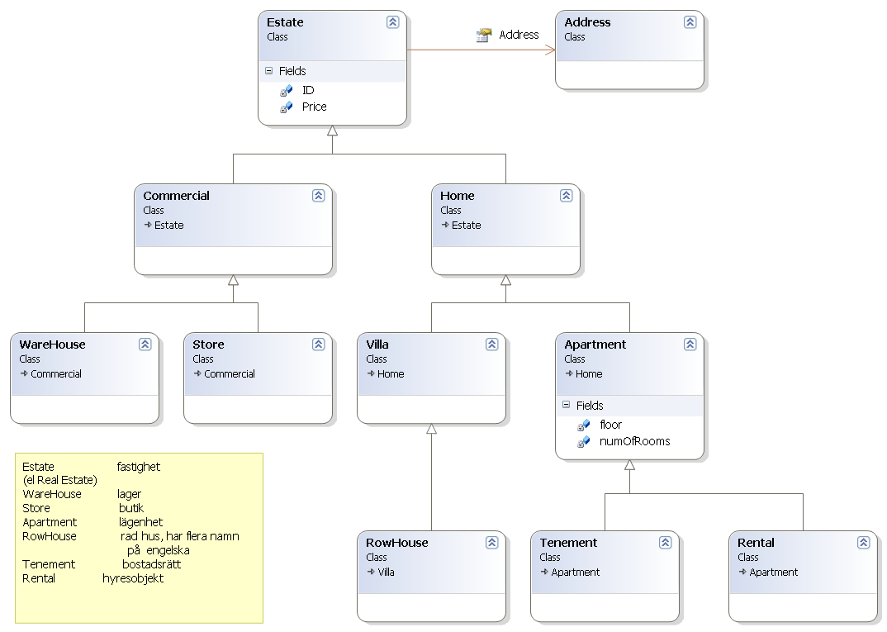

Notes:. The Address class shows an aggregation, i.e. the class is a field in the class Estate. Aggregation is drawn as an open arrow. Inheritance is drawn as an arrow with a closed hollow tip. Notice also the direction of the arrows!

Good Luck!
Programming is fun. Never give up. Ask for help!
Farid Naisan, Course Coordinator and Instructor

