SMART INDIA HACKATHON 2026 · PROBLEM STATEMENT 26167 · ISRO
SatQuery AI
An Agentic Vision-Language Assistant for Multimodal Remote-Sensing Image Analysis through Text Queries

Technical Report — Approach, Architecture and Evidence
TEAM
BUGHEBUG
Problem Statement ID 26167
Organisation Indian Space Research Organisation (ISRO)
Theme / Category Space Technology / Software
Version 1.0 · 26 September 2026

Document Control
Field | Value
Document | SatQuery AI — Technical Report: Approach, Architecture and Evidence
Problem Statement | PS 26167 · SatQuery AI — An Interactive Vision-Language Assistant for Multimodal Remote Sensing Image Analysis through Text Queries
Organisation | Indian Space Research Organisation (ISRO), Department of Space
Theme / Category | Space Technology / Software
Team | BUGHEBUG
Version / Date | 1.0 / 26 September 2026
Status | Submission baseline. Every number in this report was measured; none is a target presented as a result.
Source of record | The team repository: 167/docs/ (problem statement, PRD, TRD, system design, ADRs, decision record) and 167/models/MANIFEST.md (measured model results).

How to read this report
The report is written so that a reader with no background in satellite imagery or machine learning can follow the whole approach. Section 1 explains the problem, Section 2 teaches the minimum domain knowledge needed, and Sections 3 onward describe what we built, why, and how well it works. A reader in a hurry should read the Executive Summary, then Section 3.2 (how a question travels through the system) and Section 8 (results).
Label | Meaning in this report
Built | Implemented, running in the repository, and covered by tests.
Measured | A number produced by a script whose predictions are stored on disk and can be recomputed.
Planned | Designed and specified, not yet implemented. Always labelled as such.
Synthetic | Demo scenes whose pixels are generated, because Cartosat-2S and RISAT imagery is not publicly available. The algorithms that read those pixels are real.
[n] | A citation to entry n in Section 15, Research and References. Every reference carries a hyperlink.

Index
Every entry is a link to its section. In Word, the Navigation Pane (View → Navigation Pane) shows the same outline.
Executive Summary
1 Problem Statement Understanding
1.1 The problem statement at a glance
1.2 The problem in plain words
1.3 The five mandatory capabilities
1.4 The three input modes
1.5 Representative queries and how SatQuery routes them
1.6 How the solution will be evaluated — and what the PS does not say
1.7 Why this is hard, and why a generic AI model is not enough
2 Background Primer — Satellites, Sensors and AI in Plain Words
2.1 Two kinds of satellite eyes: optical and SAR
2.2 Co-registration, GeoTIFF and coordinates
2.3 The AI tasks
2.4 The five levels of a change answer
3 Proposed Solution
3.1 Our answer in one sentence
3.2 How a question travels through the system
3.3 Three principles that make the answers trustworthy
3.4 The agentic router
3.5 The four specialists
3.6 Evidence, confidence and the execution trace
3.7 Worked example — seeing under cloud
4 The Remote-Sensing-Adapted Model (M1)
4.1 Model inventory
4.2 Choosing the base model by benchmark, not reputation
4.3 How the adapter was trained (LoRA / QLoRA)
4.4 The data ladder and the result
4.5 Is the gain real? Significance and split integrity
4.6 Where the gain came from
4.7 Calibration and the confidence gate
4.8 How M1 is served
5 System Design and Architecture
5.1 System context
5.2 Containers
5.3 Components and the six processing layers
5.4 Deployment view
5.5 Runtime views
5.6 API and result contract
5.7 Cross-cutting concerns
5.8 Quality-attribute targets
6 Technology Stack
7 The Web Application
8 Evaluation and Results
8.1 Remote-sensing adaptation (M1)
8.2 Classical specialists — against ground truth the pipeline never reads
8.3 Ablation — what each layer adds
8.4 What we deliberately do not claim
9 Novelty and Differentiation
9.1 The research gap
9.2 Six differentiators
9.3 Comparison with existing approaches
9.4 How the research literature maps onto our pipeline
10 Feasibility and Viability
10.1 Risks and mitigations
11 Scalability and Future Roadmap
11.1 Roadmap
12 Impact and Benefits
12.1 Who benefits
12.2 Benefits
12.3 Application case study — supporting Forest Rights Act claims (proposed extension)
13 Key Design Decisions
13.1 What is real and what is simulated
14 Team BUGHEBUG
14.1 Anticipated questions
15 Research and References
Appendix A — Glossary
Appendix B — Reproducing the Results

Executive Summary
Satellite imagery answers questions that matter to India every day — how far a flood has spread, how much a city has grown, whether a forest is intact — but today each answer needs a specialist who knows which software, model and parameters to use. SatQuery AI removes that barrier. A user uploads imagery and asks in plain English; the system picks the right remote-sensing specialist, checks that the imagery can answer the question, and returns the answer with its evidence: a map, a calibrated confidence value and an auditable record of exactly what ran.
THE RULE THAT GOVERNS THE WHOLE DESIGN
Vision models produce the facts. The language layer only phrases them. Never the reverse. The component that writes the answer receives validated measurements and never sees a pixel, so it cannot invent a number that no model measured.

+13.3 pts  Measured gain from remote-sensing adaptation (VQA 0.527 → 0.660) | p = 1.2e-35  Paired McNemar significance of that gain on 2,000 held-out items | 0.107 %  Share of model parameters trained (QLoRA adapter, 20 MB) | 0 of 29,614  Images shared between training and evaluation splits (counted)

What ISRO asked for, and what we deliver
# | Mandatory capability (PS 26167) | Our answer | State
1 | Remote-sensing adaptation of at least one visual / vision-language component | M1: a QLoRA adapter on Qwen2-VL-7B trained on VRSBench; zero-shot 0.5270 → adapted 0.6600 | Built · Measured
2 | Single-image VQA plus one more single-image task | VQA (M1 + classical measurement) and text-guided region grounding with georeferenced boxes | Built
3 | Bi-temporal change analysis | Change detection, change description and change-VQA with a change map in hectares | Built (classical)
4 | Optical–SAR cross-modal analysis | Separate SAR path (speckle filter, backscatter) and late fusion; quantifies built-up area hidden under cloud | Built (classical)
5 | Agentic orchestration | A constrained router: classify → validate → select from a fixed registry → sequence → execute, with a full execution trace | Built

Why it is different
- It refuses impossible questions before any model runs — and tells the user what to upload instead.
- It sees under clouds: radar + optical fusion measured 1,466.7 ha of built-up area hidden beneath cloud in the demo.
- Every number traces to a measurement, with calibrated confidence; below the gate, it abstains.
- It shows an auditable execution trace, not chain-of-thought — exactly what ISRO says it evaluates.
- It runs fully offline on one laptop; the only GPU-bound part is isolated behind a fallback.

1 Problem Statement Understanding

1.1 The problem statement at a glance
Field | Value
Problem Statement ID | 26167
Title | SatQuery AI — An Interactive Vision-Language Assistant for Multimodal Remote Sensing Image Analysis through Text Queries
Organisation | Indian Space Research Organisation (ISRO), Department of Space
Category / Theme | Software / Space Technology
Primary adaptation dataset | BigEarthNet.txt [1]
Public evaluation benchmarks | VRSBench [4] and RSVQA [5] (single image); CDVQA [7] (change)
Hidden evaluation set | ISRO/SAC: co-registered Cartosat-2S optical + RISAT SAR pairs; annotations not disclosed

1.2 The problem in plain words
A district officer wants to know whether construction has increased near a reservoir since 2024. The imagery exists — much of it free — but extracting an answer requires knowing which model applies, how the sensors behave, how GIS software works and which parameters to set. Existing tools are built one task at a time: land-cover classification here, building detection there, change detection somewhere else. None of them accepts a question.
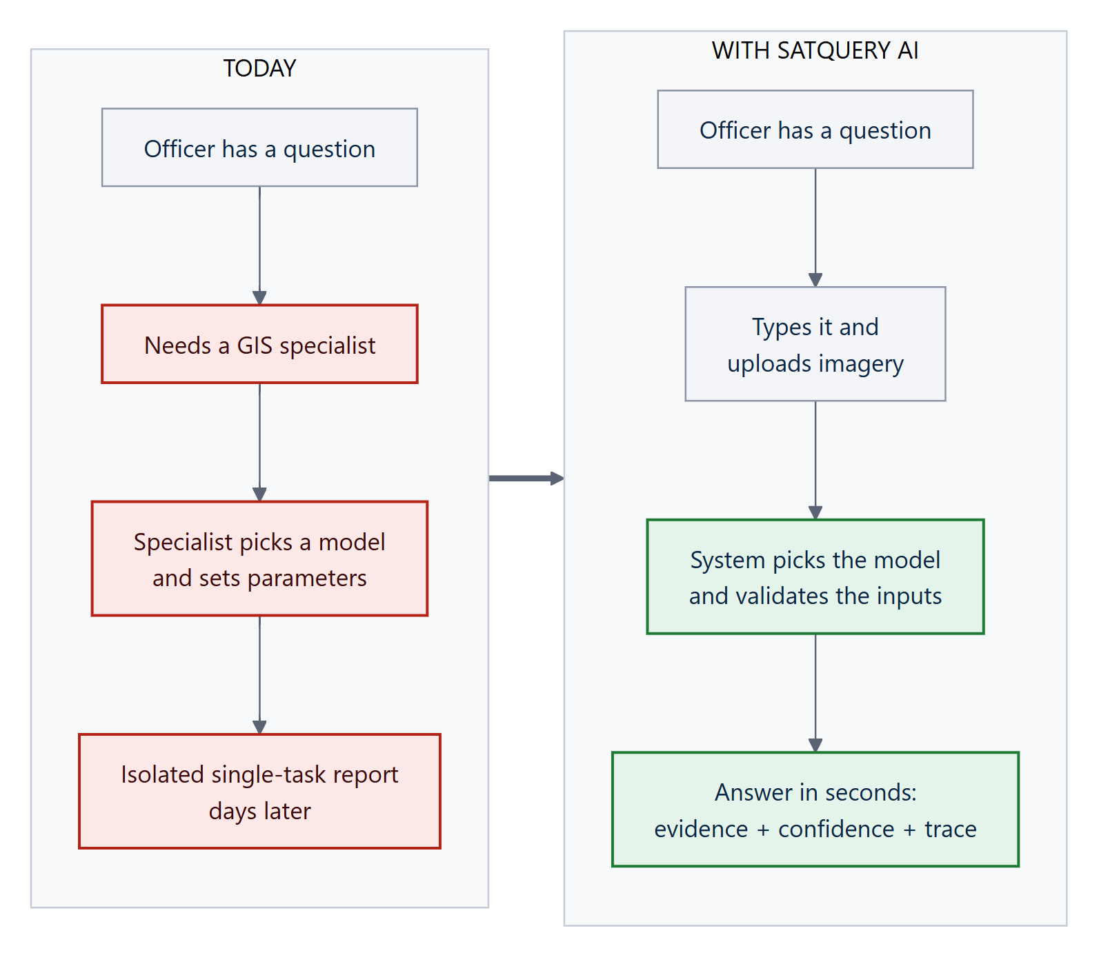
Figure 1. Today's workflow compared with the SatQuery AI workflow.
THE REAL GAP
The gap is not model capability. It is that no interface accepts a question, checks whether the imagery can answer it, and shows its working.

1.3 The five mandatory capabilities
The problem statement makes five capabilities compulsory. The system must satisfy all five; the table maps each to where it is addressed in this report.
# | Capability | What the PS requires | Section
R1 | Remote-sensing adaptation | At least one visual or vision-language component fine-tuned or adapted using BigEarthNet.txt or any open-source training data. “A generic LLM or VLM without remote-sensing adaptation will not satisfy the requirements.” | §4
R2 | Single-image baseline | VQA mandatory, plus captioning/scene description or text-guided region grounding. | §3.5
R3 | Multi-image change analysis | Change description or change-based VQA from a bi-temporal pair; a change map where masks exist. | §3.5
R4 | Cross-modal pair analysis | Extract complementary information from a co-registered optical/multispectral + SAR pair. | §3.5
R5 | Agentic orchestration | Automatically select, sequence and execute specialist models/tools from a predefined registry, with only permitted parameters, and emit an auditable execution summary. | §3.4

1.4 The three input modes
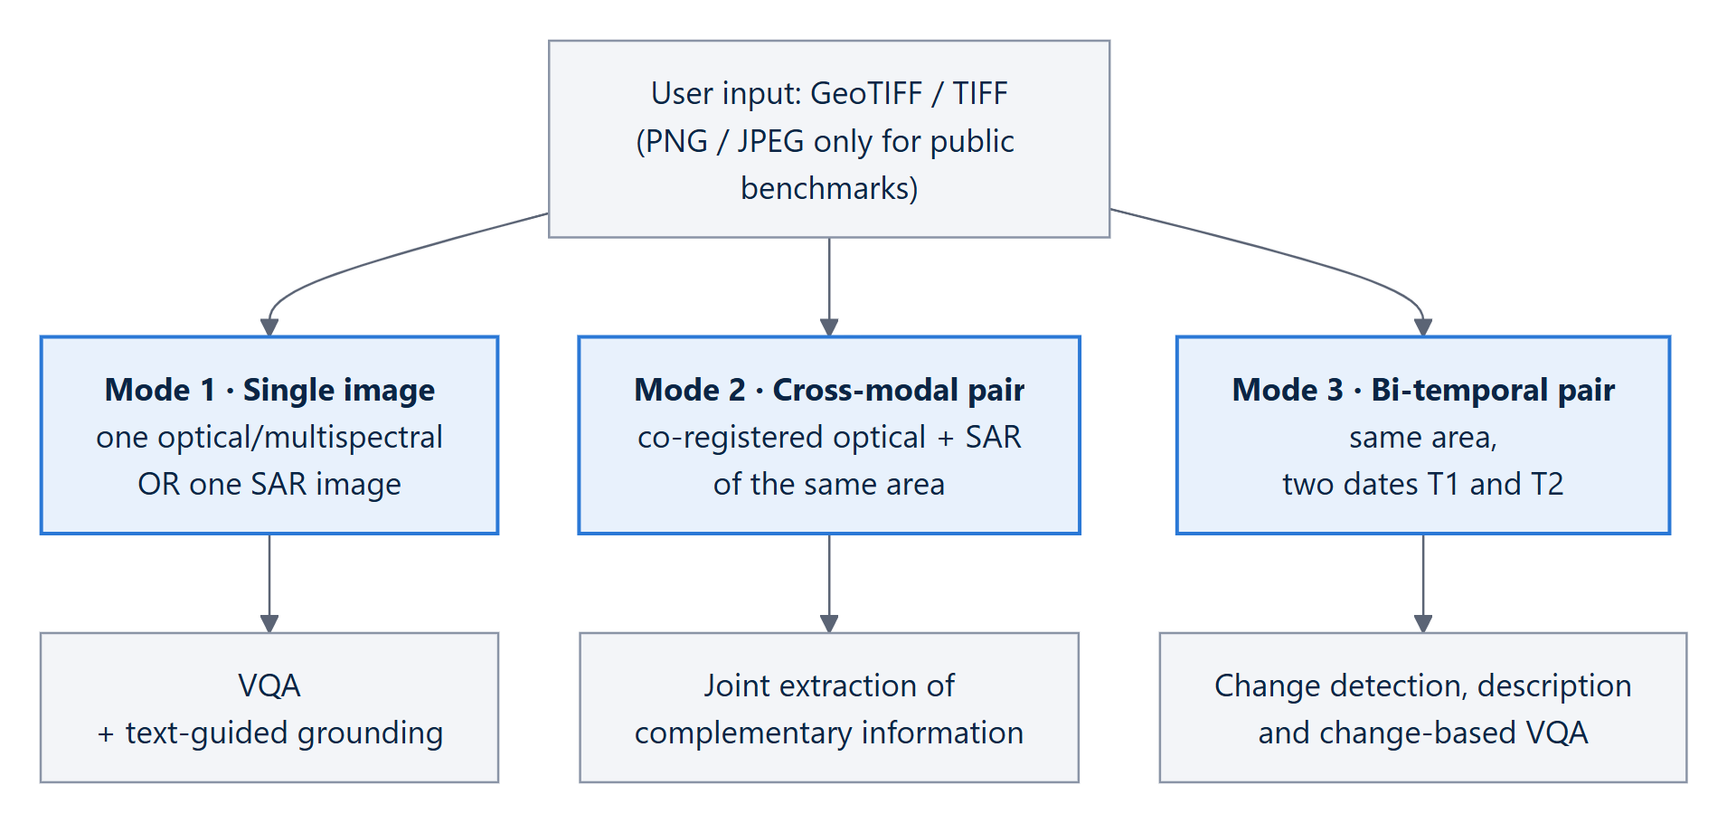
Figure 2. The three input configurations defined by the problem statement and the tasks each one supports.

1.5 Representative queries and how SatQuery routes them
Representative query (from the PS) | Task classified | Tool from registry | Inputs required
“Describe the land-cover and major objects visible in this image.” | single_vqa | rs_vqa | one image
“Highlight the water body referred to in the query.” | grounding | grounding | one image
“What changed between these two dates, and where did the change occur?” | temporal_change | change_vqa | bi-temporal pair
“Use the optical and SAR images together to identify built-up and water-covered regions.” | cross_modal | optical_sar | optical + SAR pair
“Has the built-up area increased, decreased, or remained unchanged?” | temporal_change | change_vqa | bi-temporal pair

The last query is a deliberate trap: it names no date and no second image, yet it can only be answered by comparing two. The router treats a verb of change over a quantity (increased, shrunk, encroached) as a temporal question; routing it to single-image VQA would return a confident area that answers a different question.

1.6 How the solution will be evaluated — and what the PS does not say
Evaluation uses the prescribed public benchmark test splits plus an ISRO/SAC set of pre-georeferenced, co-registered Cartosat-2S optical and RISAT SAR pairs [20][21] whose answers are hidden. Scores are normalised before combining. A careful reading of the official record surfaced three facts that shaped our plan:
Finding in the official text | Consequence for our design
The judging-criteria table is an unfilled placeholder — the text literally reads “Add ‘Evaluation/Judging Criteria’ table here”. | Weights are unknown. We built a balanced, separately visible and separately measured result for all five capabilities instead of optimising one.
The dataset field is truncated at 355 characters, cutting off ISRO's guidance for VRSBench, RSVQA and CDVQA. | We default to each benchmark's official published split and never re-split it.
Only the observable execution trace is evaluated; “internal reasoning text is neither required nor evaluated”. | The interface shows a factual audit log (task, tools, parameters, outputs) and never streams chain-of-thought (ADR-008).
The scored imagery is Indian, sub-metre and unseen. | The objective is robustness to unseen data, not a benchmark peak: input validation, calibrated confidence and abstention.

1.7 Why this is hard, and why a generic AI model is not enough
Any one of the following is a respectable project; the problem statement asks for all three, orchestrated:
- Two sensor types. Optical imagery records reflected sunlight — colour and material. SAR emits its own radar pulse and records backscatter — structure and roughness, through cloud and at night. They are different physical measurements and must be reasoned over together.
- Time. Two images of the same place on different dates, and an understanding of what changed and where — not merely that some pixels differ.
- Choice, including refusal. The system must pick the specialist from the question and the inputs, and must refuse when the inputs cannot support the question.

A general-purpose vision-language model (for example GPT-4V) fails for concrete technical reasons: it accepts three colour channels where satellites carry up to thirteen; it reads bright SAR pixels as “bright things” rather than strong backscatter; a building may be four pixels at 10 m resolution; the viewpoint is overhead; a coordinate reference system means nothing to it; and it can state a number that nothing measured. It also needs the internet, which a venue demo cannot rely on. A general language model still has a place — interpreting the query at the front and phrasing verified facts at the end — but never as the thing that looks at pixels and decides what is there.

2 Background Primer — Satellites, Sensors and AI in Plain Words
This section gives a reader new to remote sensing the minimum vocabulary needed for the rest of the report.

2.1 Two kinds of satellite eyes: optical and SAR
 | Optical / multispectral | Synthetic Aperture Radar (SAR)
How it sees | Records sunlight reflected from the ground, in several wavelength bands (red, green, blue, near-infrared …) | Sends its own microwave pulse and records how much energy bounces back (backscatter)
What it tells you | Colour and material — vegetation, water, soil | Structure, roughness and geometry
Clouds and night | Blocked by cloud; needs daylight | Sees through cloud, day and night
Noise | Mostly additive sensor noise | Speckle — multiplicative noise that needs its own filter (Lee filter [34])
Indian missions | Cartosat-2S [21] | RISAT / EOS-04 [20]
Open data used | Sentinel-2 [28] | Sentinel-1 (paired with Sentinel-2 in BigEarthNet.txt [1] and SEN12MS [18])

What SAR brightness means. Calm water reflects the radar pulse away and looks very dark; smooth bare soil is dark; vegetation scatters diffusely and looks mid-grey; buildings and metal act as corner reflectors and look very bright. This is why a model trained on ordinary photographs misreads radar — and why SatQuery gives SAR its own processing path (ADR-003).

2.2 Co-registration, GeoTIFF and coordinates
- Co-registration means two images are aligned pixel-for-pixel over the same ground. ISRO's scored pairs arrive already co-registered, so SatQuery verifies alignment (phase correlation, tolerance 2 px) rather than solving it [19].
- GeoTIFF is an image file that also carries its location: a coordinate reference system (CRS, e.g. EPSG:4326 latitude/longitude, or UTM in metres) and a geotransform that maps each pixel to a ground coordinate [17]. This is what lets SatQuery turn a box in pixels into latitude/longitude on a map and an area in hectares.
- Ground sample distance (GSD) is the ground size of one pixel — 10 m for Sentinel-2, sub-metre for Cartosat-2S.

2.3 The AI tasks
Term | Plain meaning | Example
Visual Question Answering (VQA) | Answer a natural-language question about an image | “How many bridges are visible?” → 2
Grounding | Find and outline the thing the text refers to | “Highlight the water body” → a box/mask on the map
Captioning | Describe an image in a sentence | “A river crossing farmland”
Change detection | Find what differs between two dates, and where | “10 changed regions, 1,663 ha”
Vision-language model (VLM) | A neural network that reads images and text together | Qwen2-VL [32], GeoChat [9]
Fine-tuning / adaptation | Further training of a pre-trained model on domain data | Training on satellite VQA pairs
LoRA / QLoRA | Train a small add-on (adapter) instead of the whole model; QLoRA also compresses the frozen model to 4 bits [12][33] | 20 MB adapter on a 7-billion-parameter model
Calibration | Whether a stated confidence matches real accuracy | Answers given at 0.9 are right ~90 % of the time

2.4 The five levels of a change answer
Subtracting two images tells you pixels changed; it cannot tell you a field became a warehouse, because a seasonal crop change and a construction project produce similar pixel differences. A real change answer climbs five levels:
Level | Question | Example output | Produced by
1 | Did anything change? | yes / no | vision
2 | What changed? | Vegetation → built-up | vision
3 | How much? | +4.37 percentage points built-up | vision
4 | Where? | boxes / mask in lat-long | vision
5 | What does it mean? | “consistent with construction” | language layer, phrasing facts only

3 Proposed Solution

3.1 Our answer in one sentence
SATQUERY AI IN ONE SENTENCE
Do not build a chatbot that looks at satellite images. Build a remote-sensing analysis system that happens to accept natural language. A constrained agent routes each question to a registry of remote-sensing specialists, validates the inputs first, fuses the measured evidence, and phrases only what was measured — with confidence, a map and an auditable trace.

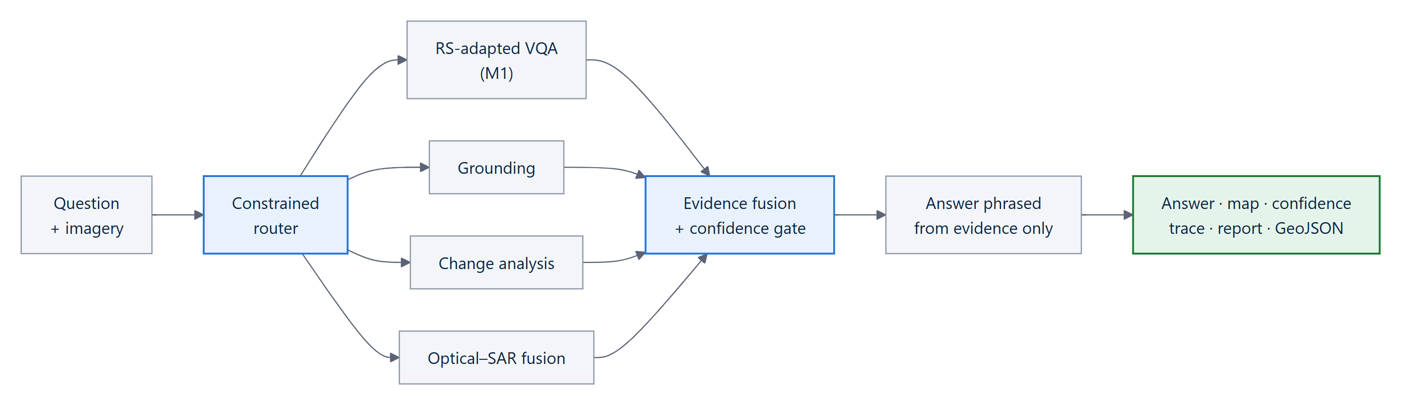
Figure 3. The solution at the highest level: one entry point, a fixed set of specialists, and evidence-gated answers.

3.2 How a question travels through the system
Every request follows the same fixed nine-step path. Each step writes one line into the execution trace — which step ran, what it decided and how long it took.
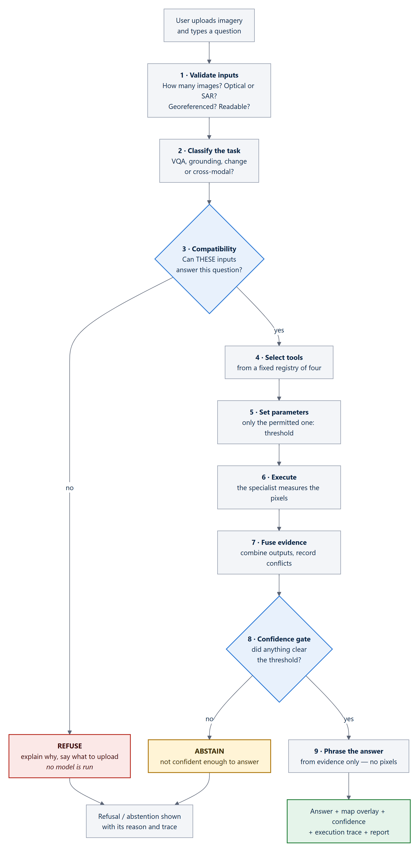
Figure 4. The nine-step request path. Two of the three possible outcomes are the system saying “no” — which is what makes the “yes” answers trustworthy.
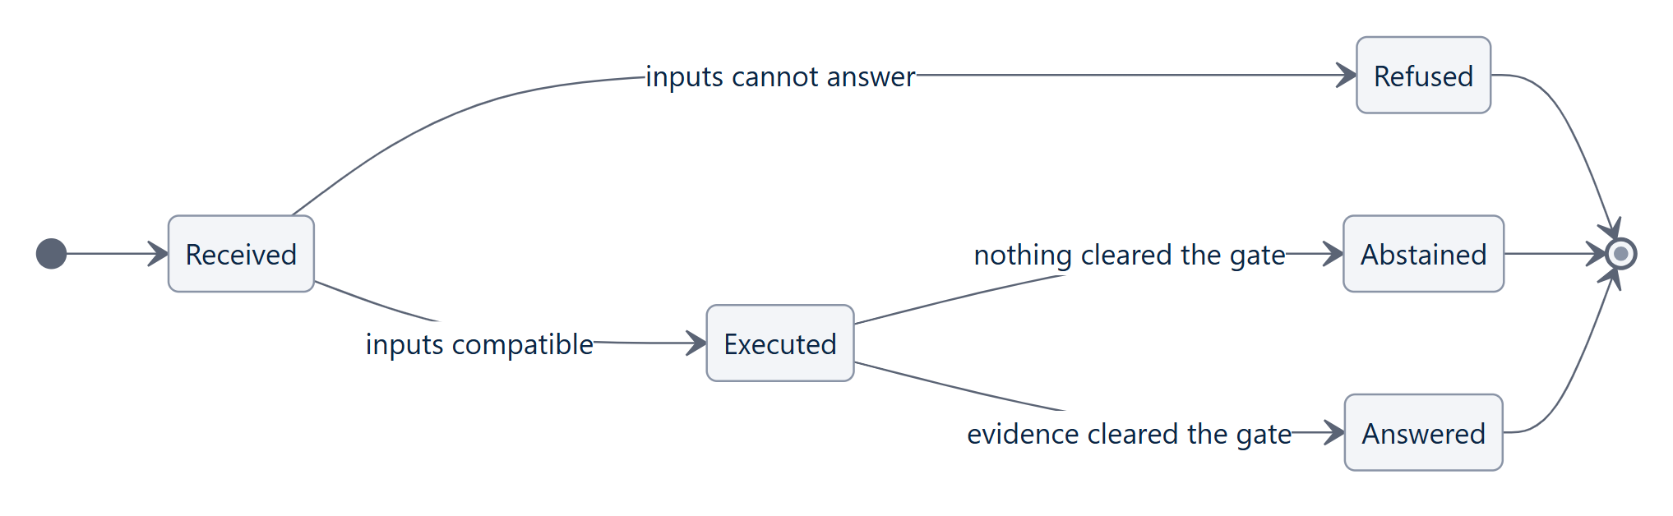
Figure 5. The three outcomes of every query.

3.3 Three principles that make the answers trustworthy
Principle | What it means | How it is enforced
Refuse rather than guess | Incompatible inputs are refused before any model runs, with what to upload instead. | Router step 2 (validate) precedes selection; the refusal path has no call into the model runtime.
Facts before words | Vision specialists produce structured evidence; the language layer only phrases it. | pipeline.answer() accepts an EvidenceSet and no raster — enforced by the type signature and asserted by a test (ADR-007).
Abstain below threshold | If no evidence clears the confidence gate, the system declines rather than guesses. | Gate at 0.45, chosen from measured calibration data (§4.7).

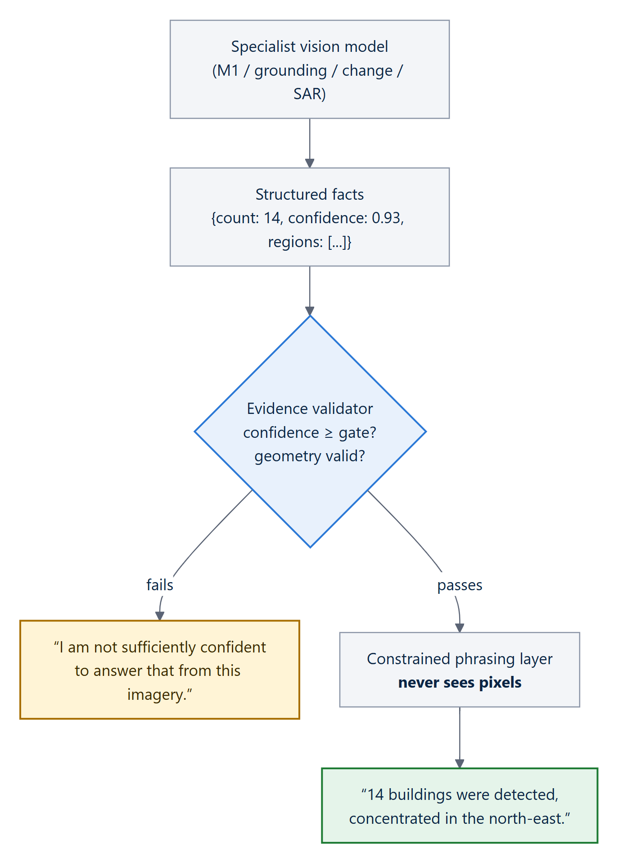
Figure 6. Evidence-gated generation (ADR-007): the language layer cannot invent a number because it never had the image.

3.4 The agentic router
The problem statement calls the router the novelty of the whole system. It is deliberately a constrained agent, not an open-ended one: ISRO asks for tools selected “from a predefined registry” with “only permitted task parameters”. SatQuery's router is a plain, readable Python function (ADR-004) that performs five jobs in strict order:
# | Job | What it does | PS wording it satisfies
1 | Classify | Reads the question and decides the task (single_vqa, grounding, temporal_change, cross_modal). | “interpret the query and classify the requested task”
2 | Validate | Checks number, modality, format, CRS and alignment of the uploads against what the task requires. | “check the number, modality, format, metadata, and compatibility of the input images”
3 | Select | Picks tools only from the registry — never invents one. | “select one or more models or tools from a predefined registry”
4 | Sequence | Orders tools when more than one is needed. | “select, sequence, and execute”
5 | Execute | Runs with permitted parameters only (the confidence threshold). | “configure only permitted task parameters”

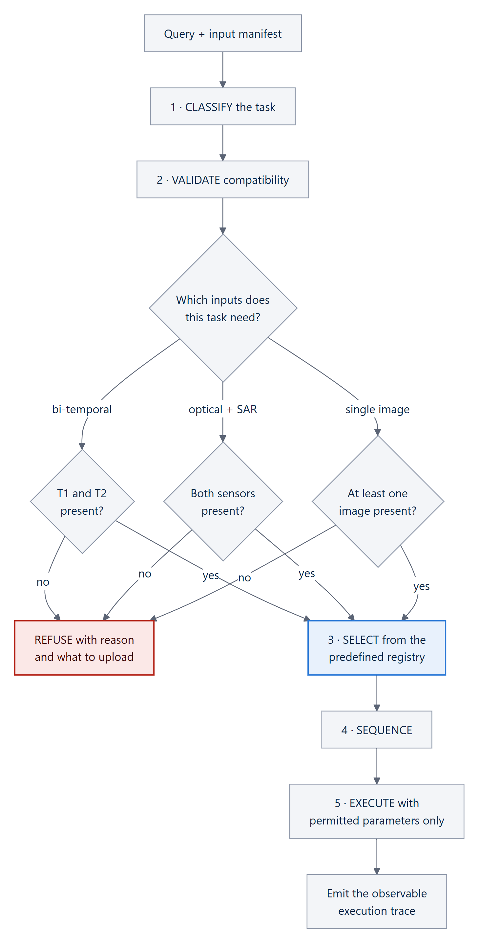
Figure 7. The router's five jobs, including the refusal branch that runs no model.

The tool registry — the only tools the router may select
Tool | Task | Requires | Outputs | Model slot | Permitted parameter
rs_vqa | single-image VQA | single image | text, confidence | M1 (trained) | threshold ∈ [0, 1]
grounding | text-guided grounding | single image | georeferenced boxes, confidence | M2 (planned) | threshold ∈ [0, 1]
change_vqa | change, change-VQA | bi-temporal pair | text, change regions, area | M3 (planned) | threshold ∈ [0, 1]
optical_sar | cross-modal | co-registered optical + SAR | per-modality evidence, fused evidence | M4 (planned) | threshold ∈ [0, 1]

Adding a capability means adding one registry row that declares its inputs, outputs and permitted parameters; a tool without a row cannot be selected. Classification today is a deterministic, rule-based stand-in with the same interface as the trained classifier specified for M5, so replacing it is a one-line change and the trace records which one ran.

The refusal matrix
Task asked | Inputs needed | If missing, the system says
Single-image VQA / grounding | ≥ 1 image (a pair also satisfies it) | “Upload at least one image.”
Change analysis | a bi-temporal pair | “Change analysis needs a bi-temporal pair. Upload an image for T1 and an image for T2.”
Cross-modal analysis | co-registered optical + SAR | “Upload a co-registered optical image and a SAR image of the same area.”
Anything needing geography | a georeferenced raster | Refuses, naming the missing field (e.g. no CRS)
Target outside the vocabulary | — | Proceeds, then abstains at the confidence gate

3.5 The four specialists

Single-image VQA — the remote-sensing-adapted model (M1)
Questions about one image (“how many bridges?”, “is there water?”, “what type of area is this?”) are answered by M1, our QLoRA-adapted Qwen2-VL-7B (Section 4), alongside classical measurements (spectral indices, segmentation). For what / where / which questions M1 leads the answer; for counts and areas a measured value leads, because M1 counts less reliably (object-quantity accuracy 0.56). When M1 disagrees with a measurement, the disagreement is recorded as a conflict and confidence drops. SAR is never shown to M1, which was trained on optical imagery.

Text-guided region grounding (second single-image task)
“Highlight the water body” returns boxes and masks that are converted through the GeoTIFF geotransform into latitude/longitude, drawn on the map and exported as GeoJSON. We chose grounding over captioning (ADR-002) because a box is verifiable in one second, it feeds the map and the evidence layer, and it is scored by an objective geometric metric (IoU) rather than word-overlap metrics. The current implementation uses NDVI/NDWI spectral indices and multi-level Otsu thresholding [35] with connected components; the M2 adapter is planned.

Bi-temporal change analysis
Given images for T1 and T2 of the same area, the change specialist performs change vector analysis, finds changed regions, measures them in hectares and characterises the change (for example, a mean NDVI drop of −0.707 inside the changed region is consistent with construction). The planned M3 model is a Siamese encoder with a difference head, trained on CDVQA [7].
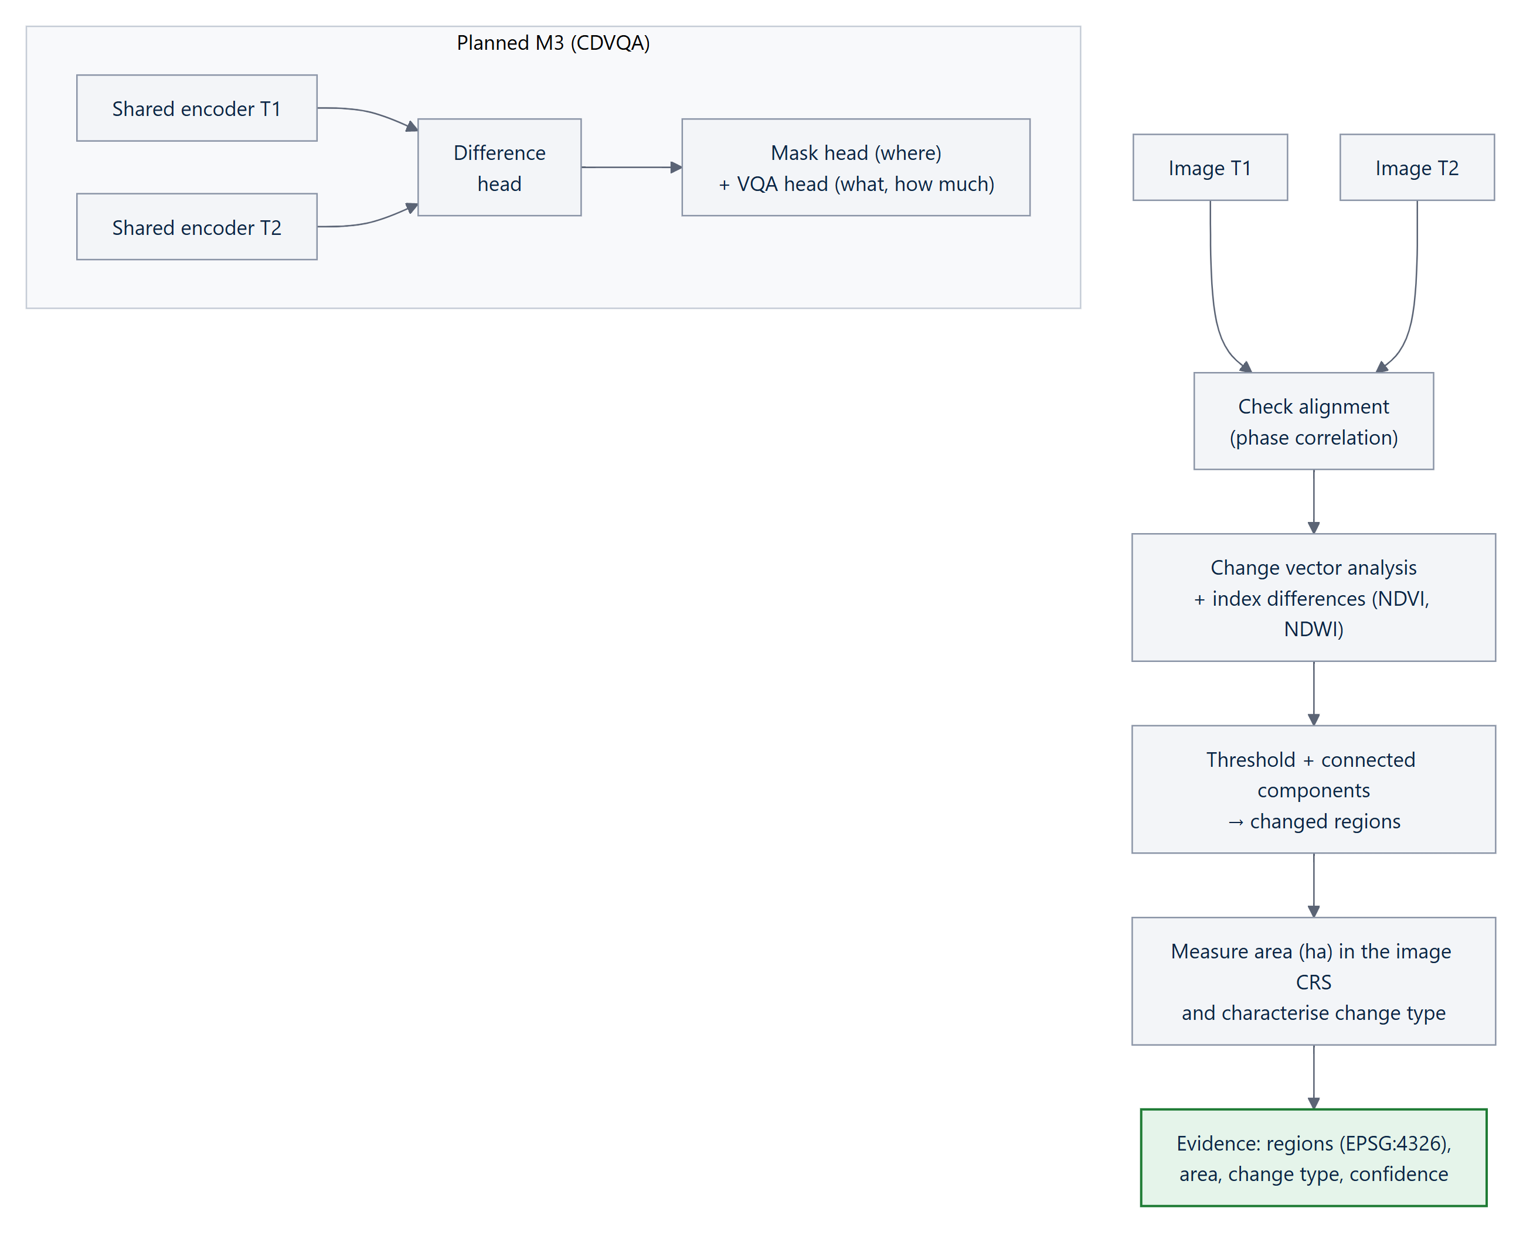
Figure 8. Change analysis: the built classical path and the planned learned model.

Optical–SAR cross-modal fusion
This is where SatQuery shows why two sensors beat one. SAR is processed on its own path — Lee speckle filtering [34] followed by Otsu thresholding [35] on backscatter — never converted to a greyscale photograph (ADR-003). Optical imagery provides cloud masks and vegetation indices. The two conclusions are combined by late fusion (ADR-005), which keeps “optical said X, SAR said Y” visible and lets conflicts lower confidence instead of being silently resolved.
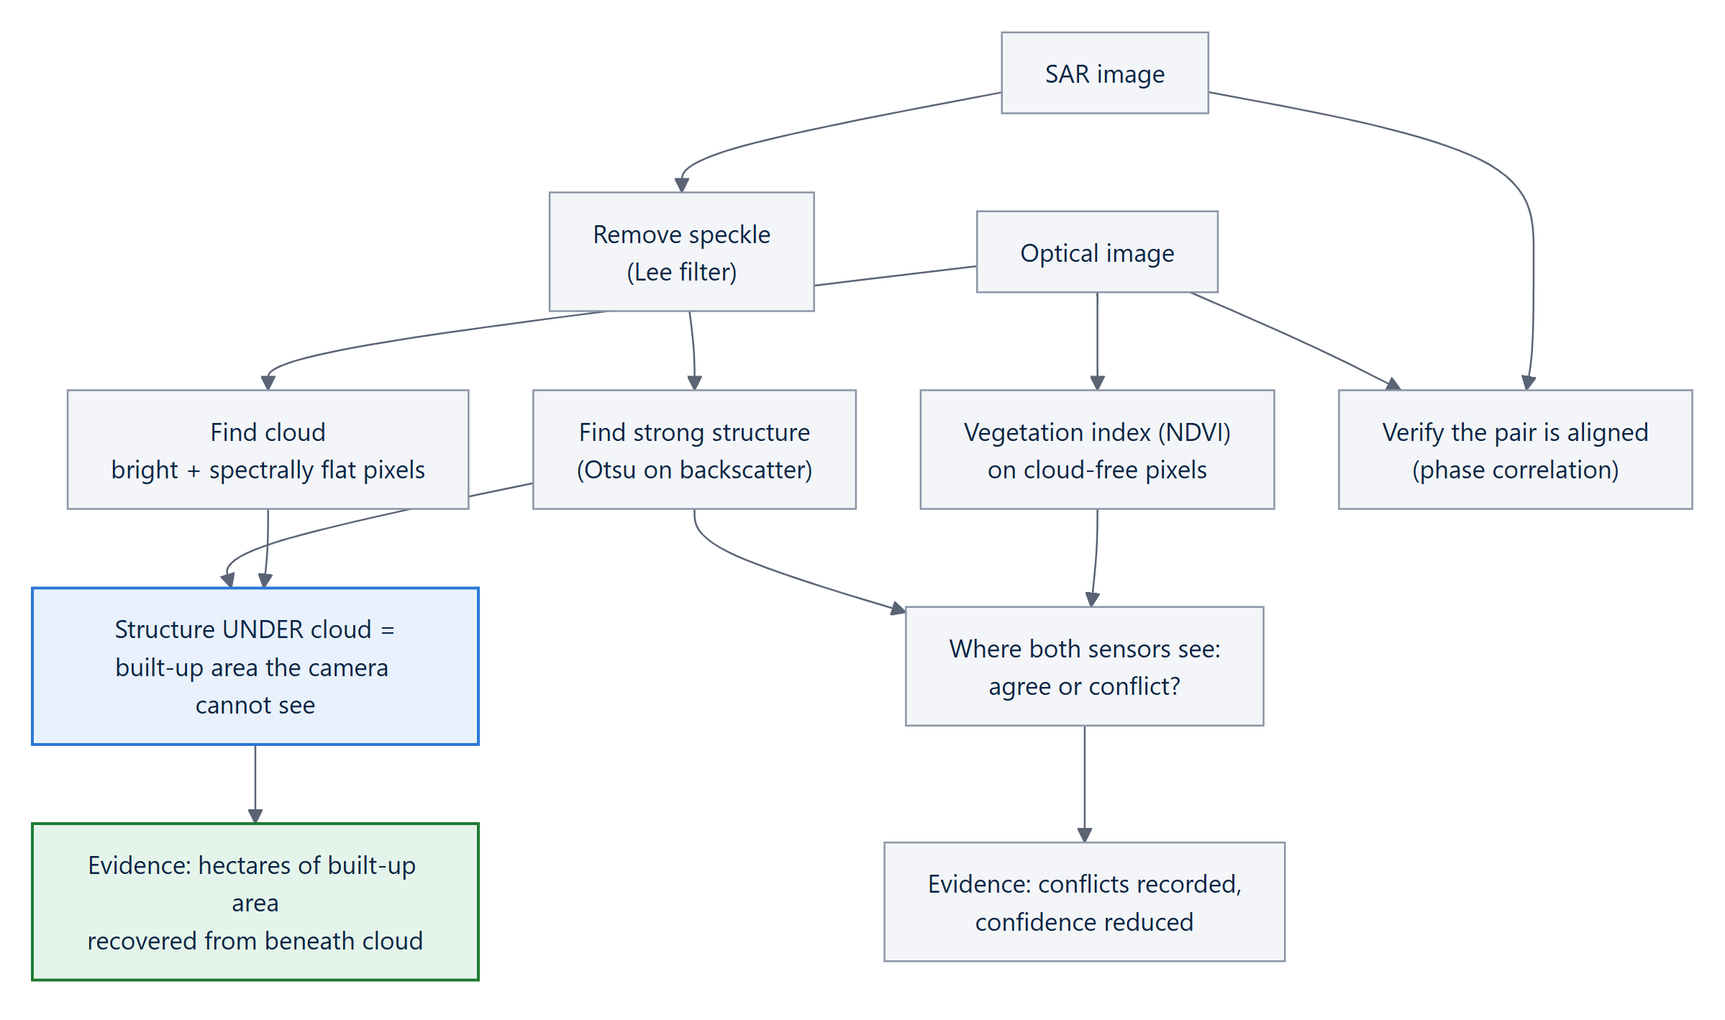
Figure 9. Optical–SAR late fusion. The key output is the built-up area that only radar can see.

3.6 Evidence, confidence and the execution trace
Every specialist returns the same normalised evidence record, so fusion, the map, the report and the answer layer all read one format:
{
"claim": "built-up areas recovered by SAR beneath cloud",
"value": 1, "unit": "areas", "confidence": 0.93,
"modality": "fused", // optical | sar | fused | temporal | derived
"source": { "model": "fusion_late_v0", "version": "0.1.0" },
"spatial_evidence": [
{ "geometry": "POLYGON((...))", "crs": "EPSG:4326", "area_ha": 1466.7 }
],
"supporting": ["cloud obscures 6.0 % of the optical scene"],
"conflicts": [], // each disagreement lowers confidence
"method": "Lee filter + Otsu on backscatter, late fusion"
}

The execution trace is a factual audit log — the observable record the problem statement says it will evaluate. Below is a real trace produced by the running system for the cross-modal query (from python -m satquery.cli demo):
query use the optical and SAR images together to identify built-up regions
task cross_modal tools: optical_sar engine: classical 64 ms

✓ Input validated 2 raster(s) · optical_sar
✓ Task identified cross_modal · matched /optical and/
✓ Compatibility check optical_sar satisfies optical_sar
✓ Tool selected optical_sar (fusion_late_v0)
✓ Parameters threshold=0.45
✓ Co-registration checked optical/sar · offset 0.00 px (tolerance 2 px)
✓ Executed optical_sar 5 evidence item(s) · path classical
✓ Confidence 0.93 · 5/5 items passed the gate
✓ Evidence returned 7 feature(s) · EPSG:4326

3.7 Worked example — seeing under cloud
For the query “Use the optical and SAR images together to identify built-up regions” on the cross-modal demo scene, the system answered:
SYSTEM ANSWER (CONFIDENCE 0.93)
“SAR detects 6 built-up areas totalling 2,539.0 ha. Cloud obscures 6.0 % of the optical scene. 1 of them — 1,466.7 ha — lies beneath that cloud and is invisible to the optical sensor. Radar recovered it because radar penetrates cloud and built structures return strongly from corner reflection. That is information neither sensor provides alone.”

Evidence item | Value | Confidence | Modality
Co-registration verified | 0.0 px offset | 0.95 | fused
Optical scene obscured by cloud | 6.0 % | 0.88 | optical
Built-up areas detected by backscatter | 6 areas | 0.97 | SAR
Built-up areas recovered by SAR beneath cloud | 1 area (1,466.7 ha) | 0.93 | fused
Cross-modal agreement in clear sky | 98.36 % | 0.94 | fused

DISCLOSURE
The demo scene is synthetic: pixels are generated on a real EPSG:4326 geotransform, and the cloud deck is placed over the settlement on purpose, because that is the case where the two sensors genuinely differ. It is a designed scenario, not a discovery. The algorithms that read the pixels are real, and uploaded GeoTIFFs are analysed as supplied.

4 The Remote-Sensing-Adapted Model (M1)
Requirement R1 is the one the problem statement calls disqualifying to omit. This section documents the adapted component end to end: what was trained, on what, how, and — most importantly — the measured gain over the same model without adaptation.

4.1 Model inventory
# | Component | Type | State
M0 | Base vision-language model | Qwen/Qwen2-VL-7B-Instruct [32], frozen, 4-bit | Selected by benchmark
M1 | RS-adapted VQA | QLoRA adapter on M0, trained on VRSBench | Trained · measured · serving
M2 | Grounding | LoRA adapter on M0 (VRSBench) | Planned — classical path serves today
M3 | Change / change-VQA | LoRA adapter + Siamese difference head (CDVQA) | Planned — classical path serves today
M4 | SAR encoder + fusion | Separate small encoder (Sentinel-1), late fusion | Planned — classical path serves today
M5 | Router | Rule-based classifier; trained classifier planned | Built (rules)
M6 | Answer phrasing | Constrained templates over evidence records | Built

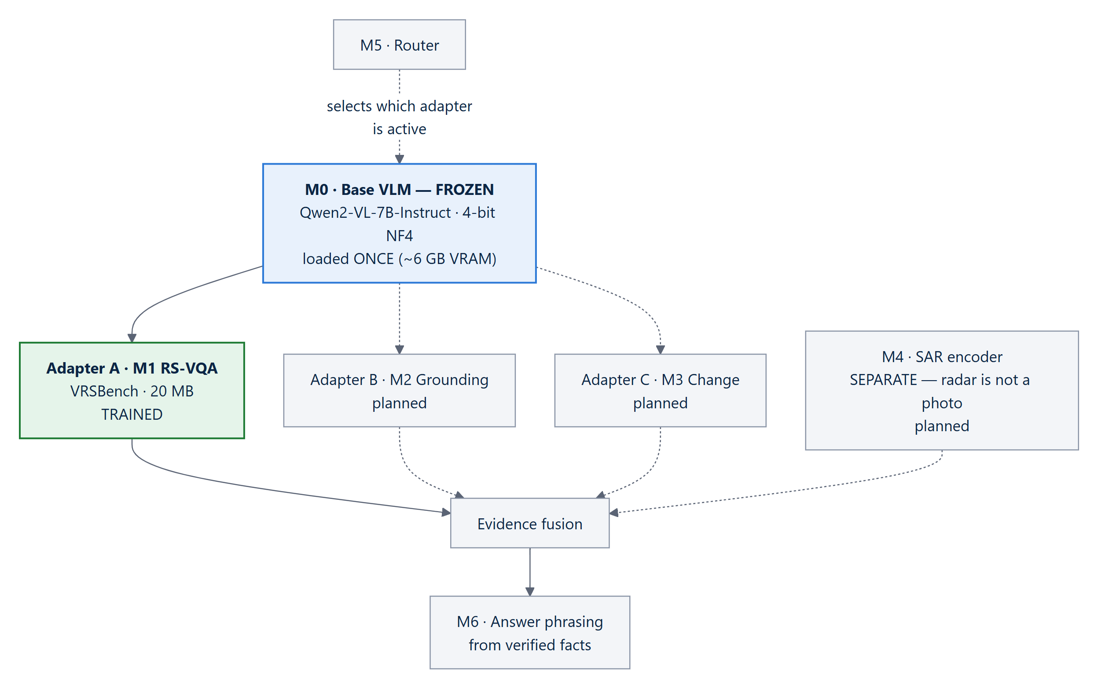
Figure 10. One frozen base, many swappable adapters (ADR-001). Solid lines are built; dashed lines are planned.
Why one base with adapters: four separately fine-tuned 7B models would need 60 GB of GPU memory; one frozen base with swappable adapters needs 15 GB at 16-bit or ~6 GB at 4-bit, each adapter is a few tens of MB, swaps take milliseconds, and each capability can be ablated independently.

4.2 Choosing the base model by benchmark, not reputation
The base model is the least reversible decision — every adapter is trained against it — so ADR-010 required it to be chosen by measurement. Two candidates were evaluated:
Candidate | Outcome | Decision
MBZUAI/geochat-7B [9] | Could not be loaded: the checkpoint declares model_type: geochat with no auto_map, and its code pins transformers ~4.31, which breaks Qwen2-VL. A base an evaluator cannot load is not a deliverable. | Rejected (recorded, not worked around)
Qwen/Qwen2-VL-7B-Instruct [32] | Loads cleanly; zero-shot VRSBench VQA 0.5270; licence Apache-2.0 (verified) — suitable for handing weights to a government agency. | Selected

A generic base also makes the adaptation visible: requirement R1 asks for evidence of adaptation, and a model that starts generic leaves a measurable gain to demonstrate.

4.3 How the adapter was trained (LoRA / QLoRA)
LoRA [12] freezes the pre-trained model and learns two small low-rank matrices beside selected weight matrices; only those are trained. QLoRA [33] additionally stores the frozen model in 4-bit precision so a 7-billion-parameter model fits on a free 16 GB GPU. The result is a 20 MB adapter file that turns the generic model into a remote-sensing one.
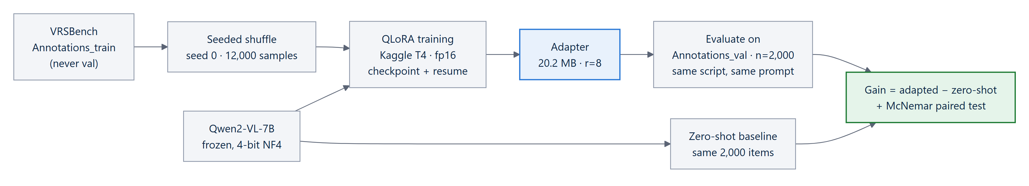
Figure 11. The M1 training and evaluation pipeline. The zero-shot baseline and the adapted model are scored by the same script on the same items.
Setting | Value
Method | QLoRA — 4-bit NF4 frozen base, fp16 compute (the Kaggle T4 has no bf16)
LoRA rank / alpha / dropout | r = 8, α = 16, dropout = 0.05
Target modules | q_proj, k_proj, v_proj, o_proj (attention projections)
Trainable parameters | 5,046,272 of 4,696,922,624 packed — 0.107 %
Optimiser | learning rate 2e-4, cosine schedule, 3 % warm-up, effective batch 32 (1 × 32 accumulation)
Samples / epochs / steps | 12,000 / 1 / 375 optimiser steps (shipped rung 2)
Hardware and time | Kaggle T4 (free tier), 2.2 s per sample, 7.4 h wall time; interrupted and resumed from checkpoint with optimiser, scheduler and RNG state restored
Artefact | models/adapters/m1-rs-vqa/ — PEFT adapter + pack.json manifest; SHA-256 prefix 2ea5192277839e63 matches checkpoint-375

4.4 The data ladder and the result
Rather than training on everything at once, the adapter was trained in rungs, measuring after each. The first 4,000 samples bought ten points; the next 8,000 bought three. The curve is still rising but flattening; a third rung would cost ~7 more GPU-hours for an expected point or two, so the climb stopped by decision, not by hitting a ceiling.
Rung | Training samples | VRSBench VQA accuracy (exact match) | Gain over zero-shot
zero-shot | 0 | 0.5270 | —
rung 1 | 4,000 | 0.6305 | +10.35 points
rung 2 (shipped) | 12,000 | 0.6600 | +13.30 points

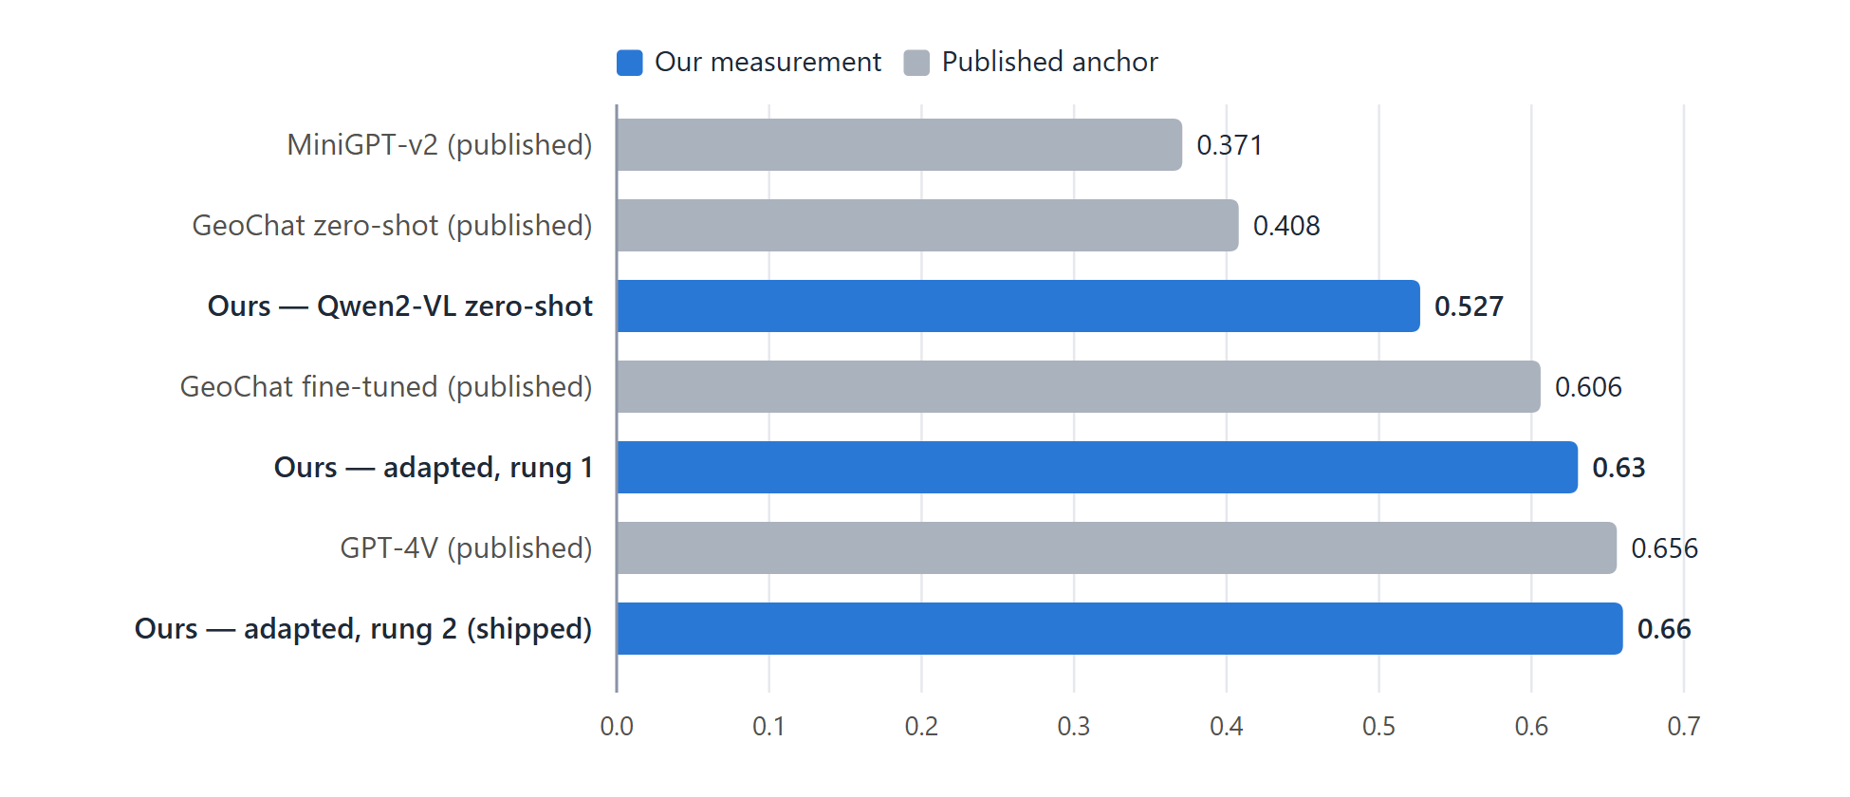
Figure 12. VRSBench VQA accuracy: our measurements (blue) beside published anchors (grey). Our figures are on a 2,000-item subset of the validation split; published figures are on the full test set.
STATED CAREFULLY
This is not an apples-to-apples comparison. At n = 2,000 the 95 % interval on 0.6600 is roughly 0.639–0.681, which contains GPT-4V's 0.6560. The defensible claim is “above the published GeoChat fine-tuned result and level with GPT-4V, on our subset” — not “beats GPT-4V”.

4.5 Is the gain real? Significance and split integrity
Because the zero-shot and adapted runs answered the same 2,000 question IDs, the gain can be tested item by item with McNemar's paired test [36] rather than as a difference of two percentages:
Outcome per item | Count
Zero-shot wrong → adapted right (fixed) | 359
Zero-shot right → adapted wrong (broken) | 93
Right in both | 961
Net improvement | +266 items = +13.30 points
McNemar χ² / p-value | 155.4 / 1.2 × 10⁻³⁵

The adapter breaks some answers and fixes nearly four times as many; reporting both is what makes the net credible. Leakage was counted, not assumed: training reads VRSBench's Annotations_train (20,264 images) and evaluation reads Annotations_val (9,350 images); the overlap is zero. Every figure is recomputable from prediction rows stored in models/results/.

4.6 Where the gain came from
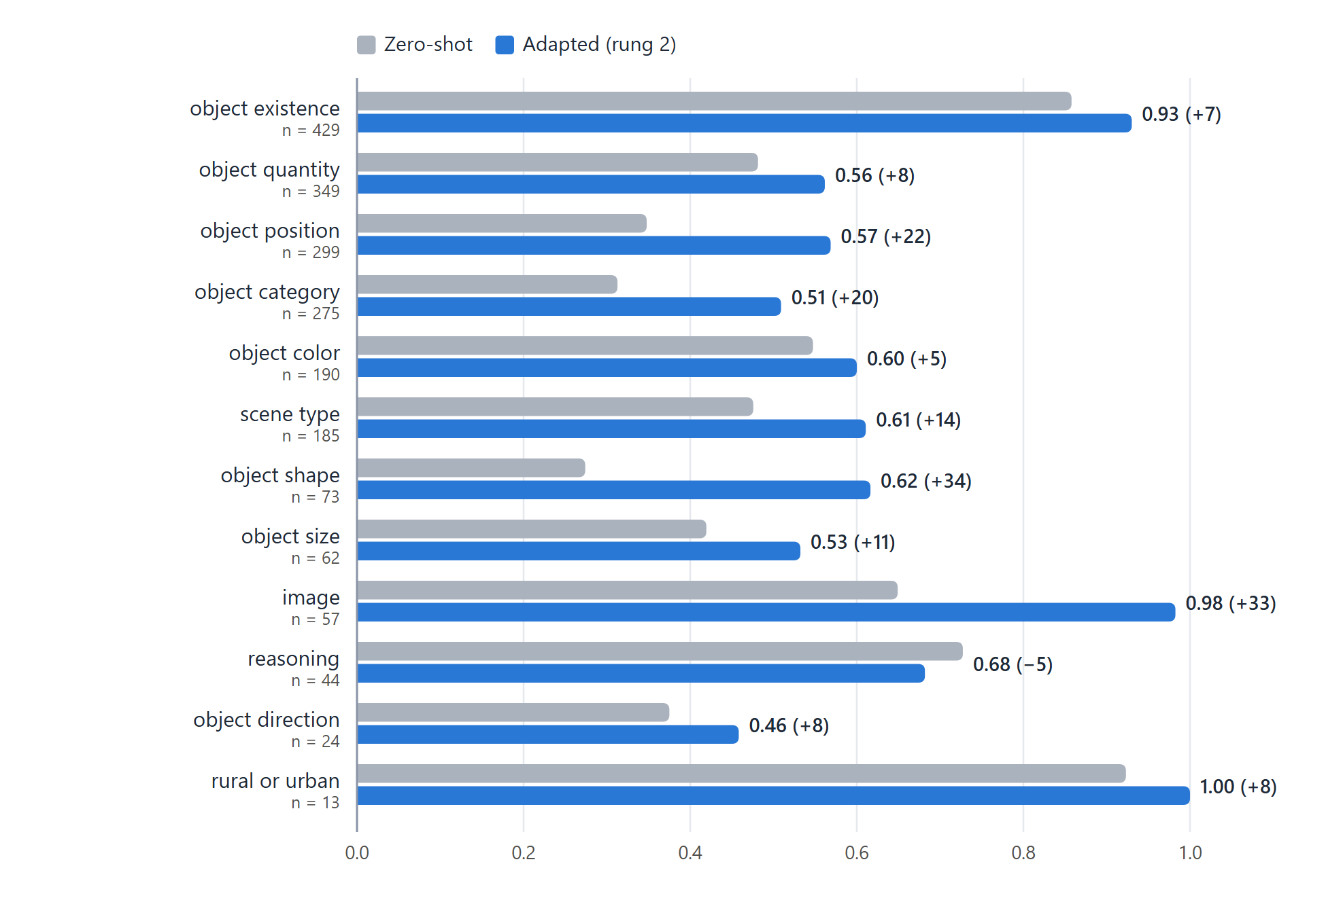
Figure 13. Per-category VQA accuracy, zero-shot versus the shipped adapter (rung 2). Categories sorted by number of evaluation items.
The gain landed where the pre-training error analysis predicted. Before adaptation, the dominant failure was vocabulary rather than perception: ground-track-field answered as Stadium, small-vehicle as Car, rectangular as Square, image-relative Top answered as North. The three weakest categories — shape (+34 points), position (+22) and category (+20) — are the three that moved most. Two small categories (reasoning, n = 44; object size, n = 62) moved within their ±13-point noise band; every category with more than 180 items improved.

4.7 Calibration and the confidence gate
A confidence value is only useful if it means something. On 300 questions asked directly of M1, accuracy rises with confidence in every band:
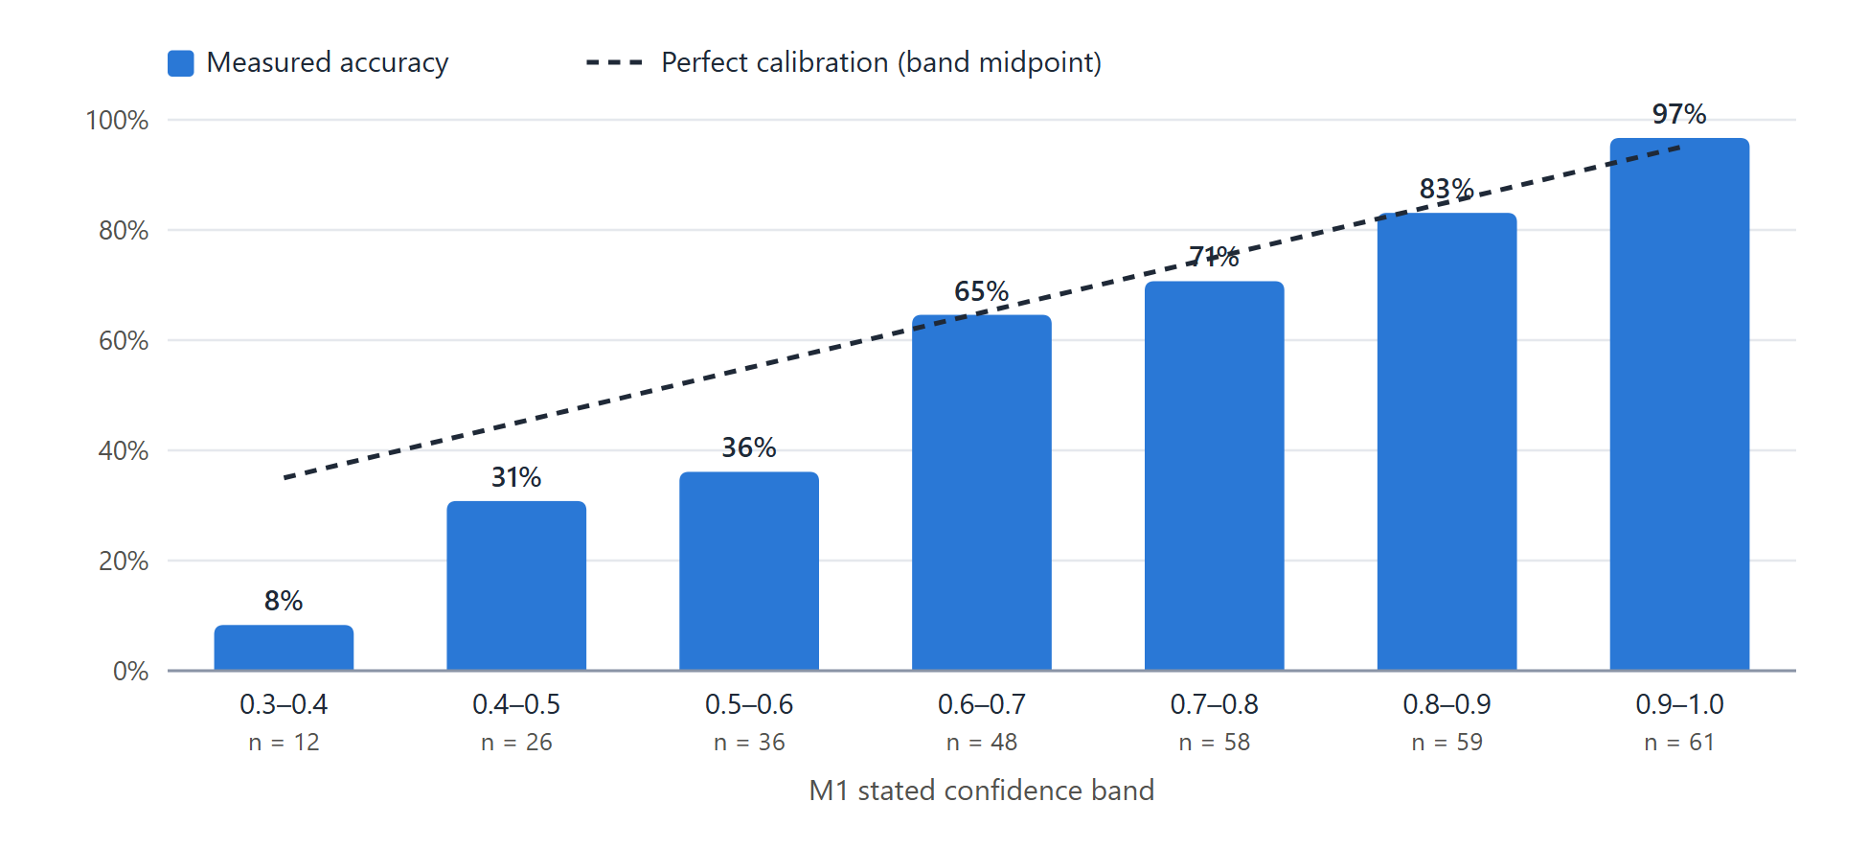
Figure 14. M1 accuracy by confidence band (n = 300). Above 0.6 the stated confidence closely tracks accuracy; below 0.6 it overstates it.
Gate | Answers withheld | Of which wrong | Abstention precision | Right answers lost
0.40 | 12 | 11 | 91.7 % | 1
0.45 (chosen) | 23 | 19 | 82.6 % | 4
0.50 | 38 | 29 | 76.3 % | 9
0.60 | 74 | 52 | 70.3 % | 22

At 0.45 the system withholds 7.7 % of M1's answers, 83 % of which would have been wrong, raising answered accuracy from 0.673 to 0.715 at a cost of 4 correct answers in 300. The serving class (M1Live) gave 300 of 300 answers identical to the run that measured 0.660, proving that what runs in the product is the model that was evaluated.

4.8 How M1 is served
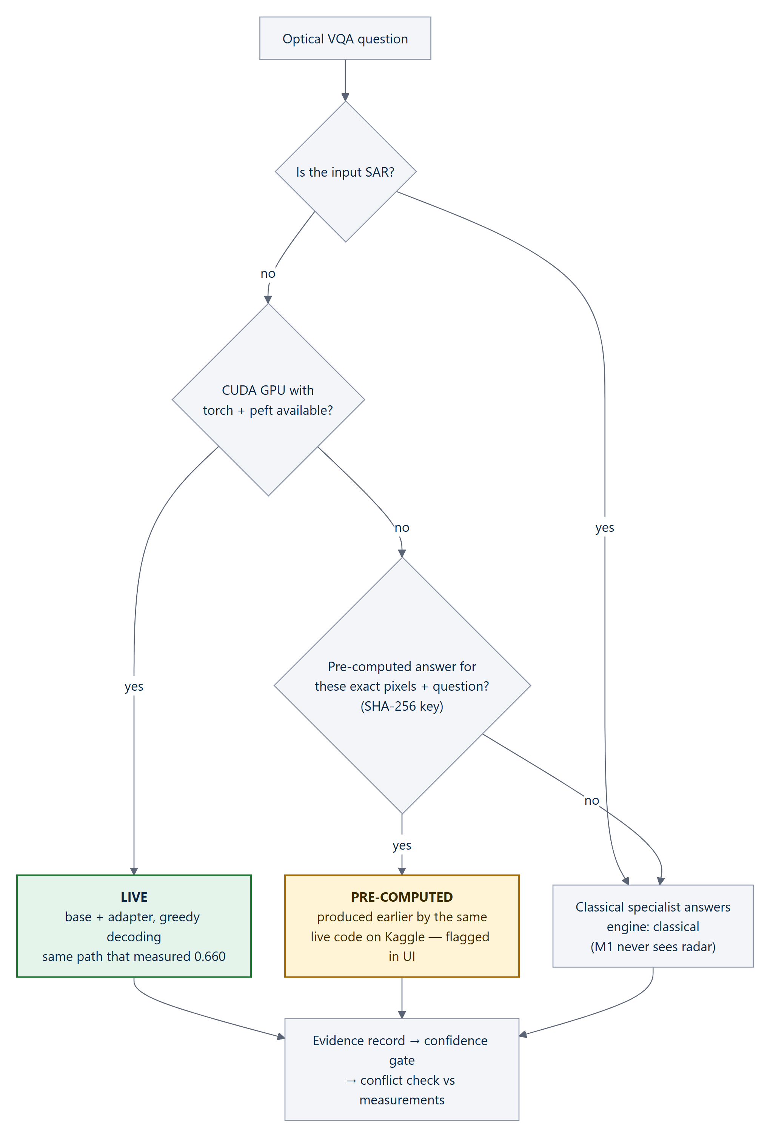
Figure 15. M1 serving modes. The result's engine and precomputed fields always disclose which path answered.
On real imagery the whole system was run end to end over every question on 10 VRSBench validation images (38 questions): exact match 0.605; M1 answered 30 and was right on 23 (77 %). This small sample (±16 points) is used to find where answers are lost — it is not a headline figure.
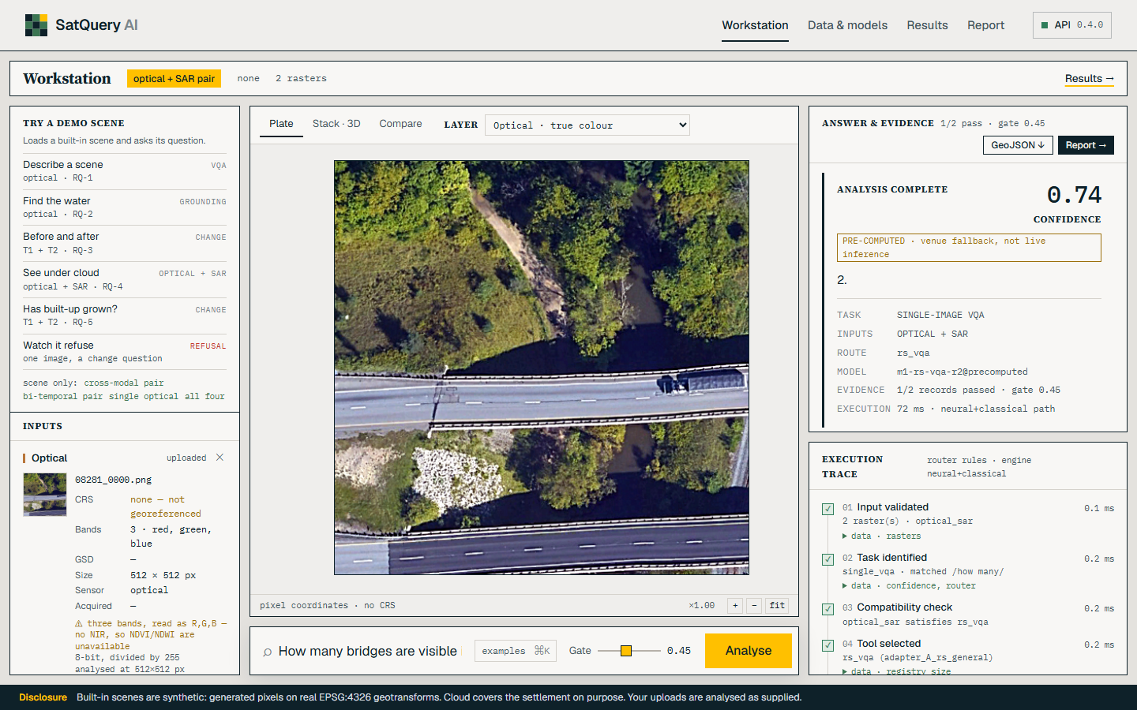
Figure 16. The workstation answering “How many bridges are visible?” on a real VRSBench validation photograph with M1 (answer: 2, confidence 0.74, clearly labelled PRE-COMPUTED).

5 System Design and Architecture
The structure is described with the C4 model [38] — context, containers and components — followed by the deployment and runtime views that matter most for a hackathon system that must survive a venue.

5.1 System context
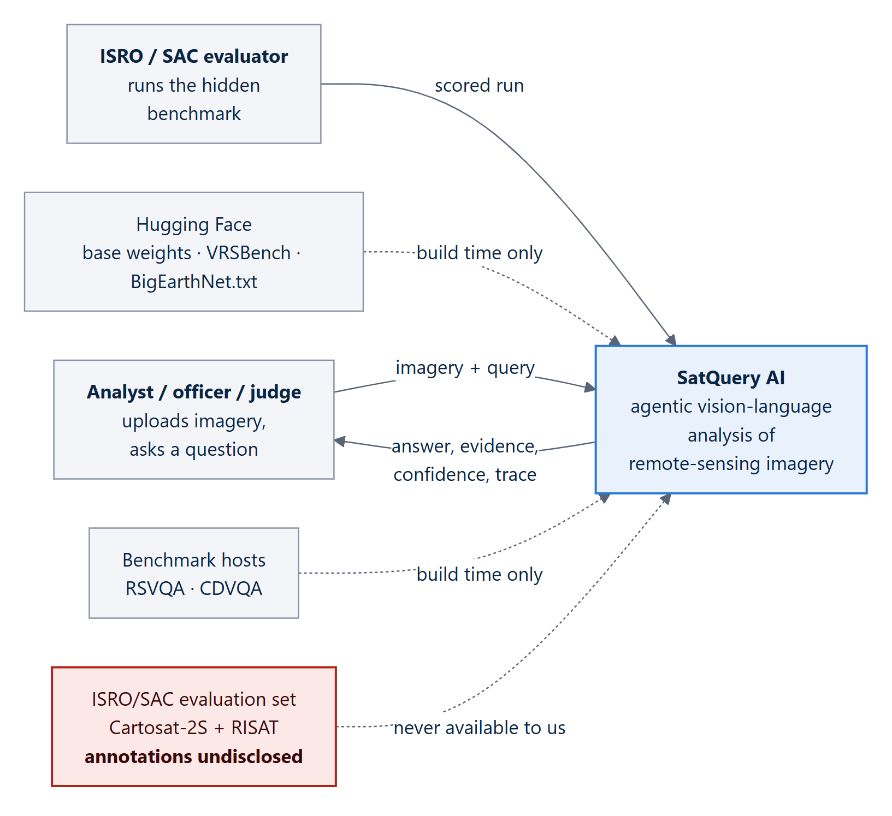
Figure 17. Level 1 — system context. Every external dependency is build-time only; at run time the system needs no network.

5.2 Containers
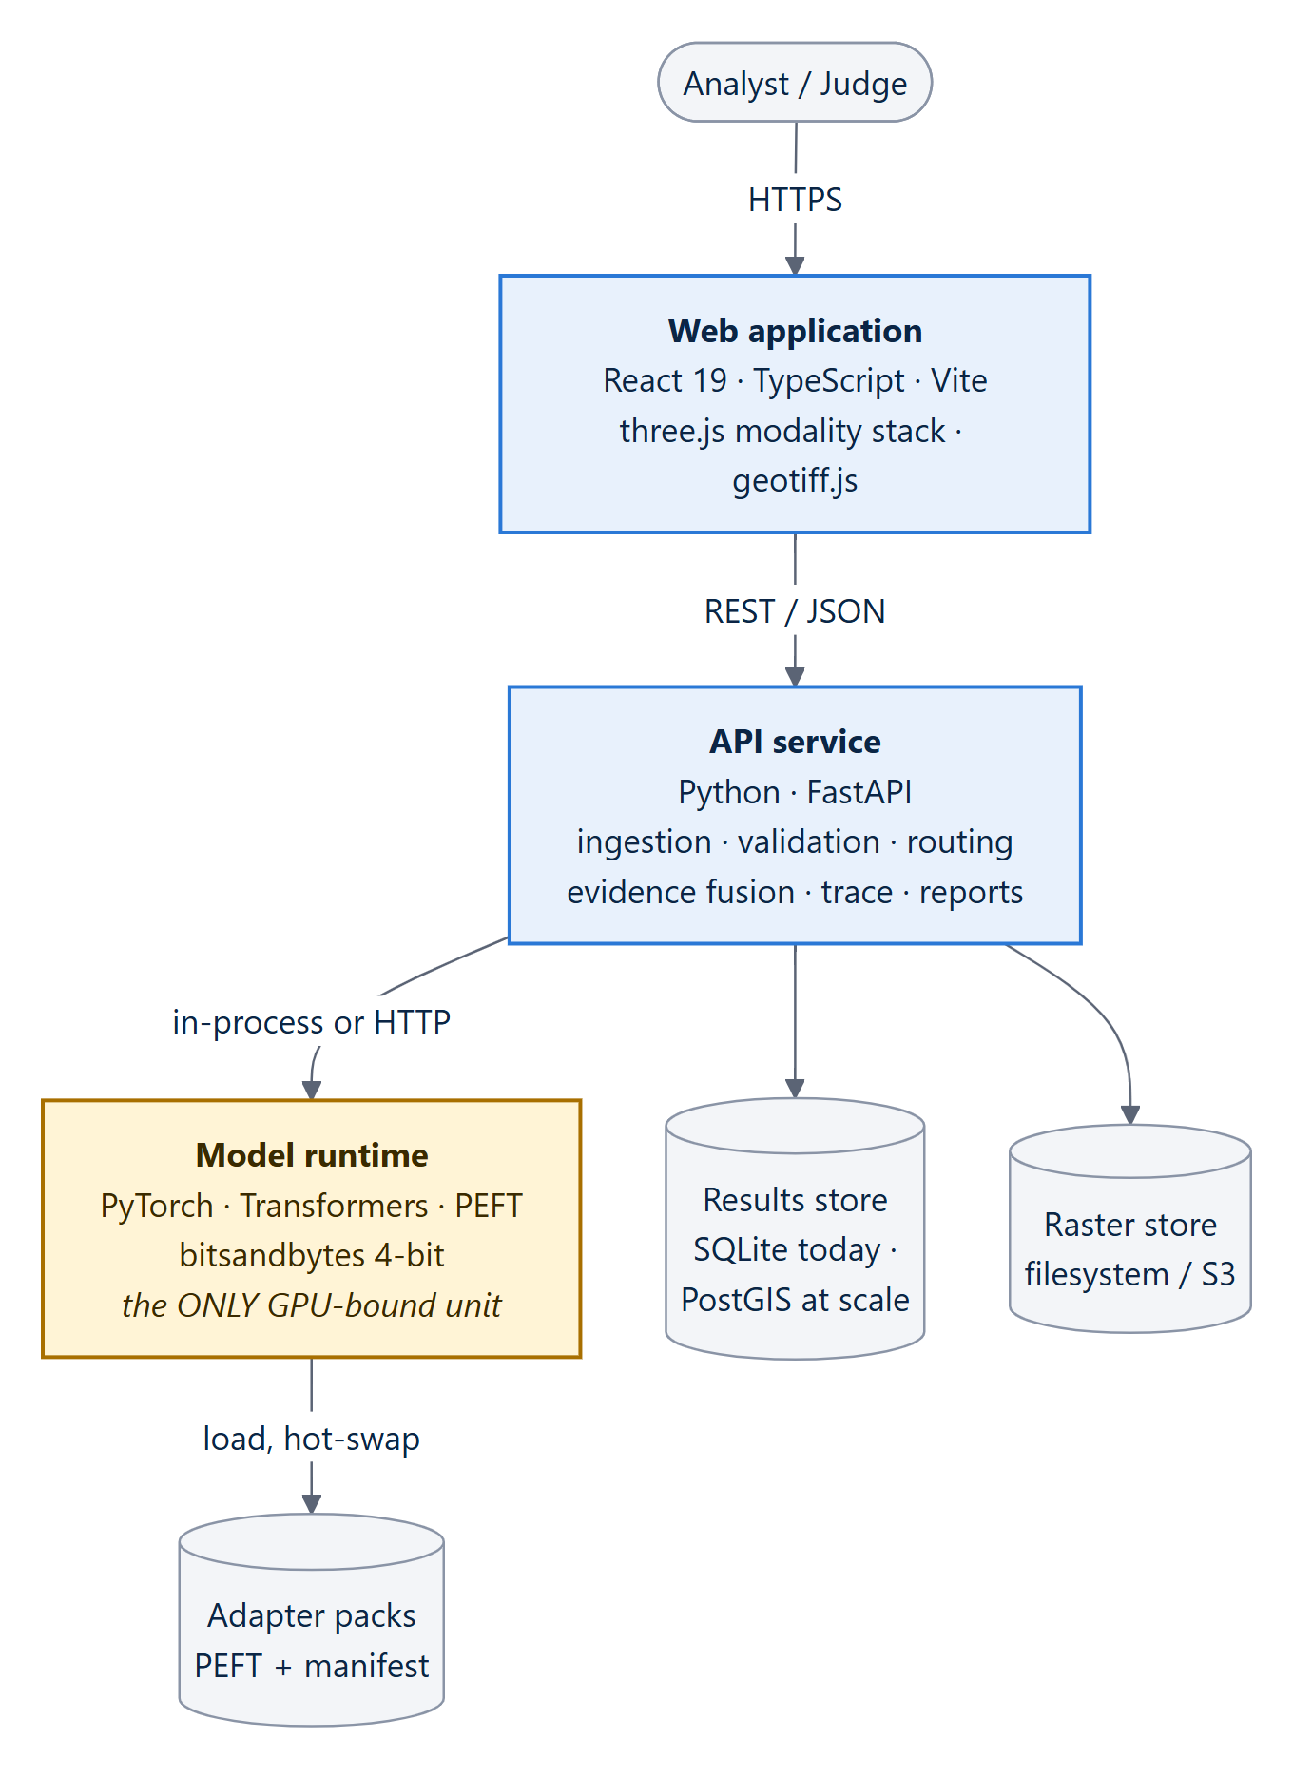
Figure 18. Level 2 — containers. The model runtime is isolated because it is the only unit that needs a GPU and the only one that can run out of memory.
Container | Technology | Scales | If it fails
Web application | React 19, TypeScript, Vite, Tailwind, three.js | CDN, stateless | Answer text still renders
API service | Python, FastAPI, uvicorn | Horizontally, stateless | Total outage
Model runtime | PyTorch, Transformers, PEFT, bitsandbytes | Vertically — bound by GPU memory | Falls back to pre-computed or classical, disclosed
Results store | SQLite (today); PostgreSQL + PostGIS (ADR-009) | Single instance is ample | Results not persisted; live queries still answer
Raster / adapter stores | Filesystem or S3-compatible; PEFT packs | — | Base model only, degraded accuracy

5.3 Components and the six processing layers
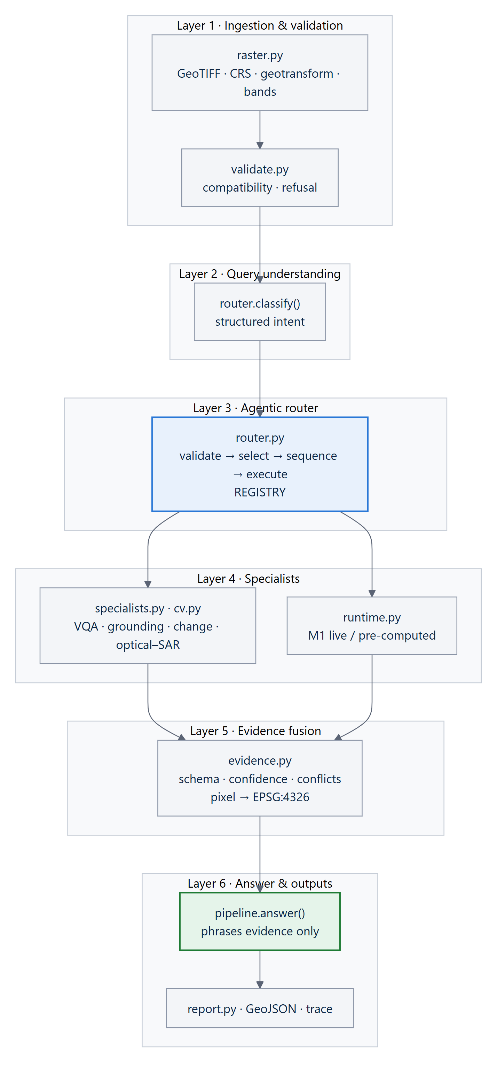
Figure 19. Level 3 — components, mapped one-to-one onto modules of the satquery Python package.
Two structural rules are checkable by following the arrows: the answer layer is downstream of evidence, never of a model (ADR-007); and SAR processing sits on its own path rather than inside the optical model (ADR-003).

5.4 Deployment view
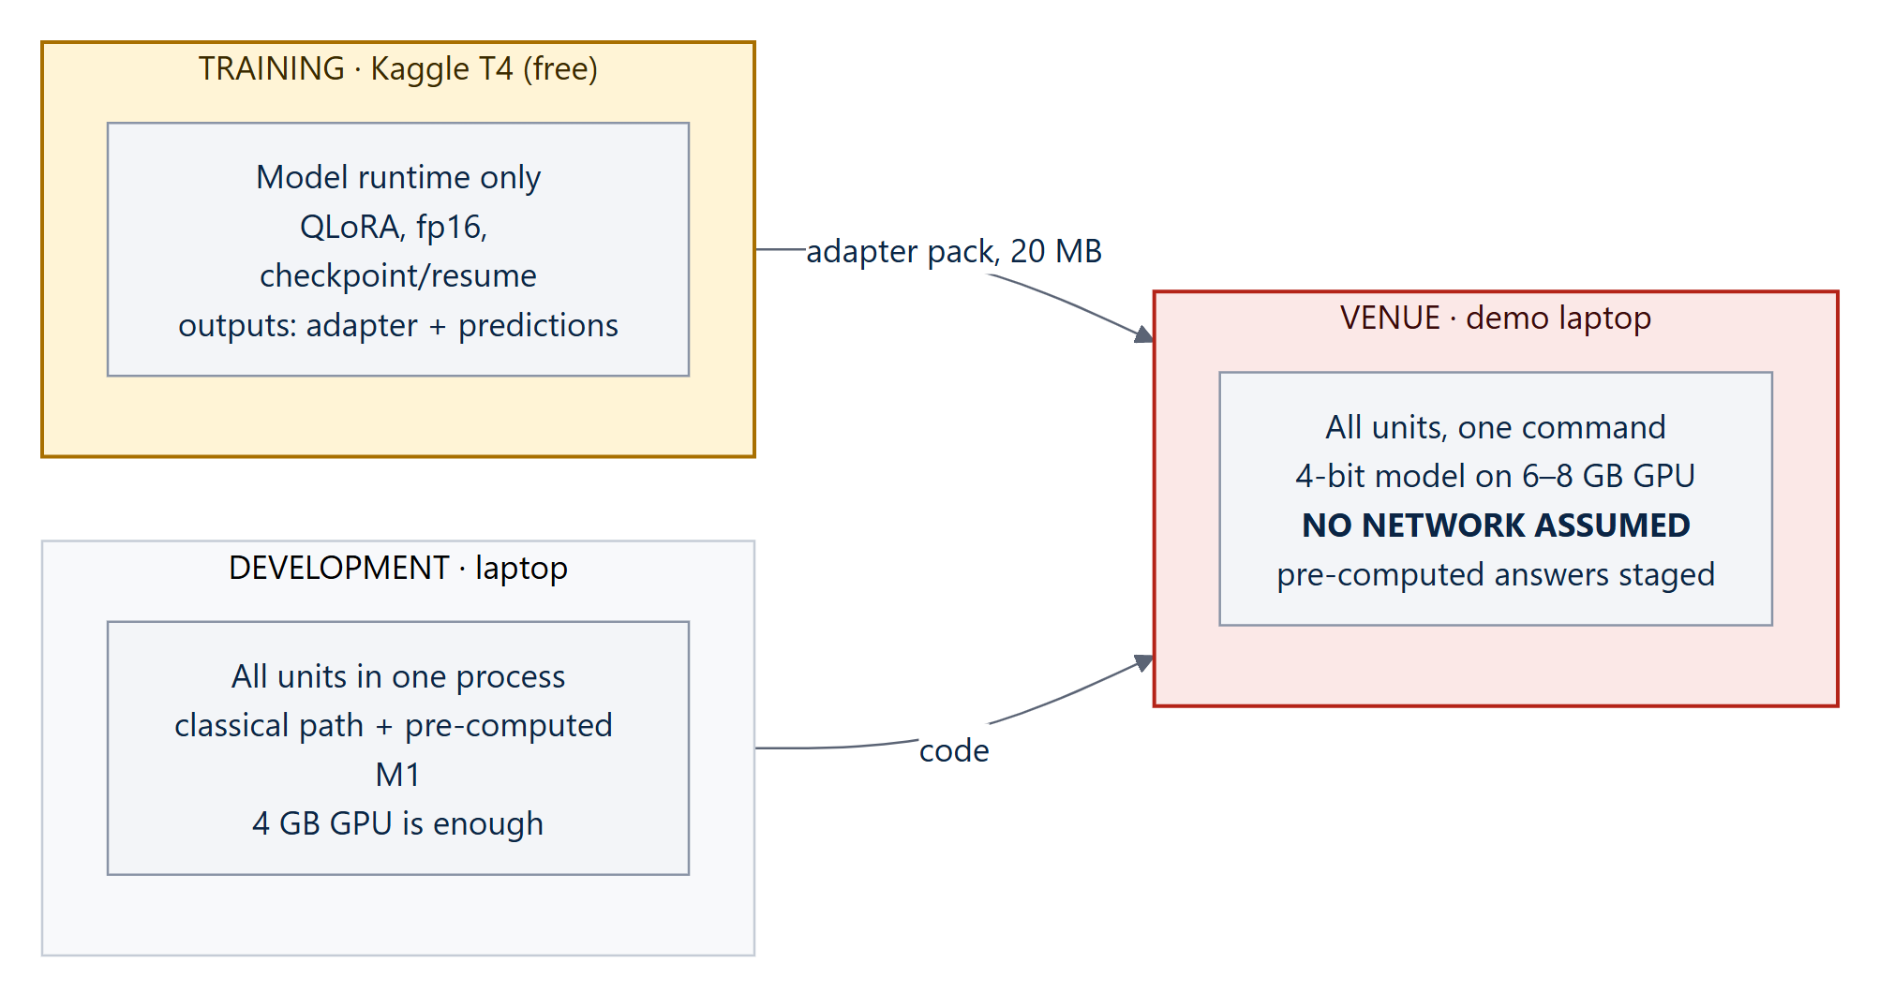
Figure 20. Three environments with genuinely different constraints.
Venue constraint | Consequence for the design
No network | Every weight, dataset sample and map asset is local; no CDN fonts, remote basemaps or model downloads.
6–8 GB GPU | 4-bit quantisation is mandatory, not an optimisation.
One machine | One command must bring everything up, cold, first time.
Ten-minute slot | Latency budget of seconds; the model is warmed before the judge arrives.
Unreliable conditions | Pre-computed results for demo scenes, labelled as such in the trace.

5.5 Runtime views

Nominal path — a bi-temporal change query
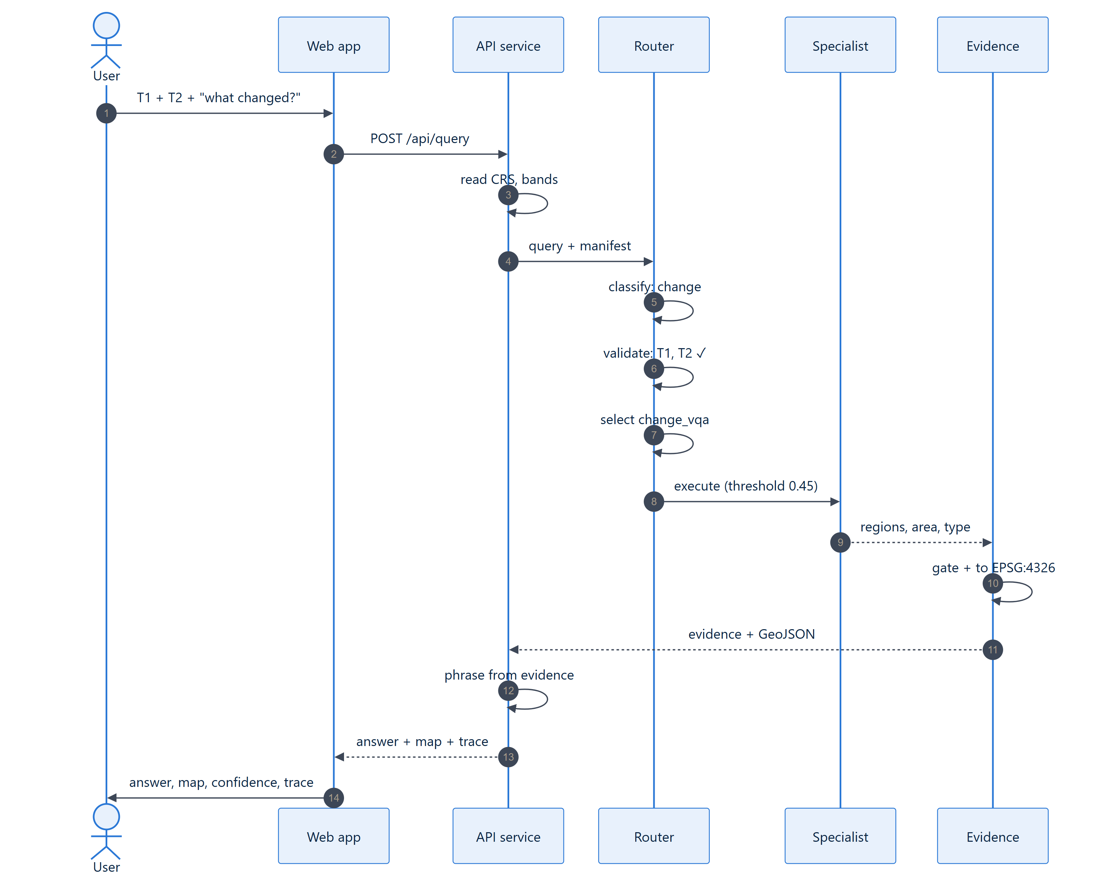
Figure 21. Sequence of a nominal change query. The answer is written from evidence, never from the image.

The refusal path
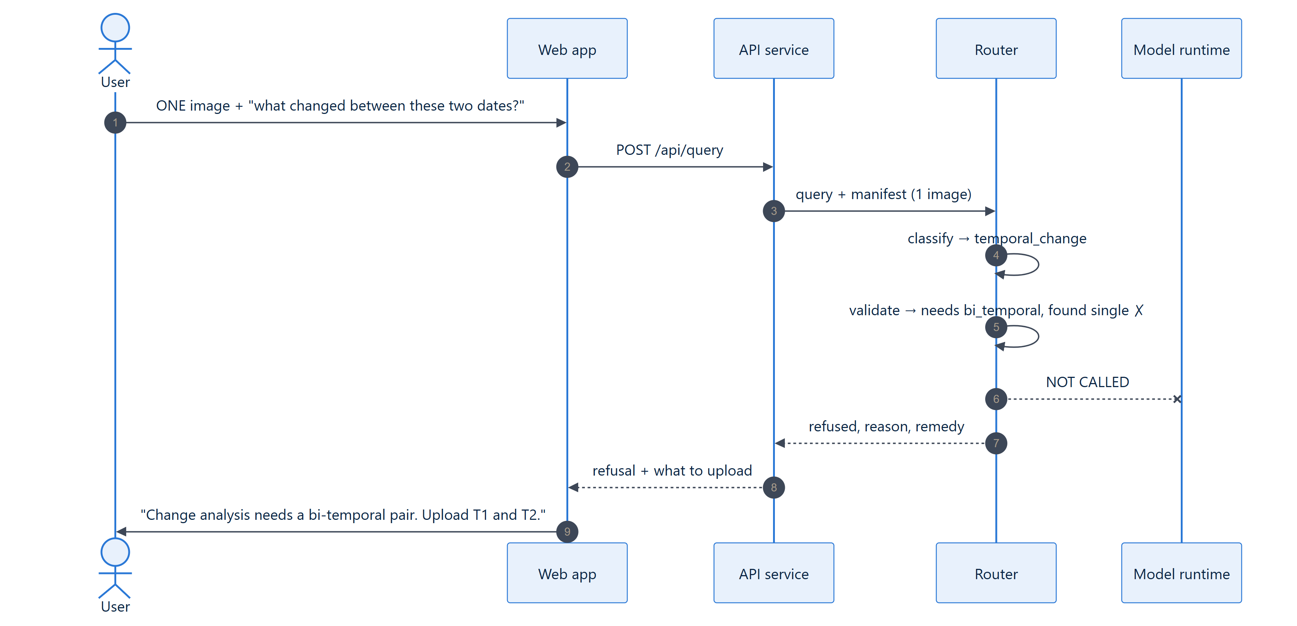
Figure 22. The refusal path completes in under a second and invokes no model.

The degraded path — venue fallback
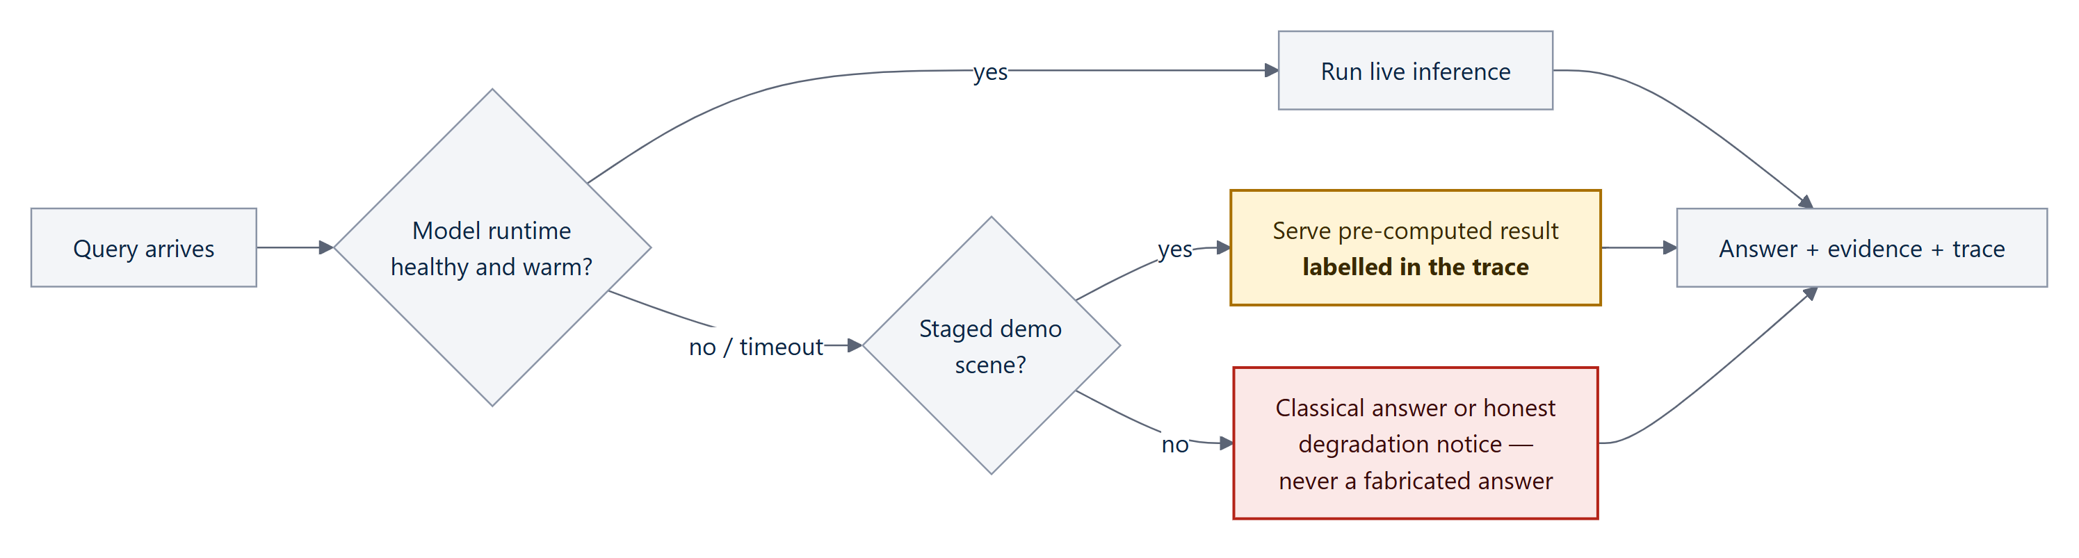
Figure 23. Degraded operation. A pre-computed result presented as live would be a fabrication; disclosed, it is engineering prudence.

5.6 API and result contract
Operation | Purpose
Upload imagery with a role | optical, SAR, T1 or T2; returns a raster summary (CRS, bands, GSD, size)
Query | query text + input set + threshold → the result contract below
Get run / trace | replay and audit any stored run
Download report and GeoJSON | hand-off artefacts that open in QGIS
Health | version, engine, each adapter pack's serving mode (live / pre-computed / not serving, with reason)
Registry | the tool registry exactly as the router sees it
Evaluation | metrics, ablation, calibration — with composite formulas printed

{
"query": "...", "answer": "...",
"refused": false, "abstained": false, "confidence": 0.93,
"task": "cross_modal", "tools": ["optical_sar"], "params": {"threshold": 0.45},
"evidence": { "count": 5, "passing": 5, "items": [ /* evidence records */ ] },
"geojson": { "type": "FeatureCollection", "features": [ /* EPSG:4326 */ ] },
"trace": [ { "step": "...", "detail": "...", "ok": true, "ms": 0.1 } ],
"manifest": { "modality": "optical_sar", "count": 2, "rasters": [ ... ] },
"elapsed_ms": 64, "engine": "classical | neural+classical", "precomputed": false
}

5.7 Cross-cutting concerns
Concern | Rule
Coordinate integrity | Every spatial output carries its CRS. UTM uploads (how Cartosat and Sentinel-2 are delivered) are converted to WGS84 and measured in metres; unsupported projections are refused into pixel space with a stated reason, never guessed. Areas on geographic imagery account for latitude.
Confidence | Every claim carries one; it is calibrated and measured (ECE), not decorative.
Auditability | Every request emits a trace — never chain-of-thought (ADR-008).
Abstention | Below threshold, decline; abstention precision is measured alongside accuracy.
Failure | Flag with a reason, never silently drop. A malformed GeoTIFF produces a readable error naming the missing field, not a stack trace.
Determinism | Seeds are recorded; a run replayed from its record gives an identical result.

5.8 Quality-attribute targets
# | Scenario | Target
QA-1 | Single-image VQA on the venue laptop, no network | < 8 s at p95
QA-2 | Bi-temporal or cross-modal query, same machine | < 15 s at p95 (classical path measured ~64–90 ms)
QA-3 | One image uploaded with a change question | Refusal in < 1 s, no model invoked
QA-4 | Malformed GeoTIFF with no CRS | Readable error naming the field; no crash
QA-5 | Model runtime unavailable | Staged scenes answer, labelled pre-computed
QA-6 | System states confidence 0.9 | Correct on ≈ 90 %; ECE reported
QA-7 | 4-bit model on a 6 GB laptop GPU | Loads and serves without running out of memory
QA-8 | Adapter swapped between requests | < 200 ms added

6 Technology Stack
Every component is open source and runs offline. The stack was chosen for three properties: the ML and the backend share one language, the geospatial path preserves coordinates end to end, and nothing at run time needs the internet.
Layer | Technology | Why this choice
Base model | Qwen2-VL-7B-Instruct (Apache-2.0) [32] | Loads on current libraries; licence permits handing weights to ISRO; measured zero-shot baseline
Adaptation | PEFT LoRA / QLoRA, bitsandbytes 4-bit NF4, Hugging Face Transformers, PyTorch [12][33] | 0.107 % of parameters trained; fits a free 16 GB GPU; 20 MB artefact
Training compute | Kaggle T4 (free tier), fp16, checkpoint + resume | No paid GPU required; 9-hour sessions handled by resume
Classical vision | NumPy, Pillow; Lee speckle filter [34], multi-level Otsu [35], NDVI/NDWI, change vector analysis, phase correlation, connected components | Transparent, fast (~90 ms), and physically correct for SAR
Geospatial | GeoTIFF/TIFF reader with CRS + geotransform; WGS84/UTM conversion; GeoJSON (EPSG:4326) | Every box becomes lat/long; areas in hectares; opens in QGIS
Agent | Plain Python router + declarative registry (ADR-004) | The requirement is constraint, not capability; explainable on one slide; no framework drift
Backend API | Python, FastAPI, uvicorn | Same language as the ML stack; typed JSON contract
Web application | React 19, TypeScript 6, Vite 8, Tailwind CSS 4, three.js, geotiff.js | Fast, typed UI; 3D modality stack to pull optical, SAR and fusion layers apart
Storage | SQLite today; PostgreSQL + PostGIS and S3-compatible object storage at scale (ADR-009) | Spatial queries (“every change in this district”) come free; rasters never stored as blobs
Quality | 49-check self-test, headless UI verification, stored prediction rows | Every number recomputable; regressions caught before a demo

7 The Web Application
The workstation is laid out as a map table: inputs and demo scenes on the left, the imagery plate in the centre, and the answer, evidence and execution trace on the right. A permanent disclosure bar states which scenes are synthetic.
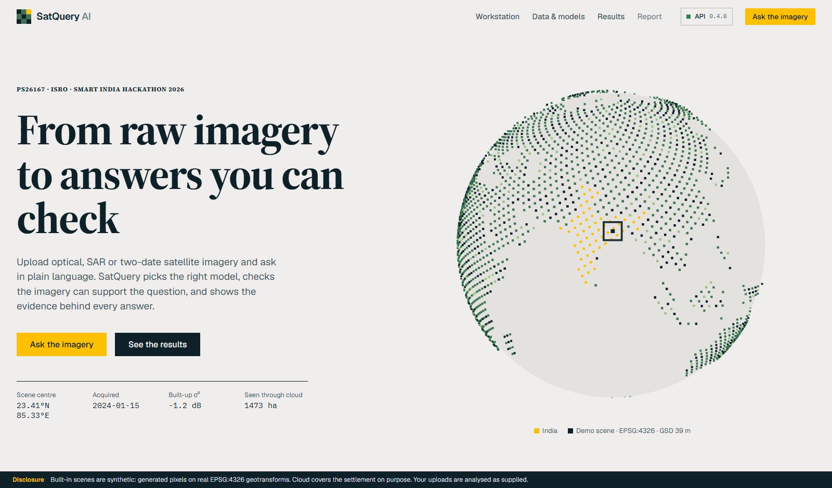
Figure 24. Landing page: “From raw imagery to answers you can check.”
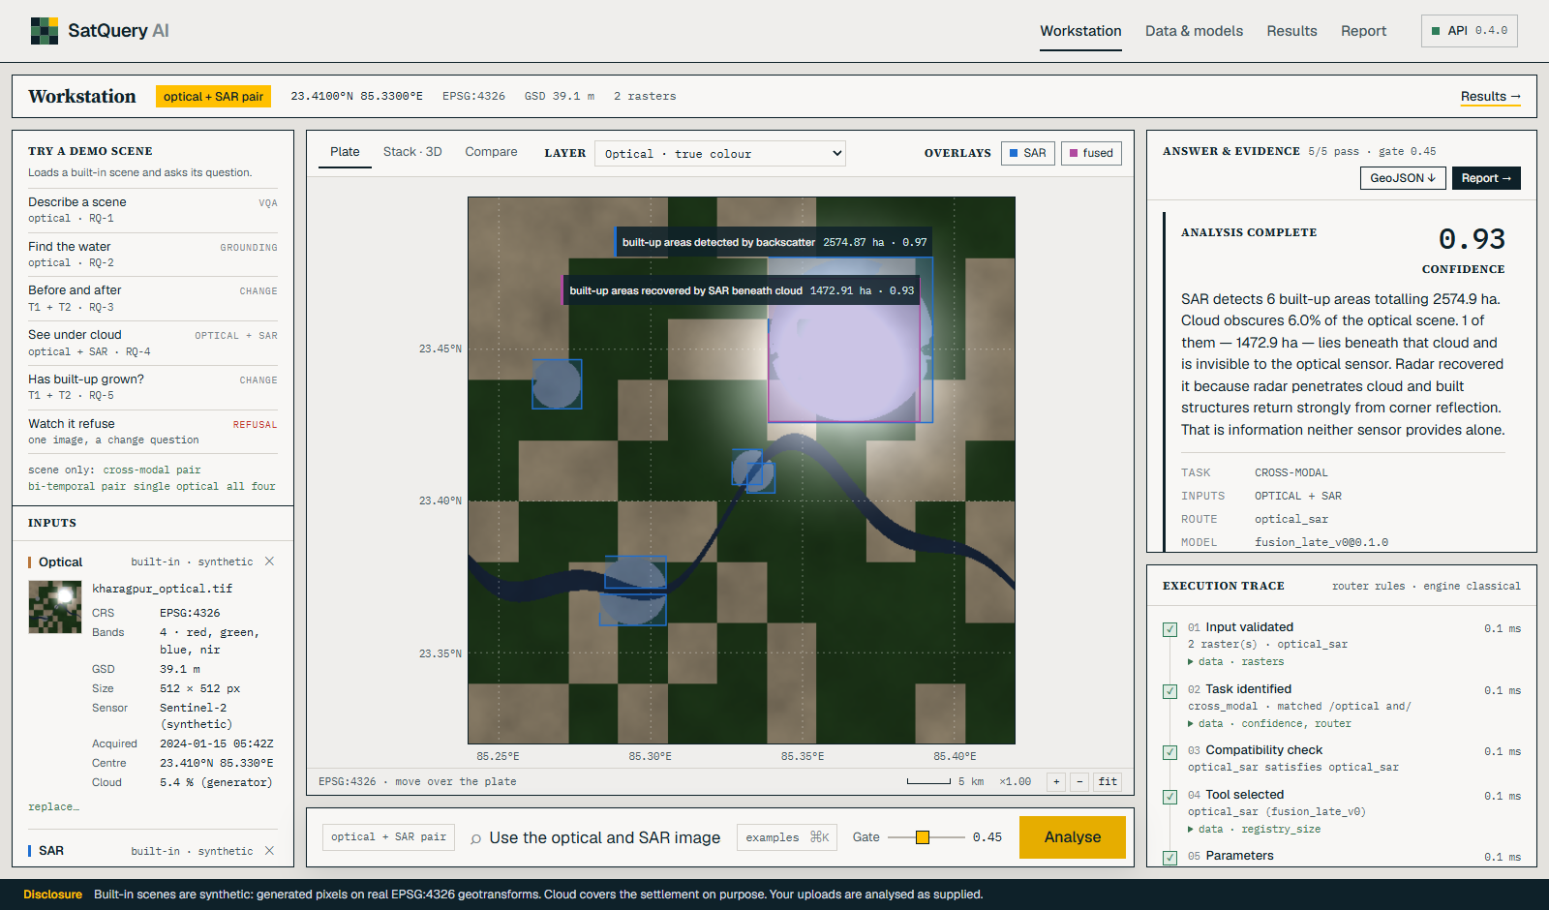
Figure 25. Cross-modal query: SAR-detected built-up areas, the area recovered beneath cloud, confidence 0.93 and the execution trace.
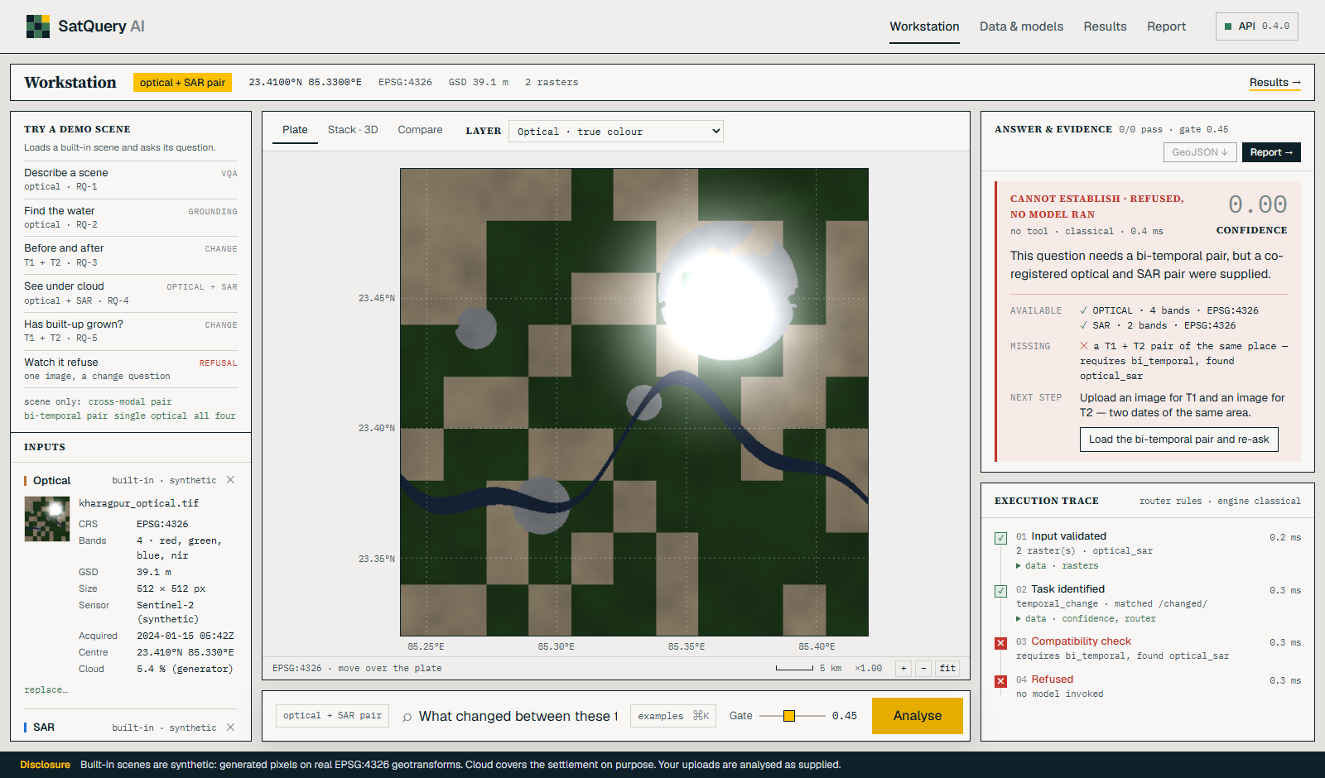
Figure 26. The refusal: a change question with an optical + SAR pair loaded. The compatibility check fails, no model runs, and the system states what is missing and what to upload.
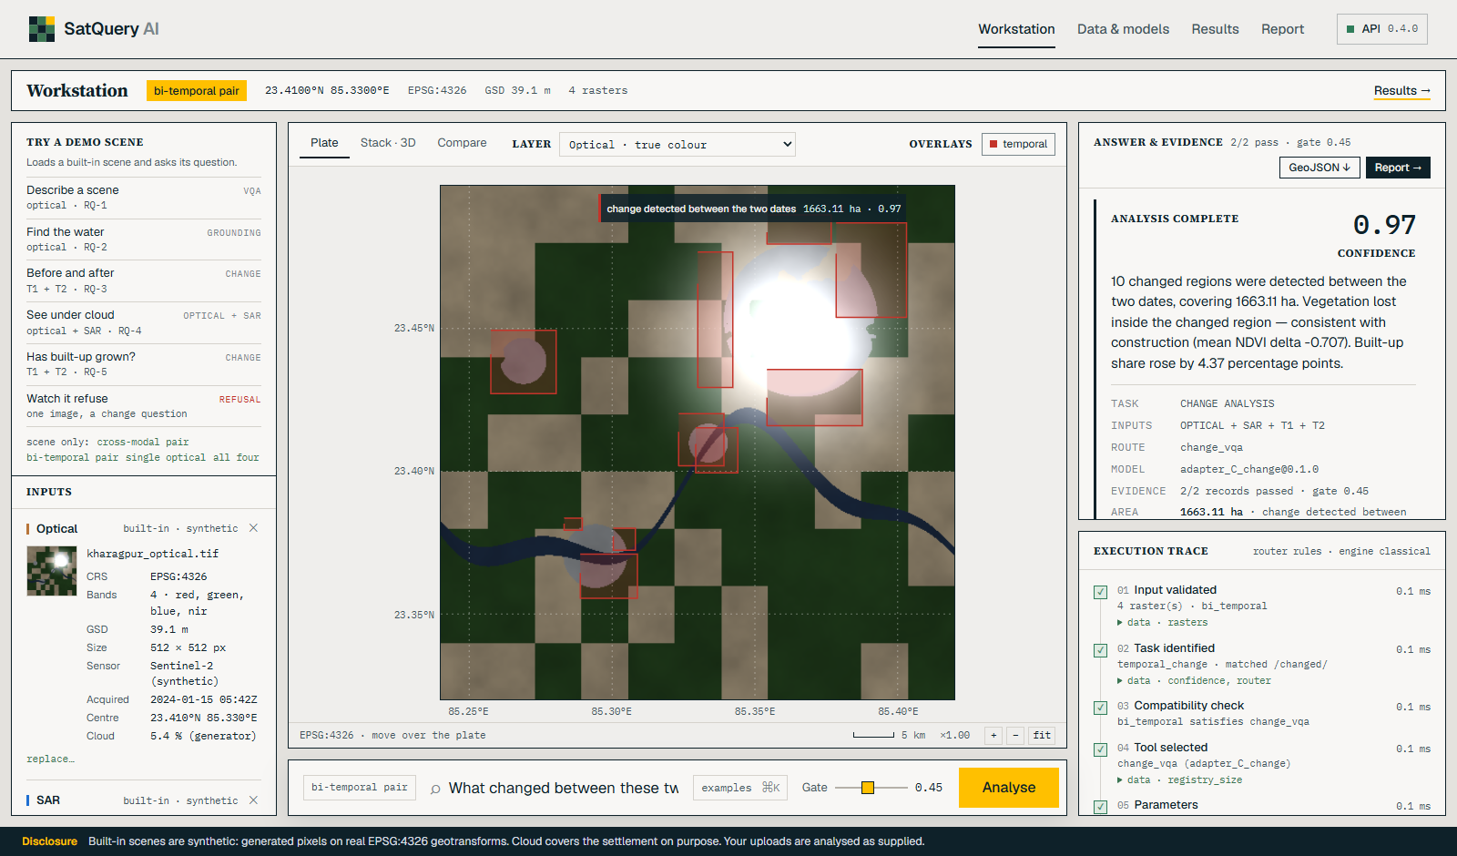
Figure 27. Bi-temporal change: 10 changed regions covering 1,663 ha, a mean NDVI drop consistent with construction, built-up share up 4.37 percentage points.
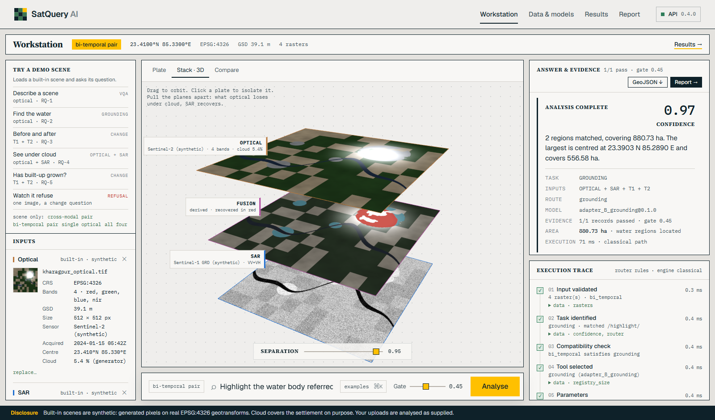
Figure 28. The 3D modality stack: optical, fusion and SAR plates pulled apart to show what optical loses under cloud and SAR recovers.

8 Evaluation and Results

8.1 Remote-sensing adaptation (M1)
Measurement | Value
VRSBench VQA, zero-shot (n = 2,000, held-out) | 0.5270
VRSBench VQA, adapted — rung 2 (shipped) | 0.6600
Adaptation gain | +13.30 points
Paired McNemar test | χ² = 155.4, p = 1.2 × 10⁻³⁵
Train/val image overlap | 0 of 20,264 / 9,350
Latency (Kaggle T4, 4-bit) | ~0.8–0.9 s per item (p50)
End-to-end on real VRSBench photos (38 questions) | 0.605 exact match (small sample; diagnostic)

8.2 Classical specialists — against ground truth the pipeline never reads
Reproduce with python -m satquery.cli eval. These are measured on synthetic test scenes, so they show that each method works on the populations it was designed for — not accuracy on real Cartosat imagery.
Task | Metric | Value | Meaning
Water grounding | IoU | 1.0000 | Outline matches the true water area
Vegetation grounding | IoU | 0.9958 | Near-perfect overlap
SAR built-up detection | F1 | 0.9450 | Radar finds built-up area accurately
Bi-temporal change | F1 | 0.7698 | Change found, with errors at boundaries
Calibration | ECE | 0.0328 | Stated confidence matches accuracy (n = 4 bins; small)
Cross-modal query | Latency | ~64–90 ms | At 512 × 512 px, CPU
Built-up structures recovered under cloud | share | 57.0 % | Only possible with SAR + optical together

8.3 Ablation — what each layer adds
An ablation switches parts on one at a time to show what each contributes. All five rows are classical computer vision (no neural model is loaded in any row), and the rows are named for what actually runs.
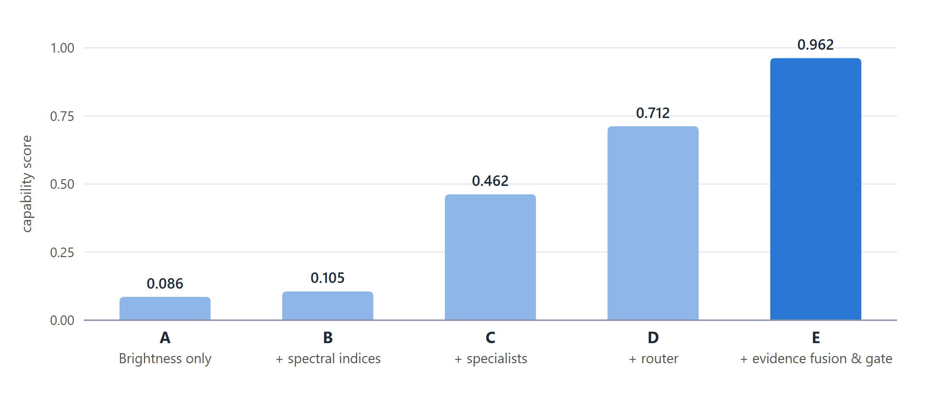
Figure 29. Ablation A–E on the same scene. Capability = 0.50 × mean segmentation F1 + 0.25 × router accuracy + 0.25 × cross-modal recovery present — a composite defined by this project, not a standard metric.
Row | Configuration | Seg. F1 | Router | Cross-modal | Capability
A | Panchromatic brightness only | 0.1711 | — | — | 0.0856
B | + spectral indices | 0.2109 | — | — | 0.1055
C | + specialists, no router | 0.9240 | — | — | 0.4620
D | + router | 0.9240 | 1.00† | — | 0.7120
E | + evidence fusion and gating | 0.9240 | 1.00† | yes | 0.9620

† Router accuracy of 1.00 is measured on the same labelled queries the rules were written from, so it reports construction, not generalisation. It is shown only inside this ablation and is not claimed as a result until a held-out paraphrase set exists.

8.4 What we deliberately do not claim
- Router accuracy on unseen phrasings — not yet measured on a held-out set.
- RSVQA and CDVQA scores — no benchmark loader exists yet; these are planned.
- Accuracy on Cartosat-2S / RISAT — that imagery is not publicly available and the ISRO/SAC set is hidden.
- “Beats GPT-4V” — our 0.660 is level with GPT-4V's 0.656 within the confidence interval, on a subset.

9 Novelty and Differentiation

9.1 The research gap
What prior work does | The measured gap | What SatQuery AI adds
Each benchmark targets one capability in isolation: RSVQA [5] → question answering; CDVQA [7] → change detection + VQA; GeoChat [9] → object grounding. | VRSBench [4] reports general-purpose VLMs trailing remote-sensing-adapted models on captioning, grounding and VQA. | One natural-language entry point over remote-sensing-adapted specialists, with a constrained router and geo-referenced, auditable evidence.

9.2 Six differentiators
# | Differentiator | Why it matters | How to see it
1 | Refuses impossible questions — no model runs | Proves validation is real, not decorative; most systems answer anyway. | One image + “what changed?”
2 | Sees under clouds with radar + optical | Makes R4's “complementary information” a number in hectares. | Cross-modal query; pull the 3D stack apart
3 | Facts from vision, words from language — enforced in code | The answer cannot contain a number no measurement produced. | One evidence item beside the sentence
4 | Auditable trace, not fake reasoning | Matches exactly what ISRO says it scores. | The trace panel
5 | Calibrated confidence and abstention | “0.9” means about 90 %; low-confidence answers are withheld. | Raise the gate and watch it abstain
6 | Fully offline, adaptation proven by a measured gain | Survives venue Wi-Fi; R1 evidenced by +13.3 points with p = 1.2e-35. | Unplug the network

9.3 Comparison with existing approaches
Capability | Single-task RS tool | Generic AI chatbot | SatQuery AI
Ask in plain language | ✗ | ✓ | ✓
Picks the right analysis automatically | ✗ | ✗ | ✓
Checks inputs, refuses impossible questions | ✗ | ✗ | ✓
Optical + SAR together (sees under cloud) | partial | ✗ | ✓
Every number traceable to a measurement | ✓ | ✗ | ✓
Remote-sensing adapted | ✓ | ✗ | ✓
Works offline | ✓ | ✗ | ✓

9.4 How the research literature maps onto our pipeline
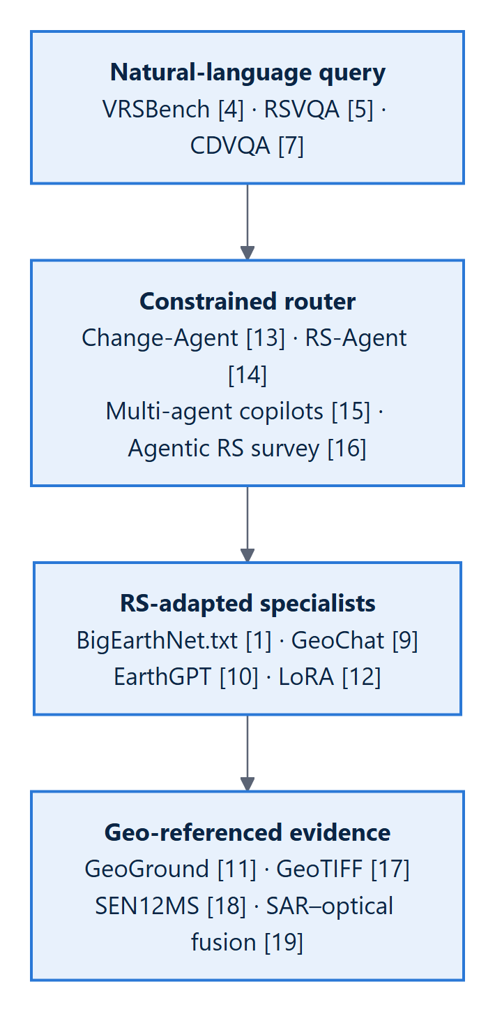
Figure 30. Pipeline mapping: each stage of SatQuery AI and the published work it builds on.
Change-Agent [13] established the pattern of an LLM as the controller with vision models as the eyes; we adopt it with a stricter constraint. RS-Agent [14] demonstrated a tool registry with structured task planning; our registry is closed and declarative. Multi-agent geospatial copilots [15] validate dispatching to specialists; the agentic remote-sensing survey [16] served as our failure-mode checklist (hallucinated tools, unchecked inputs, unverifiable outputs). GeoChat [9] is the grounded remote-sensing VLM baseline, EarthGPT [10] demonstrates multi-sensor feasibility, and GeoGround [11] informs the box/mask output format.

10 Feasibility and Viability
Feasibility is not argued here — it is demonstrated. Every capability claimed in this report runs in the repository today, and the one component that needed GPU training was trained on free compute.
Dimension | Evidence
Technical | All five mandatory capabilities built and tested (49-check self-test). M1 trained, measured and wired into the pipeline, served live on a GPU or from pre-computed answers on any laptop.
Compute | M1 trained on a free Kaggle T4 in 9.6 GPU-hours across two rungs. Inference needs 6 GB of GPU memory at 4-bit; the classical path runs on a CPU in under 100 ms.
Data | All training and evaluation data is open: VRSBench (12.5 GB) [4], BigEarthNet.txt annotations [1][3], RSVQA [5], CDVQA [7], Sentinel-1/2 [28]. The PS explicitly permits “any open-source training data”, which avoided a 155 GB BigEarthNet image download.
Economic | Zero licence cost: every dependency is open source; the base model is Apache-2.0. No paid GPU was required to reach the submitted result.
Operational | Browser application, drag-and-drop GeoTIFF upload, downloadable report and GeoJSON, fully offline, one command to start.
Trust | Refusal before any model runs; answers phrased only from measured evidence; calibrated confidence; complete execution trace; synthetic scenes disclosed on screen.

10.1 Risks and mitigations
Risk | Impact | Mitigation
Domain gap: Sentinel / Google Earth → Cartosat-2S / RISAT | Public scores may not transfer | Robustness over peak: input validation, calibrated confidence, abstention; Indian imagery from Bhuvan / Bhoonidhi [21][29] where obtainable
SAR treated as a greyscale photo | Confident nonsense; exposed by an ISRO panel | Separate SAR path; M1 never sees SAR (ADR-003)
Data leakage from random splits | Inflated scores, failure on the day | Official splits; overlap counted (zero); geographic tile-level splits for new data (ADR-006)
A metric measured on its own construction | One caught number discredits all others | Router accuracy not claimed until held-out; composite formulas printed; ablation rows named for what runs
Venue compute or network fails | Demo cannot run | 4-bit model; offline by design; labelled pre-computed fallback; classical path always available
Judging weights unknown | Cannot optimise one metric | All five capabilities separately visible and measured
Licence blocks delivery of weights | Deliverable includes models | Apache-2.0 base verified on the model card
Kaggle limits (no bf16, 9-hour sessions) | Lost training days | fp16; checkpoint and resume built from day one — both runs survived interruption

11 Scalability and Future Roadmap
The architecture was drawn so that growth is a configuration change rather than a rewrite. Scaling happens along four independent axes:
Axis | How SatQuery scales
More users | The API service is stateless and scales horizontally behind a load balancer; the web app is static and served from a CDN.
More models / tasks | A new capability is one registry row plus one adapter pack (tens of MB) on the same frozen base — no new 7B model, no router rewrite. The pack contract (PEFT files + manifest with measured scores) is already defined.
More GPU throughput | The model runtime is the only GPU-bound unit and sits behind its own interface, so it can move to a separate GPU server or a pool of them without touching the API; adapters hot-swap per request.
Larger imagery and archives | Rasters live in S3-compatible object storage and are read as tiles; results with geometry go to PostGIS, so spatial questions (“every change in this district since 2024”) become SQL rather than application code.

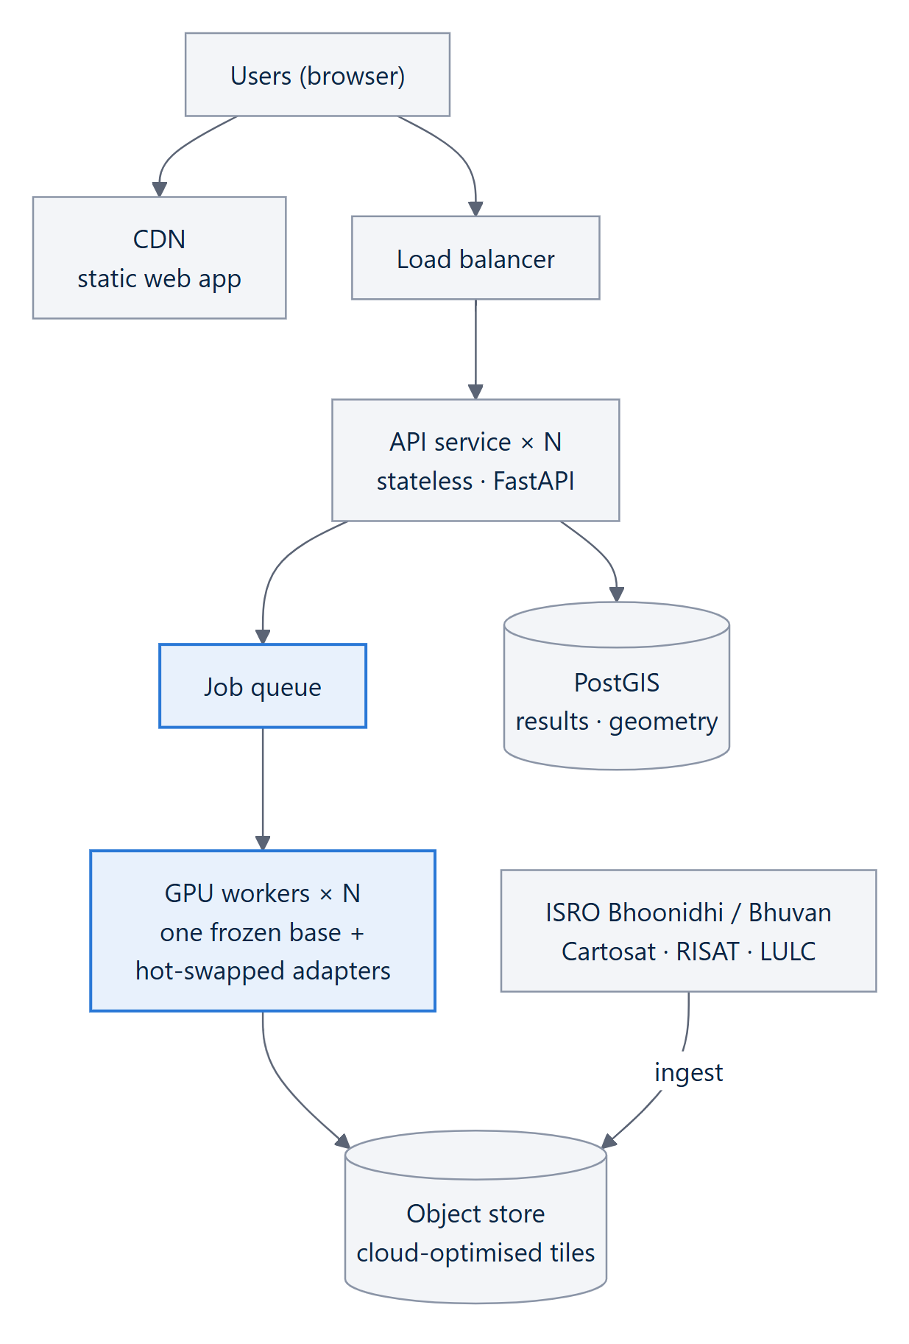
Figure 31. Target production architecture: stateless API replicas, a queue feeding GPU workers that share one base model with hot-swapped adapters, and spatial storage.

11.1 Roadmap
Phase | Window | Deliverables
Selection (done) | Sep 2026 | All five capabilities built; M1 trained and measured (+13.3 points); web workstation; upload; reports; this document
Build | Oct – Nov 2026 | M2 grounding adapter (VRSBench); M3 change adapter + Siamese head (CDVQA); M4 SAR encoder on Sentinel-1 with late fusion; RSVQA and CDVQA loaders; held-out router paraphrase set; stress suite; venue-laptop test in November
Grand Finale | Dec 2026 | Integration, rehearsal, labelled venue fallback — not new construction
Beyond | 2027 | Trained router classifier (M5); Indian-sensor adaptation on Cartosat/RISAT via Bhoonidhi [21]; PostGIS-backed archive queries; historical time-series tools (LandTrendr [30], CCDC [31])

12 Impact and Benefits

12.1 Who benefits
User | Situation today | With SatQuery AI
District and disaster officers | Operational decisions, no GIS training | Flood extent, damage and construction questions answered with a map, hectares and a confidence value
Agriculture and water departments | Depend on specialist analysis cycles | Vegetation and water-body extent from imagery, on demand
Urban planners | Manual comparison of dates | Built-up growth between two dates, mapped and measured
ISRO / SAC analysts | Routine questions consume expert time | Skip manual model selection; inspect exactly which tool ran with which parameters
Students and researchers | Specialist software barrier | Remote sensing through plain-language questions

12.2 Benefits
Dimension | Benefit
Social | Faster, evidence-backed answers in disasters — including through cloud, when optical satellites are blind and decisions are most urgent; wider access to India's space data.
Economic | Less specialist time per question; open-source stack with no licence cost; trainable on free compute.
Environmental | Monitoring of vegetation, water bodies and land-use change over time.
Governance | Every answer traceable to a measurement, with an audit trail — fit for official use where a wrong number stated confidently is worse than no answer.

12.3 Application case study — supporting Forest Rights Act claims (proposed extension)
STATUS
This is a proposed application of the SatQuery architecture, showing how its evidence-first design serves a real governance need. It is not part of the built system.

The Forest Rights Act, 2006 [22] recognises the rights of forest-dwelling communities over land occupied before 13 December 2005, with appeal through Sub-Divisional and District Level Committees (SDLC / DLC). The FRA Amendment Rules, 2012 [23] allow satellite imagery to supplement — not replace — other evidence, with the final decision resting with the human authority. The scale of the need is large: the Ministry of Tribal Affairs' March 2026 progress report records 47,901 community forest-rights claims rejected nationally [24], and the DAJGUA programme commits ₹79,156 crore across 17 ministries focused on 22 lakh FRA patta holders [25].
SatQuery's design fits this setting unusually well, because the legal framework demands exactly what ADR-007 enforces — evidence that informs a human decision without replacing it:
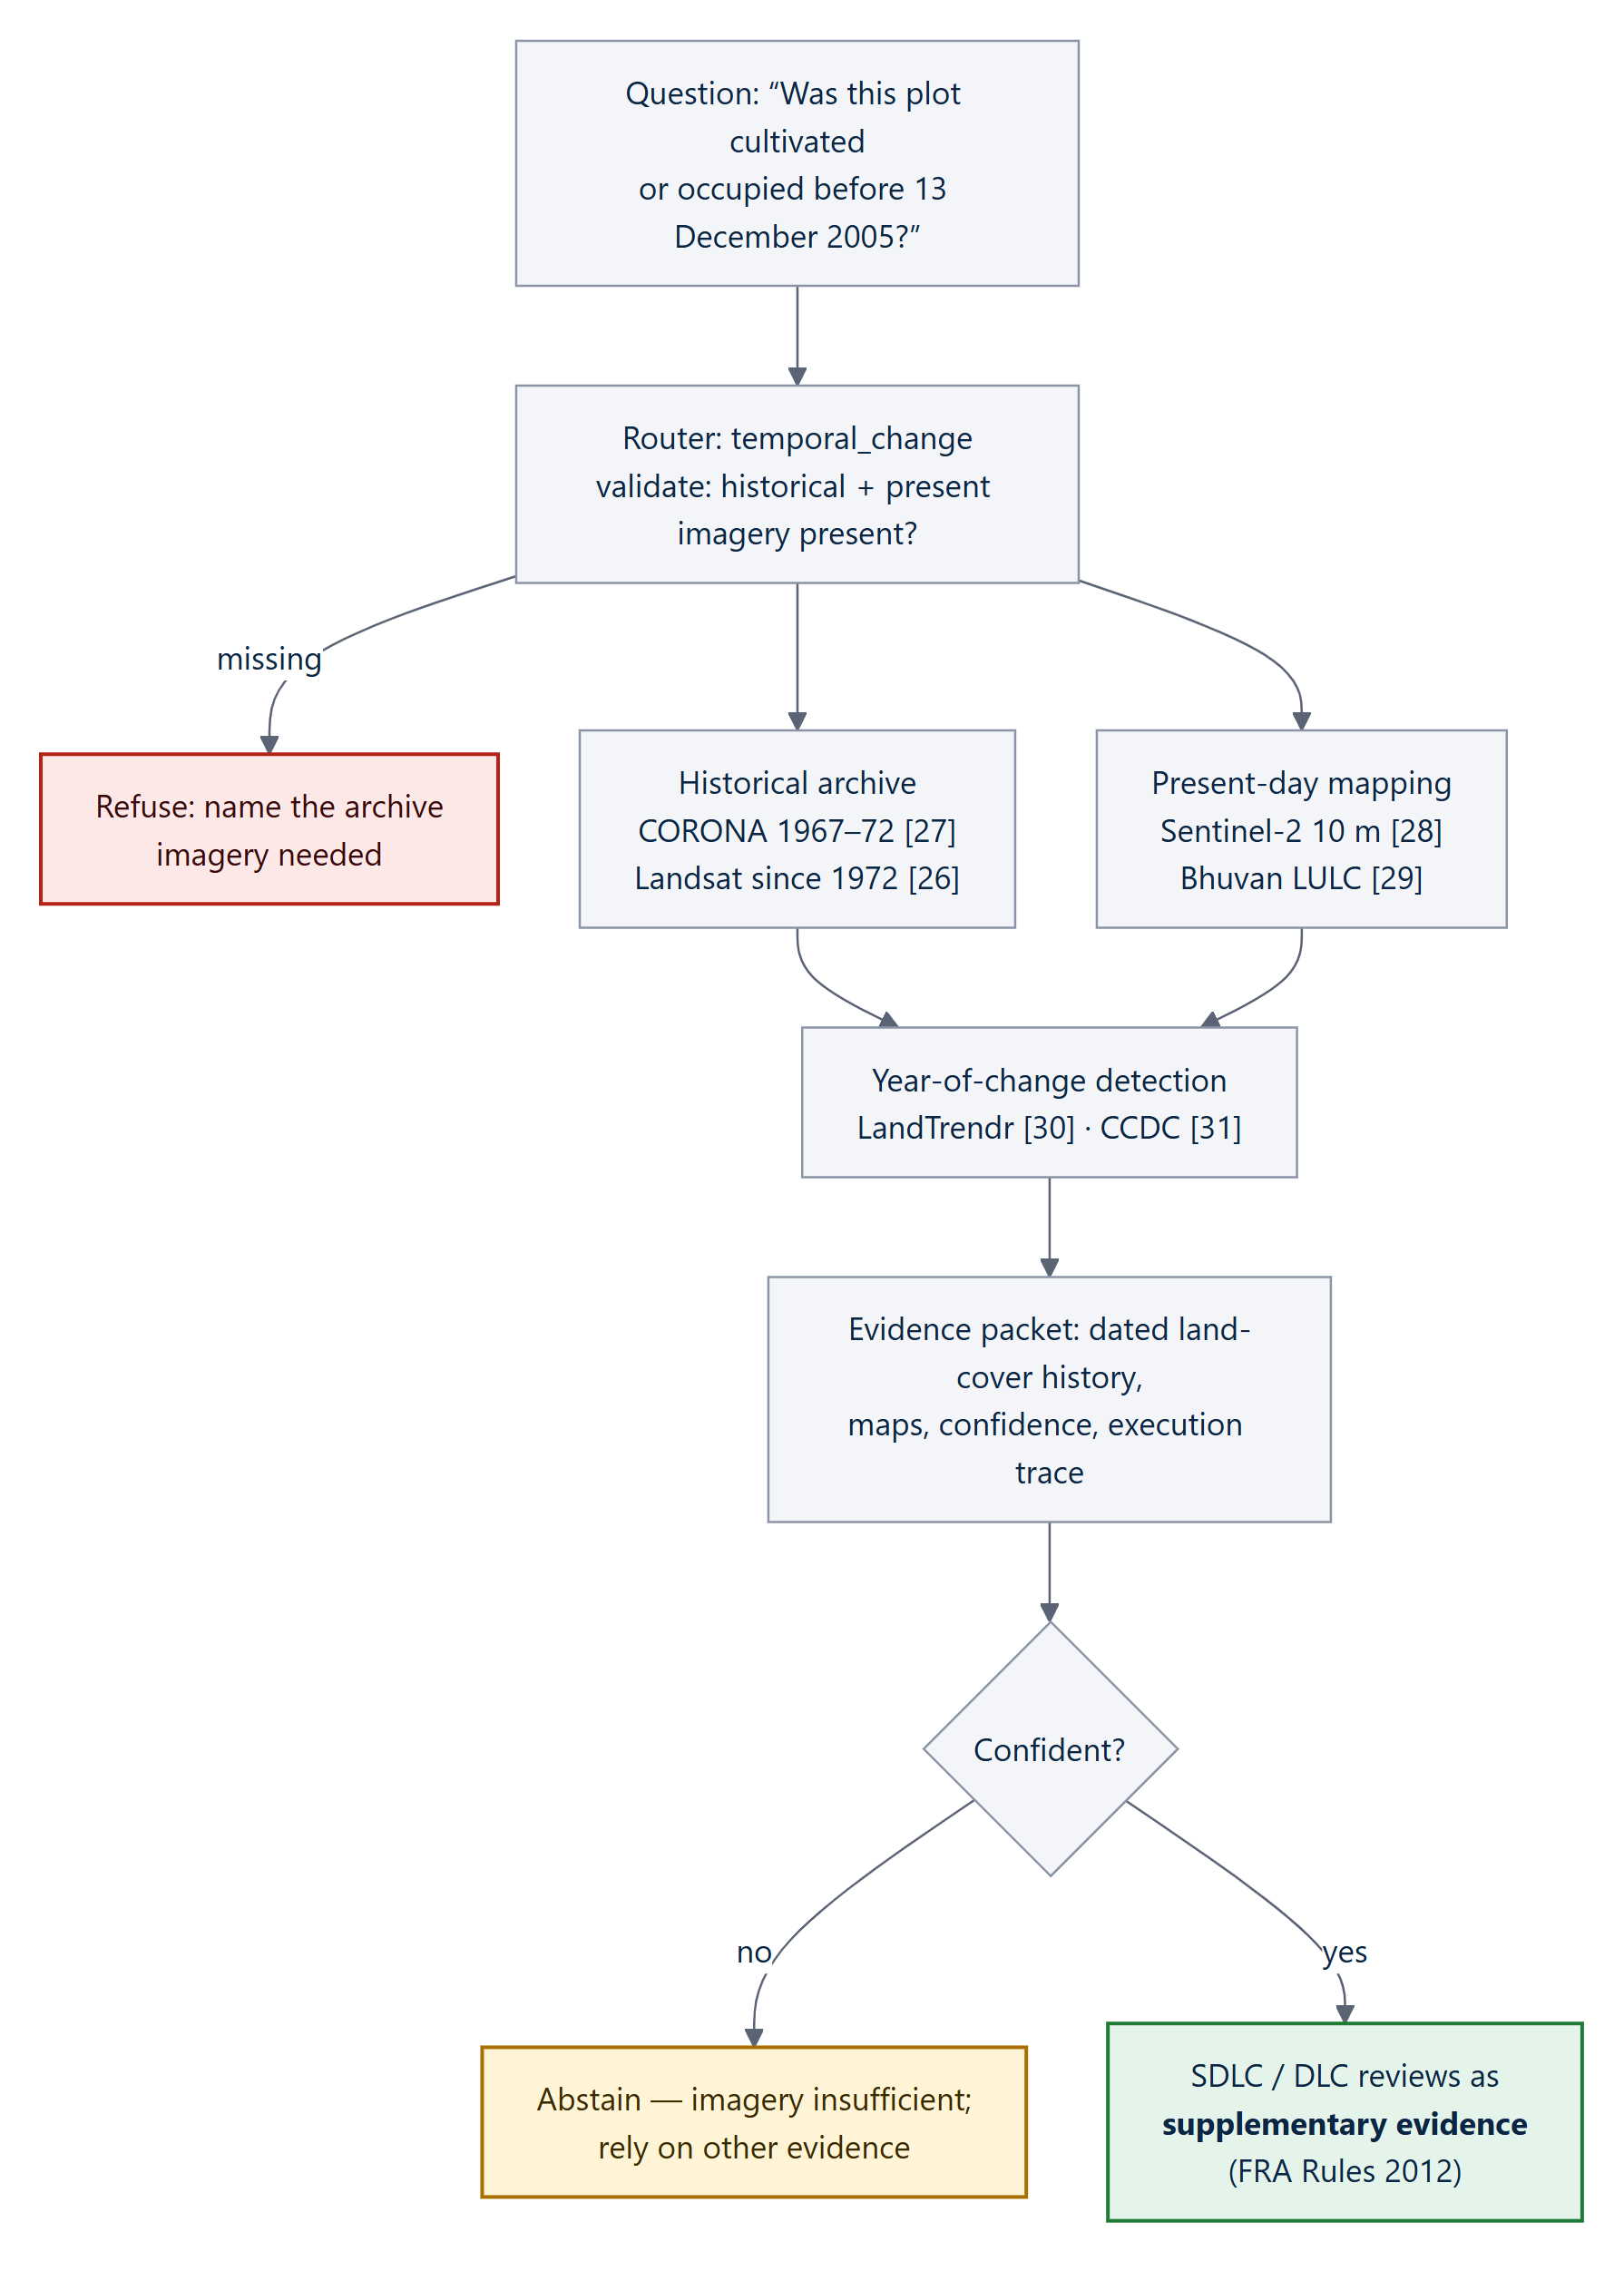
Figure 32. Proposed FRA evidence-support workflow: SatQuery supplies a dated, auditable land-cover history; the statutory authority decides.
- Registry extension, not redesign: archive-imagery ingestion and year-of-change tools (LandTrendr, CCDC) become new registry rows.
- Supplement, not replace: the output is an evidence packet with confidence and trace for the committee, never a verdict — matching the 2012 Rules.
- Abstention protects claimants: where imagery cannot establish the history, the system says so rather than producing a confident negative that could wrongly count against a claim.

13 Key Design Decisions
Every contested, non-obvious or expensive-to-reverse choice is recorded as an Architecture Decision Record (ADR) with the alternatives that were rejected. They double as answers to “why not …?” questions.
ADR | Decision | Main alternative rejected, and why
001 | One frozen base VLM, swappable LoRA adapters | Four fully fine-tuned models: ~60 GB GPU memory, four full training runs, no per-capability ablation
002 | Grounding, not captioning, as the second single-image task | Captioning: slow to verify, produces nothing the map can use, scored by word-overlap metrics
003 | SAR gets its own processing path | SAR as a greyscale PNG into an optical model: reads backscatter as brightness, no speckle prior
004 | Plain Python router, not an agent framework | LangGraph-style framework: built for capability, but the PS asks for constraint; hides the judged component
005 | Late fusion for optical–SAR | Feature-level / cross-attention fusion: destroys the “optical said X, SAR said Y” separability the ablation needs
006 | Geographic tile-level splits, never random | Random 80/10/10: neighbouring tiles leak; measures memorisation
007 | The language layer phrases validated evidence only | End-to-end VLM generation: no meaningful confidence, no abstention, no audit trail
008 | Show the execution trace, hide chain-of-thought | Streaming reasoning: explicitly not evaluated, adds latency, invites attack
009 | PostgreSQL + PostGIS; rasters in object storage (proposed) | MongoDB: weaker geospatial support; rasters as blobs: bloats everything
010 | Base model chosen by benchmark, not reputation | Pick GeoChat by reputation: it could not even be loaded on current libraries

13.1 What is real and what is simulated
Category | What
Real | Every algorithm that reads pixels: Lee speckle filter, multi-level Otsu, connected components, change vector analysis, NDVI/NDWI, phase-correlation co-registration, inverse geotransform, the router's classify–validate–select–sequence–execute cycle, and the confidence gate. Uploaded GeoTIFFs are analysed as supplied.
Trained | M1 — the QLoRA adapter on Qwen2-VL-7B, measured at 0.660 on held-out VRSBench.
Synthetic | Pixel values of the built-in demo scenes, because Cartosat-2S and RISAT imagery cannot be obtained and the ISRO/SAC set is undisclosed.
Constructed on purpose | The cloud placement over the settlement in the cross-modal scene — the case where the sensors genuinely differ.
Planned | M2 grounding, M3 change and M4 SAR adapters; RSVQA/CDVQA loaders; trained router classifier.

14 Team BUGHEBUG
The work is split along the architecture's own seam: the model runtime is the only GPU-bound unit and sits behind a defined adapter-pack contract, so the two halves meet in one agreed place.
Area | Responsibilities
Models and training (Mridul) | Base-model benchmark and selection; M1 training and the measured adaptation gain; later M2–M4; data preparation, splits and licences; benchmark runs; quantisation for the venue
Systems, orchestration and interface (Shreyash) | Ingestion, upload, validation and refusal; router and registry; evidence layer, confidence gate, answer layer and trace; API, reports and GeoJSON; web application; evaluation harness and ablation integrity; venue deployment and fallback

14.1 Anticipated questions
Question | Answer
Why not just use GPT-4V? | The PS disqualifies a generic model without remote-sensing adaptation; it needs the internet; and it can invent numbers — our architecture structurally cannot (ADR-007).
Where is your fine-tuning? | M1: QLoRA on Qwen2-VL-7B, VRSBench, 0.527 → 0.660 on 2,000 held-out items, p = 1.2e-35, zero train/val overlap (§4).
How do you know the confidence is honest? | Calibration is measured; accuracy rises with confidence in every band, and the 0.45 gate was chosen from data (§4.7).
Is this real imagery? | Demo scenes are synthetic and disclosed on screen; every algorithm is real; M1 is shown on real VRSBench photographs; uploads accept real GeoTIFFs.
What is “agentic” here? | Classify → validate → select from a fixed registry → sequence → execute with permitted parameters, all in the trace (§3.4).
Why show no reasoning? | ISRO scores only the observable trace and says reasoning text is “neither required nor evaluated” (ADR-008).
What if the sensors disagree? | The conflict is recorded in the evidence and confidence is reduced — never silently resolved.
How will it handle the hidden ISRO data? | Official and geographic splits, input validation, calibrated confidence and abstention — built for data we have not seen.

15 Research and References

Datasets
[1] BigEarthNet.txt — Large-Scale Multi-Sensor Image-Text Dataset. BIFOLD / TU Berlin, 2026. 464,044 Sentinel-1/Sentinel-2 image pairs · 9.6M text annotations.
→ Our adaptation set
https://arxiv.org/abs/2603.29630
[2] BigEarthNet.txt — Project Portal. Official project portal for the BigEarthNet.txt dataset.
https://txt.bigearth.net/
[3] BigEarthNet.txt — Hugging Face Dataset Card. BIFOLD-BigEarthNetv2-0 dataset resource.
https://huggingface.co/datasets/BIFOLD-BigEarthNetv2-0/BigEarthNet.txt
[4] VRSBench — NeurIPS 2024. 29,614 images · 123,221 VQA.
→ Single-image benchmark; M1 training and evaluation corpus
https://github.com/lx709/VRSBench
[5] S. Lobry et al., RSVQA: Visual Question Answering for Remote Sensing Data — IEEE TGRS 2020. 772 images · 77,232 QA.
→ VQA sanity check
https://arxiv.org/abs/2003.07333
[6] RSVQA Dataset Portal. LR + HR dataset resources.
https://rsvqa.sylvainlobry.com/
[7] CDVQA — Change Detection Meets Visual Question Answering. IEEE TGRS, 2022. 2,968 image pairs · 122k QA.
→ Bi-temporal benchmark
https://arxiv.org/abs/2112.06343
[8] CDVQA — Official Code & Dataset Splits. Official GitHub repository.
https://github.com/YZHJessica/CDVQA

Model baselines
[9] GeoChat — Grounded Large Vision-Language Model for Remote Sensing. CVPR 2024. First grounded remote-sensing vision-language model.
→ Our grounding baseline
https://github.com/mbzuai-oryx/GeoChat
[10] EarthGPT — Multi-Sensor MLLM (optical · SAR · infrared). IEEE TGRS 2024.
→ Demonstrates multi-sensor feasibility
https://arxiv.org/abs/2401.16822
[11] GeoGround — Unified LVLM for Remote-Sensing Visual Grounding, 2024.
→ Our box and mask output
https://arxiv.org/abs/2411.11904
[12] E. Hu et al., LoRA — Low-Rank Adaptation of Large Language Models. ICLR 2022. Freeze backbone · train lightweight adapters.
→ Our adaptation method
https://arxiv.org/abs/2106.09685

Agentic orchestration
[13] Change-Agent — Interactive Change Interpretation, 2024. LLM as the brain · vision model as the eyes.
→ Our router pattern
https://arxiv.org/abs/2403.19646
[14] RS-Agent — Automating Remote-Sensing Tasks through an Intelligent Agent. Tool registry + structured task planning.
→ Our closed tool set
https://arxiv.org/abs/2406.07089
[15] Multi-Agent Geospatial Copilots for Remote-Sensing Workflows.
→ Validates specialist dispatch
https://arxiv.org/abs/2501.16254
[16] Agentic AI for Remote Sensing — Challenges and Directions. Survey of open problems.
→ Our failure-mode checklist
https://arxiv.org/abs/2604.24919

Optical–SAR and ISRO data
[17] OGC GeoTIFF Standard — georeferencing tags (CRS and geotransform) for raster imagery.
→ Our coordinate-integrity contract
https://www.ogc.org/standard/geotiff/
[18] SEN12MS — Georeferenced Sentinel-1/Sentinel-2 fusion corpus.
→ Our cross-modal design
https://arxiv.org/abs/1906.07789
[19] Chen & Bruzzone, Self-Supervised SAR-Optical Data Fusion. Co-registration and joint feature learning.
→ Our alignment check
https://arxiv.org/abs/2103.05543
[20] EOS-04 (RISAT-1A) Handbook — NRSC / ISRO. SAR product specifications.
→ Sensor in the evaluation set
https://bhoonidhi.nrsc.gov.in/
[21] ISRO Bhoonidhi EO Data Hub — Cartosat-2S and RISAT data access.
→ Our test-imagery source
https://bhoonidhi.nrsc.gov.in/

Legal and policy basis
[22] Forest Rights Act, 2006 — pre-13 December 2005 occupation and SDLC/DLC appeal mechanism.
https://tribal.nic.in/fra.aspx
[23] FRA Amendment Rules, 2012 — satellite imagery can supplement, not replace, other evidence; final decision remains with the human authority.
https://www.tribal.mp.gov.in/CMS/Uploaded%20Document/RTI/Rules%20%26%20Regulation/Forest%20Rights%20Amendment%20Rules%202012.pdf
[24] Ministry of Tribal Affairs — Monthly Progress Report, March 2026. 47,901 community forest-rights claims rejected nationally.
https://tribal.nic.in/downloads/FRA/MPR/2026/%28B%29%20MPR%20Mar%202026.pdf
[25] DAJGUA — ₹79,156 crore · 17 ministries · focus on 22 lakh FRA patta holders (PIB).
https://archive.pib.gov.in/newsite/PrintRelease.aspx?relid=259904

Satellite data and time-series research
[26] Landsat — USGS. Historical satellite imagery available from 1972.
https://www.usgs.gov/landsat-missions/landsat-1
[27] CORONA — USGS EROS Archive. Declassified historical satellite imagery, 1967–1972.
https://www.usgs.gov/centers/eros/science/usgs-eros-archive-declassified-data-declassified-satellite-imagery-1
[28] Sentinel-2 — Copernicus Data Space. 10 m imagery for present-day asset mapping.
https://dataspace.copernicus.eu/data-collections/copernicus-sentinel-missions/sentinel-2
[29] ISRO Bhuvan — Indian geospatial and LULC layers for present-day mapping.
https://bhuvan.nrsc.gov.in/
[30] Kennedy et al., LandTrendr, 2018 — detects the year of land-cover change from Landsat time-series.
https://doi.org/10.3390/rs10050691
[31] Zhu & Woodcock, CCDC, 2014 — continuous land-cover change detection using Landsat observations.
https://doi.org/10.1016/j.rse.2014.01.011

Additional references used in this report
[32] Qwen Team, Qwen2-VL: Enhancing Vision-Language Model's Perception of the World at Any Resolution, 2024.
→ Our base model (M0)
https://arxiv.org/abs/2409.12191
[33] T. Dettmers et al., QLoRA: Efficient Finetuning of Quantized LLMs, NeurIPS 2023.
→ 4-bit training on a free GPU
https://arxiv.org/abs/2305.14314
[34] J.-S. Lee, Digital Image Enhancement and Noise Filtering by Use of Local Statistics, IEEE TPAMI, 1980.
→ SAR speckle filter
https://doi.org/10.1109/TPAMI.1980.4766994
[35] N. Otsu, A Threshold Selection Method from Gray-Level Histograms, IEEE Trans. SMC, 1979.
→ Segmentation thresholds
https://doi.org/10.1109/TSMC.1979.4310076
[36] Q. McNemar, Note on the Sampling Error of the Difference Between Correlated Proportions, Psychometrika, 1947.
→ Paired significance test
https://doi.org/10.1007/BF02295996
[37] VRSBench on Hugging Face — dataset files used for training and evaluation.
https://huggingface.co/datasets/xiang709/VRSBench
[38] S. Brown, The C4 Model for Visualising Software Architecture.
→ Architecture notation in §5
https://c4model.com/
[39] Smart India Hackathon 2026 — official portal (problem statement 26167, ISRO).
https://sih.gov.in/

Appendix A — Glossary
Term | Meaning
Ablation | Switching parts of a system on one at a time to measure what each contributes
Abstention | Declining to answer because no evidence cleared the confidence threshold
Adapter (LoRA) | A small set of trained weights added to a frozen model to specialise it
Backscatter | The radar energy returned to a SAR sensor; bright for buildings, dark for calm water
Calibration / ECE | Agreement between stated confidence and actual accuracy; Expected Calibration Error measures the gap
Co-registration | Pixel-for-pixel alignment of two images of the same ground
CRS / EPSG code | Coordinate reference system, e.g. EPSG:4326 (latitude/longitude) or UTM (metres)
Execution trace | The factual audit log of what the system ran — the part ISRO evaluates
F1 / IoU | Standard accuracy measures for detection (F1) and overlap of regions (Intersection over Union)
GeoJSON | Open format for map features; opens directly in QGIS and web maps
GeoTIFF | An image file that also stores where on Earth each pixel is
Grounding | Locating the region an instruction refers to
Late fusion | Analysing each sensor separately, then combining their conclusions
McNemar's test | A significance test for paired right/wrong outcomes on the same items
NDVI / NDWI | Spectral indices that highlight vegetation and water
QLoRA | LoRA training on a model stored in 4-bit precision, to fit small GPUs
SAR | Synthetic Aperture Radar — an active sensor that sees through cloud, day and night
Speckle | Grainy multiplicative noise inherent to SAR images
VQA | Visual Question Answering
Zero-shot | A model evaluated without any training on the target task — the baseline for measuring adaptation

Appendix B — Reproducing the Results
All commands run from the 167/ folder of the team repository.
python -m satquery.cli selftest # 49 checks, ~2 s
python -m satquery.cli demo # one cross-modal run with its trace
python -m satquery.cli eval # task metrics and the A–E ablation
python -m satquery.cli serve --adapters models/adapters # UI + API on :8000

# M1 — zero-shot and adapted, same script, same 2,000 items
python models/eval_baseline.py --seed 0 --limit 2000
python models/eval_baseline.py --seed 0 --limit 2000 --adapter <adapter-dir>

# M1 — training (Kaggle T4, resumable)
python models/train_rs_vqa.py --resume

Path | Contents
docs/ | Official problem statement, deep analysis, model specification, system design, PRD, TRD, decision record, ADRs
satquery/ | The Python package: raster, validate, router, specialists, runtime, evidence, pipeline, report, server
web/ | React + three.js workstation
models/ | Training, evaluation, calibration and pre-compute scripts; MANIFEST.md; stored prediction rows in results/; the M1 pack

