

**学生实验实习报告册**

|  |  |
| --- | --- |
| 学年学期： | 2023 学年 🗹春🞏秋学期 |
| 课程名称： | 软件测试工具与平台 |
| 学生学院： | 软件工程 |
| 专业班级： | 13002008 |
| 学生学号： | 2020214644 |
| 学生姓名： | 秦攀 |
| 联系电话： | 17623363059 |

**重庆邮电大学教务处制**

**第一部分 QTP自动化测试工具的使用**

1. **测试对象**

QTP自带的飞机订票系统

1. **测试类别**

功能测试

1. **任务描述**

**1、登录功能测试**

**2、订票功能测试**

**3、查询功能测试（选作）**

1. **业务流程分析**
2. **登录业务流程分析**

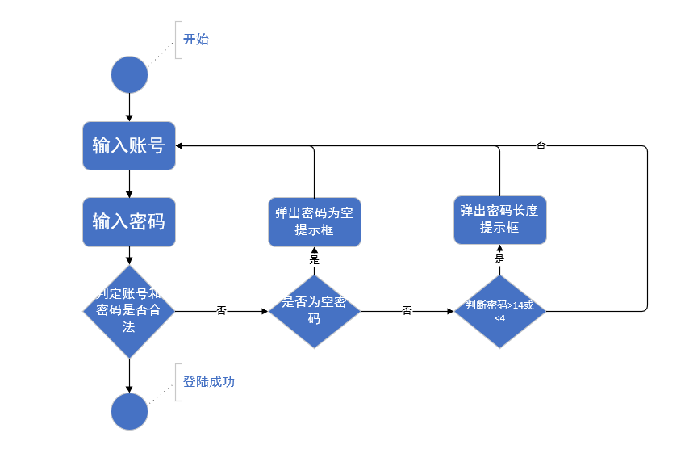**2、订票业务流程分析**

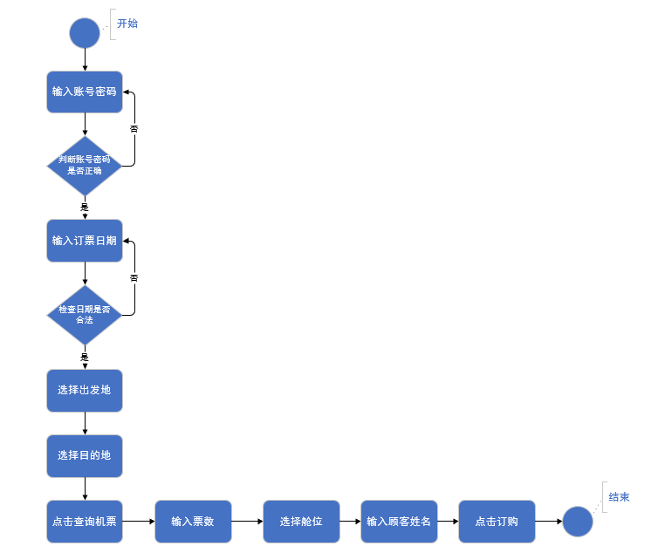

**3、查询业务流程分析（选作）**

1. **测试用例设计**
2. **登录业务测试用例设计**

|  |  |  |  |  |
| --- | --- | --- | --- | --- |
| **序号** | **输入** | **预期输出** | **实际输出** | **是否通过** |
| 1 | 123123  qinpan | Incorrect password. Please try again | Incorrect password. Please try again | Yes |
| 2 | 1234  Null | Please enter password | Please enter password | yes |
| 3 | Null  qinpa | Please enter agent name | Please enter agent name | yes |
| 4 | 12345  qq | Password must be at least 4 characters long | Password must be at least 4 characters long | yes |
| 5 | Mercury  mercury |  |  | yes |

1. **订票业务测试用例设计**

|  |  |  |
| --- | --- | --- |
| **序号** | **输入**  **(date,naem,num,order)** | **是否通过** |
| 1 | 112523 test1 3 14 | Yes |
| 2 | 112623 test2 4 15 | yes |
| 3 | 112723 test3 5 16 | yes |
| 4 | 102523 test4 1 17 | yes |
| 5 | 102623 test5 1 18 | yes |

图表 1

1. **查询业务测试用例设计（选作）**

|  |  |  |
| --- | --- | --- |
| **序号** | **输入**  **(date,naem,num,order)** | **是否通过** |
| 1 | qinpan | Yes |
| 2 | Qinpan2 | yes |
| 3 | Qinpan3 | yes |

图表 2

1. **测试执行**
2. **登录业务脚本及测试结果（截图）**

**Dialog("Login").WinEdit("Agent Name:").Set DataTable("userName", dtGlobalSheet)**

**Dialog("Login").WinEdit("Password:").SetSecure DataTable("passWord", dtGlobalSheet)**

**Dialog("Login").WinButton("OK").Click**

**wait(1)**

**If Dialog("Login").Dialog("Flight Reservations").Exist(2) Then**

**Dialog("Login").Dialog("Flight Reservations").Static("Please enter agent name").Check CheckPoint("Please enter agent name")**

**Dialog("Login").Dialog("Flight Reservations").WinButton("确定").Click**

**Dialog("Login").WinButton("Cancel").Click**

**End If**

**wait(1)**

**If Window("Flight Reservation").Exist(2) Then**

**Window("Flight Reservation").Check CheckPoint("Flight Reservation")**

**Window("Flight Reservation").Activate**

**Window("Flight Reservation").Close**

**End If**

**wait(1)**

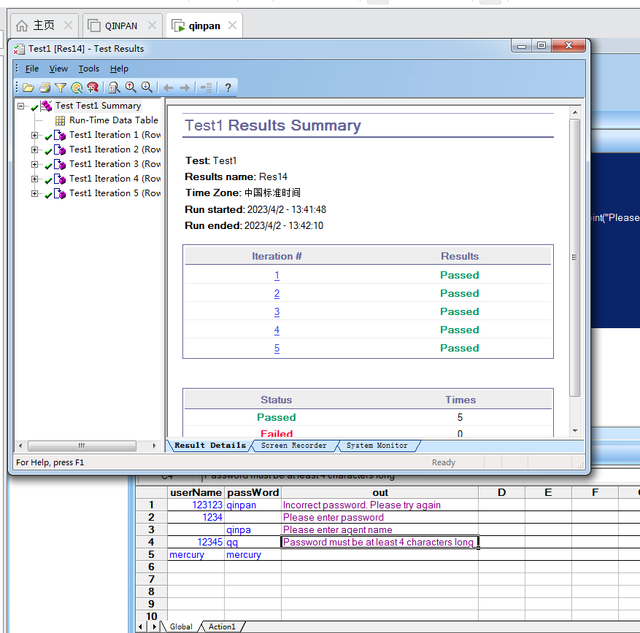

1. **订票业务脚本及测试结果（截图）**

**Function getNum(i)**

**num=randomNumber(0,i-1)**

**getNum=num**

**End Function**

**Dialog("Login").WinEdit("Agent Name:").Set "mercury"**

**Dialog("Login").WinEdit("Agent Name:").Type micTab**

**Dialog("Login").WinEdit("Password:").SetSecure "64217913f813ce33bca787d6623cd583bb1cc2b9"**

**Dialog("Login").WinButton("OK").Click**

**Window("Flight Reservation").WinObject("Date of Flight:").Type DataTable("date", dtGlobalSheet)**

**Window("Flight Reservation").WinComboBox("Fly From:").Select getNum(Window("Flight Reservation").WinComboBox("Fly From:").GetItemsCount)**

**wait(1)**

**Window("Flight Reservation").WinComboBox("Fly To:").Select getNum(Window("Flight Reservation").WinComboBox("Fly To:").GetItemsCount)**

**wait(1)**

**Window("Flight Reservation").WinButton("FLIGHT").Click**

**Window("Flight Reservation").Dialog("Flights Table").WinList("From").Select getNum(Window("Flight Reservation").Dialog("Flights Table").WinList("From").GetItemsCount)**

**wait(1)**

**Window("Flight Reservation").Dialog("Flights Table").WinButton("OK").Click**

**Window("Flight Reservation").WinEdit("Name:").Set DataTable("name", dtGlobalSheet)**

**Window("Flight Reservation").WinEdit("Tickets:").SetSelection 0,1**

**Window("Flight Reservation").WinEdit("Tickets:").Set DataTable("num", dtGlobalSheet)**

**Dim a**

**a=Array("first","Business","Economy")**

**Window("Flight Reservation").WinRadioButton(a(getNum(3))).Set**

**Window("Flight Reservation").WinButton("Insert Order").Click**

**wait(3)**

**Window("Flight Reservation").WinEdit("Order No:").Check CheckPoint("Order No:")**

**Window("Flight Reservation").Close**

**wait(1)**

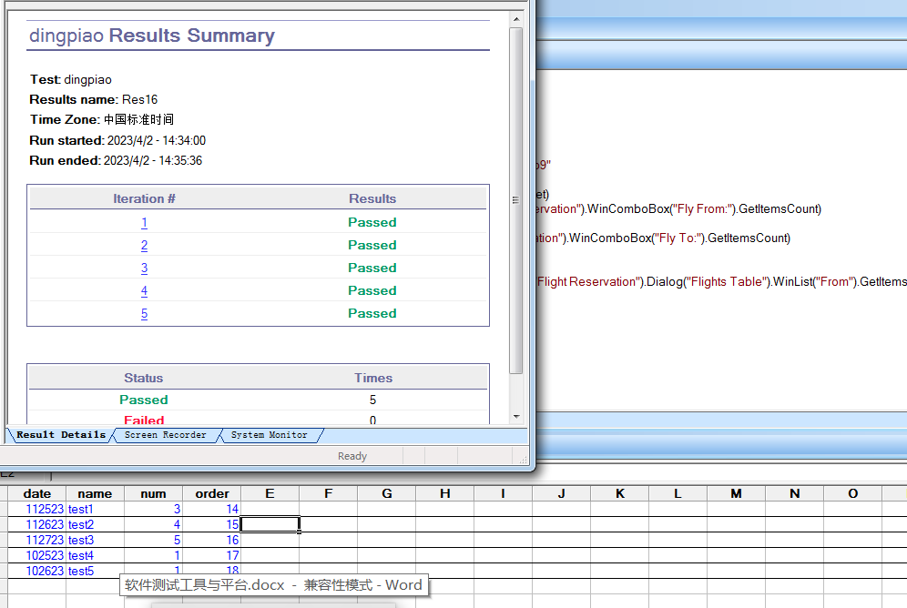

**3、查询业务脚本及测试结果（截图）（选作）**

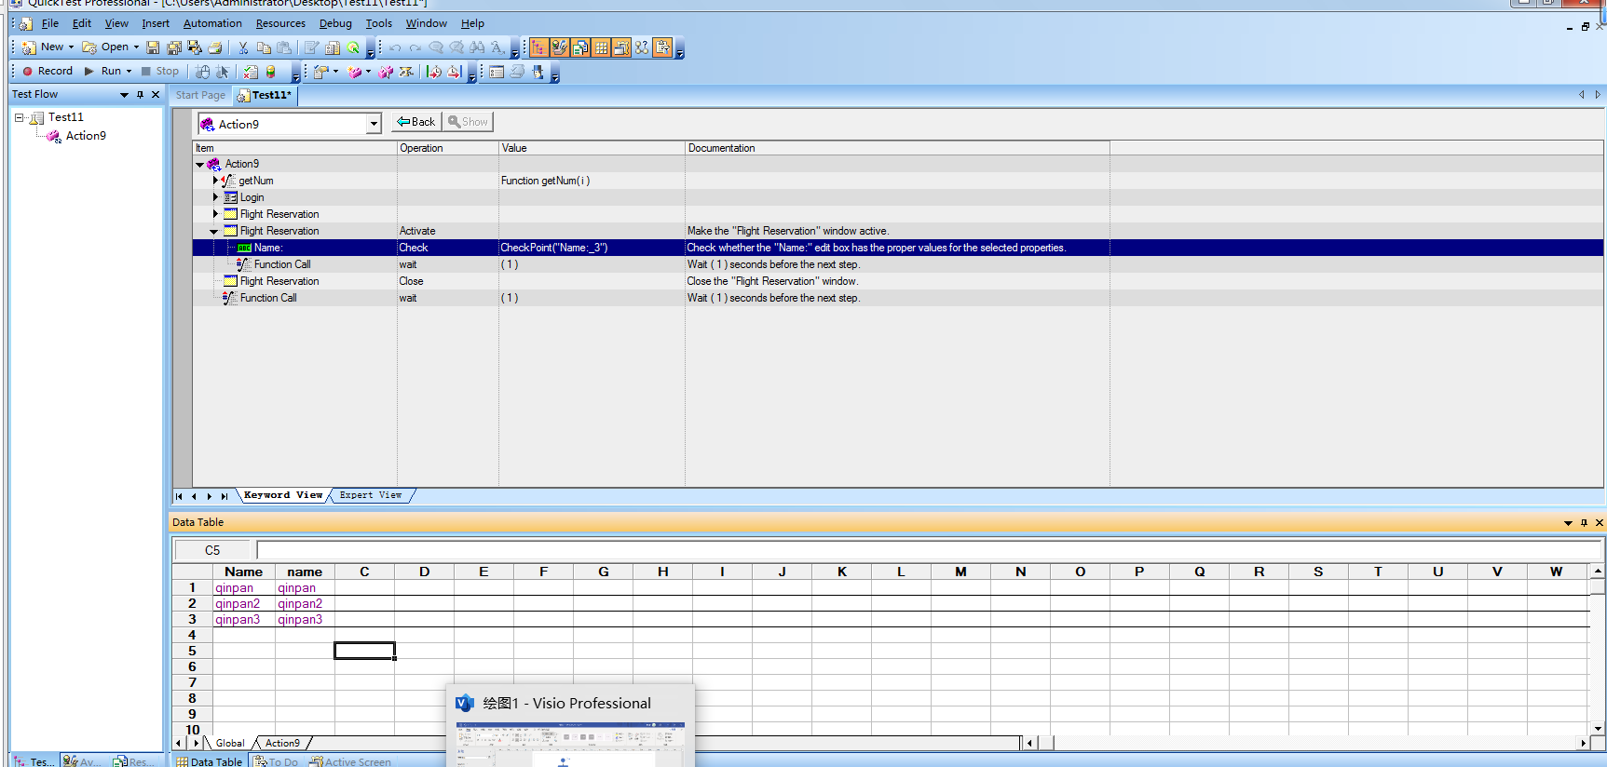

**Function getNum(i)**

**num=randomNumber(0,i-1)**

**getNum=num**

**End Function**

**Dialog("Login").WinEdit("Agent Name:").Set "mercury"**

**Dialog("Login").WinEdit("Password:").SetSecure "mercury"**

**Dialog("Login").WinButton("OK").Click**

**Window("Flight Reservation").WinMenu("Menu").Select "File;Open Order..."**

**wait(2)**

**Window("Flight Reservation").Dialog("Open Order").WinCheckBox("Customer Name").Set "ON"**

**Window("Flight Reservation").Dialog("Open Order").Activate**

**Window("Flight Reservation").Dialog("Open Order").WinEdit("Edit").Set DataTable("name", dtGlobalSheet)**

**wait(2)**

**Window("Flight Reservation").Dialog("Open Order").WinButton("OK").Click**

**Window("Flight Reservation").Dialog("Open Order").Dialog("Search Results").Activate**

**wait(1)**

**Window("Flight Reservation").Dialog("Open Order").Dialog("Search Results").WinList("Flight No.").Select getNum(Window("Flight Reservation").Dialog("Open Order").Dialog("Search Results").WinList("Flight No.").GetItemsCount)**

**wait(1)**

**Window("Flight Reservation").Dialog("Open Order").Dialog("Search Results").WinButton("OK").Click**

**Window("Flight Reservation").Activate**

**Window("Flight Reservation").WinEdit("name:").Check CheckPoint("Name:_3")**

**wait(1)**

**Window("Flight Reservation").Close**

**wait(1**