WEEK 07 FULL PROGRESS SUMMARY
Fabrication Strategy, Sensor Signal Architecture and Supervisor Review Workflow
Ultra-Low-Cost Wearable Smart Patch for Diabetic Foot Ulcer Monitoring

Project stage | Final Year Project - Week 07
Prepared by | Vikum
Prepared for | Dr. Ruwan and Dr. Anjali - Supervisory Review
Reporting period | Week 07
Main focus | Prototype fabrication planning and complete sensor-to-DAQ architecture
Document status | Engineering progress report; laboratory validation pending

Scope statement: This document records the design work completed in Week 07. It is intended for supervisor discussion and bench-prototype planning. It does not claim that the patch is medically certified, sterile, biocompatible, clinically accurate or ready for use on an open wound.
July 2026

Document Overview
Section | Purpose
1. Executive Summary | Summarizes the engineering progress and the most important Week 07 outcomes.
2. Week 07 Objectives and Status | Shows what was planned, completed, defined or left for validation.
3. Fabrication and BOM Study | Presents the six-layer low-cost fabrication strategy, materials and accessible facilities.
4. Sensor Signal and DAQ Architecture | Explains pH, temperature and moisture signal requirements and the revised electronics.
5. Patch-to-Module Interface and Safety | Defines the 12-pin interface, separation, current limiting and mechanical protection.
6. Integrated Week 07 Workflow | Connects research, fabrication, hardware and validation in one workflow.
7. Validation and Week 08 Plan | Lists tests, acceptance evidence, actions and decisions required from supervisors.
8. Supervisor Presentation Script | Provides a concise speaking guide for the meeting.

1. Executive Summary
Week 07 marked the transition from literature-based concept development to an implementable engineering prototype plan. The work combined four uploaded fabrication planning sheets with the complete sensor signal and data-acquisition design. The resulting architecture separates the system into a low-cost disposable sensing patch (Stage A) and a reusable electronic acquisition module (Stage B).
The principal outcomes achieved during the week were:
- A six-layer, undergraduate-accessible fabrication stack was defined using PET for early bench prototypes, printed conductive traces, carbon sensing structures, a PANI active pH layer, an Ag/AgCl reference concept and PU-film passivation.
- The required facilities and fallback fabrication methods were mapped to university laboratories, SLINTEC or manual bench alternatives. Supplier names and prices remain provisional until quotations and stock checks are completed.
- The three sensor channels were treated according to their different signal physics: potentiometric voltage for pH, digital I2C data for temperature and AC impedance-derived response for moisture.
- A critical hardware correction was made after confirming that the ESP32-C3 does not provide a true voltage-output DAC. The moisture channel was therefore redesigned around PWM or complementary GPIO excitation, attenuation, AC coupling, current limiting and envelope detection.
- A keyed 12-pin patch connector was defined to separate high-impedance pH lines from noisy digital or PWM traces and to provide strain relief between the flexible patch and reusable electronics.
- A bench-validation workflow was established for electrical integrity, sensor calibration, integrated wound-simulant testing, mechanical bending and drift assessment.
Central Week 07 achievement: The project now has one connected workflow from material selection and layer fabrication to signal conditioning, digitization, firmware acquisition and validation.

2. Week 07 Objectives and Completion Status
Objective | Status | Evidence / Remaining Work
Review low-cost fabrication routes | Completed | Four fabrication/BOM workbooks consolidated; expensive cleanroom methods compared with accessible alternatives.
Define physical layer stack | Completed at prototype-planning level | Six-layer stack and proposed process sequence documented.
Define pH signal chain | Completed at architecture level | High-impedance differential acquisition using two buffers and a 16-bit ADC.
Define temperature signal chain | Completed at architecture level | Four TMP117 sites, I2C addressing and bus-separation requirement documented.
Define moisture signal chain | Corrected and completed at architecture level | DC drive rejected; current-limited zero-mean AC/PWM method selected.
Define patch connector | Completed at architecture level | Keyed 12-pin interface, signal separation and strain-relief rules prepared.
Confirm total prototype cost below USD 50 | Not yet confirmed | Target remains feasible but complete BOM, shipping, fabrication charges and replacements must be quoted.
Prove biocompatibility and clinical safety | Not started | Requires approved materials, ethics, electrical safety and clinical pathway.
Fabricate and calibrate sensors | Planned for Week 08 onward | Laboratory access, materials and fabrication artwork must be finalized.

3. Physical Fabrication and Material Strategy

3.1 Stage A and Stage B Partition
System stage | Contents | Purpose and disposal strategy
Stage A - Disposable sensing patch | Flexible substrate, printed traces, PANI working electrode, reference-electrode interface, carbon IDE moisture geometry, TMP117 sites if retained on the patch, passivation and connector tail. | Placed near the wound/dressing and replaced at each dressing change. No battery, radio or charger is placed on the wound-facing disposable portion.
Stage B - Reusable DAQ module | High-impedance pH buffers, ADS1115, I2C bus switch, moisture excitation/detector, ESP32-C3 or nRF52, BLE, regulated battery supply and charging/protection. | Remains outside the contaminated wound-contact region. It is detached before disposal and cleaned only using a validated method.

3.2 Proposed Six-Layer Prototype Stack
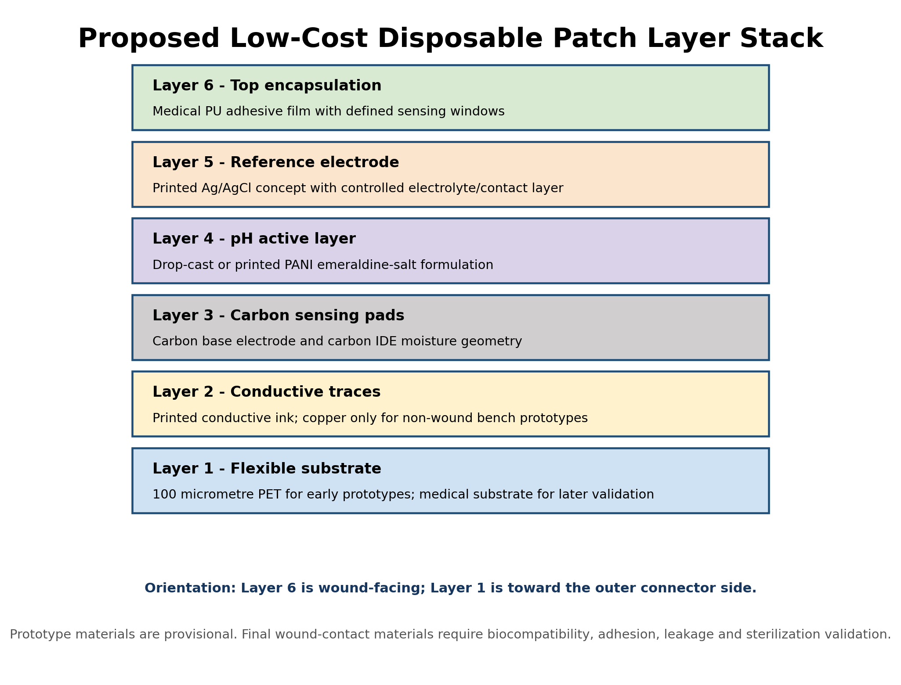
Figure 1. Proposed low-cost six-layer bench-prototype stack derived from the fabrication planning sheets.
The stack represents a practical development route, not a final medical-device construction. PET transparency film, graphite-pencil tracks, packing tape and household heating methods may be useful for non-clinical proof-of-concept work, but they must not be described as wound-safe materials. Copper tape or etched copper may be used only in isolated bench prototypes where it is fully encapsulated and cannot contact fluid.

3.3 Material and Facility Mapping
Process | Preferred prototype method | Facility / tool | Backup method | Week 07 conclusion
Substrate preparation | Cut and clean 100 micrometre PET sheets | Scalpel, cutting mat, template | Clear PVC/OHP sheet for dry bench tests | Low complexity; medical substrate required later.
Trace patterning | Screen-print or stencil conductive ink | Screen mesh, squeegee, controlled curing oven | Fine brush or syringe dispensing | Screen printing preferred for repeatable geometry.
Carbon electrodes | Printed carbon paste for base pads and IDEs | Screen/stencil and oven | 6B-10B graphite only for early geometry trials | Ink formulation and curing must be standardized.
PANI layer | Chemical synthesis, formulation and drop-casting/printing | Fume hood, ice bath, stirrer, filtration | Pre-purchased PANI powder if synthesis delayed | Chemistry-lab route identified; safety procedure mandatory.
Ag/AgCl reference | Printed Ag/AgCl or controlled silver chloridization | Chemistry/electrode fabrication facilities | Silver wire or paste conversion for bench testing | Reference stability and ion leakage remain major risks.
Encapsulation | Medical PU film with cut sensing windows | Clean cutting and manual lamination | Tegaderm-type film for prototype evaluation | Window geometry, adhesion and fluid isolation require testing.
Electronics assembly | SMD assembly and connector attachment | EEE lab, fine-tip soldering, hot plate/reflow | Breakout modules during first validation | Reusable module should be debugged before integration.

3.4 Preliminary BOM Position
The fabrication sheets list a preliminary subtotal of approximately LKR 8,000 for selected chemicals, conductive material, PET, a controller, an op-amp and PU tape. This subtotal is not a complete system cost because it excludes or incompletely prices the four TMP117 sensors, ADS1115, I2C switch, battery, charger/protection, regulator, detector components, connector, PCB/flex manufacture, shipping, customs and rejected fabrication samples.
Cost reporting rule: Present “below USD 50” as the design target until a complete quantity-based BOM and supplier quotations demonstrate it. Do not present the preliminary spreadsheet subtotal as the final prototype cost.

4. Sensor Signal Parameters and Data-Acquisition Architecture
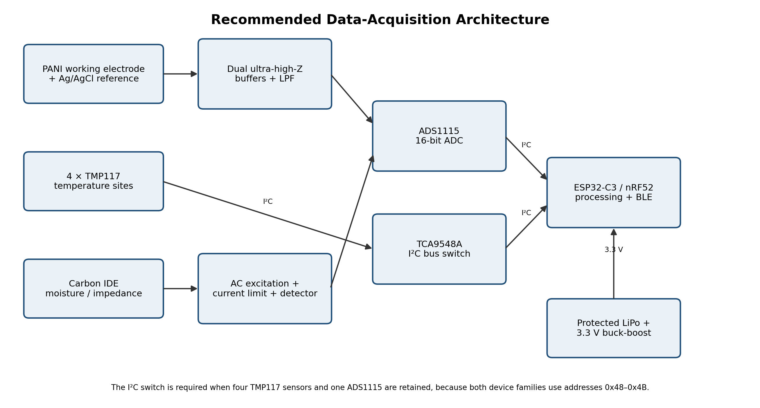
Figure 2. Recommended separation of pH, temperature and moisture acquisition paths.

4.1 PANI / Ag/AgCl pH Channel
Parameter | Week 07 design value / requirement | Engineering implication
Transduction | Potentiometric open-circuit voltage between PANI working electrode and Ag/AgCl reference | No excitation should be applied to the pH cell.
Expected sensitivity | Batch-dependent, approximately 50-60 mV per pH; theoretical Nernst magnitude is about 59.16 mV/pH at 25 degrees C | Use measured slope and intercept; do not assume a universal value.
Source impedance | Very high; potentially megaohm to gigaohm range | The electrode cannot directly drive a typical ADC input.
Analogue front end | Two ultra-high-input-impedance voltage followers, followed by low-pass filtering | Buffer both electrodes; the reference electrode is not circuit ground.
Digitization | ADS1115 differential input after buffering | Store raw millivolts, calibrated pH and a stability/drift flag.
Calibration | At least two buffers bracketing the range; preferably pH 4, 7 and 10 | Record temperature, stabilization time, slope, intercept, hysteresis and sensor batch.
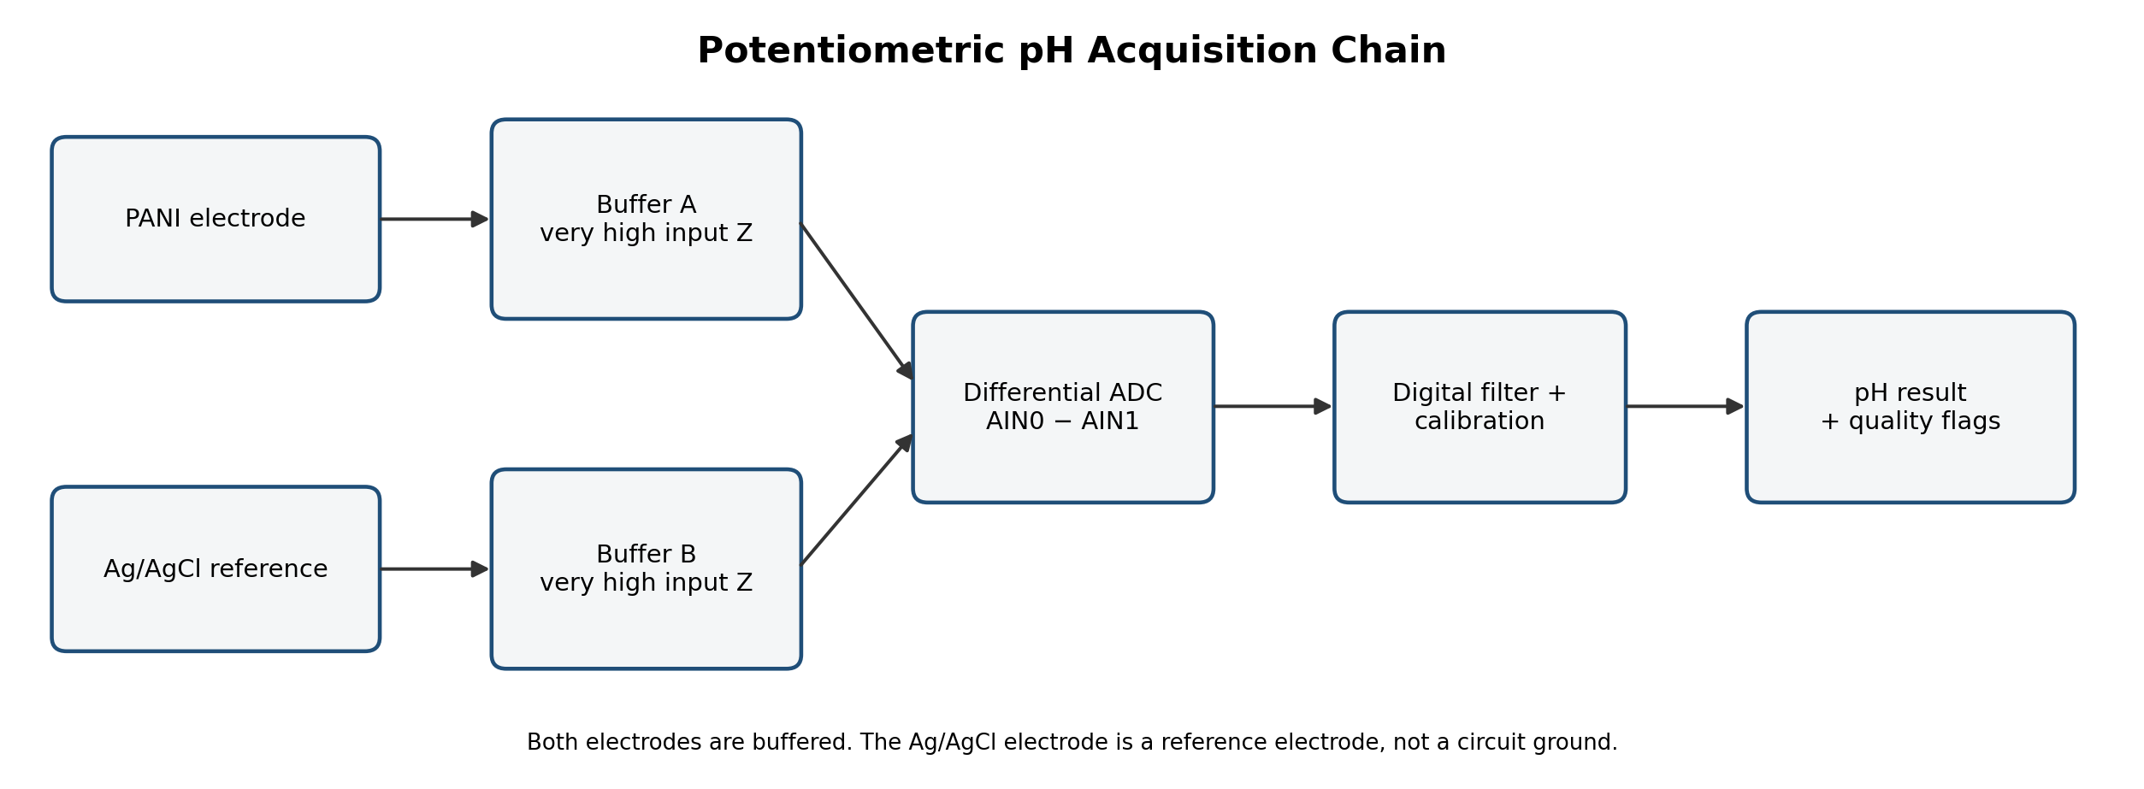
Figure 3. Differential high-impedance pH signal chain selected in Week 07.

4.2 TMP117 Temperature Channel
Parameter | Week 07 design value / requirement | Engineering implication
Interface | Digital I2C | No external analogue ADC channel is required.
Supply | 1.7-5.5 V device range; 3.3 V proposed system rail | Provide 100 nF local decoupling at each device.
Resolution | 16-bit register; 0.0078125 degrees C per LSB | Firmware must read signed two-complement data correctly.
Accuracy statement | TMP117 has high datasheet accuracy, but the assembled patch accuracy is not yet known | Encapsulation, contact pressure, thermal lag and local heating must be validated.
Array | Four spatial temperature sites | Calculate each site, maximum, minimum, spatial gradient and rate of change.
Addressing | Four TMP117 addresses overlap the ADS1115 address range | Use an I2C bus switch such as TCA9548A or separate buses.
Layout | Pull-ups and powered electronics away from sensing area | Reduce self-heating and thermal conduction from the reusable module.

4.3 Carbon IDE Moisture / Exudate Channel
Critical Week 07 correction: the ESP32-C3 does not have a true voltage-output DAC. More importantly, continuously applying DC across a wet ionic sensor can cause electrode polarization, electrochemical drift and material degradation. The moisture channel was therefore redesigned as a low-energy, zero-mean AC or biphasic measurement.
Parameter | Initial bench target | Reason
Excitation source | ESP32-C3 PWM or complementary GPIO, followed by attenuation and AC coupling | Provides alternating excitation without claiming a true DAC.
Frequency | Begin near 1 kHz; compare 100 Hz, 1 kHz, 5 kHz and 10 kHz during characterization | Select frequency from separation, repeatability and drift data.
Electrode amplitude | Small zero-mean waveform; final safe amplitude to be set by bench testing and safety review | Reduce electrochemical polarization and exposed current.
Current limiting | Series reference resistor, initially selectable among 100 kOhm, 470 kOhm and 1 MOhm | Prevents unrestricted GPIO current into a wet electrode.
Detection | Precision rectifier/envelope detector plus low-pass filter | Converts the AC response into a stable ADC-readable voltage.
Reported value | Raw detector voltage plus calibrated wetness/exudate index | Do not claim absolute moisture percentage without traceable calibration.
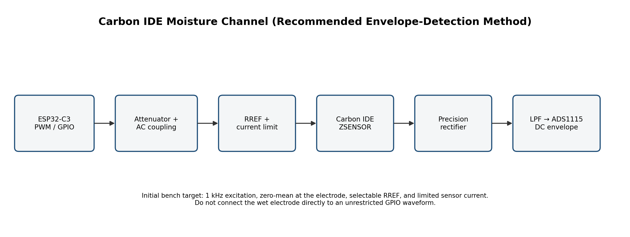
Figure 4. Recommended current-limited envelope-detection path for the carbon IDE moisture channel.

4.4 Consolidated Sensor Signal Matrix
Sensor | Raw signal | Excitation | Front end | DAQ / interface | Primary output
PANI pH | High-impedance differential DC voltage | None | Two high-Z buffers and LPF | ADS1115 differential | pH, raw mV, stability flag
TMP117 array | 16-bit digital temperature word | 3.3 V supply and I2C commands | Local decoupling and pull-ups | I2C through bus switch | Four site temperatures and spatial trends
Carbon IDE | Frequency-dependent impedance response | Low-energy zero-mean PWM/AC burst | Attenuator, coupling, RREF, rectifier and LPF | ADS1115 single-ended | Wetness index and raw envelope

5. Patch-to-Module Interface, Noise Control and Safety

5.1 Proposed 12-Pin Keyed Connector
Pin | Signal | Direction | Design note
1 | PANI_WORK | Patch to module | High-impedance input; guard and separate from clocks.
2 | AGAGCL_REF | Patch to module | High-impedance reference; not electronic ground.
3 | MOIST_A | Bidirectional | Current-limited excitation/sense electrode.
4 | MOIST_B | Bidirectional | Current-limited return/sense electrode.
5 | 3V3_SENSOR | Module to patch | Regulated sensor supply.
6 | GND_SENSOR | Shared return | Return for protected electronics only; must not be exposed to wound fluid.
7 | SDA_TMP | Bidirectional | TMP117 I2C data.
8 | SCL_TMP | Module to patch | TMP117 I2C clock.
9 | ALERT_TMP | Patch to module | Optional shared open-drain alert/data-ready.
10 | SHIELD_GUARD | Module to patch | Shield or driven guard; not a wound-contact conductor.
11 | PATCH_ID | Patch to module | Optional resistor/EEPROM identification or batch code.
12 | RESERVED | - | Future second moisture region or connector interlock.

5.2 Layout and Isolation Rules
- Place PANI_WORK and AGAGCL_REF at one side of the connector and route them away from PWM, SCL, BLE antenna and switching-regulator nodes.
- Place the pH buffers physically close to the connector to reduce leakage, cable noise and contamination-sensitive high-impedance trace length.
- Use a defined analogue ground and digital ground strategy on the reusable PCB, joining them at a controlled point after layout review rather than creating unrelated grounds.
- Switch the radio off during pH and moisture measurements where possible; acquire, average and store data before BLE transmission.
- Use series resistors/current limits on every waveform that can reach a wet electrode and verify the maximum possible electrode current under single-fault conditions.
- Provide mechanical strain relief so pulling the reusable cable cannot crack PANI, carbon or printed traces.
- Prevent the reusable connector contacts from touching the wound-facing surface; define a clean/dirty boundary in the mechanical design.

5.3 Prototype-Use Restriction
Mandatory restriction: Week 07 designs are for buffer solutions, saline, artificial wound fluid and dressing/tissue simulants. Do not apply the prototype to a patient, volunteer or open wound before ethics approval, biocompatibility testing, electrical-safety review, sterilization and infection-control validation, and medical supervision.

6. Integrated Week 07 Workflows
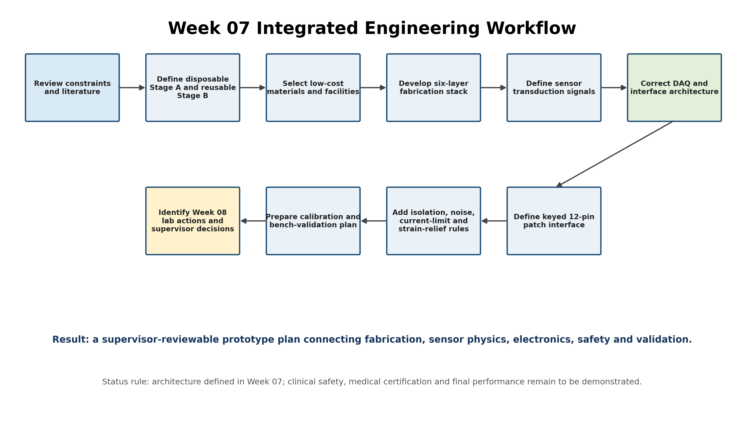
Figure 5. Week 07 workflow linking research constraints to a supervisor-reviewable implementation plan.

6.1 Detailed Fabrication Workflow for Week 08 Execution
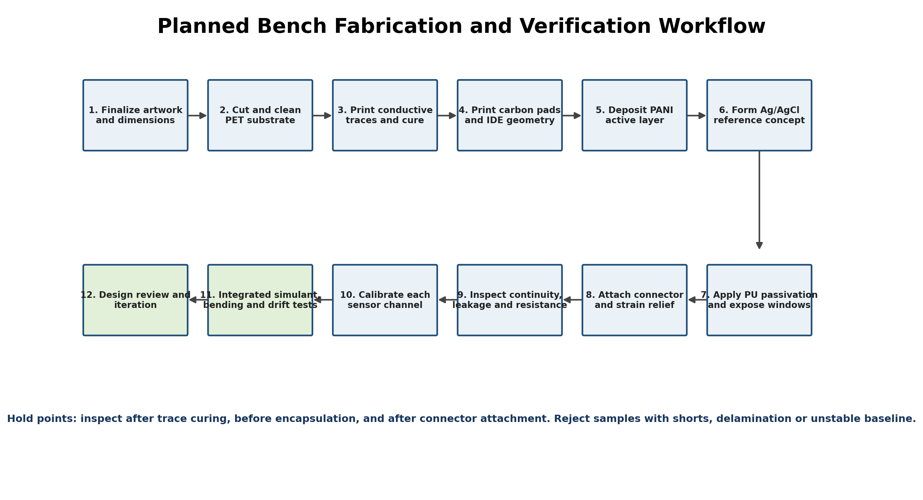
Figure 6. Planned bench fabrication, inspection and calibration sequence.

6.2 Sensor-to-Data Workflow
- Power up the reusable module and verify the protected 3.3 V rail before connecting the disposable patch.
- Read the patch identifier or confirm the sensor batch and calibration record.
- Disable BLE transmission and noisy switching activity where practical during precision measurement.
- Select the ADS1115 bus segment; read and average the buffered differential pH voltage.
- Generate a short current-limited moisture excitation burst, allow the envelope detector to settle, read the ADC and stop excitation.
- Select the TMP117 bus segment and read all four temperature sites.
- Apply sensor-specific calibration equations, calculate spatial or trend features and generate quality flags.
- Store raw values together with calibrated values, timestamp, battery voltage and error flags.
- Transmit a compact BLE packet, then return the system to a low-power state until the next sample interval.

7. Technical Decisions and Corrections Made in Week 07
Earlier assumption / risk | Week 07 correction | Reason and impact
ESP32-C3 internal DAC can directly excite the moisture IDE | Use PWM/complementary GPIO followed by attenuation, AC coupling and current limiting | ESP32-C3 has no true output DAC; the revised method also reduces DC polarization.
One ADC path can directly acquire all three sensors | Use separate pH, temperature and moisture signal chains | The sensors produce fundamentally different electrical outputs.
Connect Ag/AgCl reference to circuit ground | Buffer the reference electrode separately and measure differentially | A reference electrode is an electrochemical reference, not a ground node.
Use ADS1115 directly on PANI electrode | Insert ultra-high-input-impedance buffers before the ADC | Direct connection can load the electrode and cause drift/error.
Four TMP117 sensors and ADS1115 can share one simple I2C bus | Use an I2C bus switch or separate buses | Their selectable addresses overlap.
Datasheet sensor accuracy equals wound-surface system accuracy | Validate the complete encapsulated assembly | Thermal lag, contact, self-heating and packaging alter system performance.
Dry/wet output can be called moisture percentage | Initially report a calibrated wetness/exudate index and raw detector voltage | Absolute percentage needs mass/volume-based traceable calibration.
Preliminary material list proves the complete prototype is under USD 50 | Maintain the cost as a target pending complete BOM and quotations | Several major electronic, fabrication and logistics costs are missing.

8. Validation Plan and Evidence Required
Validation stage | Test method | Required evidence | Indicative acceptance decision
Electrical integrity | Continuity, short-circuit, leakage and supply-ripple tests | Measured resistance table, rail waveforms and inspection photographs | No short; stable rails; pH inputs do not show unacceptable leakage.
PANI material check | Colour, film adhesion and conductivity screening | Batch record, photos and repeat measurements | Uniform adherent film; no obvious delamination; conductivity adequate for sensing trials.
pH calibration | Fresh pH 4, 7 and 10 buffers with repeated centre point | Slope, intercept, R-squared, response time, hysteresis and drift | Slope and repeatability within a supervisor-approved project range.
Temperature calibration | Reference thermometer and controlled bath/surface points | Error per site, repeatability, lag and spatial consistency | Assembly-level error and lag documented; outliers corrected or rejected.
Moisture characterization | Controlled saline/wound-simulant additions and frequency sweep | Raw impedance/envelope, repeatability, hysteresis and saturation curves | Distinct, repeatable levels without excessive polarization or current.
Integrated cross-talk | All channels operating with BLE off/on | Comparison of pH/moisture/temperature readings across operating modes | No unacceptable radio, I2C or PWM-induced shift.
Mechanical reliability | Bend radius, repeated flex and connector cycling | Resistance and sensor output versus cycle count | No cracking, unstable connector contact or delamination.
Safety review | Maximum electrode current, exposed conductor and single-fault review | Circuit calculation and measured worst-case current | Supervisor approval before any advanced biological test.

8.1 Recommended Minimum Sample Plan
- Fabricate at least 10 carbon IDE specimens from one controlled batch to quantify manufacturing variability.
- Fabricate multiple PANI electrodes from the same synthesis batch and retain at least one unused reference sample.
- Repeat each calibration level at least three times and report mean, standard deviation, hysteresis and drift rather than a single best curve.
- Store raw data in CSV format with sample ID, fabrication batch, date, temperature, excitation frequency, reference resistor and calibration-fluid details.

9. Week 08 Action Plan
No. | Action | Deliverable | Owner / facility | Timing
1 | Freeze sensor geometry and connector-tail dimensions | Patch artwork, dimensioned drawing and screen/stencil files | Student + supervisor review | Before fabrication
2 | Confirm lab access and chemical safety procedure | Approved lab date, risk assessment, PPE and waste plan | UOP Chemistry / project team | Before PANI synthesis
3 | Obtain supplier quotations and stock confirmation | Updated complete BOM with unit price, quantity, delivery and alternatives | Project team | Early Week 08
4 | Assemble reusable DAQ on breakout boards first | Verified pH buffer, ADS1115, I2C switch and moisture detector | EEE laboratory | Before patch integration
5 | Fabricate first trace/carbon coupons | Continuity, line width, curing and bending results | Project team / printing facility | Week 08
6 | Synthesize or obtain PANI and prepare coating ink | Batch sheet, colour, mass, formulation and safety record | Chemistry laboratory | Week 08
7 | Run first pH and moisture calibration trials | Raw datasets and preliminary plots | Project team | After electrical verification
8 | Review results with supervisors | Approved changes for Version 2 fabrication | Dr. Ruwan and Dr. Anjali | End of Week 08

9.1 Decisions Requested from Supervisors
- Approve the Stage A / Stage B partition and confirm whether the four TMP117 devices should remain on the disposable patch or be implemented as a detachable reusable sensing strip.
- Approve the proposed pH reference-electrode development path and identify the minimum stability and leakage tests expected before integrated testing.
- Confirm the acceptable moisture-excitation current and voltage limits for the bench prototype.
- Confirm which materials may be used only for dry proof-of-concept testing and which are acceptable for artificial wound-fluid testing.
- Approve the minimum number of fabricated samples and repeated measurements required for the FYP evaluation.
- Confirm whether SLINTEC or another facility should be approached for screen printing, curing and material characterization.
- Review the revised full BOM before maintaining the below-USD-50 target in formal project presentations.

10. Supervisor Meeting Presentation Script
Suggested 3-4 minute verbal summary:
During Week 07, we moved from the literature-review stage to an integrated prototype design. First, we reviewed the fabrication plans and compared expensive cleanroom processes with methods that can be carried out using university laboratories and locally available materials. From this study, we prepared a six-layer prototype stack consisting of a flexible substrate, printed conductive traces, carbon sensing structures, a PANI pH layer, an Ag/AgCl reference concept and a PU passivation layer. We also separated the design into a disposable sensing patch and a reusable data-acquisition module.
Next, we finalized the electrical signal requirements of the three sensors. The PANI pH electrode is a very high-impedance potentiometric source, so both the working and reference electrodes must be buffered before differential ADC measurement. The TMP117 temperature sensors provide digital I2C data, but the four TMP117 addresses overlap the ADS1115 addresses, so an I2C bus switch or separate bus is required.
The most important correction this week was in the moisture channel. We confirmed that the ESP32-C3 does not contain a true voltage-output DAC, and we also recognized that applying continuous DC to a wet ionic electrode would create polarization and drift. Therefore, we changed the design to a small zero-mean PWM or biphasic excitation with attenuation, AC coupling, a current-limiting resistor and an envelope detector.
We then defined a keyed 12-pin connector between the patch and the reusable module. The connector separates the high-impedance pH signals from PWM and I2C lines and includes provisions for strain relief, shielding and patch identification. Finally, we prepared a Week 08 plan covering artwork finalization, lab access, PANI synthesis, trace and carbon coupon fabrication, reusable DAQ testing and the first calibration experiments. At this stage, the architecture is defined, but the below-USD-50 cost, medical material suitability and final sensor accuracy still require quotation and laboratory evidence. We request supervisor approval for the architecture, reference-electrode route, sample numbers and laboratory testing sequence.

10.1 Key Points to Emphasize During Discussion
- The moisture DAC correction demonstrates a hardware-level redesign based on the actual microcontroller capability and electrochemical safety considerations.
- The proposed system does not force all sensors into one circuit; each channel has a front end matched to its signal physics.
- The under-USD-50 objective is still a target, not a confirmed result, and a complete BOM will be prepared before repeating the claim.
- Week 08 is structured around measurable evidence: raw data, waveforms, calibration equations, repeatability, drift and mechanical reliability.

Appendix A - Week 07 Deliverables Prepared
Deliverable | Status | Use
Fabrication method comparison sheets | Completed | Selection of accessible materials, tools and fallback routes.
Six-layer patch stack | Completed at prototype level | Guides artwork and fabrication order.
Preliminary BOM and local sourcing map | Completed but incomplete in cost coverage | Used for quotation and procurement planning.
Complete sensor signal parameter document | Completed | Defines electrical interfaces, conversion, calibration and safety limitations.
Recommended system architecture diagram | Completed | Supervisor review and reusable-module design.
pH acquisition-chain diagram | Completed | Analogue front-end implementation.
Moisture acquisition-chain diagram | Completed | AC/PWM excitation and detector implementation.
12-pin connector pinout | Completed at architecture level | Mechanical/electrical interface design.
Week 08 fabrication and validation workflow | Completed | Laboratory execution plan.

Appendix B - Risks to Track in the Project Log
Risk | Consequence | Mitigation / evidence required
PANI batch variability | Different slope, offset, response time and drift | Standardize synthesis/coating, label batches, calibrate each sample.
Reference-electrode instability or silver leakage | Incorrect pH and material-safety concern | Define membrane/contact layer; perform soak, drift and leakage assessment.
Printed-trace cracking | Intermittent readings under bending | Use strain relief, flex coupons and repeated bend tests.
Moisture polarization and corrosion | Drift and electrode degradation | Zero-mean burst excitation, current limiting and wet/dry cycling.
Temperature thermal lag | Delayed or biased wound-surface result | Thin validated encapsulation and assembly-level calibration.
I2C address conflict | Missing devices or bus failure | Use bus switch or separated buses and verify every address.
Radio/switching noise | pH and moisture measurement error | Measure with radio off; filtering, layout separation and controlled grounding.
Incomplete cost calculation | Unreliable budget claim | Complete quantity-based BOM with supplier quotations and contingency.
Use of non-medical prototype materials | Unsafe interpretation of proof-of-concept | Restrict to bench simulants and clearly label material-development stages.

