WEEK 8
FULL PROGRESS REPORT
Smart Sensor-Based Monitoring of Chronic Diabetic Wounds
Dataset construction • exploratory machine learning • journal-manuscript revision
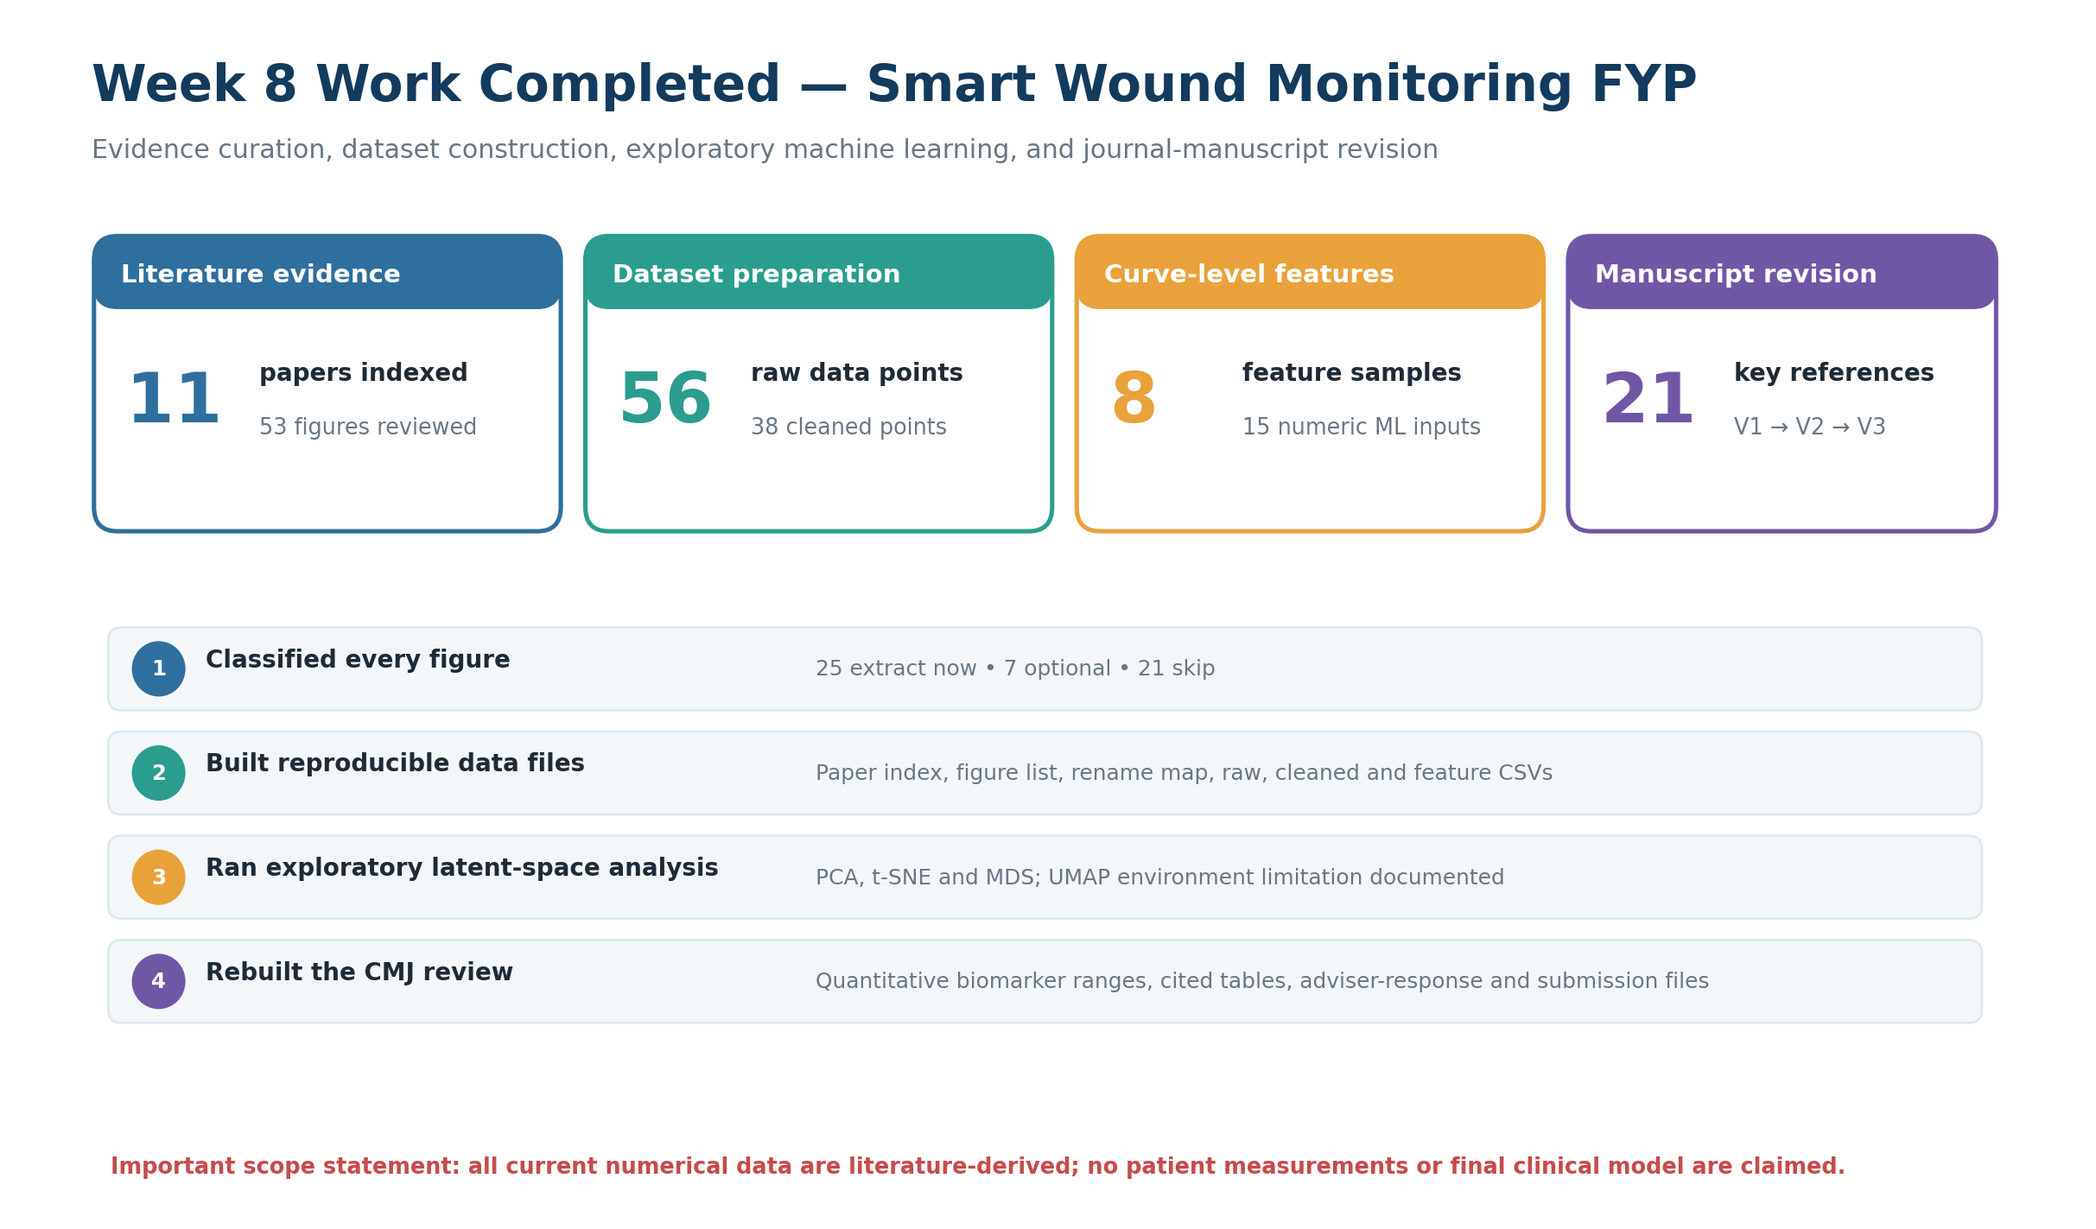
Cover evidence summary generated from the files contained in WEEK8.zip.
Prepared by | H.M.V.V.W. Wickrama (Vikum Vichakshana) and project team
Project team | H.M.V.V.W. Wickrama; K.K.G.T. Gimhani; V.S. Jayaweera
Supervisor | Dr. Ruwan Ranaweera
Institution | Department of Electrical and Electronic Engineering, Faculty of Engineering, University of Peradeniya
Report date | 12 July 2026

Purpose of this report
This document consolidates and explains all substantive work found in the uploaded WEEK8.zip. It is written for supervisor review and shows what was completed, what the current results mean, which claims are safe to make, and what must be done next. The archive contains two connected Week 8 workstreams: (1) preparation of a literature-derived wound-monitoring dataset and exploratory dimensionality-reduction pipeline, and (2) correction and strengthening of a Ceylon Medical Journal structured narrative review.
Scope boundary
The ZIP does not contain new patient measurements, wound-sensor prototype measurements, wet-laboratory results, or a validated clinical machine-learning model. Every numerical dataset in this report was transcribed or digitised from published literature and must be presented as preliminary method-development evidence.

Report contents
- 1. Executive summary and Week 8 achievements
- 2. Archive inventory and evidence reviewed
- 3. Literature-derived dataset construction
- 4. Cleaned trajectories and feature engineering
- 5. Exploratory PCA, t-SNE, MDS and model-planning work
- 6. Ceylon Medical Journal manuscript revision
- 7. Integrated Week 8 workflow
- 8. Limitations, supervisor decisions and Week 9 action plan
- Appendix: key files and supervisor-ready talking points

1. Executive summary
Week 8 converted a large, unstructured collection of research papers, cropped figures, draft manuscripts and analysis packages into a traceable working evidence base. The main achievement was not a final predictive model; it was the construction of a reproducible pipeline that can now be expanded using additional published curves and, later, real sensor measurements after ethics and validation procedures are in place.
Area | Week 8 result
Literature base | 11 papers indexed with topic, target parameters, wound type, sensor type, DOI/URL, priority and notes.
Figure triage | 53 figures classified: 25 selected for extraction, 7 optional, and 21 excluded as unsuitable for numerical analysis.
Data transcription | Five clear published tables transcribed; 56 raw data rows created.
Cleaned dataset | 38 tidy time-series rows organised into 8 curve-level samples.
Feature engineering | A 28-column feature table produced; 15 numerical features used for dimensionality reduction.
Exploratory analysis | PCA, t-SNE and MDS outputs generated; PCA PC1+PC2 explained approximately 90.8% of variance.
Model planning | Random Forest identified as a future nonlinear baseline, but no current diagnostic accuracy is claimed.
Journal review | CMJ manuscript progressed through V1, V2 and V3; V3 contains 21 key references, quantitative biomarker ranges and a formal response to adviser feedback.

What the supervisor should understand immediately
- The project now has an organised literature-to-data workflow rather than isolated papers and screenshots.
- The current dataset is sufficient to demonstrate data handling, feature extraction and latent-space visualisation, but it is too small and heterogeneous for a reliable supervised clinical model.
- The analysis consistently groups curves by parameter type; this is encouraging evidence that the features capture trajectory differences, but it is not evidence of diagnostic performance.
- The journal manuscript was corrected to remain a pure structured narrative review and strengthened using quantitative pH, temperature and moisture interpretation.
- The next priority is additional high-quality curve digitisation, followed by a clear separation between literature-derived method development and future hardware/clinical validation data.
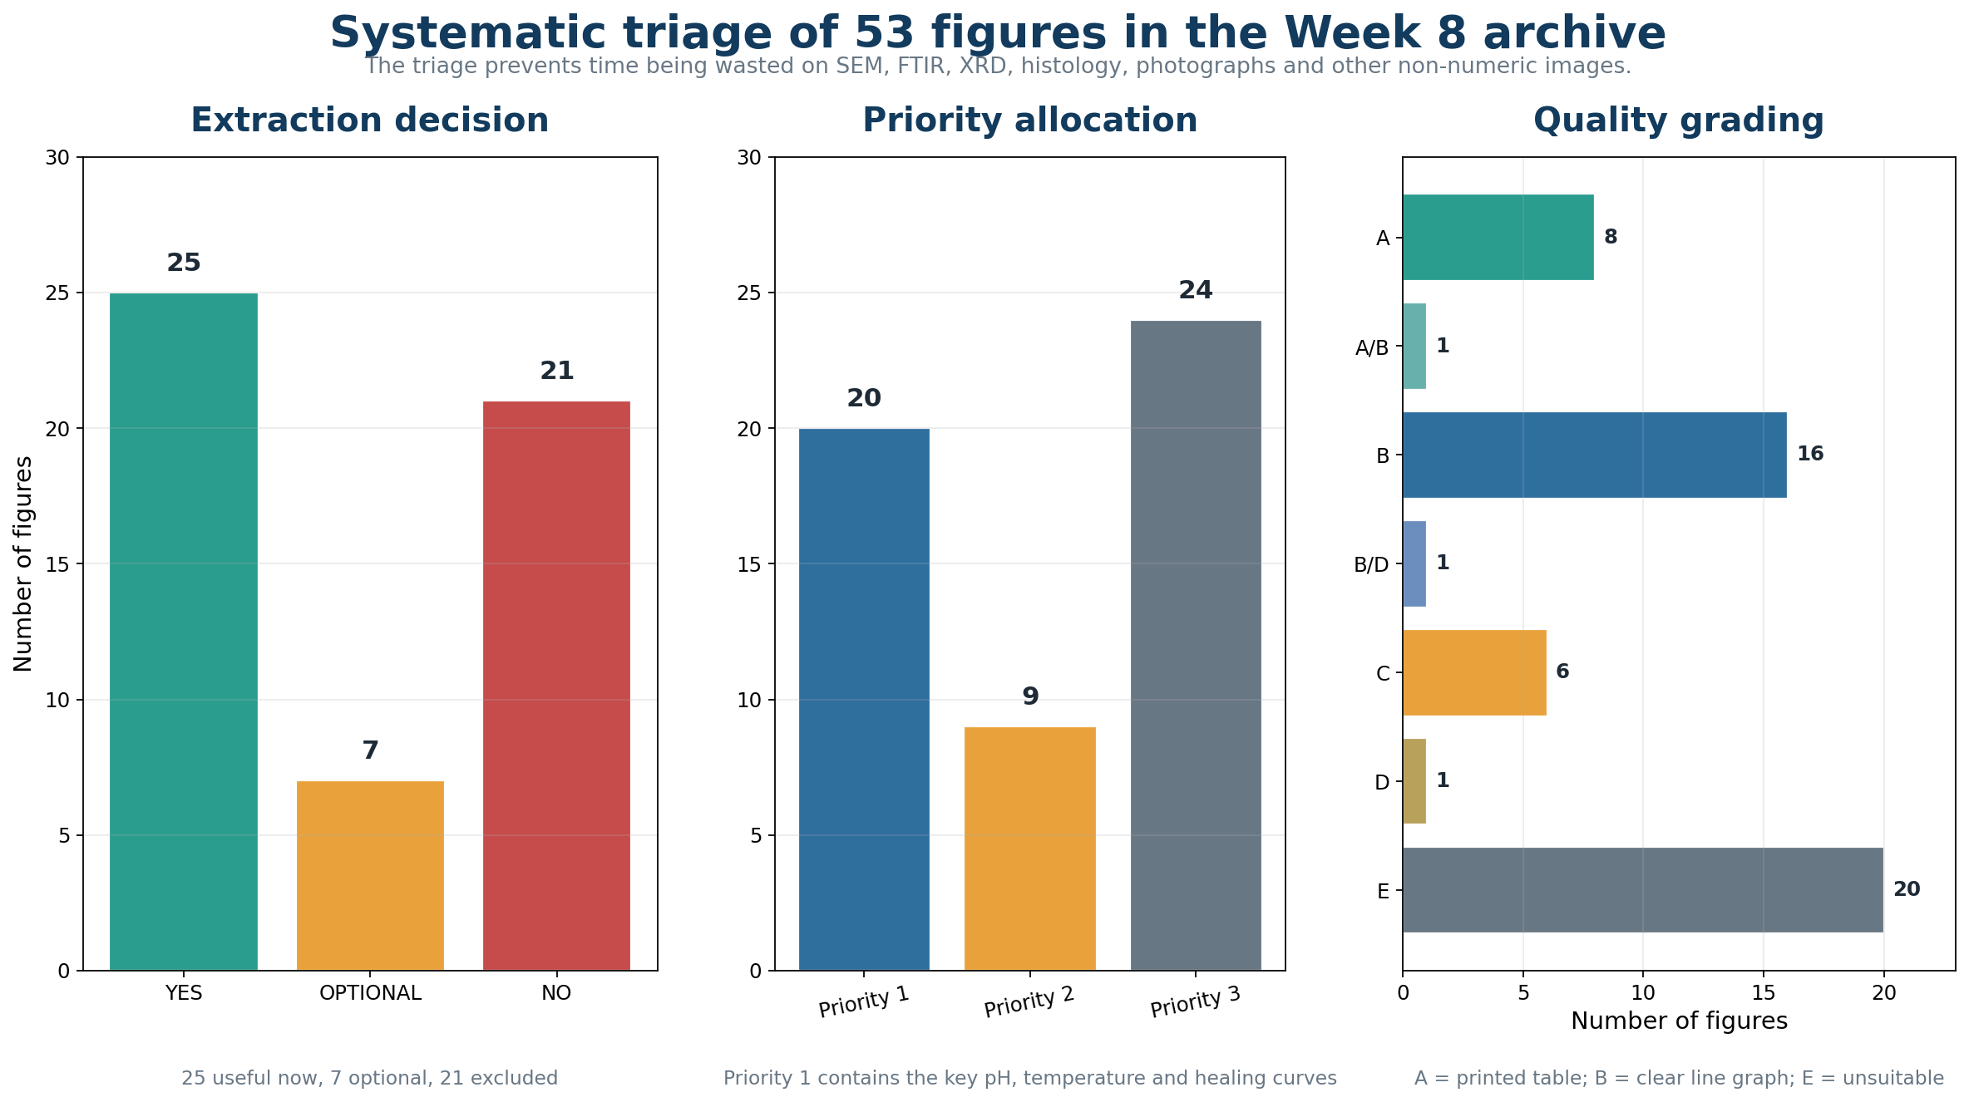
Figure 1. Systematic classification, priority assignment and quality grading of all 53 figures in the archive.

2. Archive inventory and evidence reviewed
The uploaded ZIP contains 190 files with an uncompressed size of approximately 193.8 MB. It includes 89 PNG images, 22 CSV files, 16 Word documents, 13 PDFs, 10 nested ZIP packages, two Excel workbooks, Overleaf/LaTeX sources and supporting readme files. Several packages contain duplicated exports of the same dataset or manuscript version, which is useful for traceability but should later be simplified under version control.
Work package | Main folder/package | Evidence contained
Dataset preparation | DATASET_PREPARED_RENAMED and WoundDataset_Organized | Paper PDFs, renamed figures, master workbook, raw/cleaned/feature CSVs and instructions.
ML pipeline | FYP_Wound_ML_Analysis_Package | Dataset summary, plots, embeddings, method report, model-planning files and reusable script.
Dimensionality reduction | Dimensionality_Reduction_PCA_tSNE_UMAP_MDS | PCA, t-SNE, MDS and UMAP-labelled fallback coordinates, plots and loadings.
Latent-space presentation | Latent_Space_Visualisation_PCA_tSNE_UMAP | Static comparison, animation frames, GIF, HTML visualisation and combined coordinates.
Manifold CSV package | Manifold_Learning_CSV_Files | Scaled input, PCA/MDS/Isomap outputs and instructions for generating true UMAP later.
CMJ manuscript V1 | CMJ_Submission_Package_With_Authors | Initial author/anonymised Word package, title page, cover letter, checklist and figure.
CMJ manuscript V2 | CMJ_Pure_Review_All_Files | Corrected pure structured narrative review in Word and Overleaf formats.
CMJ manuscript V3 | CMJ_Advisor_Rebuilt_All_Files | Adviser-rebuilt manuscript, 21-reference evidence set, response document, checklist and proof PDF.

Evidence-management improvement achieved
- Every paper was assigned a stable paper ID, such as Zhang_2022, Ryu_2024 and Liu_2024_DFU.
- Every cropped figure was mapped from its original filename to a clear new filename that identifies paper, crop number, parameter and chart type.
- Extraction suitability, priority, quality grade and recommended method were recorded before digitisation.
- The dataset includes separate raw, cleaned and feature-level files so future edits can be traced and reproduced.
- Readme files explicitly warn that the dataset is literature-derived and not collected patient data.

3. Literature-derived dataset construction

3.1 Paper indexing
The paper index contains 11 studies selected around wound pH, temperature, wound area, healing, granulation, bacterial response and smart dressing technologies. The strongest numerical sources were prioritised, while review-only and material-characterisation papers were marked as lower priority.
Source | Main evidence | Priority | Use in Week 8
Zhang 2022 | pH + temperature smart dressing | Priority 1 | In-vivo infected/uninfected trajectories and pH-voltage calibration.
Ryu 2024 | Wireless temperature/thermal transport | Priority 1 | Multi-sensor temperature and thermal-response curves.
Zhang 2021 | Flexible infection-prediction temperature platform | Priority 1 | Temperature trajectories for different bacterial conditions.
Liu 2024 DFU | Clinical wound temperature monitoring | Priority 1 | 29-patient characteristics and temperature-versus-time tables.
Srivastava 2022 | NPWT thermometry and healing | Priority 1 | Wound size, healing percentage, granulation and temperature tables.
McArdle 2023 | pH and bacterial survival | Priority 1 | Printed pH-versus-bacterial-survival table.
Ju 2024 / AlGhezi 2022 | Dressing-related wound healing | Priority 2 | Useful wound-healing/wound-area curves; much material data excluded.
Chen 2023 / Khan 2004 | Review or off-target perfusion evidence | Priority 3 | Retained for context; largely excluded from the core numerical dataset.

3.2 Figure triage and digitisation plan
The 53 figures were not treated equally. The classification step prevents time being spent on images that cannot produce valid time-series or calibration data. The final triage was:
- 25 figures marked YES for extraction.
- 7 figures marked OPTIONAL because they are useful but not central to pH, temperature or healing trajectories.
- 21 figures marked NO because they are SEM, FTIR, XRD, histology, photographs, schematics or otherwise unsuitable for numerical curve extraction.
- 20 Priority-1 figures, 9 Priority-2 figures and 24 Priority-3 figures.
- Quality grades: 8 A-grade printed tables; 16 B-grade line graphs; 6 C-grade bar charts; the remaining figures were mixed, colour-map or unsuitable grades.
Priority digitisation order
The archive recommends starting with Zhang 2022 pH/temperature infected-versus-uninfected trajectories, Zhang 2022 pH-voltage calibration, Zhang 2021 infection-temperature curves, Ryu 2024 diabetic temperature curves, and the AlGhezi/Ju wound-healing curves.

3.3 Data files created
File | Current size | Purpose
01_Paper_Index.csv | 11 rows | Study-level metadata and scientific relevance.
02_Figure_List.csv | 53 rows | Figure type, axes, parameter, condition, extraction decision, priority and quality.
03_Rename_Map.csv | 53 rows | Traceable mapping from original images to standardised names.
04_Raw_Digitized_Data.csv | 56 rows | Directly transcribed or digitised literature points.
05_Cleaned_TimeSeries.csv | 38 rows | Tidy one-row-per-point curves with sample IDs S001–S008.
06_Feature_Table.csv | 8 rows × 28 columns | Curve-level metadata and calculated ML features.
Master Excel workbook | 8 sheets | Integrated workbook containing index, figure list, raw data, cleaned data, feature calculations and instructions.

3.4 Eight completed curve samples
Sample | Parameter | Condition/site | Literature-derived trajectory
S001 | Wound area | NPWT | 20.46 → 4.21 cm² over 21 days
S002 | Wound area | Conventional dressing | 19.87 → 10.53 cm² over 21 days
S003 | Healing percentage | NPWT | 0 → 79.42% by day 21
S004 | Healing percentage | Conventional dressing | 0 → 47.00% by day 21
S005 | Granulation tissue | NPWT | 1.39 → 4.47 cm²
S006 | Granulation tissue | Conventional dressing | 1.40 → 3.43 cm²
S007 | Temperature | Wound centre | 35.3 → 36.3 °C over the encoded follow-up period
S008 | Temperature | Distal tibia | 35.4 → 36.3 °C over the encoded follow-up period

Preliminary pattern observed: within the transcribed Srivastava dataset, the NPWT group shows a larger wound-area reduction and higher healing percentage than conventional dressing by day 21. This is a finding from the cited source data and must not be presented as a new clinical experiment performed by the project team.
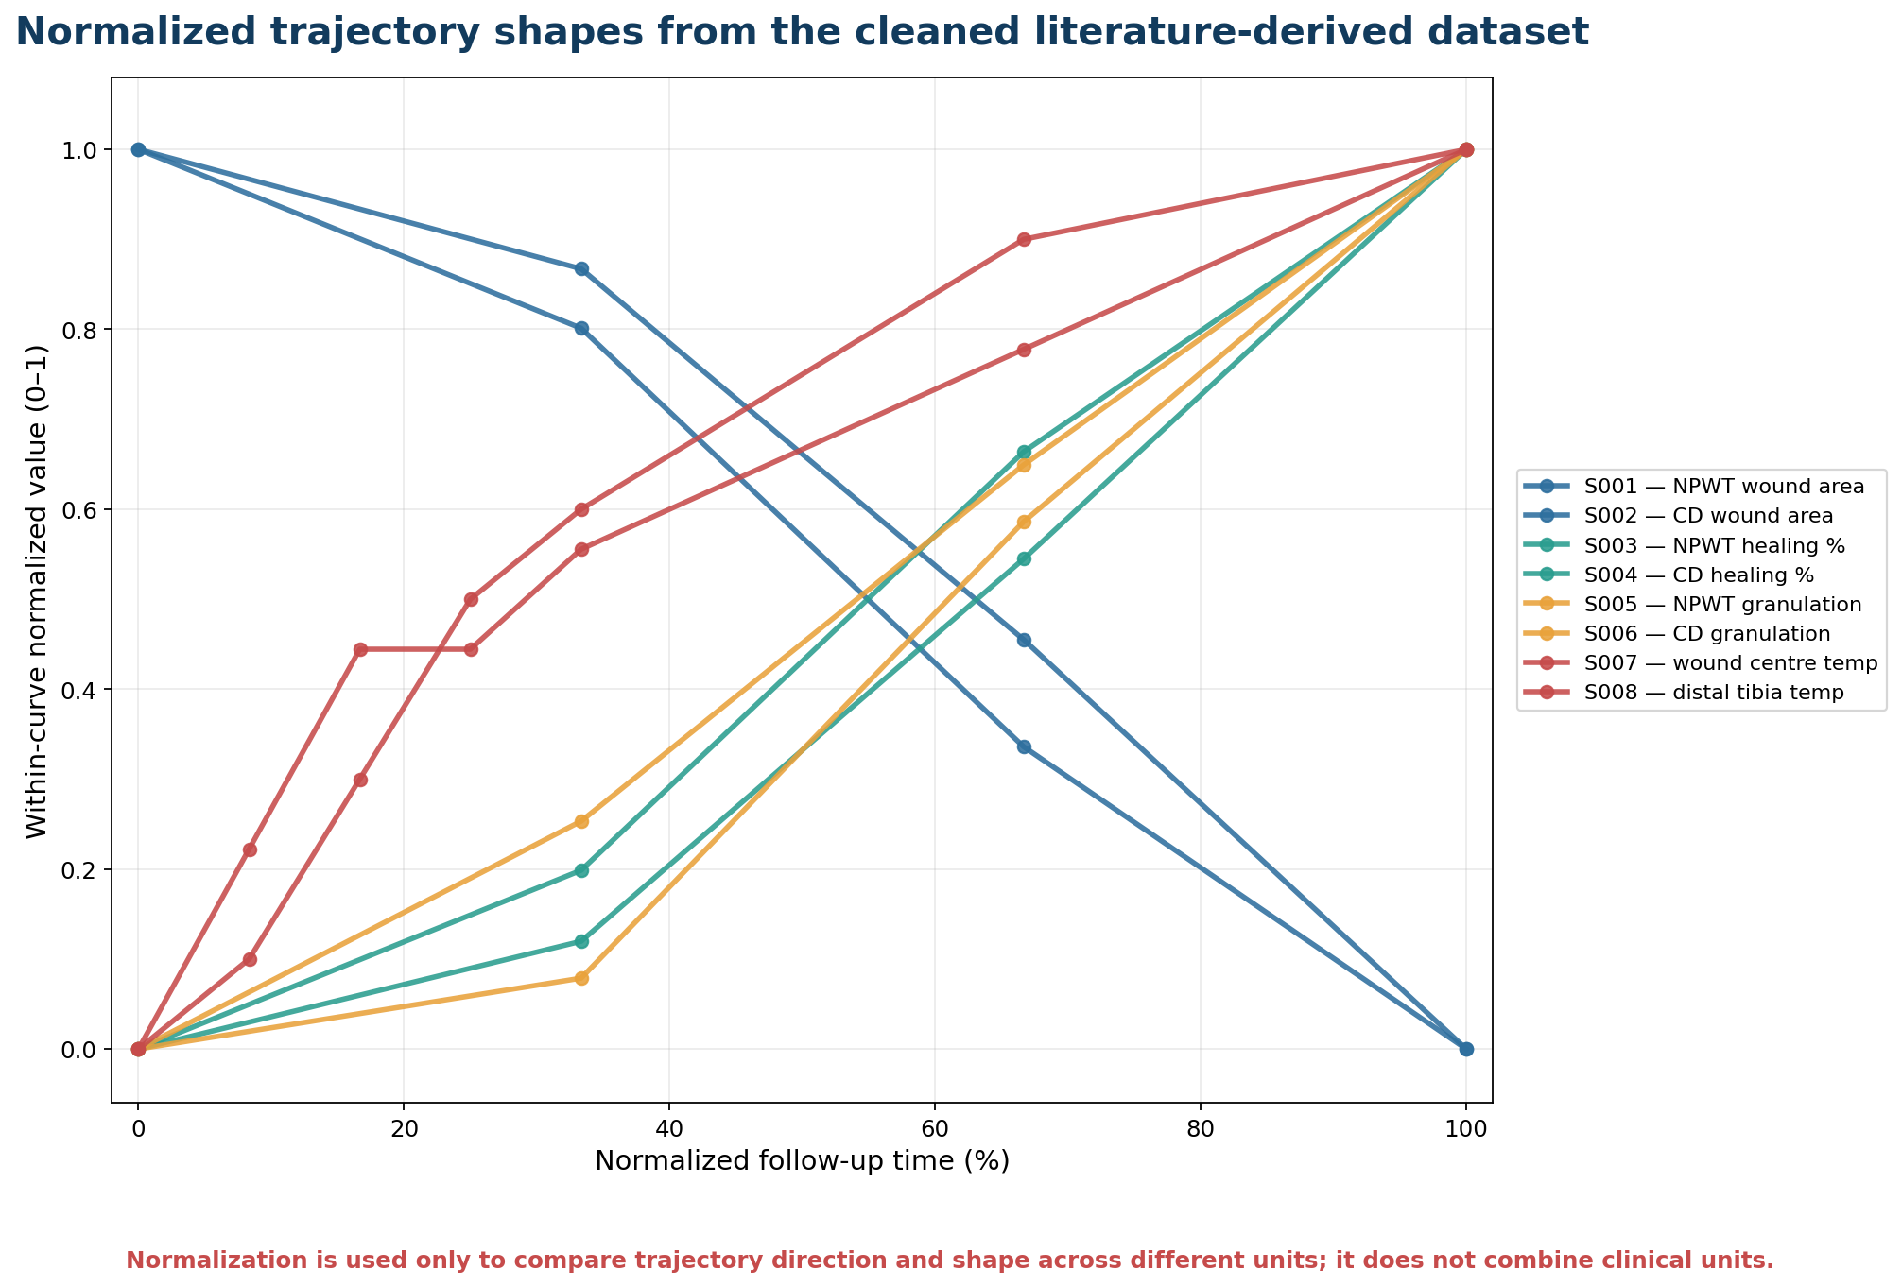
Figure 2. Normalised shapes of the eight cleaned curves. Normalisation allows comparison of direction and shape across mixed units only.

4. Feature engineering and exploratory analysis

4.1 Curve-level feature table
Each cleaned curve was converted into one feature row. This transforms variable-length time-series into a fixed-length matrix suitable for dimensionality reduction and later supervised modelling. The table contains metadata plus calculated descriptors.
Feature group | Variables | Interpretation
Curve structure | n_points, x_start, x_end, x_span | How long and how densely the curve was sampled.
Starting/ending state | y_start, y_end | Initial and final wound-related value.
Distribution | y_min, y_max, y_mean, y_std, y_range | Magnitude, spread and variability.
Change | total_change, slope | Direction and speed of change.
Integrated response | AUC | Overall accumulated response across time.
Timing | time_to_peak and pH-threshold fields | When important events occur; pH fields are currently empty because no pH curve samples have yet been cleaned.

4.2 Dimensionality-reduction work completed
Method | Status | Week 8 output | Safe interpretation
PCA | Completed | Linear overview; PC1=50.5%, PC2=40.3%, total ≈90.8%. | Best first method for explaining dominant feature variation.
t-SNE | Completed with perplexity 3 | Local-neighbourhood visualisation for eight samples. | Presentation only; coordinates and global distances are not stable clinical measures.
MDS | Completed | Distance-based representation of curve-feature similarity. | Useful to compare relative similarity of trajectories.
UMAP | Not treated as fully completed | One package uses Spectral Embedding as a small-dataset fallback; another provides instructions for true UMAP. | Install umap-learn and rerun after the sample set is larger.
Isomap | Available as fallback | Nonlinear manifold alternative in the analysis package. | Exploratory only.

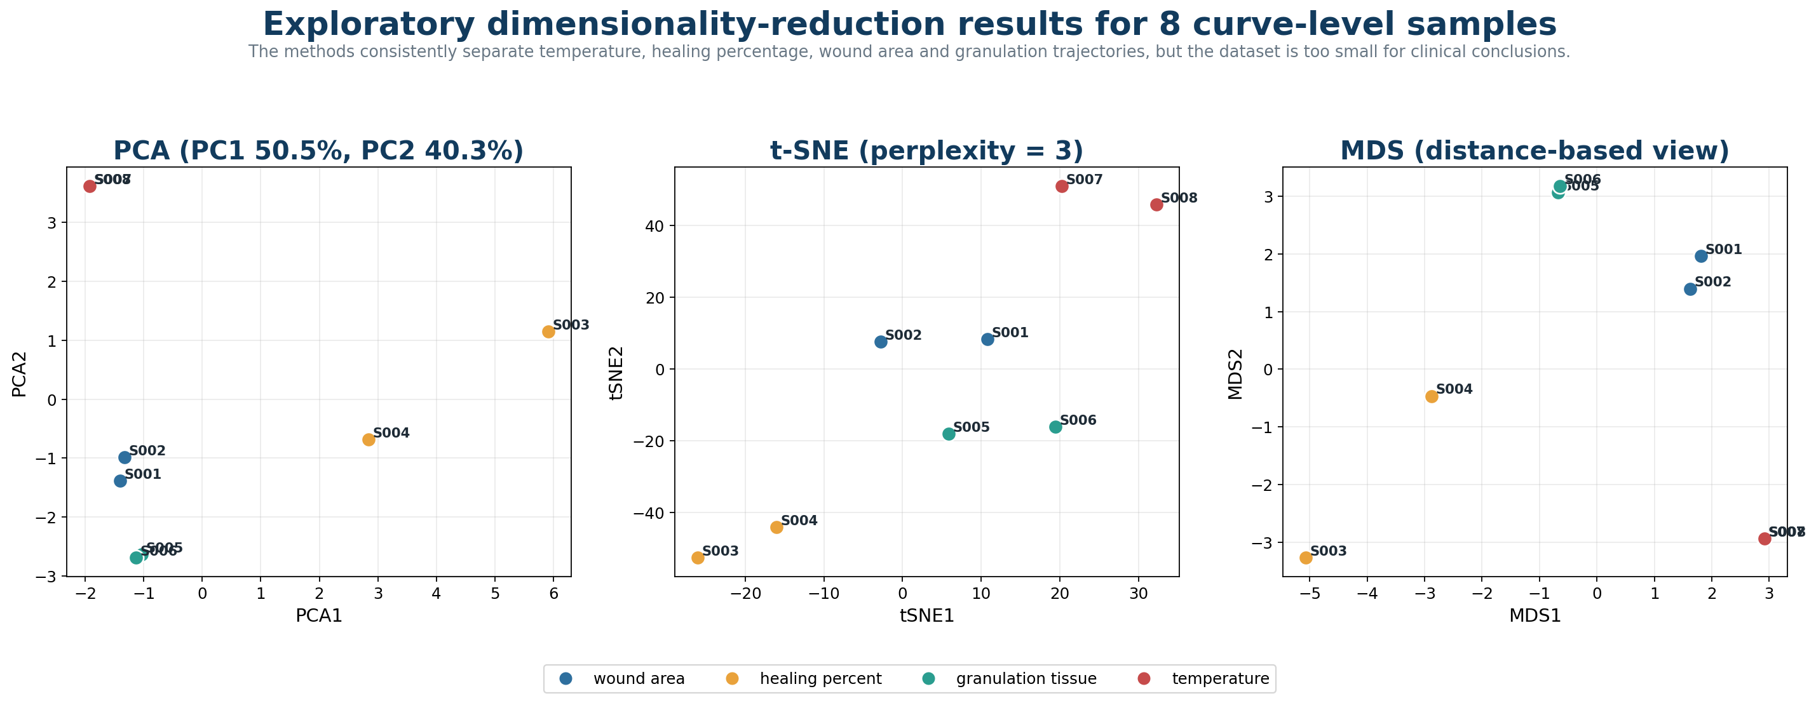
Figure 3. PCA, t-SNE and MDS views generated from the eight curve-level samples.

4.3 Interpretation of the exploratory plots
- Temperature samples S007 and S008 are almost identical in PCA and MDS space, reflecting very similar trajectories and feature values.
- Granulation samples S005 and S006 also remain close, showing that the feature extraction preserves their similarity.
- Healing-percentage samples are separated from wound-area and temperature curves because their ranges, slopes and total changes differ strongly.
- PCA loadings indicate that PC1 is strongly influenced by y standard deviation, y range, total change and slope, while PC2 is influenced by mean/minimum values and curve-span/sample-count terms.
- The apparent four-parameter grouping is technically useful for checking the pipeline, but eight samples are insufficient for a valid clustering or classification claim.

4.4 Model-planning work
The archive includes demonstration tests for Linear Regression, Ridge, Decision Tree, Random Forest Regressor and RBF-SVR, plus a recommendation to use Random Forest as the first serious nonlinear baseline after the dataset is expanded. The demonstration error values should not be reported as model performance because the target combines heterogeneous parameters and the dataset contains only eight feature rows.
Recommended future modelling sequence
Sensor calibration: linear/polynomial regression. Exploratory structure: PCA first, then true UMAP/t-SNE and MDS. Wound-status classification after sufficient labelled data: Random Forest compared against SVM-RBF and Logistic Regression. Healing/outcome prediction: Random Forest Regressor compared with Ridge/linear baselines.

5. Ceylon Medical Journal manuscript revision
The second major Week 8 workstream was the revision of the manuscript on smart wound monitoring. Three versions are preserved in the archive so the development path and the response to feedback are transparent.
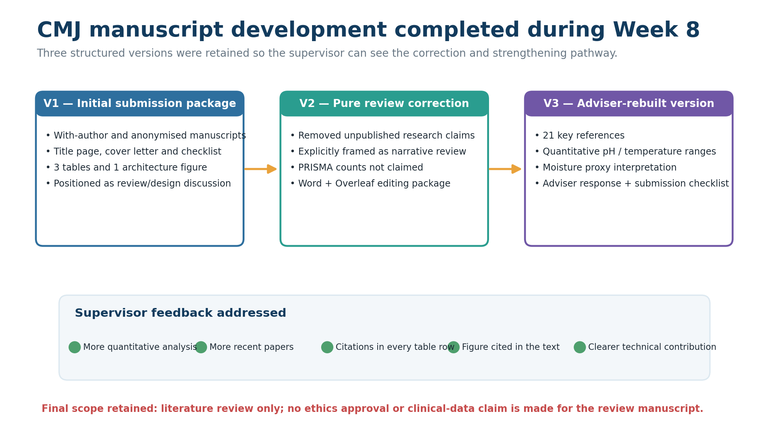
Figure 4. Development of the CMJ manuscript from the initial submission package to the adviser-rebuilt quantitative review.

5.1 Version-by-version development
Version | Main work completed
V1 — Initial submission package | Prepared with-author and anonymised manuscripts, title page, cover letter, comments-to-editor text and compliance checklist. Included three tables and one architecture figure.
V2 — Pure review correction | Corrected the article framing so it does not present unpublished project findings or original clinical claims. Explicitly retained it as a structured narrative literature review and avoided unsupported PRISMA counts.
V3 — Adviser-rebuilt version | Revised title and focus around quantitative interpretation of pH, temperature and moisture biomarkers; expanded to 21 references; added adviser-response and submission-checklist documents; rebuilt evidence-to-interpretation workflow.

5.2 Adviser feedback addressed
Supervisor/adviser comment | Revision made
Need more quantitative analysis | Added a quantitative biomarker table covering pH, temperature and moisture/exudate interpretation.
Need more and newer papers | Expanded the evidence base to 21 key references, including 11 references from 2023–2025 as recorded in the manuscript.
Tables must cite papers | Citations inserted into every table row.
Figure not mentioned in text | Rebuilt the figure and cited it in the Introduction, Results and Discussion.
Technical contribution unclear | Reframed the review around multimodal, trend-based quantitative interpretation while avoiding unpublished project claims.

5.3 Quantitative ranges included in the revised review
Range/proxy | Interpretation used in V3
pH 4.0–6.5 | Generally described as compatible with intact or healing skin/wound environments.
pH 6.5–7.0 | Transition zone requiring trend monitoring and multimodal context.
pH 7.0–9.0 | Frequently associated in the reviewed literature with chronicity, bacterial activity or delayed healing.
Temperature <33 °C | May indicate impaired repair or low-perfusion context in the reviewed evidence.
Approximately 37.5–38.5 °C | Examples reported in infection/inflammation models; not a universal standalone diagnostic threshold.
Temperature difference ≈2.2 °C | A warning difference proposed in reviewed literature; trajectory and adjacent-skin comparison remain important.
Moisture/exudate | No universal clinical numeric range; impedance, resistance, capacitance and thermal transport are treated as device-specific proxies.

Clinical interpretation principle
The V3 manuscript correctly emphasises that trends and agreement between pH, temperature and moisture are more useful than one isolated measurement. These parameters support clinician review and dressing decisions; they should not be described as autonomous infection diagnosis.

5.4 Submission items still requiring confirmation
- Confirm final author spelling, order and affiliations.
- Insert the corresponding author’s postal address, email and telephone number.
- Verify the final main-text word count and article category required by the journal.
- Confirm funding, conflict-of-interest and author-contribution statements.
- Use the anonymised manuscript for blinded review if required by the submission system.
- Do not add a PRISMA numerical flow diagram unless an exact reproducible search-and-screening log is completed.

6. Integrated Week 8 workflow
The following flowchart shows how the dataset/ML and manuscript workstreams were carried out in parallel and then combined into a supervisor-ready Week 8 deliverable.
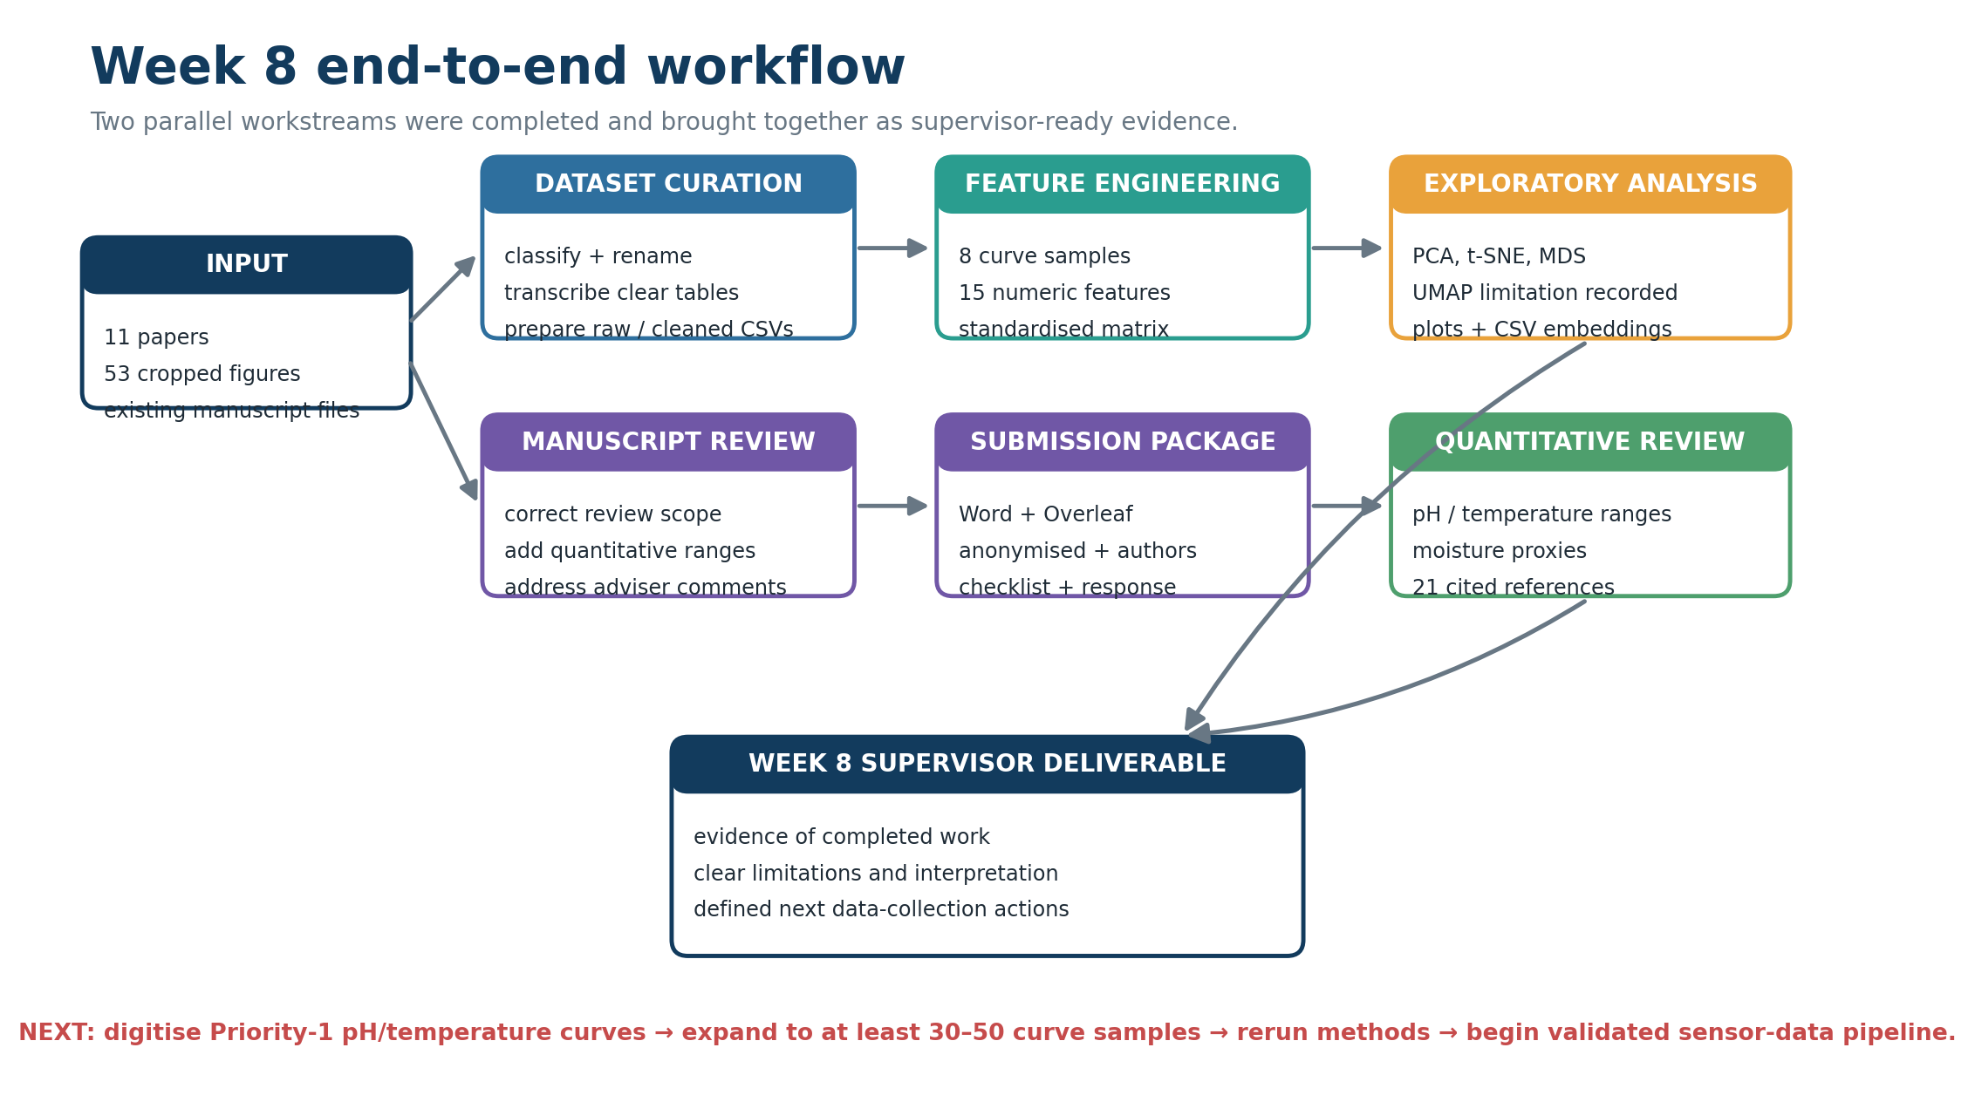
Flowchart. End-to-end Week 8 work completed from literature inputs to dataset, exploratory analysis and revised manuscript deliverables.

Why these two workstreams belong together
- The literature review identifies clinically relevant parameters and sensor principles.
- The data-curation workflow converts published quantitative evidence into a structured learning dataset.
- Feature engineering and dimensionality reduction test whether the extracted trajectories can be represented meaningfully.
- The manuscript provides the clinical and engineering interpretation needed to prevent overclaiming the exploratory analysis.
- Future sensor measurements can later enter the same data architecture, but must be kept separate from literature-derived data and validated independently.

7. Limitations and quality-control findings
Limitation | Implication for reporting and next work
Small sample size | Only 8 curve-level feature samples are available. PCA visualisation is possible, but supervised modelling and cluster validation are not reliable.
Heterogeneous units | Wound area, healing percentage, granulation and temperature are different clinical quantities. They should not share one unqualified prediction target.
Literature-derived observations | The data are copied or digitised from published studies with different populations, protocols and devices; they are not a single harmonised cohort.
Digitisation incomplete | Many Priority-1 pH and temperature line graphs are classified but not yet converted into cleaned time-series samples.
UMAP limitation | A spectral-embedding fallback is labelled as the UMAP view in one package. True UMAP should be rerun using umap-learn after expansion.
Potential package duplication | Multiple ZIPs and repeated output copies increase the risk of editing an outdated version. A single controlled repository should become the source of truth.
Clinical validity | No result in the archive proves infection detection accuracy, dressing-change accuracy or patient outcome prediction.

8. Recommended Week 9 action plan
- Digitise the highest-value pH and temperature curves first: Zhang 2022 infected/uninfected pH-temperature trajectories and pH-voltage calibration, followed by Zhang 2021 and Ryu 2024 temperature curves.
- Assign new sample IDs S009 onward and preserve raw WebPlotDigitizer exports separately from cleaned curves.
- Increase the feature table to at least 30–50 curve samples before relying on nonlinear manifold visualisations; use a larger target for any supervised classification claim.
- Add parameter-specific features: pH threshold-crossing time, temperature change relative to adjacent skin, wound-area percentage reduction, and sensor-calibration sensitivity/linearity.
- Separate analysis tasks: calibration regression, healing-trajectory regression, and labelled wound-status classification should use different datasets and target variables.
- Rerun PCA, t-SNE, true UMAP and MDS using a single reproducible script with fixed random seeds and saved preprocessing parameters.
- Create a data dictionary and version-controlled master repository; avoid multiple ambiguous “final” ZIP packages.
- Complete the CMJ author details and submission checks only after the supervisor approves the V3 scientific framing and quantitative ranges.

Supervisor decisions requested
Decision area | What is needed from the supervisor
Dataset direction | Approve the literature-derived dataset as a preliminary methods/demo dataset and confirm the next 10 figures to digitise.
Primary ML task | Choose the first target: sensor calibration, healing prediction, or wound-status classification.
Sample target | Confirm minimum sample target before formal model comparison; recommended immediate milestone is 30–50 curves.
Manuscript | Confirm whether V3 is ready for journal-format polishing or requires one further scientific revision.
Project integration | Confirm when the literature-derived feature pipeline should be linked to real pH/temperature prototype measurements.

Appendix A. Key deliverables produced in Week 8
Deliverable | Representative file | Purpose
Organised dataset workbook | DATASET_Wound_Monitoring_MASTER.xlsx | Central 8-sheet data-management workbook.
Paper index | 01_Paper_Index.csv | 11-study evidence map.
Figure extraction plan | 02_Figure_List.csv | 53-figure triage, priority and quality plan.
Traceable filenames | 03_Rename_Map.csv | Old-to-new figure naming map.
Raw data | 04_Raw_Digitized_Data.csv | 56 transcribed/digitised points.
Cleaned data | 05_Cleaned_TimeSeries.csv | 38 tidy time-series points.
Feature matrix | 06_Feature_Table.csv | 8 sample rows and calculated features.
ML method report | Wound_ML_Method_Report.md | Analysis order, model recommendation and cautions.
Dimensionality outputs | PCA/t-SNE/MDS CSVs and PNGs | Exploratory latent-space evidence.
V3 manuscript | CMJ_Wound_Smart_Sensors_Advisor_Rebuilt_With_Authors.docx | Current quantitative structured narrative review.
Adviser response | CMJ_Response_to_Adviser_Feedback.docx | Five feedback items and completed revisions.
Submission checklist | CMJ_Submission_Checklist_Advisor_Rebuilt.docx | Remaining submission actions and compliance.

Appendix B. Five-minute supervisor presentation script
Stage | Suggested wording
Opening | During Week 8, we organised the published wound-monitoring evidence into a traceable dataset and corrected the review manuscript in response to adviser feedback.
Dataset | We indexed 11 papers and classified 53 figures. Twenty-five are suitable for extraction, seven are optional and twenty-one were excluded. Five printed tables were transcribed, producing 56 raw points and 38 cleaned points.
Features | The cleaned data currently form eight curve samples: NPWT and conventional wound area, healing percentage and granulation, plus two temperature trajectories. We calculated 15 numerical features for exploratory analysis.
Analysis | PCA, t-SNE and MDS were generated. PCA explains about 90.8% of variance in two components and separates the parameter types, but the sample size is too small for clinical ML claims.
Manuscript | The CMJ review was corrected from an initial review/design package to a pure narrative review, then rebuilt around quantitative pH, temperature and moisture interpretation. It now contains 21 key references and a response to adviser feedback.
Next step | Our next priority is digitising the key pH and temperature curves, increasing the feature table to 30–50 samples, rerunning the analysis and then linking the same structure to validated prototype sensor data.

Appendix C. Final conclusion
Week 8 successfully established the project’s evidence and data-analysis foundation. The archive demonstrates disciplined literature selection, figure triage, traceable data cleaning, initial feature engineering, exploratory dimensionality reduction and a substantial journal-manuscript revision. The strongest next move is not to train more complex models on the current eight samples, but to complete the Priority-1 digitisation plan, standardise task-specific targets and preserve a strict boundary between published literature data and future experimental sensor data.
Report evidence basis
Prepared solely from the contents of WEEK8.zip and the project identity recorded in the manuscript package. No external web sources or unsupported experimental claims were added.

