WEEK 9
FULL PROGRESS REPORT
Smart Sensor-Based Monitoring of Chronic Wounds
Literature expansion • biomarker evidence synthesis • smart-dressing design translation
Prepared for Supervisor Review
Student | Wickrama H.M.V.V.W. (E/21/430)
Programme | B.Sc. Engineering – Electrical & Electronic Engineering
Institution | University of Peradeniya
Supervisor | Dr. Ruwan Ranaweera
Reporting period | Week 9 – July 2026

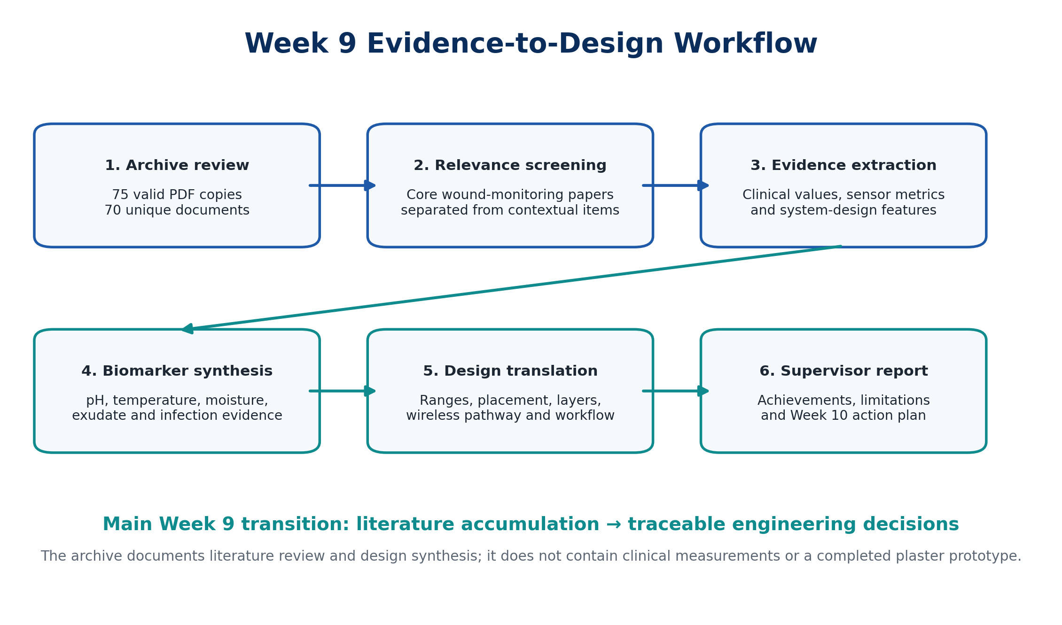
Cover evidence summary generated from the complete Week 9 archive.

Purpose of this report
This document consolidates all substantive work found in the uploaded week9.zip and translates it into a clear supervisor-level record. It identifies what was collected, what was learned from the studies, how the evidence affects the proposed smart wound monitoring system, what has not yet been completed, and the practical actions required for Week 10.

Report contents
- 1. Executive summary and Week 9 achievements
- 2. Archive audit and relevance screening
- 3. Clinical evidence on wound pH, temperature, moisture and infection
- 4. Smart-dressing and wearable-sensor technologies reviewed
- 5. Quantitative evidence extracted for engineering decisions
- 6. Translation into the proposed project architecture
- 7. Limitations, risks and supervisor decisions
- 8. Week 10 practical action plan
- Appendices: study matrix, archive inventory and supervisor presentation script

1. Executive summary
Week 9 was primarily a structured literature-expansion and evidence-translation week. The archive contains a large dermatology journal collection, focused smart-wound sensor papers, foundational clinical wound literature, and a smaller group of dataset-ready observational studies. The central technical achievement was not simply collecting more papers: the work established a defensible bridge from clinical biomarkers to sensor specifications, patch geometry, electronics architecture and future validation experiments.

What was completed this week
- Compiled 75 valid PDF copies representing 70 unique documents after duplicate-content checking.
- Collected 13 directly focused engineering papers on pH, temperature, moisture, flexible electronics, wireless monitoring and smart dressings.
- Collected 21 foundational or clinical papers covering chronic wounds, pH measurement, wound temperature, biofilms, infection and assessment practice.
- Collected seven papers specifically useful for numerical dataset construction and trend extraction.
- Reviewed a 34-PDF Journal of Investigative Dermatology issue collection and separated directly relevant wound/skin-microenvironment content from contextual or unrelated dermatology articles.
- Extracted clinically important pH, temperature and wound-size trends from observational and cohort studies.
- Extracted sensor-performance values from PANI, textile, thermal-array, wireless and multimodal smart-dressing studies.
- Defined a four-location spatial measurement concept: wound centre, two wound-edge regions and a periwound/reference region.
- Defined a proposed architecture separating a disposable sensing patch from reusable electronics and a mobile/clinician interface.
- Established that interpretation should use time trajectories and agreement between multiple modalities rather than one isolated threshold.
Supervisor-critical clarification
The archive does not document clinical data collection, a completed plaster prototype, patient testing, sensor calibration results or a validated diagnostic algorithm. The folder named “PRACTICAL VERTION OF PLASTER” is empty. Therefore, Week 9 should be reported as literature synthesis and engineering specification work, not prototype validation.

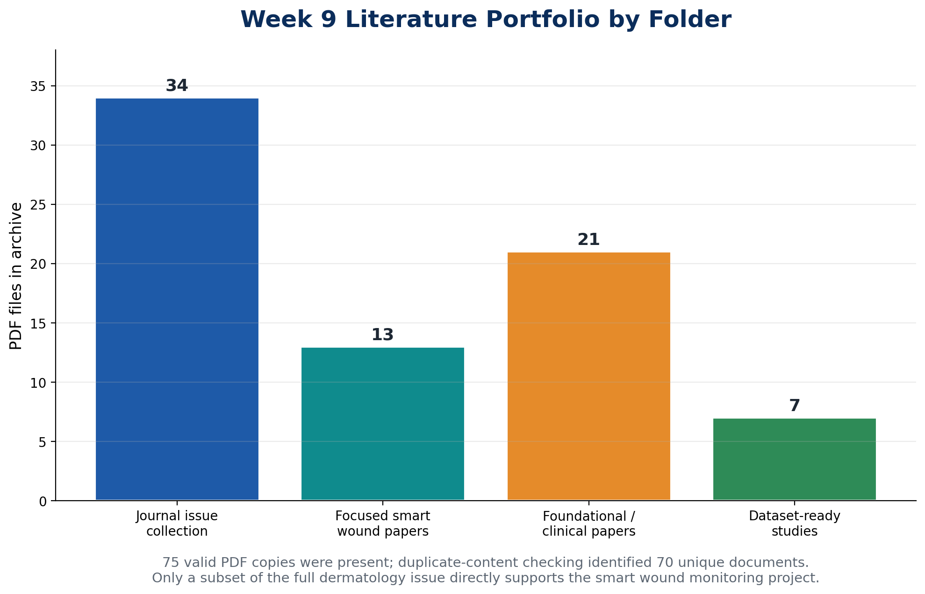
Figure 1. Composition of the Week 9 literature archive. Counts are PDF copies by folder; duplicate checking produced 70 unique documents.

2. Archive audit and relevance screening
The archive was inspected at both the root and nested-ZIP levels. Thirteen files inside the “Papers” package were macOS resource-fork artefacts rather than readable PDF documents and were excluded. Five groups of exact duplicate PDF content were identified across the focused, foundational and dataset folders. The resulting evidence base contains 70 unique readable documents.
Archive component | Readable PDFs | Main content | Week 9 treatment
Journal of Investigative Dermatology issue collection | 34 | A broad dermatology issue containing wound microbiology, skin pH, diabetic-foot-ulcer single-cell research and many non-project articles. | Screened; selected content retained as direct or contextual evidence.
Focused “Papers” collection | 13 | Smart dressings, pH sensors, temperature arrays, moisture sensing, wireless systems and closed-loop treatment. | Highest engineering relevance.
Foundational/clinical collection | 21 | Wound burden, chronic-wound pathophysiology, pH and temperature assessment, sensor reviews and infection evidence. | High clinical and methodological relevance.
Dataset-published collection | 7 | Observational and cohort studies with numerical pH, temperature, size or infection data. | Highest value for quantitative extraction.
Practical version of plaster folder | 0 | No files were present. | No prototype evidence available.

2.1 Relevance-screening logic
- Direct engineering relevance: a device, sensor, dressing or wireless system that measures a wound-related parameter.
- Direct clinical relevance: human or animal evidence connecting pH, temperature, exudate, bacterial burden or wound size with healing or infection.
- Contextual relevance: skin barrier biology, microbial ecology, inflammation, single-cell analysis or scar biology that helps explain the wound microenvironment.
- Low immediate relevance: melanoma diagnosis, rosacea, fungal itch, educational programmes, subscription pages, editorial-board information and other dermatology topics not used for the current sensor design.

2.2 Why the journal issue still had value
Although much of the Journal of Investigative Dermatology issue was outside the immediate project scope, it provided useful contextual evidence on the skin acid mantle, wound microbial communities, diabetic-foot-ulcer tissue biology, spatial transcriptomic methods, metagenomics and inflammatory mechanisms. This broader biological context strengthens the justification for multimodal sensing, while the screening step prevents unrelated articles from being treated as core design evidence.

3. Clinical evidence on wound biomarkers
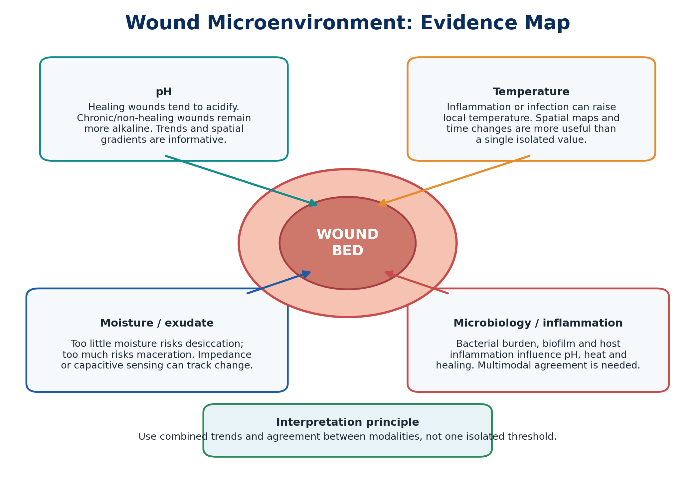
Figure 2. Integrated Week 9 evidence map linking pH, temperature, moisture/exudate and microbiology with wound status.

3.1 Wound pH
The strongest and most consistent Week 9 finding is that wound pH is a promising non-invasive biomarker of healing progression. Intact skin is acidic, injury exposes near-neutral tissue, and many chronic or infected wounds become alkaline. Across historical studies, observational work and the 2026 multicentre cohort, wound improvement is generally associated with movement from alkaline values toward a more acidic condition. However, pH varies with wound type, location, dressing, treatment, bacterial burden and measurement method; it should be evaluated as a trend and spatial pattern rather than a universal diagnostic cut-off.
- Shukla et al. studied 50 wounds and reported that most baseline values were above pH 8.5; as wound condition and exudate improved, pH commonly fell below 8.0.
- Gethin et al. followed 50 neuropathic foot ulcers for 12 weeks. Mean pH was 6.95 at baseline and 6.72 among remaining wounds at follow-up; 25 wounds healed.
- A four-week observational study of 97 participants found mean pH decreased from 8.34 to 7.71 while mean wound area decreased by 62%.
- The 2026 prospective multicentre cohort included 117 patients, 226 pH measurements and 181 temperature measurements. Chronic and non-healing wounds had mean pH values around 7.1, higher than acute and healing wounds, and healing wounds showed an average weekly pH decline of approximately 0.05 units.
- The multicentre study also identified a centre-to-surrounding-skin pH gradient, supporting spatially distributed sensing rather than a single electrode location.
- Animal evidence from Sim et al. showed that controlled acidic treatment at pH 4 or 6 accelerated wound closure compared with saline in a non-infected murine model. This supports biological relevance but does not directly define a safe treatment protocol for humans.

3.2 Wound temperature
Temperature reflects perfusion, inflammation, infection, tissue metabolism and environmental conditions. The evidence supports temperature as an important complementary parameter, but it is less specific than pH when interpreted alone. A scoping review of 13 studies and 477 patients proposed a typical chronic-wound bed range of approximately 30.2–33.0 °C, with an overall weighted mean of 31.7 °C. Infection or strong local inflammation may produce a sudden rise, while very low temperature may be associated with poor perfusion or impaired repair. Spatial differences and changes over time are therefore more informative than one absolute value.
- The 97-participant observational study reported a mean temperature reduction from 32.86 °C to 31.90 °C over four weeks, alongside wound-size reduction.
- Large-area flexible sensor arrays can map local inflammation with reported temperature sensitivity around 0.1 °C, demonstrating the value of multiple sensing points.
- The flexible integrated sensing platform reviewed in Week 9 used a wound-mounted sensor chip, controlled PCB, Bluetooth Low Energy and a smartphone application to monitor wound temperature without repeatedly opening the dressing.
- Temperature measurements require compensation for ambient temperature, sensor contact pressure, dressing insulation and patient-specific baseline differences.

3.3 Moisture and wound exudate
Moisture management is essential because a dry wound may desiccate and delay cellular migration, whereas excessive exudate can cause maceration, leakage, discomfort and delayed dressing changes. Week 9 studies demonstrated that conductive-polymer textile sensors can detect large impedance changes between dry and wet states and can be integrated with RFID for wireless monitoring. Other smart-bandage designs combined one-way exudate drainage with pH sensing. For the present project, moisture should initially be treated as a relative state variable—dry, controlled, high or saturated—until clinically meaningful quantitative thresholds are established.

3.4 Infection, bacterial burden and inflammation
Infection cannot be reliably inferred from one parameter. Bacterial activity, biofilm, inflammation and tissue breakdown can influence pH, temperature, exudate and optical appearance simultaneously. The Week 9 literature included animal infection models, fluorescence and hyperspectral imaging, wound-microbiome analysis and reviews of pH effects on antimicrobial performance. A hyperspectral imaging study achieved 74% overall classification accuracy across infected, inflamed and non-infected wounds, illustrating the benefit of multimodal data but also showing that clinically complex categories remain difficult to separate.

4. Smart-dressing and wearable-sensor technologies reviewed
Week 9 reviewed several technological pathways rather than committing to one device prematurely. The strongest candidates for the current low-cost project are electrochemical/conductimetric pH sensing, contact temperature sensing and an optional impedance-based moisture channel. More complex platforms—hyperspectral imaging, multiplexed electrochemical biomarker arrays and closed-loop drug delivery—are valuable future references but exceed the first prototype scope.
Technology | Principle | Evidence extracted | Project relevance
Flexible PANI pH sensor | PANI membrane on interdigitated electrodes / flexible substrate | Range 5.45–8.62; 58.57 mV per pH reported. | Strong fit with the project; requires stable reference electrode and temperature compensation.
Soft pH + temperature dressing | PANI/Ag–AgCl pH sensor plus temperature array | pH range 4–10; 99.8% fitting accuracy; response <6 s; temperature tested from 30–40 °C. | Supports dual-parameter patch and rapid response target.
Textile PEDOT:PSS/IrOx pH bandage | Printed textile sensing layer with absorbent exudate transport | pH 6–9; sensitivity 59±4 µA/pH; limited interference and temperature effect in 22–40 °C tests. | Shows how wound fluid can be delivered to a sensor through dressing layers.
Liquid-diode M-PANI bandage | Unidirectional exudate drainage plus 3D PANI pH mesh | 61.5 mV/pH; range 4–10; 48 h dynamic stability; 28-day storage with 4.8% signal decline. | Useful model for combining fluid handling and sensing.
Textile moisture sensor | PEDOT:PSS printed on gauze with impedance readout and RFID | Large dry-to-wet impedance change; disposable and wireless. | Suitable optional moisture channel; first prototype can use relative calibration.
Flexible integrated temperature platform | Flexible sensor chip + PCB + BLE smartphone app | Real-time temperature monitoring and infection-pattern experiments in rabbits. | Directly supports reusable electronics and phone display architecture.
Large-scale temperature array | Flexible amorphous-silicon array with hydrogel/drug-delivery integration | Spatial resolution with temperature sensitivity around 0.1 °C. | Supports multi-segment sensing, though full array fabrication is beyond current resources.
Wireless thermal-transport system | Wireless spatial temperature and thermal-property monitoring | Continuous on-wound monitoring; bioresorbable options explored. | Demonstrates importance of thermal trends and conformal materials.
Stretchable multiplexed bioelectronic patch | Electrochemical biomarker array + wireless monitoring + combination therapy | Continuous multimodal monitoring and controlled treatment in preclinical models. | Long-term project direction; not an initial prototype requirement.
Printed smart bandage | Low-cost printed sensing for bleeding, pH and pressure with wireless alerts | Disposable sensor section plus reusable electronics. | Strong architectural precedent for cost reduction and modularity.

5. Quantitative evidence extracted for engineering decisions
The following values are not final clinical thresholds. They are literature-derived design targets for selecting sensor ranges, calibration points, resolution and validation tests.
Design element | Proposed target | Evidence-based justification
pH measurement span | 4–10 | Covers acidic treatments, intact/near-normal environments and alkaline chronic/infected conditions reported in smart-dressing studies.
High-priority pH region | 6–9 | Most clinical wound data and textile pH-sensor validation are concentrated in this region.
Proposed pH resolution | ≤0.1 pH unit | Required to detect gradual trends such as the approximately 0.05-unit weekly decline reported in healing wounds; exact achievable accuracy must be experimentally confirmed.
pH calibration points | 4, 6, 7, 8 and 10 | Provides full-span and wound-relevant calibration; include repeated cycles to quantify hysteresis and drift.
Temperature measurement span | 25–45 °C | Provides margin around the literature wound-bed range and possible inflammatory elevations.
Temperature target resolution | 0.1–0.2 °C | Allows detection of small spatial and temporal changes; accuracy must be verified against a traceable reference.
Expected chronic-wound bed range | Approximately 30.2–33.0 °C | Scoping-review hypothesis; use as contextual baseline, not a diagnostic boundary.
Spatial locations | Centre, two edge positions, periwound/reference | Supported by centre-to-skin pH gradients and the need for local temperature comparison.
Sampling concept | Hourly during early prototype studies | Balances battery, memory and trajectory resolution; faster sampling can be used during calibration and laboratory response tests.
Moisture output | Relative dry/controlled/high/saturated state | More defensible initially than claiming a universal clinical moisture threshold.
Communication | BLE to phone/laptop | Supported by reviewed wearable platforms and compatible with the current reusable-module concept.
Interpretation | Trend + spatial difference + multimodal agreement | Avoids false conclusions from one value and aligns with clinical variability in the literature.

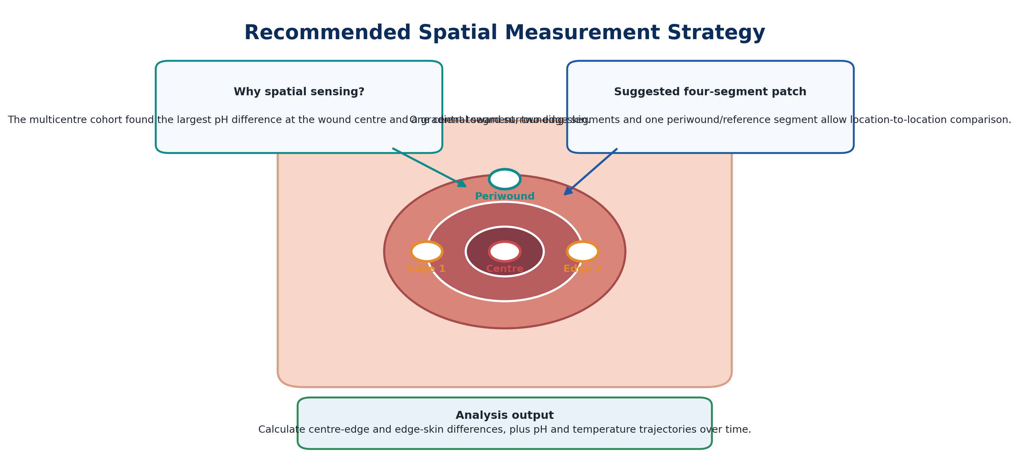
Figure 3. Proposed four-location spatial measurement strategy derived from the Week 9 cohort evidence.

6. Translation into the proposed project architecture
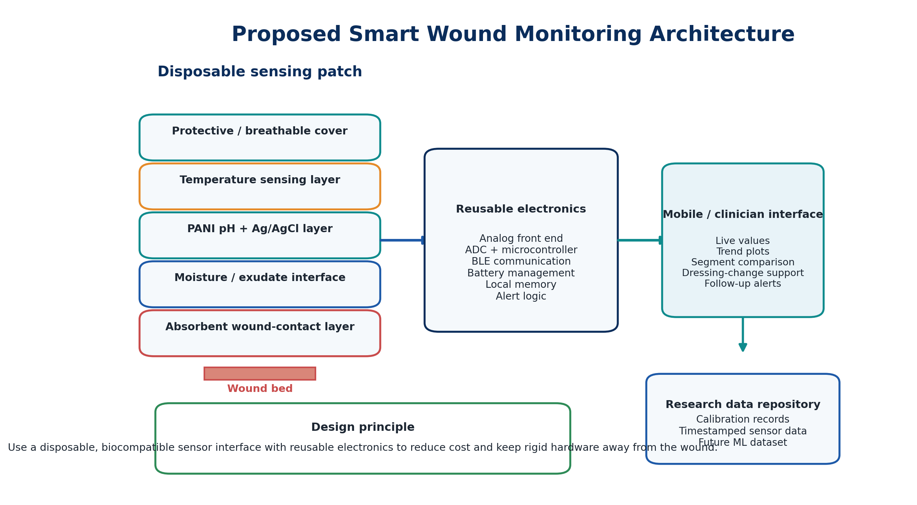
Figure 4. Proposed architecture separating the disposable wound-contact patch, reusable electronics and data interface.

6.1 Disposable patch concept
- A soft wound-contact and absorbent layer that preserves moisture balance and transports exudate to the sensing regions.
- A PANI-based pH working electrode with an Ag/AgCl reference system, arranged so that the reference remains hydrated and mechanically stable.
- Contact temperature sensing at multiple spatial positions. The first prototype may use discrete sensors rather than a high-density array.
- An optional impedance or capacitive moisture channel located where exudate accumulation can be detected without blocking the pH sensor.
- A breathable protective layer and flexible interconnect to the reusable module.
- Four sensing regions to support centre, edge and periwound comparison.

6.2 Reusable electronics module
- High-input-impedance analog front end for the pH electrode and stable reference measurement.
- ADC and microcontroller for sampling, timestamping, filtering and BLE transmission.
- Temperature acquisition with calibration coefficients stored per sensor channel.
- Moisture-channel excitation/readout if the optional impedance sensor is included.
- Battery charging and power management designed for several days of intermittent sampling.
- Local memory to avoid data loss during temporary wireless disconnection.
- Firmware that records raw values and calibrated values separately to preserve traceability.

6.3 Data and interpretation pathway
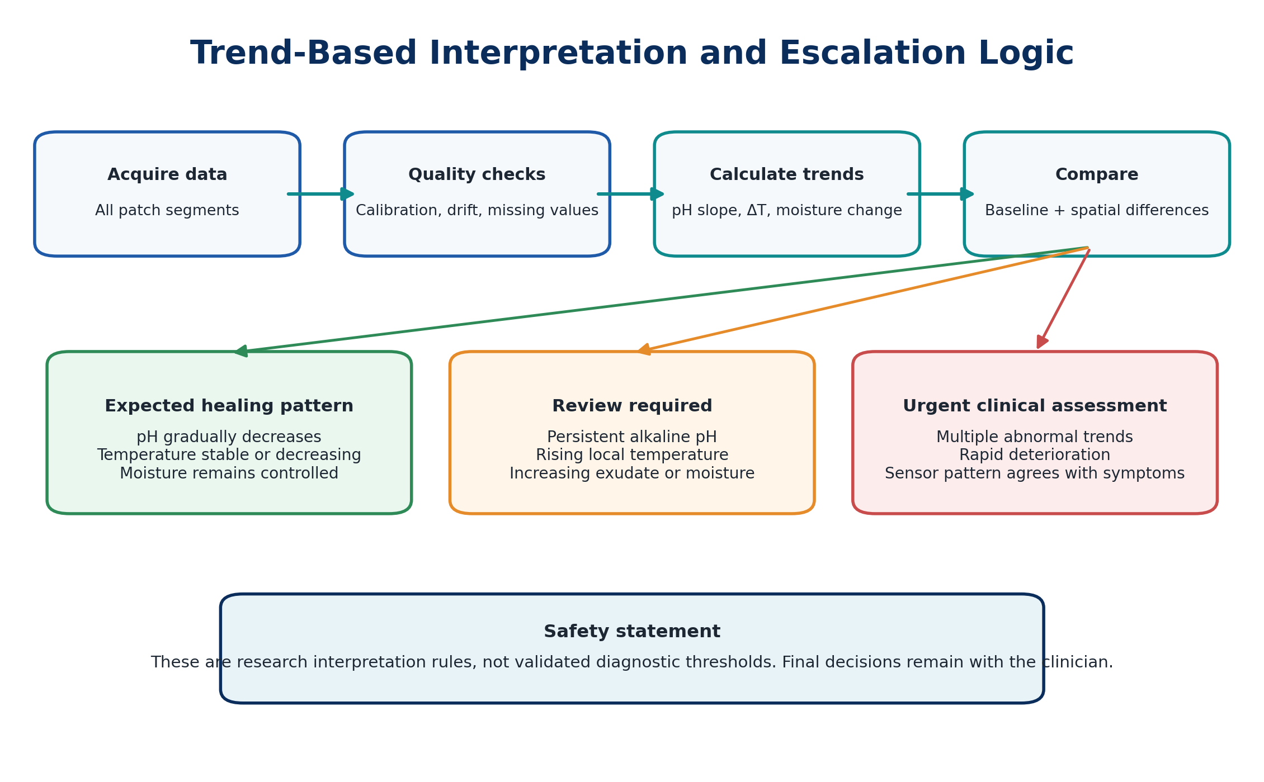
Figure 5. Research-stage trend and escalation logic. This is not a validated diagnostic algorithm.
The software should first perform signal-quality checks, then calculate pH slopes, temperature changes, moisture-state changes and centre-to-edge differences. The interface should display trends and flags for clinician review. It should not label a wound as infected or healed based only on a single threshold. Any future decision-support model will require ethically approved prospective data and clinician-defined outcomes.

7. Limitations, risks and supervisor decisions

7.1 Limitations of the Week 9 evidence
- The archive contains heterogeneous wound types, measurement methods, treatments, sensor technologies and preclinical models; values cannot be pooled as if they were one uniform dataset.
- Several device papers report excellent laboratory or animal performance, but this does not prove clinical reliability, comfort, sterilisation compatibility or long-term safety.
- pH indicator strips, electrochemical electrodes, optical systems and conductimetric sensors do not have identical accuracy or response characteristics.
- Temperature is influenced by ambient conditions, blood perfusion, dressing thickness, sensor pressure and anatomical location.
- Moisture studies often report device-specific impedance rather than a universal clinical unit.
- The newest 2026 cohort is highly valuable but still observational; association does not establish a validated diagnostic threshold.
- The large dermatology journal collection contains many low-relevance articles; only screened content should be cited as project evidence.
- No practical plaster files, laboratory notebooks, circuit tests or sensor calibration data were present in the Week 9 archive.

7.2 Engineering risk register
Risk | Potential effect | Mitigation
PANI drift and hysteresis | Incorrect pH trends | Perform repeated up/down pH cycles, soak testing and daily recalibration checks.
Ag/AgCl reference instability | Baseline shift | Use a defined chloride environment, protective hydrogel and reference-electrode conditioning.
Temperature cross-sensitivity of pH | False pH change | Record temperature simultaneously and establish compensation experimentally.
Biofouling / protein deposition | Slow response and drift | Test in synthetic wound fluid before biological samples; consider replaceable/disposable sensor regions.
Pressure and bending | Mechanical artefacts | Conduct bend, compression and repeated attachment tests.
Exudate saturation | Sensor shorting or leakage | Separate fluid pathway, insulating barriers and overflow handling.
Patient-to-patient variability | False universal thresholds | Use individual baseline and trajectory-based interpretation.
Wireless or battery failure | Missing data | Local timestamped memory and visible connection/battery status.
Unvalidated clinical alert | Unsafe interpretation | Keep alerts advisory and clinician-reviewed until prospective validation is complete.

7.3 Decisions requested from the supervisor
- Confirm whether the first physical prototype should include pH and temperature only, with moisture added after stable calibration, or all three channels from the beginning.
- Approve the four-segment centre/edge/periwound patch geometry for benchtop development.
- Confirm the pH calibration range and acceptable target accuracy for the first prototype.
- Confirm whether an NTC/TMP117-style discrete temperature approach is sufficient before attempting a flexible array.
- Approve the disposable-patch/reusable-module architecture.
- Confirm the synthetic wound-fluid recipe and non-clinical validation sequence.
- Confirm which measurements must be demonstrated before an ethics application or clinical collaboration meeting.

8. Week 10 practical action plan
Step | Task | Method | Required evidence
1 | Freeze requirements | One-page specification: ranges, resolution, four locations, sampling, power and BLE fields. | Supervisor-approved requirements sheet.
2 | Build pH benchtop sensor | Fabricate/condition PANI working electrode and Ag/AgCl reference; test pH 4, 6, 7, 8, 10. | Calibration curve, sensitivity, response time, hysteresis and drift.
3 | Calibrate temperature channel | Compare each sensor against a reference from 25–45 °C. | Per-sensor correction equation and accuracy table.
4 | Assess moisture channel | Test dry-to-saturated response using saline and synthetic exudate on candidate dressing materials. | Relative moisture-state separation and repeatability.
5 | Prepare non-clinical patch mock-up | Create four-segment flexible layout with wound-contact and protective layers. | Photographs, dimensions, layer diagram and connection map.
6 | Develop data logger | Log raw ADC, pH, temperature, moisture, segment ID, battery and timestamps. | CSV dataset and live trend display.
7 | Run integration test | Simulate changing pH, temperature and moisture over several hours. | Complete system trace showing independent and combined changes.
8 | Update documentation | Add test protocol, results, failures and design changes to the project repository. | Week 10 report and reproducible evidence package.

Appendix A. Key study-by-study synthesis
Study | Type / scope | Main Week 9 finding | Project implication
Buck et al., 2002 | pH measurement standards | Defines pH terminology, reference procedures and traceability. | Use standard buffers and record calibration conditions.
Schmid-Wendtner & Korting, 2006 | Skin surface pH review | Acidic skin surface supports barrier and antimicrobial function. | Provides biological context for wound acidification.
Schneider et al., 2007 | pH and wound healing review | pH influences enzymes, proteins, bacterial colonisation and repair. | Supports pH as both biomarker and mechanistic variable.
Shukla et al., 2007 | 50 acute/chronic wounds | Most baseline pH >8.5; pH fell below 8 as condition/exudate improved. | Confirms non-invasive serial pH assessment value.
Schreml et al., 2010 | Skin integrity and wound pH review | Explains pH effects across inflammation, proliferation and remodelling. | Supports physiological interpretation.
Dargaville et al., 2013 | Sensors and imaging review | Diagnostic and theranostic sensors can complement wound dressings. | Provides early system-level framework.
Percival et al., 2014 | pH, biofilms and antimicrobials | pH affects biofilm behaviour and antimicrobial efficacy. | Avoid interpreting pH independently of treatment and microbes.
Frykberg & Banks, 2015 | Chronic-wound challenges | Reviews pathophysiology and comprehensive management needs. | Clinical justification and scope control.
Farooqui & Shamim, 2016 | Inkjet-printed wireless bandage | Printed bandage senses bleeding, pH and pressure with reusable wireless electronics. | Strong low-cost modular architecture precedent.
Power et al., 2017 | Systematic review: 23 studies | Lower pH tended to associate with improvement; evidence insufficient for universal predictor use. | Supports pH focus but requires cautious claims.
Gethin et al., 2018 | 50 neuropathic foot ulcers | Baseline pH 6.95, temperature 30.91 °C; 25 healed by 12 weeks. | Provides human baseline and longitudinal context.
Li et al., 2020 | Flexible PANI sensor | 58.57 mV/pH across pH 5.45–8.62; flexible interdigitated design. | Direct candidate sensing principle.
Zhang et al., 2021 | Flexible integrated temperature platform | Sensor chip + PCB + BLE app; animal infection monitoring. | Supports real-time covered-wound monitoring.
Mariani et al., 2021 | Textile pH bandage | pH 6–9; 59±4 µA/pH; synthetic exudate flow validation. | Shows textile integration and fluid delivery.
Tessarolo et al., 2021 | Wireless textile moisture sensor | PEDOT:PSS gauze impedance plus RFID differentiates moisture states. | Candidate optional moisture channel.
Tang et al., 2021 | Wearable pH and temperature review | Summarises materials, transduction, integration and challenges. | Supports selection criteria and gap analysis.
Iversen et al., 2022 | Printed pH + hydration patch | Low-cost fully printed PDMS patch; 7.1 Ω/pH and moisture resistance change. | Supports simple dual-sensor fabrication.
Sim et al., 2022 | Acidic treatment in mice | pH 4 and 6 buffers increased closure versus saline. | Biological support; not a human treatment recommendation.
Zhang et al., 2022 | Soft pH + temperature dressing | pH 4–10, 99.8% fit, <6 s response; temperature 30–40 °C. | Sets ambitious range and response targets.
Derwin et al., 2022 | Systematic narrative review | Examined how topical agents/dressings alter pH, temperature and healing. | Measurement context must record dressing/treatment.
Derwin et al., 2022/23 | 27 wounds, 2-week feasibility | pH 6–8.7; temperature 28.4–36.4 °C; average wound-size reduction 39%. | Supports joint monitoring during inflammation management.
Falanga et al., 2022 | Chronic wounds primer | Comprehensive clinical, biological and treatment overview. | Strengthens clinical problem definition.
Sani et al., 2023 | Stretchable multiplexed patch | Wireless multimodal monitoring plus controlled therapy in preclinical chronic wounds. | Long-term theranostic direction.
Mirani et al., 2023 | Dual-sensor wound dressing | pH/glucose sensing plus drug/growth-factor delivery in mice. | Shows monitoring-treatment integration.
McArdle et al., 2023 | pH and medical-grade honey | Honey retained antibacterial effects across pH 6–8 in vitro. | pH interacts with therapy but may not dominate all antimicrobial effects.
Derwin et al., 2023 | 97 participants, four weeks | pH 8.34→7.71; temperature 32.86→31.90 °C; wound area reduced 62%. | Key quantitative trend dataset.
Ramirez-GarciaLuna et al., 2023 | Hyperspectral infection study | 74% overall three-class accuracy; 100% sensitivity for infected wounds in study model. | Multimodal imaging potential and classification limitations.
Ryu et al., 2024 | Wireless thermal monitoring | Spatial temperature and thermal transport recorded during healing. | Supports spatial thermal features.
Liu et al., 2024 | Large-area temperature array | ~0.1 °C sensitivity with spatial inflammation mapping and triggered therapy. | Supports multiple sensing positions.
Wang et al., 2024 | Liquid-diode M-PANI bandage | 61.5 mV/pH, pH 4–10, 48 h dynamic stability, 28-day storage. | Strong pH sensor and exudate-handling reference.
Brooks et al., 2024 | Skin acid mantle update | Reviews skin pH, barrier, microbiome and inflammation. | Context for acidic barrier and sensor interpretation.
Rembe et al., 2026 | 117-patient multicentre cohort | 226 pH and 181 temperature measurements; non-healing wounds higher pH; healing pH fell ~0.05/week. | Strongest spatial and longitudinal design evidence in archive.

Appendix B. Full archive inventory
The lists below record the readable PDF filenames reviewed. Exact duplicate copies are marked in the explanatory notes above and were not treated as independent evidence.

B1. Focused smart-wound papers
- A soft intelligent dressing with pH.pdf
- A stretchable wireless wearable bioelectronic system.pdf
- Advanced Wound Dressing for Real-Time pH Monitoring.pdf
- Chronic wound management.pdf
- Flexible integrated sensing platform.pdf
- Flexible pH sensor based on a conductive PANI.pdf
- Flexible, Wearable and Fully-printed Smart Patch.pdf
- Materials and Device Designs for Wireless Monitoring.pdf
- Smart Dual-Sensor Wound Dressing.pdf
- The impact of wound pH on the antibacterial properties.pdf
- Wireless Textile Moisture Sensor for Wound Care.pdf
- liu-et-al-2024-flexible-bioelectronic-systems-with-large-scale-temperature-sensor-arrays-for-monitoring-and-treatments.pdf
- pH profiling reveals progressive.pdf

B2. Foundational and clinical papers
- The-impact-of-topical-agents-and-dressing-on-scp-pH-scp-and-temperature-on-wound-healing.pdf
- Wound-pH-and-temperature-as-predictors-of-healing-an-observational-study.pdf
- buck2002.pdf
- dargaville2013.pdf
- dissemond2016.pdf
- falanga2022.pdf
- farooqui2016.pdf
- frykberg2015.pdf
- gethin2018.pdf
- gethin2021 (1).pdf
- gethin2021.pdf
- gualandi2021.pdf
- ijms-23-13655-v2.pdf
- percival2014.pdf
- power2017.pdf
- schmid-wendtner2006.pdf
- schneider2006.pdf
- schreml2010.pdf
- sen-2023-human-wound-and-its-burden-updated-2022-compendium-of-estimates.pdf
- shukla2007.pdf
- tang2021.pdf

B3. Dataset-published papers
- Wound-pH-and-temperature-as-predictors-of-healing-an-observational-study.pdf
- derwin2022.pdf
- fmed-10-1165281.pdf
- ijms-23-13655-with-cover.pdf
- power2017.pdf
- s41598-026-45000-7.pdf
- shukla2007.pdf

B4. Journal of Investigative Dermatology issue collection
- Adiponectin-Prevents-Skin-Inflammation-in-Rosacea-.pdf
- Ancestral-Diversity-of-Skin-Reaches-Single-Cell-Re.pdf
- Classification-of-Cutaneous-Melanoma-and-Melanocyt.pdf
- Clinical-Snippets_jid.pdf
- Combining-Automated-Lesion-Risk-and-Change-Assessm.pdf
- Comparative-Whole-Metagenome-Analysis-in-Lesional-.pdf
- Designing-and-Evaluating-Circadian-Experiments-on-.pdf
- Development-of-a-Cellular-Assay-as-a-Personalized-.pdf
- Editorial-Board_jid.pdf
- Editors#U2019-Picks_jid.pdf
- Endolysins-Target-Bad-Neighbors-in-the-Wound-Micro.pdf
- Enhanced-Intratumoral-Delivery-of-Immunomodulator-.pdf
- Flipping-the-Script--Are-Cellular-Assays-and-Wound.pdf
- Fungal-Defensins--Dual-Roles-in-Itch-and-Inflammat.pdf
- Hepatocyte-Growth-Factor-Has-Unique-Functions-in-K.pdf
- Heterogeneity-in-Keloid-Scars--Influence-of-Mechan.pdf
- How-Can-Spatial-Transcriptomic-Profiling-Advance-O.pdf
- Integrated-Single-Cell-Analysis-Reveals-Spatially-.pdf
- Invasion-of-Human-Epidermis-by-Malassezia-furfur-I.pdf
- MicroRNA-Quantification-as-an-Accurate-and-Cost-Ef.pdf
- Neurturin-GF-Enhances-the-Acute-Cytokine-Response-.pdf
- Penn-Academy-for-Skin-Health-(PASH)--An-Experienti.pdf
- Pumping-the-Breaks-on-Acantholytic-Skin-Disorders-.pdf
- Single-Cell-Analysis-of-Debrided-Diabetic-Foot-Ulc.pdf
- Spesolimab-Reduces-Inflammation-in-Generalized-Pus.pdf
- Subcellular-Fractionation-and-Metaproteogenomic-Id.pdf
- Subscription-Information_jid.pdf
- Table-of-Contents_jid.pdf
- Tebentafusp-Induces-a-T-Cell#U2013Driven-Rash-in-Melano.pdf
- The-Fungal-Secretory-Peptide-Micasin-Induces-Itch-.pdf
- The-Skin-Acid-Mantle--An-Update-on-Skin-pH_2024_ji.pdf
- The-Stephen-Rothman-Memorial-Award-2024_2024_jid.pdf
- Tumor-RNA-Sequencing-Identifies-a-Group-of-Patient.pdf
- Vasoactive-Intestinal-Peptide-Operates-as-a-Negati.pdf

Appendix C. Five-minute supervisor presentation script
Opening: In Week 9, I expanded and screened the wound-monitoring literature, then translated the clinical and device evidence into specific design requirements for our smart wound patch.
Evidence base: The archive contains 75 readable PDF copies and 70 unique documents. The most useful groups were 13 focused smart-dressing papers, 21 foundational or clinical papers and seven dataset-oriented studies. I also screened a complete dermatology journal issue and retained only directly or contextually relevant content.
Clinical conclusion: The strongest biomarker is wound pH. Across the reviewed human studies, healing generally corresponds to decreasing pH, while chronic or non-healing wounds remain more alkaline. Temperature is useful as a complementary inflammatory parameter, and moisture provides information about exudate balance.
Engineering conclusion: The evidence supports a four-segment disposable patch measuring the wound centre, two edge regions and a periwound reference. The patch should connect to reusable electronics with ADC, microcontroller, BLE, battery and local memory.
Important limitation: This week did not include clinical data collection or a completed plaster prototype. The practical plaster folder was empty. Therefore, the current outputs are evidence synthesis, specifications and a prototype plan.
Next action: In Week 10, I will first validate the pH, temperature and optional moisture channels in controlled laboratory conditions, create a four-segment non-clinical patch mock-up and demonstrate timestamped wireless data logging.
Decision request: I need approval on whether the first prototype should use pH and temperature only or include moisture immediately, and confirmation of the proposed four-segment geometry and calibration targets.

Appendix D. Selected references reviewed in Week 9
Brooks, S.G. et al. (2024). The Skin Acid Mantle: An Update on Skin pH. Journal of Investigative Dermatology.
Buck, R.P. et al. (2002). Measurement of pH: Definition, Standards, and Procedures. Pure and Applied Chemistry, 74(11), 2169–2200.
Dargaville, T.R. et al. (2013). Sensors and Imaging for Wound Healing: A Review. Biosensors and Bioelectronics, 41, 30–42.
Derwin, R. et al. (2022). The Impact of Topical Agents and Dressing on pH and Temperature on Wound Healing: A Systematic Narrative Review. International Wound Journal.
Derwin, R. et al. (2022/2023). The Effect of Inflammation Management on pH, Temperature, and Bacterial Burden. International Wound Journal.
Derwin, R. et al. (2023). Wound pH and Temperature as Predictors of Healing: An Observational Study. Journal of Wound Care, 32(5).
Falanga, V. et al. (2022). Chronic Wounds. Nature Reviews Disease Primers.
Farooqui, M.F. and Shamim, A. (2016). Low Cost Inkjet Printed Smart Bandage for Wireless Monitoring of Chronic Wounds. Scientific Reports.
Frykberg, R.G. and Banks, J. (2015). Challenges in the Treatment of Chronic Wounds. Advances in Wound Care.
Gethin, G. et al. (2018). Monitoring pH and Temperature of Neuropathic Diabetic and Non-Diabetic Foot Ulcers for 12 Weeks: An Observational Study.
Gethin, G. et al. (2021). What Is the “Normal” Wound Bed Temperature? A Scoping Review and New Hypothesis. Wound Repair and Regeneration.
Iversen, M., Monisha, M. and Agarwala, S. (2022). Flexible, Wearable and Fully-Printed Smart Patch for pH and Hydration Sensing in Wounds. International Journal of Bioprinting, 8(1).
Li, Y. et al. (2020). Flexible pH Sensor Based on a Conductive PANI Membrane for pH Monitoring. RSC Advances, 10.
Liu, J. et al. (2024). Flexible Bioelectronic Systems with Large-Scale Temperature Sensor Arrays for Monitoring and Treatments of Localized Wound Inflammation.
Mariani, F. et al. (2021). Advanced Wound Dressing for Real-Time pH Monitoring. ACS Sensors, 6, 2366–2377.
McArdle, C., Coyle, S. and Santos, D. (2023). The Impact of Wound pH on the Antibacterial Properties of Medical Grade Honey. Journal of Foot and Ankle Research, 16, 66.
Mirani, B. et al. (2023). Smart Dual-Sensor Wound Dressing for Monitoring Cutaneous Wounds. Advanced Healthcare Materials, 12, 2203233.
Percival, S.L. et al. (2014). The Effects of pH on Wound Healing, Biofilms, and Antimicrobial Efficacy.
Power, G. et al. (2017). pH, Exudate Composition and Temperature as Predictors of Wound Healing: A Systematic Review. Journal of Wound Care, 26(7).
Ramirez-GarciaLuna, J.L. et al. (2023). Is My Wound Infected? A Study on the Use of Hyperspectral Imaging to Assess Wound Infection. Frontiers in Medicine, 10, 1165281.
Rembe, J.-D. et al. (2026). pH Profiling Reveals Progressive Wound Acidification during Healing and Higher pH in Chronic Non-Healing Wounds: A Prospective Multicenter Cohort Study. Scientific Reports, 16, 10522.
Ryu, H. et al. (2024). Materials and Device Designs for Wireless Monitoring of Temperature and Thermal Transport Properties of Wound Beds during Healing. Advanced Healthcare Materials, 13, 2302797.
Schmid-Wendtner, M.-H. and Korting, H.C. (2006). The pH of the Skin Surface and Its Impact on the Barrier Function. Skin Pharmacology and Physiology, 19, 296–302.
Schneider, L.A. et al. (2007). Influence of pH on Wound Healing: A New Perspective for Wound Therapy? Archives of Dermatological Research, 298, 413–420.
Schreml, S. et al. (2010). The Impact of the pH Value on Skin Integrity and Cutaneous Wound Healing.
Shirzaei Sani, E. et al. (2023). A Stretchable Wireless Wearable Bioelectronic System for Multiplexed Monitoring and Combination Treatment of Infected Chronic Wounds. Science Advances.
Shukla, V.K. et al. (2007). Evaluation of pH Measurement as a Method of Wound Assessment. Journal of Wound Care, 16(7).
Sim, P. et al. (2022). Influence of Acidic pH on Wound Healing In Vivo: A Novel Perspective for Wound Treatment. International Journal of Molecular Sciences, 23, 13655.
Tang, N. et al. (2021). Wearable Sensors and Systems for Wound Healing-Related pH and Temperature Detection. Micromachines.
Tessarolo, M. et al. (2021). Wireless Textile Moisture Sensor for Wound Care. Frontiers in Physics, 9, 722173.
Wang, X., Cheng, J. and Wang, H. (2024). Chronic Wound Management: A Liquid Diode-Based Smart Bandage with Ultrasensitive pH Sensing Ability. Microsystems & Nanoengineering, 10, 193.
Zhang, Y. et al. (2021). Flexible Integrated Sensing Platform for Monitoring Wound Temperature and Predicting Infection. Microbial Biotechnology, 14(4), 1566–1579.
Zhang, Z. et al. (2022). A Soft Intelligent Dressing with pH and Temperature Sensors for Early Detection of Wound Infection. RSC Advances, 12, 3243.
Final Week 9 conclusion
Week 9 produced a substantially stronger evidence base and a clear engineering direction. The next progress milestone must now shift from literature synthesis to repeatable benchtop measurements and a documented non-clinical four-segment patch prototype.

