WEEK 10
FULL PROGRESS SUMMARY AND SUPERVISOR UPDATE
Smart Wound Monitoring System for Early Wound-Healing Assessment
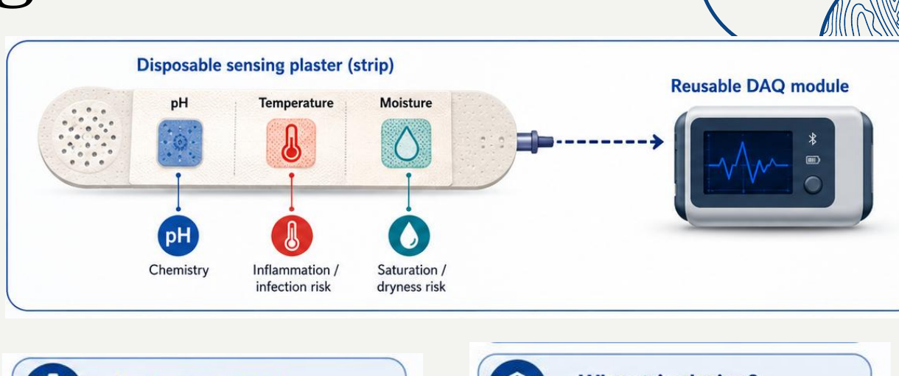
Project | Ultra-Low-Cost Wearable Smart Plaster for Diabetic Foot Ulcer Monitoring
Group | Group 36
Prepared by | Vikum
Supervisor | Dr. Ruwan Ranaweera
Co-supervisor | Dr. Manjula Pieris, Department of Surgery, Faculty of Medicine
Reporting stage | Week 10 - fabrication and laboratory preparation stage
DOCUMENT STATUS: ENGINEERING DESIGN AND LABORATORY PREPARATION ONLY
No clinical testing, human application, or completed sensor calibration is claimed in this report.

Executive Summary
Week 10 marked the transition from high-level system design to a detailed, fabrication-ready and laboratory-ready preparation package. The work consolidated the disposable sensing strip, reusable data-acquisition module, PANI preparation method, chemical safety controls, flexible copper/carbon fabrication route, screen-printing process, preliminary cost model, and validation workflow.
The main Week 10 achievement was not a completed clinical prototype; it was the creation of the controlled procedures and design decisions required to fabricate and test the first non-human laboratory prototype safely. This distinction is important when reporting progress to the supervisors.
Key Week 10 Outcome
A complete engineering preparation package was produced for the next build stage: PANI synthesis for approximately 10 pH pads, risk assessment and safety documentation, hybrid flexible-patch fabrication using buried copper with exposed carbon/PANI windows, screen-printing and etching workflow study, circuit/firmware consolidation, and a structured calibration plan.

Work area | Week 10 status | Evidence / output
System architecture | Consolidated | Disposable multi-zone strip and reusable DAQ architecture documented.
PANI preparation | Procedure prepared | Recipe, quantities, laboratory handout, coating paste plan and pH 4-10 test plan.
Chemical safety | Prepared for approval | Risk assessment, safety handbook, PPE, waste, spill and first-aid controls.
Flexible fabrication | Design route prepared | V1/V2 prototype guides and corrected hybrid copper-carbon layer strategy.
Screen printing | Process studied | Materials list and reference sequence for emulsion, UV exposure, stencil development, printing, etching and cleaning.
Physical fabrication | Not yet verified | Requires facility access, supervisor approval, material procurement and coupon trials.
Calibration results | Not yet available | pH, moisture and temperature calibration, drift and repeatability remain next-stage work.

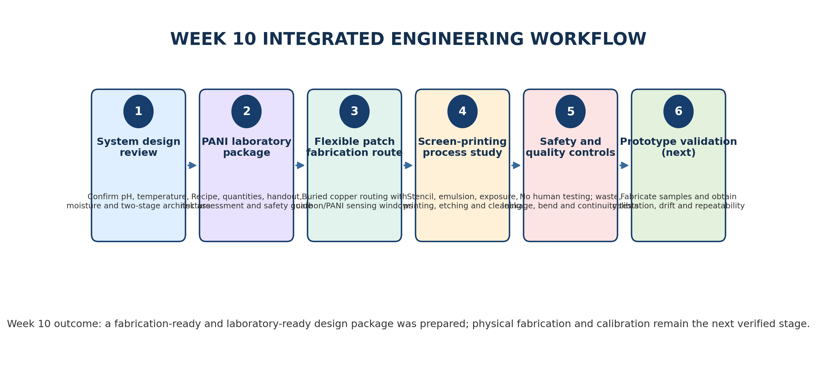
Figure 1. Integrated Week 10 workflow and the boundary between completed preparation and pending experimental validation.

Contents
- 1. Week 10 scope and evidence reviewed
- 2. System architecture consolidated in Week 10
- 3. PANI laboratory preparation package
- 4. Flexible plaster fabrication strategy
- 5. Screen-printing and etching process study
- 6. Safety, risk and medical-use boundary
- 7. Testing and quality-control plan
- 8. Preliminary cost and resource assessment
- 9. Critical technical findings and corrections
- 10. Decisions requiring supervisor approval
- 11. Next-stage action plan
- 12. Supervisor presentation summary
- Appendices: materials, deliverables and source inventory

1. Week 10 Scope and Evidence Reviewed
The Week 10 summary was prepared by combining the project presentation with the full documentation package contained in the Week 10 archive. The evidence covers system design, sensor-interface planning, laboratory PANI preparation, chemical safety, prototype fabrication, screen-printing, etching and testing preparation.
Source item | Main contribution to Week 10
Smart wound monitoring system presentation | Project need, 122-paper review result, selected parameters, methodology, disposable strip circuit, DAQ circuit, firmware flowchart, cost estimate and Gantt plan.
PANI preparation plan for 10 samples | Chemical quantities, synthesis workflow, paste preparation, coating quantities and pH-buffer verification.
PANI laboratory handout | Simple step-by-step laboratory procedure and expected visual observations.
PANI safety handbook | PPE, chemical handling, spill response, first aid, waste and pre-lab checklist.
Filled risk-assessment form | CAS numbers, quantities, operating conditions, hazards and required controls.
Initial prototype guide - V1 | Copper data lines, carbon/graphite moisture electrodes, PANI pH boundary and material-use corrections.
Flexible copper prototype guide - V2 | Refined layer stack, copper encapsulation, sensor-window rules, etching controls and bench test checklist.
Flexible PCB screen-printing guide | Fabrication route comparison, complete materials list, printing/etching steps, curing and quality tests.
Reference screenshots | Visual study of conventional screen preparation, exposure, developing, printing, ferric-chloride etching and rinsing.

Progress-reporting boundary
The Week 10 files demonstrate detailed preparation and design maturity. They do not prove that PANI was synthesized, the flexible circuit was printed, or the sensors were calibrated. Those activities should be reported as planned next-stage experiments unless laboratory records and measured data are available.

2. System Architecture Consolidated in Week 10
The presentation defines a two-stage system intended to reduce disposable cost and separate wound-contact materials from most electronics. Stage A is a thin disposable sensing strip. Stage B is a reusable data-acquisition and communication module. The selected first-line parameters are pH, temperature and moisture/exudate, supported by the 122-paper review dataset and parameter-priority analysis.

2.1 Sensor functions
Parameter | Proposed sensor | Signal mechanism | Clinical/engineering role
pH | PANI-coated carbon working electrode with Ag/AgCl reference | Potentiometric DC voltage requiring an ultra-high-input-impedance front end | Track wound chemistry and alkalinity/acidity trend.
Temperature | Four TMP117 digital sensors | I2C digital temperature data with local spatial readings | Detect local thermal rise that may indicate inflammation or infection risk.
Moisture/exudate | Carbon interdigitated electrodes (IDE) | AC impedance/capacitance response that changes with liquid level | Estimate dry, balanced, high-exudate or saturated conditions.

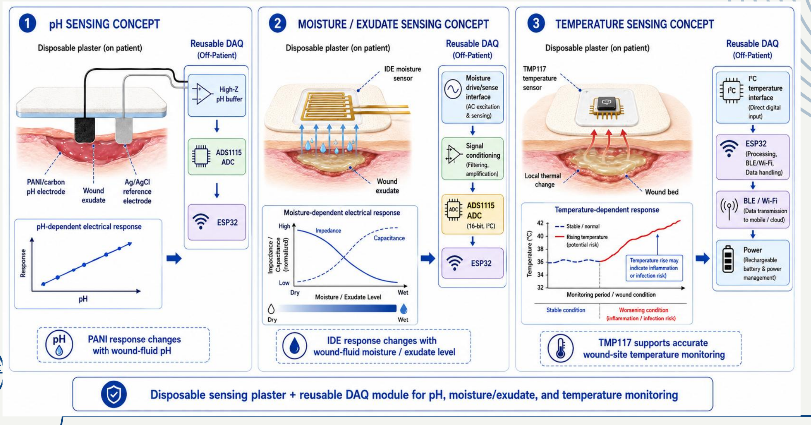
Figure 2. Consolidated sensing concepts for pH, moisture/exudate and temperature from the project presentation.

2.2 Disposable multi-zone strip
The current concept divides the disposable strip into four spatial sections. Each section is intended to provide local wound information instead of producing only one average value over the entire wound. The presentation circuit allocates one PANI working electrode, one moisture IDE and one TMP117 node per section, with shared supply and communication lines and a common reference electrode.
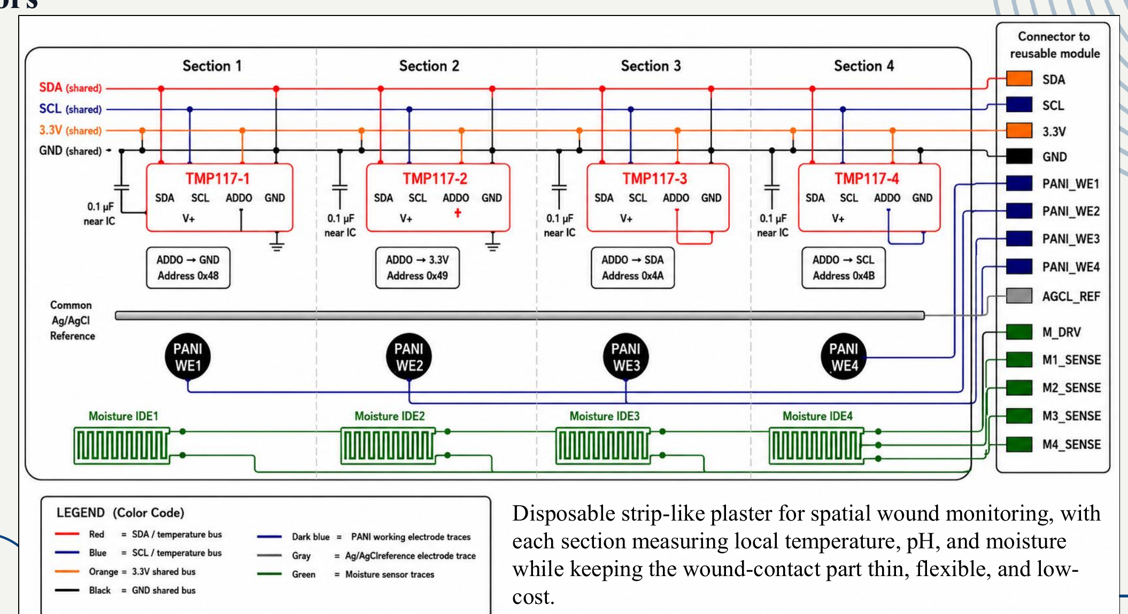
Figure 3. Proposed four-zone disposable strip circuit, including four TMP117 addresses, four PANI electrodes, four moisture IDE channels and a common reference connection.

2.3 Reusable DAQ and firmware
The reusable module is expected to provide regulated power, signal conditioning, channel selection, analog-to-digital conversion, processing, BLE/Wi-Fi communication and battery management. The firmware flow proposes initialization, baseline calibration, deep sleep, timed wake-up, zone-by-zone scanning, temperature compensation, data transmission and repeated monitoring.
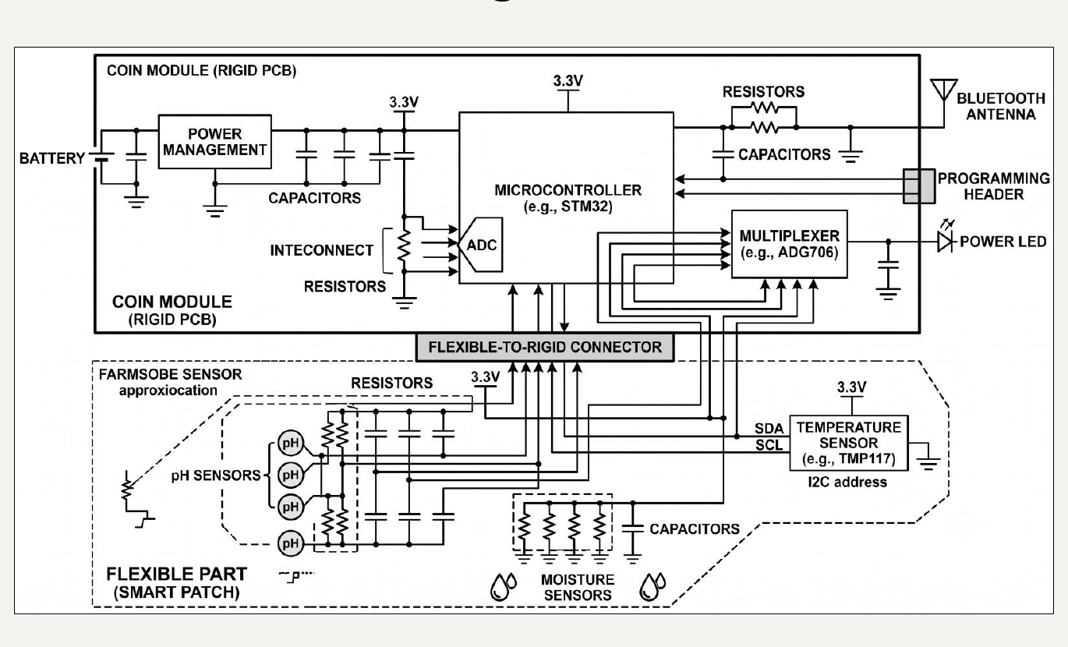  Reusable DAQ circuit model | 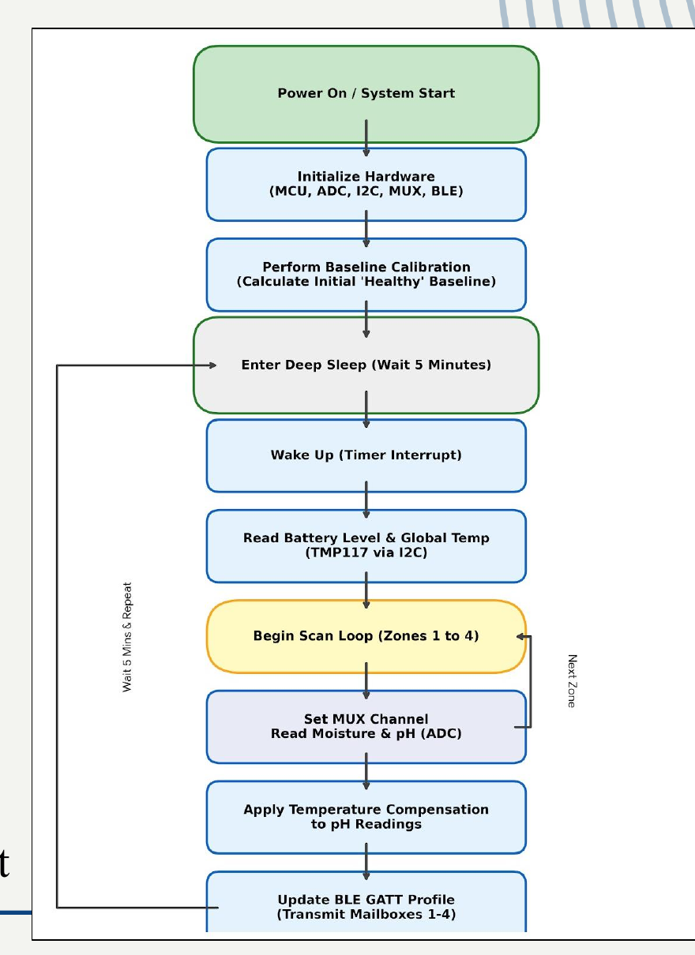  Firmware acquisition flowchart
Figure 4. Proposed reusable DAQ architecture and firmware sequence.
- Analog pH and moisture channels are routed to the ADC through suitable conditioning and multiplexing.
- TMP117 measurements use the I2C bus; the presentation assigns addresses 0x48, 0x49, 0x4A and 0x4B by configuring the ADD0 pin.
- A 0.1 microfarad local decoupling capacitor is shown near each TMP117 node.
- Low-power operation is planned using periodic wake-up and deep-sleep intervals.
- Warning outputs should remain clinician-in-the-loop rather than automatically diagnosing infection.

3. PANI Laboratory Preparation Package
A major Week 10 output was a complete laboratory-preparation package for producing polyaniline emeraldine salt and coating approximately ten PANI-based pH pads. This package includes a full idea document, a simplified laboratory handout, a safety handbook and a filled risk-assessment form.
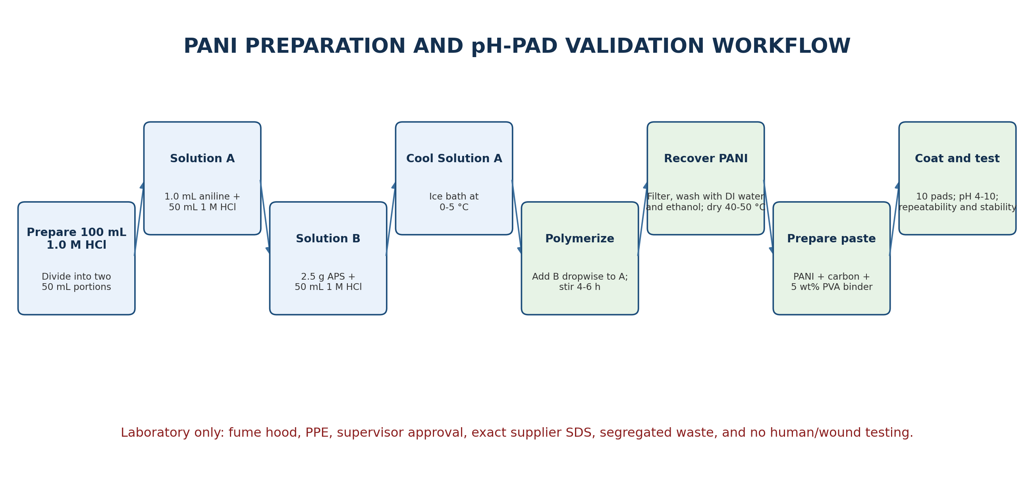
Figure 5. PANI synthesis, coating and pH-buffer validation workflow prepared during Week 10.

3.1 Small-batch synthesis quantities
Material | Planned amount for one small batch | Function / note
Aniline monomer | 1.0 mL | Monomer; handle only in a working fume hood.
1.0 M hydrochloric acid | 100 mL total | Acid medium and dopant; divide into two 50 mL portions.
Ammonium persulfate (APS) | 2.5 g | Oxidizer; prepare freshly in one 50 mL HCl portion.
DI/distilled water | 500 mL to 1 L for washing | Repeated washing after filtration.
Ethanol | 100-200 mL | Wash organic impurities; flammable.
Acetone | 50-100 mL, optional | Optional final quick wash; highly flammable.

3.2 Expected process observations
1. Prepare 100 mL of 1.0 M HCl. When dilution from concentrated acid is authorized, add acid slowly into water, never water into acid.
2. Prepare Solution A using 1.0 mL aniline in 50 mL of 1.0 M HCl and stir in the fume hood.
3. Prepare Solution B by dissolving 2.5 g APS in 50 mL of 1.0 M HCl immediately before use.
4. Cool Solution A in an ice bath to approximately 0-5 °C.
5. Add Solution B slowly and dropwise into Solution A while stirring continuously.
6. Continue polymerization for approximately 4-6 hours. The expected color transition is pale yellow to blue/green and then dark green or black-green precipitate.
7. Filter, wash with DI water and ethanol, optionally use a final acetone wash, and dry at 40-50 °C or in a desiccator.

3.3 PANI coating paste for ten pH pads
Component | Planned amount | Purpose
Prepared PANI powder | 100 mg | Primary pH-responsive conducting polymer.
Graphite/carbon additive | 20-30 mg | Improves electrical conduction and forms a stable carbon-supported coating.
5 wt% PVA solution | Approximately 1.0 mL | Binder to immobilize PANI and reduce loose-particle release.
0.1 M HCl | Approximately 0.5 mL | Maintains acidic/protonated condition during paste preparation.
Ethanol or DI water | 0.5-1.0 mL, adjusted gradually | Controls viscosity for coating.

- Target pad size: approximately 5 mm x 5 mm to 10 mm x 10 mm.
- Planned coating: 10-20 microlitres per sample, using one to three thin layers with drying between layers.
- PANI must be immobilized in the binder film; loose powder is not acceptable at the sensing surface.
- Calibration range: pH 4-10, with at least three repeats per condition and consistent lighting for any RGB/colour analysis.

3.4 What still requires experimental verification
- Actual dried PANI yield and conductivity.
- Coating uniformity and cracking after drying or bending.
- Potentiometric sensitivity, linearity and baseline stability against the chosen reference electrode.
- Response time, hysteresis, repeatability, drift and storage stability.
- Interference from saline, proteins, medicine residue and artificial wound fluid.

4. Flexible Plaster Fabrication Strategy
The Week 10 fabrication documents compare three routes: copper foil with screen-printed etch resist, direct printing of conductive inks, and a hybrid route. The recommended practical route is hybrid fabrication: low-resistance copper is used only for buried routing, while carbon and PANI are used at the exposed sensing windows.
Route | Strength | Limitation | Week 10 recommendation
Copper foil + etched traces | Low resistance and suitable for shared power/data routing. | Copper, adhesive and etchant residue are unacceptable at wet wound-contact regions. | Use only as completely buried routing.
Direct conductive printing | Avoids wet copper exposure and is suitable for sensor electrodes. | Requires stable conductive ink, stencil quality and curing control. | Use carbon for moisture IDE and carbon/PANI for pH window.
Hybrid route | Combines reliable routing with safer exposed sensing materials. | Requires a well-sealed copper-carbon junction. | Preferred route for the first laboratory prototype.

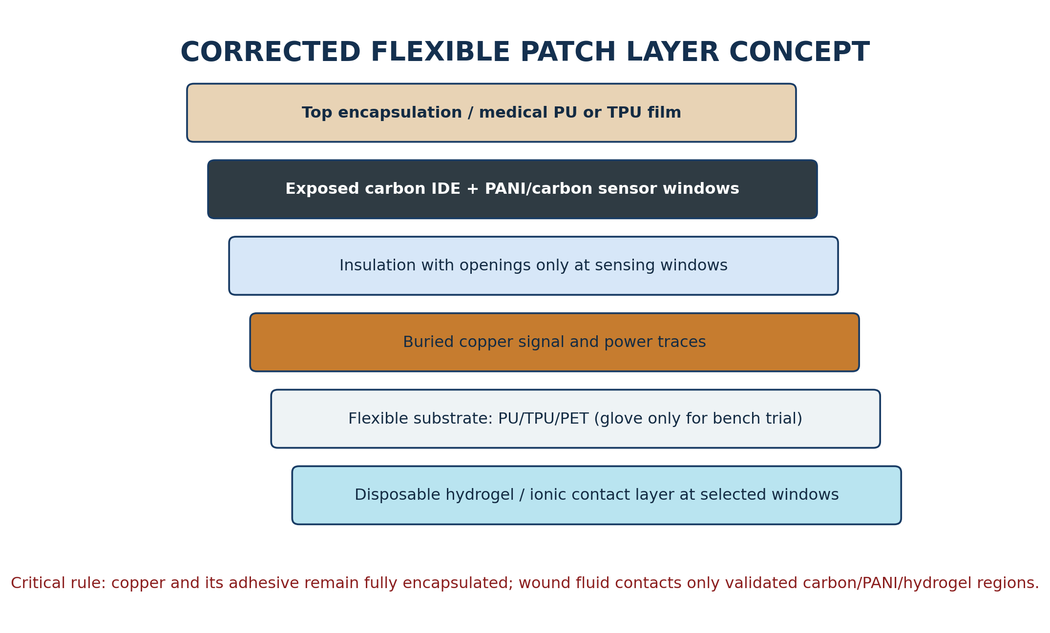
Figure 6. Corrected Week 10 layer concept: copper is buried and only controlled carbon/PANI/hydrogel windows contact test liquid.

4.1 Corrected fabrication sequence
1. Draw the trace and sensor-window layout, including supply, ground, I2C or analog lines, pH channels, moisture channels and connector pads.
2. Cut the flexible substrate. Surgical/nitrile glove material may be used only for early non-human bending trials; PU, TPU, PET, polyimide or medical dressing film is preferred for later prototypes.
3. Laminate thin copper foil smoothly and apply the trace mask or screen-printed etch resist.
4. Etch unwanted copper in an approved chemical area, collect copper-containing waste and rinse/dry completely.
5. Perform continuity and short-circuit tests before adding upper layers.
6. Laminate the top insulation and seal all copper edges and adhesive regions.
7. Open only the planned sensor windows.
8. Print carbon base pads and moisture IDEs. Create the copper-carbon overlap only in a sealed dry area.
9. Apply PANI/carbon paste to the pH carbon pad and dry gently.
10. Add the controlled hydrogel/ionic contact layer and an insulated temperature interface.
11. Complete bend, leak, insulation and individual sensor-response tests before system integration.

4.2 Material-selection corrections
Original low-cost idea | Correct Week 10 interpretation
Surgical glove as final substrate | Acceptable only for bench handling and flexibility trials. It is not automatically a medical-grade wound-contact material.
Copper electrodes exposed to fluid | Not accepted. Copper is restricted to buried conductors; carbon/PANI/hydrogel forms the fluid-contact interface.
Unknown glue or industrial adhesive | Not allowed at the wound-contact side. Later stages require a suitable medical adhesive or validated dressing film.
Reusable wound-contact patch | Not recommended. The wound-contact layer is disposable; only the off-wound electronics are intended for reuse after suitable cleaning.
Immediate human testing | Not permitted at this stage. Begin with pH buffers, saline and artificial wound-fluid tests.

5. Screen-Printing and Etching Process Study
The Week 10 archive includes a screen-printing materials and step guide together with a visual reference sequence. The studied sequence covers screen preparation, emulsion coating, drying, artwork alignment, UV exposure, stencil development, printing, curing, copper etching, rinsing and finishing. These reference images should be described as process-learning evidence, not as photographs of the project prototype being fabricated.
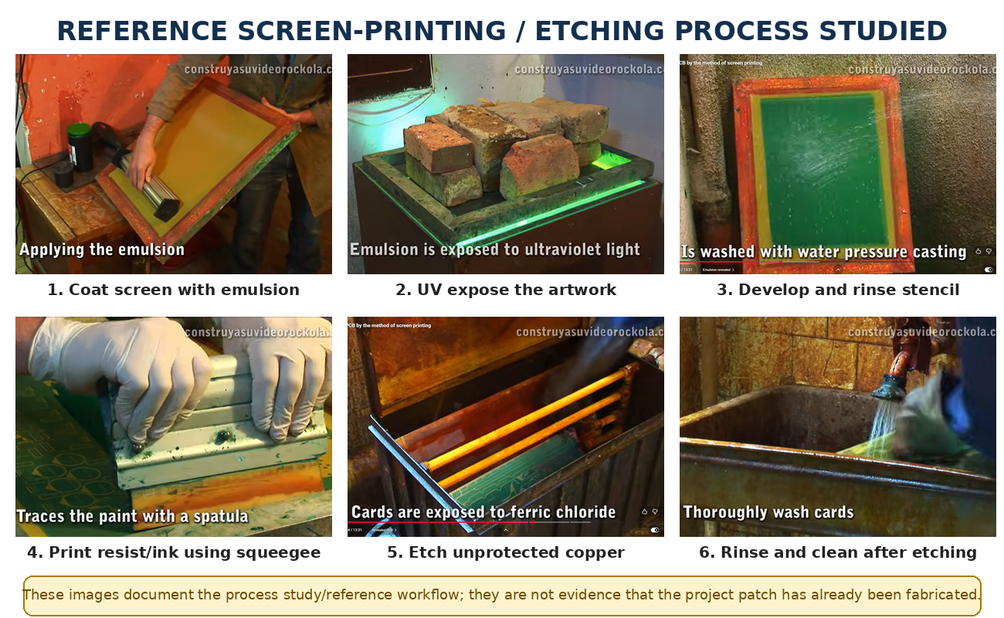
Figure 7. Reference process study used to understand conventional screen preparation, printing and copper etching.

5.1 Materials and equipment identified
Category | Required items
Screen preparation | Polyester screen mesh, frame, emulsion or stencil film, developer, UV exposure source and clean water rinse.
Printing | Squeegee, substrate holding fixture, etch-resistant ink for copper patterning, carbon conductive ink/paste and PANI coating paste.
Copper patterning | Adhesive copper foil or copper-clad flexible sheet, approved PCB etchant, plastic tray/tweezers and labeled waste container.
Encapsulation | PU/TPU/PET or polyimide cover film, suitable edge sealing and dry connector area.
Testing | Multimeter, magnifier/microscope, pH buffers, saline/artificial wound fluid, impedance front end or LCR instrument and temperature reference.

5.2 Process controls identified
- Stencil and trace widths must be practical for the available mesh and manual squeegee process.
- The flexible substrate must tolerate the selected curing temperature without shrinking or losing adhesion.
- Etch resist must be completely cured before ferric-chloride exposure.
- Etching time must be controlled to avoid over-etching or broken narrow tracks.
- All etchant residue must be removed before sensor materials are added.
- The screen-printing facility and waste-disposal route must be approved before work begins.

6. Safety, Risk and Medical-Use Boundary
The Week 10 safety package is one of the strongest outputs because it converts the PANI procedure into a controlled laboratory activity. The risk assessment identifies the exact classes of chemical hazards and requires supplier-specific SDS documents before work begins.
Chemical/material | Main hazard | Required control
Aniline monomer | Toxic by skin contact, inhalation and ingestion; serious eye hazard. | Fume hood only, nitrile gloves, goggles, minimal open-bottle time and urgent medical action after exposure.
Hydrochloric acid | Corrosive; can cause severe burns and respiratory irritation. | Add acid to water, use face/eye protection and confirm eyewash/safety shower access.
Ammonium persulfate | Oxidizer, irritant and sensitizer. | Avoid dust, prepare fresh, keep away from combustible/organic materials and add slowly.
Ethanol / acetone | Highly flammable; vapour and eye irritation. | No ignition sources, good ventilation and closed containers.
Graphite/carbon/PANI powder | Dust irritation and loose-particle contamination risk. | Control dust, wet wipe, use extraction/mask when needed and immobilize powder in a binder.
Ferric chloride / copper etchant | Corrosive and produces metal-containing waste. | Approved chemical area, PPE, tray, spill controls and segregated hazardous waste.

6.1 Mandatory safety boundary
Non-human laboratory prototype only
No project document should describe the current patch as clinically safe, medical-grade, sterile, biocompatible or approved. Human skin or wound testing requires suitable validated materials, biocompatibility planning, sterilization compatibility, medical-supervisor approval and ethics approval.

- Do not work alone during hazardous chemical steps.
- Attach the exact SDS supplied with the purchased aniline, APS, HCl, solvents, carbon materials, PVA and buffers.
- Label and separate aniline/organic waste, acidic waste, solvent waste and PANI/carbon solid waste.
- Use the fume hood for aniline, acid handling and polymerization.
- Prepare spill, first-aid and exposure-response arrangements before opening chemicals.
- No chemical or etching waste may be discharged to the sink unless the technical officer explicitly authorizes the disposal route.

7. Testing and Quality-Control Plan
The Week 10 documents define a staged verification approach. Mechanical and electrical coupon tests should come before complete patch fabrication, and individual sensor calibration should come before multi-sensor integration.
Test stage | Method | Evidence required
Copper routing | Continuity, adjacent-line short test, visual inspection and trace resistance. | Recorded resistance values and photographs before/after encapsulation.
Mechanical flexibility | Bend each coupon approximately 20-50 cycles and repeat continuity test. | No open circuit, lifting, cracking or large resistance shift.
Liquid isolation | Apply saline only to sensor windows and inspect buried copper/connector regions. | No visible wetting, corrosion or measurable leakage path.
PANI pH response | Test pH 4-10 using controlled volume and a stable reference; at least three repeats. | Calibration curve, sensitivity, R-squared, response time, hysteresis and drift.
Moisture IDE | Use low-amplitude AC excitation; add controlled saline volumes or artificial wound fluid. | Impedance/amplitude versus volume, repeatability and selected frequency.
TMP117 temperature | Compare each node with a traceable/reference thermometer over the expected range. | Offset, repeatability, spatial consistency and response time.
Integrated DAQ | Scan all four zones and transmit labelled data through BLE/Wi-Fi. | No channel mix-up, stable timing, correct addresses and data logging.

7.1 Recommended experimental order
1. Fabricate simple copper/insulation coupons without sensors.
2. Fabricate carbon IDE coupons and determine a safe, sensitive AC frequency and excitation amplitude.
3. Synthesize one PANI batch, record yield and prepare a small number of coating coupons before coating all ten pads.
4. Calibrate pH, moisture and temperature channels separately.
5. Freeze the sensor geometry and materials only after repeatable individual results are obtained.
6. Integrate one zone first, then expand to the four-zone strip.
7. Add firmware classification only after the raw sensor trends are validated.

8. Preliminary Cost and Resource Assessment
The presentation provides a preliminary disposable-patch estimate of USD 6.65. This value is useful as a design target, but it is not yet a procurement-verified unit cost. It should be separated from reusable DAQ cost, laboratory chemicals, screen preparation, tooling, wastage and shipping.
Patch item | Preliminary estimate (USD) | Comment
PANI/carbon pH electrode | 0.65 | Material-level estimate; excludes failed coatings and calibration consumables.
Ag/AgCl reference | 0.50 | Depends strongly on whether it is disposable or moved to the reusable module.
IDE moisture sensor | 0.50 | Assumes low-cost carbon patterning.
Four TMP117 devices/modules | 2.00 | Must be confirmed with the selected package/module and supplier.
Flexible substrate, adhesive and encapsulation | 2.00 | Medical-grade materials may cost more than bench materials.
Interconnect / connector | 1.00 | Final connector and strain-relief design not yet fixed.
Total disposable patch target | 6.65 | Preliminary design estimate, not a verified bill of materials.

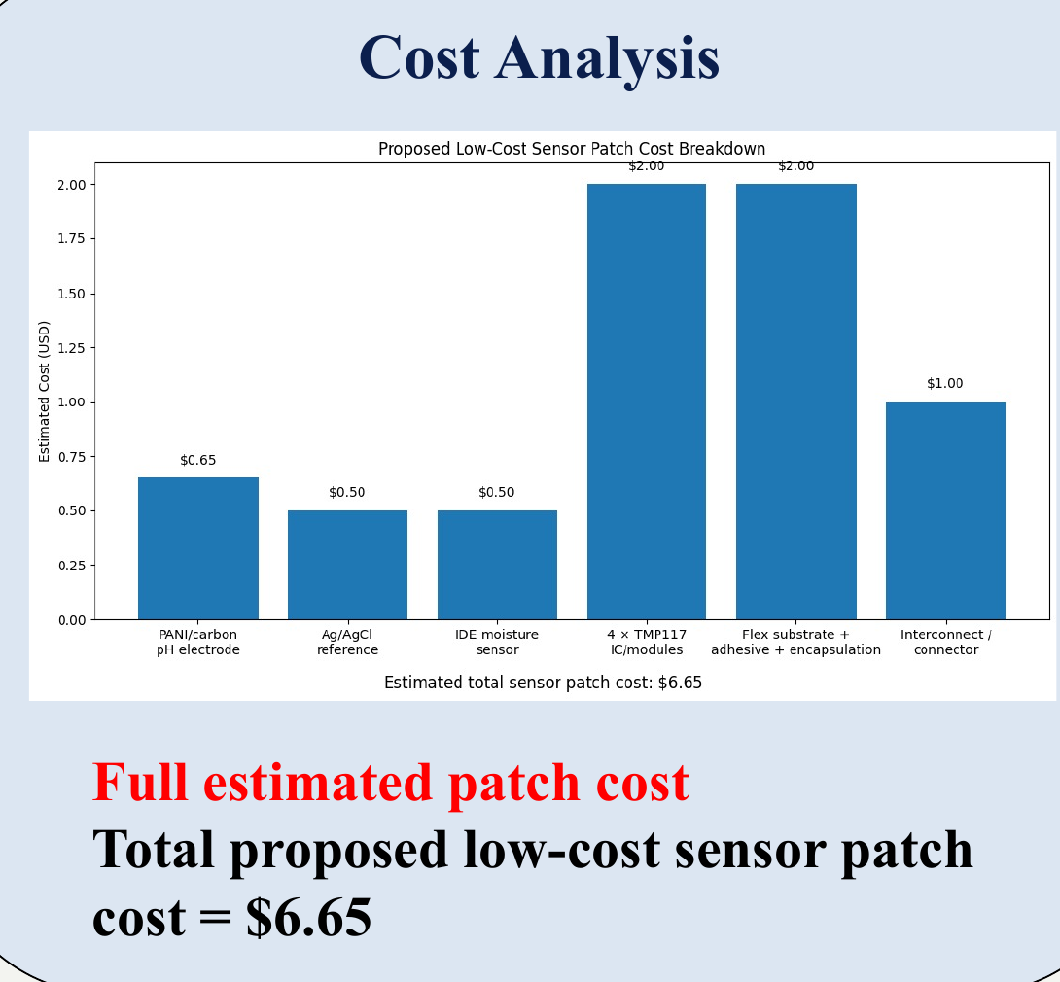
Figure 8. Preliminary disposable-patch cost breakdown reported in the project presentation.
Cost interpretation
The USD 6.65 value should be presented as a preliminary target. A final cost report needs local supplier quotations, minimum-order quantities, imported-component shipping, fabrication yield, reusable electronics cost and replacement frequency.

9. Critical Technical Findings and Corrections
Finding / correction | Why it matters
The Week 10 output is preparation maturity, not completed fabrication. | Prevents overclaiming progress and establishes a clear next experimental milestone.
Use a hybrid buried-copper / exposed-carbon architecture. | Retains low-resistance routing while avoiding uncontrolled copper contact with ionic test liquid.
Surgical glove material is bench-only. | A glove is not automatically suitable as a final wound-contact substrate because additives, extractables and sterilization behavior are unknown.
Moisture electrodes must use AC or biphasic excitation. | Reduces electrode polarization, corrosion and DC electrochemical side effects.
PANI requires a stable reference electrode and a very high-impedance input. | Prevents signal loading and improves repeatable potentiometric measurement.
Sensor windows and copper-carbon junctions must be separated. | The overlap junction should remain dry and sealed while only carbon/PANI/hydrogel is exposed.
One-zone integration should precede the full four-zone strip. | Reduces debugging complexity and material waste.
Clinical warnings must be trend-based and clinician-led. | The prototype is a monitoring aid and should not be presented as an autonomous diagnostic device.

10. Decisions Requiring Supervisor Approval
The Week 10 files reveal several design alternatives that should be resolved before procurement and fabrication. These are suitable agenda items for the next supervisor meeting.
Decision | Option A | Option B | Recommended discussion point
TMP117 placement | Four TMP117 devices on the disposable strip, as shown in the presentation. | Reusable TMP117 module coupled through thin thermal windows, as suggested in fabrication guides. | Compare spatial accuracy, cost, sterilization/cleaning and thermal response.
Ag/AgCl reference location | Common disposable reference printed on the strip. | Reusable Ag/AgCl reference connected through a controlled ionic bridge. | Resolve stability, contamination, connector complexity and replacement cost.
Substrate | Glove/nitrile strip for first mechanical bench trial. | PU/TPU/PET/polyimide or commercial dressing film for sensor prototype. | Approve which material can be purchased and processed in available labs.
Fabrication route | Etched copper plus carbon/PANI windows. | Fully screen-printed conductive layers. | Select based on screen-printing access, trace resistance and curing capability.
Connector/interface | Current multi-line connector concept. | Reduced-pin bus plus multiplexing near the patch. | Balance disposable complexity, noise, flexibility and wet-area separation.
First prototype scale | Fabricate all four zones immediately. | Validate one zone and then replicate. | One-zone-first is lower risk and easier to debug.

10.1 Direct questions for the supervisors
- Do you approve the hybrid route in which copper is completely buried and only carbon/PANI/hydrogel is exposed to test liquid?
- For the first prototype, should TMP117 devices be disposable on the strip or retained in the reusable module through thermal windows?
- Should the Ag/AgCl reference be printed on each disposable strip or maintained in the reusable module?
- Which UOP/partner facility can provide screen preparation, UV exposure, printing, low-temperature curing and controlled etching?
- Which substrate should be purchased for the first meaningful sensor prototype: PU, TPU, PET, polyimide or another recommended film?
- May the team proceed with PANI synthesis using the prepared risk assessment after the technical officer reviews the exact supplier SDS documents?
- Should the first integration milestone be one complete sensing zone before expanding to four zones?

11. Next-Stage Action Plan
Priority | Action | Expected output
1 | Obtain supervisor decisions on TMP117 placement, reference-electrode location, substrate and fabrication route. | Frozen architecture and procurement list.
2 | Confirm laboratory/facility access and attach exact supplier SDS documents. | Approved risk assessment and booked work area.
3 | Purchase small quantities and fabricate copper/insulation and carbon-IDE coupons. | Continuity, bend, adhesion and saline-isolation results.
4 | Synthesize one PANI batch and record temperature, colour, time and dried yield. | Labeled PANI sample and completed batch record.
5 | Prepare coating paste and coat a small pilot set before all ten pads. | Uniform coating method and drying condition.
6 | Calibrate pH, moisture and TMP117 channels separately. | Curves for sensitivity, response time, repeatability and drift.
7 | Build and debug one integrated zone with the reusable DAQ. | Stable labelled data from all three sensing modes.
8 | Replicate the verified zone into the four-zone strip. | First complete prototype ready for artificial wound-fluid tests.

11.1 Suggested one-week execution schedule
Day | Planned activity
Day 1 | Supervisor/facility approval, architecture freeze and safety-document review.
Day 2 | Prepare screens/stencils or masks and fabricate simple routing coupons.
Day 3 | PANI synthesis under supervision; begin carbon IDE coupons.
Day 4 | Filter, wash and dry PANI; test continuity, bending and insulation coupons.
Day 5 | Prepare PANI paste and pilot coatings; assemble one-zone mechanical stack.
Day 6 | pH-buffer and moisture-volume calibration; verify TMP117 addressing.
Day 7 | Repeatability analysis, photographs, plots, findings and supervisor update.

12. Supervisor Presentation Summary
Suggested 3-4 minute update
Use the following speech as a clear verbal summary. It deliberately separates completed engineering preparation from pending experimental work.

Good morning Sir. During Week 10, we moved from the system-level design into detailed laboratory and fabrication preparation for the first smart wound-plaster prototype. Our selected parameters remain pH, temperature and moisture/exudate, based on the 122-paper dataset. We consolidated the design into a disposable multi-zone sensing strip and a reusable DAQ module with signal conditioning, ADC, ESP32 processing and wireless communication.
The main new work this week was the preparation of the PANI pH-sensor laboratory package. We completed a small-batch synthesis plan using 1 millilitre of aniline, 2.5 grams of APS and 100 millilitres of 1 molar HCl, together with a coating-paste plan for approximately ten pH pads. We also prepared the laboratory handout, safety handbook and risk-assessment form, including fume-hood use, PPE, first aid, waste segregation and supplier-SDS requirements.
For the flexible plaster, we compared copper etching, direct screen printing and a hybrid method. Our corrected recommendation is a hybrid structure: copper is used only as a buried low-resistance conductor, while exposed sensing windows use carbon IDEs for moisture and PANI-coated carbon for pH. We studied the complete screen-printing and etching sequence and prepared the materials, curing and quality-test requirements. Surgical glove material is treated only as a bench trial substrate, not as the final medical material.
We have also defined the first verification tests: continuity, short-circuit, bending, saline leakage, pH calibration, AC moisture-impedance testing, TMP117 comparison and one-zone DAQ integration. At this point, the procedures and design package are ready, but physical fabrication and calibration are still pending.
Before purchasing and fabrication, we need your guidance on four main decisions: whether the TMP117 sensors remain on the disposable strip or in the reusable module, whether the Ag/AgCl reference is disposable or reusable, which flexible substrate and fabrication facility we should use, and whether we should validate one sensing zone before building all four zones. After these decisions, our next milestone will be one fabricated and calibrated sensing zone tested only with buffers, saline and artificial wound fluid.

12.1 One-sentence Week 10 conclusion
Week 10 converted the smart wound-monitoring concept into a controlled fabrication and laboratory preparation package, while clearly identifying the design decisions and experimental validation required before claiming a working prototype.

Appendix A - Consolidated Materials and Resources
Group | Materials / resources identified
PANI synthesis | Aniline monomer, APS, HCl, DI water, ethanol, optional acetone, filter paper, ice bath, stirrer, filtration setup and low-temperature drying.
PANI paste | PANI powder, graphite/carbon additive, PVA binder, 0.1 M HCl and controlled liquid vehicle.
Flexible circuit | PU/TPU/PET/polyimide or bench substrate, copper foil, screen mesh/frame, stencil/emulsion, etch resist, ferric chloride or approved etchant.
Sensor interfaces | Carbon conductive ink/paste, PANI coating, hydrogel or agar/PVA ionic layer, reference electrode and insulated thermal interface.
Encapsulation | Top film, medical-like adhesive film, edge seal, dry connector pads and strain relief.
Testing | Multimeter, magnifier, pH buffers, pH meter/reference system, saline, artificial wound fluid, impedance circuit/LCR instrument and temperature reference.
Safety | Fume hood, lab coat, nitrile gloves, goggles, face shield for acid dilution, spill kit, eyewash/shower access and labeled waste bottles.

Appendix B - Week 10 Deliverables Checklist
Deliverable | Status | Use in project
Project architecture and presentation | Prepared | Defines system concept, circuits, methods, cost and planned progress.
PANI preparation plan for ten samples | Prepared | Supports chemical procurement and laboratory execution.
PANI laboratory handout | Prepared | Provides a concise bench procedure and expected observations.
PANI safety handbook | Prepared | Guides PPE, handling, spills, first aid and waste.
Filled risk assessment | Prepared; signatures/SDS pending | Supports formal laboratory approval.
Initial flexible prototype guide V1 | Prepared | Establishes copper/carbon connection and early material boundaries.
Corrected prototype guide V2 | Prepared | Defines encapsulation, sensor windows, testing and medical-use corrections.
Screen-printing materials and step guide | Prepared | Supports facility discussion and fabrication setup.
Reference process screenshots | Collected for study | Visual learning evidence; not proof of project fabrication.
Fabricated one-zone prototype | Pending | Next physical milestone.
Calibration curves and integrated results | Pending | Required before claiming functional sensing performance.

Appendix C - Source File Inventory
- smart wound monitoring system.pdf
- Flexible_PCB_Screen_Printing_Materials_and_Step_Guide.docx
- Initial_Flexible_Smart_Plaster_Prototype_Copper_Carbon_Assembly_Guide.docx
- Flexible_Copper_Disposable_Plaster_Prototype_Guide.docx
- PANI_Preparation_With full idea.docx
- PANI_Laboratory_Preparation_Handout.docx
- PANI_Preparation_Safety_Handbook.docx
- PANI_Preparation_Filled_Risk_Assessment_Form.docx
- Twenty-seven reference screenshots of screen preparation, printing and etching steps.

Appendix D - Reference Basis Retained from the Presentation
[1] T. R. Dargaville et al., “Sensors and imaging for wound healing: A review,” Biosensors and Bioelectronics, 2013.
[2] R. Derwin et al., “The impact of topical agents and dressing on pH and temperature on wound healing,” International Wound Journal, 2022.
[3] N. Tang et al., “Wearable sensors and systems for wound healing-related pH and temperature detection,” Micromachines, 2021.
[4] G. Gethin et al., “What is the normal wound bed temperature? A scoping review,” Wound Repair and Regeneration, 2021.
[5] M. F. Farooqui and A. Shamim, “Low cost inkjet printed smart bandage for wireless monitoring of chronic wounds,” Scientific Reports, 2016.
[6] L. Meng et al., “A conducting polymer-based array with multiplex sensing and drug delivery capabilities for smart bandages,” Communications Materials, 2024.
[7] Texas Instruments, TMP117 Digital Temperature Sensor Datasheet.
[8] Texas Instruments, ADS1115 16-bit High-Accuracy ADC Datasheet.

