SAVEETHA SCHOOL OF ENGINEERING
SAVEETHA INSTITUTE OF MEDICAL AND TECHNICAL SCIENCES
INSTITUTE OF CSE
CSA15 – CLOUD COMPUTING AND BIG DATA ANALYTICS
LAB RECORD
Name: B RUTHESH
Register No: 192521465

INDEX
Ex. No. | Date of the Experiment | Title of the Experiment | Page No. | Signature
1 |  | Flight Reservation System
2 |  | Property Buying & Rental Process (Chennai City)
3 |  | Car Booking Reservation System
4 |  | Library Book Reservation System (SIMATS Library)
5 |  | Mark Sheet Processing System
6 |  | Payroll Processing System
7 |  | Students Attendance System
8 |  | Student Counselling System
9 |  | Hospital Information System (SIMATS Hospital)
10 |  | Student Information Display System (C Program Template)
11 |  | Online Super Market

Experiment No. 1: Flight Reservation System

Aim:
To create a simple cloud software application for a Flight Reservation System using a Cloud Service Provider to demonstrate SaaS, including fields such as One Way, Round Trip, From, To, Departure Date, Travelers & Class, Fare Type, and International/Domestic Flights.

Procedure:
1. Login to the Cloud Service Provider platform using valid credentials.
2. Create a new application and name it “Flight Reservation System”.
3. Design a form with fields such as Passenger Name, Arrival Airport, Seat Preference, Payment Status, Booking Date, Reservation Number and Contact Email.
4. Configure field types (text, dropdown, date-time, email) and set validation rules for mandatory fields.
5. Add a trip type option to support One Way and Round Trip selection along with Travellers & Class and Fare Type fields.
6. Publish the application to make it accessible as a SaaS module.
7. Enter sample passenger and flight details into the application to test the workflow.
8. Generate the report view to verify that the submitted data is stored and displayed correctly.

Algorithm / Output Screenshot:
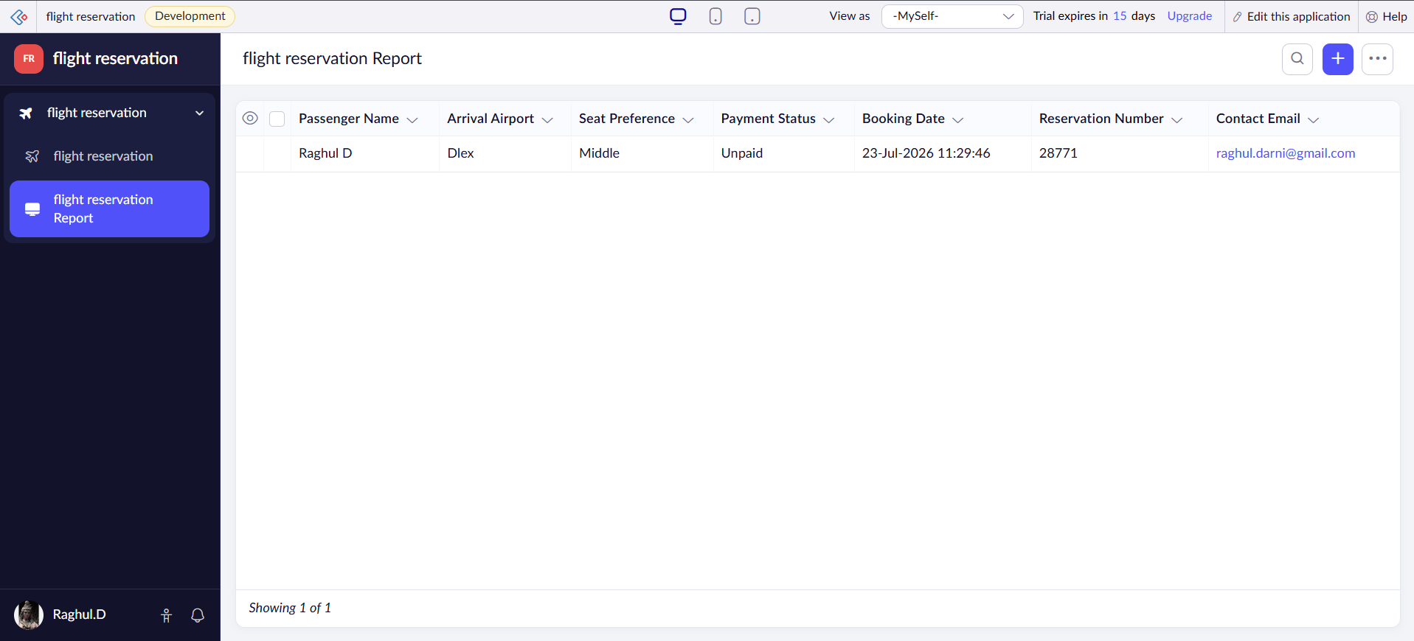

Result:
A cloud-based Flight Reservation System application was successfully designed and deployed using a Cloud Service Provider, and the SaaS model was demonstrated by capturing and displaying passenger and reservation details as shown in the output.

Experiment No. 2: Property Buying & Rental Process (Chennai City)

Aim:
To create a simple cloud software application for the Property Buying & Rental process in Chennai city using a Cloud Service Provider to demonstrate SaaS, including fields such as Buy, Rent, Commercial, Rental Agreement, Area, Place, Range and Property Value.

Procedure:
1. Login to the Cloud Service Provider platform and create a new application.
2. Name the application “Property Buying & Rental Process”.
3. Design the input form with fields such as Name, Email, Address, Phone, Date, Available From and Time.
4. Add selection fields to distinguish between Buy, Rent and Commercial property types.
5. Include fields for Rental Agreement details, Area, Place, Range and Property Value.
6. Set appropriate field validations such as mandatory phone number and email format.
7. Publish the application and enter a sample property record to test its functionality.
8. View the generated report to confirm the property details are stored correctly.

Algorithm / Output Screenshot:
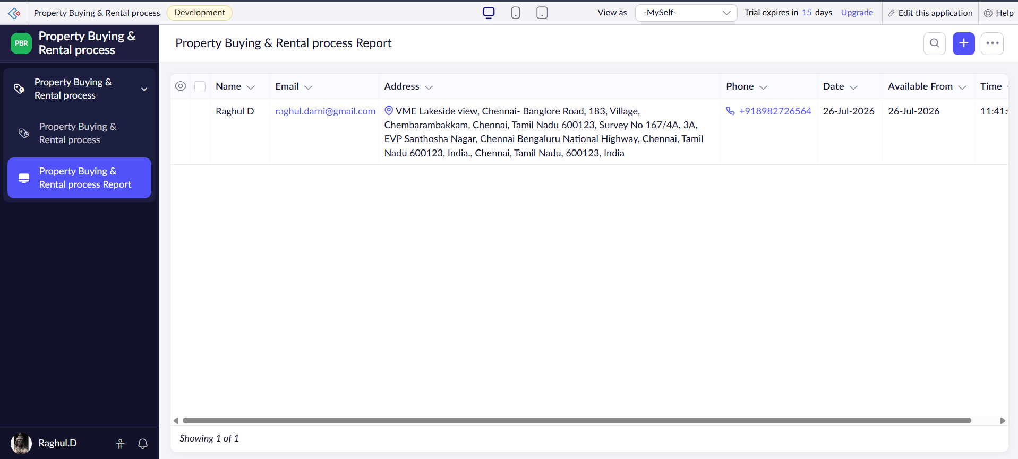

Result:
A cloud application for the Property Buying & Rental process was successfully created and deployed, demonstrating SaaS by capturing property details of buyers/renters in Chennai city as shown in the output.

Experiment No. 3: Car Booking Reservation System

Aim:
To create a simple cloud software application for a Car Booking Reservation System using a Cloud Service Provider to demonstrate SaaS, including fields such as Search for Cabs, From, To, Rental, Outstation, Package Type and Hours/Days.

Procedure:
1. Login to the Cloud Service Provider platform and create a new application named “Car Booking Reservation System”.
2. Design a booking form with fields such as Name, Employee ID, Email ID, Mobile Number and Gender.
3. Add fields for Booking Date and Pickup Time to capture reservation timing.
4. Include options for Rental and Outstation package types along with Hours/Days selection.
5. Configure the From and To location fields for cab search functionality.
6. Set field validations for mandatory details such as mobile number and email.
7. Publish the application and add a sample booking entry to test the workflow.
8. Verify the bookings report to confirm the entered data is displayed correctly.

Algorithm / Output Screenshot:
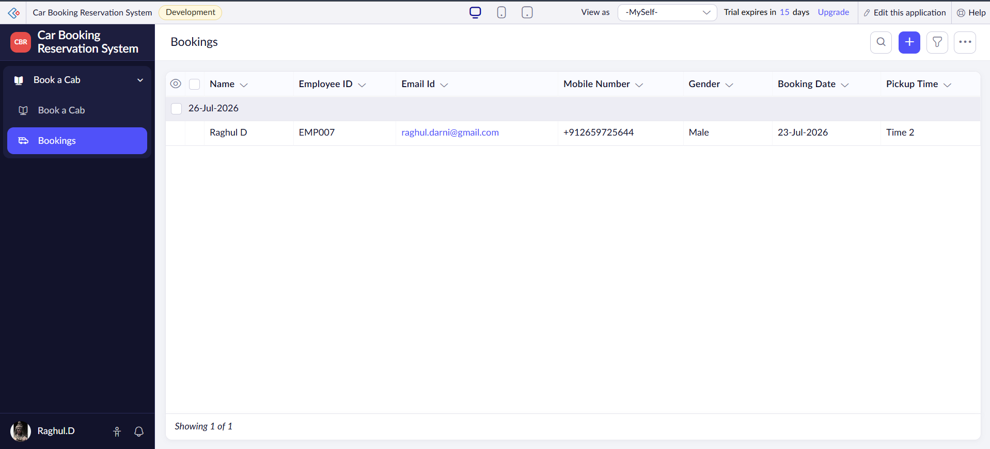

Result:
A cloud-based Car Booking Reservation System was successfully developed and deployed, demonstrating SaaS by capturing cab booking details as shown in the output.

Experiment No. 4: Library Book Reservation System (SIMATS Library)

Aim:
To create a simple cloud software application for the Library Book Reservation System for SIMATS library using a Cloud Service Provider to demonstrate SaaS, including fields such as Title, Author, Publications, Year, Edition, Number of Copies, Rack Number and Status.

Procedure:
1. Login to the Cloud Service Provider platform and create a new application named “Library Book Reservation System”.
2. Design the form with fields such as Name, Email, Address, Phone and Reservation Type.
3. Add an Availability field to indicate whether the book is available for reservation.
4. Include a Status field to mark the reservation as Pending, Approved or Returned.
5. Configure additional fields such as Rack Number, Edition and Number of Copies as required.
6. Set validation rules for mandatory fields like Name, Email and Phone.
7. Publish the application and enter a sample book reservation request to test it.
8. Generate the report to verify the reservation record and status are displayed correctly.

Algorithm / Output Screenshot:
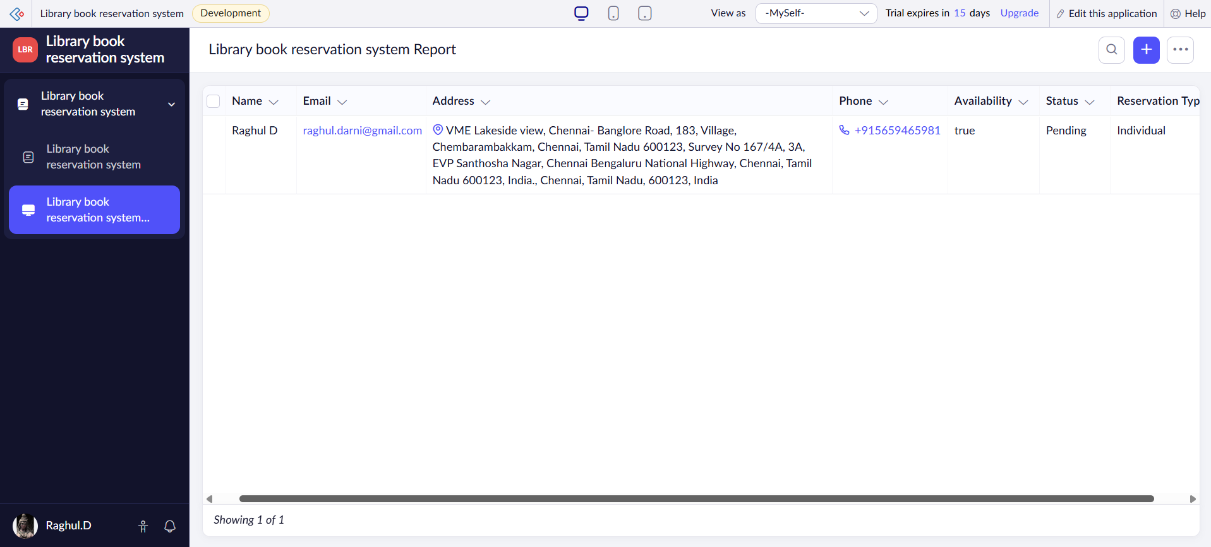

Result:
A cloud application for the SIMATS Library Book Reservation System was successfully created and deployed, demonstrating SaaS by managing book reservation requests and their status as shown in the output.

Experiment No. 5: Mark Sheet Processing System

Aim:
To create a simple cloud software application for a Mark Sheet Processing System using a Cloud Service Provider to demonstrate SaaS, including fields such as Name of Student, Register Number, Subjects, Marks, Average, Percentage, Rank and Overall Performance.

Procedure:
1. Login to the Cloud Service Provider platform and create a new application named “Mark Sheet Processing System”.
2. Design a form with fields such as Name, Student ID, Faculty Name and Attendance.
3. Add fields for Percentage, Exam Type and Obtained Marks to record academic performance.
4. Configure numeric field types with validation for Attendance and Percentage values.
5. Include a dropdown for Exam Type such as Internal, Semester Final, etc.
6. Set mandatory validation for Student ID and Obtained Marks fields.
7. Publish the application and enter a sample student mark record to test the form.
8. View the generated report to verify the mark sheet details are stored and calculated correctly.

Algorithm / Output Screenshot:
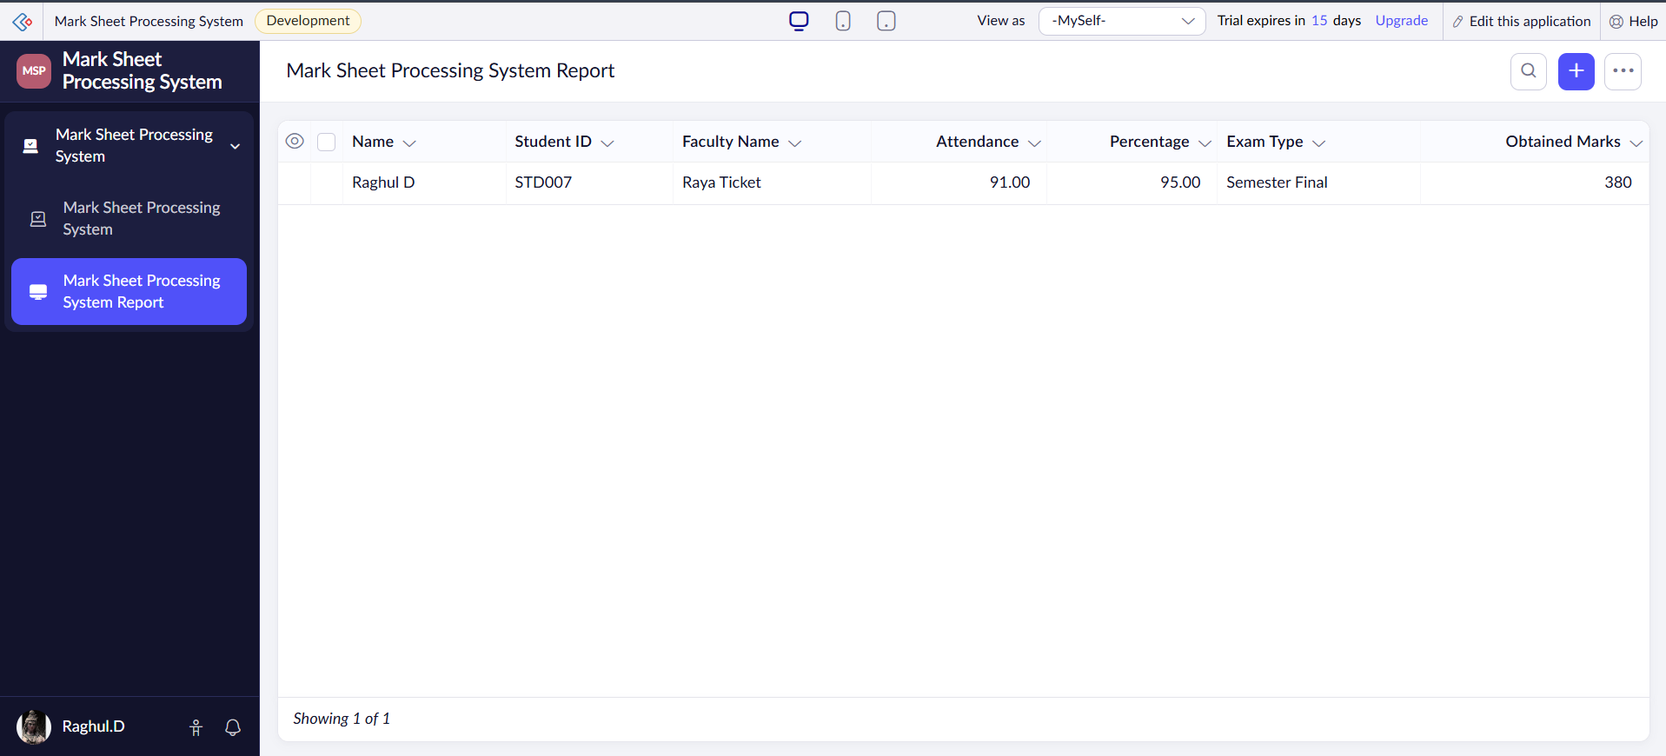

Result:
A cloud-based Mark Sheet Processing System was successfully designed and deployed, demonstrating SaaS by capturing and displaying student academic performance details as shown in the output.

Experiment No. 6: Payroll Processing System

Aim:
To create a simple cloud software application for a Payroll Processing System using a Cloud Service Provider to demonstrate SaaS, including fields such as Name of Employee, Experience, Basic Pay, HRA, DA, TA, Net Pay and Gross Pay.

Procedure:
1. Login to the Cloud Service Provider platform and create a new application named “Payroll Processing System”.
2. Design the form with fields such as Name, Email and Phone of the employee.
3. Add a Payment Status field to indicate whether the salary has been Processed or Pending.
4. Include Allowance Type and Deduction Type fields to record HRA, DA, TA and other components.
5. Add a Payment Method field with options such as Cash, Bank Transfer, etc.
6. Set validation rules for mandatory fields such as Name, Email and Phone.
7. Publish the application and enter a sample employee payroll record to test it.
8. Generate the report to verify the payroll details are computed and displayed correctly.

Algorithm / Output Screenshot:
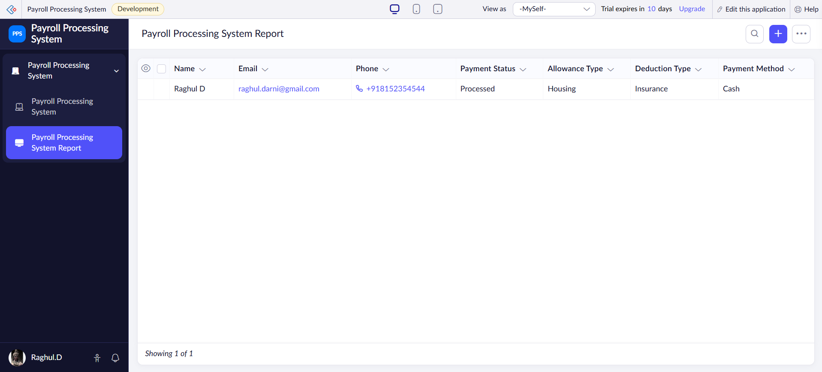

Result:
A cloud application for the Payroll Processing System was successfully created and deployed, demonstrating SaaS by processing and displaying employee salary details as shown in the output.

Experiment No. 7: Students Attendance System

Aim:
To create a simple cloud software application for a Students Attendance System using a Cloud Service Provider to demonstrate SaaS, including fields such as Name of Student, Course, Present, Absent, Course Attendance, OD Request, Grade and Attendance Percentage.

Procedure:
1. Login to the Cloud Service Provider platform and create a new application named “Students Attendance System”.
2. Design the form with fields such as Name, Email and Attendance Date.
3. Add a Status field with options such as Present or Absent to mark daily attendance.
4. Include Check In Time and Check Out Time fields to record student presence duration.
5. Add an Updated At field to automatically capture the last modification timestamp.
6. Set validation rules to make Name, Email and Attendance Date mandatory.
7. Publish the application and enter a sample attendance record to test the workflow.
8. View the generated report to verify the attendance data is stored and displayed correctly.

Algorithm / Output Screenshot:
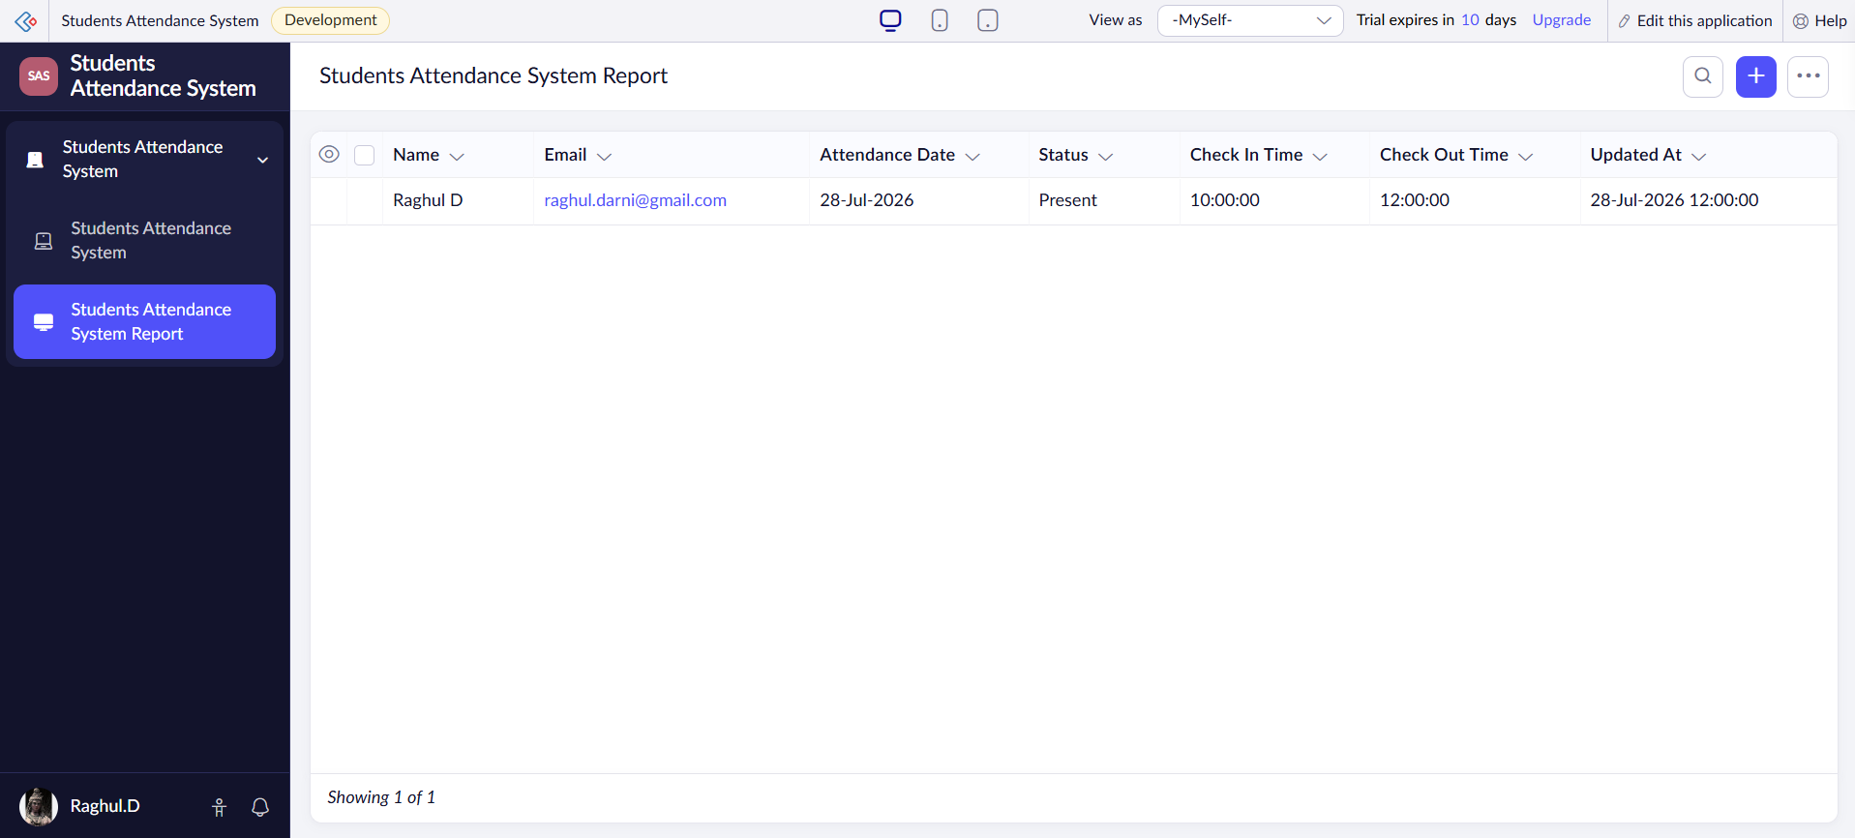

Result:
A cloud-based Students Attendance System was successfully developed and deployed, demonstrating SaaS by recording and displaying student attendance details as shown in the output.

Experiment No. 8: Student Counselling System

Aim:
To create a simple cloud web application for a Student Counselling System using a Cloud Service Provider to demonstrate SaaS, including fields such as Student Name, Age, Address, Phone, Subjects Studied, Year of Passing, Percentage of Marks and Domain Interest.

Procedure:
1. Login to the Cloud Service Provider platform and create a new application for the Student Counselling System.
2. Design the form with fields such as Name, Email and Phone of the student.
3. Add Region and Availability Zone fields to record the counselling centre/location details.
4. Include Onboarding Time and Response Time fields to track the counselling session schedule.
5. Configure field validations to make Name, Email and Phone mandatory.
6. Add dropdown options where applicable to standardise data entry.
7. Publish the application and enter a sample student counselling record to test it.
8. Generate the report to verify that the counselling details are captured and displayed correctly.

Algorithm / Output Screenshot:
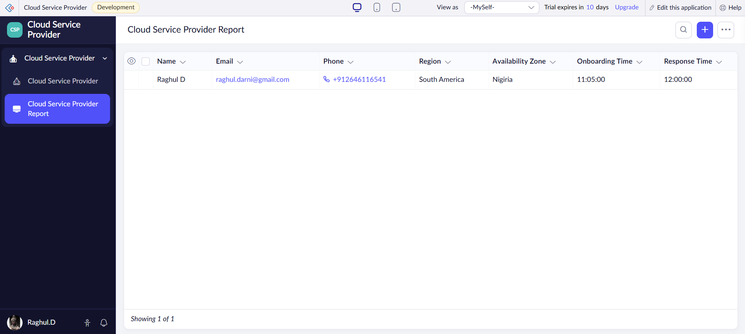

Result:
A cloud web application for the Student Counselling System was successfully created and deployed, demonstrating SaaS by capturing student counselling details as shown in the output.

Experiment No. 9: Hospital Information System (SIMATS Hospital)

Aim:
To create a simple cloud software application for a Hospital Information System for SIMATS Hospital using a Cloud Service Provider to demonstrate SaaS, including fields such as Patient Name, Age, Address, Phone, Email, Attender Name, Attender Phone, Doctor Name and Diseases.

Procedure:
1. Login to the Cloud Service Provider platform and create a new application named “Hospital Information System”.
2. Design the form with fields such as Name, Email, Phone and Address of the patient.
3. Add a Diseases field to record the medical condition of the patient.
4. Include Attender Name and Doctor Name fields to capture attendant and consulting doctor details.
5. Configure the Address field to auto-capture location details for the patient.
6. Set validation rules to make Name, Phone and Diseases mandatory fields.
7. Publish the application and enter a sample patient record to test the workflow.
8. View the generated report to verify the patient and hospital details are displayed correctly.

Algorithm / Output Screenshot:
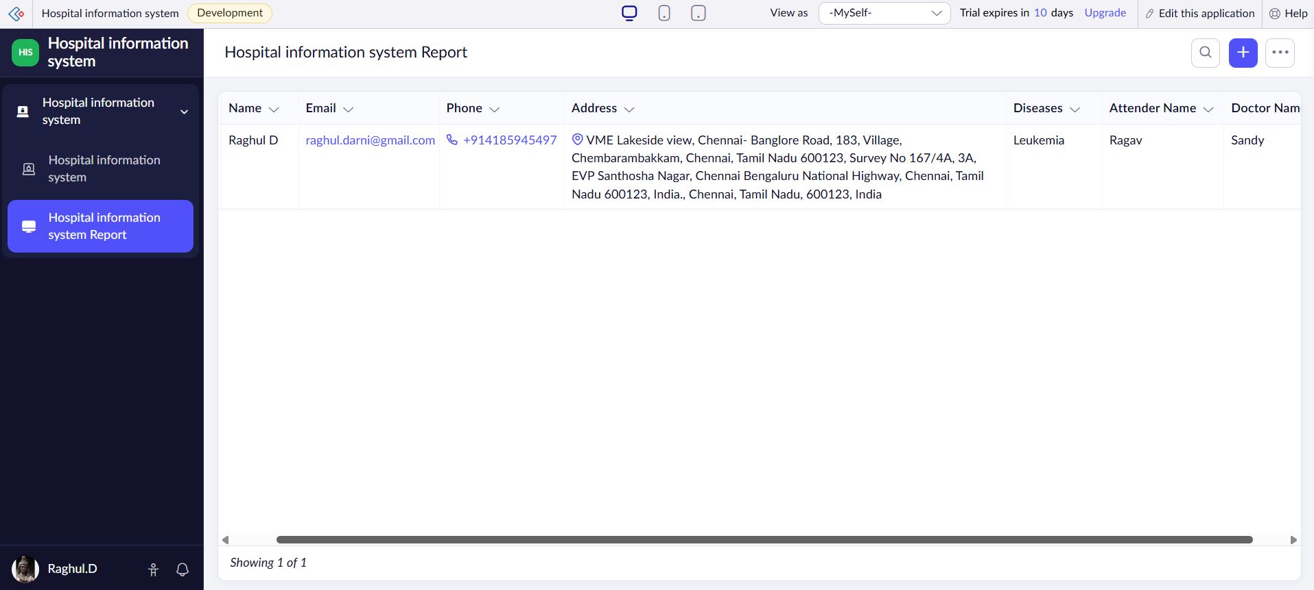

Result:
A cloud-based Hospital Information System for SIMATS Hospital was successfully designed and deployed, demonstrating SaaS by capturing and displaying patient information as shown in the output.

Experiment No. 10: Student Information Display System (C Program Template)

Aim:
To create a simple cloud software application to run a C program to display student information using a Cloud Service Provider to demonstrate SaaS, with the template of Student Name, Register Number, Address, Phone, Age, Courses, Grades, Attendance Report, Progress Report and Semester Mark Sheet forms.

Procedure:
1. Login to the Cloud Service Provider platform and create a new application named “Cloud Service Provider 1” for student information.
2. Design the form with fields such as Name, Register Number and Address of the student.
3. Add Phone and Age fields to capture the personal details of the student.
4. Include Courses and Grade fields to record academic enrolment and performance.
5. Configure field types such as numeric for Age and dropdown for Grade.
6. Set validation rules to make Name, Register Number and Phone mandatory.
7. Publish the application and enter a sample student record to test the C program based template.
8. Generate the report to verify the student information is stored and displayed correctly.

Algorithm / Output Screenshot:
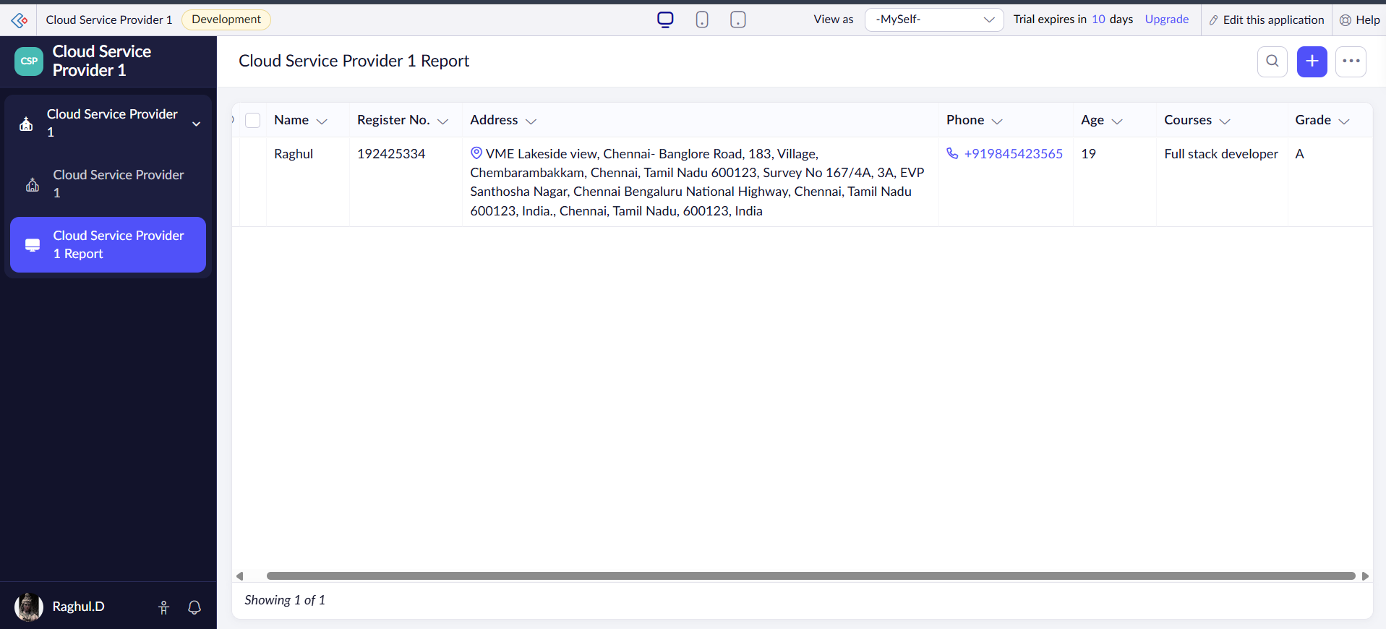

Result:
A cloud application to display student information based on a C program template was successfully created and deployed, demonstrating SaaS by capturing student academic and personal details as shown in the output.

Experiment No. 11: Online Super Market

Aim:
To create a simple cloud software application for an Online Super Market using a Cloud Service Provider to demonstrate SaaS, with the template of Customer Name, Address, Phone, Email, Items, Quantity and item classification form.

Procedure:
1. Login to the Cloud Service Provider platform and create a new application named “Cloud Service Provider 2” for the Online Super Market.
2. Design the form with fields such as Customer Name, Customer Address and Customer Phone.
3. Add Customer Email and Order Date fields to capture order details.
4. Include a Total Amount field to compute the value of items purchased.
5. Configure an item classification form to categorise products such as groceries, electronics, etc.
6. Set validation rules to make Customer Name, Phone and Email mandatory fields.
7. Publish the application and enter a sample customer order to test the workflow.
8. View the Customer Order Report to verify the order details are displayed correctly.

Algorithm / Output Screenshot:
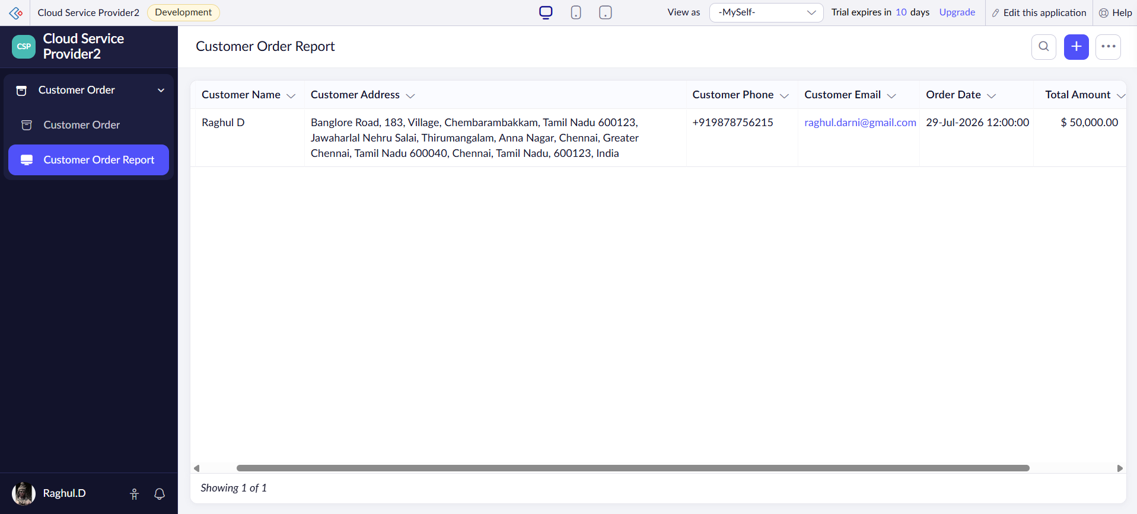

Result:
A cloud application for the Online Super Market was successfully created and deployed, demonstrating SaaS by capturing and displaying customer order details as shown in the output.

