**In this document, we are going to setup the IDE for development of Hadoop applications.**

**We recommend you use Linux or MacOS, rather than Windows.**

**Note: the IDE we are going to setup is used to rapidly develop your applications and evaluate the logic the correctness of your code. If you want your code to run on a real distributed environment, you need real clusters.**

Contents

**1.** **Run the WordCount example (Windows 10+IDEA)** 1

**2.** **Run the WordCount example (Linux Ubuntu 14+ IDEA)** 6

**3.** **Run the WordCount example (Linux Ubuntu + Eclipse)** 6

**4.** **Run the WordCount example (MacOS + IDEA)** 13

# **Run the WordCount example (Windows 10+IDEA)**

You can follow this guide to run the first MapReduce example: **WordCount**.

**Step1:**

1.1 Make sure you have installed JDK on Windows.  
  
1.2 Make sure the installation path do not have a space, e.g. **C:/Program Files/Java/jdk1.8.0_144** will cause some errors.

**Step2:**

2.1 Download the Hadoop and install it on windows.  
  
2.2 Set the Environment variables:  
**HADOOP_BIN_PATH : %HADOOP_HOME%\bin  
HADOOP_HOME : E:\soft\hadoop-2.7.4 (your Hadoop’s installation path)**  
Add **%HADOOP_HOME%\bin;%HADOOP_HOME%\sbin** to your system Path  
  
2.3 The downloaded binary files from Apache web site do not contain some Windows native components( such as winutils.exe, hadoop.dll…). You can download them from <https://github.com/steveloughran/winutils> and then copy them into your $**hadoop/bin.**

**Step3:**

3.1 Installing Intellij IDEA as the IDE  
3.2 Start Intellij IDEA as Administrator  
3.3 Create Maven project by File -> New -> Project -> Maven, please see below picture:  
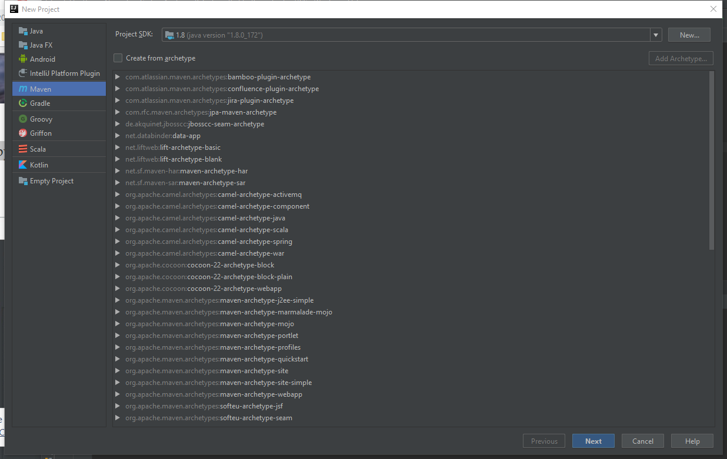

3.3 Next, specify GroupId, ArtifactId as WordCount.

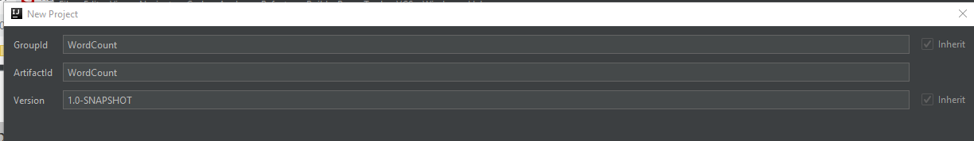

3.4 Next and click Finish.

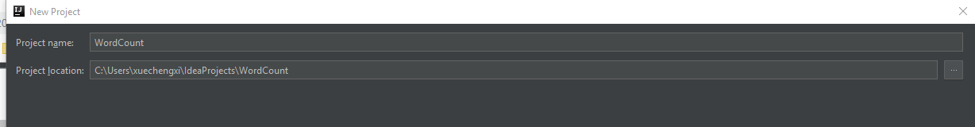

3.5 Create a Java class on left panel of Intellij IDEA, click WordCount -> src -> main ->java, then right click to choose New ->Java Class, type WordCount as class name.

Add the provided code in **WordCount.java** (you can remove the first line: package wordcountpkg; if you do not create a package)

3.6 you will see some errors, don’t worry. We need to add Hadoop Library. click File -> Project Settings -> Modules -> Dependencies -> +.

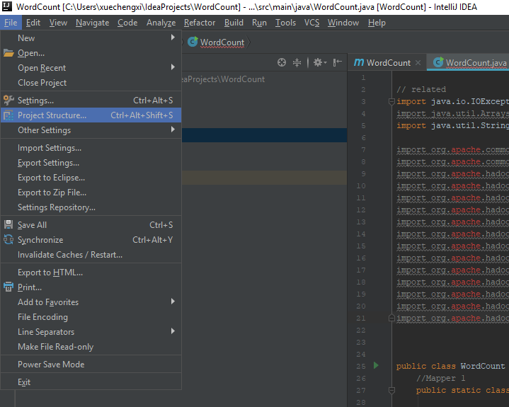

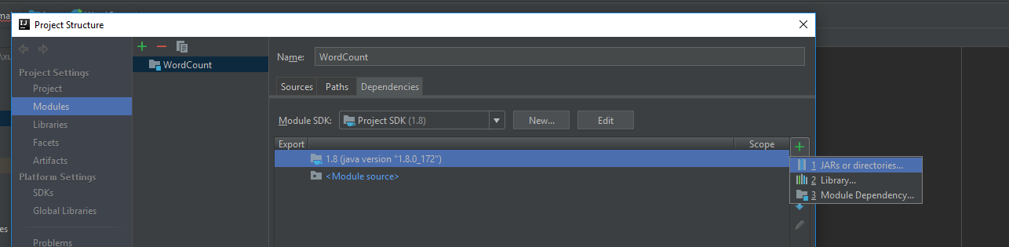

Find you Hadoop, add all this libraries.

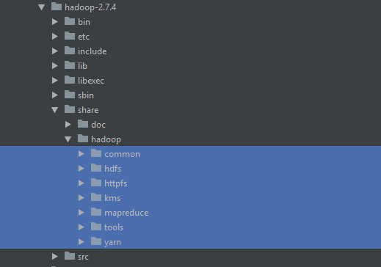

Also add this lib.

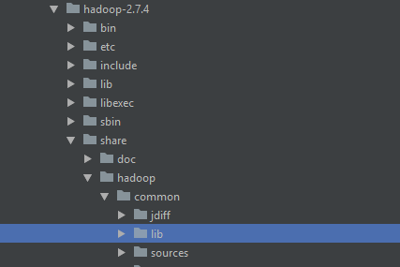

3.7 Edit Running Configuration. Click Run -> Edit Configuration.. -> + , see the below picture:

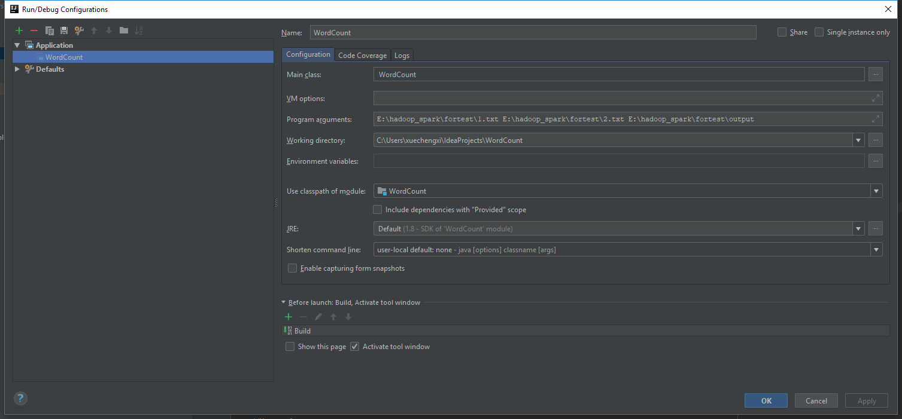

You need to use your own Program arguments. Two input files and the output path. You do not need to create the output directory, Hadoop application will create the output directory for you automatically.

3.8 Run the application, if no error, you will see the result in your output file.

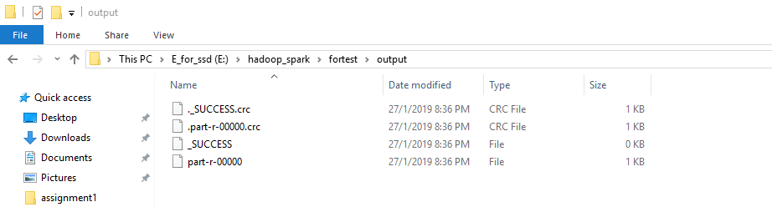

if you want to run the Hadoop and use HDFS on windows, here are some materials for you **(untested)**: 1.[**https://wiki.apache.org/hadoop/Hadoop2OnWindows**](https://wiki.apache.org/hadoop/Hadoop2OnWindows)2.<https://github.com/MuhammadBilalYar/Hadoop-On-Window/wiki/Step-by-step-Hadoop-2.8.0-installation-on-Window-10>  
3.<http://hadooponwindows10.blogspot.com/2016/07/apache-hadoop-271-installation-on-win10.html>

# **Run the WordCount example (Linux Ubuntu 14+ IDEA)**

You can follow this guide to run the first MapReduce example: **WordCount**.

**Step1:**

1.1 Make sure you have installed JDK (jdk1.8 has been tested)

**Step2:**

2.1 Download the Hadoop and install it.  
you can read: **http://hadoop.apache.org/docs/stable/hadoop-project-dist/hadoop-common/SingleCluster.html**

**Step3:**

Same as previous step3 on windows.

# **Run the WordCount example (Linux Ubuntu + Eclipse)**

**You can use eclipse. In this example, you can access the hdfs directly.**

**Step1:**

1.1 Download eclipse

1.2 Put “hadoop-eclipse-plugin-2.8.3.jar” (we assume Hadoop is 2.8.3 or you need to find corresponding plugins) into eclipse/dropins. (where to download.)

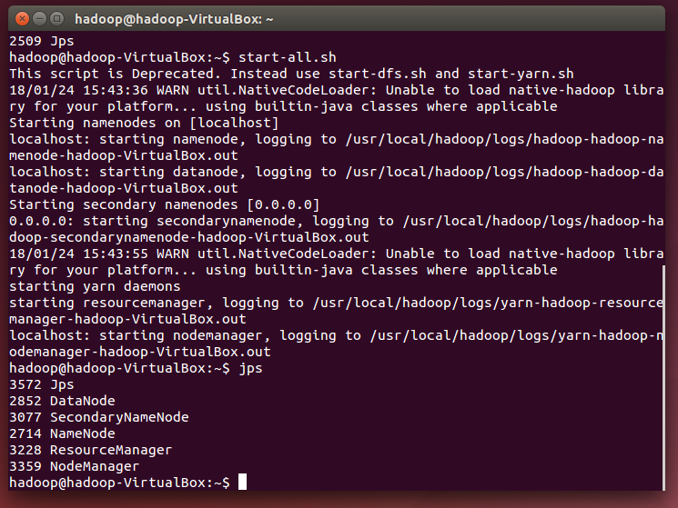1.3 Restart eclipse (make sure you have started the Hadoop, /sbin/start-all.sh)

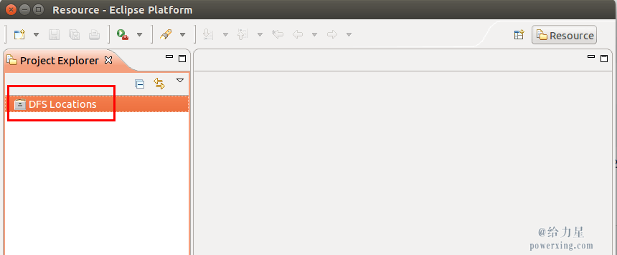You will see the dfs locations

1.4 Click “Windows” then “preferences”

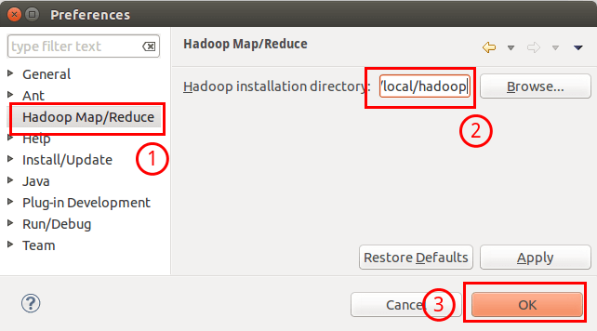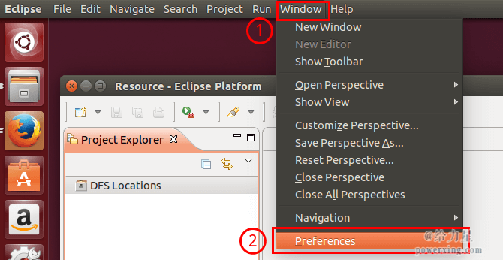1.5 Choose your Hadoop path

1.6 Click “windows” —> ”perspective” —> ”open perspective”—> ”other” —> ”Map/Reduce”

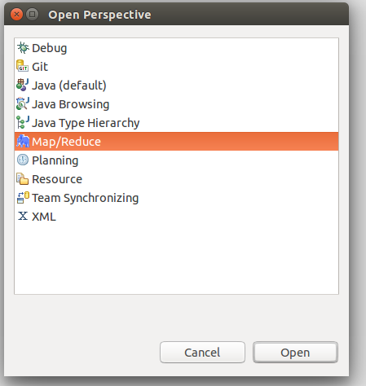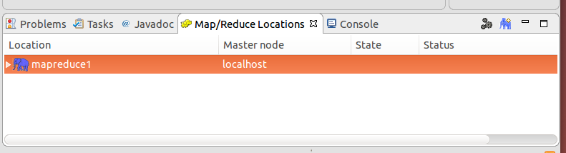1.7 Connect to Hadoop, right click the window below the Map/Reduce Location, choose New Hadoop Location

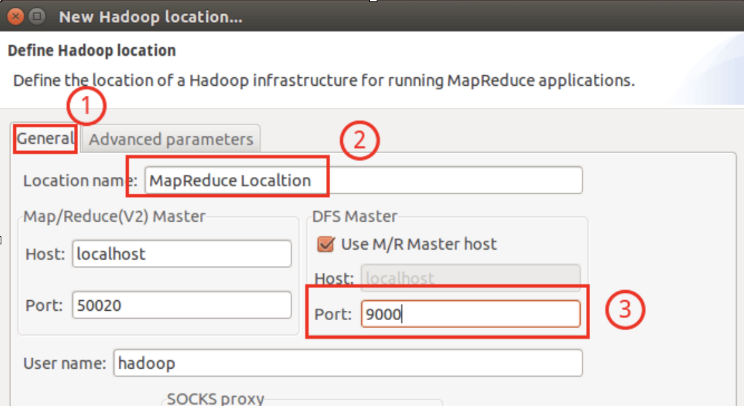1.8 Choose the location name, fill up the DFS Master port. (in core-site.xml)

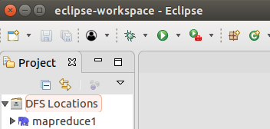1.9 Then you can see a blue elephant!

**Step2**

2.1 Now you can create a project click file—>new—>project—>Map/Reduce Project—>next—> Project name—>finish. You can see your project now.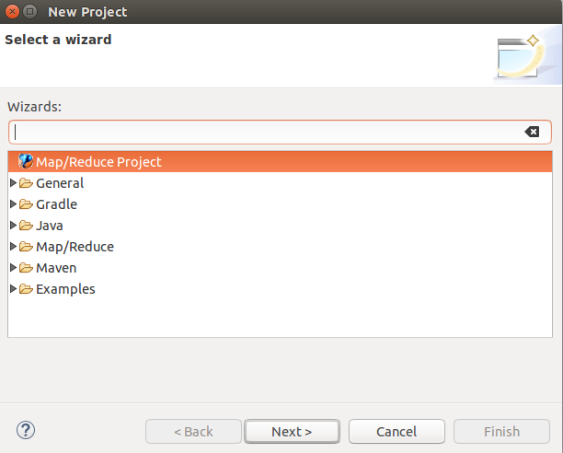

2.2 Right Click your project—> new —>class, you need to fill up the package and name

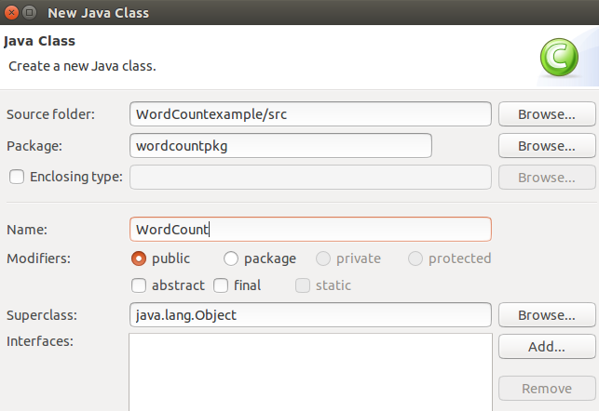

2.3 Copy WordCount.java into your java file.(you need to change some details if using different configuration like paths)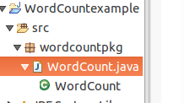

2.4 Using Hadoop commands (put) to put our data into hdfs (like: hadoop fs -put data1.txt /data/inout) you can find them here (need to refresh after every operation)

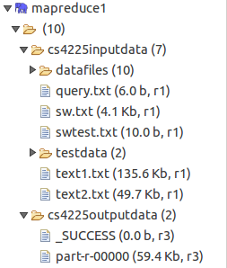

2.5 Right click your java file —>run as—>run configurations—>Arguments

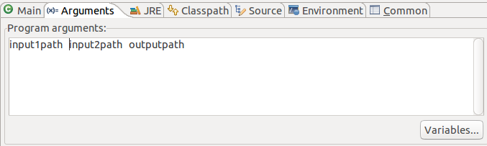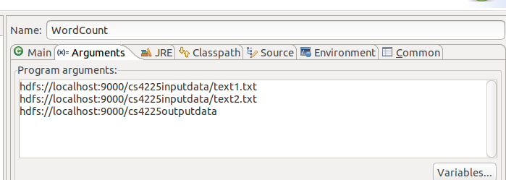Here you need to fill up your arguments, for example:

2.6 Run and you will see the result.

# **Run the WordCount example (MacOS + IDEA)**

You can follow this guide to run the first MapReduce example: **WordCount**.

**Step1:**

1.1 Make sure you have installed JDK (jdk1.8 has been tested)

**Step2:**

2.1 Download the Hadoop and install it,   
You can use Homebrew to make it very easy, brew install Hadoop (it will install the latest version, so pay attention to the difference between Hadoop 3.* and Hadoop 2.*)

You can use this guide to build a single cluster Hadoop system (3.1.1) on mac to test: **https://hadoop.apache.org/docs/r3.1.1/hadoop-project-dist/hadoop-common/SingleCluster.html**

Note: difference between Hadoop 3.* and Hadoop 2.*: 1. default ports are different,

2. start-yarn.sh, and a lot of other differences.

**Step3:**

Same as previous step3 on windows.