### **Installation (it should work following the steps)**

1. Make sure you have the Java 8 JDK (also known as 1.8)
   * Run javac -version on the command line and make sure you see javac 1.8._or above__
   * If you don’t have version 1.8 or higher, [install the JDK](http://www.oracle.com/technetwork/java/javase/downloads/index.html).
2. Next, download and install [IntelliJ Community Edition](https://www.jetbrains.com/idea/download/)
3. Then, after starting up IntelliJ, you can download and install the Scala plugin by following the instructions on [how to install IntelliJ plugins](https://www.jetbrains.com/help/idea/installing-updating-and-uninstalling-repository-plugins.html) (search for “Scala” in the plugins menu, see the below figure.) Note, downloading the Scala plugin might take some time (around 10 minutes in my case), depending on your network.

When we create the project, we’ll install the latest version of Scala. Note: If you want to open an existing Scala project, you can click **Open** when you start IntelliJ.

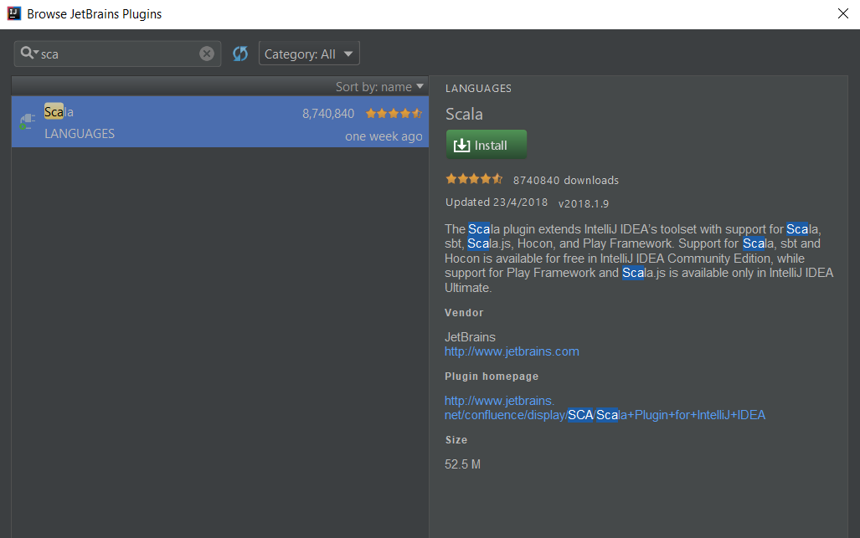

### **Creating the Project**

1. Open up IntelliJ and click **File** => **New** => **Project**
2. On the left panel (see the below figure), select Scala. On the right panel, select IDEA.

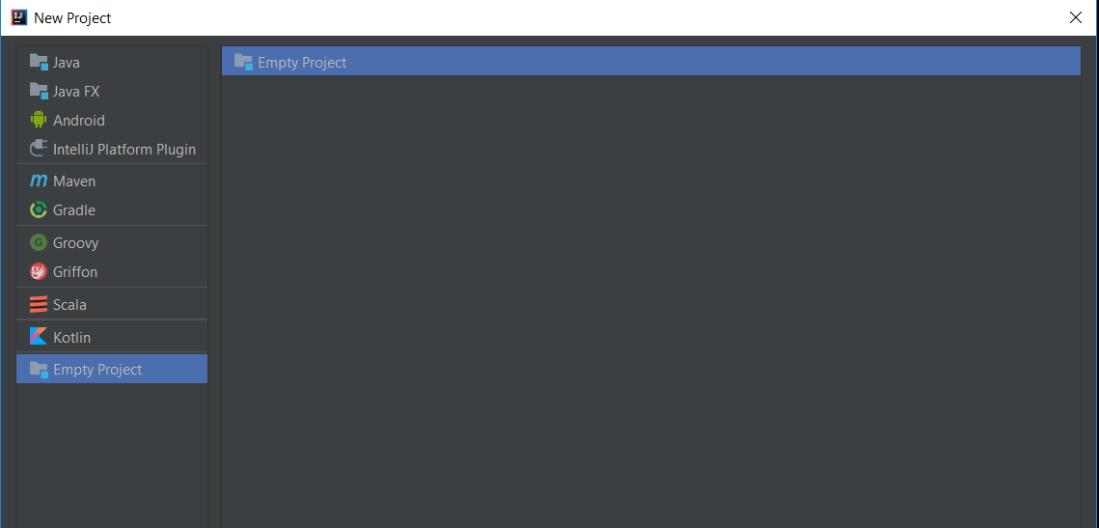

1. Name the project **HelloWorld.**
2. Assuming this is your first time creating a Scala project with IntelliJ, you’ll need to install a Scala SDK. To the right of the Scala SDK field, click the **Create** button.
3. Select the highest version number (e.g. 2.12.2) and click **Download**. This might take a few minutes but subsequent projects can use the same SDK.
4. Once the SDK is created and you’re back to the “New Project” window click **Finish**.

### **Writing code**

1. On the **Project** pane on the left, right-click src and select **New** => **Scala class**.
2. Name the class Hello and change the **Kind** to object.
3. Change the code in the class to the following:

**object** Hello **extends** App {  
 *println*("Hello World!")  
}

### **Running it**

* Right click on Hello in your code and select **Run ‘Hello’**.
* You’re done!